Supporting
transitions in the early years
The
Handbook
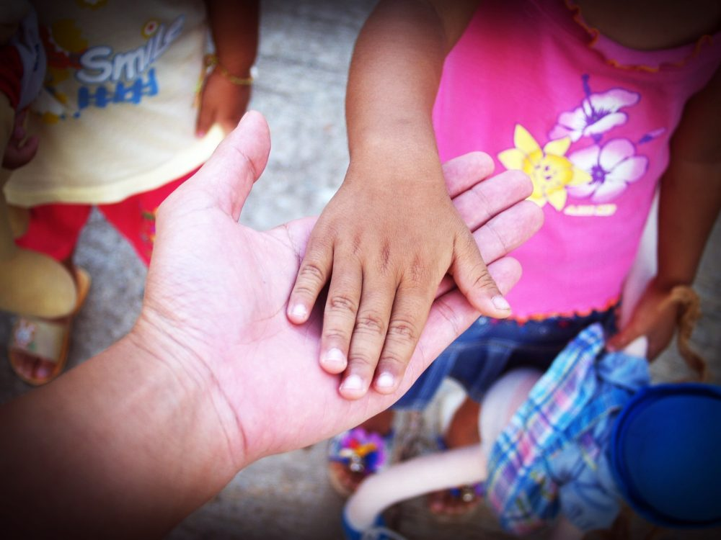
Contents
Aims
Introduction
The needs of the child
The role of the adult
The importance of partnerships
Interventions
Proposed outcomes
References

Introduction to transitions
This handbook aims to promote awareness and an understanding of transitions for practitioners supporting children in the early years. The handbook discusses how practitioners can support transitions through an understanding of the needs of the child and signifies the importance of partnerships. Brooker (2008) believes in the value of positive transitions and how they can be enriching experiences, which will help the child in their developmental journey.

What is a transition?
The centre for high impact philanthropy (no date) defines early childhood as the period of time between birth to eight years. The centre for high impact philanthropy (no date) goes on to suggest that age eight is a good end to how we define early years, as it is the stage where most children have reached significant developmental milestones. Brooker (2008) describes transitions as changes that have a significant effect on how lives are shaped, whether through positive experiences or traumatic events. According to Brooker (2008) Urie Bronfenbrenner, an American psychologist, gave a theoretical explanation of a transition as a change in role, in setting or both, resulting in the individual’s position in an environment being altered.
Brooker (2008) believes that transitions, in any society, are part of every human’s life and development. Brooker (2008) goes on to suggest that in modern society, change is becoming more frequent, but this should not be considered less significant. In the early years, children go through changes frequently, whether public or private, personal or in relationships. Brooker (2008) provides examples of some transitions that children may go through, for instance, the birth of a new sibling, the breakdown of a family or the move from home to daycare or school. Brooker (2008) introduces transitions as being horizontal or vertical. The open university (no date) distinguishes between horizontal and vertical transitions by providing examples for both. Horizontal transitions are changes that happen regularly, such as, going between a childminder to school and back again, or going from the classroom to the lunch hall. Vertical transitions are the changes that happen over time and can be seen as more significant, for example, moving from nursery to infant school, or welcoming a new sibling at home. These changes may lead them to question their position in society and give them a sense of vulnerability. Therefore, it is significant for practitioners to consider whether transitions in their setting are supported and well- planned, or sudden and frightening (Brooker, 2008).

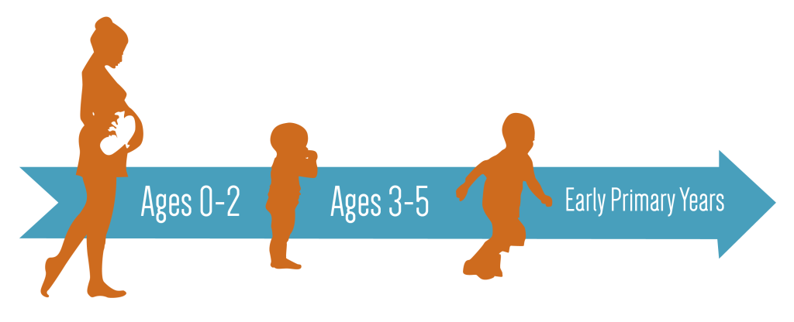
The centre for high impact philanthropy (no date)

The needs of the child
According to Brooker (2008) our expectations of children can change dramatically within a very short space of time. A sensitive organism developing in the care of their parents or care givers, who know and love them more than anyone else, becomes a pupil who needs to be socialised with others and disciplined into conformity. Brooker (2008) goes on to suggest that this can overturn a child’s sense of security and leave them feeling unsafe in an unfamiliar place. According to Holmes (2014) John Bowlby, a psychological theorist, it is instinctive for a child to display attachment behaviour when separated from the primary caregiver. Bowlby listed some of these behaviours as, clinging on, crying, and screaming. Holmes (2014) goes on to suggest that Bowlby believed that when children have strong relationships with parents, based on warmth and sensitivity, they will flourish in the learning environment. Children will learn and grow, explore, and take risks, in the knowledge that they have a place of security. According to Simply Psychology (2023) Bowlby’s theory suggests that a child’s value and worthiness is based on their relationship with their primary caregiver and positive relationships encourage confident and adaptive children. According to Brooker (2008) Bronfenbrenner, an American psychologist, believed that to achieve a successful transition, responsibility lies with the adults, to prepare the child for the process of change. Brooker (2008) goes on to suggest that children with additional learning needs may find transitions more challenging as typically developing children as they may struggle to comprehend change. Preparing for transitions will be introduced and discussed further on in this handbook.

According to Mcloed (2021) Maslow’s hierarchy of needs is significant when considering the needs of the child.
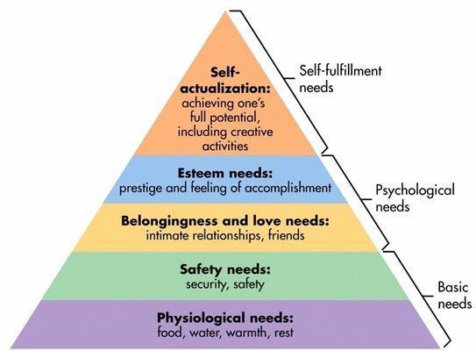
Abraham Maslow was an American psychologist who, according to McLeod (2021) Maslow argued that individuals cannot satisfy needs higher up the hierarchy until needs lower down are fulfilled. Mcloed (2021) states that the lower levels of the hierarchy are the basic survival needs of any human being. Food, water, warmth, and rest are basic requirements for physical survival, impacting and motivating an individual’s behaviour. McLoed (2021) goes on to suggest that once the physiological needs have been met, the need for security and safety become predominant. It is then that the social needs can be satisfied, with the goal of reaching the needs of self- fulfilment and becoming what one is capable of. McLoed (2021) states that it is the responsibility of families and society to support and fulfil these needs. UNICEF (no date) is an organisation set up for the protection of childhood, UNICEF supports the rights of the child and stands with United Nations Convention of the rights of the child. Article 6 states that, ‘Governments must do all they can to ensure that children survive and develop to their full potential.’ The United Nations Convention of the rights of the child is an international agreement, which is legally-binding, which protects the human rights of children up to the age of 18.

The role of the adult
Trodd (2012) suggests that a child’s experience of a transition can influence development, academic achievement, and emotional well-being. According to Trodd (2012) Albert Bandura’s theory supports this viewpoint. Bandura was a psychologist who believed that experience of positive change can help build resilience and self-efficiency. Bandura also shared the opinion that negative change may leave a child feeling depleted.
So, what can the adult do to support transitions? Trodd (2012) suggests that understanding the child is significant in recognising the impact of any transition. Brooker (2008) supports this view, but further suggests that it is significant to recognise that every child is an individual, with their own unique needs. Brooker (2008) goes on to suggest that practitioners may be guilty of recognising children in terms of what group they fit into. Are they one of the confident, able children, or the shy and quiet children? Or are they part of the group of boisterous boys? Trodd (2012) believes that practitioners need to be careful not to categorise children this way, as it may be perceived as prejudice. Brooker (2012) believes that close attention during time of transition and recognising individuality, can help children to thrive and flourish. According to Brooker (2008) Bronfenbrenner believed that the links between systems can determine whether a transition is positive or negative. This is dependent on strength of the setting and the partnerships between primary carers, practitioners and other care provides. The importance of partnerships will be introduced in the next section of the handbook.
Future Learn (no date) suggests that during transitions the role of the adult is to build relationships with children based on trust. Reassurance of presence, consistency and being able to listen and respond to physical and emotional needs is significant when building a relationship of trust. Future Learn (no date) goes on to suggest that forming relationships with trusted adults can help develop important social skills. Future Learn (no date) believes that during times of change and disruption, good communication between caregivers and finding ways to keep the child connected is significant. Early Years Matter (no date) states that for a transition to be successful, communication between organisations should begin early.
Trodd (2012) believes in the significance of practitioners recognising early signs of a child who may be struggling with a transition. Trodd (2012) suggests that these signs may include, a difficulty to engage and learn, or appearing sad or lethargic. Early Years Matter (no date) believes in the importance of a key person in early years care. Early years Matter (no date) states that it is the key person’s role to respond to the physical and emotional needs of a child in the absence of their primary care person. Early years matter (no date) suggests that children can form strong attachments to key people, which allows them to thrive and flourish with the comfort of a secure relationship. According to Mickleburgh (2021) Bowlby suggests that infants can be overwhelmed and distressed during periods of change and comforted by the familiar. Bowlby strongly believed a key person approach was significant in the early years. According to Mickelburgh (2021) Bowlby believed that the distress of change can be comforted by the familiar, a key person who demonstrates warmth, sensitivity and who makes themselves available. Bowlby suggests that a key person is valuable when supporting both parent and child when it is time to say goodbye, but also to pass on any information at the end of the day, providing links between home and school (Mickelburgh, 2021).
Gueterbock (no date) believes that there is a strong relationship between the Montessori practise and the early years foundation stage. Gueterbock (no date) suggests that Dr Montessori was one of the earliest pioneers to recognise the importance of the learning environment on outcomes for children. Montessori believed in child centred environments, where everything has a purpose and where materials and equipment is ordered and accessible. Children have freedom to explore their own interests in their own time (Gueterbock, no date). However, Gueterbock (no date) does suggest that the Early Years Foundation Stage framework places emphasis on target-based planning and may lead practitioners to provide more focused learning experiences. This is done so at the expense of allowing an active learner to follow their own interests (Gueterbock, no date)

The importance of partnerships
Wilson (2016) suggests that communication between practitioner’s, children and parents encourages trusting relationships. According to Wilson (2016) a partnership promotes a shared understanding of a child’s interests and abilities, consequently enhancing the development of a child. Positive relationships, and information shared, can help practitioners understand if a family needs any further support (Wilson, 2016). Birth to 3 matters (no date) stresses the significance of early intervention, suggesting that this supports children to reach their full potential and live successful lives. Froebel saw parents as a child’s first teacher, he stressed the importance of the parental role in a child’s development (early education, 2021). Trodd (2021) believes that through communication with parents and previous carers, a child’s view can be accessed.
Brooker (2008) suggests that it is important for practitioners to understand parents, and respect how they see best to teach their child. Brooker (2008) goes on to say that through building trusting relationships with parents, information can be shared encouraging the education of parents to work alongside practitioners. This may give the child a consistent approach to learning and encourages their development.
According to Brooker (2008) Bronfenbrenner believed that the links between systems can determine whether a transition is positive or negative. This is dependent on strength of the setting and the partnerships between primary carers, practitioners and other care provides.
Interventions
Trodd (2012) believes that strategies should provide a smooth transition for children, to avoid regression in their development and encourage them to build on previous knowledge. Brooker (2008) suggests that during times of transition, listening to children and making observations should be the main form of assessment. Trodd (2012) suggests that awareness of the voice of the child is significant and allows children to have agency and autonomy in matters that concern their own lives. Trodd (2012) goes on to say that growth and development can be achieved through allowing children autonomy, and seeking the child’s views creates opportunities to learn and change. Smidt (2015) believes that through interactions with others and the world a child can develop. Sigmund Freud had a similar view, Freud was a neurologist who believed that through exploration of the world, children can develop confidence in themselves and their abilities. According to Tovey (no date) Froebel’s theory suggests that with a strong and supportive community, which encourages individuality and uniqueness a child can flourish. Froebel believed in the significance of providing opportunities for children to pursue their own interests, solve problems and think for themselves.
Welsh Government (no date) reflects this in the new curriculum for Wales framework. The framework is based around the four purposes, which is a shared vision for what we aspire every child to achieve. The four purposes are a starting point for all decisions made when planning content and experiences for the curriculum. One of the four purposes is the aspiration of healthy, confident individuals who, face and overcome challenges and are building their mental and emotional well-being by developing confidence, resilience, and empathy. The statement of what matters code is developed under section 6 of the Curriculum and Assessment (Wales) Act 2021. It sets out the 27 statements of what matters across the six areas of learning and experience on which all maintained schools and funded non-maintained setting must base their curriculum. The statement of what matters code suggests that ‘supporting learners to develop strategies which help them to regulate their emotions can contribute towards good mental health and emotional well-being.
Brooker (2008) suggests that preparations for a smooth transition can include, informal meetings between parents and practitioners, time spent at the setting by the parent and objects of comfort carried to and from the setting. Brooker (2008) believes that this will create a supportive link between the home and the setting. Brooker (2008) goes on to suggest that negative feelings may resurface time is spent away from the setting, whether through holiday or illness. Brooker (2008) states that this encourages supportive links to be constantly reviewed and made available.
Bandura believed that through times of transition children should have opportunities to observe others, and to explore stories that may offer them some understanding of how to navigate through their own transitions. Bird and Gerlach (2005) suggests that there is association between a child’s sense of identity and self-worth, and their ability to navigate through uncertainty.

Proposed outcomes
According to Holmes (2014) Bowlby believed that when children have strong relationships with parents, based on warmth and sensitivity, they will flourish in the learning environment. Holmes (2014) suggests that children will learn and grow, explore, and take risks, in the knowledge that they have a place of security.
Trodd (2012) suggests that a child’s experience of a transition can influence development, academic achievement, and emotional well-being. According to Trodd (2012) Bandura believed that experience of positive change can help build resilience and self-efficiency. Bandura also shared the opinion that negative change may leave a child feeling depleted. Trodd (2012) believes that strategies should provide a smooth transition for children, to avoid regression in their development and encourage them to build on previous knowledge.
According to Tovey (no date) Froebel believed that through a framework of respect for others, children can be supported and encourage to develop autonomy and self-discipline. This can be done through opportunities to think for themselves, solve problems and explore their talents (Tovey, no date). Brooker (2008) suggests that through encouraging children to think of a solution to any challenge they may face, practitioners can help children to build resilience. Building resilience is an ability to navigate through unprecedented circumstances and develop normally (Brooker, 2008).
Brooker (2012) believes that close attention during time of transition and recognising individuality, can help children to thrive and flourish. Trodd (2012) believes in the significance of practitioners recognising early signs of a child who may be struggling with a transition. Early interventions can limit negative consequences in a child’s future and enable them to reach their full potential, living a happy and successful life (Early intervention foundation, no date). The statement of what matters code suggests that ‘supporting learners to develop strategies which help them to regulate their emotions can contribute towards good mental health and emotional well-being.’
Early years matter (no date) suggests that children can form strong attachments to key people, which allows them to thrive and flourish with the comfort of a secure relationship. According to McLeod (2021) Maslow’s theory supports the significance of meeting the needs of the child to encourage best outcomes for children.
According to Tovey (no date) Froebel’s theory suggests that with a strong and supportive community, which encourages individuality and uniqueness a child can flourish.

Reference List
Brooker, L (2008) Supporting Transitions in the Early Years. McGraw-Hill Education, Maidenhead. Available from: ProQuest Ebook Central. Accessed: 9th November 2023).
Birth to 5 Matters. Available at: https://birthto5matters.org.uk/observation-assessment-and-planning/ (Accessed: 25 October 2023.
Holmes, A (2014) John Bowlby and Attachment Theory. 2nd Ed. London: Routledge.
Langston, A (no date) Transitions. Available at: https://www.earlyyearsmatter.co.uk/eyfs/positiverelationships/transitions/ (Accessed: 17th November 2023)
McLoed, S (2021) Maslow’s Hierarchy of needs. Simply Psychology. Available at: https://www.simplypyschology.org/maslow.html (Accessed: 28th November 2023).
Mickelburgh, M (2021) Attachment theory and the key person approach. Available at: https://eyfs.info/articles.html/general/attachment-theory-and-the-key-person-approach-r64/ (Accessed: 26th November 2023).
Future Learn (no date) Adult roles in child transitions. Available at: https://www.futurelearn.com/info/courses/coping-with-changes/0/steps/160348 (Accessed 29th November 2023).
The British Association for early childhood education (no date) Available at:
https://early-education.org.uk/friedrich-froebel/ (Accessed: 26th October 2023).

The centre for high impact philanthropy (no date) Available at: https://www.impact.upenn.edu/early-childhood-toolkit/what-is-early-childhood/ (Accessed: 27th November 2023).
The Laney College, Adult transitions Available at: https://laney.edu/adult-education/communities-resources/ (Accessed: 28th November 2023).
Tovey, H (no date) Froebel’s principles in practice today. Available at: https://www.froebel.org.uk/uploads/documents/FT-froebels-principles-in-practice-today.pdf (Accessed: 20th November 2023).
Trodd, L (2012) Transitions in the early years: Working with children and families. Sage Publications.

