Fieraru Ema Florans
Me yesterday, Me today

Moodle Assignment Submission
Student name | Fieraru Ema Florans
Student number | 1811979
Module No | BMSK4005
Module Title | Professional Career Development

Statement of Confirmation of Authenticity
By the act of making this submission, the student declares that this is the work of
the student name above. The work has not, in whole or in part, been knowingly
presented elsewhere for assessment, or where assessment has been built.

Fieraru Ema Florans 20.08.2019

Me yesterday, me today

My objectives were well established both on social plan and on personal plan. I know that on my social plan I want to become a medical nurse and work in the hospital. I’ve always had this motivation: to be as close as I can to the people that need help and to be able to help them through different means so that they can live a healthy life, smiling every day. Dedication towards others is manifested both in my personal life and in my professional life. My life philosophy is “gift and you will gain” which is the same thing I hope to accomplish as well: to gift and develop by gifting.
If I have to consider a personal development plan, it is already with all the details: My current situation, my strong and weak points of my character, with the purpose to use them to my benefit; I would like to know in what direction I want to go, to reflect more carefully to my future.
When I decided to begin a new life abroad I knew a part of my strong points: serious, patient, calm, open to new things and persistent. On the other hand, there were weak points as well: low self-esteem, little money, low motivation, emotivity, indecision and disbelief in success. All of these come to define me as a person.
The fact that I started working in a care home wasn’t by chance. To understand how things are going you have to begin with the beginning
I considered that the first step is to work as a support worker in order to learn little, but meaningful things. It was the first time that I worked in a team, I had to communicate efficiently with them, I had to know to listen to information or the different aspects we would have to deal with.
I was pleasantly surprised I saw that people were appreciating me for what I was doing, for who I was, how they related with my colleagues and with the residents.
I was getting along wonderfully with my colleagues, I was communicating very good with them, with the team leader and with the manager. Good communication made the messages transmitted or received from other people around me to be beyond comprehension. I knew to listen, I was a good listener
Getting along with and working well with other people being relatable and dependable are the most important employability skills
I did not know really know why I was being appreciated. I quickly integrated into their midst.
If up until now I worked alone, now there were two: myself and my colleague. Up until now I knew I had to take the decisions; now we agree on the decisions. I talked and I was listened and I understood that I had to do the same, to learn to listen. My attention to small details persuaded many people to work with me as a team with great satisfaction.
Nothing unusual so far, for the next year and a half I worked as a permanent and another half a year I worked through an agency. Then everything crashed around me, I lost my mother. She wished a lot for me to study abroad. However, she died knowing I was a student. I was studying Health Social Care Skills for the Workplace, only now I was starting to understand a lot. There were a lot of disciplines that helped me chase in me new skills such as: teamwork, communication, time management. How curious! These skills were inside me, I never gave them attention, I didn’t give them any consideration. In school, I learned to make differences between employment skills and academic skills
The fact that I wasn’t studying in my own language wasn’t making my job harder. But it was a challenge, one which I had to accept, I didn’t have anything to lose, only to gain.
So, I understood that a job that’s done with a team is more efficient and has a lot of benefits: faster creativity and learning mixt strength, grow up the trust, encourages healthy risk taking, efficiency, predictability, member’s team satisfaction.
What would we be without personal development? How would our life’s road be if we would know from school what are we going to do in life and with what resources. Maybe it would simpler but we wouldn’t need to study, so in conclusion we wouldn’t need personal development.
During life, we assimilate knowledge and skills, either from our parents, either from school and from teachers. They provide us with advice and guide us, in order to develop ourselves personally it takes time. It’s a long process and it requires a lot of time. It’s also a possibility to evolve our skills, but with the condition to consider our life purpose and what are the objectives that need to already be established in time. We have to also consider the resources available and here we are talking about: time, money, knowledge, skills, but more with motivation. All of these lead to the achievement of our purpose and goals.
The first question in personal development is “How well do I know myself?”. I can answer this question myself and I enjoy being in the center of attention.
If I’d have to consider the line of life and make an inventory of the positive and negative events from my life I can tell you it’s a good one. The fact that I finished a good high school with a human profile later helped me choose what faculty I want to follow. But, because I fell in love irreversibly and as a result I got married, this aspect made me late to start studying college. The baby appeared and the big health problems. The little boy's immunity has given me a headache for decades. Faced with such a situation, I preferred to sacrifice myself and to remain caring for the child. My maternal spirit became known but I did not give up the desire to study. I was divided between homework, time spent with the child through hospitals and study. Not at all easy, there were some attempts of employment but failed due to the poor health of the child. I was able to cope with the situation very hard and in order not to get caught up in the time when the child was in school I would do different training in cleaning or in elderly care at home. I never lost hope in my dream of being a person who always helps with advice or even material. I couldn't see the horizon because the child's health situation targeted me at home. I patiently armed myself and waited. I knew time would solve everything. Years later, I decided to attend elderly at home only during summer and not in my own country. I had just completed an elderly care course at home that helped me a lot in the next period. There were questions that scared me: How will I handle this? Do I have to take responsibility for what I was doing? Was it truly what I wanted?
I often wondered if the confidence I was giving was enough. Fear of failure made me say “It’s not the time now” but a well-established purpose and the quantity of energy that I had to invest in achieving my goal made me see more clearly things and take initiative. I knew I had knowledge about caring for the elderly, I had notions of Italian language, so I left for the summer. The fact that we raised ourselves financially did not motivate me in any way. Other summers followed in different houses even in different countries like Germany. To be honest, I didn’t know German language but I knew I was open to information and I also knew that the second spoken language was English, I studied it in school. During all this time my husband was beside me, supporting me permanently and taking care of the child. It was a long time without too many achievements. Where I had passed I left my place for a “good day”. I knew different people, I knew their cultures and traditions, I gained their trust and they made friends with me, and most of them appreciated me for the work I was doing, for my courage to leave my family and come in contact with them. I returned home and again began to reflect on my own person. What stage was I in? I was financially accomplished, I learned Italian and German, I met people and I saw countries. I wasn’t satisfied! I wanted something new! The fact that I did not have a training in the field of health and due to my curiosity to learn about diseases and how to care for people with different disabilities caused me to start studying nursing school. Where did all this come from? We should see things from a different perspective. Thus, the fact that my child was very cold all the time, and most of the time, the counselling of being hospitalized, the contact with the hospital and the staff there to see me among them doing the same work, that of always helping for the good of the people, for their health. What I mean is that things have to be seen from a different perspective. It was not easy to spend nights and days in the hospital, but they made me understand that I had hidden abilities and I was pleased to discover a positive, loving people dedicated to them. They saw me how well I fulfilled my role as a mother but it helped me to understand that deep inside I have some qualities and skills that I should highlight. The school helped me to understand more about the health in general and the mistakes I had made. I remember enough sadness when I accused myself that I am not good enough to be a mother, that I am unskilled and because of me the child often cools and that I do not know how to care for him. Later, studying, I understood that judging the problem from a genetic perspective, in fact the parents were the sensitive ones and they had been just as exposed as they had suffered in their childhood.
There were not a few moments when I broke up, but my dear people and people with moral values, doctors and nurses, I always met in the way of my life ready at any time to support me and to encourage me to continue the fight. All the nursing helped me to understand that my child's illness during childhood and until adolescence was not an extreme one, it was not an easy one, but there could be other difficult ones with high risk. I had escaped easily, I was lucky that life had only tried so hard.
The period I was going to talk about was not a great one in Romania. Politics was in power, strong relationships favoured people who wanted a good job, what could have been done with studies that I had no job. And then I devised a new plan. Someone had to be there, to see that I was capable, that I know, that I can. But nobody in Romania. Where then? I considered that Italy would no longer be the future and Germany was not my strong point in terms of language, I couldn’t learn it. But my English was good, the classes for care and school taught me. But it was time for a change, if until now the position we applied was a live in, with only two hours of rest per day, now I wanted a normal work schedule. Now I was interested in an employment contract and a place. So, I aspired to something better.
I started from the premise that I have start from the bottom, so you will never understand how a system works.
Specifically speaking: I applied for a support worker position in England. I prepared for the interview which turned out to be one not as hard as I expected. For the first time, no references were requested from the old jobs or from the school where I had studied. I brought with me very good references from former teachers but also from places where I had worked in the past, in Italy and Germany. "Here I am in England, as a support worker". It was everything new, everything different. We work in an asylum of the elderly, with dementia, compared to the working environments so far. If until now I was working alone, now I would learn to work as a team. All resident activity should be recorded and reported. We were led by a team leader and he guided us how to organize our day to end successfully. The new environment in which I work, the conditions and the atmosphere motivated me to move on, to resist for myself, for my child, for my family. Again, it was not easy, again I was alone, away from family and home, again in the face of a new challenge. I had the courage, I tried and I succeeded. Personal development is so you can become brighter, better, happier than yesterday.
So, it was time to ask myself: Who am I now and who were you a year ago?
I didn't stop here and thought I should know even more. I managed one of the faculties: Health and Social Care. I started studying things that made me wonder: Who am I now and who was I two years ago?
Thus, I understood that regardless of my position at the moment: new graduate student. My goal is to realize myself. The motivation comes from inside or outside of me. Whether we want a certain position in a company, or we want a certain job for each situation, you have to have a certain level of education. Interesting is that you can learn at any age. The important thing is: to want. If you want to achieve something, perseverance and ambition will help you succeed in what you have proposed. You just have to be prepared. Whether you work or study, it is important to be motivated in what you do.
The first step to get where you want, whether it's a professional plan or another field, is to plan everything. A good plan will get you started planning your career. Through career planning, I have learned that I must outline a direction, set goals in relation to my career. To plan a career, you do not need to plan for your entire life. You must always consider adjusting your personal career goals and relate them to your personal characteristics.
Thus, I began to plan my entire career. We started with self-knowledge to choose the most suitable profession, first of all, you have to know yourself. I know many of my skills, as well as I know about my abilities and skills. However, my education and training need improvement. Then, I explored the professions, gathered information about the professions and found the profession that is in line with my interests and skills: nurse
But for this I must continue my studies, I must equate my diploma that attests that I studied in Romania nurse school. It's time to ask myself some questions: Where do I want to go? In what area do I want to practice? What qualities qualify me for this position? What am I missing? What can I improve? Who can help me get where I want? What are the obstacles that may arise? What risks are there? Can I minimize the risks, can I remove the obstacles?
I need more study, to know more essentials about how to succeed. I understood that I must arm myself with ambition. You need ambition when the situation becomes difficult. The ambition helped me to move on, to get to study at a college in the U.K. It was hard, but extremely interesting. I met new people, I met different and difficult situations studying in a language that is not your language is really difficult. It was not easy, but I accepted the challenge, because I realized that I had nothing to lose, but only to learn. Accepting new information makes you stronger, more confident in your own strengths, keeps you up to date with everything new. Life puts you in different situations. If you do not know how to respond in different situations, if you do not know how to respond to a challenge, you may end up not being respected. How to make yourself respected? Through diplomacy and tact, it shows that you have seven years at home, to which you add empathy and analyse the advantages and disadvantages of the situation.
With perseverance and patience, the results will not delay to appear, it is important not to give up.
I asked myself: Who am I now? What makes me different from others? Do I have strengths? But what are my weaknesses? What can I do to develop my qualities and overcome my weaknesses?
All of these questions actually have my own answers that define me as a person, which helps me to increase my self-esteem and confidence in my own strengths. It helps me develop my creativity and control ability. It makes me able to communicate skilfully and relate to the people I come in contact with.
Age and study also taught me how to start the knowledge process. I had enough qualities and skills but I didn't know they existed inside me. The school made me understand that they exist there within each one but it is in everyone's power to highlight them, to learn how to develop them. Thus, I came to understand my style of learning, my values and my interests: professional and financial. This is how I discovered in myself skills and qualities such as: entrepreneurial spirit, good organizer, meticulousness, spirit of responsibility.
I should confess that I often get hit by the fact that I am alone, the family being in my native country. Yes, I wish to come, to be with me. It's part of my plan to bring them here in the U.K, but it's a distant plan because at the moment I have to focus on my own people and how to develop myself.
Not infrequently I was hit by situations in which I felt the lack of my partner. Why? Because my partner is the mirror that helps us get to know each other better in different situations and because each one of us define ourselves through our families or our group of friends
But when you are alone with yourself and put everything aside, what do you have left? What defines me? What are my wishes, but what are my needs? Do I know my strengths? But the weak ones I still have to work with? Do I really know myself?
"Who am I?" and “what can I do?" they are elements that compose the self-image, both that which comes from outside the world but also from one's own behaviours. My family, my parents, my brother, friends, teachers were the ones who by their expression, their words, their reactions, were like a mirror to me. In this mirror my behaviours were not reflected and through them I built my own image. The fact that I passed the exams during the first semester increased my self-esteem and increased my confidence in my own strengths. I have improved my learning techniques and set some standards according to my intellectual possibilities.
I could say that I am proud of my achievements, preferably independence, I assume responsibilities. I am given new tasks and I am involved in solving them. I managed to express myself according to the positive and negative emotions and I assume the consequences of their action. I find that new situations are a challenge for me and not a threat.
Today, because of the time crisis in the "everything has to be done today" kind of relationships and human activities seem to be lacking in consistency and are treated superficially. We are less and less connected with ourselves, with that part of us that can help us discover ourselves.
When we talk about self-assessment because this is about it, we should consider the following:
- I know my real possibilities to get to do what I love and then get the material benefits
- I can talk at least 10 minutes about my studies, about my work experience, about what I know how to do
- When I introduce myself to the interview I know for sure why I am interested in that job
- Success does not depend on a single skill. It is important how personality islands interact with skills but also how they react to each other. Some of us manage to show up in an activity even if the skills are not special. Thus, the poorly developed skills can be compensated by other skills or by perseverance and ambition! This explains how some students with low intellectual potential achieve better results than those who are intelligent, because they are persistent. Or for example intelligent people "from nature" cannot boast that they have great results in the activity because they lack motivation.

Lack of self-confidence is a very common theme and it also characterizes me. Exams, tests, public speaking make me feel in a permanent fear of failure and what's worse I don't trust you will see in your career. Self-confidence is a difficult chapter to tackle and an objective that is hard to reach but not impossible. Whatever the field you want to practice in, self-confidence is the key ingredient to success. It would be normal in situations where they do not trust to act. For example: I am afraid to speak in public, so whenever I have the opportunity to speak in public I have to act. The most successful recipe is to act as if I already trust myself. I will always think of success and not failure. I have already learned to say "I will succeed!" or "I'll take the exam!" Success does not require superintelligence. I have faith in great things and I know that my success is given by the confidence I have in myself. The dimension of success is given by the size of the confidence you have in yourself. If you intend to reach high goals, then success will be equally important.
That's why I still work on my beliefs, what I tell myself about myself: I will manage to reach my goal, "I will succeed", "I can".
I know another great enemy of mine is fear. Many times, I felt when I went on a new road, but I learned how to manage it. Simply put, "I went through it." I looked at the fear and saw how real it is: "If the plane rolls with me?". It will not happen and I know it very well, but every time I go through the same emotions. Or I'm afraid of what others say or even sometimes I'm afraid of people. But when I think that the person next to me is just another person and resembles me, then I return to normal and breathe easy. No matter how important I find the people I meet all I know is that I am an important person and I may later be a colleague with that person.
It must be understood that service is not the most important aspect of life, it is only part of life. It is essential to find a balance between personal and personal life. The two seem to assume each other: when your personal life is fulfilled, you can approach the problems at work with a free mind that is set on solving problems. Only then can we successfully fulfil any task. A fulfilled professional life means less stress. There is no myth of sacrificing one's personal life for a successful career.

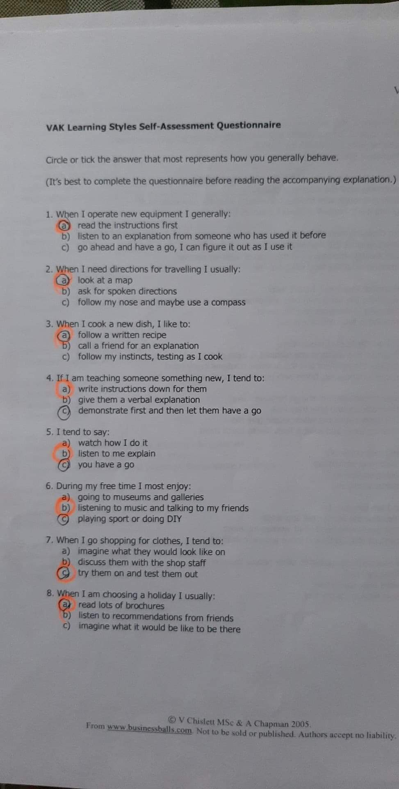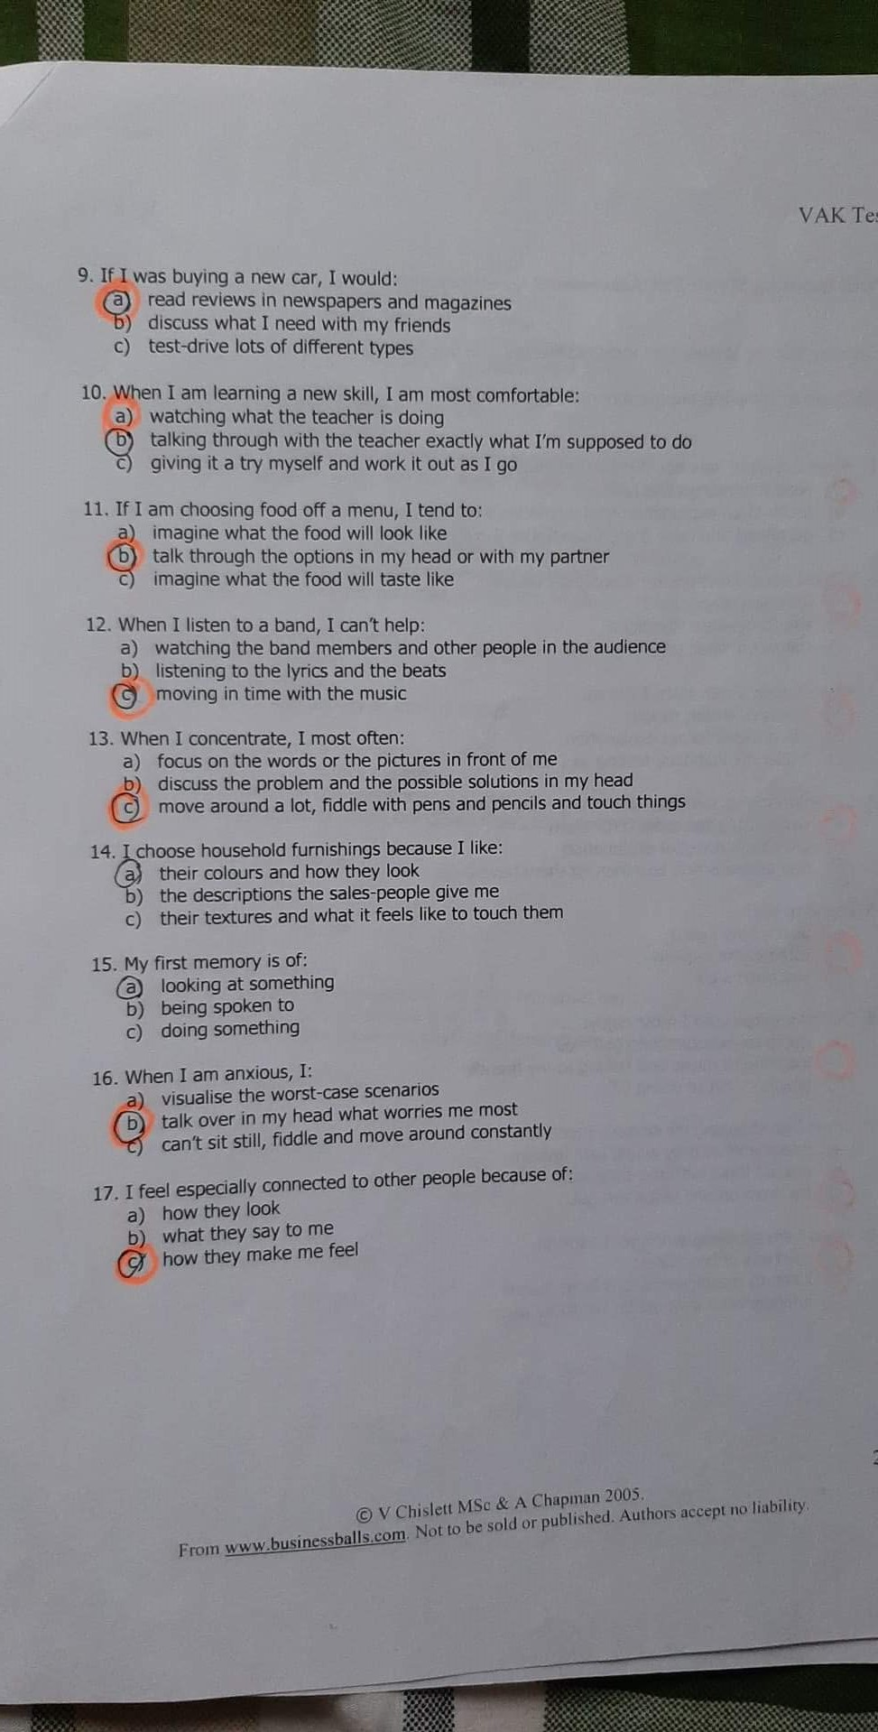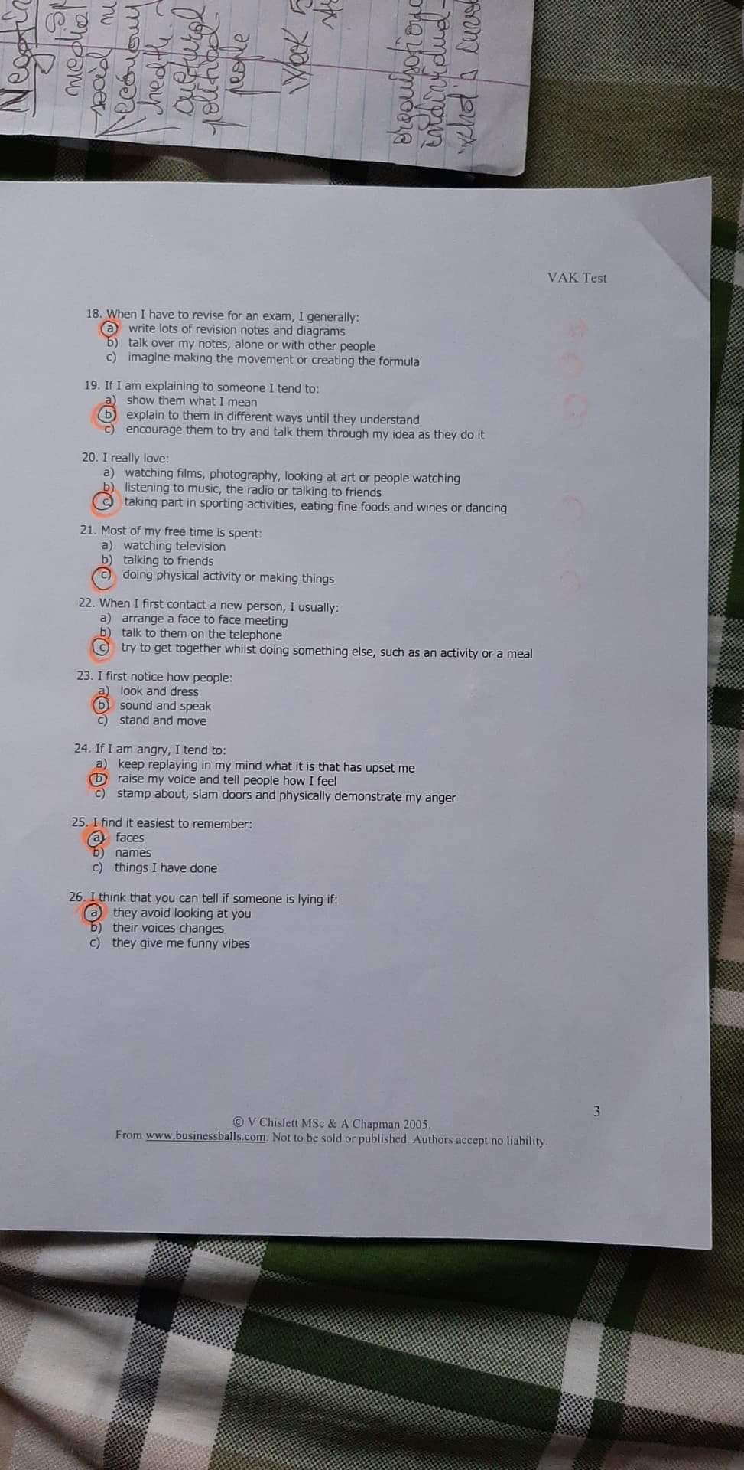
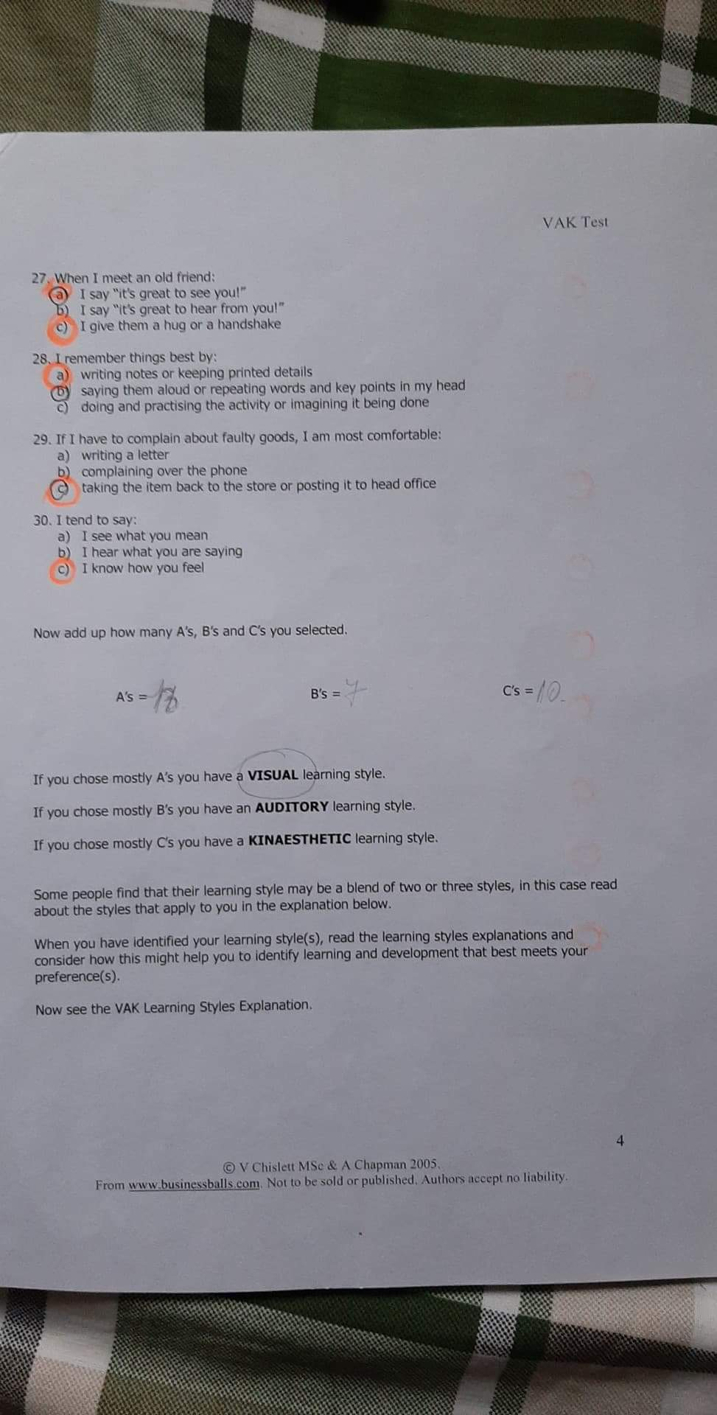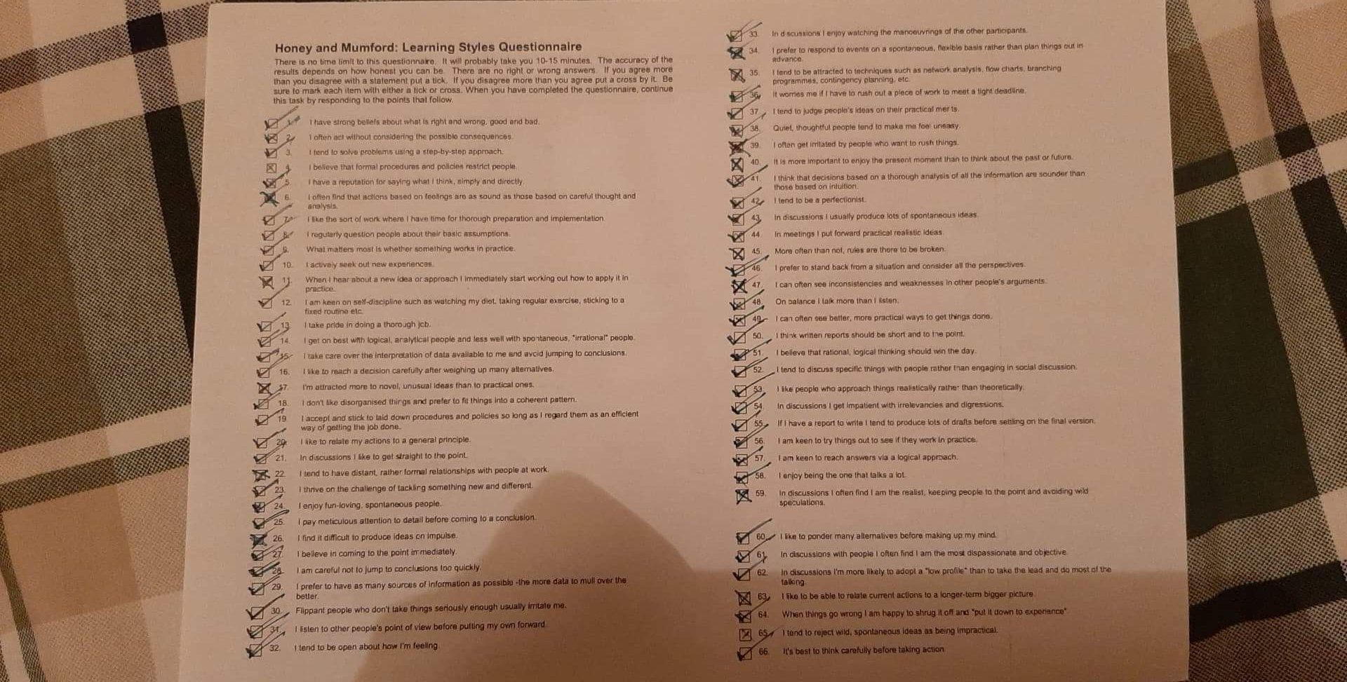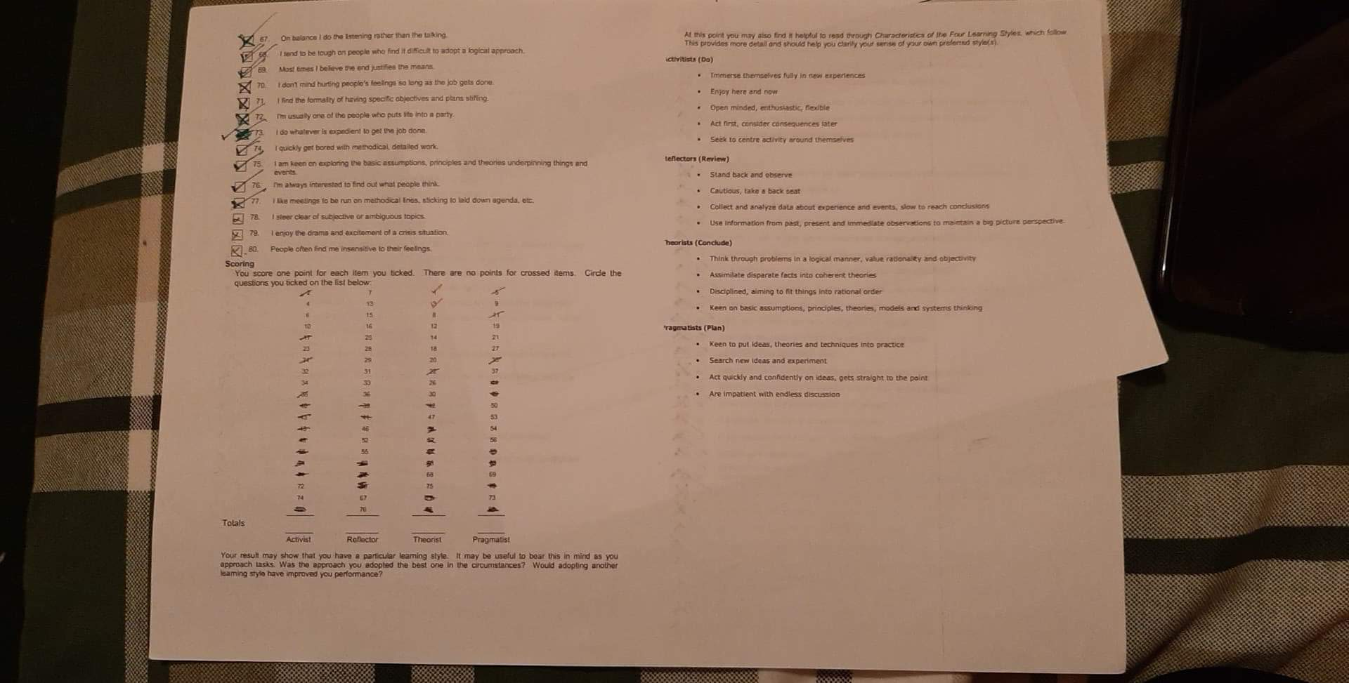
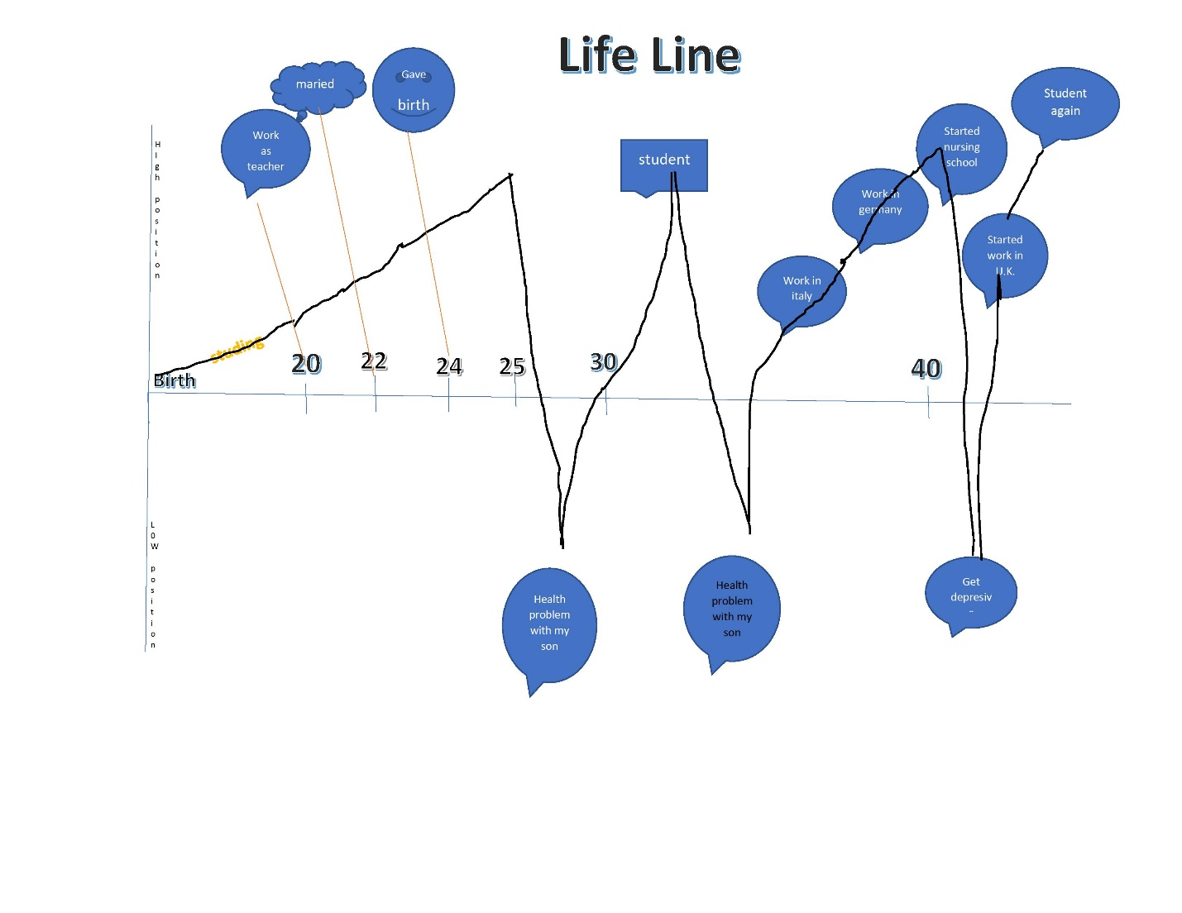

Strengths  What do you do well?  What unique resources can you draw on? What do others see as your strengths? | Weaknesses  What could you improve?  Where do you have fewer resources than others? What are others likely to see as weaknesses?
Get along well with people  Adapting fast in a different situation  Supportive  Patient | Being too detail oriented  Not assertive  Talks too much
Opportunities  What opportunities are open to you?  What trends could you take advantage of?  How can you turn your strengths into opportunities? | Threats  What threats could harm you?  What is your competition doing?  What threats do your weaknesses expose you to?
Opportunity to study in University  Possibility to work in Hospital  Teamwork, leadership capabilities  Assuming decisions in key moments | New legislation (External)  Internal threats could include: a skill or shortage, the potential actions of a competitor, loss of talent

 | Short-Term Time Frame  What do I want to accomplish in the next three to six months? | Mid-Term Time Frame  What do I want to accomplish in the next six months to two years? | Long-Term Time Frame  What do I want to accomplish in the next two to three years?
Section 1: My Goals  What are my overall goals that I want to accomplish in this period?  Example: Became a Student Affairs Officer, learn computer graphics | More studying, more working, more sustaining financially my family | Focus on studying | Become a nurse
Section 2: Skills and knowledge to be learned  What specifically do I need to learn? What project do I need to work on?  Example: Student advising; Banner, Dreamweaver, Develop a procedures manual | Learning to empathize | NIELDS
Section 3: Next Steps  How I am going to acquire the skills and knowledge? How am I going to do this project?  Example: Take Dreamweaver class; do an informational interview; set up a project outline | Getting help from online courses | Taking additional classes | Equivalent the studies I made in Romania in Nurse School

