A study on the effectiveness of MUSIC model of academic motivation to improve the motivation and confidence of adolescent singing students
15418 words
Contents
Proposal 2
Report 7
Literature Review 13
Methodology 22
Findings 32
Conclusion and Directions for Further Research 54 References 56
Appendices 74

Proposal
Context
I am a voice teacher of young people aged 5-18 and it has been my observation during my teaching experience that the adolescent population more commonly lose their motivation and confidence to sing. My previous research has focused on this age group, studying performance anxiety (Kenny, 2011; 2016), confidence (Bonshor, 2017), self-efficacy (Bandura, 1977) and theories of learning motivation (Oyserman and James, 2010; Vansteenkiste, Niemiec and Soenens, 2010), aiming to provide frameworks and resources for singing teachers looking to improve their adolescent students’ confidence through a range of physical and cognitive methods. This work-based learning project will investigate the research question: "to what extent can the MUSIC model of academic motivation improve the motivation and confidence of adolescent singing students?” I will be undertaking this project to discover if the MUSIC model (Jones, 2009) can be effective in altering adolescent confidence through their singing lessons.
Justification
Aside from Xu’s (2023) thesis on self-efficacy in adolescent singers, there is little to be found to specifically address the problem of the loss of motivation in this age group which is well documented in the literature (Paul, Juncos and Winter, 2024). While Xu’s (2023) research gathered data through questionnaires with participants, this research will aim to fill a scholarly gap by employing case study methods (often used in qualitative studies in social sciences and education research) to investigate the effects on teaching and learning theories over time (Starman, 2013). Case studies can be used as a “description and analysis of an individual matter or case [...] with the purpose to identify variables, structures, forms and orders of interaction between the participants in the situation” (Mesec, 1998, p.45); in this research the variable will be the use of the MUSIC model measuring levels of motivation and confidence in adolescent singers.
This project will aim to build on the teaching methods and resources I have previously researched and created to build a stronger pedagogical foundation for voice teachers wishing to improve their students’ confidence and build a life-long positive relationship with singing, which in turn can provide positive health benefits (Kreutz, Bongard et al., 2003).
In an early examination of the existing literature, I discovered the MUSIC Model of Academic Motivation (Jones, 2009). Originally presented as a tool for motivating students in higher education, the model has also been found to be reliably effective for instructors in medicine (Jones, Byrnes and Jones, 2019; Pace, Ham et al., 2016), in music education from elementary to high school level (Parkes, Jones et al., 2017) and across languages (Jones, 2020) and cultures (Jones, Li and Cruz, 2017).
It is also particularly relevant for this research as it was designed to give educators a theoretical basis in understanding why certain strategies are effective to motivate students (Jones, 2009). This model comprises of five elements that teachers can use to encourage motivation in music students: eMpowerment, Usefulness, Success, Interest and Caring (Jones, 2009). it succinctly aligns with previous research I have undertaken, with eMpowerment relating to a student’s sense of autonomy over their learning and the theory of self-determination which have both been found to be effective in improving intrinsic motivation for learning (Krause, North and Davidson, 2019).
This model also draws on research about goal setting, methods of effectively challenging students, the teachers’ responsibility in their relationship with their students and pre-existing theories of cognition and self-efficacy (Jones, 2009). Additionally, this model has been proven effective through research in music education; however, despite this model’s name it is created from educational psychology and there are no studies specific to singing to be found (Jones, 2009). This model will therefore provide the basis for my research project and fill a gap in research regarding singing education.
Intended Impact
This work-based learning project will work to achieve the following aims:
- To investigate the effectiveness of teaching and learning methods and theories influenced by the MUSIC model on adolescent singing students
- To critically analyse the literature on the factors affecting confidence, self-efficacy and intrinsic motivation to sing within this age group and their relationship to the MUSIC model
- To use the MUSIC model and previous literature to discover if the model provides an effective framework for voice teachers of adolescents.
It is also my aim that using the MUSIC model (Jones, 2009) and relating it to singing education will provide a pedagogically sound framework for singing teachers who work with adolescents and are looking for methods to improve their confidence while in lesson time. Using the existing research on this model, this could also be expanded to use on children and adults, and if effective this model could even benefit traditional classroom educators who need to provide music education but are not confident singers themselves.
In my personal practice, I intend to use this model to experiment with categorising lesson content into the five groupings of the MUSIC model (Jones, 2009) to provide focus to each individual student and their learning. I also intend to discover how flexible these groupings can be in providing for each student’s individual learning needs and if this can extend to varying levels of ability.
Outlined Intention
This project will choose participants that attend private voice lessons with me and that are aged between 12-18. It will aim to achieve the following objectives:
- To continue my development of my teaching in the private voice studio by building on my previous research and combining this with the most up-to-date research in the field and the MUSIC model to create effective research design for this project
- To continue to develop a practice that is accessible and inclusive by considering not only the needs of my student participants but also by carefully considering appropriate ethics for this age group
- To conclude the research with a pedagogically researched and effective rationale for using the MUSIC model in voice teaching, if effective.
The research will used qualitative or mixed-methods methods and will use questionnaires and in-lesson observations to study the phenomenon; this will take the form of participant observation where students are aware that they are being observed and notes will be taken after lessons, as opposed to unobtrusive observations where students would be unaware that they are being observed, to make research more ethical (Driscoll, 2011).
Questionnaires will use Jones’ (2009) MUSIC model as a basis and will collect data from both participants and non-participants of the use of the model in lessons. A Likert scale questionnaire will be provided to make results easily comparable adapted from an index used in existing research that has employed Jones’ (2009) MUSIC model.
I will also record participants’ thoughts on their confidence through a focus group, as confidence is subjective and hard to observe as an outsider (Roland, Matheson et al., 2015). The consideration of participants’ worldviews will align this research with the constructivist paradigm, which is commonly used in educational research (Taylor and Medina, 2011).
The study will also use ethnographic observations during lessons; sections of the lesson will be sorted into the categories of the MUSIC model (eMpowerment, Usefulness, Success, Interest and Caring) with each category being represented as equally as possible. Although the observations will be pulling from a small sample, it will use triangulation to improve its validity and credibility (Carter, Bryant-Lukosius et al., 2014). Responses will also be coded to identify themes across the responses. To expand on this, I am aiming to provide the questionnaire to both my students who will be participating in the research and others who will not to be able to compare results at the end of the research and examine if using the MUSIC model (Jones, 2009) is effective to improve adolescent singers’ confidence.
Project Timeline (Figure 1)
Figure 1 – Project Timeline


Ethics and Insider Research
For this research project, I will have to consider that I am an insider researcher and while this benefits this study as I have personal interest in the topic, it can create a challenge in being objective (Saidin, 2016). I will also have to consider my pre-existing teacher relationship to the participants, and this angle will make my research ethnographic (Russell, 2005).
I will also follow the guidelines set out by UWTSD; participants will be made aware that their participation is voluntary and can be withdrawn at any time. The participants will also be able to make informed consent to participate as I will outlay the project details to them verbally and in writing. Participants will also be asked for parental consent if they are under 18. Participants will also made aware that their responses will be anonymised in the findings and that they will be able to obtain a copy of the research report if they wish to.
Learning Outcomes
Aside from the impact of this research in my own practice and the wider field, I would also like to aim to improve my skills as a researcher. My module 3 reflections considered that to reach saturation when coding responses, a much larger sample size would be most effective. I aim to do this by collecting data from questionnaires both from my students who are partaking in the research and outsiders. However, where this isn’t possible, I will aim to continue my development as a researcher by creating a deeper synthesis of my findings.
This research will also benefit from being able to be studied over a longer period than my module 3 research, making results more reliable as they will not be just considering the feelings of participants on a single day. I also aim to consider my questionnaire wording more carefully to reduce desirability bias as an insider researcher (Fowler, 1995). With more research in this field now under my belt, I will also be able to consider my new understanding when researching the vast and complex phenomenon which is confidence building in music education. These are my personal aims for this extended research project.
Report
Introduction
The MUSIC Model of Academic Motivation
The MUSIC Model of Academic Motivation is a practical framework developed by Jones (2009) that assists educators with the design of academic courses. Informed by the field of educational psychology, the aim is to provide a model that simplifies the existing literature and turn theory into practice (Jones, 2009). Some of the key theories influencing the elements of the MUSIC model are self-determination (Ryan and Deci, 2000), expectancy-value (Wigfield and Eccles, 2000) and Hidi and Renniger’s (2006) model of interest.
Jones (2009) suggests that motivation is a process informed by actions and verbalisations from students, and that motivated students are more engaged leading to better achievement. This is represented in the following diagram (figure 2):
Figure 2 – Model showing connection between component, action and outcome (Jones, 2009)
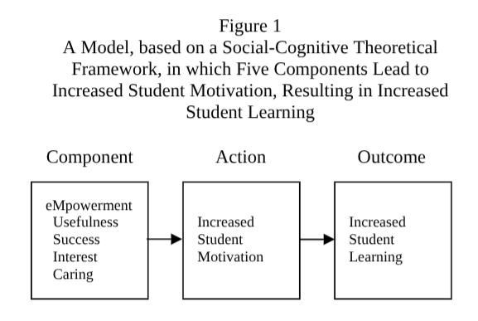
As in this diagram, the model is made up of five components: eMpowerment, Usefulness, Success, Interest and Caring (Jones, 2009). It is suggested that a combination of these elements is required to achieve the desired outcome of increased student learning, as they are largely correlated (Kaufman and Dodge, 2009). The model is intended to provide educators with an understanding of theoretical concepts so that they can practice each element with an understanding of the intended impact (Jones, 2009).
While designed with academic achievement in mind, the MUSIC model is intended for use in any discipline (Jones, 2009). Existing studies have indicated a positive association between motivation, self-efficacy and achievement (Kordsalarzehi, Salehipour et al., 2025; Basith, Syahputra et al., 2020; Maraghi, Mortazavi-Tabatabaei et al., 2018) so it is therefore feasible that this would also be true for singing students. This study will be the first to test the MUSIC model with adolescent singing students, to discover whether it is effective to improve their motivation and therefore their self-efficacy.
This will inform the answer to my research question: to what extent can the MUSIC model of academic motivation improve the motivation and confidence of adolescent singing students?
Context
Context of previous research
My module 3 research project (Cleary, 2024) examined if using a physical warm-up method could increase feelings of self-efficacy in adolescent singers. This small-scale study with a sample of four participants found that a group workshop using a physical method increased physiological state but was limited by a lack or a large and varied sample size. This research project aims to build on my research on self-efficacy by expanding to a larger sample size and one that is partially made up of both singers who I currently teach and singers who I don’t. This will aim to create a study with increased validity as it will include a broader range of experiences and viewpoints, as well as ages, genders and backgrounds.
A positive outcome from this study could help to create a base point for singing teachers looking to create meaningful lesson plans, using the MUSIC model (Jones, 2009) which is already proven and validated in multiple academic studies. This project will also aim to link teaching and learning theories I have used in my previous research to link self-efficacy, confidence, the body-mind connection and academic and professional achievement.
The setting for this project is my group vocal class, where amateur adolescent singers have an hour-long lesson once a week developing their singing technique and skill, alongside acting technique for musical theatre. To expand on this project, research will also be collected from amateur adolescent singers that do not have lessons with me to compare the MUSIC model’s (Jones, 2009) usefulness.
I have observed through experience teaching the adolescent population that this is a crucial age for developing confidence and connection to their voices. I have found that this is also supported in the literature as adolescents face specific problems regarding peer pressure (Abril, 2007) and voice change (Bizjak and Freer, 2015) which can provide a barrier to continuing to sing into adulthood.
Low self-esteem in singing can also affect their willingness to perform in front of others, thus hindering their development (Jiang and Tong, 2024); this can then result in them missing opportunities for external feedback and management of adrenaline and anxiety associated with music performance (Osborne and McPherson, 2018). It is my aim to find ways of encouraging a lifelong positive connection to singing that in turn can provide positive health benefits throughout students’ lives, including improved mental and cardiovascular health (Campbell, Bodkin-Allen et al., 2022).
Justification
The MUSIC model was chosen as it is designed to compile many smaller theories into a pedagogically sound motivational tool for educators (Jones, 2009). It also makes definitions clear for theories with similar concepts and is intended to be practically applied instead of just theory based (Jones, 2009). This is significant to singing instruction as although teachers may understand specific strategies for singing, they may not understand learning processes, instead adopting a trial-and-error approach (Shirel, 2018). It has also been validated through many academic studies (Jones, Byrnes and Jones, 2019; Pace, Ham et al., 2016; Jones, 2020; Jones, Li and Cruz, 2017), although not in singing or performing arts, presenting a gap in the research.
The project will draw on theories of cognitive motivation (Vansteenkiste, Niemiec and Soenens, 2010), pre-existing teaching and learning theories and confidence (Benabou and Tirole, 2001) and self-efficacy theory (Bandura, 1997) to further authenticate the research. While in my previous research (Cleary, 2024) I have identified the factors that can affect confidence in singers of this age bracket and some methods for improving this, a gap still remains in the existing literature for building confidence in amateur adolescent singers and the effect that lessons for this age group can have on their relationship to their voice into adulthood and beyond. This research will aim to provide teachers with a pedagogically sound framework for building confidence in their adolescent students and will also fill the gap in research for this demographic with the MUSIC model, if proven effective (Jones, 2009).
Intended Impact
It is my aim to provide tools for educators who teach singing, either professionally or in the traditional classroom, that will connect adolescent students to the understanding of their own voice and improve their singing confidence. It will also be my aim to improve my own lessons, testing to see if the sections of the MUSIC model (Jones, 2009) (eMpowerment, Usefulness, Success, Interest and Caring) can provide a framework for lesson plans with a strong pedagogical footing.
As providing singing education is currently largely unregulated and lacking in formal frameworks (Reeve, 2018), it is important to continue to develop necessary frameworks and developments for use in the field. Existing studies of frameworks used in singing instruction are largely unidentified, and tools used for teaching (in technical and musical skills, as well as student practice regimes) are often invalidated by lack of high-quality evidence (Crocco, Madill and McCabe, 2017). Empirically there is also a lack of research on how singing students learn and develop skills (Latukefu, 2010).
In the wider field of voice pedagogy, it is my aim that this research will be useful in bridging the gap between theories of motivation, teaching and learning from traditional education to music and education (Evans, 2015) by using the MUSIC model. This will provide educators with not only an understanding of voice pedagogy but also how to best motivate and encourage their students to improve. Additionally, for educators working with adolescents, it can provide teachers with the tools to mitigate issues specific to this age group.
If successful, the MUSIC model could also be used as a blanket framework and lesson plan structure for voice teachers looking to address the issue of adolescent self-confidence in their lessons and be expanded for other students (younger children, adults or those with special educational needs and disabilities (SEND)).
The MUSIC model has been previously tested for validity using confirmatory factor analysis in the wider field of music education and was found to be reliable (Parkes, Jones et al., 2017), however it has not been tested specifically with singing students. it is my aim to discover if it can be effective to create a positive change in adolescent singers and their self-confidence in their voice. This could also move beyond just singing education to discover its usefulness in other voice-related fields, such as roles involving public speaking or teaching itself.
Learning Outcomes
During the research, I aimed to:
- Explore and synthesise the current literature, drawing on existing research in music and voice pedagogy, as well as research in education including existing teaching and learning theories
- Design my research project to be comprehensive and inclusive, improving on my previous research by coding and reach data saturation through open coding from a wider range of participants than my previous research while considering appropriate ethics
- Effectively corroborate the findings of my research to better understand and develop my understanding of the research question and teaching.
It is my aim to not only consider the wider field of voice pedagogy and education but to improve my personal practice, drawing on my previous research to create an environment in my singing education that is tailored to each student’s needs and aims for their voice and development.
Methodology for Lit Review
This study will employ a narrative literature review; the purpose of this type of review is to synthesise the available literature, often chronologically, summarising the history of research and existing trends (Ferrari, 2015). As a narrative literature review, the aim is to identify gaps in the literature that this study aims to fill and the current impact and scope of existing literature (Baumeister and Leary, 1997). This will also help to provide context for my research and determine its usefulness (Winchester, 2016).
To reduce the risk of selection bias, a common disadvantage of narrative literature reviews (Silva, Padilha et al., 2022), I will establish an inclusion/exclusion criterion. This will be achieved by considering information from a wide range of sources and avoiding selecting only material that supports or uses the MUSIC model (Winchester, 2016). Interpretation of the data, avoiding personal interpretations, and assessment of the data quality will also effectively avoid bias in my review (Winchester, 2016). Effective inclusion/exclusion criteria should be explicit enough that if searches were replicated, the same studies would be found (Meline, 2006).
As such, key words and phrases were used in searches (motivation, self-confidence, teacher-student relationship, self-efficacy, adolescent singers, self-determination, positive health benefits of singing) and only academic sources were included (journals, studies or academic papers). These were largely selected from music specific sources, with some crossover into social science and health studies were appropriate. Some grey literature was also included to avoid publication bias, creating a more balanced report with increased validity (Nair and Nitin, 2023). Where possible, sources were selected from the 21st century, the exception being the sources of older but prominent theories. Studies of children or adults were also excluded.

Literature Review
Introduction
The purpose of this literature review is to synthesise research on adolescent confidence and motivation theories relating to the research question: to what extent can the MUSIC model of academic motivation improve the motivation and confidence of adolescent singing students? Initially, the review broadly defines motivation and confidence and how these can be measured to assess the research question. The review is then narrowed into specific confidence issues facing the adolescent population (Orton and Pitts, 2019), before looking specifically at the MUSIC model and how adolescent confidence issues relate to each of the five elements: eMpowerment, Usefulness, Success, Interest and Caring (Jones, 2009).
Motivation
To assess the research question, there needs to be a measurement for motivation. Jones (2018, p.6) suggests that “motivation is the extent to which one intends to engage in an activity”. This idea is represented in the following diagram (figure 3):
Figure 3 – The relationship between motivation, engagement and outcomes (Jones, 2018)
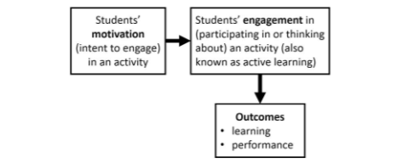
This diagram suggests that motivation (defined as a students’ intention to continuously engage in an activity) results in learning and performance (Jones, 2018). This relationship between motivation, engagement and learning outcomes is also corroborated by recent research (Hu, Ke et al., 2025; Liu, Ma et al., 2025; He, Wang et al., 2025). To measure this against the research question, consistent engagement in the activity of learning a song and then producing a performance will represent high motivation.
Confidence
To assess confidence, there also needs to be a clear definition. Self-confidence and self-esteem have been commonly explored in psychology throughout the ages, with emphasis being placed on how one’s self-image can affect motivation and the complimentary relationship between high self-confidence and the willingness and motivation to act (Benabou and Tirole, 2001). Self-confidence has been viewed as sitting between a personality trait and an ability trait (Stankov, 1999).
Empirically, this has been measured through a range of methods. In some studies, self-confidence has been measured through self-reporting, where participants complete a questionnaire reporting their levels of confidence in both specific and general areas (Burns, Nicholas and Ward, 2016). In other metacognitive studies, students rate their confidence that the answer they have just given is correct (Burns, Nicholas and Ward, 2016). These varied ways of collecting data about self-confidence reflect the disparity between self-confidence as either a personality trait (self-reporting) or ability trait (“online” metacognitive studies) (Burns, Nicholas and Ward, 2016).
Emerging studies have also reported on the effect self-confidence can have on academic achievement, with self-confidence as a trait being easier to affect and change than other more pre-determined factors affecting ability (Burns, Nicholas and Ward, 2016; Stankov, Lee et al., 2012). However, once these beliefs are fully formed, they can be difficult to alter (De Vries, 2017); this highlights the importance of developing self-belief in young people and adolescents as they are still developing.
The teacher’s role in this cannot be understated, as research shows that the teacher’s style and influence can affect the adolescent singer’s enjoyment and experience (Patston and Osborne, 2015). Additionally, students are more likely to seek their teacher’s advice than a clinical professional if they are experiencing performance anxiety (Williamon and Thompson, 2006). In this way, the voice teacher’s influence on their adolescent students extends beyond just singing training into influencing their patterns of learning and ability to deal with performance anxieties (Gebhardt, 2016; Paul, Juncos and Winter, 2024); the adolescent brain is still changing, developing and forming into early adulthood (Mills and Anandakumar, 2020).
Self-Efficacy
Sitting alongside self-confidence is self-efficacy; while the former is associated more with self-image, self-efficacy is described as a person’s assessment of their ability to carry out a task successfully (Waddington, 2023). While the aforementioned metacognitive studies are a post-task assessment of confidence (Burns, Nicholas and Ward, 2016), self-efficacy is the self-belief that you can succeed in a future task (Bandura, 1997).
Self-efficacy as a belief is separate from a person’s actual abilities, and it is suggested that beliefs slightly above a person’s actual capabilities can increase motivation and persistence through a difficult task (Mills, Pajaraes and Herron, 2007; Artino, 2012). There is a balance to be struck however, as low self-efficacy can lead to avoidance and an over inflated sense of self-efficacy can lead to complacency (Wyatt, 2018). This is also true of self-confidence, where a higher perceived ability can cause a person to exert less effort in the task, or minimise their previous success in order to set their expectations for the next task (Benabou and Tirole, 2001).
Bandura (1977) coined four indicators of self-efficacy: mastery experiences (repeated successes in a task), vicarious experiences (watching others achieve), verbal persuasion (feedback from others) and physiological state (the body’s physical reaction to performing the task). Bandura identified mastery experiences as the most influential factor on self-efficacy (Bandura, 1997). This is particularly relevant in music education as there is always an element of performance, suggesting that repeated successes in being able to perform are paramount to increasing an individual’s self-efficacy.
However, my previous research found that physiological state was most improved from pre-post research in improving self-efficacy in adolescent singers (Cleary, 2024); this was also found in studies of singers by Lewis (2018) and Xu (2023) suggesting that for tasks that are inherently performance based, the physiological state of the performer can have the biggest influence on their self-efficacy and confidence.

Adolescent confidence
Adolescent singers face specific challenges unique to this population. In studies of this age group, student enjoyment is influenced by motivation, self-efficacy and autonomy much like what the MUSIC model aims to include in teaching (Orton and Pitts, 2019). Both male and female students are affected by their changing voices during adolescence, with males in particular viewing voice change negatively and are most affected by their perceived inability as singers (Orton and Pitts, 2019). Females were found to be more affected by social factors, such as feeling judged by others, and both sexes cited choice of repertoire as a key factor in affecting their enjoyment of singing (Orton and Pitts, 2019).
This factor, relating to autonomy, is also an aim of the MUSIC model, particularly in eMpowerment where teaching styles are categorised as controlling or autonomy-supportive (Jones, 2009). Influenced by self-determination theory, this is the idea that students enjoy activities more when they feel some sense of control over them, and choices such as these create an internal locus of control (Deci and Ryan, 2000; Jones, 2009).
Identity
Adolescence is a crucial time where young people are developing their sense of identity. Parental influence diminishes during this life stage and is replaced by that of peers (Stangor and Wallinga, 2019). Adolescents also try out different social identities, sometimes adopting different identities in different social situations, and find meaning in identifying with the categories they belong to (Stangor and Walinga, 2019). Due to some of the adolescent-specific reasonings, enjoyment in singing tends to waver before and during adolescence (Orton and Pitts, 2019; Welch et al. 2009; Lamont et al., 2003). Adolescence is therefore a crucial time for young people to identify with singing if they are going to continue to adulthood (Legg, 2013).
Connection to MUSIC model
The MUSIC Model of Academic Motivation was presented by Jones (2009) to provide a framework for instructors looking to design lessons that engage their students and motivate them to learn. Developed from the research field of educational psychology, it aims to make clear definitions of the theories of learning motivation and to not only provide practical ideas for lesson design but to aid teachers in understanding the theory of why these methods work (Jones, 2009). Jones (2009) highlights that the components of the model are best used in combination with each other and that many of their concepts work naturally in tandem. Evidenced by socio-cognitive, psychological and educational research, the five components of the MUSIC model are eMpowerment, Usefulness, Success, Interest and Caring (Jones, 2009).
EMpowerment
The first aspect of the model concerns the autonomy that individuals feel over their own learning. This is built on the theory of self-determination, which suggests that the student’s enjoyment is increased when they feel some control over their learning which in turn motivates them to continue (Jones, 2009). Inside of this theory is Cognitive Motivation Theory, which is the concept of intrinsic motivation whereby people are internally motivated to seek challenging and satisfying behaviours (Vansteenkiste, Niemiec and Soenens, 2010).
In this way, intrinsic motivation, enjoyment and autonomy are interlinked. In music education, research supports these theories by suggesting that one of the most cited reasons for taking part in singing activities is for enjoyment (Lucas, 2011; Orton and Pitts, 2019; Richards and Durrant, 2003) and that not singing the music they like decreases their enjoyment (Turton and Durrant, 2002).
Jones (2009) suggests that teachers can increase students’ feelings of control over their learning by giving them meaningful choices and allowing their opinion and contribution to be heard in lesson time. In singing instruction, this could look like allowing them to choose their own material or duet partner, or to take some control over the pace of the lesson and how much they want to achieve within that time. Jones also suggests allowing students to contribute to rules or policies or providing rationale for rules and boundaries. This creates an autonomy-supportive teaching style in which rules are still enforced without being controlling (Jones, 2009; Reeve, 1995).
Usefulness
Usefulness is the idea of providing to students why they are learning what they are learning. In education, this means providing short-term goals towards longer-term goals to improve motivation and positive learning outcomes for the future (Jones, 2009; Simons, Vansteenkiste et al., 2004; Van Calster, Lens and Nuttin, 1987). Expectancy, often used interchangeably with self-efficacy, is a key influence of student performance (Jones, 2009).
To achieve this, Jones (2009) suggests giving real-world opportunities and examples of the usefulness of the skills they are learning. This could look like preparing for a mock audition, attending a masterclass from a working singer or preparing a range of material for different industry scenarios. This could also mean providing autonomy education alongside vocal function exercises, as this has been found to be lacking in many voice students therefore emitting the usefulness of the warm-ups they are asked to perform (Sielska-Budarek, Osuch-Wójcikiewicz et al., 2017). Increasing the utility value of learning (usefulness in relation to goals) directly contributes to students’ effort and future intentions for study (Jones, 2009; Cole, Bergin and Whittaker, 2008).
Success
This element relates to how an individual’s concept of their own competence can influence their motivation (Jones, 2009). It is suggested that competence and wanting to be successful is an inherently human trait (Elliot and Dweck, 2013; Jones, 2009). Succeeding or failing at a task can provide valuable feedback that can lead to an individual altering their self-perception of their competence in that task, and individuals with a better perception of their competence are more likely to seek out that task, be resilient when facing it and achieve more (Jones, 2009).
For educators considering this, the best way to achieve this is by providing challenges that match their ability; providing tasks that are too easy or challenging can be demotivational (Jones, 2009). To achieve this, Jones (2009) suggests providing clear and direct instructions and expectations; providing challenging activities split into smaller sections that can be ordered by progressive difficulty; providing opportunities for students to receive feedback often where they can set short-term goals towards longer term goals and allowing students to try again, providing help where needed, with opportunities for encouraging and honest feedback.
Interest
Lasting interest in what they are learning can improve student’s engagement. The lesson content and environment can have the effect of the individual liking that activity, which fosters a more individual interest and therefore is more long-lasting than a temporary interest (Jones, 2009). Interest can be determined by environmental or situational factors, but it is suggested that a personal interest can have the positive benefits for a student of greater attention and cognitive engagement, allowing for less time and effort needing to be employed on the task (Jones, 2009). Hidi and Renninger (2006) developed this four-phase model for creating sustained interest (figure 4):

Figure 4 – Four-phase model of interest (Hidi and Renninger, 2006; Jones, 2009 p.285)
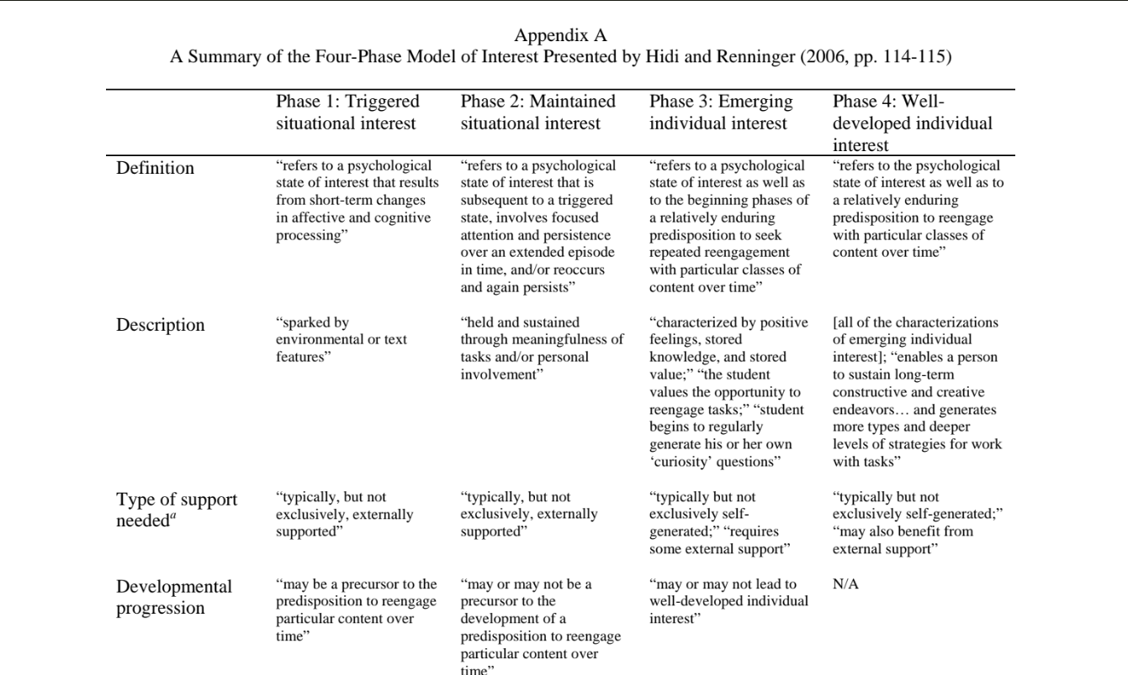
The model highlights how situational interest can develop to create lasting individual interest (Hidi and Renninger, 2006). At all stages, external support is suggested to contribute to the level of interest being developed by the student. Individual and situational factors also interact to create the second phase of maintained situational interest, where students begin to understand a task’s importance (Jones, 2009).
Jones (2009) suggests generating situational interest through physical movement; in singing instruction, this could look like instructing the student on the mind-body connection. Although inherently physical, to create a lasting interest, it is suggested that teachers should use situational interest to develop students’ understanding of its meaning; for example, understanding why certain physical movements or postures affect the sound.
Jones (2009) also suggests using students’ prior knowledge and interests; this could be choosing repertoire that students have a pre-existing interest in. This also relates to the affective nature of creating interest, by giving students choices or autonomy over their singing (Jones, 2009). It is suggested that a vested personal interest can also be fostered through delivering unexpected knowledge or through changing the style in which information is delivered (Jones, 2009). By modelling enthusiasm for learning to sing, the instructor can also contribute to situational or personal interest in students and through leaving space for students to discuss or ask questions, indicating students’ engagement (Jones, 2009)
Caring
Where Interest considers the students’ personal investment in their learning, Caring relates to the concept of how a student believing that their teacher cares about their learning can influence them (Jones, 2009). This is interlinked with the idea of belonging or sense of community, something which is a highly purported benefit of singing throughout the literature (Hendry, Lynam et al., 2022). A caring teacher-student relationship can also be beneficial to improve intrinsic motivation, self-efficacy and performance (Jones, 2009).
To improve this relationship, Jones (2009) suggests showing genuine interest in students’ successes or failures. While success can be more subjective in the arts, this could look like listening to students’ feedback on how they feel a performance has gone and goal setting for next time. This could also look like making allowances for students by showing understanding in the case of adverse events (Jones, 2009); while teachers should be careful to not cross the boundary of teacher and student, having flexibility to reschedule lessons or performances in light of events in students’ personal lives could improve this relationship.
Uses of the MUSIC model (Jones, 2009) in existing literature
There are many existing studies validating the use of the MUSIC model of academic motivation (Jones, 2009) across cultures (Jones, Sahbaz et al., 2017; Schram and Jones, 2016; Wang et al., 2021) and across the elementary (Jones and Sigmon, 2016), secondary and university level (Jones and Skaggs, 2012). It has influenced teaching styles for in person and online learning (Borup et al., 2014), providing lesson structure to diagnose issues of motivation in students to improve intrinsic motivation and therefore students’ learning outcomes (Jones and Wilkins, 2013; Jones, 2018).
While the guide for using the MUSIC model states it can be used “in any subject area at any grade level” (Jones, 2018, p.3), arts specific subject studies are lacking. Existing studies are often measured across courses without looking specifically at arts courses (Jones, 2019). This presents a significant gap in the research, as although validity has been tested across many subjects and cultures, it is difficult to truly state its validity without it being tested in the arts.
The most relevant field of research that has used the MUSIC model is in sports, as achievement is similarly based on performance. Adapted from the MUSIC model is the MUSIC model of athletic motivation; this has been tested for validity and found to be robust with strong evidence of its application (Munz, 2018). This adaptation also synthesises existing motivation theories around learning and performance, suggesting the need for a holistic approach for sports coaching that provides a framework for instruction that is built on these existing theories (Munz, 2018). Based on the evidence of the MUSIC model’s validity when adapted to different settings, it is my belief that the same can be beneficial for use in performance-based arts.

Methodology and Methods
Ontology and Epistemology
As the nature of this research is to collect data from students’ personal views relating to their self-confidence, this research will be conducted under a constructivist paradigm. Commonly used in the social sciences, constructivism is the epistemological stance that new knowledge is created and that there are “no universal ‘truths’ or valid categories for human experience; hence knowledge is the production of social and personal processes of meaning making” (Pilarska, 2021, p.64). This stance is particularly relevant for this research project, as self-confidence, self-efficacy and achievement as a student rely not only on cognitive measures but on self-perceptions and are therefore subjective (Leung and Xu, 2013). Although subjective measures face issues of validity, they also benefit from flexibility of length and content and ease of obtaining data when compared to quantitative measures (Leung and Xu, 2013).
The constructivist paradigm often does not start with a theory but instead looks for patterns in the research data (Mackenzie and Knipe, 2006). This means that my research used a largely inductive approach (Bhandari, 2022). Aligning with this paradigm, the research will employ qualitative and mixed methods data collection. The use of mixed methods in education research can be beneficial to strengthen research by employing the researchers’ skill in analysing different types of data and creating a broader picture of the phenomena being studied (Gorard, 2004).
As the nature of this research and of the constructivist paradigm is that meaning will be derived from participant responses, the research will therefore utilise a phenomenological and hermeneutic approach whereby the research considers understanding created by lived experience and language used (Dowling, 2004). Most commonly in this type of research, methods include interviews and observations where this type of interpretative data can be collected (Mackenzie and Knipe, 2006).
Methodology
For initial data collection, I used questionnaires aimed at adolescent singing students to understand existing feelings about their confidence in singing before the MUSIC model was used. This incorporated a combination of closed and open-ended questions to gather quantitative and qualitative data. One of the benefits of using a questionnaire is that it can reach a large group of participants beyond those that I am already teaching to gather a wider range of data, and questionnaires are standardised meaning that answers are easier to code than in other forms of research collection.
As all of the participants are answering the same questions, I also considered using interviews as a research method as it is possible to ask further questions to gain a deeper level of understanding from participants (Goddard and Villanova, 2006); however, this would limit the number of participants and could mean it is more likely for peer pressure or researcher bias to affect the answers given. Questionnaires offer participants anonymity in their responses, which seems more appropriate in this research due to the personal and subjective nature of self-confidence.
Participants were recruited through purposive sampling; this means the deliberate selection of adolescent singers who can best contribute to the research, rather than using convenience sampling, which is much more random, or theoretical sampling where there are multiple stages of data collection driven by emerging theory (Alele and Malau-Aduli, 2023). The use of this type of purposeful participant selection helped to improve the research’s validity and target this specific population.
While the nature of the research and time constraints mean there were not multiple repetitions of the research to achieve saturation, the aim was to use a combination of questionnaires, observations and focus group responses to provide enough data that it is possible to reach saturation through coding.
As the questionnaire provided quantitative data and the other research methods are qualitative, this was a mixed-methods study. Data collected was triangulated, which improves validity by providing multiple perspectives for the results of the research (Alele and Malau-Aduli, 2023).
In the first line of enquiry, a pre-research questionnaire was provided to participants adapted from the MUSIC model inventory to be relevant to singing instruction (figure 5).
Figure 5 – MUSIC model inventory (Jones, 2012-2016; Pace et al., 2016).
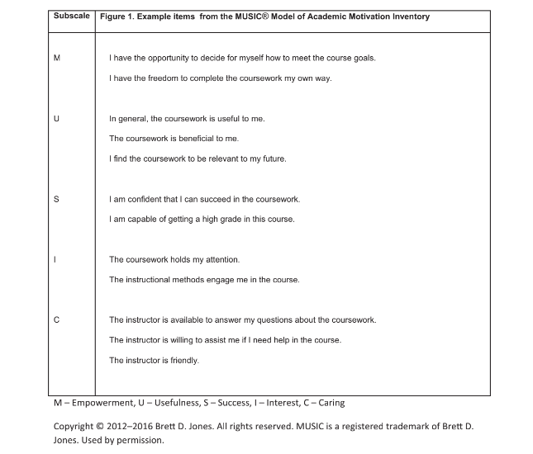
This inventory has proven reliable across education research in medicine (Pace et al., 2016), ages, languages and cultures (Jones and Sigmon, 2016) and has been tested for validity through classical item analysis, confirmatory factor analysis, Rasch scales and Pearson’s correlation coefficients (Jones and Skaggs, 2016). The full inventory is adapted to be used before and after the research (Appendix 1).
Following the completion of these pre-research questionnaires, I designed a lesson plan for adolescent singers using the elements of the MUSIC model that can be repeated (appendix 4). This is based on Jones (2016) suggestions for integrating the model into teaching and learning (figure 6).
Figure 6 – Jones (2016) suggestions for integrating the MUSIC model into teaching and learning
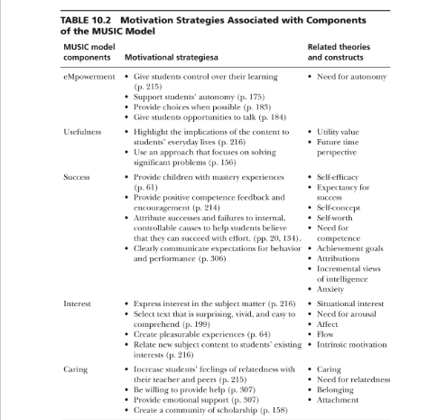
My lesson plan (appendix 4) adapted Jones’ motivation strategies (figure 3) for each of the five elements, for example supporting autonomy in the eMpowerment category by presenting a choice of two songs and allowing free choice of working groups. Once I had ensured that all the elements were being met, I reordered the elements into a structure for the lesson (Appendix 5) based on pedagogically researched phasing for lesson planning (Krepf and Konig, 2022; Figure 7):
Figure 7 – Four-phase structure suggested for lesson planning (Krepf and Konig, 2022)
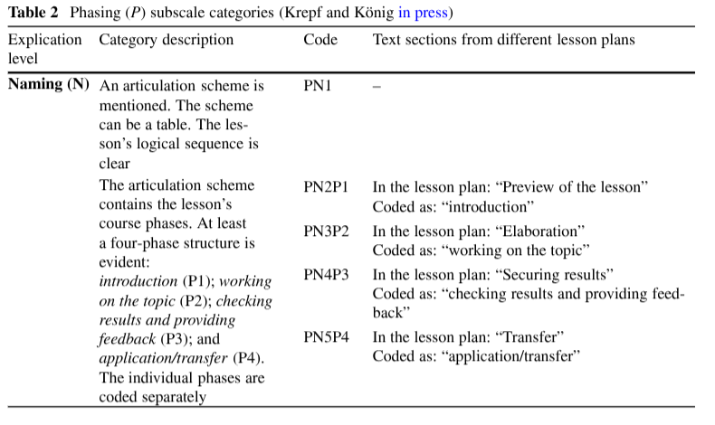Using this structure as a framework for lesson planning meant that there was structure while allowing for flexibility to adapt to individual learners (van Diggele, Burgess et al., 2020).
Following the delivery of these lessons, observations were recorded by myself as an insider as I was teaching, demonstrating and delivering the lessons. This type of research can be beneficial to observe behaviour between participants and allow for unexpected results (Alele and Malau-Aduli, 2023). However, as I am already known to the students, I had to consider the likelihood of both researcher bias and confirmation bias from the participants (Alele and Malau-Aduli, 2023).
Participants who took part in the lessons using the MUSIC model were also offered the opportunity for interviews within a focus group. The questions asked to participants were adapted from the open-ended questions provided by Jones (2009) in their MUSIC model (appendix 2) and were also categorised into eMpowerment, Usefulness, Success, Interest and Caring. While some may prefer to feel more anonymity in their responses, these interviews added depth to the research as having them face-to-face with the participants will also allow for the observation of non-verbal behaviours (Alele and Malau-Aduli, 2023). These can be compared to research in non-verbal communicators of confidence to provide a gauge for the perceived confidence of these participants.
Research was undertaken in a weekly group singing class. To increase validity, these classes were the same length with the same participants. The research followed UWTSD ethical guidelines as well as following safeguarding procedures as outlined by Rising Aspirations Academy where the participants are students. Data was only recorded for students who agree to participate and have parental consent to participate if they are under 18. Students were also made aware that they can withdraw their consent at any time.
As the elements of the lesson plan for these workshops were grouped into the five MUSIC categories, the first parts of these workshops included context setting. This worked naturally with the eMpowerment elements where students are invited to collaborate and improve their feelings of autonomy over their learning (Jones, 2009). It also incorporated the Usefulness category where the content is explained in terms of relevancy to their future learning and Success where students are given clear expectations from their teacher. As an insider researcher known to the participants it was also important to consider how this and pre-determined factors, such as age, influenced and could be interpreted in the research (Angrosino and Rosenburg, 2011).
Observations
After the distribution of the initial questionnaire, consenting participants within the relevant age range took part in two singing workshops with a lesson plan based on the MUSIC model (Jones, 2009; Appendix 4). Observations are a useful research method, both naturalistically where research takes place in its natural environment (in this instance, a class and location that the students are used to) and in the postmodernist approach whereby the participants have a greater understanding of the research goals and are active collaborators (Angrosino and Rosenburg, 2011). Observations also have the added benefit over interview and questionnaires of observing human behaviour in their natural environment (Marvasti, 2014).
Observations were recorded over two sessions. There were nine participants aged between twelve and eighteen and all but one attended both sessions. After explaining the context and purpose of the session, the students were given the choice between two comedy musical theatre solos of different eras. These were Anything Goes (from Anything Goes by Cole Porter or The History of Wrong Guys (from Kinky Boots) by Cyndi Lauper.
The purpose of this was to fulfill the suggestion of Usefulness from the MUSIC model whereby the students could see the evolution of this type of song between musical eras and how these songs could fit into their repertoire. It is commonly accepted that in musical theatre training, the teacher should suggest songs to their students based on a solid historical understanding of the genre, considering the students’ opinions (Moore and Bergman, 2008; Holley, 2017). This also gave the participants some autonomy over their learning, as outlined in the eMpowerment category of the MUSIC model (Jones, 2009).
While ethical considerations for bias must be made in my role as an insider researcher, having a rapport with the participants can be beneficial to the research: “without a sufficiently close relationship with the people being observed, the observer at most is afforded a superficial glance of the other's world” (Marvasti, 2014, p.6). In this way, the research observations are collaborative and constructivist rather than completely objective (Marvasti, 2014). This also aligns with the MUSIC model, particularly in Interest and Caring where it is a suggested benefit for educators to show an interest in students’ lives (Jones, 2009).
Although students were aware they were being observed, I tried to keep my observations as unintrusive as possible. This was achieved by remaining an observer while the students worked on their songs in the workshops rather than actively participating in this process. This made the observations unreactive, as the other self-reporting research methods used such as the questionnaire and focus groups can be prone to changes in behaviour as participants are aware of wanting to give more favourable answers (Lee, 2019). While this effect can produce changes in behaviour, it can also have the more positive effect of improved performance (Lied and Kazandjian, 1998).
This can also be true of music performance, where it has been found that participants perform significantly better if they are being watched, even by a small audience, as motivation for a successful performance is increased (Chib, Adachi et al., 2018). This research also aligns with Bandura’s (1997) self-efficacy theory, as arousal (positive emotional state) and mastery (repeated successful performances) are indicators of self-efficacy, and the Success category of the MUSIC model (Jones, 2009) where students who are encouraged to believe in their ability to succeed have greater motivation.
With the observations recorded, the findings are partly an inductive analysis, where specific observations are connected to develop larger theories and relationships (Marvasti, 2008; Strauss and Corbin, 1994). This is one of the key elements of grounded theory (Marvasti, 2008). However, as this research is based on the pre-existing theoretical framework of the MUSIC model, the research is deductive rather than inductive where new theory is being created (Newman, 2000). In this way the analysis borrows from grounded theory but is more informed by the MUSIC model, creating an abductive approach to research.

Additional questions
In addition to the categories of the MUSIC model, the open-ended questions end with an Effort category (Jones, Byrnes and Jones, 2019). These questions (“How much effort do you put into this course? Why do you put this amount of effort into this course?” (Jones, Byrnes and Jones, p.112) are suggested to influence participants to think about their perceived amount of effort. This is sometimes used alongside a quantitative course effort scale. Typically only the second question is coded as this quantitative data is already provided.
This addition was added in response to a study using the model where responses to the pre-existing category questions were coded, finding that responses either related to why or why not students put in effort (Jones, Byrnes and Jones, 2019). Within this, the most common reasons for putting in effort were that students wanted to perform well (Success) or gain knowledge for their future (Usefulness), and most commonly didn’t put in effort if the course was too easy (Success) (Jones, Byrnes and Jones, 2019). This corroborates hypotheses that MUSIC model perceptions influence effort (Jones, Byrnes and Jones, 2019; Jones, Krost and Jones, 2021). These questions were included in my research as open-ended questions (despite quantitative data on this not being collected) to compare effort in comparison with the MUSIC model categories and motivation.
Coding
Observations and focus group responses will be coded first through open coding. This is the process of identifying key themes and concepts from data related to the research topic (Alhassan, Salmonn et al., 2023; Bhattacherjee, 2012). This was followed by axial coding, a second interpretation of data where categories are refined and relationships are identified (Dezdar and Sulaiman, 2009). This helped to further analyse the collected data to find deeper meaning than just the MUSIC model categories that responses were categorised into.
Ethics
At the forefront of the research, especially when working with children, is participant safety and wellbeing. To ensure this, I gave as full information to the participants as possible, in writing and verbally, to ensure that they were giving their informed consent to participate and they were made aware that they can withdraw their consent at any time (Lincoln and Guba, 1989). Their consent will also be voluntary and in no way coerced (Bhandari, 2025). In participation of the questionnaires and focus groups, participants were made aware that they do not have to answer any question they do not wish to to minimise psychological and social harm from any sensitive topics (Bhandari, 2025).
As I am known to the participants taking part in lessons guided by the MUSIC model, I was an insider researcher. This offers benefits to the research, such as genuine passion for the subject being researched, the ability to relate to the participants and the benefits of natural social interaction (Saidin, 2016). However, I considered that having prior knowledge of the participants could affect the objectivity of the research (Saidin, 2016). In addition, I aimed to make my observations detailed so as not to omit important details that I may have only considered as an outside researcher (Saidin, 2016).
I also considered how researcher bias may affect the research by making my position as clear as possible and avoiding projecting personal views or opinions on to the participants (Greene, 2014). It was also worth considering that due to the students being made aware of the nature of the research, the participants’ behaviour may be altered by expectations they may feel during interviews or observations leading to confirmation bias (Greene, 2014).
Following the research, participant answers and information were anonymised in the findings and recordings and answers will be stored only until completion of the study (Bhandari, 2025). However, participants were made aware of the risks of participation as I am unable to completely guarantee confidentiality in the focus group setting (Bhandari, 2025). This risk is minimised by storing the recording and answers in a locked folder on my personal device that only I can access. Participants were also made aware that they can read the report in full if they wish to.
For the analysis of these observations, it is relevant as an ethnographer to give context to the setting where the workshops took place (Marvasti, 2014). Workshops took place in a familiar environment to the students, where at this same time each week the students take part in an hour-long musical theatre exam preparation class. These classes are often split between several teachers, often via age or exam grade.

Findings
Quantitative Analysis
Questionnaire Results
In the initial phase of my research, a questionnaire using the existing MUSIC model questionnaire was adapted to be relevant to singing (Jones, 2009; Appendix 2) and administered to 12–18-year-old singing students inside and outside of my own teaching. These questionnaires were identical and were delivered before any other research took place. As in the MUSIC model inventory, the results were averaged by category (Empowerment, Usefulness, Success, Interest and Caring) and not given an overall average so as not to produce a meaningless value; the inventory makes clear that it is not the intention of the model to suggest that motivation is the sum of all five components, and instead that a student can be highly motivated and score highly on only some of the components (Jones, 2009).
Cronbach’s Alpha
Although this study has a relatively small sample size when compared to other studies testing the inventory, Cronbach’s alpha was used to test the validity of the model (Cronbach, 1951). As one of the most trusted and important statistics in research, it is used routinely to indicate a scale’s validity and quality (Taber, 2018). When using these statistics, for the measurement to be considered satisfactorily internally reliable the score should be between 0.45 and 1 (Taber, 2018).
When these results were put through a Cronbach’s Alpha calculator (calculategwa.com), the score came back as 0.9887 suggesting high validity. Other studies testing the MUSIC Model with Cronbach’s Alpha have produced scores of between 0.64 and 0.96, suggesting generally good reliability and this has been tested across age groups and cultural contexts (Jones and Skaggs, 2016; Jones, Byrnes et al., 2019; Gladman, Gallagher et al., 2020; Jones, 2020). However, a very high score such as this may also suggest that questions are too similar and therefore some of the questions are redundant (Tavakol and Dennick, 2011). For the purposes of the analysis of this quantitative data, analysis will be descriptive and based on relationships between data collected as it cannot be confirmed that this data has a high validity.
Results Analysis
The version of the questionnaire that was administered to my own students had 12 participants with an average age of 13.9 and 10 of the participants described themselves as Girl/Female with 2 describing themselves as Male. This question was left open ended to increase inclusivity for participants to be able to write their self-identified gender; for ease of comparing the results “Girl” was converted to “Female”. Of the 12 participants, half attended only group lessons; 25% attended just private lessons and the other 25% attended both private and group singing lessons (figure 8):
Figure 8 – Chart of participant singing lesson attendance
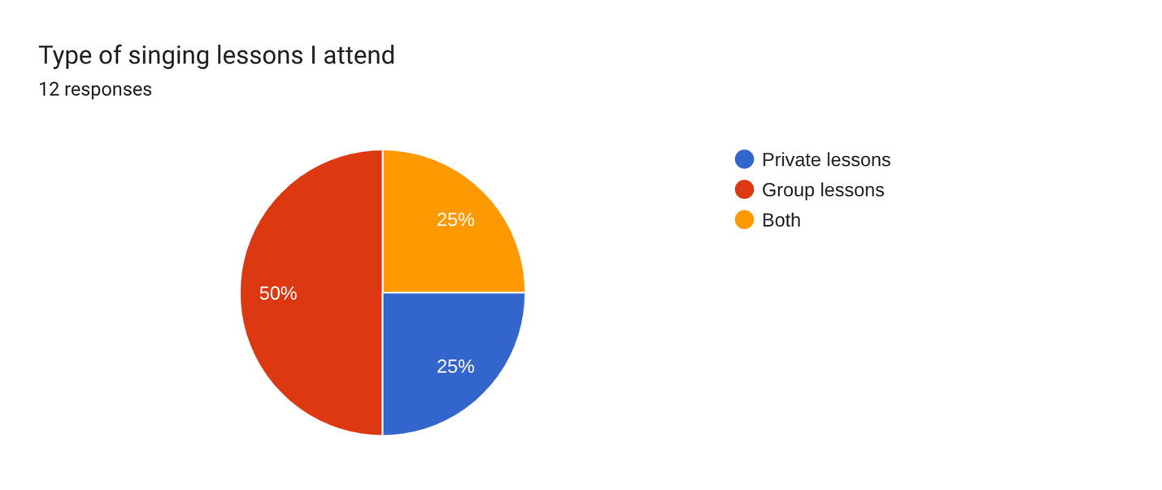
When scores were averaged according to category as in the MUSIC model inventory (Jones, 2009) the results were as follows (figure 9):
Figure 9 – Participant Questionnaire Results (score out of a possible 72)
Empowerment score | 58.75
Usefulness score | 59.66666667
Success score | 61.5
Interest score | 62.66666667
Caring score | 65
These results show that amongst my students in this age range, the highest scoring motivational factor was Caring. The average for this result was taken from the questions: “My singing teacher cares about how well I do in singing lessons”, “My singing teacher is friendly”, “My singing teacher is willing to help me” and “My singing teacher is respectful of me” with the highest scoring question being: “My singing teacher is friendly” with an average score of 67/75. These results suggest that students are motivated the most by their relationship to the teacher, however these results may have been affected by confirmation bias as they were aware that I was the researcher.
The lowest scoring category was Empowerment at 58.75/72. These results were taken from the questions: “I have the freedom to learn to sing in my own way in my singing lessons”, “I have choices in what I am allowed to do in singing lessons”, “I have control over how I learn the content in singing lessons” and “I have options in how I achieve my goals in singing lessons.” The lowest scoring of these questions was “I have choices in what I am allowed to do in singing lessons” with 56/72. This may be because the structure of the average music lesson has less variables and opportunities for student input and choice than some traditional academic subjects (Chardonnens, 2023; Sherwood, 2019).
Interestingly, participants who only attend group singing lessons reported a lower average for this question than other participants with a mean average of 4.0. Those who attend just group lessons scored lower on average for all the Empowerment categories, however the biggest disparity was for this question. There was also a disparity between ages, with younger participants perceiving that they have more choice in singing lessons than older participants.
When analysing these results, the importance of knowledge gained, confidence, interest, enjoyment, and usefulness of lessons have mean average scores of between 5 and 5.25, indicating generally positive engagement and perceived value. Younger students reported higher levels of interest and autonomy than older students and positive view of their teacher was high across all the demographics.
Level of interest drops the most between ages 14 to 16 and increases again for students aged 17 and 18; this may be due to the lower number of participants in this age group, or the content no longer engaging them (figure 10):

Figure 10 - Graph showing age vs mean average score for Interest
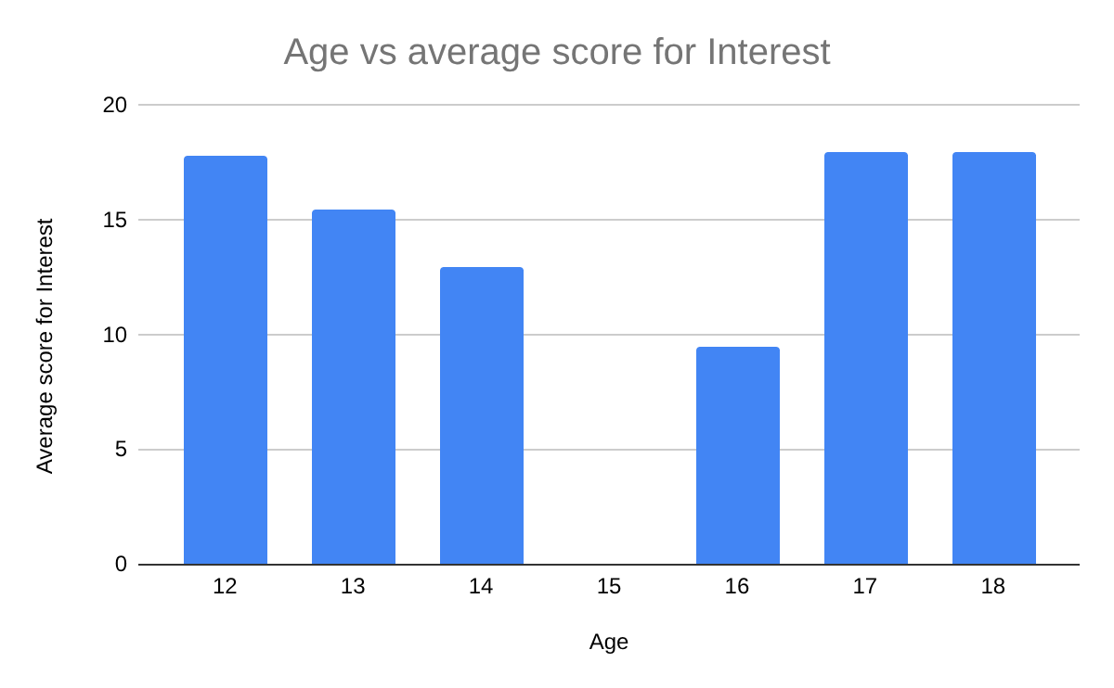This is also true for perceived levels of choice; research shows that feelings of autonomy over choice of repertoire increases motivation and engagement (Renwick and McPherson, 2002). Encouraging autonomy, the key concept of eMpowerment, is also an important factor in the MUSIC model (Jones, 2009).
Decline in interest in this age group is true in wider research, as it has been found that in mid-late adolescence there is a 50% decline in participation in musical activities (Ruth and Mullensiefen, 2021). The reasons for this are both innate and environmental, with boys in particular stating voice change paired with improper coaching as a reason for stopping singing (Ashley, 2022; Sweet, 2018). Navigating the incrementally increasing pressures of academics at school is also a factor in disengagement (Freer, 2006), as is an unsupportive home environment (Ruth and Mullensiefen, 2021).
Further research could consider the reasons for student attendance, whether that be genuine want to learn singing or encouragement from home; these factors, including discrepancies across adolescence and developmental stages, is not heavily considered in the MUSIC model (Jones, 2009).

Questionnaire for Non-Participants of Workshops
An identical questionnaire was created with the intention of comparing results of my pre-existing students to adolescent singers unknown to me. The questionnaire was shared in voice groups on Facebook, other voice teachers and through Voice Study Centre however it only yielded one response (Figure 11).
Figure 11 – Results from non-participant questionnaire
1 = Strongly Disagree – 6 = Strongly Agree (Jones, 2009)
Age | 16
Gender | F
Type of singing lessons I attend | Private lessons
The knowledge I gain in my singing lessons is important for my future. | 3
I am confident that I can succeed in my singing lessons. | 5
My singing teacher cares about how well I do in singing lessons. | 5
I am capable of achieving in my singing lessons. | 5
I have the freedom to learn to sing in my own way in my singing lessons. | 3
Singing lessons are interesting to me. | 5
I feel that I can be successful in meeting challenges in singing lessons. | 5
I enjoy completing my singing lessons. | 5
In general, singing lessons are useful to me. | 6
During my singing lessons, I feel that I can be successful in my learning. | 5
My singing teacher is friendly. | 5
I have choices in what I am allowed to do in singing lessons. | 2
I find what I learn in singing lessons to be relevant to my future. | 2
My singing teacher is willing to help me. | 5
My singing teacher is respectful of me. | 6
I have control over how I learn the content in singing lessons. | 2
Singing lessons hold my attention. | 5
I have options in how I achieve my goals in singing lessons. | 2

Due to the low response number, an average cannot be taken. However, if I compare the mean average for each question with the non-participant answers there are discrepancies between the results (figure 12):
Figure 12 – Table showing non workshop participant results against participant mean average results
Higher score represented in bold
Question | Non-Participant Response | Participant Average
The knowledge I gain in my singing lessons is important for my future. | 3 | 5
I am confident that I can succeed in my singing lessons. | 5 | 5
My singing teacher cares about how well I do in singing lessons. | 5 | 5
I am capable of achieving in my singing lessons. | 5 | 5
I have the freedom to learn to sing in my own way in my singing lessons. | 3 | 5
Singing lessons are interesting to me. | 5 | 5
I feel that I can be successful in meeting challenges in singing lessons. | 5 | 5
I enjoy completing my singing lessons. | 5 | 5
In general, singing lessons are useful to me. | 6 | 5
During my singing lessons, I feel that I can be successful in my learning. | 5 | 5
My singing teacher is friendly. | 5 | 6
I have choices in what I am allowed to do in singing lessons. | 2 | 5
I find what I learn in singing lessons to be relevant to my future. | 2 | 5
My singing teacher is willing to help me. | 5 | 5
My singing teacher is respectful of me. | 6 | 5
I have control over how I learn the content in singing lessons. | 2 | 5
Singing lessons hold my attention. | 5 | 5
I have options in how I achieve my goals in singing lessons. | 2 | 5

The results show that the participants of the workshops scored higher in more questions than the non-participant, suggesting they had lower motivation for their singing lessons. The largest discrepancies were in eMpowerment categories relating to autonomy, such as “I have choices in what I am allowed to do in singing lessons” and “I have control over how I learn the content in singing lessons” suggesting a more controlling, as opposed to autonomy-supportive, teaching style in these lessons (Jones, 2009; Reeve and Jang, 2006). However, without further results to compare to this is difficult to validate.
In future research, it would be interesting to further contextualise the results of non-workshop participants by asking further questions about their level of training, teacher and teaching and learning style. The results available suggest that there may be more influential factors at play than generalised demographics such as age and gender, however without more results to compare to this is very difficult to corroborate. Further directions for research could also collect data on voice teachers, such as age, experience and teaching style to further synthesise data and understand what motivates adolescent singers.
Qualitative Analysis
Observations
Through open coding of the recorded observations, the findings were categorised into the following themes: age and group dynamics, willingness to perform, use of expression and pitch security.
Age and Group Dynamics
The participants split off into three equal groups, with two of the groups working on one of the songs and the other group practicing the other. These groups formed naturally based on the song that the individuals had chosen, with no influence from myself. These groups also seemed to form based on similar ages of the participants; in academic research, this is common as much of education is based on age groups and additionally the forming of cliques in adolescence based on the perception of those with similar shared experiences and developmental relatability (Hartup, 1984). Stable clique structures also have a positive influence on adolescent behaviour and social conduct (Pattiselanno et al., 2015).
Following context setting and expectation for the workshop, students were observed to be more tentative than usual; from my prior knowledge of the participants, I suspect that this is due to it feeling like a different class than they normally have, or more pressurised or serious as they are aware it is being observed. This phenomenon, known as the Hawthorne effect, could have been present during this research (Sedgwick and Greenwood, 2015). This effect could perhaps have been stabilised if the workshops were delivered over a longer period (Swanson, 2008).
One participant asked early in the workshop if it was necessary for her to perform completely by herself. This participant may have had lower self-efficacy in singing than her peers, as it is documented that solo performances are generally more prone to performance anxiety than performing in a group (Papageorgi and Welch, 2024). Research shows that performing solo is better for increasing self-efficacy, and performing in a group can result in social loafing (putting in less effort than when alone) (Zelenak, 2020; Latane, Williams et al., 1979). However, group performance with high collective efficacy can result in better group performance than individual efficacy (Zhao and Wang, 2017). On this occasion, I allowed participants to perform in the groups they had been rehearsing in with the same song. It would be interesting in further research to compare the results if participants were asked to sing alone.
Willingness to Perform
There were differences in self-efficacy represented throughout the workshops as in the first session, two participants declined to perform (indicating low self-efficacy) while one participant voiced that they would rather perform on their own (indicating higher self-efficacy). By the end of the second workshop, all participants had performed at least once. This may suggest that more time is needed for some students to feel comfortable performing, and that as in Bandura’s (1997) self-efficacy theory, watching others perform can take away some of the anxiety from individuals watching (vicarious experience).
While the workshops were restricted by time, as part of the suggestions from the MUSIC model (Jones, 2009) participants were told they could rehearse and then perform when they felt ready. This was a new concept for these students and as a result the participants waited for me to tell them when there was only a short amount of time left. There is little in the way of academic sources to be found about the recommended amount of musical rehearsal time, suggesting that this factor depends on the ability of the students and time constraints before the performance. This may be one element of the MUSIC model that works better for academic performance and doesn’t translate effectively to music performance. This is unsurprising as the model was developed with academic contexts in mind, however does claim to be useful for any subject and level (Jones, 2017).
Part of the Success category in the MUSIC model is that students feel appropriately challenged (Jones, 2009). Zajonc’s (1964) theory on social facilitation argues that audience arousal may enhance performance for simple of well-rehearsed tasks but may have the opposite effect for tasks that are too complex or unfamiliar. This may explain why some students did not want to perform at the end of the first workshop and is one of the challenges of designing group lessons when there are mixed abilities.
This may be oversimplifying however, as social facilitation theory has now evolved into the theory of audience effects (Hamilton and Lind, 2016). Rather than just suggesting that audience arousal influences simple or difficult tasks, this may be the effect of self-presentation theory, where being seen to fail in front of an audience causes lowered self-esteem, causing worse performance on future tasks (Bond, 1982). This theory has since developed into reputation management theory, where people are continually modulating their response to tasks when being watched to be viewed more favourably (Tennie, Frith et al., 2010).
For the population being studied, these theories may be particularly significant as adolescents are thought to have the belief that they are being always watched by others (Cingel and Krcmar, 2014; Lapsley et al., 1989; Elkind, 1967). Adolescent egocentrism is thought to be part of the stage in development where young people are developing their identity separate from their parents (Cingel and Krcmar, 2014). They may therefore have increased anxiety about performing in front of others when compared with other populations as adolescent egocentrism increases sensitivity to evaluation (Paul, Juncos and Winter, 2024). This may be even more pronounced in adolescents today as they are developing in the social media age (Cingel and Krcmar, 2014).

Use of Expression
I observed during the performances that some participants were performing with the use of facial expression, gesture and movement. I noted that for others they performed with a visible nervousness. As singing is a form of communication, audiences respond more positively to direct eye contact, upright posture and a happy facial expression (which conveys confidence) than when the opposite is displayed (Urbaniak and Mitchell, 2024). During my observations, I noted that participants performed with confidence when they displayed these characteristics.
Participants were also using gesture and facial expression to convey the meaning and style of their chosen song. Gesture is suggested to be crucial to creating meaning (Johnson, 2006) and can increase musical intelligibility to audiences whether they are musically inclined or not (Thompson, Graham et al., 2005). Although many of the students were doing this naturally without my direction, the use of movement and gesture also supports learning (Juntunen, Arlin et al., 2023). Generally, I observed that the older students were performing with more expression suggesting that they are doing this from learned experience, as visual signifiers convey control harbored by a more distinguished performer (Thompson, Graham et al., 2005). The only exception to this was when participants were focusing more on accurate pitching during their performance.
Pitch Security
I observed that during the performances there was a disparity in pitch security. This was particularly true in second group that performed Anything Goes, despite this being an older and more experienced group. Comparatively, although the songs were chosen to be of a similar upbeat and comedic style, the jazzier rhythms of Anything Goes require more controlled breath support and pitching precision for fast sections; The History of Wrong Guys is more character driven than technically difficult. This may explain why the Anything Goes group had less pitch accuracy during their performance.
Pitch inaccuracy could have also been affected by external auditory feedback, as singing in a group may have made it harder for them to hear themselves (Bottalico, Graetzer et al., 2017). Lack of direct feedback by myself while they were rehearsing (due to observations being unobtrusive) may have also meant that they practiced the intervals of the song incorrectly (Berglin, Pfordfresher et al., 2021).
I further observed that some of the participants would look for my approval that they are singing it correctly during their performance. Teacher support is well documented as a key influence on self-efficacy in music education, particularly in this age group (Orejudo, Zarza-Alzugaray et al., 2021).
In performance settings, studies have shown that music students appreciate their teachers’ presence as they value their feedback and want to perform well for them (Ryan, Boucher et al., 2021). This observation that participants made direct eye contact with me during their performance for my visual feedback suggests to me that I have developed a strong relationship with these students and that they value my feedback. Supportive feedback can increase student motivation; their increase in feeling competent fulfills a psychological need, a key message in self-determination theory (Deci and Ryan, 1985) which in turn influenced the fundamentals of the MUSIC model (Jones, 2009).
Outcomes
Jones (2018) suggests that motivation is measured by the extent to which an individual engages in an activity. This then produces the outcome of learning and performance (Jones, 2018; Figure 13).
Figure 13 – Relationship between motivation, engagement and oucomes (Jones, 2018)
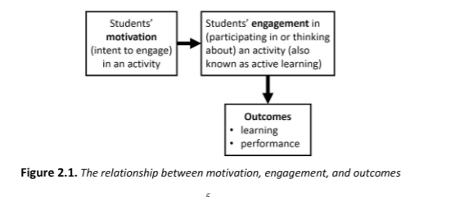
By this metric, the observations suggest that the MUSIC model was effective in increasing motivation. Participants were actively engaged in the workshops, as they worked together on creating the outcome (performance) autonomously and all produced a performance by the end of the second workshop. Cognitive engagement (thinking about the activity) is more difficult to quantify through observation (Jones, 2018) but could be suggested to have manifested as peer feedback and asking questions about what was expected from their performance. This suggests that motivation was high in these workshops as participants were behaviourally and cognitively engaged (Jones, 2018). To better measure this, future research could observe engagement before and after the MUSIC model is implemented.
Focus Groups
Following the questionnaires and workshops, the participants were invited to answer questions in a focus group. This method benefits from social interaction being able to be observed as part of the method when compared to individual interviews (Smithson, 2000). As this research takes place in a controlled and manufactured environment, it should not be analysed as naturally occuring interaction (Smithson, 2000).
Initially these common themes were identified from focus group responses (figure 14):
Figure 14 – Initial themes found from focus groups
Song choice | Preference for familiarity | Preference for  variety | Preference  for independence | Preference for  peer feedback | Space and time  to practice | Teacher interaction | Characterisation | Perceived effort
These were identified as themes that more than one response could fit into, with some overlapping into more than one category. It was then identified that some of the recorded observations could also fit into one or more of these categories, and some new categories were also formed (figure 15):
Figure 15 – table of codes from focus groups
Most common code across all groups represented in bold
Nervousness/visibly nervous performance
Age dynamics
Performed in group
Performed with independence
Pitch security/insecurity
Use of gesture
Use of facial expression
Focused performance
Refusal to perform
These codes were then narrowed down again as in axial coding. The codes from focus groups were found to be able to fit into broader modes of learning which is further explored in the analysis. The observation codes were categorised into broader themes that fit several of the codes. These narrowed-down themes created the core of the analysis for the qualititative findings (figure 16):
Figure 16 – Table from second round of coding from focus groups
Focus Groups
Teacher-led learning
Peer-led learning
Self-led learning

How the initial codes from the focus groups fit into these codes is represented in the following diagram (figure 17):
Figure 17 – themes that were generated through coding of focus group responses
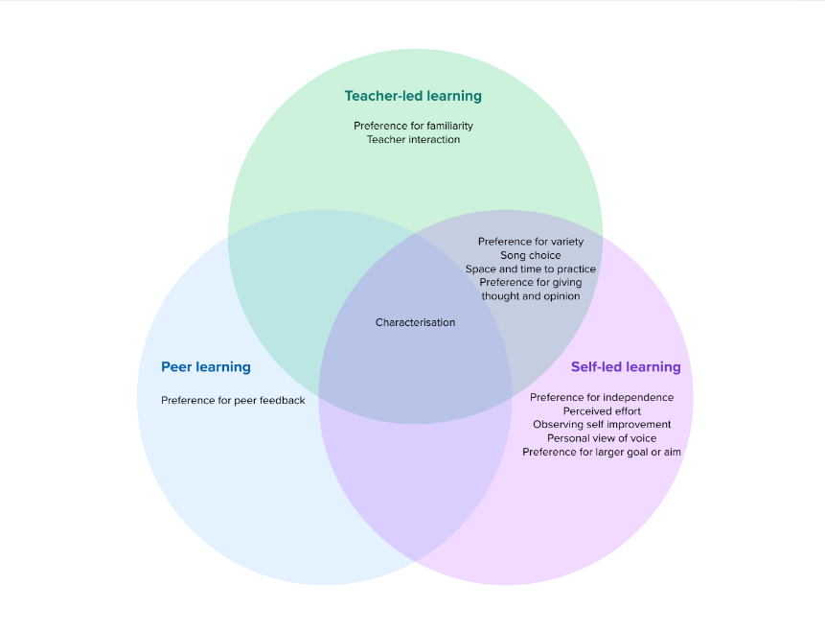
The codes formed from the responses fit into one or more of these modes of learning: teacher-led, peer and self-led learning. Each of these modes of learning can also linked to the elements of the MUSIC model (Jones, 2009) and Bandura’s (1977) self-efficacy theory (figure 17):
Figure 18 – Table showing how codes, MUSIC model elements and self-efficacy theory are linked
Learning Mode | Elements of the MUSIC model | Elements of Bandura’s self-efficacy theory
Teacher-led learning | Success (teacher expectations, appropriate level of challenge, feedback)  Usefulness (relating students’ learning to their goals)  Caring (students believe their teacher cares about their wellbeing and achievement) | Verbal persuasion (feedback, encouragement)  Vicarious experience (modelling)
Peer learning | Caring (opportunities for positive peer interaction) | Vicarious experience (watching peers succeed)
Self-led learning | EMpowerment (autonomy and control over learning, autonomy-supportive teaching style)  Interest (situational and individual interest in course content) | Mastery experience (suceeding, building autonomy)  Physiological state (control of emotional arousal)
The connection between these teaching modes and elements of the MUSIC model is synthesised through the findings.
Language
In interpreting the answers given from these focus groups, it is also important also to consider the language that adolescents use in my interpretation. For this population, language is particularly important as it is being used to construct identity and align the individuals with social norms (Gee, Allen and Clinton, 2001). This can also be said of the voice; through self-expression, adolescents experiment with their identity and the correlation between singing voice and self-esteem is well documented (Wolfe, 2016). This is why for the analysis of the focus groups, in vivo quotations were used as this can help create meaning through both the words used and their social context (Manning, 2017).
EMpowerment
In the EMpowerment category, relating to students’ sense of autonomy over their learning, participants identifed the choices they were given between which songs to learn and who they worked with, but they also identifed what choices they had in creating their performance and the sense of control this gave them:
“When you kind of like left us to do our own staging and characterisation in our own way, and we got to practice by ourselves.”
Performance instruction is unique to other forms of education that the MUSIC model may be used for as it is open to much more interpretation (Jones, 2009). The individualised nature of teaching in the arts is often more interpretive and collaborative than other styles of education (Jorgenson, 2000) and it is suggested that motivation in music education is inherently linked to individualised identity and interpretation (Evans and McPherson, 2015). This response suggests that the EMpowerment design of the workshop was successful, as Jones (2009, p.274) suggests: “it does not matter whether the instructor thinks that he or she is giving students control; rather, what matters is that students perceive that they have control over some aspect of their learning”.
This response also mirrors the participants’ feelings of choice:
“It feels like we got to choose if we performed in a group or individually or like if we like restarted or if we kind of just left it as it was and what song we did”.
As part of the design of the workshops, students were told that they could have the option to restart their song during their performance if they wished. The eMpowerment category of the MUSIC model (Jones, 2009) is constructed from research on self-determination theory; the participants being able to identify the choices they were given suggest an internal locus of control as they have a feeling of control over their actions (Deci and Ryan, 2000; Jones, 2009).
Many of the participants also identified them being able to have control over their groups, aligning with Jones’ (2009) concept that having their own choice, instead of being assigned groups by their teacher, increases motivation (Ciani, Summers et al., 2008). This appeared to be a highly motivating factor in their enjoyment of the workshops, as it was also identified across the other categories.
Usefulness
In the Usefulness category, participants were asked what they found useful about the course. One participant responded:
“I was gonna say about the groups, we could like give each other like help and like corrections like or what our like faces or like how we sounded when we were doing the song.”
This comment from the participant relates to Bandura’s (1977) theory of self-efficacy, which identifies verbal persuasion as a key influence on confidence and self-belief.
Participants also commented on their desire for student feedback in the Caring category:
“Like maybe like after if they could have corrections from like each other like on what to do.”
".. people who did the same song as you. Like if they could give you how to like, improve your song. That’ll be quite helpful.”
Peer feedback is proven to be useful in developing listening and reflective learning skills, as well as creating a collaborative feel in a group class where students can learn what makes a performance successful (Sargent and Koehler, 2007; Blom and Poole, 2004; Burwell, 2005; Daniel, 2001). This is also reflected in Bandura’s (1997) self-efficacy theory, where vicarious experience (the idea that watching others succeed fosters self-belief in also succeeding) is indicated as a crucial influence in creating self-efficacious students.
While students did have the opportunity to do this in the workshops, there was less opportunity for the verbal persuasion of self-efficacy theory due to time constraints; Bandura (1997, p.101) suggests that: “people who are persuaded verbally that they possess the capabilities to master given tasks are likely to mobilize greater effort and sustain it”. Peer and teacher feedback are valuable when used side by side, where teacher feedback offers more direct corrections and peer feedback encourages reflection and autonomy (Black and William, 1998; Hughes, 2009). Putting a larger emphasis on peer feedback could have reinforced the eMpowerment concepts of the MUSIC model (Jones, 2009) while also reflecting the verbal persuasion element of self-efficacy theory (Bandura, 1997).
Success
Success is similar to Bandura’s (1977) indicator of self-efficacy vicarious experience that postulates that performance anxiety can be reduced through repeated feelings of success in learning. Participants opinions differed on whether they felt they had had enough time to rehearse:
“I felt like... we were successful because we had a lot of time to practice it.”
“I just think that um because it was such a short amount of time it was harder to get like a grip of the characters. I think it was also good that it was a short amount of time because I think I learnt like the song quicker than I normally would, like, melodically.”
Participants had been given two hour-long sessions and were informed that they could perform when they felt ready; this was also designed as an element of eMpowerment and student autonomy, although wasn’t identified as a choice given to them in student responses. The variation in responses to amount of rehearsal time are consistent with music education research, where it is suggested that the effective amount of rehearsal time varies depending on ability, goals and difficulty of the task (Apfelstadt, 2000). More important than allocated rehearsal time is consistent, structured and on-task rehearsal (NAfME, 2014; Yarbrough and Price, 1989) which in this instance resulted in all participants producing a performance.
Interest
Participants were asked what they liked about the workshops and what they would have changed. Participants commented on the choices they had and the challenge that this offered:
“I think I find it interesting like it was like songs I hadn’t really seen before. So I was able to like have a different like kind of choice like what I would normally like to sing.”
“...we did a performance at the end of each like session how quickly like you had to like make something which I thought was like fun and challenging.”
Creating the correct level of challenge is crucial to learning; this is also a key concept of the MUSIC model which suggests that making tasks too difficult or too easy can have a demotivational effect (Jones, 2009). Repeated failures from tasks perceived as too difficult can decrease confidence (O’Neill and Sloboda, 1997) and affects students’ identity in relation to music (Evans and McPherson, 2015). These responses suggest that the correct level of challenge was created for students, as they didn’t express that the task was too easy or too difficult and they all achieved the goal of performing their chosen song in one or both workshops.
On reflection, to better consider the opinions of the participants, it could have been more beneficial to ask these questions after the first workshop, make changes for the second workshop and then ask these questions again. Considering the opinions of the participants is also a key concept of eMpowerment (Jones, 2009). This is also relevant to the perception by students of their relationship with their teacher.
Caring
The final category of the focus group was Caring. It is also well documented that student-teacher relationship can have a big influence on learning and relationship to singing (Carey and Grant, 2014; Kennell, 2002) and can have a long-term effect on student motivation in singing (Crook, 2012). Participants commented on how they felt the instructor had shown that they cared about their learning:
“...every like once in a while you like came and like watched us and like asked us how we were doing, like, with the piece like, how we were like, improving or what we needed help with.”
“...you’re like wanting our opinion on like what we could do better.”
"...when we were practicing performing, you came round to see how we were doing and checked up on us, seeing how much time we needed.”
These responses relate across categories, as students’ having their opinions heard and not feeling too controlled are key concepts of eMpowerment (Jones, 2009). Crucially, the participant response about believing their teacher wants them to improve is well-documented in music education literature as motivational (Jorgenson, 2000; Woody, 2000; Creech, Hallam et al., 2008; Parkes and Jones, 2012).
As I have a pre-existing relationship with the students, it is important to consider that their answers may be the product of some unintentional confirmation bias. However, these answers reflect literature in music research that suggests that a caring student-teacher relationship encourages more creative risk taking (Crook, 2012), a strong musical identity (Evans and McPherson, 2015) and long-term engagement with music (Creech, Hallam et al., 2008).
The answer given that “...you’re like wanting our opinion on like what we could do better” is particularly significant as it directly reflects the MUSIC model concept in the Caring category that suggests that “the key to designing for caring is that students believe that the instructor cares about their learning” and that teachers should “listen to and value students’ opinions and ideas” (Jones, 2009, pp.279-280).
In Self-Determination theory (Deci and Ryan, 2000) feeling cared about (relatedness) is one of the key psychological needs that influence intrinsic motivation. The Caring concept suggests that teachers should not just care about their learning but about them personally (Jones, 2009). This is an added benefit of being previously known to the students, and it would be interesting to further research this with a new group of students.
One student expressed their desire for a clearer goal:
“if there’s like... a more like definitive... end goal or objective to maybe like each session because then like, I feel like for me and maybe like the people around like, it’s just, you have something to like, like something clear to like aim for”
Within the workshop, the expectation was set that they should aim to learn and perform their chosen song by the end of the session. However, it is suggested that motivation is increased when students have not only short-term goals but longer-term goals as well, with an understanding of how their goals work together (Simons, Vansteenkiste et al., 2004). Literature in music education suggests that goal setting is beneficial to motivation, positive behaviour practices and self-efficacy in students (Mantie, 2019; Silva and Marinho, 2024; Aydiner-Uygun, 2020).
Music students may be inclined towards a particular learning orientation which can be categorised as achievement (where students make effort to succeed) or avoidant (where students make effort so as not to achieve a negative outcome) (Aydiner-Uygun, 2020). Similarly to achievement learning orientation, Bandura (1997) suggests that Mastery Experiences is the biggest influence on self-efficacy, which means repeated successes in a task. This response suggests that this participant did not feel that they had a clear enough goal for the task, resulting in lack of motivation.
This response also suggests that this participant may not have felt challenged enough; in the Success category, Jones (2009) surmises that students should be challenged appropriately and not find tasks too hard or easy. Finding this balance was a challenge of delivering the workshops as there can be a difference in ability between the youngest (12) and oldest (18) attendees.
With a longer time frame, it may have also been possible to encourage participants to set smaller goals towards the larger goal of performing their song and outline clearly what they wanted to achieve in their performance. Goals make clear what is attainable and short-term goals combined with feedback can help students to make adjustments towards their larger goal (Alderman, 2008). Participants could have also been encouraged to think about their longer-term goals outside of the workshop, for example performance or career goals. This could have also influenced Usefulness, as participants could have had a clearer understanding of how attending the workshops influences their larger performance goals.

Focus Group Outcomes
Using Jones (2018) model again that engagement reflects motivation, the level of reflection in the answers given by the participants suggests that they were cognitively engaged. Although the questions were categorised into the elements of the MUSIC model, the participants were not specifically aware of this and yet their answers still reflected the concepts and theories behind the model suggesting its effectiveness. Additionally, many of their answers reflected self-determination and autonomy, suggesting self-efficacious students. The level of reflection and engagement in their given answers suggests that the model was effective in increasing motivation.

Conclusion
Summary of Findings
The aim of this research project was to discover if the MUSIC model was effective to increase confidence and motivation in adolescent singing students. I aimed to create a rationale for using the MUSIC model if deemed effective for motivation and based on the triangulation of the results from the questionnaire, observations and focus groups I can surmise that the model is effective as cognitive engagement was clear; from their responses, the participants were actively thinking about their learning (Jones, 2018). Behavioural engagement was also observed, as participants worked independently and produced a performance at the end of the workshops. This is in line with Jones’ (2018) model that suggests that motivation and intent to engage leads to active learning which leads to performance (figure 13, p.43). The ability to produce a performance also indicates confident and self-efficacious students (Orejudo, Zarza-Alzugaray et al., 2020).
Interestingly, eMpowerment had the lowest quantitative scores but following the workshops participants identified several choices that they had been given suggesting intrinsic motivation. From this, it is suggested that voice lessons often do not allow for much student autonomy and this could be hindering motivation and achievement. The MUSIC model could be used here as an effective framework to improve this.
However, Jones (2009) suggests there is no evidence that all five elements are required to increase motivation, but that combinations of them are more effective than implementing them alone. It was observed that there was considerable crossover between elements, also aligning with elements of self-efficacy theory and styles of teacher-led, peer-led and self-led learning (figure 16, p.43). It could therefore be suggested that for singing instruction that is effective to increase adolescent motivation, a combination of the MUSIC model elements provides a useful framework for lesson planning.
Limitations of the Study
This study was limited by lack of responses from participants outside of the MUSIC model workshops. It was my aim to improve on my previous research by recruiting more outsider participants, however perhaps due to the challenges of finding participants from the adolescent demographic, this was not possible. Additionally, as the model was tested with lessons planned around the model, other measures beyond the inventory could better validate its effectiveness.
Recommendations for further research
This study found that the MUSIC model (Jones, 2009) was effective to increase adolescent singers’ motivation and confidence. In my personal practice, I will consider shaping lesson plans around the model particularly when teaching adolescent groups. However, it was limited by a small sample size. Further research could improve validity by testing the MUSIC model with a larger group of participants as an outside researcher to fully corroborate these findings.

References
Abril, C.R. (2007) ‘I have a voice but I just can't sing: A narrative investigation of singing and social anxiety’, Music education research, 9(1), pp.1-15.
Alele, F., Malau-Aduli, B. (2023). An Introduction to Research Methods for Undergraduate Health Profession Students. JCU Pressbooks, Australia. Available at: https://jcu.pressbooks.pub/intro-res-methods-health/ (Accessed 15th April 2025).
Alhassan, I., Sammon, D., Daly, M., Wibisono, A., Kasraian, L., Nagle, T., Heavin, C., Dennehy, D., Zamani, E., Qaffas, A. (2023). The use of open, axial and selective coding techniques: A literature analysis of IS research. UKAIS Conference, Kent.
Angrosino, M., Rosenberg, J. (2011). ‘Observations on observation’. The Sage handbook of qualitative research, 4, pp.467-478.
Apfelstadt, H. (2000). ‘Effective rehearsal techniques’, Music Educators Journal, 87(3), pp.33–36.
Artino, A.R. (2012) ‘Academic self-efficacy: from educational theory to instructional practice’, Perspectives on medical education, 1, pp.76-85.
Ashley, M. (2022). ‘Memorable years, formative years: Why do boys stop singing in their teens?’, Oxford University Press Blog. Available at: https://blog.oup.com/2022/10/memorable-years-formative-years-why-do-boys-stop-singing-in-their-teens/ (Accessed 21/08/25)
Aydıner‑Uygun, M. (2020). ‘Achievement goal orientations of students studying instrument education as predictors of their learning approaches’, Music Education Research, 22(2), 130–144.
Bandura, A., (1977). ‘Self-Efficacy: Toward a Unifying Theory of Behavioral Change’ Psychological Review, 84.
Bandura, A. (1997). Self-efficacy: The exercise of control. New York: Freeman.
Basith, A., Syahputra, A. and Ichwanto, M.A., (2020). ‘Academic self-efficacy as predictor of academic achievement’, JPI (Jurnal Pendidikan Indonesia), 9(1), pp.163-170.
Baumeister, R.F., Leary, M.R. (1997) ‘Writing narrative literature reviews’, Review of general psychology, 1(3), pp.311-320.
Bénabou, R., Tirole, J., (2001). ‘Self-confidence and personal motivation’, The quarterly journal of economics, 117(3), pp.871-915.
Berglin, J., Pfordresher, P., Demorest, S., (2022). ‘The Effect of Visual and Auditory Feedback on Adult Poor-Pitch Remediation’, Psychology of Music. 50. Pp.1077-1090. Available at: 10.1177/03057356211026730 (Accessd 21/08/25).

Bhandari, P. (2022). ‘Inductive Reasoning | Types, examples, explanation’. Scribbr. Available at
https://www.scribbr.co.uk/research-methods/inductive-reasoning-types/ (Accessed 21/08/25)
Bhandari, P. (2025). ‘Ethical Considerations in Research | Types & Examples’, Scribbr. Available at: https://www.scribbr.co.uk/research-methods/ethical-considerations/ (Accessed 18/08/25)

Bhattacherjee, A., (2012) Social science research: Principles, methods, and practices.
University of South Florida.
Bizjak, M., Freer, P.K. (2015) ‘Do We Realize the Importance of Vocal Technique in Adolescence?’, Glasbenopedagoški Zbornik, 23, pp.39-48.
Black, P., Wiliam, D. (1998). ‘Assessment and classroom learning’, Assessment in Education: Principles, Policy & Practice, 5(1), pp.7–74.
Blom, D., & Poole, K. (2004). ‘Peer assessment of tertiary music performance: Opportunities for understanding performance assessment and performing through experience and self-reflection', British Journal of Music Education, 21(1), pp.111–125.
Bond, C.F., (1982). ‘Social facilitation: A self-presentational view’, Journal of Personality and Social Psychology, 42(6), p.1042.
Bonshor, M., 2017. The confident choir: A handbook for leaders of group singing. Bloomsbury Publishing PLC.
Borup, J., Graham, C. R., West, R. E., Archambault, L., Spring, K. (2014). ‘The adolescent community of engagement framework: A model for research on adolescent online learning’, Journal of Technology and Teacher Education, 22(1), pp.107–130.
Bottalico, P., Graetzer, S., Hunter, E.J. (2017) ‘Effect of training and level of external auditory feedback on the singing voice: pitch inaccuracy’, Journal of Voice, 31(1), pp.122-e9.
Burns, K.., Burns,N., Ward, L. ‘Confidence—More a Personality or Ability Trait? It Depends on How It Is Measured: A Comparison of Young and Older Adults’, Frontiers in Psychology 7, (2016): pp.187440. Available at:. https://doi.org/10.3389/fpsyg.2016.00518 (Accessed 18/02/25)
Burwell, K. (2005). ‘A degree of independence: Teachers’ approaches to instrumental tuition in a university college’, British Journal of Music Education, 22(3), pp.199–215.
Campbell, Q, Bodkin-Allen, S, Swain, N. ‘Group singing improves both physical and psychological wellbeing in people with and without chronic health conditions: A narrative review’, J Health Psychol. 2022 Jul;27(8), pp.1897-1912. Available at: doi: 10.1177/13591053211012778. Epub 2021 Apr 29. PMID: 33913360 (Accessed 21/08/25)

Carey, B., & Grant, C. (2014). ‘Teacher and student perspectives on one-to-one pedagogy: Practices and possibilities’, British Journal of Music Education, 31(2), pp.209–225.
Carter, N., Bryant-Lukosius, D., DiCenso, A., Blythe, J., & Neville, A. J. (2014). ‘The use of triangulation in qualitative research’, Oncology Nursing Forum, 41(5), 545–547. https://doi.org/10.1188/14.ONF.545-547
Chardonnens, S. (2023). ‘Music teachers’ stance in action to develop student autonomy’, Psychology of Music, 52(5), pp.569-583. Available at: https://doi.org/10.1177/03057356231216876 (Accessed 21/08/25)
Chib, V.S., Adachi, R., O’Doherty, J.P. (2018) ‘Neural substrates of social facilitation effects on incentive-based performance’, Social Cognitive and Affective Neuroscience, 13(4), pp.391-403.
Ciani, K.D., Summers, J.J., Easter, M.A., Sheldon, K.M. (2008) ‘Collaborative learning and positive experiences: does letting students choose their own groups matter?’,. Educational Psychology, 28(6), pp.627-641.
Cingel, D.P., Krcmar, M. (2014) ‘Understanding the experience of imaginary audience in a social media environment’, Journal of Media Psychology. 26. pp.155-160.
Cleary, E. (2024) ‘An assessment of self-efficacy in amateur adolescent performing arts students through physical warm-up methods’. Unpublished.
Cleary, E. (2024) ‘Creation of an artefact to improve adolescent singers’ self-confidence in preparation for their first performance’. Unpublished.
Clift, S.M., Hancox, G. (2001) ‘The perceived benefits of singing: findings from preliminary surveys of a university college choral society’, The journal of the Royal Society for the Promotion of Health, 121(4), pp.248-256.
Cogdill, S.H. (2013) The identification of factors contributing to first-year college students' mindset of singing ability, and the relationship of that mindset to intent to participate in singing activities. The University of Nebraska-Lincoln.
Cole, J.S., Bergin, D.A., Whittaker, T.A. (2008) ‘Predicting student achievement for low stakes tests with effort and task value’, Contemporary Educational Psychology, 33(4), pp.609-624.
Creech, A., Hallam, S., Varvarigou, M., McQueen, H. (2008). ‘Musical progression and teacher support in one-to-one music tuition’, Music Education Research, 10(3), pp.387–403.
Crocco, L., Madill, C.J., McCabe, P. (2017) ‘Evidence-based frameworks for teaching and learning in classical singing training: a systematic review’, Journal of Voice, 31(1), pp.130-e7.
Cronbach, L. J. (1951). ‘Coefficient alpha and the internal structure of tests’, Psychometrika, 16(3), pp.297–334. Available at: doi:10.1007/bf02310555 (Accessed 21/08/25)
Crook, A. C. (2012). ‘Exploring relationships in vocal pedagogy: A multi-case study’, International Journal of Music Education, 30(4), pp.321–336.
Daniel, R. (2001). ‘Self-assessment in performance studies’, British Journal of Music Education, 18(3), pp.215–226.
Deci, E.L., Ryan, R.M. (2000) ‘The" what" and" why" of goal pursuits: Human needs and the self-determination of behavior’, Psychological inquiry, 11(4), pp.227-268.
De Vries, P., (2017). ‘Self-efficacy and music teaching: Five narratives’, International Journal of Education & the Arts, 18(4).
Dezdar, S., Sulaiman, A. (2009) ‘Successful enterprise resource planning implementation: taxonomy of critical factors’, Industrial Management & Data Systems, 109(8), pp.1037-1052.
dos Santos Silva, C., & Marinho, H. (2024). ‘Self-regulated learning processes of advanced musicians: A PRISMA review’, Musicae Scientiae, 29(1), pp.89-108. Available at: https://doi.org/10.1177/10298649241275614 (Accessed 21/08/25).
Dowling, M. (2004) 'Hermeneutics: an exploration'. NURSE RESEARCHER, 11 (4):pp.30-39.
Driscoll, D.L., (2011). ‘Introduction to primary research: Observations, surveys, and interviews’, Writing spaces: Readings on writing, 2(2011), pp.153-174.
Elkind, D. (1967) ‘Egocentrism in adolescence’, Child development, pp.1025-1034.
Elliot, A.J., Dweck, C.S. (eds) (2013). Handbook of competence and motivation. Guilford Publications.
Evans, P. (2015) ‘Self-determination theory: An approach to motivation in music education’, Musicae Scientiae, 19(1), pp.65-83.
Evans, P., McPherson, G. E. (2015). ‘Identity and practice: The motivational benefits of a long-term musical identity’, Psychology of Music, 43(3), pp.407–422.
Ferrari, R., (2015) ‘Writing narrative style literature reviews’, Medical writing, 24(4), pp.230-235.
Fowler, F. J., Jr. (1995). Improving survey questions: Design and evaluation.
Thousand Oaks, CA: Sage Publications.
Freer, P.K. (2006) ‘Hearing the voices of adolescent boys in choral music: A self-story', Research Studies in Music Education, 27(1), pp.69-81.
Gebhardt, R. H. (2016). ‘The adolescent singing voice in the 21st century: Vocal health and pedagogy promoting vocal health’, DMA Document. Columbus, OH: The Ohio State University.
Gee, J.P., Allen, A.R., Clinton, K. (2001) ‘Language, class, and identity: Teenagers fashioning themselves through language’, Linguistics and Education, 12(2), pp.175-194.
Gladman, T., Gallagher, S., Ali, A. (2020). ‘MUSIC® for Medical Students: Confirming the Reliability and Validity of a Multi-Factorial Measure of Academic Motivation for Medical Education’, Teaching and Learning in Medicine, 32(5), pp.494–507. Available at: https://doi.org/10.1080/10401334.2020.1758704 (Accessed 21/08/25)
GODDARD III, R.D., Villanova, P. (2006) ‘QUESTIONNAIRES FOR RESEARCH’, The psychology research handbook: A guide for graduate students and research assistants, p.114.
Gorard, G. (2004). Combining Methods in Educational and social research. Berkshire: Open University Press.
Greene, M.J., (2014) ‘On the inside looking in: Methodological insights and challenges in conducting qualitative insider research’, The qualitative report, 19(29), pp.1-13.
Hamilton, A.F.D.C., Lind, F. (2016) ‘Audience effects: what can they tell us about social neuroscience, theory of mind and autism?’, Culture and brain, 4(2), pp.159-177.
Hartup, Willard W. (1984) “The Peer Context in Middle Childhood”, in Development During Middle Childhood: The Years from Six to Twelve, Washington, DC: National Academies Press. Available at: doi: 10.17226/56 (Accessed 21/08/25)
He, J., Wang, Q. & Lee, H. ‘Enhancing online learning engagement: teacher support, psychological needs satisfaction and interaction’, BMC Psychol 13, 696 (2025). Available at: https://doi.org/10.1186/s40359-025-03016-0 (Accessed 21/08/25)
Hendry N, Lynam DS, Lafarge C. ‘Singing for Wellbeing: Formulating a Model for Community Group Singing Interventions’, Qual Health Res. 2022 Jul;32(8-9, pp.1399-1414. Available at: doi: 10.1177/10497323221104718 (Accessed 21/08.25)
Hidi, S., & Renninger, K. A. (2006). ‘The four-phase model of interest development’, Educational Psychologist, 41(2), 111-127.
Holley, G.S. (2017) From Classical to Music Theatre: A Vocalist’s Experience, Professional Doctorate thesis, Queensland Conservatorium, Griffith University.
Hu, K., Dongmei T., Huan H. ‘The Mediating Role of Learning Engagement in the Relationship between Master's Students' Learning Motivation and Scientific Research and Innovation Capability’, Frontiers in Education 10, (2025): 1604792. Available at: 2025. https://doi.org/10.3389/feduc.2025.1604792 (Accessed 19/08/25).
Hughes, S. J. (2009). ‘The role of peer assessment in developing self-regulated learning in music performance: A pilot study’, British Journal of Music Education, 26(1), pp.21–35.
Jiang, L.., Tong, R. (2024). ‘Psychological capital and music performance anxiety among Chinese undergraduate music majors: The mediating role of self-esteem and flow experience’, Frontiers in Psychology, 15, pp.1461235. Available at: https://doi.org/10.3389/fpsyg.2024.1461235 (Accessed 21/08/25)
Johnson, M. (2006) ‘Merleau-Ponty’s embodied semantics—from immanent meaning, to gesture, to language’, EurAmerica, 36(1), pp.1-26.
Jones, B.D., (2009). ‘Motivating students to engage in learning: the MUSIC model of academic motivation’, International Journal of Teaching and Learning in Higher Education, 21(2), pp.272-285.
Jones (2016) in Smith, M., Defrates-Densch, N (eds) Challenges and Innovations in Educational Psychology Teaching and Learning. IAP, UK.
Jones, B.D. (2017) ‘User guide for assessing the components of the MUSIC® Model of Motivation’, Dilayari January, 18, p.2018.
Jones, B.D. (2018) Motivating students by design: Practical strategies for professors. CreateSpace Independent Publishing Platform.

Jones, B.D. (2019) ‘Testing the MUSIC Model of Motivation Theory: Relationships between Students' Perceptions, Engagement, and Overall Ratings’, Canadian Journal for the Scholarship of Teaching and Learning, 10(3), p.3.
Jones, B.D., (2020). ‘Engaging second language learners using the MUSIC model of motivation’, Frontiers in Psychology, 11, p.1204.
Jones, B.D., Byrnes, M.K. and Jones, M.W., (2019). ‘Validation of the MUSIC Model of Academic Motivation Inventory: Evidence for use with veterinary medicine students’, Frontiers in veterinary science, 6, p.11.
Jones, B.D., Krost, K. and Jones, M.W. (2021) ‘Relationships between students’ course perceptions, effort, and achievement in an online course’, Computers and Education Open, 2, p.100051.
Jones, B.D., Li, M. and Cruz, J.M., (2017). ‘A cross-cultural validation of the MUSIC® Model of Academic Motivation Inventory: Evidence from Chinese-and Spanish-speaking university students’, International Journal of Educational Psychology, 6(1), pp.25-44.

Jones, B.D., Sahbaz, S., Schram, A.B., Chittum, J.R. (2017). ‘Using psychological constructs from the MUSIC Model of Motivation to predict students’ science identification and career goals: Results from the US and Iceland’, International Journal of Science Education, 39(8), pp.1089-1108.
Jones, B.D., Sigmon, M.L. (2016) ‘Validation evidence for the elementary school version of the MUSIC® Model of Academic Motivation Inventory’, Electronic Journal of Research in Educational Psychology, 14(1), pp.155-173.
Jones, B.D., Skaggs, G (2012) ‘Validation of the MUSIC Model of Academic Motivation Inventory: A measure of students’ motivation in college courses’, International Conference on Motivation. Frankfurt, Germany.
Jones, B.D., Skaggs, G. (2016) ‘Measuring Students' Motivation: Validity Evidence for the MUSIC Model of Academic Motivation Inventory’, International Journal for the Scholarship of Teaching and Learning, 10(1), p.1.
Jørgensen, H. (2000). ‘Student learning in higher instrumental education: Who is responsible?’, British Journal of Music Education, 17(1), pp.67–77.
Juntunen, Marja, Elina, P. Arlin., Katri L. (2023) ‘Expression in Popular Music Singing as Embodied and Interpersonal’, Frontiers in Education 8, pp.1092736. Available at: https://doi.org/10.3389/feduc.2023.1092736. (Accessed 5/08/25).
Kaufman, A., Dodge, T., (2009). ‘Student perceptions and motivation in the classroom: Exploring relatedness and value’, Social Psychology of Education, 12(1), pp.101-112.
Kennell, R. (2002). ‘Toward a theory of applied music instruction’, International Journal of Music Education, 39, pp.30–39.
Kenny, D. T. (2011). The psychology of music performance anxiety. Oxford University Press. Available at: https://doi.org/10.1093/acprof:oso/9780199586141.001.0001 (Accessed 21/082025).
Kenny, D. T. (2016). Managing music performance anxiety. Routledge. Available at: https://doi.org/10.4324/9781315662359 (Accessed 21/08/2025)
Kordsalarzehi, F., Salehipour, S., Hamedani, M.A., Jahromi, R.Z., Arbabisarjou, A. and Ghaljeh, M., (2025). ‘The impact of academic skills training on academic self-efficacy and motivation in nursing and midwifery students: A quasi-experimental study’, Journal of Education and Health Promotion, 14(1), p.56.
Krause, A.E., North, A.C. and Davidson, J.W. (2019) ‘Using self-determination theory to examine musical participation and well-being', Frontiers in Psychology, 10, pp.405.
Krepf, M., König, J. (2022) ‘Structuring lessons as an aspect of pre-service teachers’ planning competence: A scaling-up analysis’, Zeitschrift für Erziehungswissenschaft, 25(4), pp.917-946.
Kreutz, G., Bongard, S., Rohrmann, S., Grebe, D., Bastian, H.G. and Hodapp, V. (2003) ‘Does singing provide health benefits’, Proceedings of the 5th Triennial ESCOM Conference, Hanover, Germany, September, pp. 8-13.
Lamont, A., Hargreaves, D.J., Marshall, N.A., Tarrant, M. (2003) ‘Young people's music in and out of school’, British Journal of Music Education, 20(3), pp.229-241.
Lapsley, D.K., Fitzgerald, D.P., Rice, K.G., Jackson, S. (1989) ‘Separation-individuation and the" new look" at the imaginary audience and personal fable: A test of an integrative model’, Journal of Adolescent Research, 4(4), pp.483-505.
Latane, B., Williams, K., & Harkins, S. (1979). ‘Many hands make light the work: The causes and consequences of social loafing’, Journal of Personality and Social Psychology, 37(6), pp.822–832. Available at: https://doi.org/10.1037/0022-3514.37.6.822 (Accessed 21/08/25)
Latukefu, L. (2010) The constructed voice: A socio-cultural approach to teaching and learning singing. Australia: University of Wollongong.
Lee, R. (2019) ‘Unobtrusive Methods’ in Liamputtong, P (ed) Handbook of research methods in health social sciences (Vol. 10, pp. 978-981). Singapore: Springer.
Legg, R. (2013). ‘Reviewing the situation: A narrative exploration of singing and gender in secondary schools’, Music Education Research, 15(2), pp.168-179.
Leung, S.O., Xu, M.L. (2013) ‘Single-item measures for subjective academic performance, self-esteem, and socioeconomic status’. Journal of Social Service Research, 39(4), pp.511-520.
Lewis, M.C. (2018) ‘"I Think I Can!": The Influences of the Four Sources of Self-Efficacy upon the Development of Vocal Performance Belief in Nine Classical Collegiate Vocalists’, Dissertation. Boston University.
Lied, T.R., Kazandjian, V.A. (1998) ‘A Hawthorne strategy: implications for performance measurement and improvement. Clinical performance and quality health care’, 6, pp.201-204.
Lincoln, Y.S., Guba, E.G (1989) ‘Ethics: The failure of positivist science’, The Review of Higher Education, 12(3), pp.221-240.
Liu, Y., Shuai, M., Yue, C. ‘The Impacts of Learning Motivation, Emotional Engagement and Psychological Capital on Academic Performance in a Blended Learning University Course’, Frontiers in Psychology 15, (2024): 1357936. Available at: https://doi.org/10.3389/fpsyg.2024.1357936.(Accessed 19/08/25)
Lucas, M. (2011) ‘Adolescent Male Attitudes about Singing in Choir’, National Association of Music Education, 30(1), pp.46-53.
Mackenzie, N., Knipe, S. (2006) ‘Research dilemmas: Paradigms, methods and methodology’, Issues in Educational Research, 16(2), pp.1-13.
Manning, J. (2017). ‘In Vivo Coding’ in Matthes, J (ed) The International Encyclopedia of Communication Research Methods. Hoboken, USA Wiley-Blackwell.
Mantie, A. (2019). The Effects of Goal Setting on Persistence, Resilience, Engagement, and Self‑efficacy of Students Taking a Required Concert Band Class. Doctoral dissertation, Arizona State University.
Maraghi, M., Mortazavi-Tabatabaei, S.A., Ahmady, S. and Hosseini, M., (2018). ‘The relation of educational self-efficacy and motivation among Medical Education students’, Journal of Advances in Medical Education (JAMED), 1(2), pp.1-5
Marvasti, A.B. (2014) ‘Analysing observations’ in Flick, U (ed) The SAGE handbook of qualitative data analysis, pp.354-366. SAGE Publications Ltd.
Meline, T. (2006) ‘Selecting studies for systemic review: Inclusion and exclusion criteria’, Contemporary issues in communication science and disorders, 33(Spring), pp.21-27.
Mesec, B. (1998). ‘Uvod v kvalitativno raziskovanje v socialnem delu’, Ljubljana: Visoka šola za socialno delo.
Mills, K., Anandakumar, J. (2020). ‘The adolescent brain is literally awesome’, Front. Young Mind,s 8:75. Available at: doi: 10.3389/frym.2020.00075 (Accessed 21/08/25)
Mills, N., Pajares, F., Herron, C. (2007) ‘Self‐efficacy of college intermediate French students: Relation to achievement and motivation’, Language learning, 57(3), pp.417-442.
Moore, T. & Bergman, A. (2008). Acting the song: Performance skills for the musical theatre. New York: Allworth Press
Moss, H., Lynch, J., O’donoghue, J. (2018) ‘Exploring the perceived health benefits of singing in a choir: An international cross-sectional mixed-methods study’, Perspectives in public health, 138(3), pp.160-168.
Munz, S.G. (2018) ‘Assessing Student-Athletes' Motivation: The Development and Validation of the MUSIC® Model of Athletic Motivation Inventory’. Doctoral Dissertation. Virginia Tech.
Nair, A., Nitin, B. ‘Significance of Including Grey Literature Search in Systematic Reviews and Meta-analyses', Saudi Journal of Anaesthesia 17, no. 2 (2023): 295. Available at: https://doi.org/10.4103/sja.sja_635_22 (Accessed 21/08/25).
National Association for Music Education (NAfME). (2014). Opportunity-to-learn standards for music instruction. NafME.
Newman, I. (2000) A Conceptualization of Mixed Methods: A Need for Inductive/Deductive Approach to Conducting Research. American Educational Research Association. New Orleans.
O'Neill, S. A., Sloboda, J. A. (1997). ‘The effects of failure on children's ability to perform a musical test’, Psychology of Music, 25(1), pp.18–34.
Orejudo, S., Zarza-Alzugaray, F.J., Casanova, O., McPherson, G.E. (2021) ‘Social support as a facilitator of musical self-efficacy', Frontiers in Psychology, 12, p.722082.
Osborne, M. S.., McPherson, G. E. (2018). ‘Precompetitive appraisal, performance anxiety and confidence in conservatorium musicians: A case for coping’, Psychology of Music, 47(3), pp.451-462. Available at: https://doi.org/10.1177/0305735618755000 (Accessed 21/08/25)
Orton, A.., Pitts, S.E. (2019) ‘Adolescent perceptions of singing: Exploring gendered differences in musical confidence, identity and ambition’, Music Education Research, 21(1), pp.40-51.
Oyserman, D. and Destin, M. (2010) ‘Identity-based motivation: Implications for intervention’, The Counseling Psychologist, 38(7), pp.1001-1043.
Pace, A.C., Ham, A.J.L., Poole, T.M. and Wahaib, K.L., (2016). ‘Validation of the MUSIC® Model of Academic Motivation Inventory for use with student pharmacists’, Currents in Pharmacy Teaching and Learning, 8(5), pp.589-597.
Papageorgi, I., Welch, G. F. (2024). ‘Self-efficacy and music performance: A meta-analysis', Psychology of Music. Available at: https://doi.org/10.1177/03057356241228030 (Accessed 21/08/25).
Parkes, K. A., Jones, B. D. (2012). ‘Motivational constructs influencing undergraduate students’ choices to teach instrumental music’, Journal of Research in Music Education, 60(1), pp.101–123.
Parkes, K. A., Jones, B. D., Wilkins, J. L. M. (2017). ‘Assessing Music Students’ Motivation Using the MUSIC Model of Academic Motivation Inventory’, Applications of Research in Music Education, 35(3), pp.16-22. Available at: https://doi.org/10.1177/8755123315620835.(Accessed 21/08/25)
Patston, T., Osborne, M. (2015). ‘The developmental features of music performance anxiety and perfectionism in school-age music students’, Perf. Enhanc. Health 4, pp.42–49.
Pattiselanno, K., Dijkstra, J. K., Steglich, C., Vollebergh, W., Veenstra, R. (2015). ‘Structure matters: The role of clique hierarchy in the relationship between adolescent aggression, prosocial behavior, and status’, Journal of Youth and Adolescence, 44(12), pp.2257–2271
Paul, A.E., Juncos, D.G. and Winter, D. (2024) ‘Acceptance and commitment coaching for music performance anxiety in adolescent singers’, Frontiers in Psychology, 15, p.1386559.
Pilarska, J. in: Pabel, A, Pryce, J, & Anderson, A (eds) (2021), Research Paradigm Considerations for Emerging Scholars, Channel View Publications, Limited, Bristol.
Reeve, J., (1995). Motivating others: Nurturing inner motivational resources. Allyn & Bacon.
Reeve, K. (2018). ‘Voice pedagogy: Contemporary perspectives’ In P. Shehan Campbell (Ed.), The Cambridge Companion to Singing (pp. 259–274). Cambridge University Press.
Reeve, J., Jang, H. (2006) ‘What teachers say and do to support students' autonomy during a learning activity’, Journal of educational psychology, 98(1), p.209.
Renwick, J.M., McPherson, G.E. ‘Interest and choice: student-selected repertoire and its effect on practising behaviour’, British Journal of Music Education. 2002;19(2) pp.173-188. Available at: doi:10.1017/S0265051702000256 (Accessed 21/08/25).
Richards, H., Durrant, C. (2003) ‘To Sing or Not to Sing: A study on the development of non-singers' in choral activity’, Research Studies in Music Education, 20(1), pp.78-89.
Roland, D., Matheson, D., Coats, T. and Martin, G., (2015). ‘A qualitative study of self-evaluation of junior doctor performance: is perceived ‘safeness’ a more useful metric than confidence and competence?’. BMJ open, 5(11), p.e008521.
Russell, L. (2005). ‘It’s a question of trust: balancing the relationship between students and teachers in ethnographic fieldwork’, Ethnography and Education Quarterly, 6(1), 37–52.
Ruth N, Müllensiefen D. ‘Survival of musical activities. When do young people stop making music?’, PLoS One. 2021 Nov 24;16(11):e0259105. Available at: doi: 10.1371/journal.pone.0259105. (Accessed 21/08/25).
Ryan, C., Boucher, H., Ryan, G. (2021) ‘Performance preparation, anxiety, and the teacher. Experiences of adolescent pianists’, Revue musicale OICRM, 8(1), pp.38-62.

Ryan, R.M., Deci, E.L., (2000). ‘Self-determination theory and the facilitation of intrinsic motivation, social development, and well-being', American psychologist, 55(1), p.68.
Saidin, K. (2016) ‘Insider researchers: Challenges & opportunities’, Proceedings of the ICECRS, 1(1), pp.v1i1-563.
Sargent, J., Koehler, M. (2007). ‘Evaluating music performance: An investigation of the assumptions and practices of music teachers’, Music Education Research, 9(1), pp.23–36.
Schram, Á.B., Jones, B.D. (2016) ‘A cross-cultural adaptation and validation of the Icelandic version of the MUSIC Model of Academic Motivation Inventory’, Tímarit um uppeldi og menntun, 25(2), pp.159-181.
Sedgwick, P., Greenwood, N. (2015) ‘Understanding the Hawthorne effect’, Bmj, pp.351.
Sherwood, T. (2019) ‘Inspiring Autonomous Artists: A Framework for Independent Singing’, Journal of Singing, 75(5).
Shirel, S.E., (2018). ‘Using Learning-Theory-Based Teaching Strategies for Teaching Singing: An Explanatory Sequential Study of Collegiate Teachers of Singing’. Ball State University.
Sielska-Budarek, E., Osuch-Wójcikiewicz, E., Sobol, M., Kazanecka, E., Niemczyk, K. (2017) ’Singers’ Vocal Function Knowledge Levels, Sensorimotor Self-awareness of Vocal Tract, and Impact of Functional Voice Rehabilitation on the Vocal Function Knowledge and Self-awareness of Vocal Tract’, Journal of Voice, 31(1) pp. 122.e17-122.e24.

Silva, A., Padilha, M., Itayra, Petry, Stefany, M., Silva. E., Vanessa, Woo, Kevin, Galica, Jacqueline, Wilson, Rosemary, Luctkar-Flude, Marian. ‘Reviews of Literature in Nursing Research: Methodological Considerations and Defining Characteristics’, Advances in Nursing Science 45(3), pp.197-208, July/September 2022. Availlable at: DOI: 10.1097/ANS.0000000000000418 (Accessed 21/08/25).
Simons, J., Vansteenkiste, M., Lens, W., Lacante, M. (2004) ‘Placing motivation and future time perspective theory in a temporal perspective’, Educational psychology review, 16, pp.121-139.
Smithson, J., (2000) ‘Using and analysing focus groups: limitations and possibilities’, International journal of social research methodology, 3(2), pp.103-119.
Stangor, C., Walinga, J. (2019). ‘14.3 Adolescence: Developing Independence and Identity’ in (eds) Cummings J., Sanders, L. Introduction to psychology. Saskatoon, SK: University of Saskatchewan Open Press.
Stankov, L. (1999). ‘Mining on the “no man’s land” between intelligence and personality’ in P. L. Ackerman, P. C. Kyllonen, and R. D. Roberts (eds) Learning and Individual Differences: Process, Trait, and Content Determinants. Washington,DC: American Psychological Association, pp.315–337.
Stankov, L., Lee, J., Luo, W., Hogan, D. (2012).’ Confidence: a better predictor of academic achievement than self-efficacy, self-concept and anxiety?’, Learn. Individ. Differ. 22, pp.747–758. Available at: doi: 10.1016/j.lindif.2012.05.013 (Accessed 21/08/25)
Starman, A.B., (2013). ‘The case study as a type of qualitative research’, Journal of Contemporary Educational Studies/Sodobna Pedagogika, 64(1).
Strauss, A., Corbin, J.M. (2011) ‘Grounded theory methodology’, Handbook of Qualitattive Research, 273, p.285.
Swanson, J.L. (2008) An analysis of the impact of high school dual enrollment course participation on post-secondary academic success, persistence and degree completion. The University of Iowa.
Sweet, B. (2018). Voice Change and Singing Experiences of Adolescent Females. Journal of Research in Music Education, 66(2), pp.133-149. Available at: https://doi.org/10.1177/0022429418763790 (Accessed 21/08/25).

Taber, K.S. (2018) ‘The Use of Cronbach’s Alpha When Developing and Reporting Research Instruments in Science Education’, Res Sci Educ 48, pp.1273–1296. Available at: https://doi.org/10.1007/s11165-016-9602-2 (Accessed 21/08/25).
Tavakol, M., Dennick, R. (2011). ‘Making sense of Cronbach's alpha’, International journal of medical education, 2, p.53.
Taylor, P.C., Medina, M. (2011). ‘Educational research paradigms: From positivism to pluralism’, College Research Journal, Vol.1(1), pp.1-16.
Tennie, C., Frith, U., Frith, C.D (2010) ‘Reputation management in the age of the world-wide web’, Trends in cognitive sciences, 14(11), pp.482-488.
Thompson, W., Graham, P., Russo, F (2005). ‘Seeing music performance: Visual inﬂuences on perception and experience’, Semiotica. 156. Pp.203-227. Availalble at: 10.1515/semi.2005.2005.156.203 (Accessed 21/08/25).
Turton, A. and Durrant, C. (2002) ‘A study of adults' attitudes, perceptions and reflections on their singing experience in secondary school: Some implications for music education’, British Journal of Music Education, 19(1), pp.31-48.
Urbaniak, O., Mitchell, H. F. (2024). ‘’Imagine you’re in the Opera House … ’ Learning nonverbal communication for the concert stage’, Music Education Research, 26(2), pp.112–126. Available at: https://doi.org/10.1080/14613808.2024.2319581 (Accessed 21/08/25)
Van Calster, K., Lens, W., Nuttin, J.R. (1987) ‘Affective attitude toward the personal future: Impact on motivation in high school boys’, The American journal of psychology, pp.1-13.
van Diggele, C., Burgess, A., Mellis, C. (2020) ‘Planning, preparing and structuring a small group teaching session’, BMC medical education, 20(Suppl 2), p.462.
Vansteenkiste, M., Niemiec, C.P. and Soenens, B. (2010) ‘The development of the five mini-theories of self-determination theory: An historical overview, emerging trends, and future directions’, The decade ahead: Theoretical perspectives on motivation and achievement, 16, pp.105-165.
Waddington, J., (2023) ‘Self-efficacy’, ELT Journal, 77(2), pp.237-240.
Wang, Y., Jones, B. D., Wang, L. (2021). ‘Investigating the cross-cultural applicability of the MUSIC model in China’, Educational Psychology, 41(5), pp.552–570.
Welch, G.F., Himonides, E., Papageorgi, I., Saunders, J., Rinta, T., Stewart, C., Preti, C., Lani, J., Vraka, M. and Hill, J. ‘The National Singing Programme for Primary schools in England: An initial baseline study’, Music Education Research , 11 (1) pp. 1-22.
Wigfield, A. and Eccles, J.S., (2000). ‘Expectancy–value theory of achievement motivation’, Contemporary educational psychology, 25(1), pp.68-81.
Williamon, A., and Thompson, S. (2006). ‘Awareness and incidence of health problems among conservatoire students’, Psychol. Music, 34, pp.411–430.
Winchester, C.L., Salji, M. (2016) ‘Writing a literature review’, Journal of Clinical Urology, 9(5), pp.308-312.
Wolfe, N. (2016) ‘Adolescent identity formation and the singing voice’, The Choral Journal, 57(3), p.49.
Woody, R. H. (2000). ‘Learning from the experts: Applying research in expert performance to music education', Applications of Research in Music Education, 19(1), pp.9–13.
Wyatt, M. (2018) ‘Language teachers’ self-efficacy beliefs: An introduction’, Language teacher psychology, pp.122-140.
Yarbrough, C., Price, H. E. (1989). ‘Sequential patterns of instruction in music’, Journal of Research in Music Education, 37(3), pp.179–187.
Xu, K. (2023) ‘The Relationship Among Self-Efficacy, Intrinsic Motivation, and Self-Worth of Adolescent Singers’. Doctorate Dissertation: Indiana University.
Zajonc, R. B., Dorfman, D. D. (1964). ‘Perception, drive, and behavior theory’, Psychological Review, 71(4), pp.273–290. Available at: https://doi.org/10.1037/h0048872 (Accessed 21/08/25).
Zelenak, M. S. (2020) ‘Self-efficacy in music performance: A study of gender and public performance experience’, Psychology of Music, 48(6), pp.862–876. Available at: https://doi.org/10.1177/0305735619826469 (Accessed 21/08/25).
Zhao, Y., & Wang, L. (2017) ‘The relationship between self-efficacy and performance in collaborative learning: The mediating role of collective efficacy’, Educational Psychology, 37(12), pp.1395–1406. Available at: https://doi.org/10.1080/01443410.2017.1342767 (Accessed 21/08/25).

Appendix 1 – MUSIC model inventory for high school students (Jones, 2017).
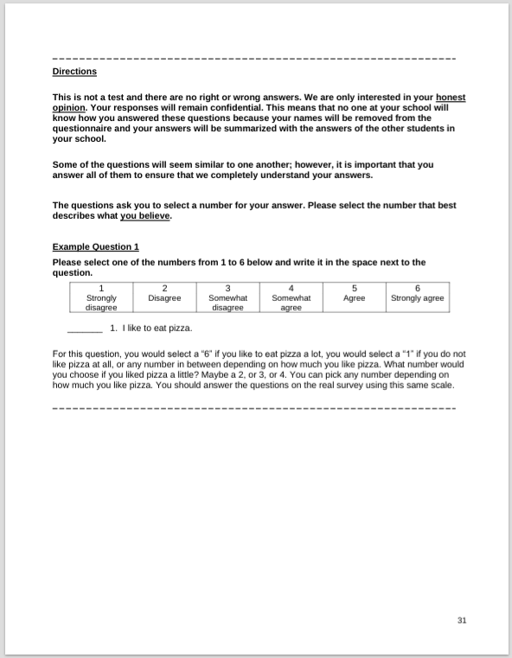

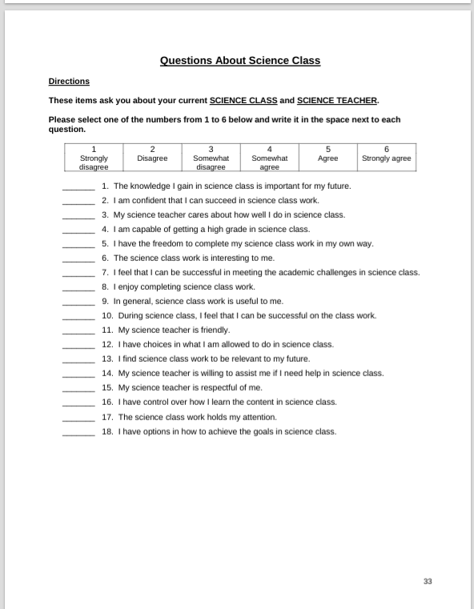

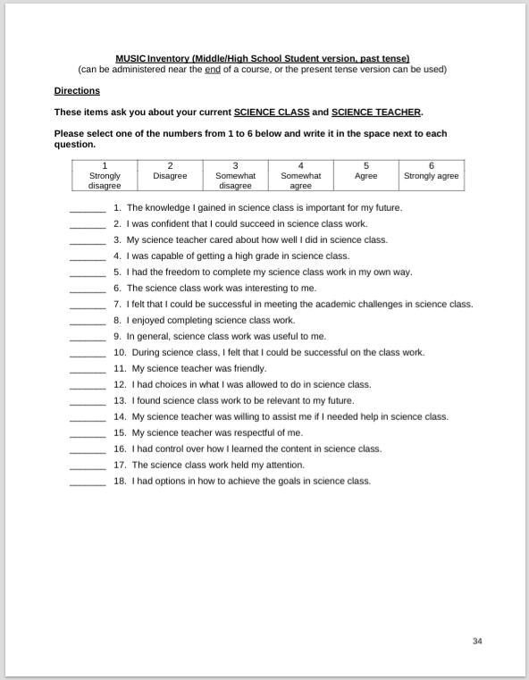

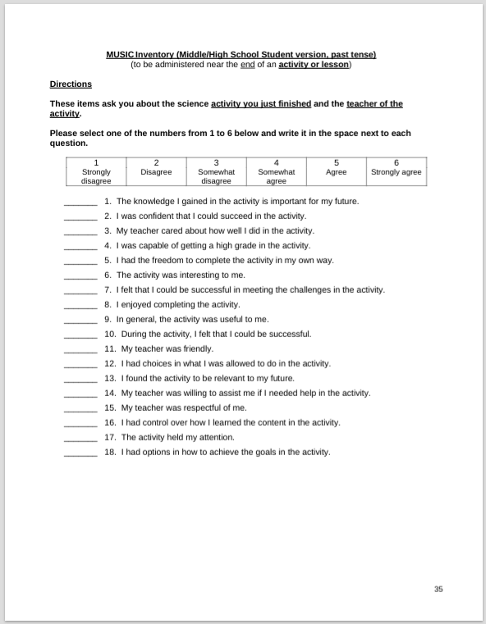

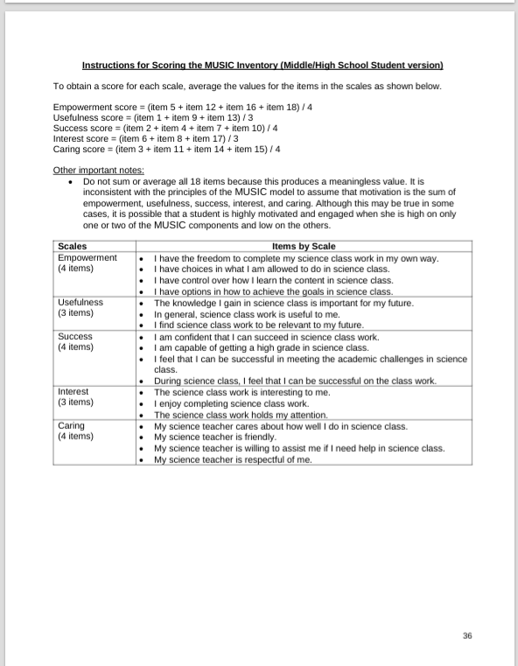
Appendix 2 – MUSIC Model Inventory adapted for use for this study
Questions About Singing Lessons
Directions
These items ask you about your current singing lessons and singing teacher.
Please select one of the numbers from 1 to 6 below and write it in the space next to each question.
1  Strongly disagree | 2  Disagree | 3  Somewhat disagree | 4  Somewhat agree | 5  Agree | 6  Strongly agree
_______ 1. The knowledge I gain in my singing lessons is important for my future.
_______ 2. I am confident that I can succeed in my singing lessons.
_______ 3. My singing teacher cares about how well I do in singing lessons.
_______ 4. I am capable of achieving in my singing lessons.
_______ 5. I have the freedom to learn to sing in my own way in my singing lessons.
_______ 6. The singing lessons are interesting to me.
_______ 7. I feel that I can be successful in meeting challenges in singing lessons.
_______ 8. I enjoy completing my singing lessons.
_______ 9. In general, singing lessons are useful to me.
_______ 10. During my singing lessons, I feel that I can be successful in my learning.
_______ 11. My singing teacher is friendly.
_______ 12. I have choices in what I am allowed to do in singing lessons.
_______ 13. I find what I learn in singing lessons to be relevant to my future.
_______ 14. My singing teacher is willing to assist me if I need help in my singing lessons.
_______ 15. My singing teacher is respectful of me.
_______ 16. I have control over how I learn the content in singing lessons.
_______ 17. The singing lesson work holds my attention.
_______ 18. I have options in how to achieve my goals in singing lessons.
Open ended/focus group questions
Empowerment
1. What could be changed in this course to make you feel you had more choices in the course?
(Jones et al., 2012, although the original question used the word “control” instead of “choices”)
Like choose our songs that we like want to go through... through the next couple of weeks.
Yeah? Like choose songs that you already had before or new songs?
Songs that we already knew.
A wider variety of songs because they’re both quite... they’re not similar, but they’re both quite similar styles.
2. What choices did you have during the course (or activity)?
The choice was between the two songs.
3. Which aspects of this course give you control over this course? (Jones et al., 2012)
When you kind of like left us to do our own staging and characterisation in our own way, and we got to practice by ourselves.
It feels like we got to choose if we performed in a group or individually or like if we like restarted or if we kind of just left it as it was and what song we did.
Usefulness
1. What could be changed in this course to make it more useful to you? (Jones et al., 2012)
2. What do you find useful about this course (or activity)?
Working in groups. Helping each other to get better.
I was gonna say about the groups, we could like give each other like help and like corrections like or what our like faces or like how we sounded when we were doing the song.
Success
1. What could be changed in this course to help you feel you could be more successful in it?
(Jones et al., 2012)
I think because we had time to practice it, I felt like um we were successful because we had a lot of time to practice it.
2. What makes you feel successful in this course?
3. What makes you feel as though you cannot be successful in this course?
The part with the belting, I felt like something was wrong with my voice.
I just think that um because it was such a short amount of time it was harder to get like a grip of the characters. I think it was also good that it was a short amount of time because I think I learnt like the song quicker than I normally would like melodically and stuff.
Interest
1. What could be changed in this course to make it more interesting and enjoyable? (Jones et al., 2012)
I think it was um like the song choices. Maybe like um having contrasting characters as well. Like maybe one of the characters could have been a villain and one could have been like a lead or like do you see what I mean? It’s good to have a variety of characters to choose from.
2. What do you like about this course?
Um I think I find it interesting like it was like songs I hadn’t really seen before. So I was able to like have a different like kind of choice like what I would normally like to sing.
3. What do you find interesting about this course?
I think it is interesting just how like I know we had a lot of time to rehearse but how quick it was until you got like reached because we did a performance at the end of each like session how quickly like you had to like make something which I thought was like fun and challenging.
Because we performed at the end of last week and the end of this week you just see the progress that we’ve made like ourselves whether it’s like little or big development.
4. Which parts of this course are boring?
Caring
1. What could be changed in this course to make you feel that the instructor or other students care about whether you learn the course content and care about you as a person?
Like maybe like after if they could have corrections from like each other like on what to do.
Building on [name]’s like, people from... people who did the same song as you. Like if they could give you how to like, improve your song. That’ll be quite helpful.
Maybe just if there’s like, like a more like definitive, like I don’t know, like end goal or objective to maybe like each session because then like, I feel like for me and maybe like the people around like, it’s just, you have something to like, like something clear to like aim for.
2. What could be changed in this course to make you feel that the instructor cares about whether you learn the course content and do well in the course? (Jones et al., 2012)
Maybe we should have had feedback from students and what they, yeah, thought could be improved and then what they liked.
3. What does the instructor do to provide you with the impression that she cares about whether you learn the course content and do well in the course? (Jones et al., 2012)
It was supportive when we performed because people would like clap and show that they were actively listening to it.
Um like every like once in a while you like came and like watched us and like asked us how we were doing, like, with the piece like, how we were like, improving or what we needed help with.
4. What does the instructor do to provide you with the impression that she cares about you as a person? (Jones et al., 2012)
I think it’s like asking the questions because you’re like, asking us what we would like to do better. And like what we think could be like improved so you’re like wanting our opinion on like what we could do better.
And um when we were practicing performing, you came round to see how we were doing and checked up on us, seeing how much time we needed.
Effort
1. Two questions: How much effort do you put into this course? Why do you put this amount of
effort into this course? (Jones, Byrnes, & Jones, 2019)
Like 100 percent because like, we didn’t have a lot of time to learn the songs.
I think because last week I didn’t like perform it so I wanted to like do it good this week.
And what changed from last week to this week do you think?
Well I feel like this week as a bit more focused on learning the song and I like tried to do it like good.

Appendix 3 – Blank Copy of Participant Consent Form
Consent to take part in research
I……………………………………… voluntarily agree to participate in this research study.
I understand that even if I agree to participate now, I can withdraw at any time.
I understand that I can refuse to answer any question involved during the research process without any consequences of any kind.
I have had the purpose and nature of the study explained to me in writing and I have had the opportunity to ask questions about the study.
I understand that participation involves two questionnaires, participation in singing classes and can include interviews at the participant and researcher’s discretion.
I understand that I will not benefit directly from participating in this research.
I understand that all information I provide for this study will be treated confidentially.
I understand that in any report on the results of this research my identity will remain anonymous.
I understand that this will be done by changing my name and disguising any details of my given answers which may reveal my identity or the identity of people I speak about.
I understand that if I inform the researcher that myself or someone else is at risk of harm they may have to report this to the relevant authorities - they will discuss this with me first but may be required to report with or without my permission.
I understand that signed consent forms and will be retained in a folder on the researcher's personal device, which is password protected until the end of 2025.
I understand that the answers from my questionnaires in which all identifying information has been removed will be retained for two years from April 2025.
I understand that under freedom of information legalisation I am entitled to access the information I have provided at any time while it is in storage as specified above.
I understand that I am free to contact any of the people involved in the research to seek further clarification and information.
Researcher: Ellen Cleary (ellenccleary@gmail.com)
Supervisor: David Cane (david@voicestudycentre.com)
Signature of research participant

Signature of research participant parent/guardian

Signature of participant
Date 10.05.25
Signature of researcher
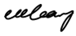
I believe the participant is giving informed consent to participate in this study
Signature of researcher Date

Appendix 4 – Lesson plan for research workshops
EMpowerment
Key concept: student autonomy
- Choice of song: between History of Wrong Guys and Anything Goes
- Choice of partner in breathing warm up
- Work on song until a point they feel ready to perform
- Set rules for working with rationale – we respect other people when they are performing because it helps to improve the confidence of other people which in turn helps us to develop as a collective
- Ask students what rules there should be

Usefulness
Key concept: students understand why the content is useful
- Explain one is a character song and one a standard classic acting song and how this can help to set them up for their career (or LAMDA success)
- Examples of performers who have sang the song and what they have gone on to do – play example
- Opportunity to perform and gain feedback

Success
Key concept: students can succeed if they gain the required skills/knowledge
- When setting task, make expectation clear: learn the song so it can be performed at the end of the class, words don’t need to be learnt but acting and emotion in the song is expected
- Level of challenge: break song down into small chunks. Challenge students by giving feedback as they rehearse
- Students perform and receive feedback from others as well as me
- Offer insight and help. Allow them to start again if they think they could do it better

Interest
Key concept: content is interesting
- Work together to receive feedback to include social interaction. Physical warm up. Discussion about content
- Relate songs to prior knowledge
- Present with enthusiasm
- Be open and allow time at the end for questions
Caring
Key concept: the instructor shows the students that they care about their achievement and learning
- When watching students perform ask them if there is anything that would help them
- Ask and value students ideas and opinions
- Insider research – show interest in their lives outside of the lesson
- Work in pairs and use their personal interests and experiences to inform their performance

Appendix 5 – Lesson Structure for workshops based on Krepf and Konig (2022)
Introduction | - Ask students what rules there should be (M)  - Set rules for working with rationale – we respect other people when they are performing because it helps to improve the confidence of other people which in turn helps us to develop as a collective (S)  - Physical warm up (I)  - When setting task, make expectation clear: learn the song so it can be performed at the end of the class, words don’t need to be learnt but acting and emotion in the song is expected (M)  - Choice of partner in breathing warm up (M)  - Discussion about content (I)  - Explain one is a character song and one a standard classic acting song and how this can help to set them up for their career (or LAMDA success) (U)  - Examples of performers who have sang the song and what they have gone on to do – play example (U)  - Choice of song: between History of Wrong Guys and Anything Goes (M)
Working on the topic | - Work on song until a point they feel ready to perform (M)  - Work in pairs and use their personal interests and experiences to inform their performance (C)  - Work together to receive feedback to include social interaction (I)  - When watching students perform ask them if there is anything that would help them (C)  - Ask for and value students ideas and opinions (C)
Checking results and providing feedback | - Level of challenge: break song down into small chunks. Challenge students by giving feedback as they rehearse (S)  - Opportunity to perform and gain feedback (U)  - Students perform and receive feedback from others as well as me (S)  - Offer insight and help. Allow them to start again if they think they could do it better (S)
Application/transfer | - Relate songs to prior knowledge (I)  - Be open and allow time at the end for questions (I)

Appendix 6 – Ethics form
APPLICATION FOR ETHICAL APPROVAL

RESEARCH STUDENTS
This form is to be completed by the student within SIX months for full-time students and TWELVE months for part time students, after the commencement of the research degree or following progression to Part Two of your course.

Once complete, submit this form via the MyTSD Doctoral College Portal at (https://mytsd.uwtsd.ac.uk).

This document is also available in Welsh.

RESEARCH STAFF ONLY
All communications relating to this application during its processing must be in writing and emailed to pgresearch@uwtsd.ac.uk , with the title ‘Ethical Approval’ followed by your name.

STUDENTS ON UNDERGRADUATE OR TAUGHT MASTERS PROGRAMMES should submit this form (and receive the outcome) via systems explained to you by the supervisor/module leader.

In order for research to result in benefit and minimise risk of harm, it must be conducted ethically. A researcher may not be covered by the University’s insurance if ethical approval has not been obtained prior to commencement.

The University follows the OECD Frascati manual definition of research activity: “creative work undertaken on a systematic basis in order to increase the stock of knowledge, including knowledge of man, culture and society, and the use of this stock of knowledge to devise new applications”. As such this covers activities undertaken by members of staff, postgraduate research students, and both taught postgraduate and undergraduate students working on dissertations/projects.

The individual undertaking the research activity is known as the “principal researcher”.

Ethical approval is not required for routine audits, performance reviews, quality assurance studies, testing within normal educational requirements, and literary or artistic criticism.

Please read the notes for guidance before completing ALL sections of the form.

This form must be completed and approved prior to undertaking any research activity. Please see Checklist for details of process for different categories of application.

SECTION A: About You (Principal Researcher)
1 | Full Name: |  | Ellen Cleary
2 | Tick all boxes that apply: |  | Member of staff: | ☐ | Honorary research fellow: | ☐
 | Undergraduate Student | ☐ | Taught Postgraduate Student | ☒ | Postgraduate Research Student | ☐

3 | Institute/Academic Discipline/Centre: | UWTSD/Voice Study Centre
4 | Campus: | Carmarthen
5 | E-mail address: | ellenccleary@gmail.com
6 | Contact Telephone Number: | 07508804453
 | For students:
7 | Student Number: | 2222963
8 | Programme of Study: | MA Professional Practice (Voice Pedagogy)
9 | Director of Studies/Supervisor: | Louise Emanuel/Julie Crossman/Debbie Winter

SECTION B: Approval for Research Activity
1 | Has the research activity received approval in principle?  (please check the Guidance Notes as to the appropriate approval process for different levels of research by different categories of individual) |  | YES | ☒ | NO | ☐
 |  |  |  |  | Date
2 | If Yes, please indicate source of approval (and date where known): Approval in principle must be obtained from the relevant source prior to seeking ethical approval | Research Degrees Committee |  | ☐
2 |  | Institute Research Committee |  | ☐
2 |  | Other (write in)  WAPPAR Ethics Board Representative |  | ☒

SECTION C: Internal and External Ethical Guidance Materials
 | Please list the core ethical guidance documents that have been referred to during the completion of this form (including any discipline-specific codes of research ethics, location-specific codes of research ethics, and also any specific ethical guidance relating to the proposed methodology). Please tick to confirm that your research proposal adheres to these codes and guidelines. You may add rows to this table if needed.
1 | UWTSD Research Ethics & Integrity Code of Practice | ☒
2 | UWTSD Research Data Management Policy | ☒
3 | [List any other relevant documents here] | ☐

SECTION D: External Collaborative Research Activity
If there are external collaborators then you should gain consent from the contact persons to share their personal data with the university. If there are no external collaborators then leave this section blank and continue to section E.
1 | Institution
2 | Contact person name
3 | Contact person e-mail address
4 | Is your research externally funded? |  | YES | ☐ | NO | ☐
5 | Are you in receipt of a KESS scholarship? |  | YES | ☐ | NO | ☐
6 | Are you specifically employed to undertake this research in either a paid or voluntary capacity? | Voluntary | YES | ☐ | NO | ☐
7 |  | Employed | YES | ☐ | NO | ☐
8 | Is the research being undertaken within an existing UWTSD Athrofa Professional Learning Partnership (APLP)? | If YES then the permission question below does not need to be answered. | YES | ☐ | NO | ☐
9 | Has permission to undertake the research has been provided by the partner organisation? | (If YES attach copy)  If NO the application cannot continue | YES | ☐ | NO | ☐

Where research activity is carried out in collaboration with an external organisation
10 | Does this organisation have its own ethics approval system? | YES | ☐ | NO | ☐
 | If Yes, please attach a copy of any final approval (or interim approval) from the organisation (this may be a copy of an email if appropriate).

SECTION E: Details of Research Activity
1 | Indicative title: | Theories of motivation in improving confidence in adolescent singers
2 | Proposed start date: | 06/01/25 | Proposed end date: | 22/08/25
Introduction to the Research (maximum 300 words per section)
Ensure that you write for a Non-Specialist Audience when outlining your response to the points below:
- Purpose of Research Activity
- Proposed Research Question
- Aims of Research Activity
- Objectives of Research Activity
Demonstrate, briefly, how Existing Research has informed the proposed activity and explain
- What the research activity will add to the body of knowledge
- How it addresses an area of importance.
3 | Purpose of Research Activity  The purpose of this research activity is to investigate methods for improving confidence and self-efficacy in adolescent singing students and how this relates to existing theories of motivation for learning. My previous research has led to finding research on motivation theory in music teaching and how this can improve learning and self-efficacy in students, however my research will hope to fill a gap in this research by considering voice and singing teaching specifically. There is also little to be found on adolescents and the issues that this age group face.  (this box should expand as you type)
4 | Research Question  To what extent can motivation theories and teaching methods improve the confidence of adolescent singers?  (this box should expand as you type)
5 | Aims of Research Activity  The aims of this research activity are to investigate methods and motivation theories and their relationship to the confidence and self-efficacy of adolescent singing students, reviewing and critically evaluating the current literature on music education and improving my understanding of issues surrounding confidence to improve my professional practice.  (this box should expand as you type)
6 | Objectives of Research Activity  The objectives of this research activity are to broaden my understanding of motivational theories, learning strategies and methods and their relationship to adolescent confidence in singing by reviewing the most recent and up-to-date literature available. Additionally, it will be my objective to comprehensively compile the most effective methods to build confidence in adolescent singing students by using the literature to develop new plans and strategies for music education.  (this box should expand as you type)
Proposed methods (maximum 600 words)
Provide a brief summary of all the methods that may be used in the research activity, making it clear what specific techniques may be used. If methods other than those listed in this section are deemed appropriate later, additional ethical approval for those methods will be needed. You do not need to justify the methods here, but should instead describe how you intend to collect the data necessary for you to complete your project.
7 | This research will be conducted with qualitative or mixed methods research.  Questionnaires where participants answer structured questions designed to answer the research question.  Semi-structured interviews where participants are asked questions and these responses may be audio or video recorded with their consent.  Focus groups where participant responses may be video or audio recorded to transcribe, code and analyse the data collected.  Observations of the participants with their knowledge where notes are collected by myself only with the participants knowledge and observation notes will be recorded by myself only.  Triangulation/grounded theory to code common findings and themes.  Narrative literature review to synthesise the recorded findings.  (this box should expand as you type)
Location of research activity
Identify all locations where research activity will take place.
8 | Research will take place in school settings in the UK, in either one-to-one or group lessons where these normally take place.  (this box should expand as you type)
Research activity outside of the UK
If research activity will take place overseas, you are responsible for ensuring that local ethical considerations are complied with and that the relevant permissions are sought. Specify any local guidelines (e.g. from local professional associations/learned societies/universities) that exist and whether these involve any ethical stipulations beyond those usual in the UK (provide details of any licenses or permissions required). Also specify whether there are any specific ethical issues raised by the local context in which the research activity is taking place, for example, particular cultural and/or legal sensitivities or vulnerabilities of participants. If you live in the country where you will do the research then please state this.
9 | (this box should expand as you type)

10 | Use of documentation not in the public domain: Are any documents NOT publicly available? | NO | ☒
10 |  | YES | ☐
11 | If Yes, please provide details here of how you will gain access to specific documentation that is not in the public domain and that this is in accordance with the current data protection law of the country in question and that of England and Wales.  (this box should expand as you type)

 | Does your research relate to one or more of the seven aims of the Well-being of Future Generations (Wales) Act 2015? | YES | NO
12 | A prosperous Wales | ☐ | ☒
13 | A resilient Wales | ☐ | ☒
14 | A healthier Wales | ☐ | ☒
15 | A more equal Wales | ☐ | ☒
16 | A Wales of cohesive communities | ☐ | ☒
17 | A Wales of vibrant culture and thriving Welsh language | ☐ | ☒
18 | A globally responsible Wales | ☐ | ☒
19 | If YES to any of the above, please give details:
 | (this box should expand as you type)

SECTION F: Scope of Research Activity
 | Will the research activity include: | YES | NO
1 | Use of a questionnaire or similar research instrument? | ☒ | ☐
2 | Use of interviews? | ☒ | ☐
3 | Use of focus groups? | ☒ | ☐
4 | Use of participant diaries? | ☐ | ☒
5 | Use of video or audio recording? | ☒ | ☐
6 | Use of computer-generated log files? | ☐ | ☒
7 | Participant observation with their knowledge? | ☒ | ☐
8 | Participant observation without their knowledge? | ☐ | ☒
9 | Access to personal or confidential information without the participants’ specific consent? | ☐ | ☒
10 | Administration of any questions, test stimuli, presentation that may be experienced as physically, mentally or emotionally harmful / offensive? | ☐ | ☒
11 | Performance of any acts which may cause embarrassment or affect self-esteem? | ☐ | ☒
12 | Investigation of participants involved in illegal activities? | ☐ | ☒
13 | Use of procedures that involve deception? | ☐ | ☒
14 | Administration of any substance, agent or placebo? | ☐ | ☒
15 | Working with live vertebrate animals? | ☐ | ☒
16 | Procedures that may have a negative impact on the environment? | ☐ | ☒
17 | Other primary data collection methods. Please indicate the type of data collection method(s) below. | ☐ | ☐
 | Details of any other primary data collection method:  (this box should expand as you type) | ☐ | ☐
If NO to every question, then the research activity is (ethically) low risk and may be exempt from some of the following sections (please refer to Guidance Notes).

If YES to any question, then no research activity should be undertaken until full ethical approval has been obtained.

SECTION G: Intended Participants
If there are no participants then do not complete this section, but go directly to section H.

 | Who are the intended participants: | YES | NO
1 | Students or staff at the University? | ☐ | ☒
2 | Adults (over the age of 18 and competent to give consent)? | ☒ | ☐
3 | Vulnerable adults? | ☐ | ☒
4 | Children and Young People under the age of 18? (Consent from Parent, Carer or Guardian will be required) | ☒ | ☐
5 | Prisoners? | ☐ | ☒
6 | Young offenders? | ☐ | ☒
7 | Those who could be considered to have a particularly dependent relationship with the investigator or a gatekeeper? | ☐ | ☒
8 | People engaged in illegal activities? | ☐ | ☒
9 | Others. Please indicate the participants below, and specifically any group who may be unable to give consent. | ☐ | ☐
 | Details of any other participant groups:  (this box should expand as you type) | ☐ | ☐

Participant numbers and source
Provide an estimate of the expected number of participants. How will you identify participants and how will they be recruited?
10 | How many participants are expected? | Between 2 and 15 students.  (this box should expand as you type)
11 | Who will the participants be? | Adolescent singing students of mine between the ages of 12-20.  (this box should expand as you type)
12 | How will you identify the participants? | They will be adolescent voice students who are taught by me between the ages outlined above. I will use purposive sampling to recruit the students who are in this demographic and they will require parental consent to participate.  (this box should expand as you type)

 | Information for participants: | YES | NO | N/A
13 | Will you describe the main research procedures to participants in advance, so that they are informed about what to expect? | ☒ | ☐ | ☐
14 | Will you tell participants that their participation is voluntary? | ☒ | ☐ | ☐
15 | Will you obtain written consent for participation? | ☒ | ☐ | ☐
16 | Will you explain to participants that refusal to participate in the research will not affect their treatment or education (if relevant)? | ☒ | ☐ | ☐
17 | If the research is observational, will you ask participants for their consent to being observed? | ☒ | ☐ | ☐
18 | Will you tell participants that they may withdraw from the research at any time and for any reason? | ☒ | ☐ | ☐
19 | With questionnaires, will you give participants the option of omitting questions they do not want to answer? | ☒ | ☐ | ☐
20 | Will you tell participants that their data will be treated with full confidentiality and that, if published, it will not be identifiable as theirs? | ☒ | ☐ | ☐
21 | Will you debrief participants at the end of their participation, in a way appropriate to the type of research undertaken? | ☒ | ☐ | ☐
22 | If NO to any of above questions, please give an explanation
 | (this box should expand as you type)

 | Information for participants: | YES | NO | N/A
24 | Will participants be paid? | ☐ | ☒ | ☐
25 | Is specialist electrical or other equipment to be used with participants? | ☒ | ☐ | ☐
26 | Are there any financial or other interests to the investigator or University arising from this study? | ☐ | ☒ | ☐
27 | Will the research activity involve deliberately misleading participants in any way, or the partial or full concealment of the specific study aims? | ☐ | ☒ | ☐
28 | If YES to any question, please provide full details
I will use a voice recorder on my personal device to record interviews. This will be conducted ethically and with consent of the participants/parents with information being stored only for the purpose of the research with personal identifiers being omitted in the report.

(this box should expand as you type)

SECTION H: Anticipated Risks

Outline any anticipated risks that may adversely affect any of the participants, the researchers and/or the University, and the steps that will be taken to address them.

If you have completed a full risk assessment (for example as required by a laboratory, or external research collaborator) you may append that to this form.
1 | Full risk assessment completed and appended? |  | Yes | ☐
1 |  |  | No | ☒
2 | Risks to participants  For example: sector-specific health & safety, emotional distress, financial disclosure, physical harm, transfer of personal data, sensitive organisational information
 | Risk to participants:  As these will be my students there is a risk of damaging the teacher/student relationship. There is also the risk of affecting their personal relationships as they may speak about themselves in a focus group making themselves vulnerable to the opinions of their peers.  (this box should expand as you type) | How you will mitigate the risk to participants:  I will make it clear to the participants that their contribution to the study is voluntary and that they can withdraw at any time. I will also make it clear that they will be anonymised, and their personal information will not be shared or kept for a long period of time.  (this box should expand as you type)
3 | If research activity may include sensitive, embarrassing or upsetting topics (e.g. sexual activity, drug use) or issues likely to disclose information requiring further action (e.g. criminal activity), give details of the procedures to deal with these issues, including any support/advice (e.g. helpline numbers) to be offered to participants. Note that where applicable, consent procedures should make it clear that if something potentially or actually illegal is discovered in the course of a project, it may need to be disclosed to the proper authorities
N/A

(this box should expand as you type)
4 | Risks to the investigator  For example: personal health & safety, physical harm, emotional distress, risk of accusation of harm/impropriety, conflict of interest
 | Risk to the investigator:  The study could alter my relationship with my students, resulting in a loss of students and therefore work. There is also a safeguarding risk as I am working with a vulnerable population (children).  (this box should expand as you type) | How you will mitigate the risk to the investigator:  I will ensure that I have parental consent before working with any children, that communication is clear between myself and the participants and that parents are able to see my DBS should they wish to. I will follow safeguarding procedures of the organisation I am working for, reporting any issues to the Designated Safeguarding Lead.  (this box should expand as you type)
5 | University/institutional risks  For example: adverse publicity, financial loss, data protection
 | Risk to the University:  There is a risk that I could bring the university into disrepute. Personal data could also be breached.  (this box should expand as you type) | How you will mitigate the risk to the University:  I will be working as an independent researcher from the university and this will be clear in my writing. Personal data will be stored safely in a password protected folder on my personal device and deleted after the research. My device will not be left unlocked or unattended.  (this box should expand as you type)
6 | Environmental risks  For example: accidental spillage of pollutants, damage to local ecosystems
 | Risk to the environment:  N/A  (this box should expand as you type) | How you will mitigate the risk to environment:  N/A  (this box should expand as you type)

 | Disclosure and Barring Service
 | If the research activity involves children or vulnerable adults, a Disclosure and Barring Service (DBS) certificate must be obtained before any contact with such participants. | YES | NO | N/A
7 | Does your research require you to hold a current DBS Certificate? | ☒ | ☐ | ☐
8 | If YES, please give the certificate number. If the certificate number is not available please write “Pending”; in this case any ethical approval will be subject to providing the appropriate certificate number. | 001899023093

SECTION I: Feedback, Consent and Confidentiality

1 | Feedback  What de-briefing and feedback will be provided to participants, how will this be done and when?
I will provide my email address so that participants or their guardians (if underage) can contact me if they should wish to read the report.
(this box should expand as you type)
2 | Informed consent  Describe the arrangements to inform potential participants, before providing consent, of what is involved in participating. Describe the arrangements for participants to provide full consent before data collection begins. If gaining consent in this way is inappropriate, explain how consent will be obtained and recorded in accordance with prevailing data protection legislation.
Participants will be informed verbally and in writing what will occur during the research and will be informed that their consent is optional and that it can be withdrawn at any time. All participants will be provided with a consent form, and participants under the age of 18 will be given a parental consent form that will have to be returned to me before research begins.

(this box should expand as you type)
3 | Confidentiality / Anonymity  Set out how anonymity of participants and confidentiality will be ensured in any outputs. If anonymity is not being offered, explain why this is the case.
Participants will be informed that they will be anonymised in the report, and this will be achieved by replacing participant names with pseudonyms that will be maintained throughout the report.

(this box should expand as you type)

SECTION J: Data Protection and Storage

 | Does the research activity involve personal data (as defined by the General Data Protection Regulation 2016 “GDPR” and the Data Protection Act 2018 “DPA”)? | YES | NO
1 | “Personal data” means any information relating to an identified or identifiable natural person (‘data subject’). An identifiable natural person is one who can be identified, directly or indirectly, in particular by reference to an identifier such as a name, an identification number, location data, an online identifier or to one or more factors specific to the physical, physiological, genetic, mental, economic, cultural or social identity of that natural person. Any video or audio recordings of participants is considered to be personal data. | ☒ | ☐
 | If YES, provide a description of the data and explain why this data needs to be collected:
2 | The participants details will be recorded on consent forms which need to be provided for the research to be ethical. The research will also involve the recording of responses either via audio recording or in writing so that these can be used in the research report.  (this box should expand as you type)
 | Does it involve special category data (as defined by the GDPR)? | YES | NO
3 | “Special category data” means sensitive personal data consisting of information as to the data subjects’ –  (a) racial or ethnic origin,  (b) political opinions,  (c ) religious beliefs or other beliefs of a similar nature,  (d) membership of a trade union (within the meaning of the Trade Union and Labour Relations (Consolidation) Act 1992),  (e) physical or mental health or condition,  (f) sexual life,  (g) genetics,  (h) biometric data (as used for ID purposes), | ☐ | ☒
 | If YES, provide a description of the special category data and explain why this data needs to be collected:
4 | (this box should expand as you type)

 | Will data from the research activity (collected data, drafts of the thesis, or materials for publication) be stored in any of the following ways? | YES | NO
5 | Manual files (i.e. in paper form)? | ☒ | ☐
6 | University computers? | ☐ | ☒
7 | Private company computers? | ☐ | ☒
8 | Home or other personal computers? | ☐ | ☒
9 | Laptop computers/ CDs/ Portable disk-drives/ memory sticks? | ☒ | ☐
10 | “Cloud” storage or websites? | ☒ | ☐
11 | Other – specify: | ☐ | ☒
12 | For all stored data, explain the measures in place to ensure the security of the data collected, data confidentiality, including details of backup procedures, password protection, encryption, anonymisation and pseudonymisation:
All data will be kept in password protected cloud storage on my personal laptop which will not be shared. Audio/visual data will be transcribed and would be shown to participants to
check accuracy of reporting. My device and any cloud storage used to store or transfer data will be password protected. All participants will be given a unique identifier to ensure confidentiality and this list will be kept securely in the password protected folder.

(this box should expand as you type)

 | Data Protection
 | Will the research activity involve any of the following activities: | YES | NO
13 | Electronic transfer of data in any form? | ☒ | ☐
14 | Sharing of data with others at the University outside of the immediate research team? | ☐ | ☒
15 | Sharing of data with other organisations? | ☐ | ☒
16 | Export of data outside the UK or importing of data from outside the UK? | ☐ | ☒
17 | Use of personal addresses, postcodes, faxes, emails or telephone numbers? | ☒ | ☐
18 | Publication of data that might allow identification of individuals? | ☐ | ☒
19 | Use of data management system? | ☐ | ☒
20 | Data archiving? | ☐ | ☒
21 | If YES to any question, please provide full details, explaining how this will be conducted in accordance with the GDPR and Data Protection Act (2018) (and any international equivalents, where appropriate):
All data will be encrypted and kept in password protected cloud storage on my personal laptop which will not be shared. Any device or cloud storage used to store or transfer data will be password protected. All data transfers will be encrypted, and password protected. All participants will be given a unique identifier to ensure confidentiality and this list will be kept securely in the password protected folder. The data will be stored until the completion of the project and then deleted. In accordance with the DPA2018, participants will have the right to ask to see what data is held relating to them, and this data will be deleted immediately if the participant requests this, in which case the data will not be used in the project.

(this box should expand as you type)
22 | List all who will have access to the data generated by the research activity:
The principal researcher.

(this box should expand as you type)
23 | List who will have control of, and act as custodian(s) for, data generated by the research activity:
The principal researcher.

(this box should expand as you type)
24 | Give details of data storage arrangements, including security measures in place to protect the data, where data will be stored, how long for, and in what form. Will data be archived – if so how and if not why not.
All data will be encrypted and kept in password protected cloud storage on my personal laptop which will not be shared. Any device or cloud storage used to store or transfer data will be password protected and will be reformatted at the end of the project in order to destroy the data. The data will be stored until the completion of the project and then deleted.

(this box should expand as you type)
25 | Please indicate if your data will be stored in the UWTSD Research Data Repository (see https://researchdata.uwtsd.ac.uk/ ). If so please explain. (Most relevant to academic staff)
N/A.

(this box should expand as you type)
26 | Confirm that you have read the UWTSD guidance on data management (see https://www.uwtsd.ac.uk/library/research-data-management/) | YES | ☒
27 | Confirm that you are aware that you need to keep all data until after your research has completed or the end of your funding | YES | ☒

SECTION K: Declaration
The information which I have provided is correct and complete to the best of my knowledge. I have attempted to identify any risks and issues related to the research activity and acknowledge my obligations and the rights of the participants.

In submitting this application I hereby confirm that I undertake to ensure that the above named research activity will meet the University’s Research Ethics and Integrity Code of Practice which is published on the website: https://www.uwtsd.ac.uk/research/research-ethics/
1 | Signature of applicant: |  | Date:  5/11/24

For STUDENT Submissions:
2 | Director of Studies/Supervisor: | Laura James | Date:  31.01.2025
3 | Signature: | Laura James | Date:  31.01.2025

For STAFF Submissions:
4 | Academic Director/ Assistant Dean: |  | Date:
5 | Signature: |  | Date:

Checklist: Please complete the checklist below to ensure that you have completed the form according to the guidelines and attached any required documentation:
☒ | I have read the guidance notes supplied before completing the form.
☒ | I have completed ALL RELEVANT sections of the form in full.
☒ | I confirm that the research activity has received approval in principle
☐ | I have attached a copy of final/interim approval from external organisation (where appropriate)
☐ | I have attached a full risk assessment (where appropriate) ONLY TICK IF YOU HAVE ATTACHED A FULL RISK ASSESSMENT
☒ | I understand that it is my responsibility to ensure that the above named research activity will meet the University’s Research Ethics and Integrity Code of Practice.
☒ | I understand that before commencing data collection all documents aimed at respondents (including information sheets, consent forms, questionnaires, interview schedules etc.) must be confirmed by the DoS/Supervisor, module tutor or Academic Director.

RESEARCH STUDENTS ONLY
Once complete, submit this form via the MyTSD Doctoral College Portal at (https://mytsd.uwtsd.ac.uk).

RESEARCH STAFF ONLY
All communications relating to this application during its processing must be in writing and emailed to pgresearch@uwtsd.ac.uk , with the title ‘Ethical Approval’ followed by your name.

STUDENTS ON UNDERGRADUATE OR TAUGHT MASTERS PROGRAMMES should submit this form (and receive the outcome) via systems explained to you by the supervisor/module leader.

Appendix 7 – letter of approval to carry out research at work


