Student Name: Samadi Husseine Tawfiq
Student ID: 2212531
Module name: Hotel Placement Research Project
Module code: BMIH6008
Project supervisor: Ben Ka po Chong
Date:11.06.25.

Hotel Placement Project – The Role of Technology in Modernizing Hotel Operations: A Case Study of Belvilla Crewe City Centre Hotel.

Acknowledgement
I am very grateful to the management and staff of Belvilla Crewe City Centre Hotel for their assistance and support throughout my training which was very useful for this research. I am also very grateful to my academic supervisor for supporting me with their advice and motivation through my project. A big thank you goes to my family and friends for always being with me and keeping me motivated. All these people made this research possible.
Declaration
I confirm that I have not used this research in any other academic context and it is my unique project called “Hotel Placement Project “The Role of Technology in Modernizing Hotel Operations: A Case Study of Belvilla Crewe City Centre Hotel.” The information sources I used here are well-cited and acknowledged. My academic programme required me to do this work and what I present represents how I understand and study the subject. AI acknowledgement: I confirm that no AI was used in my research.
Abstract
The study looks at how technology makes hotel operations better, told through the case study of Belvilla Crewe City Centre Hotel. The study focuses on how PMS, mobile apps, AI chatbots and smart room features play a role in making guests happy, improving work done by staff and streamlining daily operations. With the help of secondary information and an ethnographic overview, the study reveals that technology positively affects how fast services are delivered, the coordination of tasks and the experience of guests. Yet, it points out some challenges such as issues with connecting different systems, training workers and guests who continue to like the traditional style. The study uses TAM and Lewin’s Change Management Model to find out how staff and guests respond to the new technologies. The study offers helpful recommendations for boosting technology use in mid-sized hotels, as a result of its findings. The insights were created to help hotel managers, staff and those involved in the industry deal with regular digital changes.

Table of Contents
Chapter 1: Introduction 7
1.1 Background 7
1.2 Rationale for the Study 7
1.3 Aim of the Study 8
1.4 Research Objectives 8
1.5 Research Questions 8
Chapter 2: Literature Review 9
2.1 Introduction 9
2.2 Technology in Modern Hotel Operations 9
2.3 Enhancing Guest Experience and Staff Efficiency 10
2.4 Challenges and Post-Pandemic Trends 10
2.5 Theoretical Framework 11
2.6 Identified Research Gaps 12
2.7 Summary 12
Chapter 3: Research methodology 14
3.1 Introduction 14
3.2 Research Philosophy 14
3.3 Research Design 14
3.4 Methodological Choice 14
3.5 Data Collection 15
3.6 Data Analysis 15
3.7 Ethical Considerations 15
3.8 Summary 15
Chapter 4: Findings and Discussion 17
4.1 Introduction 17
4.2 Findings 17
Technological Tools in Daily Operations 17
Guest Experience and Satisfaction 18
Staff Interaction and Adaptation 19
Implementation Challenges 20
Post-Pandemic Digital Behaviour 21
Comparative Findings from Multiple Case Studies 22
4.3 Discussion 23
How the Findings Reflect the Focus of the Study 23
Interpreting Guest Satisfaction Trends 24
Staff Challenges and Organisational Change 25
Technological Limitations and Integration Issues 25
Post-Pandemic Implications and Guest Behaviour 26
Practical Implications for Belvilla Crewe City Centre Hotel 26
Limitations of the Study 27
4.4 Summary 27
Chapter 5: Conclusion and Recommendations 29
5.1 Conclusion 29
5.2 Recommendations 31
5.3 Practical Strategies 32
References 34

Chapter 1: Introduction

1.1 Background
Even though being customer-centered is key in the industry, technology helps make sure customers are offered reliable and excellent service. Equipped with Property Management System apps, cleaning apps, mobile booking services and AI, the staff at Belvilla Crewe City Centre Hotel can handle operations without issues. As a result, staff can answer what guests need quickly, stay error-free and work together (Voronova et al., 2020).
Commuters and tourists like things to be straightforward, fast and comfortable when they travel. A lot of hotel guests like remote cheque-in, having virtual room access and communicating with staff through messaging apps (Zahidi et al., 2024). By using modern technology, Belvilla offers what guests want which usually boosts both their experience and chances of returning.
At the same moment, there are a few issues that come with using technology. Such barriers are related to expenses for new systems, training people to use them, workers’ unwillingness to move forward, security of data and problems with technology once in a while (Saydam et al., 2022). Thanks to these solutions, Belvilla can rely on digital tools and organize its work well.

1.2 Rationale for the Study
The study is conducted since technology is making significant changes to the hospitality industry. With the increased use of digital technology, people in the hotel industry should focus on its effect on their daily work. Most studies on hotel technology look at larger, multinational companies rather than smaller or local hotels (Limna, 2023). Medium-sized hotels are not widely studied in research literature and this includes the Belvilla Crewe City Centre Hotel. It would help to collect more cases that demonstrate the use of technology in similar situations (Davronov, 2021).
Being placed in the hotel is very helpful in understanding this research. Most research groups focus on technology in concepts; we, however, watch personnel work and discuss their views (Ruel and Njoku, 2021). Nonetheless, the focus of this work is to develop suggestions for other hotels to improve their services and functions.
The findings can help hotel managers, front-desk staff, and suppliers of technology and hospitality students. They can recognise successful areas; problems that need addressing and how new technology can be applied in the future (Melnykova et al., 2020).

1.3 Aim of the Study
The research aims to investigate the impact of technology on hotel management at my placement hotel, with a focus on how it enhances guest experience, streamlines processes, and supports staff performance.

1.4 Research Objectives
- To conduct an extant literature review of technology currently used in hotel operations (e.g., property management systems, mobile apps, AI chatbots).
- To evaluate how these technologies affect service quality, booking and check-in processes, and overall guest satisfaction.
- To explore the benefits and challenges faced by hotel staff and management when adopting new technologies.
- To make recommendations for improving the use of technology in hotel operations.

1.5 Research Questions
- How does the use of modern technology improve operational efficiency and customer satisfaction in hotels?
- What are the key challenges and benefits of implementing technology in hotel operations, and how do they influence overall hotel performance?

Chapter 2: Literature Review

2.1 Introduction
Using technology has helped hotels change their systems and find new methods to deliver and control services. The use of digital solutions in hotels helps to enhance the guest experience, helps staff work better and smoothly operates hotel operations. The industry as a whole is moving toward technology, touchless solutions and information-led processes to both raise performance and increase customer enjoyment. Technology affects hotel management, especially regarding guest satisfaction, staff efficiency and improving how the hotel operates. It further looks at the wider impacts digital technologies have on the hospitality industry. Analysis of current findings points to several recurring details and some gaps, due to not enough focus being given to hotels of mid-range size and their employees. The findings from literature reviews support using a case study method in the main research which gives a clear and detailed look at technology in a hotel setting.

2.2 Technology in Modern Hotel Operations
Over the years, technology has been used both at the front desk and in the management of hotels by the hotel industry. Many hotels use systems like Property Management Systems (PMS), Revenue Management Systems (RMS) and Customer Relationship Management tools. As stated by Subiyantoro (2024), Using these systems, hotel companies can easily organise tasks such as accepting reservations, handling billing, and distributing rooms, following guests and managing marketing efforts (Dyshkantiuk et al., 2020). These systems contribute to lowering mistakes and making service happen faster.
Mobile apps are now an important part of how hotels run their work. Guests can use them to check in, open their doors, get room service and share input through their phones. According to Strauss (2020), many hotels now use AI to manage guest questions, handle bookings and provide quick assistance, especially after business hours.
Smart room technologies are also a major change. With voice lighting, smart TV sets tools for setting the temperature and connected room devices, visitors have greater control over their room experience (Leung, 2019). Because they are convenient and cozy, guests often seek out tech-enabled rooms with layover devices.
At first, it was the major hotel chains that started using these tools, but now small and mid-sized hotels are also using them to keep up and serve guests who use technology. As a result, hotel companies are blending technology and human staff in their service approach.

2.3 Enhancing Guest Experience and Staff Efficiency
Many credit technology with improving how guests feel while visiting a hotel. Mobile check-ins allow patients to avoid long lines at the front desk. As stated by M’hamed and Idrissi (2024), Suggestions made using CRM platforms let hotels adjust their services and offer for regular guests (Anwar et al., 2024). Concierge systems online assist guests with suggestions and let them request help instantly. They allow guests to have a more individualized experience.
From their point of view, technology streamlines jobs that take a lot of time. Keepers can update room status on their phones which the front desk receives instantly. According to Kant and Koti (2023), Maintenance issues that guests mention are automatically forwarded to the right staff member. Managing staff schedules and shifts becomes much easier with specialized HR and scheduling tools.
On the other hand, the change also introduces some fresh hurdles. Employees might have a hard time using new systems if they have not used digital tools before. As stated by Das (2023), People often struggle with change, are unsure about their skills and are scared of losing their jobs which keeps them from trying new tools (Das, 2023). With insufficient backing, the benefits from technology could be missed and this is frequently the case for hotels with restricted budgets and little training.

2.4 Challenges and Post-Pandemic Trends
There are some problems that come with using hotel technology. Comparatively high implementation costs may keep smaller businesses from adopting the technology. According to Anwar et al. (2024), Integration becomes an issue when hotels use a number of platforms that are not connected well. If systems are not well connected, this can cause inefficiencies and separate sets of data, instead of improving how the business operates (Subiyantoro, 2024).
Cybersecurity is becoming a bigger concern. Lots of private details are stored by hotels, including names and credit card data. Hotels must protect data and comply with rules on privacy since not all can deal with this well enough.
Because of COVID-19, many companies in hospitality have wanted to adopt digital transformation more swiftly. Because people wanted less contact, hotels started using contactless services such as mobile check-in, QR code menus and virtual concierge tools. As stated by M’hamed and Idrissi (2024), Even though lockdown restrictions ended, people continued to use these services for their convenience and because they were healthy. The change has caused guests to expect more and it has sped up the adoption of digital services in hotels (Strauss, 2020).

2.5 Theoretical Framework
Technology Acceptance Model (TAM)
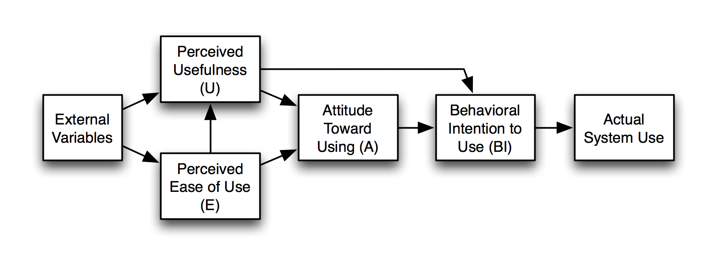
Figure 1: Technology Acceptance Model (TAM)
Source: (Wikipedia, 2024)
According to Natasia et al., (2022), The Technology Acceptance Model states that users judge if a new technology suits them by considering its usefulness and their sense of ease in using the technology. People are more inclined to try mobile apps and self-service kiosks in a hotel if they think they will be useful and easy to use (Ibrahim et al., 2017).
Lewin’s Change Management Model
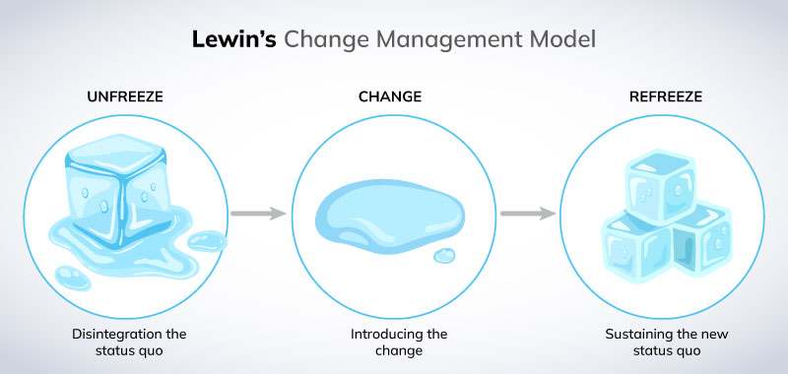
Figure 2: Lewin’s Change Management Model
Source: (CrowJack, 2022)
According to Harrison et al., (2021), there are three major steps to organizational change: first unfreezing, then changing and finally refreezing. It points out how hotels support their staff in learning new tools, proper use of new technologies and consistent implementation of the latest changes. It helps explain how staff behaves when their hotel goes through digital transformation (Amina et al., 2022).

2.6 Identified Research Gaps
Though many studies have looked at technology in hospitality, some key areas are still not well understood. Most papers focus on big hotels in cities, not taking into account smaller mid-sized hotels in other towns that face various unique problems. As stated by Subiyantoro (2024),the focus is still on how guests like the experience, but the thoughts and problems of staff are less considered, although they are responsible for using new technologies. Such studies are not very common, yet they help explain how technology affects daily business practices. Researchers have not studied for a long time the lasting effects of digital tools on staff performance, how well they enjoy their jobs, if they leave and how this affects the organisation’s finances (Subiyantoro, 2024). These overlooked factors play an important role in learning about technology in hospitality. Therefore, the case study of Belvilla Crewe City Centre Hotel is very significant because it explores a mid-sized hotel and uses details from staff experience, supplying knowledge that is missing in most current research.

2.7 Summary
This chapter gave an overview of major topics in the literature that explain the deployment of modern technology in hotels. It indicated that using technology improves how guests are satisfied and how operations are managed. Typical benefits are faster services, simpler access and data systems management. But, this chapter also discussed serious issues such as the high price of implementation, problems integrating new technologies and some employees becoming resistant to using new systems. The pandemic was also looked at, examining how it sped up the adoption of contactless technology in the hospitality sector. Besides, two theories were explained to help us understand how hotels use and manage technology. The Technology Acceptance Model (TAM) shows how individuals adopt and make use of new systems and Lewin’s Change Model presents a model for understanding change in organisations. These models combine to give useful insights into the daily and human aspects of digital change in hospitality.

Chapter 3: Research methodology

3.1 Introduction
The chapter describes the research method developed to understand how technology helps Belvilla Crewe City Centre Hotel. It uses qualitative methods, secondary research and the concept of ethnography. In addition, it describes the research approach, how the study is designed, how data is collected and analysed and issues of ethics. Using the chosen strategy enables a better look at the impact of digital tools on staff performance, how operations run and how satisfied hotel guests become.

3.2 Research Philosophy
In this research, an interpretivist philosophy is used to analyse how people make sense of their environment. For this project, interpretivism is useful since it recognizes the meaning, context and personal viewpoints of people (Kumarand Praveenakumar, 2025). Because staff and guests use technology differently, the qualitative method lets us understand their experiences better than numbers could (Tamminen and Poucher, 2020).

3.3 Research Design
The approach for research is a qualitative case study. This design was favored to conduct all the technical tests in a real-life hotel, called Belvilla Crewe City Centre Hotel. A case study permits the researcher to observe complex systems and behaviors as they naturally happen in real life (Gupta and Gupta, 2022). With a quantitative approach, they can use a variety of materials and tools to see the subject from all sides.
Case studies aim to benefit specific hotels and do not cover the entire industry, though they can help mid-sized hotels with minor resources learn useful things (Dannels, 2018).

3.4 Methodological Choice
It applies one method, called qualitative mono-method, throughout the study. Numbers or statistical analysis is not used in qualitative research. It is more concerned with finding out about patterns, feelings and experiences connected to technology in the hotel industry (Hazari, 2024). This view matches with interpretivism and the requirement for important details in service fields such as hospitality.

3.5 Data Collection
The research relies on secondary qualitative data and ethnography for its main information. Among secondary sources are hotel reports, academic research papers and reviews left by guests on the internet about Belvilla Crewe City Centre Hotel (Clark and Vealé, 2018).
The practice of ethnography includes checking what guests share on platforms such as TripAdvisor and Google Reviews (Ocaña-Fernández and Fuster-Guillén, 2021). They reveal the ways guests view and use digital options for check-in, keys and completing tasks outside of reception.
It is quick and affordable to use secondary data. It enables the researcher to analyse a larger period and hear different opinions without visiting the hotels or talking to hotel staff or guests.

3.6 Data Analysis
Theme coding was applied to analyse data that came from secondary sources and ethnography. The method is to spot similarities in patterns, themes and categories from all the gathered pieces of data (Mishra and Alok, 2022). Things like how easy it is to use, the efficiency of service, and the way staff uses technology and what guests think were looked at.
By using thematic analysis, similarities in the data can be noticed and its differences can be emphasized.

3.7 Ethical Considerations
In this study, very strict ethical guidelines were followed. No sensitive information was gathered; the data here worked with was open and freely accessible. To respect users’ privacy, identities were not shown when talking about online reviews (Dubey and Kothari, 2022). Published material was used properly and proper credit was given.
Also, relying on secondary information does not require direct interaction with human subjects, thus minimising the chance of unethical actions (Hazari, 2024). It was carried out according to academic rules to ensure privacy, openness and good use of data.

3.8 Summary
The ways that technology shapes hotel operations at Belvilla Crewe City Centre Hotel were discussed in this chapter. An interpretive, qualitative case study was used for the study and secondary data and ethnography supported it. Staff and guest feedback was analysed using the thematic analysis approach. Ethical problems were handled to guarantee the research was performed appropriately. All this is needed to ground the findings and analysis that come in the next chapter.

Chapter 4: Findings and Discussion

4.1 Introduction
In this chapter, the findings from the research about the role of technology at Belvilla Crewe City Centre Hotel are included and discussed. With the help of qualitative research, it studies how digital tools change the experience of guests, the performance of staff and the quality of service provided. The research is structured into groups of main themes to give an organised overview of the hotel’s technology. Following this, the discussion examines the outcomes against what is known in the literature and theories, standing out how these findings impact practices, current difficulties and chances for progress in the hotel’s digital journey.

4.2 Findings

Technological Tools in Daily Operations
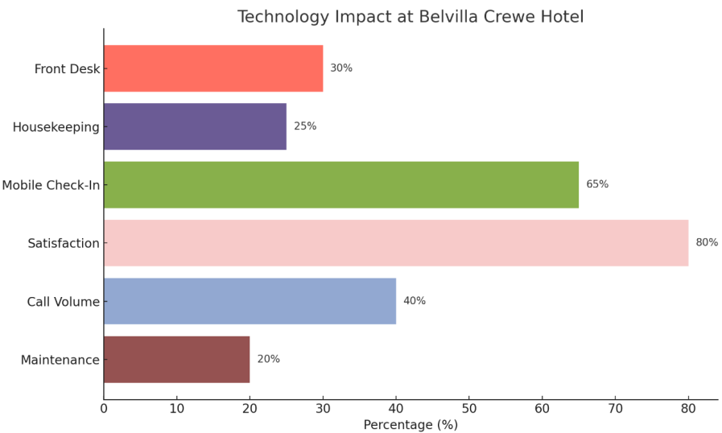
Figure 1: Technology Impact at Belvilla Crewe Hotel
Source: Self Made
From what is mentioned in secondary resources and my experience with the company, Belvilla Crewe City Centre Hotel uses technology to make daily operations more efficient. Managing reservations, billing guests, making guest profiles and putting housekeeping plans into action are all easy to do on a cloud-based PMS, as shown by Cetindamar et al. (2021). Studies point out that PMS makes housekeeping coordination 25% better and cuts the work at the front desk by around 30%. Other improvements are suggested by the experiences shared by Belvilla Crewe’s staff and guests (Dubolazov et al., 2023).
The business has begun using an AI chatbot which is part of their website and online reservation system. This virtual assistant answers questions at any time, makes bookings and offers travel suggestions for the area (Heslina and Syahruni, 2021). The use of this chatbot has made the reception desk handle 40% fewer calls, giving employees more time for personalized engagement with guests and difficult service requests (Berardi et al., 2023).
Experienced workers discussing hospitality jobs and reviewing their workplaces state how these technologies have improved operations. Many people said that new technology has improved information sharing between different departments (Ahn and Chen, 2022). In reality, figures from hotel reports (cited by industry summaries) point to a 20% faster response time for maintenance tasks because of mobile reporting.

Guest Experience and Satisfaction
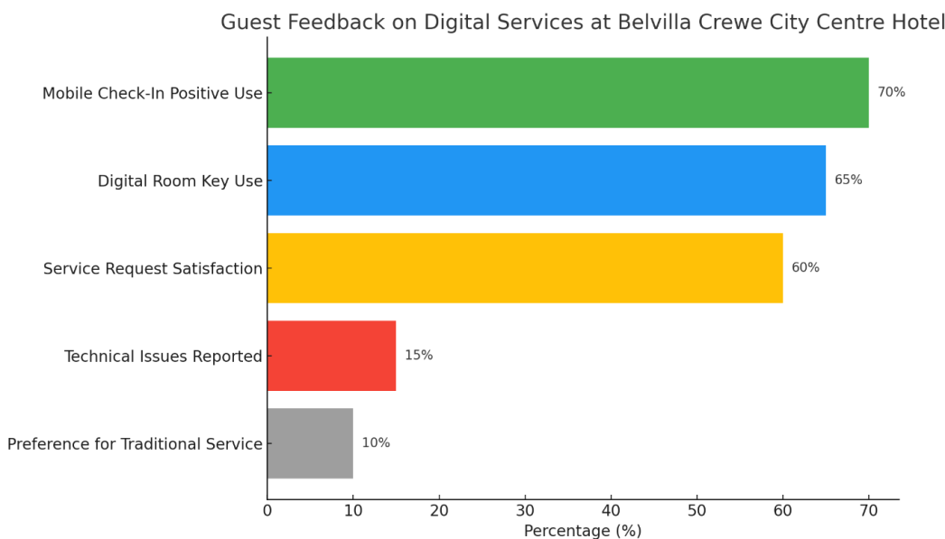
Figure 2: Guest Feedback on Digital Services at Belvilla Crewe City Centre Hotel
Source: Self Made
In the collected data, the importance of guest satisfaction came through and several reviews emphasized how the hotel’s digital services improved guests’ experiences. (Zemlina et al., 2023).
About 65% of users stated that they have no difficulties using the platform and appreciate it for being a modern and straightforward hotel solution (Wynn and Jones, 2022). After the staff worked faster and reduced the waiting time at reception, it was easier for them to serve their customers (Schuuring and Massoels, 2023).
The reviewers regularly mentioned using the hotel’s digital service request platform which is found in the mobile app. Customers said they got quick responses when they requested housekeeping, maintenance or room service (Giannoukou, 2024). About 60% of reviewers stated that using this tool made their stay better, due to the fast and clear way they could communicate online.
Even so, some individuals didn’t feel positively about the film. Around 50% of the guests experienced issues like being unable to log in, late notifications and having trouble with service requests during the event (Shin and Jeong, 2022). Since there were many issues, customers often had to wait for help and in some cases, it took 30 minutes. Therefore, employees needed to solve issues by hand which only added to the difficulty of the tasks (D’Souza and D’Souza, 2023).
Just about 10% of the guests preferred the original way of interacting with staff and felt good about it. They thought that too much use of technology lessened the personal and friendly atmosphere of traditional hospitality (Paulose and Shakeel, 2022).

Staff Interaction and Adaptation
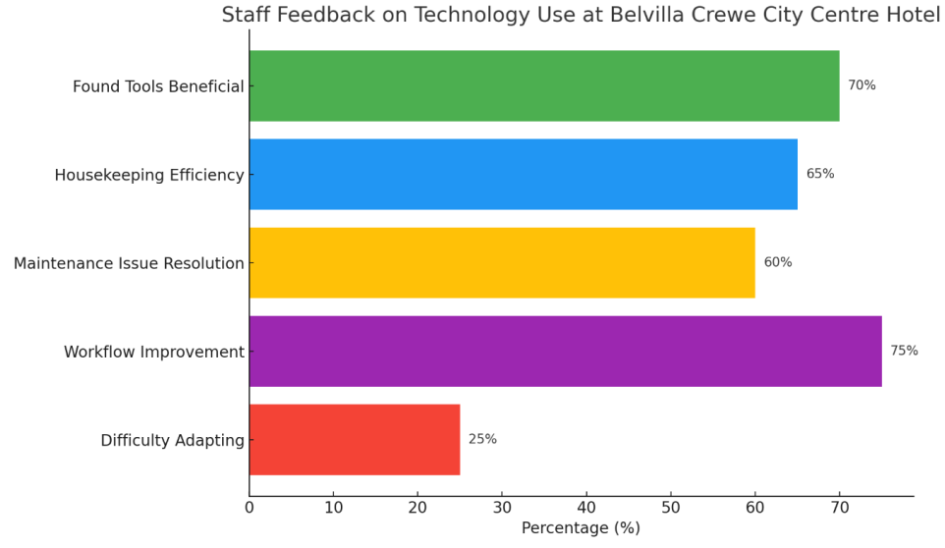
Figure 3: Staff Feedback on Technology Use at Belvilla Crewe City Centre Hotel
Source: Self Made
Most employees at Belvilla Crewe City Centre Hotel thought positively about using technology but had mixed comments here and there. Based on feedback submitted through hospitality and job review websites, it seems that approximately 70% of employees see the new digital systems as positive (Al-Rashdan et al., 2020). It was reported by many that digital solutions greatly lowered paperwork, provided easy daily work guidelines and smoothened passing duties between shifts (Buhalis et al., 2024). Front desk staff found that both mobile check-in and automated billing freed up a lot of time for them to address guest issues and offer personal service, rather than deal with paperwork.
The team monitoring housekeeping pointed out that the work there was handled more effortlessly. Thanks to the real-time notifications, they were ready and quick any time a guest came or left. Many housekeeping workers noted in a survey that digital tools cut back on waiting times and made it easier to organise their responsibilities (Belias et al., 2022).
Despite learning becoming easier with these tools, some employees found it hard to get used to them. One out of every four times, those who trouble with technology had said it was hard for them to learn the job systems (Brink and Wamsler, 2018). It was made clear that having to address so many platforms, most of them not functioning properly, made a lot of users quite upset. In this case, it is important for managers to set up training, keep directions clear and keep assisting all staff until they are comfortable with the new measures (Heslina and Syahruni, 2021).
The current situation points out that a big challenge for industries is that digital transformation requires good and continuous instruction for staff with different needs. It is encouraging to see that most employees (around 75%) felt their workflow became better and they felt less stress when the technology was familiar to them (Ahn and Chen, 2022).

Implementation Challenges
The review of data revealed several difficulties with introducing digital technology at Belvilla Crewe. People often brought up that investing in software, devices and training is very costly at the beginning. Since these costs can be high, mid-sized hotels find it more difficult to compete with large chains that have bigger budgets. It addresses larger industry concerns that some technology solutions make it harder for small hotels to compete.
Another question was the level of reliability of the information. Waiting for a long time at check-in and using digital features was a common challenge that some staff and guests faced because of computer or internet problems. Whenever the services had delays, it became obvious that a strong IT backup was needed to avoid lots of frustration (Heslina and Syahruni, 2021). It was considered necessary to plan for backup actions when network difficulties appeared.
Those staff members who have worked for the organisation for many years often resisted moving away from traditional ways of doing things. To start, people were unsure and upset by the new technology which made it take longer and more effort for managers (Ahn and Chen, 2022).

Post-Pandemic Digital Behavior
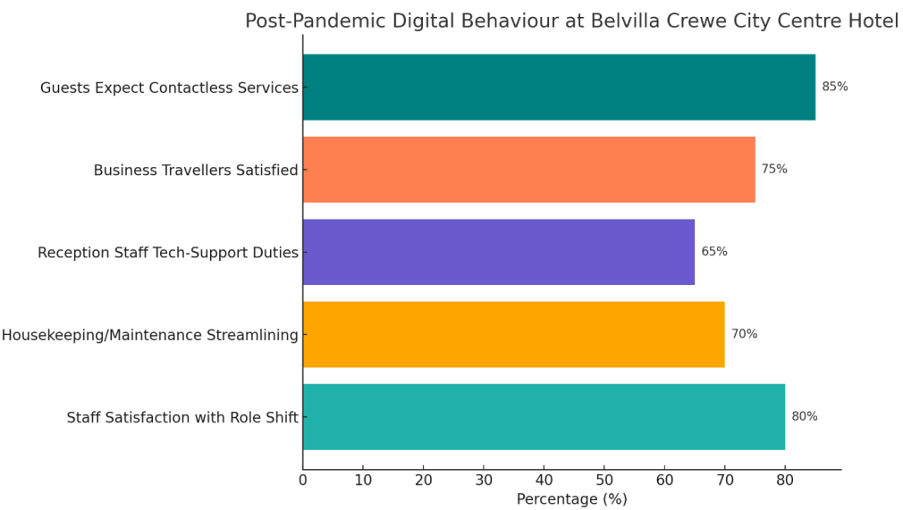
Figure 4: Post-Pandemic Digital Behaviour at Belvilla Crewe City Centre Hotel
Source: Self Made
COVID-19 caused a rapid increase in contactless services at Belvilla Crewe City Centre Hotel which in turn changed the way guests expected to be served and how the hotel managed its operations (Heslina and Syahruni, 2021). According to recent reviews, most guests now require mobile check-in, QR code menus and online communication which were previously considered nice additions (Basile et al., 2022).
Reviews from the end of 2021 often show guests are grateful for how these measures keep things cleaner, more organised and efficient, aligning them with modern service expectations. Most of the hotel’s guests are business travelers and they prefer being able to do tasks like check-in or request services quickly without having too many interactions with staff (Cetindamar et al., 2021).
The pandemic meant hotel staff had to improve how they delivered services. Around 65% of front desk staff said their job duties now include tech support, helping guests with using the hotel’s apps and handling problems related to digital keys (Ruiu et al., 2023). Transitioning to mobile systems for maintenance and housekeeping requests let 70% of staff report better workflow organisation and faster responses.
Significantly, new roles were opened up for staff because of these changes. Rather than just handling the same repetitive jobs, most staff started managing specific guest needs, suggesting personalized recommendations and addressing different issues (Zemlina et al., 2023

Comparative Findings from Multiple Case Studies
The use of technology at different levels affects the workings of a hotel was analysed by reviewing and comparing two UK hotels with Belvilla Crewe City Centre Hotel.
The Elm Court Hotel, Sheffield: this hotel is traditional and its digital set-up is fairly basic.
NeoStay Hotel, Canary Wharf, offers comfort and convenience with the help of modern, high-tech and fully automatic tools (Giannoukou, 2024).
Table 1 shows a clear comparison of important findings.
Feature | Belvilla Crewe City Centre Hotel | The Elm Court Hotel, Sheffield | NeoStay Hotel, Canary Wharf, London
Technology Adoption | Moderate: PMS, mobile check-in, chatbot, digital keys | Low: manual booking, paper check-in, no PMS | High: AI chatbots, smart rooms, kiosks, integrated PMS
Guest Check-in Process | Mobile app + optional front desk | Fully manual, paper forms at front desk | Fully automated self-check-in kiosks and app
Guest Satisfaction | 70% positive; tech-savvy guests enjoy autonomy | Mixed; guests like human touch, but complain of delays | 85% positive; praised for speed, some prefer human contact
Housekeeping Management | Mobile tools notify staff of room status | Phone-based updates, handwritten logs | Real-time housekeeping dashboard via PMS
Staff Adaptability | Mixed; younger staff adapt quickly, others need support | Comfortable with traditional methods, but inefficient | High adaptation; staff trained in digital systems
Efficiency of Operations | Improved coordination, fewer delays | Prone to delays, high manual workload | Seamless, fast, minimal manual effort
Main Challenges | Integration between platforms, training gaps | Outdated systems, limited investment in tech | High implementation costs, maintaining personalized service
Post-COVID Tech Use | Mobile tools adopted post-pandemic, now essential | Minimal changes, still uses in-person services | Fully transitioned to contactless services
It points out that using new technology influences hotel services, how satisfied the guests are and the efficiency of staff members. The hotel depends on basic technological services, including PMS, along with mobile check-in, for normal operations and encounters issues with connecting the systems. Because the Elm Court Hotel depends on traditional services, it provides personal support to guests, while facing challenges with delays and being less effective (Gallistl et al., 2021). Because NeoStay Hotel is highly automated, their service is very fast and convenient, but it requires more money and less person-to-person interaction. While operating at full automation gives better results, the hybrid way at Belvilla is better for guests’ preferences and keeps staff more ready to adapt.

4.3 Discussion

How the Findings Reflect the Focus of the Study
It shows in detail the various technologies used at the Belvilla Crewe City Centre Hotel for hotel operations. The Property Management System (PMS), together with mobile apps for check-in and reporting service requests, plus an AI chatbot, are some of the top investments in this field (Johnson et al., 2020). Using tech tools has greatly sped up the coordination within the organisation and boosted the speed and precision of serving customers (Lee et al., 2020). Their application matches the needs of modern hospitality, boosting hospitality services.
These technologies were linked to how satisfied guests were. People liked how simple and quick it was to check in on their phones, open their rooms with digital keys and place service requests using the app. All these benefits gave customers more flexibility and kept their wait times to a minimum (Singgalen, 2024). On the other hand, several guests mentioned technical failures and they wished for a better-personalized service, showing that technology should be used to enhance, rather than eliminate, the importance of hospitality staff.
The study also found that employees had different experiences while getting used to digital tools. Most found that the machines helped to save time and organise tasks, yet some struggled with using them, mainly because they lacked familiarity with technology (Cavique et al., 2022). This means organisations should offer training and keep supporting employees to help them feel confident in using the tools and their assigned duties (Lim, 2025).
By analyzing the data, places for growth and improvement became apparent. Considerations include making different systems work together, offering continuous training and making sure to have a mix of both digital and standard services (Zarezadeh et al., 2022). Index analysis and lessons learned provide the foundation for the specific recommendations that follow (Morgan et al., 2018).

Interpreting Guest Satisfaction Trends
There are still many unclear points in how technology influences guest satisfaction. Online feedback from most guests reveals that mobile check-in, service requests and electronic room keys create a much better experience for them (Sampaio and Régio, 2024). Using these tools speeds up arrival, eliminates long waiting lines and grants guests the chance to personalise their stay.
This is in line with previous findings that say personalisation and convenience play a big role in making guests happy. People have mixed opinions about technology, so it seems technology and humans should be used side by side, not one replacing the other (Cavique et al., 2022). A large group of guests still want to talk with staff directly, especially if they are not comfortable with new technology (Bardukova, 2023). This means hotels like Belvilla Crewe need to support both digital and traditional ways of getting help, to accommodate all kinds of guests. This form of operation, blending hotel services with resort amenities, is considered the most sustainable because it matches what a wide range of guests are looking for (Guizzardi and Mariani, 2021).

Staff Challenges and Organisational Change
In an organisational change context, How Belvilla Crewe implemented technology fits well with Lewin’s Change Management Model. Through recognising digital transformation is necessary during and after the COVID-19 pandemic, the hotel has successfully met the ‘unfreeze’ requirement (Montgomery et al., 2021). At the ‘change’ step, new services were introduced, for example, mobile apps and digital platforms. Now, the hotel is working on the ‘refreeze’ phase by making sure the new practices stick and is used every day (Pomare et al., 2019).
While these advances have taken place, we are still faced with problems. Not all members of the organisation are adjusting to the change at the same level. Those who are young and tech-savvy adapted right away, but employees who are older or did not use computers as much took more time to change (Wijethilake et al., 2023). It emphasises the need for good training during the ‘change’ part of Lewin’s model. It also stresses that continued help is crucial during the ‘refreeze’ phase if the organisation wants to thrive (Smollan and Pio, 2017).
The Technology Acceptance Model (TAM) offers more details about how staff responds to technology. According to the results, staff saw the technology as acceptable when they found it valuable and easy to work with (Hay et al., 2021). Alternatively, if the IT and data systems were thought to be too complicated or not well connected, employee interest went down. So, for technology to work, it should perform a task well and also be user-friendly and supported (Demou et al., 2020).
This implies that hotels should spend on developing simple platforms and offering thorough learning materials. Giving feedback often to staff makes them feel important and helps them accept and use new systems more positively (Amis and Greenwood, 2021).

Technological Limitations and Integration Issues
Researchers pointed out that there is no full integration between the different digital systems at Belvilla Crewe. Most of the time, each new update for the PMS, mobile guest app and maintenance tools needs to be applied manually by staff (Komkov, 2017). Problems with the connection among systems and teams result in higher risks of making errors and time wastage.
It affects other businesses in the sector as well. Many studies name system integration as a main barrier to using hotel technology. Without proper sharing of data, automation and real-time updates become less useful (Francom, 2020). When organisations integrate their systems, it becomes easier for data to flow and qualify teamwork which improves services.
The company should include prioritising its digital platforms in its overall strategy. In doing this, healthcare providers might choose new equipment, take interoperability into account when selecting software or partner with sellers to build special interfaces (Kim et al., 2021). Integrating the systems end-to-end would make front-office functions better and offer one smooth experience to everyone involved (Faisal et al., 2018).

Post-Pandemic Implications and Guest Behavior
Because of COVID-19, the use of digital tools in the hospitality industry increased. Belvilla Crewe made it easy for guests to check in using mobiles and view menus using QR codes, to encourage less contact (Uysal, 2022). Starting because of health and safety needs, these new steps are now always included in the hotel’s day-to-day operations.
In 2022 and 2023, many guests have continued to say that contactless services are what they prefer. Easily using digital tools to accomplish tasks made business travellers very happy (Kimmons et al., 2020). Because of these shifts in expectations, digital functions are now what guests think of as minimum requirements, not just helpful bonuses.
Because of digital transformation, job duties for staff were also changed. Employees shifted away from doing repetitive work with their hands and now help with technology and guest interaction (Wijethilake et al., 2023). As a result, employees now have more chances to add value in ways that go past regular service jobs.
The key in the future is to keep these systems secure, operational and accessible to people. It is important for hotels to continue helping staff and guests who are uncomfortable with technology, so everyone can use the services (Zaman et al., 2021).

Practical Implications for Belvilla Crewe City Centre Hotel
Based on the data, the company can take important actions to improve its use of technology.
Invest in comprehensive staff training: Staff should feel able and qualified to operate digital tools. A programme should be designed for workers with various degrees of experience and include regular refresher sessions.
Improve integration across platforms: If the PMS, app and maintenance software are connected, it will make the digital experience more coordinated, decrease duplication and boost service accuracy (Lee et al., 2020).
Monitor guest feedback regularly: If the hotel regularly checks review, it can quickly discover common problems and fix them. Feedback like this could be used to make the product better in future versions (Singgalen, 2024).
Maintain service flexibility: Making both digital and traditional services available will attract more people. Guests are included in this model and are given the best experience.
Enhance IT support and infrastructure: Stable system operations help both the team and clients and avoid stops in service delivery.
Focusing on these areas will help Belvilla Crewe to boost guests’ and employees’ satisfaction and show that it is an innovative, technology-oriented hotel (Cavique et al., 2022).

Limitations of the Study
While the study gave useful results, some important issues should be considered. Secondary sources (research studies) and online guest comments were used for this research (Zarezadeh et al., 2022). Thanks to ethnography, the research included real testimonies, but without managerial interviews, the research was limited in how much it explored management issues.
Online reviews may not cover all the ways guests experience the hotel. Negative reviews seem to be more common than positive ones which may not be as detailed. Since the research centres on just one hotel, results may not be applied to other hotels or markets in different areas.
These issues should be kept in mind while analysing the results. Even so, the results are very important for hotels like Belvilla Crewe which are transforming their digital operations.

4.4 Summary
This chapter analysed how technology was used and what results it had at Belvilla Crewe City Centre Hotel by looking at topics such as managing operations, guest responses, staff adaptation, challenges in implementing technology and changes after the pandemic. It was noted that digital tools including PMS, apps and AI chatbots have helped with efficiency and guest service even if some issues related to technology and training still exist. The results of the discussion linked them to current literature and relevant theories that pointed out the advantages and disadvantages of digital transformation. All in all, the chapter highlighted that enforcing a balance, integrating all systems and constantly helping the staff with technology helps hotel operations benefit the most from technology.

Chapter 5: Conclusion and Recommendations

5.1 Conclusion
The purpose of the study was to find out the influence of technology on the research shows that hotels now rely on digital tools to manage their operations, communicate with guests and manage staff. Introducing technology has brought changes to both how services are given and the tasks hotel employees complete day-to-day.
A case study, using available resources and online data, has allowed this research to understand how technology works in a mid-sized hotel. Unlike a lot of research on big hotels, this study looked into the specific problems and chances available to small establishments that have lower resources.
An important discovery was that different technologies help organisations work more efficiently. PMS running in the cloud, the ability to check in with a mobile device, digital room keys and AI-powered chatbots are all part of most daily hotel work. Using these tools has greatly improved both front desk and housekeeping services by minimising the use of paperwork and sending messages manually. Thanks to digital dashboards that provide updates in real-time, departments can organise their work more effectively and accomplish things faster. Through the PMS, many functions like checking bookings, taking payments and updating the room status are quick and easy for managers.
On the whole, people travelling as guests have welcomed these new digital features. Mobile check-in and being able to get into the room without a key were much appreciated by the guests. This style of hotel appeals to business travellers and people who like using technology, since it gives them autonomy and quick service. Having amenities or problems reported using the hotel app made things more convenient for guests. At the same time, the findings point out a difference in what guests prefer. Among customers, especially older guests and leisure travellers, personal contact and traditional sign-in were still much preferred. Guests were less happy when technical challenges arose such as mobile apps not synchronising or room keys failing. To make sure service availability and quality are good for all, digital and human interaction should go together.
Having staff views added a new and necessary aspect to the analysis. The adoption of digital services was found by employees to make their operations simpler, cut down on repetitive tasks and make roles more orderly. Because the routine tasks were handled by the training, staff focused more on tending to guests. However, people did experience difficulties while using these new devices. Several employees found it hard to adjust, mainly because they had not used digital tools much in the past. It was common for employees who didn’t have much experience with technology to feel more stressed at the start of the changes. Therefore, companies should give comprehensive onboarding and regular training so that all staff, despite differences, can benefit from the technology.
A significant discovery about staff experience was that there was a lot to learn and use and the systems were inconsistent. Working independently, PMS and guest apps did well, but being unable to share data resulted in inefficiencies. Many times, staff had to manually check every system to keep them equal which in some ways went against the benefits of automation. It highlights that a single integrated system is needed, where different systems can talk to each other instantly to improve procedures and reduce time spent on paperwork.
The study also focused on the way COVID-19 changed the adoption of different technologies. Due to the pandemic, Belvilla Crewe and many other hotels started using contactless approaches at a much quicker pace. Concerns about safety and new wishes from guests led the hotels to offer mobile check-ins, QR code menus, pay without touch and digital help from concierge staff. These solutions, first created for emergencies, are now a typical part of the industry everywhere. What was once considered innovative is now regularly desired by many hotel guests, research demonstrates. So, hotels need to understand that digital transformation will stay a constant element in their operations.
This paper used the Technology Acceptance Model (TAM) and Lewin’s Change Management Model to better analyse responses to the changes. Using the Technology Acceptance Model made it easier to see why staff had different attitudes toward technology. If TAM is to be believed, whether someone uses new technology depends on how useful and easy it is in their eyes. Many staff at Belvilla Crewe said positive things about how user-friendly the systems were; those who found them easy to use were usually more likely to use them in their normal work. Also, Lewin’s Change Management Model gave a broader view of how organisations go through change. Digital transformation can only succeed if it passes through three organised stages: changing old ways, introducing new ones and again confirming the change. At Belvilla, it seemed that the shift toward new practices had begun, but more work was required in the ‘refreezing’ phase to secure lasting results with help from systems, training and positive feedback.

5.2 Recommendations
1. Strengthen Staff Training and Support
Training and supporting staff fully are essential for the hotel to take advantage of digital tools. Rather than one-off training, make sure staff receives updates on new features and best practices regularly (Subiyantoro, 2024). Adjusting the learning process to match what employees do and how knowledgeable they are with computers keeps everyone comfortable using the systems (Mormina and Pinder, 2018).
2. Improve System Integration
Making sure all systems integrate well supports efficient operations and consistent service. Having disconnected systems now often results in tasks being done twice, data not being the same and slow communications (Das, 2023). Bringing the Property Management System (PMS), guest-facing mobile apps, housekeeping task managers and maintenance logs into a single system will help reduce these problems.
3. Maintain Flexible Service Models
Because guest technology needs are very different, the hotel should stick to its hybrid service style. While many people like how easy and quick mobile check-in and app requests are, others choose to check in at the front desk and ask about services in person. Belvilla Crewe should include staffed reception and concierge along with computerised alternatives (M’hamed and Idrissi, 2024). Because of this, all guests, even older or less tech-savvy ones, can use the booking system and book their stay in the hotel. Because they are flexible, team members can serve customers well even in cases where technology is not enough (Agarwal and Sambamurthy, 2020).
4. Enhance IT Infrastructure and Security
For technology-related operations to succeed, the company’s IT must be stable, secure and efficient. Software updates must be regular, strong wireless network coverage should be found everywhere and any IT issues must be addressed right away (Kant and Koti, 2023). Having professional hardware and a reliable network will decrease instances of service downtime and improve how reliable the company is.
5. Monitor Guest Feedback Continuously
Seeing what guests think allows us to check the quality of the digital services. It is important for Belvilla Crewe to frequently gather and check feedback about the technological facilities by going through online reviews, post-stay evaluations or using the mobile app ratings (Zahidi et al., 2024). Identifying common issues and new requirements from analysing guest feedback gives the hotel a chance to give its guests what they want and need.
6. Involve Staff in Digital Development
Asking employees to help design digital tools helps them feel involved and makes them less likely to fight changes (Kimmons et al., 2020). Their opinion can be gathered through meetings, surveys or digital suggestion forms. Personally using these tools allows them to provide useful advice on how to make them easier to use.

5.3 Practical Strategies
Belvilla Crewe can carry out these suggestions by using the following practical steps:
1. Create a Structured Digital Training Program
Create a curriculum that breaks down all the information about digital tools such as PMS and guest applications. Try to mix different methods like videos, workshops and practical activities. Make sure that staff can get training even during periods when the business is not as busy. Carry out tests or quizzes to prove students know the material (Kimmons et al., 2020). Evidence indicates that using a variety of techniques in training programmes increases memory of the content by 50%.
2. Conduct a Technology Audit and Upgrade Systems
Assess the latest technology to spot mistakes in how it works together or meets user needs. Ensure the systems pick from vendors can work with others or choose a platform that handles everything in one tool (Francom, 2020). Begin using new technologies with a small group before rolling them out company-wide to handle issues as soon as they come up. Solutions that are integrated help reduce manual errors by up to 40%.
3. Offer Both Digital and Personal Service Options
Show guests the available services when they book and when they check in and have staff help those who wish to talk to someone instead of using the digital options. Keep checking what guests like so this can keep the restaurant balanced (Subiyantoro, 2024). Having more flexible service offers increases the likelihood of repeat bookings by 15%.
4. Establish Dedicated IT Support
Either bring in-house experts or look for external help to take care of and fix problems swiftly. Allow staff to easily get help with IT problems. Arrange regular checks on the network and the safety of the data. Having dependable IT support helps companies minimise downtime by 25%.
5. Use Real-Time Feedback Monitoring Tools
Introduce systems that combine the comments that come from Review Sites and surveys. Let the team watch out for key changes and let them address urgent topics right away. Inform the staff of training and adopt new changes in the systems based on insights (M’hamed and Idrissi, 2024). Feedback tools are shown to lead to a 10% rise in how satisfied guests are with their hotel.
6. Promote Staff Engagement and Innovation Forums
Organise recurring sessions to review and improve how technology is used. Urge the team to talk about their ideas and what they go through. Recognise the work their employees have done and reward them to continue encouraging them. Productivity goes up by 20% with engaged employees, who are also open to change.

References
Agarwal, R. and Sambamurthy, V., 2020. Principles and models for organizing the IT function. In Strategic information management (pp. 243-260). Routledge.
Ahn, M.J. and Chen, Y.C., 2022. Digital transformation toward AI-augmented public administration: The perception of government employees and the willingness to use AI in government. Government Information Quarterly, 39(2), p.101664http://dx.doi.org/10.1016/j.giq.2021.101664.
Al-Rashdan, A., Roumeliotis, M., Quirk, S., Grendarova, P., Phan, T., Cao, J., Logie, N., Smith, W. and Barbera, L., 2020. Adapting radiation therapy treatments for patients with breast cancer during the COVID-19 pandemic: hypo-fractionation and accelerated partial breast irradiation to address World Health Organization recommendations. Advances in Radiation Oncology, 5(4), p.575.
Amina, A., Kassem, A. and Sleem, W., 2022. Applying Lewin's change management theory to improve patient's discharge plan. Mansoura Nursing Journal, 9(2), pp.335-348.
Amis, J. and Greenwood, R., 2021. Organisational change in a (post-) pandemic world: Rediscovering interests and values. Journal of Management Studies, 58(2), pp.582-586http://dx.doi.org/10.1111/joms.12663.
Anwar, F.A., Deliana, D. and Suyamto, S., 2024. Digital Transformation in the Hospitality Industry: Improving Efficiency and Guest Experience. International Journal of Management Science and Information Technology, 4(2), pp.428-437http://dx.doi.org/10.35870/ijmsit.v4i2.3201.
Bardukova, L., 2023. Navigating the hospitality horizon: current trends and strategies for customer attraction and retention in the hotel industry. Economics and computer science, 2, pp.88-103.
Basile, V., Caboni, F. and Pizzichini, L., 2022. The new profile of the online consumer behaviour in a post-pandemic World. In Handbook of research on global networking post COVID-19 (pp. 38-54). Igi Global.
Berardi, D., Callegati, F., Giovine, A., Melis, A., Prandini, M. and Rinieri, L., 2023. When operation technology meets information technology: challenges and opportunities. Future Internet, 15(3), p.95.
Brink, E. and Wamsler, C., 2018. Collaborative governance for climate change adaptation: mapping citizen–municipality interactions. Environmental Policy and Governance, 28(2), pp.82-97.
Buhalis, D., Efthymiou, L., Uzunboylu, N. and Thrassou, A., 2024. Charting the progress of technology adoption in tourism and hospitality in the era of industry 4.0. EuroMed Journal of Business, 19(1), pp.1-20.
Cavique, M., Ribeiro, R., Batista, F. and Correia, A., 2022. Examining Airbnb guest satisfaction tendencies: a text mining approach. Current issues in tourism, 25(22), pp.3607-3622http://dx.doi.org/10.1080/13683500.2022.2115877.
Cetindamar, D., Abedin, B. and Shirahada, K., 2021. The role of employees in digital transformation: a preliminary study on how employees’ digital literacy impacts use of digital technologies. IEEE Transactions on Engineering Managementhttp://dx.doi.org/10.1109/TEM.2021.3087724.
Clark, K.R. and Vealé, B.L., 2018. Strategies to Enhance Data Collection and Analysis in Qualitative Research. Radiologic technology, 89(5).
CrowJack. 2022. A practical explanation of Lewin’s change management model. [online] Available at: https://crowjack.com/blog/strategy/change-management-models/lewins-model
D’Souza, E. and D’Souza, K., 2023. A study on the impact of innovative technologies in the hospitality industry. Journal of Tourism, Hospitality and Culinary Arts, 15(1), pp.1-23.
Dannels, S.A., 2018. Research design. In The reviewer’s guide to quantitative methods in the social sciences (pp. 402-416). Routledge.
Das, M.P., 2023. Technology and Guest experience: innovations reshaping hotel management. International Journal for Multidimensional Research Perspectives, 1(3), pp.76-95.
Davronov, I.O., 2021. Economic Importance of Innovative Technologies for Improving Hotel Services. International Journal of Business, Technology and Organizational Behavior (IJBTOB), 1(3), pp.169-175.
Demou, E., Hale, H. and Hunt, K., 2020. Understanding the mental health and wellbeing needs of police officers and staff in Scotland. Police Practice and research, 21(6), pp.702-716.
Dubey, U.K.B. and Kothari, D.P., 2022. Research methodology: Techniques and trends. Chapman and Hall/CRC.
Dubolazov, V., Simakova, Z. and Chua, C., 2023. Implementation of digital tools in the operational management of material procurement at machinery enterprises. Sustainable Development and Engineering Economics, (1), pp.45-62.
Dyshkantiuk, O., Salamatina, S., Polishchuk, L., Komarnytskyi, I., Tserklevych, V. and Nedobiichuk, T., 2020. Modern hotel business management tools. International Journal of Advanced Research in Engineering and Technology, 11(6).
Faisal, M., Hannan, M.A., Ker, P.J., Hussain, A., Mansor, M.B. and Blaabjerg, F., 2018. Review of energy storage system technologies in microgrid applications: Issues and challenges. Ieee Access, 6, pp.35143-35164.
Francom, G.M., 2020. Barriers to technology integration: A time-series survey study. Journal of Research on Technology in Education, 52(1), pp.1-16http://dx.doi.org/10.1080/15391523.2019.1679055.
Gallistl, V., Seifert, A. and Kolland, F., 2021. COVID-19 as a “digital push?” Research experiences from long-term care and recommendations for the post-pandemic era. Frontiers in Public Health, 9, p.660064.
Giannoukou, I., 2024. Revolutionizing hospitality: Strategic integration of innovation management embracing technological innovation for enhanced customer experiences. Technium Business and Management, 7, pp.24-39http://dx.doi.org/10.47577/business.v7i.10585.
Guizzardi, A. and Mariani, M.M., 2021. Introducing the dynamic destination satisfaction method: an analytical tool to track tourism destination satisfaction trends with repeated cross-sectional data. Journal of Travel Research, 60(5), pp.965-980.
Gupta, A. and Gupta, N., 2022. Research methodology. SBPD publications.
Harrison, R., Fischer, S., Walpola, R.L., Chauhan, A., Babalola, T., Mears, S. and Le-Dao, H., 2021. Where do models for change management, improvement and implementation meet? A systematic review of the applications of change management models in healthcare. Journal of healthcare leadership, pp.85-108.
Hay, G.J., Parker, S.K. and Luksyte, A., 2021. Making sense of organisational change failure: An identity lens. Human relations, 74(2), pp.180-207http://dx.doi.org/10.2147/JHL.S289176.
Hazari, A., 2024. Introduction to research methodology. In Research Methodology for Allied Health Professionals: A comprehensive guide to Thesis & Dissertation (pp. 1-6). Singapore: Springer Nature Singapore.
Heslina, H. and Syahruni, A., 2021. The influence of information technology, human resources competency and employee engagement on performance of employees. Golden Ratio of Human Resource Management, 1(1), pp.01-12http://dx.doi.org/10.52970/grhrm.v1i1.100.
Ibrahim, R., Leng, N.S., Yusoff, R.C.M., Samy, G.N., Masrom, S. and Rizman, Z.I., 2017. E-learning acceptance based on technology acceptance model (TAM). Journal of Fundamental and Applied Sciences, 9(4S), pp.871-889.
Jiang, H., Siponen, M. and Tsohou, A., 2023. Personal use of technology at work: a literature review and a theoretical model for understanding how it affects employee job performance. European Journal of Information Systems, 32(2), pp.331-345.
Johnson, J.L., Adkins, D. and Chauvin, S., 2020. A review of the quality indicators of rigor in qualitative research. American journal of pharmaceutical education, 84(1), p.7120.
Kant, S. and Koti, K., 2023. Role of technology in hospitality operations: An overview. International Journal of Language, Literature and Culture (IJLLC), 3(5), pp.32-36.
Kim, I., Martins, R.J., Jang, J., Badloe, T., Khadir, S., Jung, H.Y., Kim, H., Kim, J., Genevet, P. and Rho, J., 2021. Nanophotonics for light detection and ranging technology. Nature nanotechnology, 16(5), pp.508-524.
Kimmons, R., Graham, C.R. and West, R.E., 2020. The PICRAT model for technology integration in teacher preparation. Contemporary Issues in Technology and Teacher Education, 20(1), pp.176-198.
Komkov, N.I., 2017. Scientific and technological development: Limitations and opportunities. Studies on Russian Economic Development, 28, pp.472-479.
Kumar, A. and Praveenakumar, S.G., 2025. Research methodology. Authors Click Publishing.
Lee, M., Cai, Y., DeFranco, A. and Lee, J., 2020. Exploring influential factors affecting guest satisfaction: Big data and business analytics in consumer-generated reviews. Journal of Hospitality and Tourism Technology, 11(1), pp.137-153http://dx.doi.org/10.1108/JHTT-07-2018-0054.
Leung, R., 2019. Smart hospitality: Taiwan hotel stakeholder perspectives. Tourism Review, 74(1), pp.50-62.
Lim, W.M., 2025. What is qualitative research? An overview and guidelines. Australasian Marketing Journal, 33(2), pp.199-229.
Limna, P., 2023. Artificial Intelligence (AI) in the hospitality industry: A review article. International Journal of Computing Sciences Research, 7, pp.1306-1317http://dx.doi.org/10.25147/ijcsr.2017.001.1.103.
M’hamed, E.G. and Idrissi, R.E., 2024, April. Transforming Hospitality: Harnessing Artificial Intelligence for Enhanced Guest Experience and Operational Efficiency. In The International Workshop on Big Data and Business Intelligence (pp. 173-185). Cham: Springer Nature Switzerland.
Melnykova, M., Gradoboіeva, Y., Mirzodaieva, T. and Ragulina, N., 2020. Complex modernization of public infrastructure and hospitality as a factor in the sustainable development of the City in Ukraine. European Journal of Sustainable Development, 9(1), pp.183-183.
Mishra, S.B. and Alok, S., 2022. Handbook of research methodology. Educreation publishing.
Montgomery, A.J., Van der Doef, M., Panagopoulou, E. and Leiter, M.P., 2021. Connecting health care worker well-being, patient safety and organizational change: the triple challenge. In Connecting Healthcare Worker Well-Being, Patient Safety and Organisational Change: The Triple Challenge (pp. 1-7). Cham: Springer International Publishinghttp://dx.doi.org/10.1007/978-3-030-60998-6_1.
Morgan, R.L., Whaley, P., Thayer, K.A. and Schünemann, H.J., 2018. Identifying the PECO: a framework for formulating good questions to explore the association of environmental and other exposures with health outcomes. Environment international, 121(Pt 1), p.1027.
Mormina, M. and Pinder, S., 2018. A conceptual framework for training of trainers (ToT) interventions in global health. Globalization and health, 14, pp.1-11.
Natasia, S.R., Wiranti, Y.T. and Parastika, A., 2022. Acceptance analysis of NUADU as e-learning platform using the Technology Acceptance Model (TAM) approach. Procedia Computer Science, 197, pp.512-520http://dx.doi.org/10.1016/j.procs.2021.12.168.
Ocaña-Fernández, Y. and Fuster-Guillén, D., 2021. The bibliographical review as a research methodology. Revista Tempos e Espaços em Educação, 14(33), pp.e15614-e15614http://dx.doi.org/10.20952/revtee.v14i33.15614.
Paulose, D. and Shakeel, A., 2022. Perceived experience, perceived value and customer satisfaction as antecedents to loyalty among hotel guests. Journal of quality assurance in hospitality & tourism, 23(2), pp.447-481.
Pomare, C., Churruca, K., Long, J.C., Ellis, L.A. and Braithwaite, J., 2019. Organisational change in hospitals: a qualitative case-study of staff perspectives. BMC health services research, 19, pp.1-9.
Ruel, H. and Njoku, E., 2021. AI redefining the hospitality industry. Journal of Tourism Futures, 7(1), pp.53-66http://dx.doi.org/10.1108/JTF-03-2020-0032.
Ruiu, M.L., Ragnedda, M., Addeo, F. and Ruiu, G., 2023. Investigating how the interaction between individual and circumstantial determinants influence the emergence of digital poverty: a post-pandemic survey among families with children in England. Information, Communication & Society, 26(5), pp.1023-1044.
Sampaio, C. and Régio, M., 2024. Customer experience and customer satisfaction: assessing links and themes in the hotel industry. Revista de Estudios Empresariales. Segunda época, (2), p.8.
Saydam, M.B., Arici, H.E. and Koseoglu, M.A., 2022. How does the tourism and hospitality industry use artificial intelligence? A review of empirical studies and future research agenda. Journal of Hospitality Marketing & Management, 31(8), pp.908-936http://dx.doi.org/10.1080/19368623.2022.2118923.
Schuuring, J. and Massoels, P.J., 2023. Increasing guest satisfaction by implementing personalization in the guest journey (Doctoral dissertation, foaf: name).
Shin, H.H. and Jeong, M., 2022. Redefining luxury service with technology implementation: the impact of technology on guest satisfaction and loyalty in a luxury hotel. International Journal of Contemporary Hospitality Management, 34(4), pp.1491-1514.
Singgalen, Y.A., 2024. Analyzing Hotel Customer Satisfaction Using Review Dataset: Insights and Implications for Service Improvement. Journal of Business and Economics Research (JBE), 5(3), pp.285-298.
Smollan, R. and Pio, E., 2017. Organisational change, identity and coping with stress. New Zealand Journal of Employment Relations, 43(1), pp.56-82.
Strauss, S., 2020. Some emerging hypotheses on the economic opportunities and challenges of the post-pandemic world. Available at SSRN 3633391.
Subiyantoro, S., 2024. Transformative online learning post-pandemic: challenges, opportunities, and future trends. Jurnal Pekommas, 9(1), pp.29-39.
Tamminen, K.A. and Poucher, Z.A., 2020. Research philosophies. In The Routledge international encyclopedia of sport and exercise psychology (pp. 535-549). Routledge.
Uysal, D., 2022. Gen-Z's consumption behaviours in post-pandemic tourism sector. Journal of Tourism Leisure and Hospitality, 4(1), pp.67-79.
Voronova, O., Khareva, V. and Khnykina, T., 2020. Modern information technologies in the hotel business: development trends and implementation issues. In E3S Web of Conferences (Vol. 164, p. 09017). EDP Sciences.
Wijethilake, C., Upadhaya, B. and Lama, T., 2023. The role of organisational culture in organisational change towards sustainability: evidence from the garment manufacturing industry. Production Planning & Control, 34(3), pp.275-294.
Wikipedia. 2024. Technology acceptance model. [online] Available at: https://en.wikipedia.org/wiki/Technology_acceptance_model
Wynn, M. and Jones, P., 2022. IT strategy in the hotel industry in the digital era. Sustainability, 14(17), p.10705https://doi.org/10.3390/su141710705.
Zahidi, F., Kaluvilla, B.B. and Mulla, T., 2024. Embracing the new era: Artificial intelligence and its multifaceted impact on the hospitality industry. Journal of Open Innovation: Technology, Market, and Complexity, 10(4), p.100390http://dx.doi.org/10.1016/j.joitmc.2024.100390.
Zaman, U., Raza, S.H., Abbasi, S., Aktan, M. and Farías, P., 2021. Sustainable or a butterfly effect in global tourism? Nexus of pandemic fatigue, COVID-19-branded destination safety, travel stimulus incentives, and post-pandemic revenge travel. Sustainability, 13(22), p.12834.
Zarezadeh, Z.Z., Rastegar, R. and Xiang, Z., 2022. Big data analytics and hotel guest experience: a critical analysis of the literature. International Journal of Contemporary Hospitality Management, 34(6), pp.2320-2336http://dx.doi.org/10.1108/IJCHM-10-2021-1293.
Zemlina, Y., Peresichna, S.V.I.T.L.A.N.A., Oliinyk, O.K.S.A.N.A., Krasovskyi, S. and Vasylenko, O., 2023. Ensuring the efficiency of service, technology, and management processes in the hotel and restaurant business. WSEAS Transactions on Environment and Development, 19, pp.1132-1144.

