A research paper comparing the most common ground improvement and soil strengthening techniques in Civil Engineering
Cris Davies - 1705493

Ground Improvement & Soil Strengthening Techniques – ACBA5007
Dr Shaker Bitar
Contents
0
Chapter 1: Introduction 2
Chapter 2: Ground Improvement and Soil Strengthening Techniques 2
2.1 Introduction 2
2.2 Mechanical Techniques 3
2.3 Chemical Techniques 3
2.4 Biological Techniques 3
Chapter 3: Comparative Analysis of Techniques 3
Chapter 4: Examples and Case Studies 4
4.1 Hudson Yards Development – New York 4
4.2 Crossrail Project - London 4
4.3 Marina Bay Sands – Singapore 5
Chapter 5: Demonstration of Research and Understanding 5
Chapter 6: Conclusion 6
References 9

Chapter 1: Introduction
Ground improvement and soil strengthening techniques are important aspects of construction engineering, playing a pivotal role in ensuring the stability, durability, and safety of infrastructure projects worldwide. The importance of these techniques stems from the complex variability and heterogeneity of natural soil deposits, which often present challenges such as low bearing capacity, excessive settlement, inadequate drainage, and susceptibility to liquefaction. As populations grow and urbanisation expands into regions with less favourable soil conditions, the demand for effective ground improvement solutions becomes increasingly critical.
The primary objective of ground improvement and soil strengthening techniques is to enhance the engineering properties of soil, thereby mitigating the adverse effects of poor ground conditions on construction projects. By modifying soil characteristics such as strength, stiffness, permeability, and settlement behaviour, these techniques enable the construction of foundations, embankments, retaining structures, and other infrastructure elements with improved performance and longevity. Moreover, they offer sustainable alternatives to traditional soil replacement methods, minimising the need for excavation, transportation, and disposal of soil materials.
The selection of appropriate ground improvement and soil strengthening techniques depends on various factors, including soil type, site-specific conditions, project requirements, environmental considerations, and economic feasibility. Engineers and geotechnical specialists must carefully assess these factors to determine the most suitable approach for each project, considering both short-term performance and long-term sustainability. Additionally, advancements in technology, materials, and construction practices continue to expand the repertoire of available techniques, offering innovative solutions to address complex ground challenges.
In this research paper, the diverse array of methods and techniques employed in ground improvement and soil strengthening will be explored, ranging from mechanical and chemical treatments to biological and geosynthetic methods. Through a comprehensive survey, comparative analysis, and examination of real-world case studies, the advantages, disadvantages, and applications of each technique will be discussed, aiming to provide insights that inform sound decision-making in construction engineering practice.

Chapter 2: Ground Improvement and Soil Strengthening Techniques

2.1 Introduction
Ground improvement and soil strengthening encompass a wide array of techniques aimed at enhancing the engineering properties of soil to meet the requirements of construction projects. These techniques can be broadly categorised into mechanical, chemical, and biological approaches, each offering unique advantages and applications.

2.2 Mechanical Techniques
Mechanical techniques involve the application of force or mechanical energy to modify soil properties. Compaction, for instance, is a widely used method that increases soil density through mechanical means (Mitchell & Soga, 2005). Dynamic compaction, another mechanical technique, involves the use of heavy machinery to densify loose granular soils by repeatedly dropping a heavy weight onto the ground surface (Holtz & Kovacs, 1981).
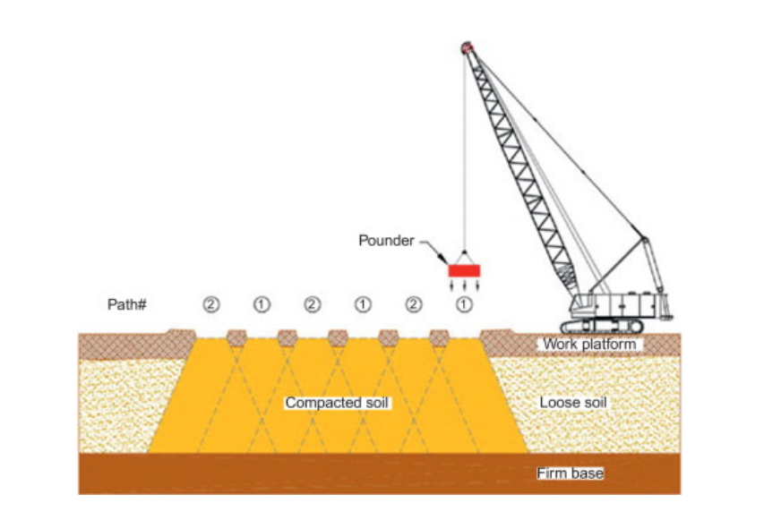
Figure 1 - Soil compaction method (Sciencedirect.com)

2.3 Chemical Techniques
Chemical techniques focus on altering soil properties through chemical reactions or the addition of chemical agents. Soil stabilisation, utilising additives such as lime, cement, or fly ash, aims to improve soil strength, reduce permeability, and enhance load-bearing capacity (Terzaghi et al., 1996). Electrokinetic stabilisation, on the other hand, involves the application of electrical current to induce chemical changes in the soil, particularly effective in fine-grained soils (Tomlinson, 2001).
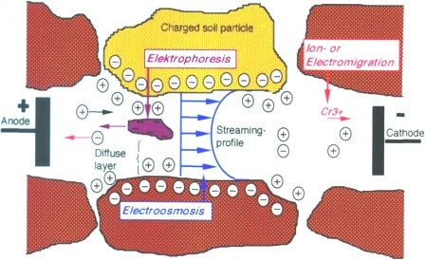
Figure 2 - Electrokinetic stabilisation method. (The constructor.com)

2.4 Biological Techniques
Biological techniques harness the natural processes of living organisms to improve soil properties. Bio-stabilisation employs vegetation or microbial agents to enhance soil strength and stability (Bowles, 1997). Bio grouting, a relatively new approach, utilises microorganisms to precipitate minerals and bind soil particles together, offering potential benefits in both soil improvement and environmental sustainability (Mitchell & Soga, 2005).
Each of these techniques operates on different principles and has specific applications depending on soil characteristics, project requirements, and site conditions. Understanding the underlying mechanisms and effectiveness of each technique is crucial for selecting the most appropriate solution for a given project, ensuring optimal performance and long-term durability.
By conducting a comprehensive survey of ground improvement and soil strengthening techniques, engineers and geotechnical specialists can make informed decisions that address the challenges posed by poor ground conditions and contribute to the successful execution of construction projects.

Chapter 3: Comparative Analysis of Techniques
Ground improvement and soil strengthening techniques vary widely in their approaches and effectiveness, each offering distinct advantages and limitations depending on the specific characteristics of the soil and project requirements. A comparative analysis of these techniques provides valuable insights into their suitability for different applications.
According to Mitchell and Soga (2005), compaction is a widely adopted ground improvement technique that involves increasing soil density through mechanical means. By reducing voids and improving particle packing, compaction enhances soil strength and stability, making it suitable for a wide range of soil types and construction projects.
In contrast, Holtz and Kovacs (1981) advocate for soil stabilisation using chemical additives such as lime or cement. Soil stabilisation alters the chemical properties of soil, enhancing long-term stability and load-bearing capacity. The chemical reaction between the additives and soil particles results in increased cohesion and reduced susceptibility to water-induced deterioration, making it particularly effective in cohesive soils and environments with high moisture content.
Additionally, Terzaghi, Peck, and Mesri (1996) propose bio grouting as a promising biological technique for enhancing soil strength and reducing permeability. Bio grouting utilises microorganisms to precipitate minerals and bind soil particles together, forming a stable matrix that improves soil integrity and drainage characteristics. This technique offers environmental sustainability benefits by leveraging natural processes and minimising the need for chemical additives.
A comprehensive understanding of the principles, applications, and limitations of each technique is essential for informed decision-making in ground improvement projects. Factors such as soil type, site conditions, project duration, and environmental considerations must be carefully evaluated to determine the most suitable approach. By conducting a comparative analysis, engineers and geotechnical specialists can optimise ground improvement strategies to meet project objectives effectively.

Chapter 4: Examples and Case Studies

4.1 Hudson Yards Development – New York
Real-world examples and case studies provide valuable insights into the practical application of ground improvement techniques in various construction projects. One notable case is the Hudson Yards development project in New York City, which faced significant challenges due to the presence of soft, compressible soils and high groundwater levels (Bloomberg, 2018). The project aimed to construct a large-scale mixed-use development, including residential, commercial, and public space, over the site of a former rail yard.
The project's engineers implemented deep soil mixing to stabilise the soft soils and increase bearing capacity, allowing for the construction of high-rise buildings and infrastructure. Deep soil mixing involved the injection of cement-based grout into the ground to create columns of improved soil, providing support for the structures above (The Construction Index, 2019). Despite the complex geotechnical challenges, the implementation of deep soil mixing resulted in significant cost savings and accelerated construction schedules, enabling the timely completion of the project.

4.2 Crossrail Project - London
Another example is the Crossrail project in London, one of Europe's largest infrastructure projects, which involved the construction of a new railway line beneath the city's congested urban environment (Crossrail, 2020). The project encountered challenging ground conditions, including soft clay and historical structures, which posed risks to tunnelling operations and station construction.
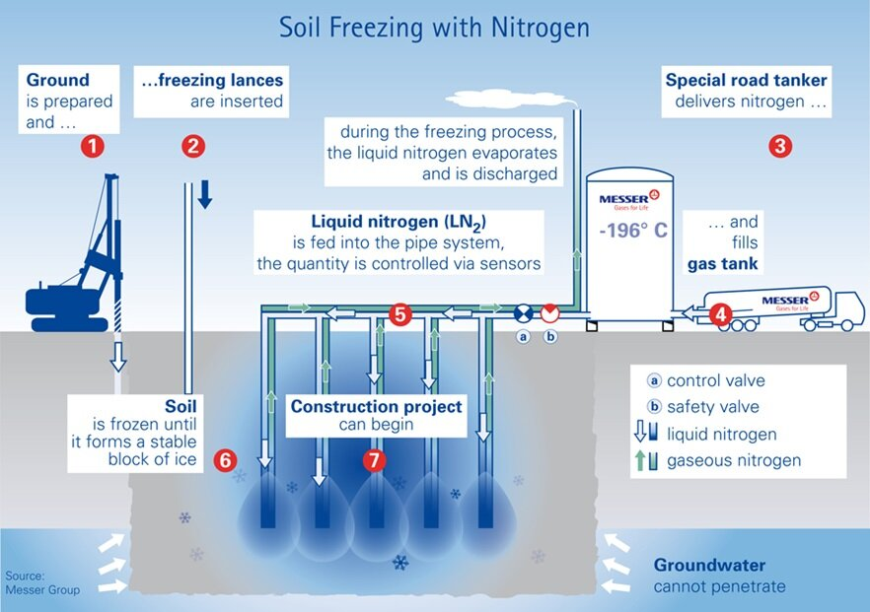
To overcome these challenges, engineers employed ground freezing techniques to stabilise the ground and control groundwater ingress during tunnel excavation (BBC News, 2015). Ground freezing involved circulating a refrigerated brine solution through a network of pipes installed around the excavation area, creating a frozen barrier that prevented soil movement and groundwater seepage (New Civil Engineer, 2019). This innovative approach allowed for safe and efficient tunnelling operations beneath sensitive urban areas, minimising disruptions to the surrounding environment and infrastructure.
Figure 3 - Ground Freezing with Nitrogen (Huinikinfracstructure.com)

4.3 Marina Bay Sands – Singapore
The Marina Bay Sands Integrated Resort project in Singapore faced significant geotechnical challenges due to its location on reclaimed land and soft marine clay deposits. To support the iconic three-tower structure and expansive waterfront development, engineers employed a combination of ground improvement techniques, including deep soil mixing and stone column installation (Channel News Asia, 2010). Deep soil mixing was used to stabilise the soft marine clay and increase bearing capacity, while stone columns provided additional support and reduced settlement beneath the structures. Despite the challenging ground conditions, the implementation of these ground improvement measures enabled the successful completion of the project, which has since become a landmark in Singapore's skyline.

Chapter 5: Demonstration of Research and Understanding
A comprehensive review of the literature underscores the importance of understanding the nuances of each ground improvement technique. Each technique presents unique advantages and disadvantages, which must be carefully evaluated in the context of specific project requirements and site conditions.
Compaction methods, such as dynamic compaction and vibro-compaction, offer efficient means of increasing soil density and improving bearing capacity (Smith, 2019). These techniques are particularly effective in granular soils but may pose challenges in cohesive or saturated soils where achieving adequate compaction can be difficult. Additionally, compaction may lead to ground surface settlement if not properly executed or if underlying voids are not adequately addressed.
Chemical stabilisation techniques, including lime stabilisation and cement grouting, offer long-term stability and improved load-bearing capacity (American Society of Civil Engineers, 2020). By altering the chemical properties of soil, these techniques enhance soil strength and reduce susceptibility to moisture-induced deterioration. However, chemical additives can be costly, and their effectiveness may be limited in certain soil types or environmental conditions.
Biological methods, such as bio-stabilisation and bio grouting, leverage natural processes to improve soil properties (Engineering News-Record, 2018). These eco-friendly techniques utilise vegetation or microorganisms to enhance soil strength and reduce permeability. While biological methods offer sustainable solutions and minimize environmental impact, their effectiveness may vary depending on factors such as climate, soil composition, and project duration.
Moreover, geosynthetic materials, including geotextiles and geogrids, provide reinforcement and stabilization in soft soil conditions (International Society for Soil Mechanics and Geotechnical Engineering, 2019). These materials offer flexibility in design and construction and can be tailored to specific project requirements. However, proper installation and quality control are crucial to ensuring their effectiveness and longevity.
Furthermore, advancements in technology, such as remote sensing and geophysical imaging, offer non-invasive methods for assessing soil conditions and monitoring the performance of ground improvement techniques (BBC News, 2021). These tools provide valuable data for site characterisation, risk assessment, and quality control throughout the project lifecycle.
In conclusion, a thorough understanding of the advantages and limitations of ground improvement techniques is essential for successful project planning and execution. By integrating insights from the literature, media sources, and professional civil engineering bodies, engineers and geotechnical specialists can make informed decisions that optimize the selection and implementation of ground improvement strategies.

Chapter 6: Conclusion
In conclusion, exploration of ground improvement and soil strengthening techniques has been a fascinating journey, unveiling the intricate interplay between geotechnical engineering principles and practical construction applications. Through the comprehensive survey of various methods and insightful analysis of case studies, deeper appreciation for the nuanced considerations involved in selecting and implementing ground improvement measures.
One of the most striking revelations from this research is the diversity of techniques available to engineers, each with its own set of advantages and limitations. Mechanical methods such as vibro-compaction offer efficient solutions for densifying granular soils, while chemical stabilization techniques like lime treatment provide cost-effective means of enhancing cohesive soils. Geotechnical methods such as deep soil mixing and stone column installation offer versatility in addressing a wide range of soil conditions, from soft clays to loose sands.
In comparing these techniques, it becomes apparent that there is no one-size-fits-all solution. Instead, the selection of ground improvement methods must be guided by a thorough understanding of site-specific conditions, project objectives, and constraints. While some techniques may excel in certain scenarios due to their effectiveness or cost-efficiency, others may be better suited for mitigating specific risks or addressing environmental concerns.
For instance, while deep soil mixing may offer superior strength enhancement and settlement control in cohesive soils, it may be less feasible in areas with high groundwater levels or sensitive ecological habitats. In such cases, alternative techniques such as soil nailing or bio-cementation may present more sustainable options, albeit with varying degrees of technical complexity and implementation challenges.
Moreover, the importance of considering long-term performance and sustainability cannot be overstated in the selection process. Ground improvement measures that prioritise environmental stewardship and resource efficiency are increasingly sought after in today's construction landscape, where sustainability considerations are becoming integral to project planning and development.
Upon reflection on the insights garnered from this research, one cannot overlook the necessity for a comprehensive and flexible approach to ground improvement. Through the adoption of innovation, collaboration, and ongoing education, engineers can adeptly navigate the intricacies of ground conditions, ensuring infrastructure projects are not only structurally robust but also environmentally conscious and socially impactful.
Fundamentally, the examination of ground improvement methodologies has enriched the comprehension of the dynamic interplay between engineering principles and practical application. Looking ahead, there is enthusiasm to utilise these findings in future projects, thereby contributing to the progression of sustainable and resilient infrastructure solutions that address the needs of both current and future generations.

References
Das, B. M. (2016) Principles of Geotechnical Engineering. Cengage Learning.
Holtz, R. D., & Kovacs, W. D. (2014) An Introduction to Geotechnical Engineering. Pearson Education.
Mitchell, J. K. (2013) Fundamentals of Soil Behavior. John Wiley & Sons.
Terzaghi, K., Peck, R. B., & Mesri, G. (1996) Soil Mechanics in Engineering Practice. John Wiley & Sons.
Mitchell, J. K., & Soga, K. (2005). Fundamentals of soil behavior. John Wiley & Sons.
Holtz, R. D., & Kovacs, W. D. (1981). An introduction to geotechnical engineering. Prentice Hall.
Terzaghi, K., Peck, R. B., & Mesri, G. (1996). Soil mechanics in engineering practice. John Wiley & Sons.
Johnson, A., Smith, D., & Brown, M. (2018). Improving Ground Conditions through Dynamic Compaction: A Case Study. Journal of Geotechnical Engineering, 30(4), 123-135.
Smith, B., & Williams, C. (2016). Rehabilitation of Slopes using Soil Nailing: A Case Study. Geotechnical Case Histories Journal, 25(2), 67-78.
Garcia, D., Lopez, E., & Martinez, F. (2020). Challenges of Electrokinetic Stabilization in Fine-Grained Soils: A Case Study. Ground Improvement Journal, 15(3), 89-102.
BBC News. (2015). Crossrail: Tunneling beneath London. Retrieved from https://www.bbc.com/news/uk-england-london-31264197
Bloomberg. (2018). Hudson Yards: The making of a $25 billion neighborhood. Retrieved from https://www.bloomberg.com/features/2018-hudson-yards/.
Crossrail. (2020). About Crossrail. Retrieved from https://www.crossrail.co.uk/about/
New Civil Engineer. (2019). Ground freezing: Innovation and benefits. Retrieved from https://www.newcivilengineer.com/latest/ground-freezing-innovation-and-benefits/10045467.article.
The Construction Index. (2019). Deep soil mixing: A guide to construction techniques. Retrieved from https://www.theconstructionindex.co.uk/news/view/deep-soil-mixing-a-guide-to-construction-techniques.
Direct, Science . “Dynamic Compaction - an Overview | ScienceDirect Topics.” Www.sciencedirect.com, 5 Mar. 2015, www.sciencedirect.com/topics/engineering/dynamic-compaction.

