Student name: Priyanka Kakadiya Student number: 2527512
Module code & title: LCHS7003, Community care and management of long-term conditions
Assignment title: Component 1 Information Booklet of Long- term Condition Management
Booklet title(topic): Type 2 diabetes in the UK Lecturer: Rahila shaikh


Table of Contents
- Introduction 3
- Explanation and evaluation of the long-term condition 3
  - Definition 3
  - Prevalence of the long-term conditions 4
  - Risk factors 5
- Critical evaluation of the impact of long-term conditions 6
  - Impact on the physical, psychological and social implications on individuals 6
  - Impact on the families involved in the care provision 9
  - Evidence-based treatments available in the UK through the NHS 9
- Investigation of current perspectives of theory or framework for improving outcomes for the affected patients 10
- Implementation of the local and national political and social care agendas to promote developmental initiatives 12
  - Critical Evaluation of the agendas for promoting initiatives of healthcare development 14
- Recommendation to improve person-centred care 15
- Conclusion 18
Reference list 20
QR Code 25

Introduction
- Chronic diseases are often called long-term conditions that require continuous medical attention.
- These are examples of the long-term conditions, including diabetes, arthritis, high blood pressure, asthma, epilepsy and others.
- The present study is going to focus on Type 2 Diabetes, which has become the most common cause of long-term illness in the UK.
- The target audience in the study is the older adults who belong to the age group from 45 to 60 affected by Diabetes Mellitus in the UK (Kaleru et al., 2020).
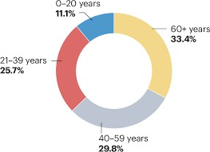
- The aim of this booklet is the development of person-centred care services for the affected people in the UK with respect to the present local as well as national care agendas.

Figure 1: Target Age group of Type 2 Diabetes in the UK
(Source: Tomic et al., 2024)

Explanation and evaluation of the long-term condition

Definition
    - Type 2 Diabetes Mellitus (T2DM) is one of the most common conditions of health, which often causes high levels of sugar in the blood (NHS Inform, 2023).
    - T2DM is a multifunctional metabolic disorder that often arises due to resistance to insulin, impairment of regulation of glucose and the progressive dysfunction of the beta-cell.

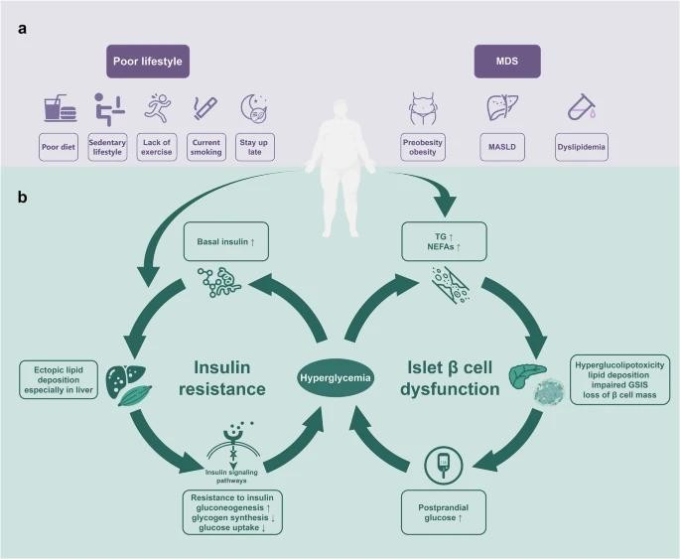

Figure 2: Pathophysiology of T2D
(Source: Lu et al., 2024)

Prevalence of the long-term conditions
    - Prevalence of T2DM has risen at an alarming rate due to the influence of genes, lifestyle, environment and the socio-economic factors.
    - In the year 2021, there were approximately 3.6 million people in England affected by Type 2 diabetes, with a prevalence rate of 7.8% (Gov.UK, 2025).
    - As per the current study, approximately 6.3 million people are at risk of type 2 diabetes in the UK, depending on the level of blood sugar (Diabetes UK, 2023).
    - Nearly 12.1 million adults in the UK are living with the symptoms of diabetes or prediabetes (Diabetes UK, 2023).

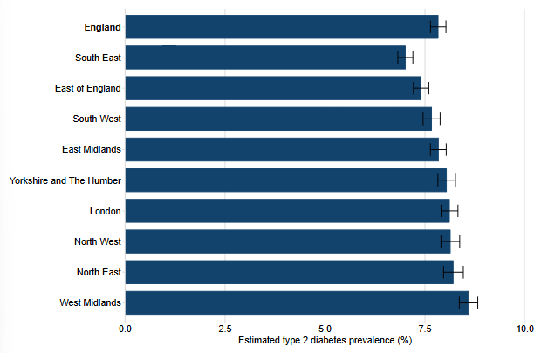

Figure 3: Estimated prevalence of type 2 diabetes patients
(Source: Gov.UK, 2025)
    - The prevalence of T2D is much higher among older adults above 50 years compared to T1D, and the percentages have increased 329% globally (Lin et al., 2025).
    - Another study has indicated the crude prevalence of type 2 diabetes in the UK rose from 2.95% to 5.41% from 2004 to 2021 (Currie, 2024).

Risk factors
    - Factors that increase the risk of type 2 diabetes are obesity, shortcomings of physical activity, unhealthy patterns of diet, predisposition of genes, psychological stress, environmental toxins and the determinants of the socio- economic factors (NIDDK, 2022).
    - Excess visceral fat often leads to insulin resistance and increased production of glucose by the liver (Chakraborty, 2025). Visceral fat secretes proinflammatory cytokines to disrupt the balance of hormones and metabolism of glucose.
    - A sedentary lifestyle, like prolonged sitting, minimal body activity, reduces the uptake of glucose from muscle and impairs the sensitivity of insulin, increasing risks.

    - Smoking is an independent factor of risk for T2DM, as the nicotine-like harmful compounds from cigarettes often contribute to the resistance of insulin and inflammation, negatively influencing the metabolism of glucose (Chakraborty, 2025).
    - Chronic stress related to the workplace, finance and emotions often triggers cortisol, which elevates the level of blood sugar by promoting the accumulation of fat.
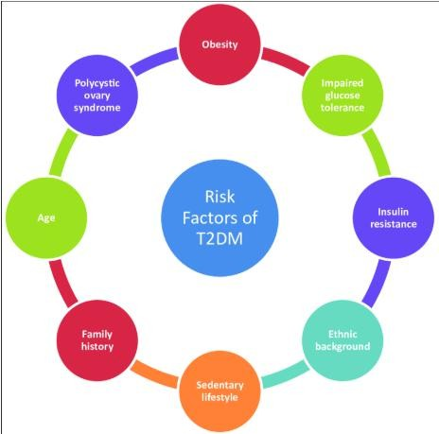
    - In England, obese adults are more likely to be diagnosed with diabetes five times than healthy adults (Public Health England, 2020).

Figure 4: Risk Factors for T2DM
(Source: Banday et al., 2020)

Critical evaluation of the impact of long-term conditions

Impact on the physical, psychological and social implications on individuals

Physical Implications
    - Type 2 diabetes often increases the risks related to cardiovascular disease; failure of the kidneys and loss of vision lead to a reduction in life expectancy, along with a reduction in life quality.
    - As stated by Nabrdalik et al. (2023), microvascular complications of diabetes often cluster and introduce high risks of cardiovascular disease (CVD).

    - Studies have shown that approximately 9.8% of Type 2 diabetics have suffered from a heart attack, 9.1% and 7.9% have suffered from coronary artery disease (CAD) and congestive heart failure (Trikkalinou et al., 2017).
    - From the point of view of Gracia-Sánchez et al. (2023), 15 to 25% of diabetes mellitus patients are often affected by the serious problem of health, such as foot ulcers, which is associated with the increased rate of morbidity, mortality and costs of healthcare.
    - As there are presently 12.3 million people in the UK who have become affected by the risk of T2DM, the NHS has spent approximately £10 billion annually on the diagnosis of patients (Edeghere and English, 2019).
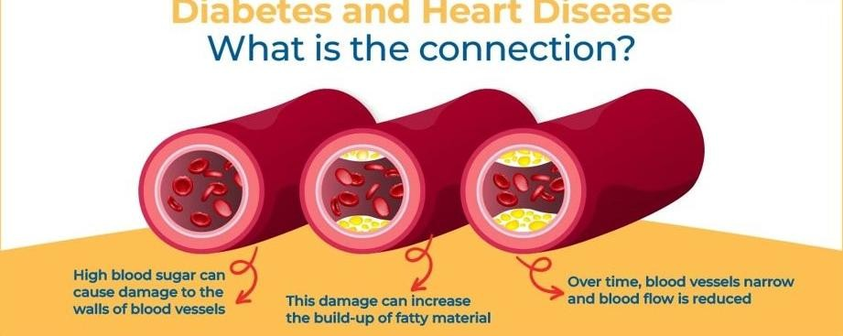
    - However, the disease has strained 9% of the annual budget launched by the NHS in a year, which has increased economic burden on both individuals and households (Smith, 2018).

Figure 5: Connection between Diabetes and heart disease
Source: (Lalpathlab, 2023)

Psychological Implications
    - People affected by Type 2 diabetes have experienced a high rate of depression, anxiety, and other distress due to the fear of complications. Approximately 63% of the people living with type 2 diabetes have encountered difficulties in managing the conditions related to the challenges of mental health (Drwf.org.uk, 2024).
    - Diagnosis of Type 2 Diabetes often worsens mental health and reduces overall satisfaction with life due to the stigma and restrictions of lifestyle.
    - Embedding psychological support in diabetes care can support individuals in self-management.

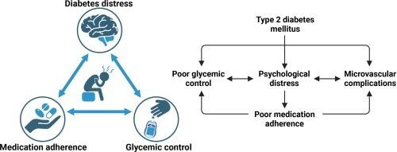

Figure 6: Diabetes causing psychological distress
(Source: Akshatha and Nayak, 2024)

Social Implications
    - Type 2 diabetes patients often experience social isolation due to the limited networks in society, social support and reduction of contact in society (Lin et al., 2024).
    - Employees living with diabetes often experience stigma; therefore, they are discouraged from performing the daily routine of self-care (CDC, 2024).
    - A vulnerable group of people with severe mental illness often experience compound emotional difficulties and poor accessibility to quality care services for diabetes.
    - Along with the medical interventions, strategies of public health are also required for addressing the stigma of lifestyle and integration of mental health.
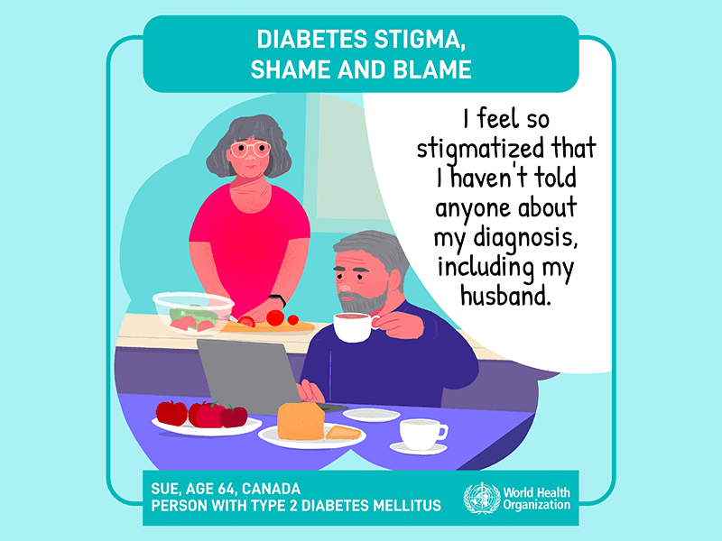

Figure 7: Diabetes and Stigma
(Source: Piemonte, 2022)

Impact on the families involved in the care provision
    - Families having Type 2 diabetes patients have demonstrated a high level of concerns related to mental health, family resilience and higher usage of the emergency care (Roy et al., 2025). Due to the constant vigilance and support requirements, partners and caregivers have reduced the quality of their care.
    - Dietary restrictions and leisure activities have reshaped the routines of households, planning of meals and the activities in the free periods. Therefore, the Type 2 diabetes related restrictions have strained the dynamics of the family and the spontaneity of social life.
    - Though the healthcare cost of the NHS is free at the point of usage, the indirect costs related to the diet and transportation to the clinics have heavily impacted families with diabetic patients.

Evidence-based treatments available in the UK through the NHS
The NHS follows the guidelines of NICE for managing Type 2 diabetes in the UK.

Interventions of the lifestyle | Pharmacological treatments | Psychological and social support
- As per NICE guidelines, it is necessary to switch to a balanced diet that is enriched in wholegrains, fruits, vegetables and pulses (NICE, 2022).  - Structured programmes of  education like DESMOND  (“Diabetes  Education and Self- | - The NHS has launched Metformin as one of the standards first- line therapies for Type 2 diabetes.  - As per the new guidance 2026, introduction of the SGLT 2 inhibitors along with the metformin has enabled them to lower the level of glucose in the | - NICE has introduced psychological support into the care of diabetes to recognise the high prevalence of depression among the patients (NICE, 2022).  - NHS programmes have also started to involve the members of the family to improve

Management for Ongoing and Newly Diagnosed”) is also available on the guidelines of NICE (NHS.UK, 2022).  - The NHS also offers a weight-loss programme for the diabetic patient. | blood. Hence, it has protected the heart and kidney from dysfunction (Nice.org.UK, 2026). | adherence and reduce stress from the caregivers (Nice.org.UK, 2026).

Table 1: Available evidence-oriented treatments for T2DM patients by the NHS
(Source: Self-developed)

Investigation of current perspectives of theory or framework for improving outcomes for the affected patients

UK model
- In order to evaluate the outcomes and costs of healthcare interventions, decision-analytic modelling can be the best approach to synthesise the clinical as well as economic data.
- The models can act as the decision-support tools for the reimbursement of the latest drugs, allocation of the resources and the estimation of the budget with respect to the health policy.
- As stated by Keng et al. (2021), "UK Prospective Diabetes Study (UKPDS) Outcomes Model" (UKPDS-OM) is one of the stochastic models for predicting the level of patients through profiling the risk factors of patients affected by T2D.
- Use of the model can support predicting the occurrence of diabetes-related complications over the lifestyle of the patients and the costs of healthcare (Leal et al., 2021).
- Being a computer simulation model, the Outcomes model has estimated the long-term impacts of the health interventions for the people affected by Type 2 diabetes. The model can support policymakers and clinicians to evaluate the interventions with real-life evidence.

- By assessing the cost-effectiveness of the treatments and strategies of prevention, the model can support the NHS in identifying health outcomes of the T2D patients.


International Model

Figure 8: UKPDS Outcomes Model
(Source: Rdm.ac.UK, 2023)

- IDF is known as the global umbrella organisation for over 240 national diabetes associations that belong to 161 countries, territories, and a diverse range of health systems.
- As per the IDF clinical and prevention recommendation, there are two levels of standards for the care of diabetes and its prevention by recognising the diversity in the global system of healthcare and constraints of the resources.

- Use of the IDF model can emphasise the equity of accessing the medications like the SGLT-2 and the GLP-1 receptor.
- It promotes multidisciplinary teams to empower patients through education.
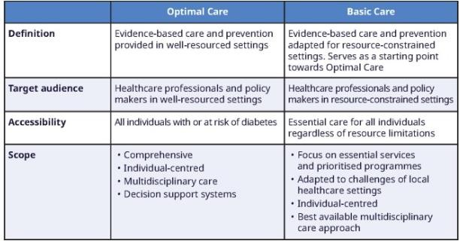

Figure 9: Standard care for diabetes and its prevention
(Source: Ceriello and Colagiuri, 2025)

Comparison between IDF and UKPDS
- IDF can support the screening process to identify people who are undiagnosed with T2D. Offering early service of treatment, IDF can improve the prevention program of diabetes (International Diabetes Federation, 2017).
- IDF supports setting an aspirational standard for the world, while the NICE guidelines can operate only within the UK, along with rising challenges like the cost-effectiveness and constraints of resources (International Diabetes Federation, 2025).
- Though the UK is aligned with the NHS realities, it is looking for global policy actions for handling misalignment of the care services for T2D.

Implementation of the local and national political and social care agendas to promote developmental initiatives

National Agendas
- Aim of the national agenda, like "NHS Diabetes Prevention Programme" (NHS DPP), is the identification of individuals at high risk and offering structured interventions for lifestyle. The agenda has become a part of the wider strategy by the government for reducing non-communicable diseases.

- As opined by Barron et al. (2025), completion of the NHS DPP program has reduced body weight by increasing physical activity and improving diet.
- Though the programme is effective, it has struggled to engage the deprived communities by highlighting the inequalities (Public Health England, 2018).
- Another agenda is the NICE guidelines to manage type 2 diabetes in a comprehensive manner through education and pharmacological interventions (NICE, 2022). Though the NICE guideline is strong for clinical management, it struggles in embedding the psychological and family support into the routine services of care.
- The vision of the Diabetes UK 10-Year agenda is the transformation of prevention, acceleration of innovation and improvement in the care pathway. This agenda often supports the long-term plan of the NHS through emphasising the diagnosis and equitable accessibility of the treatment in the UK.
- Without powerful political will and funding, the costs of NHS diabetes may rise to approximately £18 billion by 2035 (Diabetes.org.UK, 2023).
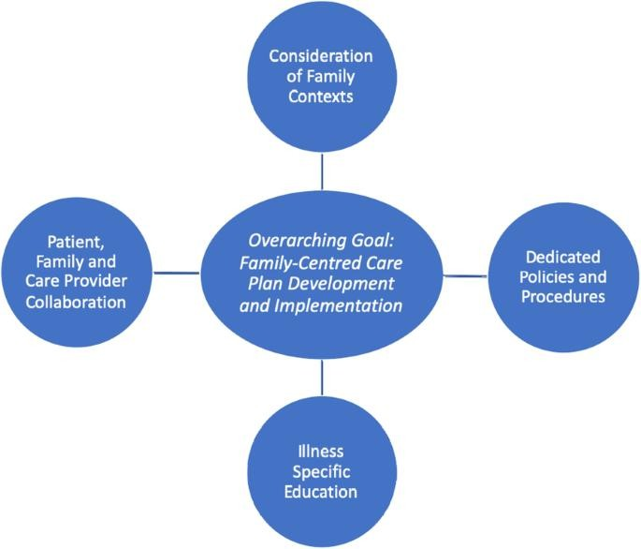

Local Agendas

Figure 10: Family-centred Care plan
(Source: Kokorelias et al., 2019)

- The purpose of Neighbourhood Health Service Initiatives is to offer care services to the elderly in the communities to decrease dependence on the hospitals (Diabetes UK, 2023).
- Neighbourhood initiatives have localised the facilities of education and screening to improve adherence of the communities.
- Another local agenda is the UK support group, NHS community programmers and the social guidance of care for the families to reduce isolation (NHS website, 2025).

Critical Evaluation of the agendas for promoting initiatives of healthcare development
Strengths | Opportunities
- National agendas like the NHS DPP and the NICE guidelines have offered a structured as well as evidence-oriented framework for the healthcare intervention of Type 2 diabetes (Whelan and Bell, 2022)  - Local agendas like the neighbourhood initiatives and community groups have enhanced accessibility to the care services and engagement of patients. | - A combination of the local and national agendas can create a seamless pathway to ensure the prevention of T2D along with the long-term management.  - Use of the digital tools of health and remote monitoring can support national as well as local systems to make a bridge with the underserved regions of society (Maita et al., 2024).
Weaknesses | Threats
- Persistent inequalities have been shown in accessing care services among the socioeconomically disadvantaged groups.  - Though NICE guidelines have focused on family involvement, | - Rising rates of disease prevalence and cost risks might strain the NHS resources.  - Shifts of political power and constraints of funds can decrease the long-term initiatives of the

the psychological as well as family-oriented care have remained underdeveloped in comparison to the physical management (Kokorelias et al., 2019). | national or local agenda.

Table 2: Critical analysis of the National and Local agendas for healthcare outcomes using the SWOT framework
(Source: Self-developed)
Though NICE has promoted the plan for personalised care, the integration of electronic health records is quite tricky due to constraints of financial resources. Key challenges of implementing the electronic health record are the large-scale nature, resistance to change, shortcomings of training among the care providers, lack of technological support, inadequate engagement of users and regional limitations (Alzghaibi and Hutchings, 2025). Shortcomings of coordination with the ongoing pathway of diabetes management have reduced the continuity of care services like NHS DPP for Diabetes in the UK.

Recommendation to improve person-centred care
This part of the study is going to generate a set of recommendations to strengthen person-centric care approaches for managing Type 2 diabetes by focusing on self- management and end-of-life care services.

Improvement in the Person-Centred Self-management
- In the form of a structured program of education, it is necessary to expand the accessibility to the DESMOND approach for ensuring the cultural versions for the tailored communities.
- Involvement of the members of the family in the educational program can reduce the stress level of the caregivers, besides improving adherence of the patients with the program.
- Self-management of the T2D patients can be improved through the wide application of the NHS-approved applications for monitoring of glucose, tracking of lifestyle and reminders for the medicines.

- Remote consultation can be a special support for the T2D patients who belong to rural as well as underserved regions.
- In terms of the psychological support, there can be the facility of routine screening of depression and T2D-oriented distress as the primary care services.
- Access to cognitive behavioural therapy (CBT) can improve the management of medication by the patients themselves.
- NHS can encourage the patients to co-design the plans of care with the support of clinicians by maintaining a balance between healthcare priorities and the individual goals.
- Following motivational interviewing can strengthen the engagement of the patients in decision-making.

Involvement of the Family and Community
- For improving family-oriented care, the development of the NHS toolkit can support the patients in making the plan for diet, medicines and resilience of emotions.
- Training sessions for caregivers can reduce their anxiety by improving their confidence level to manage emergency situations.
- In order to reduce isolation among the T2D patients, local support groups and the champions of community diabetes should be established.
- Partnerships in the schools and workplaces can develop a supportive environment for the patients to manage the disease.

Consideration of the End-of-Life Care services
- To make advancement into the care planning, it is required to encourage early discussions related to the preferences for end-of-life care. In that case, the NHS can document the preferences of the patients using the electronic records of health for ensuring continuity of care services by the healthcare professionals.
- It is necessary to prioritise the comfort level with the goals of treatment. Integration of palliative care into the diabetic services can act as a holistic approach in the future.
- Care providers need to include the patients in the decision-making to support them during transitions.

- Though the NHS developed a long-term plan and National Service Framework, the EOL was underrepresented due to a lack of an updated framework. The NHS should define clear protocols for the treatment of Diabetes Mellitus (Barron et al., 2025).

Policy-level suggestions
- Making alignment between diabetes management and the long-term priorities of the NHS can ensure a seamless level of transition among the prevention of T2D, its care and palliative services.
- In order to ensure equity in the accessibility of healthcare, the NHS can target the deprived communities to reduce disparities in uptake of the program of self- management.
- Training for the healthcare professionals can support in improving the person- oriented communication, cultural competencies and the care services for the chronic conditions.
Using the SMART framework, the study has visualised the recommended actions for improving person-centred care for Type 2 diabetes.
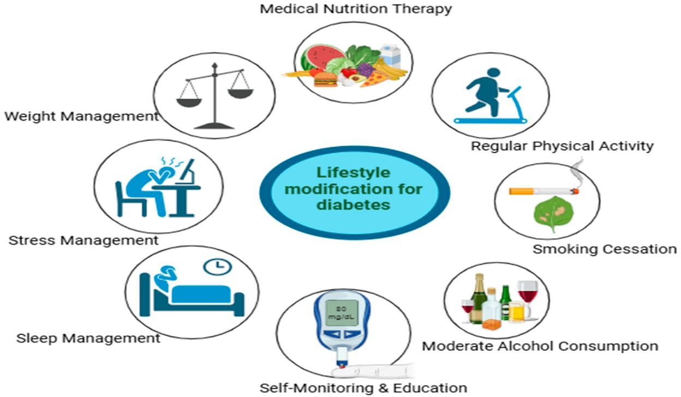

Figure 11: Modification of lifestyle for preventing Diabetes
(Source: Timsina, 2025)

Objectives | Specific | Measurab le | Achievabl e | Relevant | Time- bound

Self- management support | Expansion of the education program DESMOND by  integrating the participation of the family. | Increasing the uptake of the programm e by 25% through the NHS referral and data on attendanc e. | The NHS hub of community and digital platforms can deliver the healthcare sessions. | It can empower patients and families in managing diet and medicines. | It will take 2028.
Integration of Digital Health | NHS-certified apps for monitoring of glucose and tracking of lifestyle for the diagnosed patients. | 70% of the patients can adopt digital health as per the usage of the NHS app. | Leveragin g digital infrastruct ure by the NHS. | Improve the approach of self- management besides reducing admissions into the hospital. | It will need 2029.
Psychological and Family Support | Embedding of the routine screening for stress and depression among the diabetes patients. | Screening of 90% of patients on an annual basis. | Training the primary care staff on the psychologi cal assessme nt tools. | Reduce mental stress and improve the resilience of the family. | 2027

Conclusion

Table 3: SMART Recommendations
(Source: Self-developed)

- In the concluding section, it can be stated that management of Type 2 diabetes in the UK requires a holistic as well as person-oriented approach beyond the clinical treatment.
- The UK's political health, as well as social care agendas for Type 2 diabetes, have shown a strong presence of leadership through launching the two programmes.
- NHS DPP and the NICE guidelines have complemented through the health services offered by the local neighbourhood.

- However, gaps are identified in the equity, support of psychology and involvement of the family members.
- Improved outcomes of health often depend on the support of self-management, involvement of the family and end-of-life planning for the care services into the routine practices.
- Use of the evidence-based treatments, including the interventions of lifestyle, advanced therapies of pharmacology, psychological counselling, and digital tools of health, has become complemented by the IDF framework and the UKPDS Outcomes Model.
- The challenge is not only medical, but rather healthcare intervention of T2D is also social as well as political to tackle inequalities and stigma.
- Adoption of a more integrated and holistic approach, combined with the national policy, can offer the best possibilities to improve the outcomes of healthcare services for Type 2 diabetes in the UK.

Reference list
Akshatha, S. and Nayak, U.B. (2024) ‘The psychological distress associated with type 2 diabetes mellitus represents an unmet need for drug discovery’. Medicine in Drug Discovery 23, p. 100196. Available at:
https://www.sciencedirect.com/science/article/pii/S2590098624000216 (Accessed: 26
February 2026).

Alzghaibi, H. and Hutchings, H.A. (2025) ‘Barriers to the implementation of large-scale electronic health record systems in primary healthcare centers: a mixed-methods study in Saudi Arabia’. Frontiers in Medicine 12. doi: https://doi.org/10.3389/fmed.2025.1516714.
Barron, E., Chappell, P., Hatfield, I., David and Valabhji, J. (2025) ‘Association between the English National Health Service Diabetes Prevention Programme and incident multiple long- term conditions’. Nature Medicine , pp. 1–7. Available at: https://www.researchgate.net/publication/395403434_Association_between_the_English_Na tional_Health_Service_Diabetes_Prevention_Programme_and_incident_multiple_long- term_conditions (Accessed: 24 February 2026).
Banday, M., Sameer, A. and Nissar, S. (2020) ‘Pathophysiology of diabetes: An overview’. Avicenna Journal of Medicine 10(4), pp. 174–188. Available at: https://pmc.ncbi.nlm.nih.gov/articles/PMC7791288/ (Accessed: 26 February 2026).
CDC (2024) Diabetes Stigma. Available at: https://www.cdc.gov/diabetes/articles/diabetes- stigma.html (Accessed: 24 February 2026).
Ceriello, A. and Colagiuri, S. (2025) ‘IDF global clinical practice recommendations for managing type 2 diabetes – 2025’. Diabetes Research and Clinical Practice , p. 112152. doi: https://doi.org/10.1016/j.diabres.2025.112152.
Chakraborty, A. (2025) ‘Systematic Review: Risk Factors for Developing Type 2 Diabetes Mellitus’. European Journal of Cardiovascular Medicine 15(1), pp. 382–390. Available at: https://healthcare-bulletin.co.uk/article/systematic-review-risk-factors-for-developing-type-2- diabetes-mellitus-2743/ (Accessed: 24 February 2026).
Currie, C.J. (2024) ‘The descriptive epidemiology of type 2 diabetes in the United Kingdom from 2004 to 2021’. medRxiv (Cold Spring Harbor Laboratory) . doi: https://doi.org/10.1101/2024.03.04.24303693.
Diabetes UK (2023) How Many People in the UK Have diabetes?. Available at: https://www.diabetes.org.uk/about-us/about-the-charity/our-strategy/statistics (Accessed: 24

February 2026).
Diabetes.org.UK (2023) 10 Year Vision . Available at: https://www.diabetes.org.uk/sites/default/files/2025- 05/Diabetes%20is%20Serious_10%20year%20vision_2025%201.pdf (Accessed: 24
February 2026).

Drwf.org.uk (2024) Report on type 2 diabetes reveals many people experience anxiety and depression - Diabetes Research & Wellness Foundation. Available at: https://www.drwf.org.uk/news-and-events/news/report-on-type-2-diabetes-reveals-many- people-experience-anxiety-and-depression/ (Accessed: 24 February 2026).
Edeghere, S. and English, P. (2019) ‘Management of type 2 diabetes: now and the future’.
Clinical Medicine 19(5), pp. 403–405. doi: https://doi.org/10.7861/clinmed.2019-0318.

Gracia-Sánchez, A. et al. (2023) ‘Consensus-based recommendations on physical activity and exercise in patients with diabetes at risk of foot ulcerations: a Delphi study’. Brazilian Journal of Physical Therapy 27(2), pp. 100500–100500. doi: https://doi.org/10.1016/j.bjpt.2023.100500.
International Diabetes Federation (2017) IDF Clinical Practice Recommendations for managing Type 2 Diabetes in IDF Clinical Practice Recommendations for managing Type 2 Diabetes in Primary Care. Available at: https://idf.org/media/uploads/2023/05/attachments-
63.pdf (Accessed: 25 February 2026).

International Diabetes Federation (2025) Diabetes Facts & Figures. Available at: https://idf.org/about-diabetes/diabetes-facts-figures/ (Accessed: 24 February 2026).
Kaleru, T., Vankeshwaram, V.K., Maheshwary, A., Mohite, D. and Khan, S. (2020) ‘Diabetes Mellitus in the Middle-Aged and Elderly Population (>45 Years) and Its Association With Pancreatic Cancer: An Updated Review’. Cureus . doi: https://doi.org/10.7759/cureus.8884.
Keng, M.J., Leal, J., Mafham, M., Bowman, L., Armitage, J. and Mihaylova, B. (2021) ‘Performance of the UK Prospective Diabetes Study Outcomes Model 2 in a Contemporary UK Type 2 Diabetes Trial Cohort’. Value in Health . doi: https://doi.org/10.1016/j.jval.2021.09.005.
Kokorelias, K.M., Gignac, M.A.M., Naglie, G. and Cameron, J.I. (2019) ‘Towards a universal model of family centered care: A scoping review’. BMC Health Services Research 19(1), pp.

1–11. Available at: https://www.ncbi.nlm.nih.gov/pmc/articles/PMC6693264/.

Lalpathlab (2023) Diabetes and Heart Diseases: How Diabetes Affects The Heart - Dr Lal PathLabs Blog. Available at: https://www.lalpathlabs.com/blog/diabetes-and-heart-diseases/ (Accessed: 26 February 2026).
Leal, J. et al. (2021) ‘Estimating risk factor progression equations for the UKPDS Outcomes Model 2 (UKPDS 90)’. Diabetic Medicine 38(10). doi: https://doi.org/10.1111/dme.14656.
Lin, K., Wang, J., Bai, X. and Liu, Y. (2024) ‘Social Isolation in People with Type 2 Diabetes: a Concept Analysis’. Heliyon 10(16), pp. e36261–e36261. Available at: https://www.sciencedirect.com/science/article/pii/S240584402412292X (Accessed: 24
February 2026).

Lin, L., Chen, P., Zhang, Y., Long, J., Wang, W., Sun, X. and Zhang, X. (2025) ‘Burden of type 2 diabetes mellitus and risk factor attribution among older adults: A global, regional, and national analysis from 1990 to 2021, with projections up to 2040’. Diabetes, Obesity and Metabolism 27(8), pp. 4330–4343. doi: https://doi.org/10.1111/dom.16471.
Lu, X. et al. (2024) ‘Type 2 diabetes mellitus in adults: Pathogenesis, prevention and therapy’. Signal Transduction and Targeted Therapy 9(1), p. 262. Available at: https://www.nature.com/articles/s41392-024-01951-9 (Accessed: 24 February 2026).
Maita, K.C. et al. (2024) ‘The impact of digital health solutions on bridging the health care gap in rural areas: A scoping review’. The Permanente Journal 28(3), pp. 1–14. Available at: https://pmc.ncbi.nlm.nih.gov/articles/PMC11404635/ (Accessed: 24 February 2026).
Nabrdalik, K. et al. (2023) ‘Diabetic peripheral neuropathy is associated with diabetic kidney disease and cardiovascular disease – The Silesia Diabetes-Heart Project’. Current Problems in Cardiology 48(8), p. 101726. doi: https://doi.org/10.1016/j.cpcardiol.2023.101726.
National Health Service Inform (2023) Type 2 Diabetes Symptoms and Treatments. Available at: https://www.nhsinform.scot/illnesses-and-conditions/diabetes/type-2-diabetes/ (Accessed: 24 February 2026).
NHS website (2025) Help and support for type 2 diabetes. Available at: https://www.nhs.uk/conditions/type-2-diabetes/support/ (Accessed: 24 February 2026).
NHS.UK (2022) Structured Education for Type 2 diabetes A toolkit for optimal delivery. Available at: https://www.england.nhs.uk/london/wp-

content/uploads/sites/8/2022/09/Structured_Education_Toolkit_Final.pdf (Accessed: 24
February 2026).

NICE (2022) Type 2 Diabetes in adults: Management. Available at: https://www.nice.org.uk/guidance/ng28 (Accessed: 24 February 2026).
Nice.org.UK (2026) Major changes to type 2 diabetes treatment could save thousands of lives. Available at: https://www.nice.org.uk/news/articles/major-changes-to-type-2-diabetes- treatment-could-save-thousands-of-lives (Accessed: 24 February 2026).
NIDDK (2022) Risk factors for Type 2 Diabetes. Available at: https://www.niddk.nih.gov/health-information/diabetes/overview/risk-factors-type-2-diabetes (Accessed: 24 February 2026).
Office for Health Improvement & Disparities (2025) Diabetes profile: Statistical commentary, March 2025. Available at: https://www.gov.uk/government/statistics/diabetes-profile-update- march-2025/diabetes-profile-statistical-commentary-march-2025 (Accessed: 24 February 2026).
Public Health England (2018) Health matters: Preventing Type 2 Diabetes. Available at: https://www.gov.uk/government/publications/health-matters-preventing-type-2- diabetes/health-matters-preventing-type-2-diabetes (Accessed: 24 February 2026).
Public Health England (2020) Adult obesity and type 2 diabetes. Available at: https://assets.publishing.service.gov.uk/media/5a7f069140f0b6230268d059/Adult_obesity_a nd_type_2_diabetes_.pdf (Accessed: 25 February 2026).
Rdm.ac.UK (2023) UKPDS Outcomes Model Version 2.2 Released — Radcliffe Department of Medicine. Available at: https://www.rdm.ox.ac.uk/news/ukpds-outcomes-model-version-2- 2-released (Accessed: 24 February 2026).
Roy, Bensignor, M.O., Grolnick, W.S. and Scal, P.B. (2025) ‘The impact of type 2 diabetes on adolescent and family functioning and healthcare use: findings from the National Survey of Children’s Health’. Frontiers in Endocrinology 16. doi: https://doi.org/10.3389/fendo.2025.1589745.
Smith, J. (2018) Health Matters: Preventing Type 2 diabetes - UK Health Security Agency. Available at: https://ukhsa.blog.gov.uk/2018/05/24/health-matters-preventing-type-2- diabetes/ (Accessed: 24 February 2026).

Timsina, Y. (2025) ‘Lifestyle Interventions for the Management of Type 2 Diabetes Mellitus: A Narrative Review’. Available at: https://www.preprints.org/manuscript/202512.1879 (Accessed: 26 February 2026).
Tomic, D., Harding, J.L., Jenkins, A.J., Shaw, J.E. and Magliano, D.J. (2024) ‘The epidemiology of type 1 diabetes mellitus in older adults’. Nature Reviews Endocrinology . Available at: https://www.nature.com/articles/s41574-024-01046-z (Accessed: 26 February 2026).
Trikkalinou, A., Papazafiropoulou, A.K. and Melidonis, A. (2017) ‘Type 2 diabetes and quality of life’. World Journal of Diabetes 8(4), p. 120.
Whelan, M. and Bell, L. (2022) ‘The English National Health Service Diabetes Prevention Programme (NHS DPP): A scoping review of existing evidence’. Diabetic Medicine 39(7). Available at: https://pmc.ncbi.nlm.nih.gov/articles/PMC9321029/

QR Code



