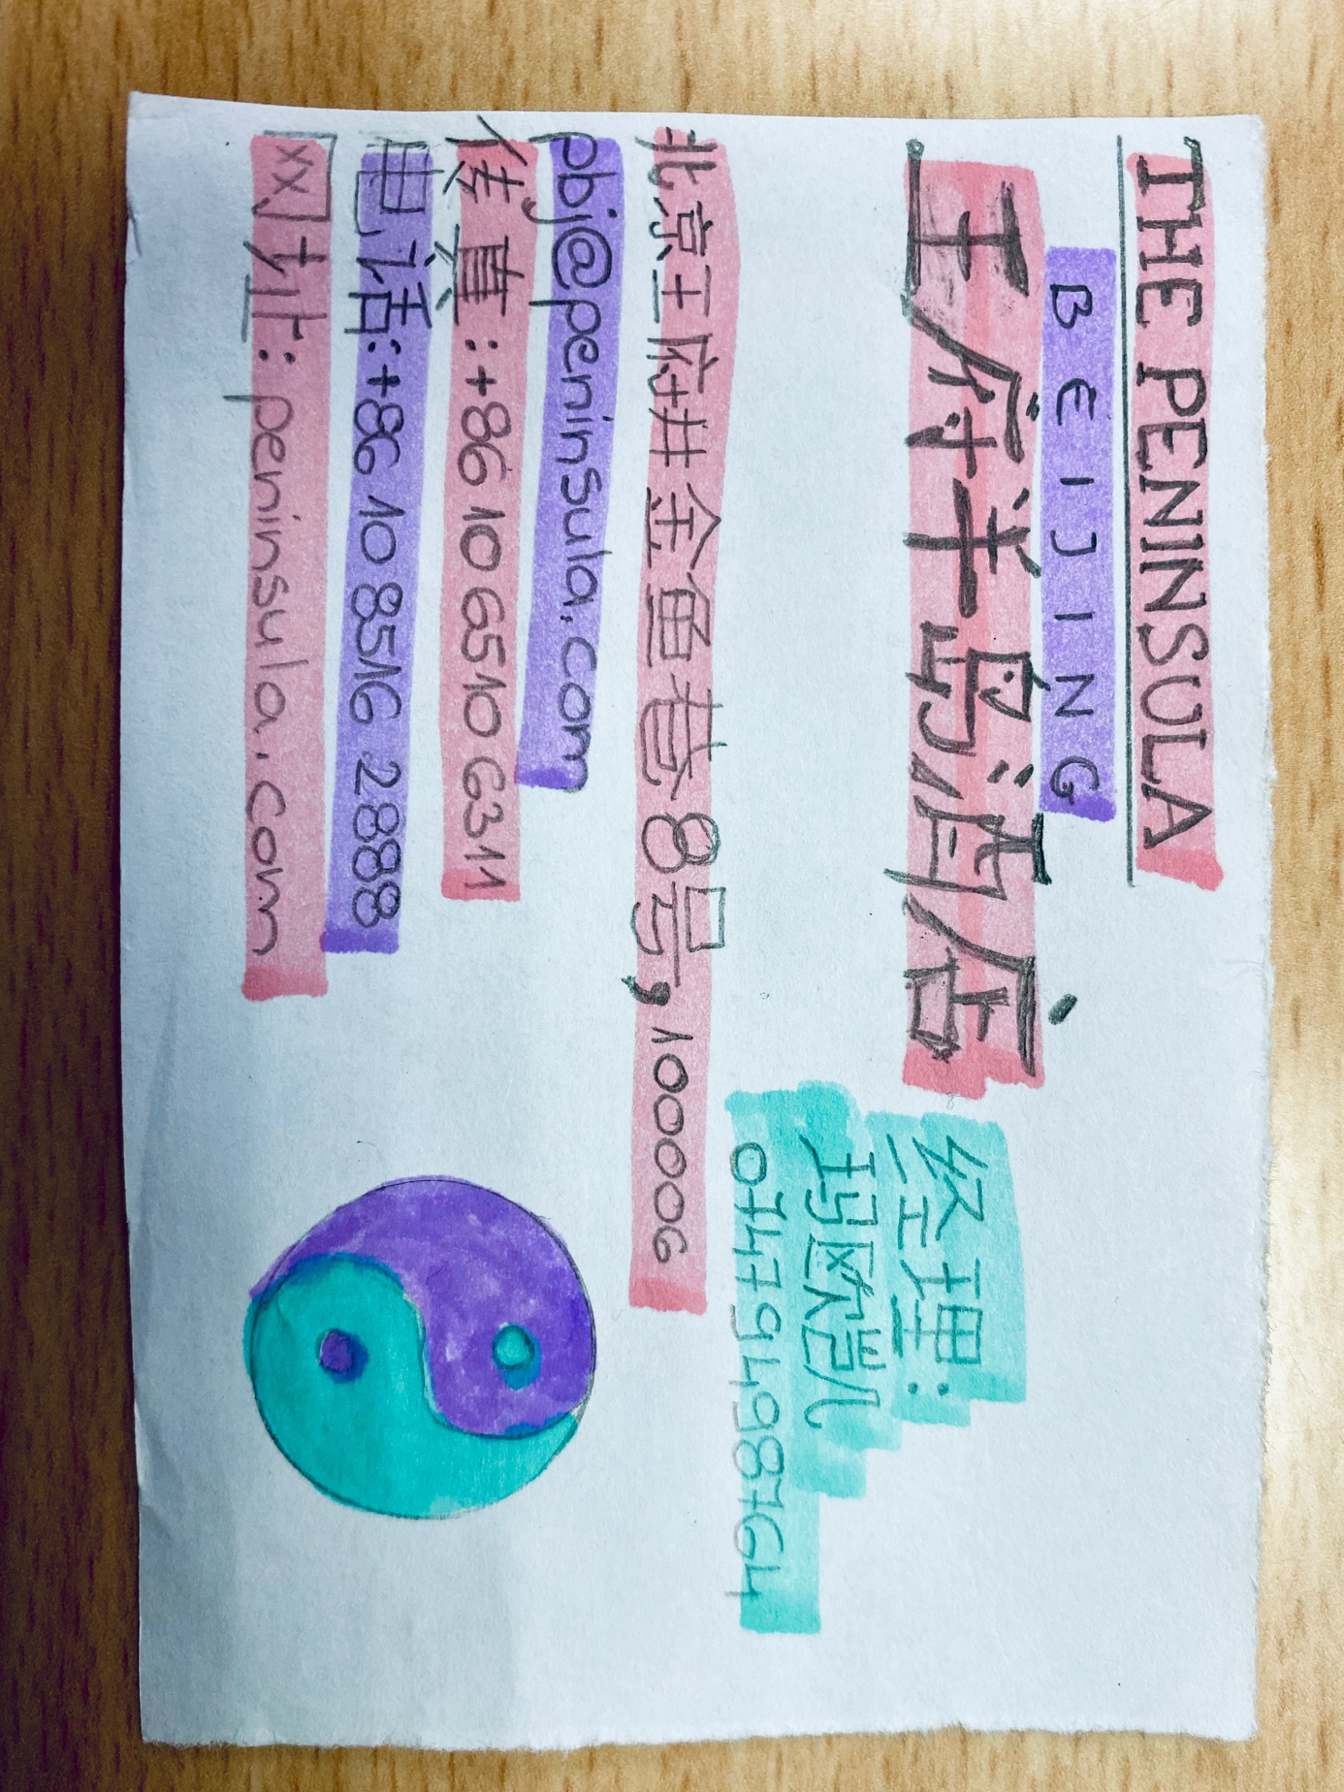
Module : Foreign Languages and Cultural Awareness
Assignment title: Business Card
Student: Emoke Gego- 1815061
Teacher: Jinping Li

University of Wales Trinity Saint David – 2019

