Video review on ‘The Battle of Hastings – Searching for Bodies.’
The YouTube video ‘The Battle of Hastings – Searching for Bodies’ (2018) by SOTNI UK, explores an alternative theory surrounding the site of the Battle of Hastings. The traditional site of Battle Abbey is disregarded as the actual site of fighting, SOTNI UK also opposes the proposed landing site of Pevensey. The theory presented is that the Norman army landed at Wilting in the Combe Haven and the Battle of Hastings took place at Crowhurst two miles south of Battle (The Past, 2013). It is also suggested that an unidentified ruin next to the current church is the abbey built on the battle site (SOTNI UK, 2018). This version of events is proposed and pursued mainly by Nick Austin a local historian and author, the video also includes research author Phillip Day and Dr Meg Watters. The video uses various techniques to influence the audience’s reception of their claims including music, maps, film excerpts and field interviews. The credibility and motivation of the claims made during the video are also worth examining as they impact the reception of the video by the public and academics.
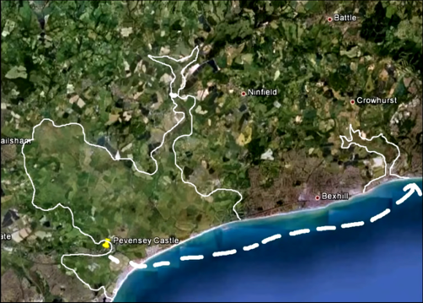
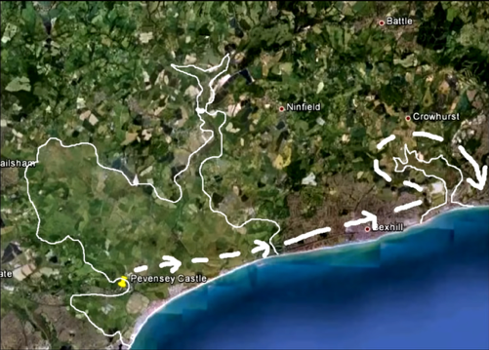
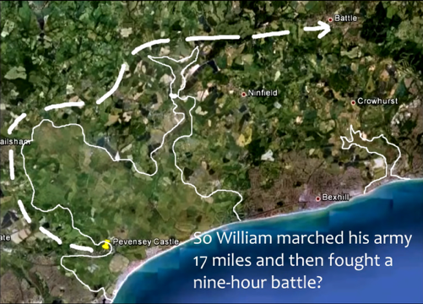
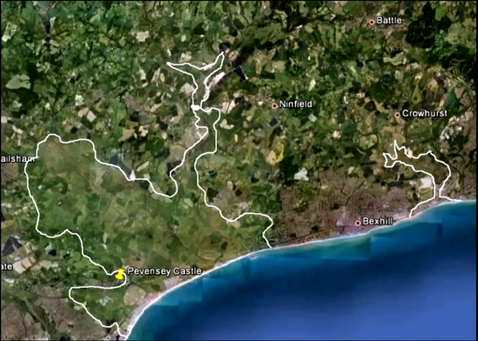
One of the major techniques used throughout the video is the use of maps to portray the reliability of the proposed theory. Figure 1 shows a satellite map of the current (as of 2018) coastline with Pevensey Castle noted. Drawn over this map is an estimate of the coastline in 1066, this allows the viewer to visualise the areas the narrator is speaking about. This map has not been interpreted unlike the maps in figures 2, 3 and 4, these highlight different routes from the proposed landing site of William to Battle the official Battle site. The narrator comments on how this would be foolish, thereby belittling the audience and the customary narrative. Other maps that are edited to present SOTNI’s theories include aerial photographs of the Wilting site with an upper and lower fort area circled, neither of which have been confirmed as forts (SOTNI, 2018). Presenting information as fact to the public - who this video is aimed at – without acknowledging the unsubstantiated nature of the claims, is deceptive and irresponsible. Orchestral music is used throughout the video to create a unified tone (SOTNI UK, 2018, Bricca, 2023). It’s used to add emotion to influence the audience and make it more convincing. Film excerpts of reenactors fighting, reminiscent of other archaeological documentaries on historical battles, adds importance and weight to their argument to make their theories more believable to their audience. Field interviews are used to manufacture credibility and mimic the format seen in other trustworthy archaeological tv shows like Digging for Britain. This creates the perception of reliability.
Figure 4: Map suggesting another route using Pevensey landing site (SOTNI UK, 2018)
Figure 3: Map with route drawn on from Pevensey (SOTNI UK, 2018)
Figure 2: Map with showing the route of William using traditional sites (SOTNI UK, 2018)

Figure 1: Map with the coastline of 1066 drawn in white (SOTNI UK, 2018)
Nick Austin claims to have been visited by the Divine Spirit who led him to believe that Crowhurst was the site of the Battle of Hastings (Hastings Online Times, 2025). He uses the video to promote his book, Secrets of the Norman Invasion (SOTNI UK, 2018). Austin also opposed the local link road that he suggested runs through the battle site, this has created some friction between himself and academics who countered his claims to the committee (Austin, no date a). He appears to be motivated by challenging the official narrative which he claims has been perpetuated by academics and English heritage (SOTNI UK, 2018). Dr Meg Watters included in the video discusses what a geological survey is, it is purely informative, and no opinion is expressed linked to their theories. Phillip Day narrates the video and is an author, screenwriter and producer who has written a historical fiction book surrounding the Norman conquest (IMDB, no date).
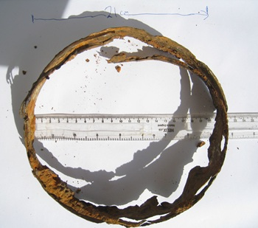
Nick Austin claims to be a local historian but appears to have no formal education in history or archaeology (Austin, no date b). This calls into question the credibility of the video. There is a lack of academics involved with the only academic being Dr Meg Watters who is impartial and offers no comment on their theories. The other major person involved, Philip Day, is presented as a research author, however this is misleading because his main area of research is health related (Credence, 2026). His focus is not archaeology or history. A lack of opposite narrative is shown in favour of their theories; they continue to ignore where their theories have been disproven, such as their claims that Wilting is the landing site, despite excavations in 2013 showing no evidence of Norman activity, this is purposely excluded from the narrative (The Past, 2013). In the video there is no critical assessment of their theories, and all information is presented as fact, an example of this, is the forts previously mentioned. The only supporting evidence provided is references to Nick Austin’s own book and research. There is no physical evidence presented in the video, despite the supposed claim to have discovered Saxon helmets (figure 5) which has been discredited by academics who identified the finds as bucket or barrel rims, not helmets (Hasting Online Times, 2025, The Past, 2013). To understand the shortcomings of their theories, it is necessary to seek information elsewhere as the video is disingenuous.
Figure 5: Metal object, Nick Austin believes to be a Saxon helmet (Hasting Online Times, 2025)

To conclude, this video stems from a deep mistrust of the official narrative of the Battle of Hastings, academics and English Heritage. This video aimed at the public is factually inaccurate, information is purposely excluded, as a result the viewer does not receive adequate information to reach an informed conclusion. The exclusion of evidence that counters the claims about both Wilting and Crowhurst illustrates that academic discussion and evidence is secondary to their intransigent beliefs. Portraying their claims in a way that mimics reliable archaeological programs, is irresponsible especially when paired with stating theories as facts, it creates a false precedent of authority and credibility. Overall, this video is intended to mislead the audience to gain support for their theories despite the evidence discrediting the narrative they have created.

Bibliography
Austin, N. (no date a) ‘Secrets of the Norman Invasion’ [Description above] Available at: https://www.academia.edu/45044701/Secrets_of_the_Norman_Invasion (Accessed: 29th January 2026)
Austin, N. (no date b) NickAustin10 Available at: https://independent.academia.edu/NickAustin10 (Accessed: 29th January 2026)
Bricca, J. (2023) 'Music', in Bricca, J. How Documentaries Work. New York, New York: Oxford University Press
Credence (2026) Phillip Day’s new UK 2026 tour Available at: https://credenceonline.co.uk/shop/product/phillip-days-tour-2026-tickets/ Accessed: 29th January 2026)
Hastings Online Times (2025) Austin backs up his claim that the Battle of Hastings was fought in Crowhurst Available at: https://hastingsonlinetimes.co.uk/hastings-life/history/austin-backs-up-his-battle-of-hastings-claim (Accessed: 28th January 2026)
IMDB (no date) Philip Day Biography. Available at: https://www.imdb.com/name/nm1635700/bio/?ref_=nm_ov_bio_sm (Accessed: 28th January 2026)
SOTNI UK (2018) The Battle of Hastings – Searching for Bodies [video]. Available at: https://www.youtube.com/watch?v=toRQiy-zdgc (Accessed: 26th January 2026)
The Past (2013) The Battle for Hastings: searching for the truth about 1066 Available at: https://the-past.com/feature/the-battle-for-hastings-searching-for-the-truth-about-1066/ (Accessed: 29th January 2026)

