Indie Games development report

Name: Ethan Randell
P Number: P150496
Course: Video Games Development
Year of Study: 2

Contents Page
Page 1: Contents Page
Page 2: Introduction
Page 2: Game’s Design
- Description of the Game
- How to play the Game?
- Controls
- Player Centric challenges and the goals to progressing and completing the game

Page 3 - 7: Implementation of Code
Page7- 8: Evaluation
Page 8 - Bibliography

Introduction
This report discusses a three dimensional maze game with objects for example enemies or barriers that has been created. The maze must dynamically generate when the game has started, the game must have an objective whether it be a finish zone or go to the next level or it could be two objectives for example get to the finish zone and collect coins on the way for points. The student must also create a HUD for the game as well e.g. photo of character, health bar etc.
This report includes screenshots of the code that the student has used to script the game using the C# coding language and of the game itself and at the end of the report is an evaluation of the game, identifying what was done well and what could be improved upon.

Game’s Design

The game that has been created is a maze game, users will control the character named Sassy and the user will have to find their way through the maze and try to reach the next level while avoiding either enemies or obstacles that will be blocking the user’s way and can also hurt Sassy and will have to get to the finish point.
How to play the game?
To play the game the user must try and reach the next level by going through the maze and looking for the finish point while avoiding all enemies and obstacles if the player gets hit by these enemies or obstacles they must restart the game and try to have to complete the maze again.
Controls
The controls that the user has assigned to the game character is very basic the W key moves the character forward the S key moves the character the A key moves the character left and the D key moves the character right.
There is no jumping so that the user cannot cheat by trying to jump up onto the maze walls and cheat their way to the finish point also there is no crouching because the obstacles are so close to the ground there is no way to crouch pass them.
There is no health system if you get hit by an object you have to restart the whole level again (due to time constraints this element of the game was not implemented into the final build).
Player centric challenges and the goals of progressing and completing the game
The challenges for the player are try and avoid all obstacles or enemies to stop them from restarting the level (due to time constraints there would be more challenges like collecting an objective e.g. coins or an item to open the finish zone). The main goal of the game is to get to the finish point which will send the player to the next level once they complete all three levels the game will finish.

Implementation of Code

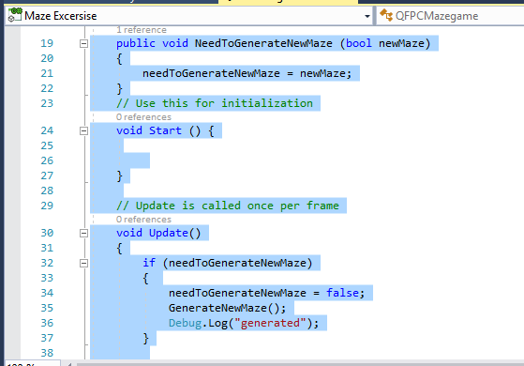

This is a screen shot of the first part of the QFPC Maze Game script the first bit of code is used for to help the finish point script generate a new maze once the player has entered the finish point.

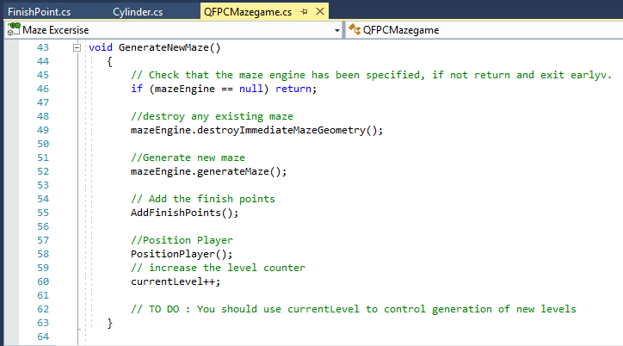

This part of the QFPC script is the generate new maze class it checks if the maze engine has been specified and it will destroy any existing maze it will add the finish point to the maze and will position the player in the maze.
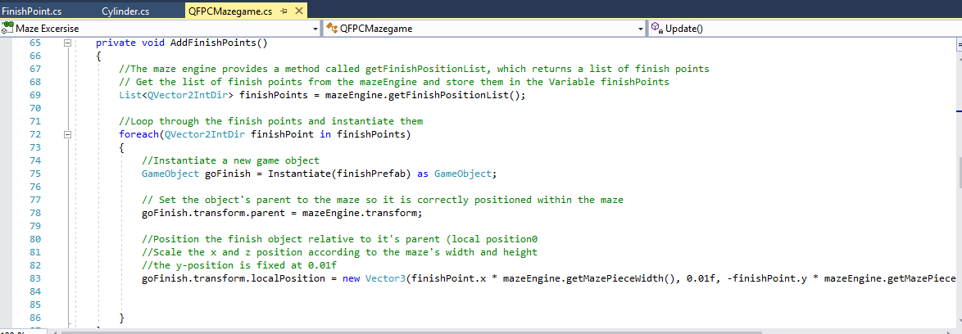
This part of the script adds the finish point in the maze it loops through the finish point every time the maze is generated it uses the finish prefab as a game object.
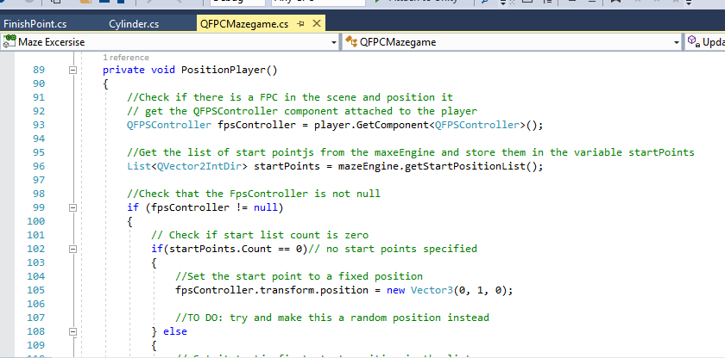
This part of the script positions the player inside the maze at a fixed point due to the student not understanding the game will not spawn the character at a random point inside the maze.
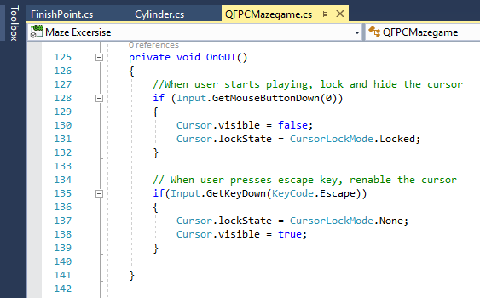
This part of the code is not really special to the script all it does is get rid of the cursor while the user is playing the maze game.
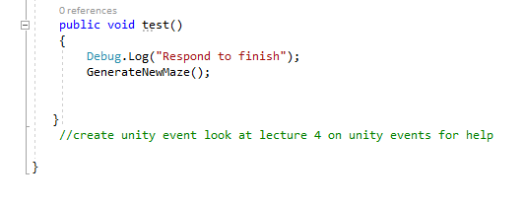
This part of the script was just a test to see if when the character walks into the finish point inside the game it will write respond to finish and was trying to generate a new maze.
The next set of screen shots come from the finish point script inside the maze game.
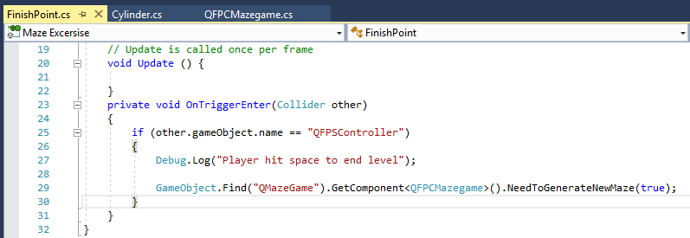
This the only part of the finish point script what it does is it calls the Qmaze game object component QFPC maze game and from that component it calls the need to generate new maze from the QFPC script once the player has collided with the finish point and will generate a new maze [1].
This is the last set of screenshots from the Cylinder or also known as the objects script
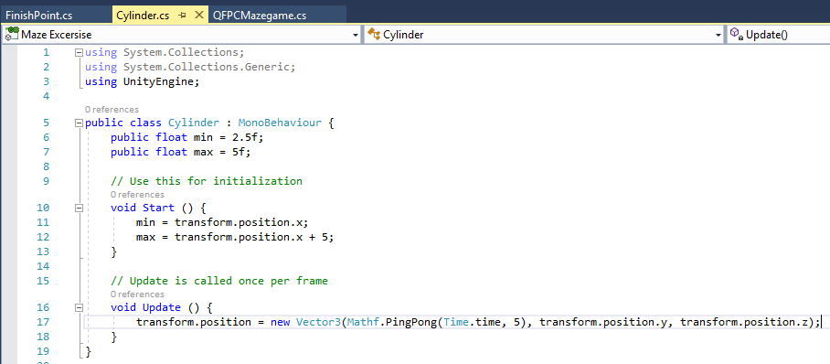
In this script it uses two floats min and max these values are used to help make the objects move and the transform code sets how far the objects will move [2] The Ping-Pong code is used to move the objects back and forth within a 5 second time frame [3].

The next of screen shots is of gameplay of the maze game with annotations of what’s going on in the game.
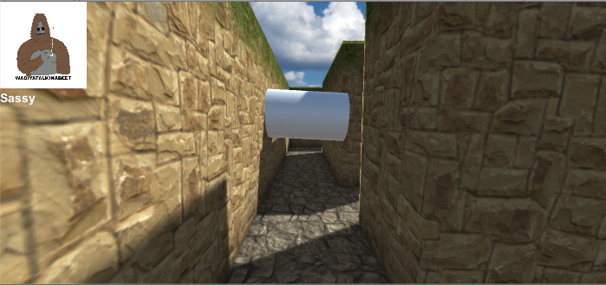
In this screen shot it shows the player inside the maze on the top left hand side of the screen it shows the character that the user is playing as (due to time constraints and lack of understanding the user could not input a health bar). In front of the player it shows an obstacle that comes up to the user and tries to block their path.
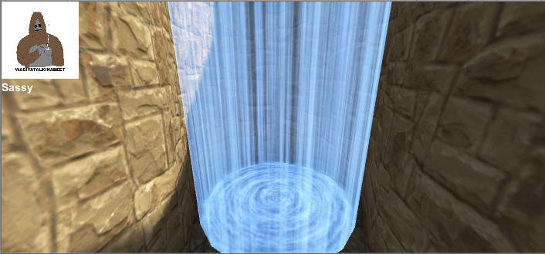
In the screenshot above it shows that the user has successfully made it to the finish zone. Once the player walks through the zone without stopping the game will automatically generate a new maze and finish zone for the player to find.

Evaluation
Errors that happened during the implementation of the game
During the implementation of this game, many errors were experienced. One of the prime examples was trying to stop the objects phasing through the character the error was caused because the student forgot to attach a rigid body onto the objects the student has fixed this error and the objects stop phasing through the character.
Another challenge was when the player hits the spawn point it would then start a new level the student did overcome this by adding the generate new maze script in the finish point script [1].
Another error was that the player could not find the finish point inside the maze due to there was no prefab connected to the finish point object but the student fixed this by adding the halo prefab in the assets folder which makes finding the end point much easier to find.
There were also other errors that sadly the student could not overcome, for example, when the object hits the player they will not restart the game but be pushed back by the object. Also the student could not include a health bar to the character also there is no level system once the user reaches the third finish point the game will carry on.
Evaluation of the completed game
Considering the game is not fully complete most of the game does still work and works will the maze can randomly generate itself and can make it very tough for the user to find the finish point which makes the game more interesting and more fun to play but can also be a little bit frustrating when the maze does not generate a way to the finish zone. The objects are really hard to pass due to them pushing the user back. The look of the game is really good as well the maze walls look good not life like but good for unity based game.
Improvements for future versions of the game
There are many improvements that the student can do for this game. First is obviously to create a health system and level system then it can be called a good completed game but there are other things that can also be improved on. For example, more enemies instead of objects that would follow you during the maze, also implement some traps that could destroy the monster for a short period of time and spawn back in.
Another improvement could be the objective for the game for example instead of just reaching the finish point maybe the player has to go and find an object e.g. a key or scroll to unlock the finish point and go onto the next level of the game. Also to add to the player’s experience, add teleporters around the maze so if the maze is expanded it could make it much easier to try and navigate the maze.
Maybe another feature that could be implemented into a future version is a power up system which makes you immune from enemies or allows you to destroy them.

Bibliography

[1] | Unity, “Overview Accessing other game objects,” Unity, Unknown Unknown Unknown. [Online]. Available: https://docs.unity3d.com/410/Documentation/ScriptReference/index.Accessing_Other_Game_Objects.html. [Accessed 12 12 2017].
[2] | Unity, “Transform,” Unity, Unknown Unknown Unknown. [Online]. Available: https://docs.unity3d.com/ScriptReference/Transform.html. [Accessed 11 December 2017].
[3] | Unity, “Mathf Ping Pong,” Unity , Unknown Unknown Unknown. [Online]. Available: https://docs.unity3d.com/ScriptReference/Mathf.PingPong.html. [Accessed 12 December 2017].

marking criteria and Student FEEDBACK

This section details the assessment criteria. The extent to which these are demonstrated by you determines your mark. The marks available for each criterion are shown. Lecturers will use the space provided to comment on the achievement of the task(s), including those areas in which you have performed well and areas that would benefit from development/improvement.

Common Assessment Criteria Applied (Assignment 1) | Marks available | Marks  awarded
1. Research-informed Literature
Extent of research and/or own reading, selection of credible sources, application of appropriate referencing conventions.
A basic reference list has been provided. Expand the scope of references consulted to help you improve the quality of your work. (Grade mark: 40.00%) | 5 | 2
2. Knowledge and Understanding of Subject
Extent of knowledge and understanding of concepts and underlying principles associated with the discipline.
Demonstrates a basic understanding of implementing a game from a dynamically generated game world. There is very little contribution to the original code given in the class to start the assignment and improvements could also be made to the little code added. (Grade mark: 42.50%) | 20 | 8.5
3. Analysis
Analysis, evaluation and synthesis; logic, argument and judgement; analytical reflection; organisation of ideas and evidence
Overall, a good evaluation of the game, identifying its limitations and some of the challenges faced. The recommendations for future improvements are relevant and practical. (Grade mark: 66.67%) | 15 | 10
4. Practical Application and Deployment
Deployment of methods, materials, tools and techniques; application of concepts; formulation of innovative and creative solutions to solve problems.
A fair attempt, but there is generally room for improvement. The main area for improvement is getting the basic mechanics right and adding goals and completion/termination conditions to the game. At the moment, the player character appears to be aimlessly wandering around the maze with no real, specific goal beyond being transported to the next level. There is no finish condition in the game. Aim to complete the class tutorial exercises to help you improve your understanding and also start your next assignment on time. See your report for additional comments. Nonetheless, a satisfactory attempt. (Grade mark: 43.64%) | 55 | 24
5. Skills for Professional Practice
Attributes in professional practice: individual and collaborative working; deployment of appropriate media; presentation and organisation.
The report is of average standard. See your report for additional comments. (Grade mark: 50.00%) | 5 | 2.5

Assignment Mark (Assessment marks are subject to ratification at the Exam Board. These comments and marks are to give feedback on module work and are for guidance only until they are confirmed. ) | Late Submission Penalties (tick if appropriate) |  | 47%
 | Up to one week late |  | 47%
 | 1st/2nd/3rd attempt? |  | 47%

