Level 4 Assignment 1.

Title: Practical Computation, Levelling and Plotting.

Name: Gethin Griffiths.

Student No: 1910877.

Module Code: ACBA4002.

Tutor: Dr Jamiu Dauda.

Completion Date: 18/06/2021.

Contents Page.
Contents. Page.
1.0. Introduction. 3.
2.0. Principles of Levelling Surveying. 3.
2.1. Type of Levelling. 3.
3.0. Levelling Instruments Used Within Surveying. 4.
3.1. Automatic Levelling Device. 4, 5.
3.2. Mounting an Automatic Levelling Instrument onto a Tripod. 5.
3.3. Levelling Staff. 6, 7.
3.4. Steel Tape. 7.
4.0. Action Plan for Levelling Procedure and Recording Data. 8.
4. 2. Series of Levelling Procedures. 9.
5.0. Computation Height of Collimation/ Check. 10, 11.
5.1. Computation Height of Collimation Data Transferred to Estimated Volume of Earthwork. 11.
6.0. Conclusion. 12.
7.0. References. 13, 14.

- Introduction.
The main purpose of this report is to demonstrate a practical levelling procedure in correspondence with planning a linking route from Llandarcy to Neath. This will be carried out by describing the stages of levelling techniques, equipment used, how data is recorded and illustrate in a certain format. The following calculations will include the Height of Collimation Method and Estimated Volume of Earthwork; entailing the reduced level of a Temporary Benchmark, ‘877.000m’ with the Reduced Levels of 40 fixed position points.
- Principles of Levelling Surveying.
Land Levelling Surveying is used to calculate elevated differences at various points, above or below the ground surface; that determines if the ground is level or not. Levelling equipment and techniques are used to create a horizontal line in relation to the vertical distance, which are measured rapidly and precisely, (Clancy, 2011, p. 93).
Levelling is established for linking routes such as, roads, railways, bridges and various areas to the outline or curves of the ground, (Clancy, 2011, p. 94).
Using surveying equipment such as;
- A spirit level sighting device (telescopic), producing a horizontal line of sight.
- A levelling staff measures the height in correspondence to the horizontal line.
- A Field book to record measured data (Clancy, 2011, p. 94).
2.1 Type of Levelling.
There are various techniques of ‘Levelling’, the main focus will include, ‘Differential Levelling’ with use of an, ‘Automatic Levelling Instrument’. Producing a horizontal line of sight; calculating various elevated positions from ‘A to B’. The device incorporates elevated differences with the use of two levelling staffs, placed at certain points. Creating accurate slope calculations over larger distances (Dream Civil. 2021).
To reduce collimation error, a (two peg test) can be used to produce accurate calculations within the survey (Dream Civil. 2021).
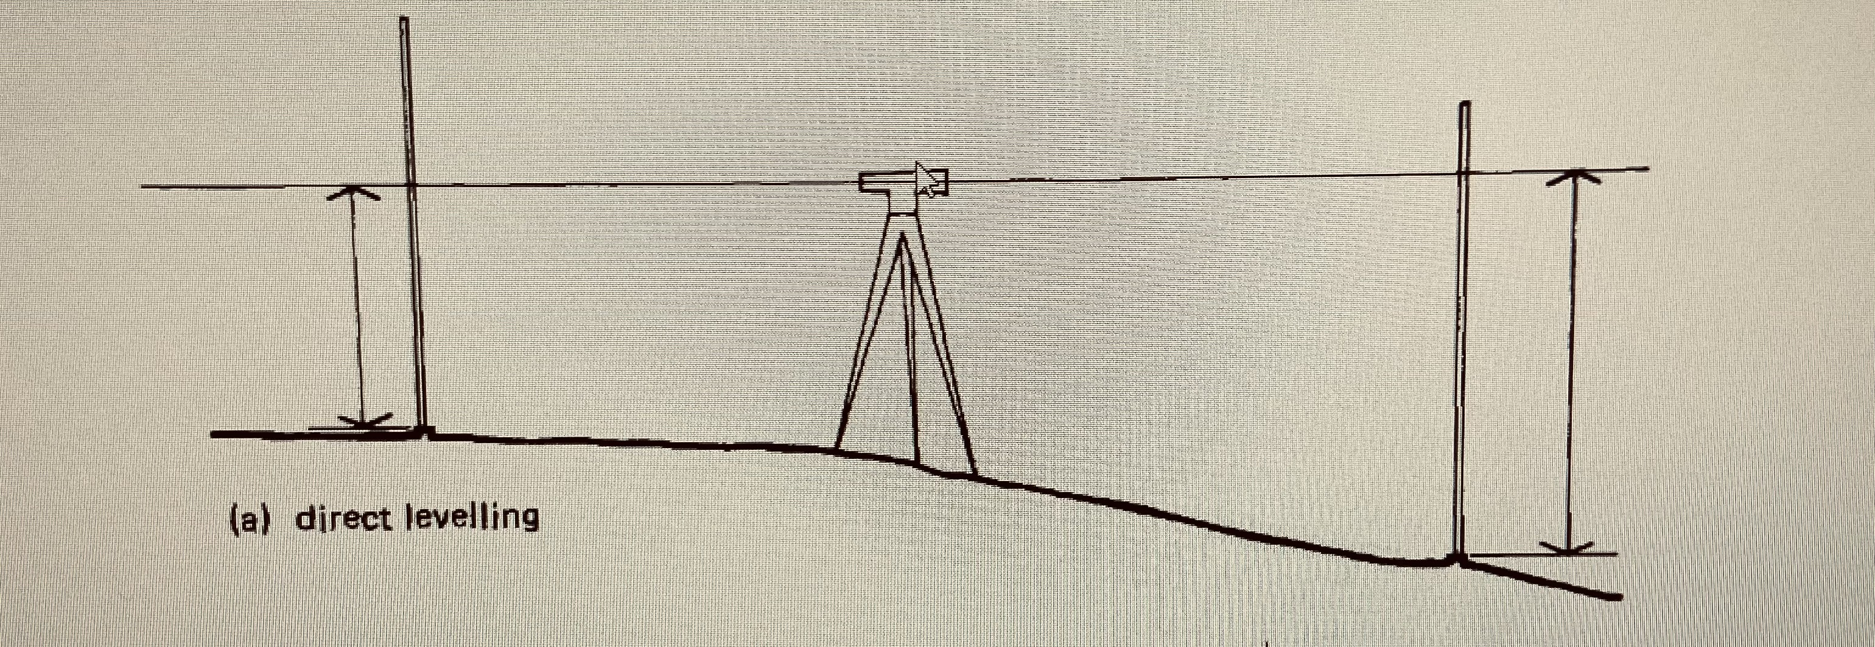

(Clancy, 2011, p. 95).

- Levelling Instruments Used Within Surveying.
3.1. Automatic Levelling Device.
A ‘Collimation Line’ is produced by an, ‘Automatic Levelling Instrument’ imaging the ray of light allowing a defined line without discrepancies, measuring a horizontal base line (Clancy, 2011, p. 107). Elevated differences are then recorded using a levelling staff (Civil E Blog, 2021).
Once the tripod/ device has been levelled and securely fixed into position. A 360⁰ rotation of the instrument will produce an accurate and level horizontal line of sight. Commonly used within construction as this piece of equipment doesn’t need any mechanical control by the user, (Clancy, 2011, p. 108).
Relating to a study, ‘Performance evaluation of automatic vis‑à‑vis manual topographic survey for precision land levelling’ automatic surveys generate; accurate readings, being more cost effective and has dramatically reduced the earthwork. Automatic levelling equipment, saved a total cost up to, ‘30.1%’ (MANPREET-SINGH, SIDHU, YADVINDER-SINGH, SINGH, and PANDEY, 2020) appose to manual surveying.
Labelled areas of the Automatic Levelling System:

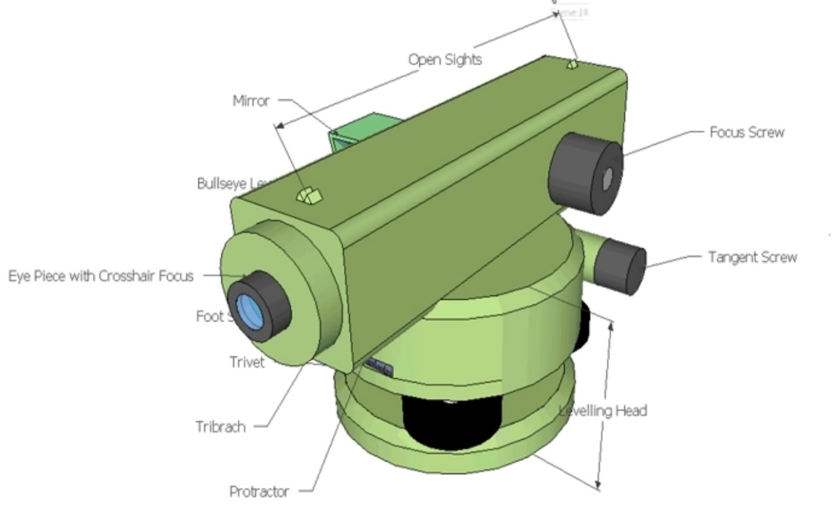

(Buildsum, 2013).
- “Levelling Head: which is known as the base part.
- Trivet: Mounted onto the tripod.
- Foot Screws: Assists with levelling.
- Tribrach: Pivots and the device.
- Protractor: Measures certain angles.
- Mirror: To signifies spirit level (bubble).
- Eye Piece: Focuses the (telescope) sight inside the level of the crosshair to the deepest darkest position onto the markings on the staff.
- Focus Screw: Focuses the optical image (staff markings etc) and reducing ‘parallax’.
- Tangent Screw: Pivots the Tribrach.
- Open Sights: Assists the eye piece.
- Stadia Line: Measure’s distance, with use of a staff.
- Crosshair: Formulates the main reading of the staff markings” (Buildsum, 2013).
3.2. Mounting an Automatic Levelling Instrument onto a Tripod.
- “The tripod legs need to be extended to the desired height, to mount the automatic level onto the tripod head; clamping the legs in place to sustain the height.
- The tripod has a threaded bolt in the centre of the base to attach the instrument securely to the dome top.
- Aline the instrument’ s foot screws to each corner of the tripod dome plate.
- Adjust the legs of the tripod to a line the eye piece of the instrument to the correct height.
- Move the tripod to a suitable area, spreading the legs evenly apart maintaining the tripod head level.
- Penetrate the surface with the leg spikes for more stability.
- Coarse levelling phase, adjust the leg lengths to centre the bubble of the mounted instrument.
- To level the instrument further, adjust the foot screws against the tripod base left to right or front to back.
- Rotate the instrument at a 360⁰, while mounted to check the tripod is level. If not level then the instrument its self will need servicing.
- Before removing the Instrument, return all foot screws to their original positions, for the next position.” (OTEN, 2014).

3.3. Levelling Staff.
A metal or fibreglass levelling staff is used in collaboration with an automatic levelling instrument, to produce precise levelling at elevated differences. To maintain the staff in a plumb position a, ‘Bipod’ can be used for ‘Staff Bubble Stabilisation’ (BRE, 1993, p. 6), producing accurate readings:
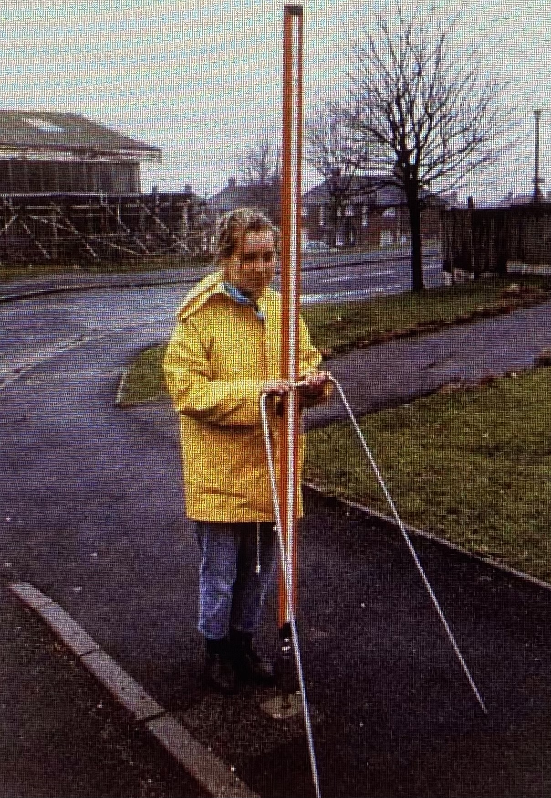

(BRE, 1993, p. 6).

The collimation line of sight produced will accurately be carried out at different benchmarks. Through the eye piece of the instrument there will show a horizontal ‘Crosshair’ and ‘Stadia Lines’ on the markings of the staff:
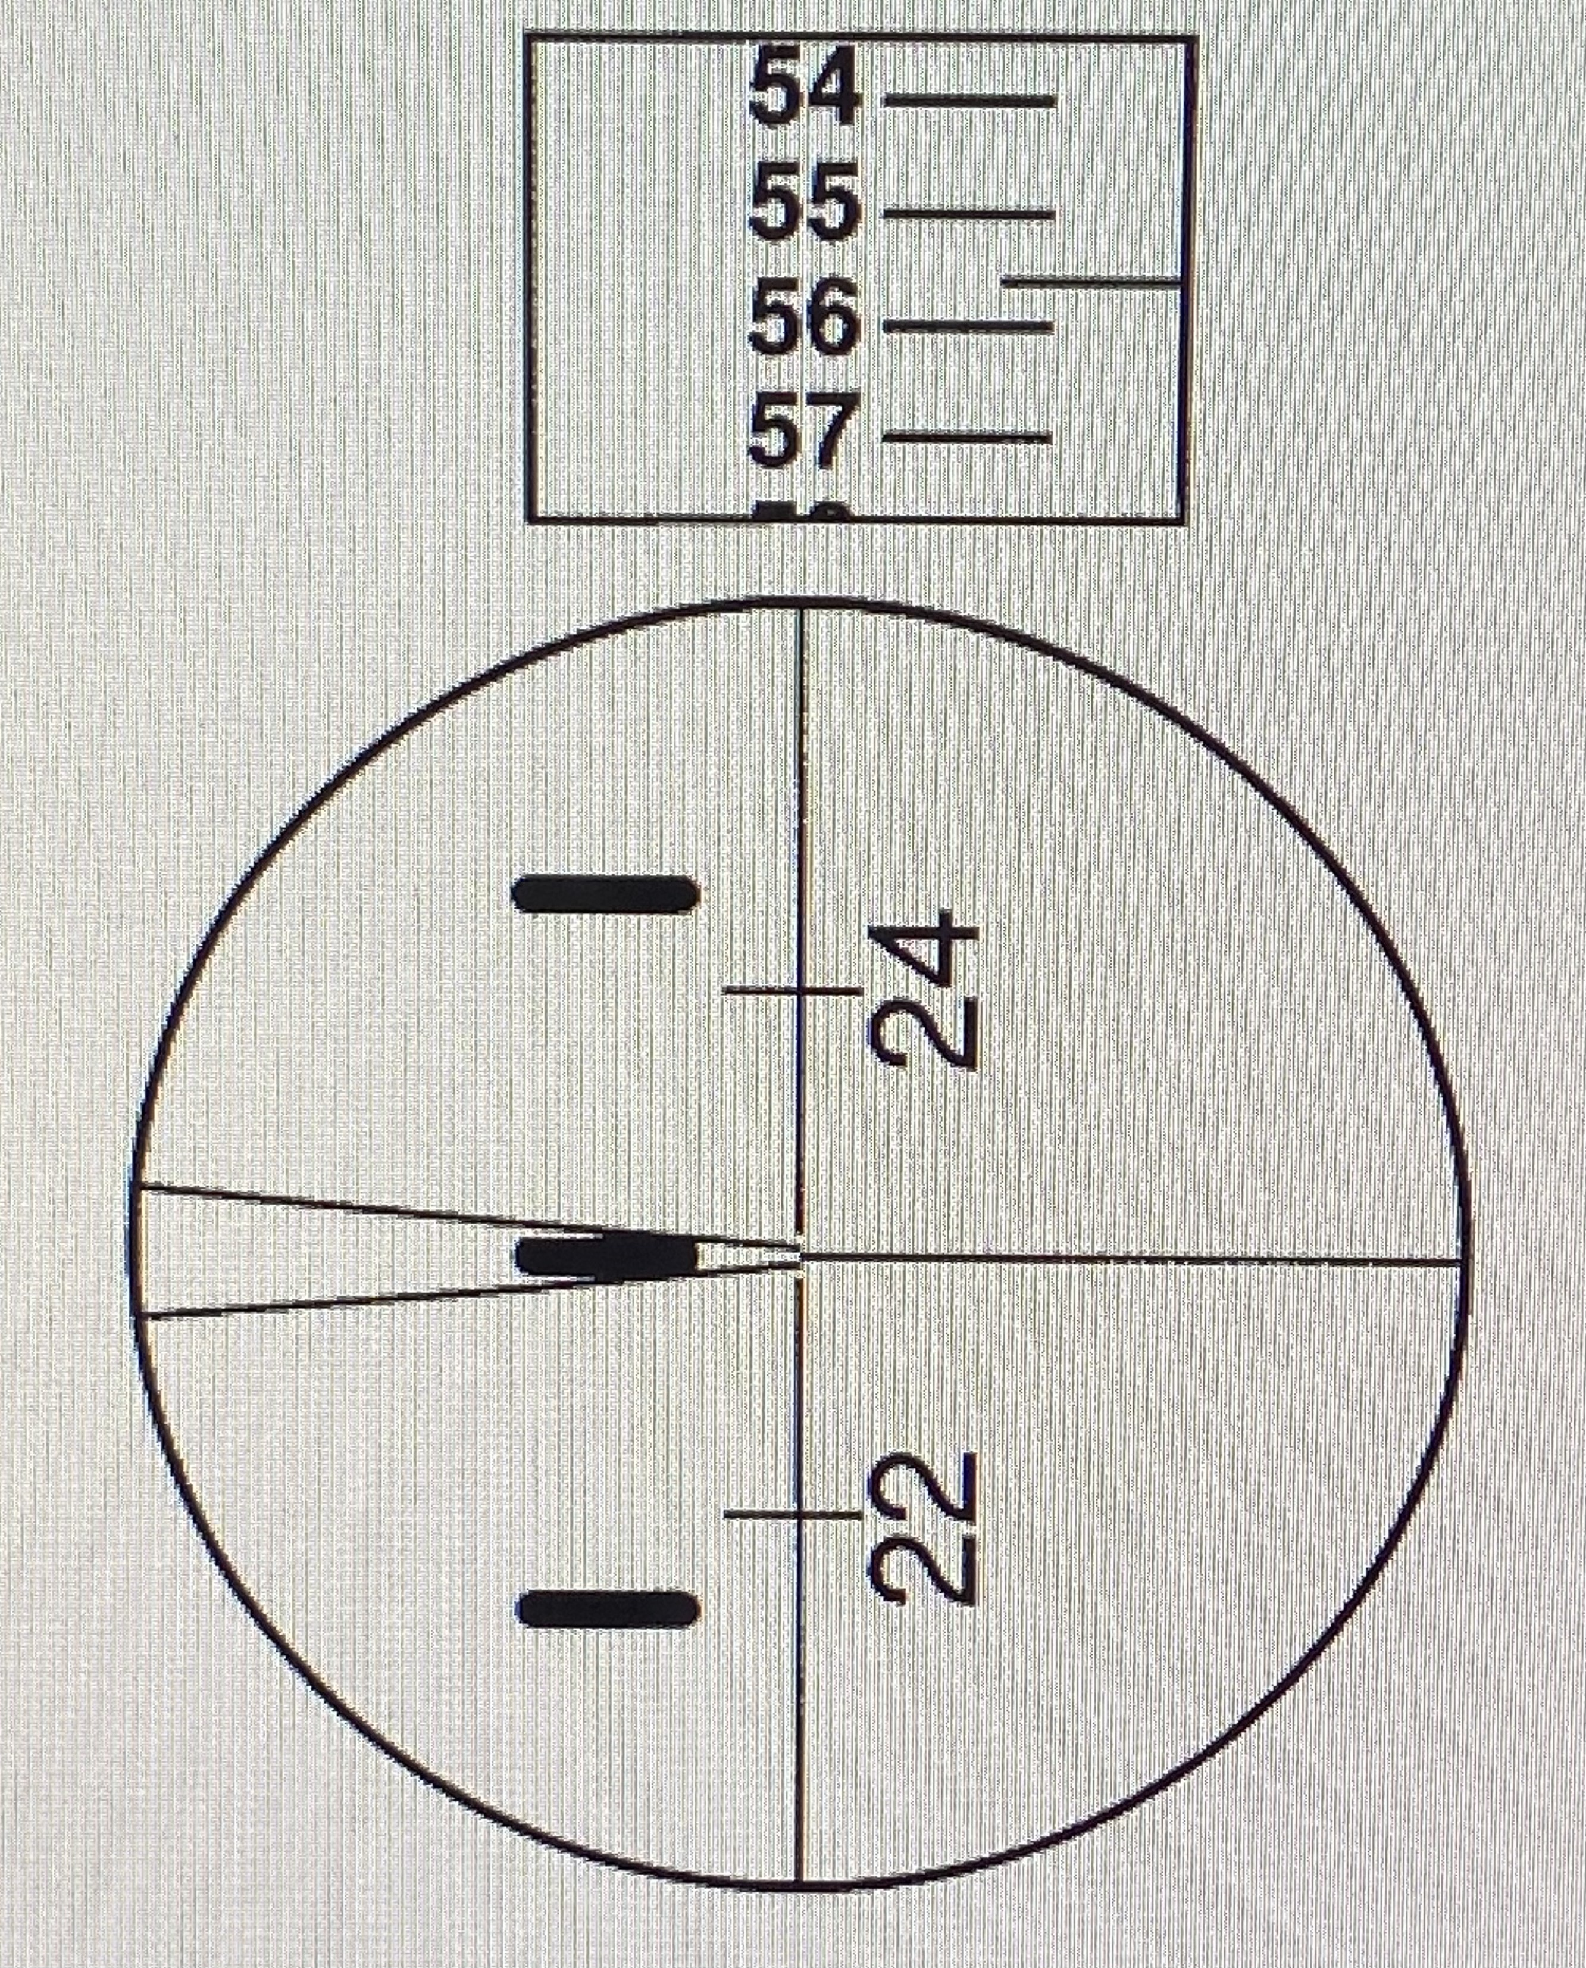

(BRE, 1993, p. 2).

The readings from the known, ‘Backsight’ (BS) benchmark towards the, ‘Foresight’ (FS) Benchmark unknown; are then recorded into a field book as various datum points throughout the land survey are developed.
A 3-4 metre levelling staff extends and clicks into position. The colour alternates up the staff making it easier to read the vertical calculations through the ocular device; under the, ‘BS 4484’ highlighted ‘E’ markings (Clancy, 2011, p. 111). A measuring tape can be used alongside the staff to calculate the exact millimetre demonstrating on the crosshair and stadia lines; as the staff markings go up in 10mm’s (OTEN, 2014).
Sight Calculations:
- Measure up from the cross section to the above stadia line.
- Measure down from the cross section to the below stadia line.
- Subtract the top from the bottom stadia line.
- Multiply the calculation by 100, to give the exact distance the instrument is away from the staff. (Buildsum, 2013).
- Two people are desired to carry out this process.
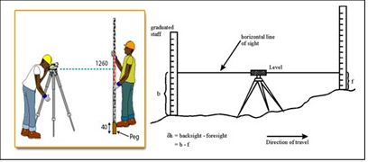
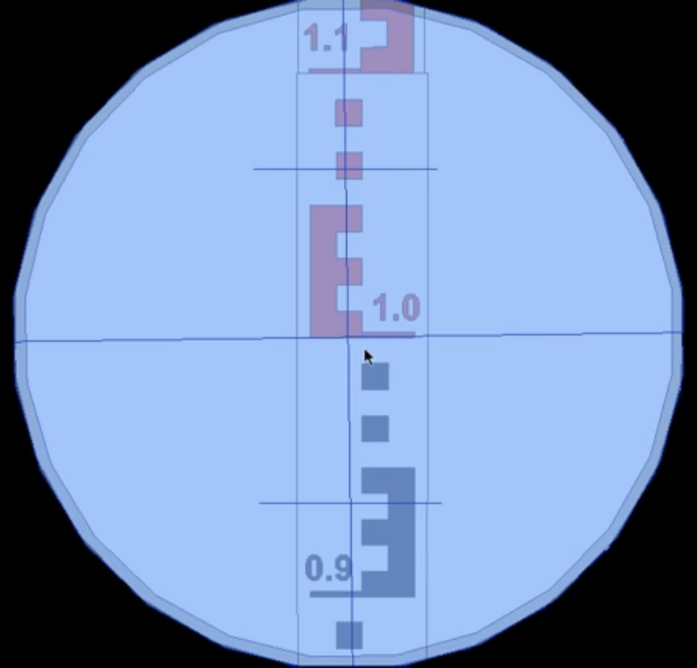

(Civil E Blog, 2021).
(Buildsum, 2013).
3.4. Steel Tape.
A steel tape can be used for ‘Linear Measurements’ and calibrated in metric metres. If you are working on a slope then the tape needs to be pulled taut at a horizontal plane from point A to B (CIRIA, 2007, p. 14).
- Two people are desired to carry out the process.
- Precise distance between 1mm to 5mm over 10m (CIRIA, 2007, p. 14).
- More time consuming and not as accurate as an, ‘Automatic Levelling Instrument’.

- Action Plan for Levelling Procedure and Recording Data.
Setting up the levelling equipment to carry out ‘Differential Levelling’ procedures will be used to calculate elevation differences between two levelling Staffs, at the horizontal line of sight of the instrument’ (Dream Civil, 2021).
The key terms used for this process:
Back Sight (BS): First reading off the levelling staff within the horizontal line of sight through the instrument, marked over the known temporary benchmark (Clancy, 2011, p. 116).
Intermediate Sight (IS): Reading recorded between the Back Sight and Foresight (Clancy, 2011, p. 116).
Foresight (FS): Last reading of the levelling staff within the horizontal line of sight, recorded from the Levelling instrument (Clancy, 2011, p. 116).
Benchmark/ Temporary Benchmark (BM/ TBM): Know elevation mark, which is the fixed or temporary starting point of the levelling process (Clancy, 2011, p. 114 -115).
Reduced Level (RL): A calculation which demonstrates the vertical distance between a datum line and the horizontal line of sight (Clancy, 2011, p. 116).
Changing Point (CP): Changing Point Elevation after the ‘Backsight and Foresight’ readings have been recorded into the field book. The instrument is then positioned to another appropriate location to continue the series of levelling (Clancy, 2011, p. 117).
Datum Line: Actual or Assumed levels of the horizontal plane, either each end of a slope (Clancy, 2011, p. 113).
Height of Instrument (HI): Referred to, ‘The Height of Collimation’. The height of the instrument’s line of sight is above the actual or assumed datum point (Clancy, 2011, p. 118).

4. 2. Series of Levelling Procedures:
A series of levelling procedures are carried out in the following format, detailing:
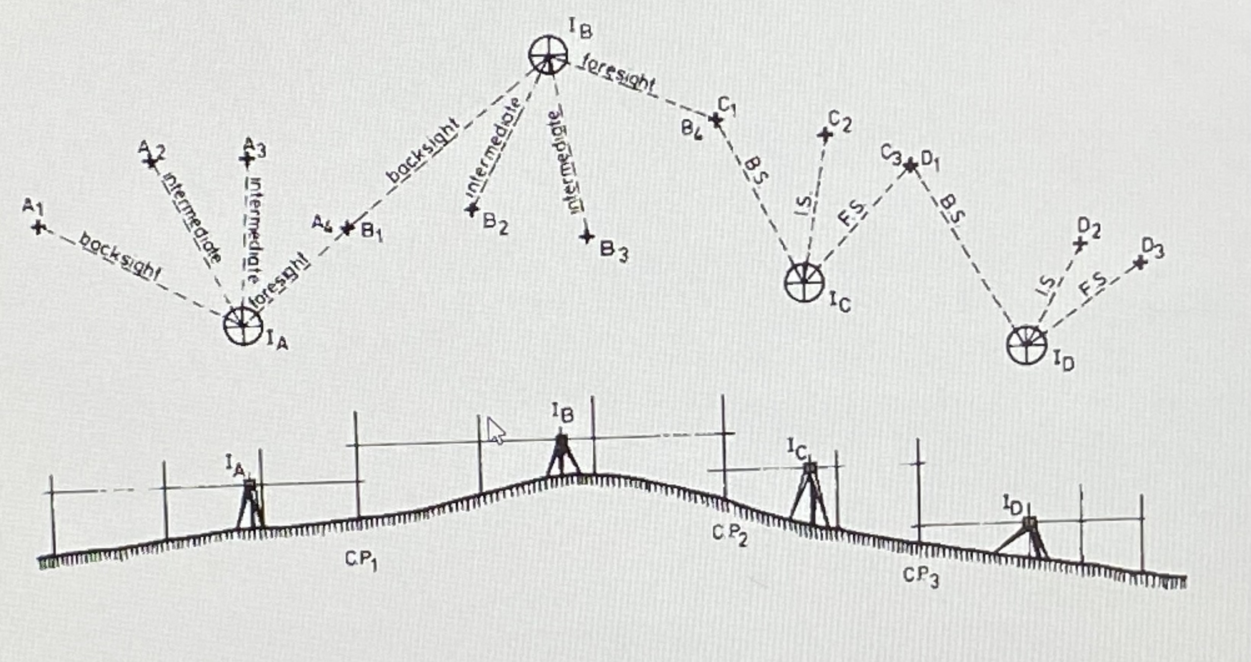

(Clancy, 2011, p. 131).
Relating to the above diagram:
- Position (A, I) instrument assembled level and stable.
- Staff level at position (A,1) at benchmark (BM); which is the Back Sight (BS) starting measurement 1 of the assumed Benchmark, measurement recorded.
- Staff transferred to (A, 2), Intermediate Sight (IS), measurement recorded.
- Staff transferred to (A, 3), Intermediate Sight (IS), measurement recorded.
- Staff transferred to (A, 4), Foresight (FS) staff level at Changing Point 1 (CP1).
- Instrument transferred to (B, I) position, repeat process from (CP1/ BS to FS).
(Clancy, 2011, p. 131).
The same process is repeated throughout the Changing Points (CP), within the series levelling procedure. Until the distance or chainage is complete. Record data within the, Height of Collimation Field Book; which will prevent error.
The above principles will be applied to the following, ‘Height of Collimation Method’ for 40 positions at 25m intervals; that will clearly demonstrate the calculations of the linking route from, ‘Llandarcy to Neath. Recorded in the ‘Height of Collimation Field Book Template’.
Reduced level starting,’ 877.000m’ Temporary Benchmark (TBM) incorporated, ‘Estimated Volume of Earthwork’ Calculations.

5.0. Computation Height of Collimation Field Book Template:
BS | IS | FS | HC | RL | Chainage | Remarks
1.371 |  |  | 878.371 | 877.000 | 0.000 | Temporary Bench Mark (TBM)
 | 2.354 |  |  | 876.017 | 25.000 | (Position 1).
 | 1.222 |  |  | 877.149 | 50.000 | (Position 2).
 | 2.591 |  |  | 875.780 | 75.000 | (Position 3).
1.432 |  | 3.587 | 876.216 | 874.784 | 100.000 | (Position 4) / (Change Point 1).
 | 1.872 |  |  | 874.344 | 125.000 | (Position 5).
3.250 |  | 0.573 | 878.893 | 875.643 | 150.000 | (Position 6) / (Change Point 2)
 | 1.925 |  |  | 876.968 | 175.000 | (Position 7).
3.015 |  | 0.496 | 881.412 | 878.397 | 200.000 | (Position 8) / (Change Point 3).
1.456 |  | 0.499 | 882.369 | 880.913 | 225.000 | (Position 9) / (Change Point 4).
 | 3.853 |  |  | 878.516 | 250.000 | (Position 10).
 | 5.433 |  |  | 876.936 | 275.000 | (Position 11).
 | 5.200 |  |  | 877.169 | 300.000 | (Position 12).
 | 4.000 |  |  | 878.369 | 325.000 | (Position 13).
3.876 |  | 3.067 | 883.178 | 879.302 | 350.000 | (Position 14) / (Change Point 5).
 | 4.533 |  |  | 878.645 | 375.000 | (Position 15).
 | 5.433 |  |  | 877.745 | 400.000 | (Position 16).
 | 5.867 |  |  | 877.311 | 425.000 | (Position 17).
 | 5.133 |  |  | 878.045 | 450.000 | (Position 18).
1.734 |  | 3.064 | 881.848 | 880.114 | 475.000 | (Position 19) / (Change Point 6).
 | 1.280 |  |  | 880.568 | 500.000 | (Position 20).
 | 1.390 |  |  | 880.458 | 525.000 | (Position 21).
3.467 |  | 2.076 | 883.239 | 879.772 | 550.000 | (Position 22) / (Change Point 7).
 | 4.147 |  |  | 879.092 | 575.000 | (Position 23).
3.371 |  | 1.976 | 884.634 | 881.263 | 600.000 | (Position 24) / (Change Point 8).
 | 2.395 |  |  | 882.239 | 625.000 | (Position 25).
 | 2.562 |  |  | 882.072 | 650.000 | (Position 26).
 | 2.591 |  |  | 882.043 | 675.000 | (Position 27).
1.432 |  | 3.587 | 882.479 | 881.047 | 700.000 | (Position 28) / (Change Point 9).
 | 1.872 |  |  | 880.607 | 725.000 | (Position 29).
1.675 |  | 0.573 | 883.581 | 881.906 | 750.000 | (Position 30) / (Change Point 10).
1.734 |  | 3.064 | 882.251 | 880.517 | 775.000 | (Position 31) / (Change Point 11).
 | 2.280 |  |  | 879.971 | 800.000 | (Position 32).
 | 2.390 |  |  | 879.861 | 825.000 | (Position 33).
3.467 |  | 3.000 | 882.718 | 879.251 | 850.000 | (Position 34) / (Change Point 12).
 | 4.147 |  |  | 878.571 | 875.000 | (Position 35).
3.371 |  | 1.976 | 884.113 | 880.742 | 900.000 | (Position 36) / (Change Point 13).
 | 1.395 |  |  | 882.718 | 925.000 | (Position 37).
 | 1.562 |  |  | 882.551 | 950.000 | (Position 38).
 | 1.859 |  |  | 882.254 | 975.000 | (Position 39).
 |  | 2.587 |  | 881.526 | 1000.000 | (Position 40).

SUM |  | SUM |  | SUM
34.651 |  | 30.125 |  | 881.526
-30.125 |  |  |  | -877.000
4.526 |  |  |  | 4.526
Check:

(No Error detected).
5.1. Computation Height of Collimation Data Transferred to Estimated Volume of Earthwork:

Cut 5.
Cut 4.
Fill 5.
Cut 3.
Fill 4.
Cut 2.
Fill 3.
Fill 2.
Fill 1.

6.0 Conclusion.
After close examination of the applications within land surveying, this assignment clearly demonstrates an understanding of how the process works., entailing:
- Levelling Equipment used and what they are used for.
- Levelling Procedures to collect accurate and precise data.
- Height of Collimation Method to calculate field data (reduced level throughout distance intervals).
- Estimated Volume of Earthwork calculations (reduced level against chainage) using the cut and fill method.
A ‘Series of Levelling Procedures’ assist calculation of, ‘Height of Collimation Method and Reduced Level’. Including 25m intervals over a 1000m Chainage, with Reduced Levels of 40 positions of the linking route from Llandarcy and Neath. The calculations within the ‘Height of Collimation’ Field Book Template demonstrate the practiced theory, with (no error detected).
The graph has been designed to present the, Reduced Level against the Chainage. Using the (Cut and Fill) method which estimates the, ‘Volume of Earthwork’. Calculating at (-18.75 cubic meters) in accordance with the assumed (TBM) of the linking route. The above methods and techniques, are an accurate process to gather information and calculate the plotted levels within the practices of Levelling Surveying.

7.0. References.

BRE. (1993) Monitoring Building and Ground Movement by Precise levelling. IHS BRE Press. Available at: https://www-ihsti-com.ezproxy.uwtsd.ac.uk/tempimg/29A4041-CIS888614800018045.pdf. (Accessed 14th June 2021).

Buildsum. (2013) Measuring distance using Stadia Lines. YouTube. Available at: https://www.youtube.com/watch?v=wYeAEpP1NYo. (Accessed 15thJune 2021).

Buildsum. (2013) Parts of an Automatic Level. YouTube. Available at: https://www.youtube.com/watch?v=73mquZh29Rw. (Accessed 13th June 2021).

CIRIA. (2007) Setting-out procedures for the modern built environment. CIRIA. Available at: https://www-ihsti-com.ezproxy.uwtsd.ac.uk/tempimg/2AA689F-CIS888614800283963.pdf. (Accessed 16th June 2021).

Civil E Blog. (2021) Levelling. Civil Engineering Blog. Available at: https://civileblog.com/levelling/. (Accessed 15th June 2021).

Clancy, J. (2011). Site Surveying and Levelling. (2nd ed.). [Online]. Routledge. Available at: https://play.google.com/books/reader?id=2NArBgAAQBAJ&hl=en&pg=GBS.PR2. (Accessed 14th June 2021).

Dream Civil. (2021) Levelling in Surveying/ Types of Levelling/ Objectives of Levelling/ Two Peg Test. Available at: https://dreamcivil.com/levelling-in-surveying/. (Accessed: 14th June 2021).

MANPREET-SINGH, SIDHU, H.S., YADVINDER-SINGH, SINGH, S.K. and PANDEY, H.S., 2020. Performance evaluation of automatic vis-à-vis manual topographic survey for precision land levelling. Precision Agriculture, 21(2), pp. 300-310. Available at: https://www-proquest-com.ezproxy.uwtsd.ac.uk/docview/2226629212/3942BB2F86B444BBPQ/4?accountid=130472. (Accessed 15th June 2021).

OTEN Building Courses. (2014) Surveying 1 – Introduction to Levelling. OTEN. YouTube. Available at: https://www.youtube.com/watch?v=j8poe2vvD2Q. (Accessed 15th June 2021).

OTEN Building Courses. (2014) Surveying 2 - Taking a Level Reading - OTEN Building & Construction. OTEN. YouTube. Available at: https://www.youtube.com/watch?v=YnDA-nAUyl8&t=112s. (Accessed 16th June 2021).

