

  - MODULE CODE: LCBB4001 ACCOUNTING FUNDAMENTALS
LECTURE NAME: D-R REXON NTING
STUDENT NAME : YANITSA GOSPODINOVA
STUDENT ID: 1907707

Task 1: Maxim

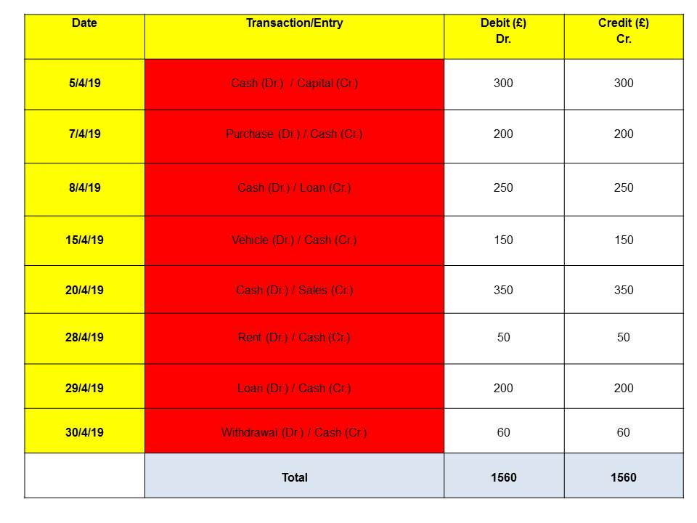

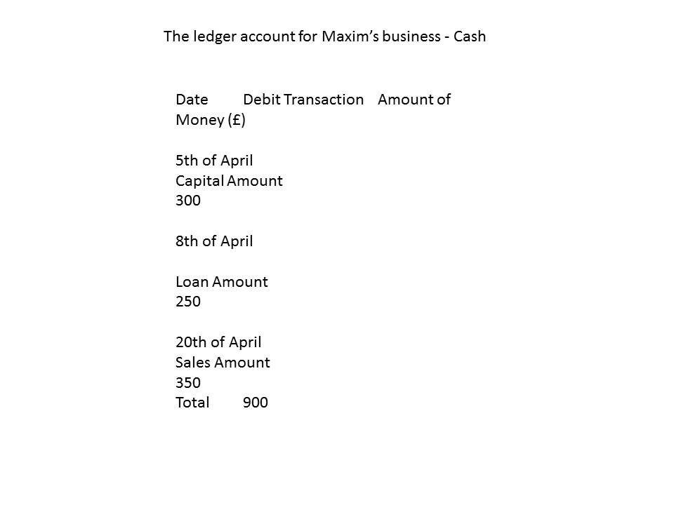

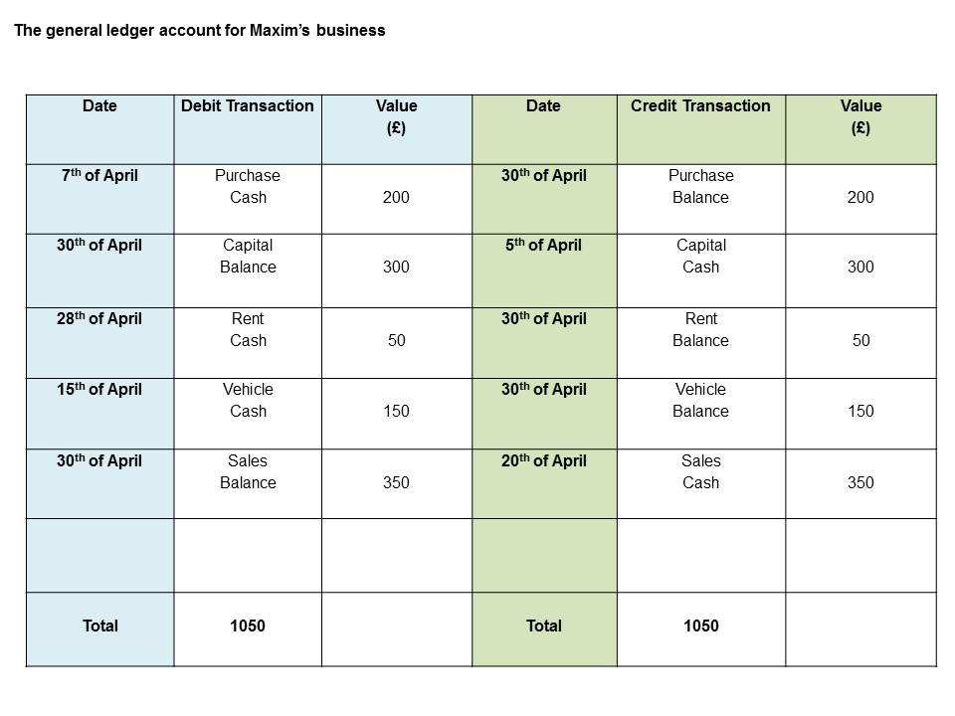
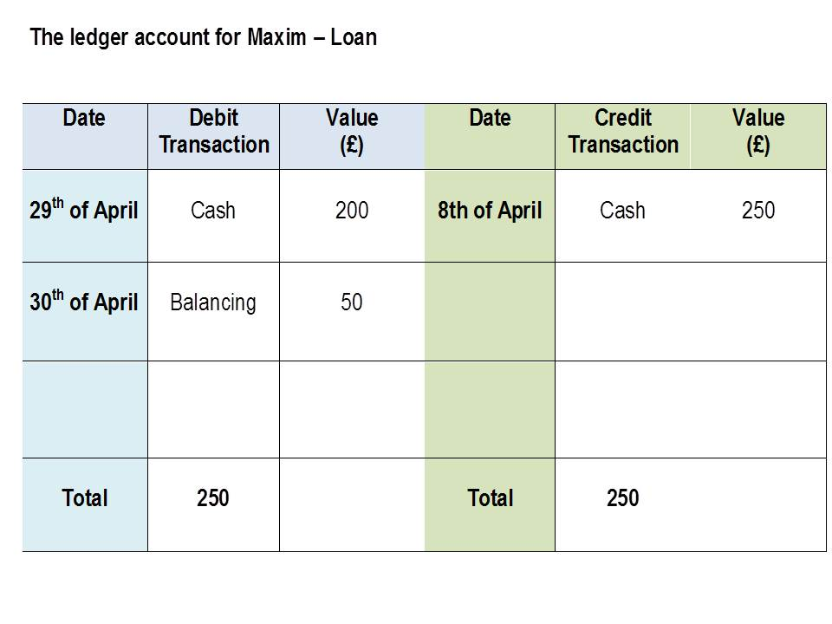
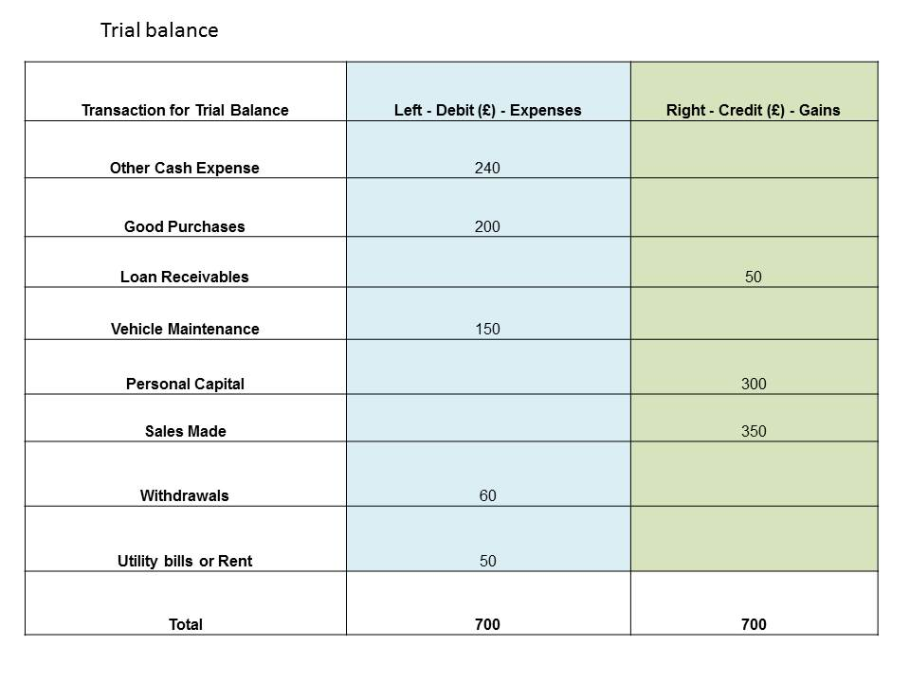

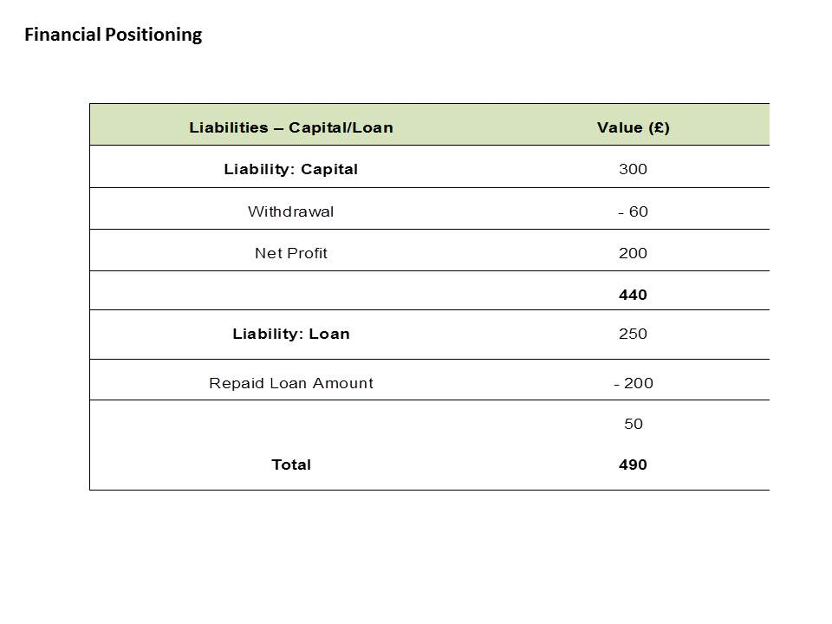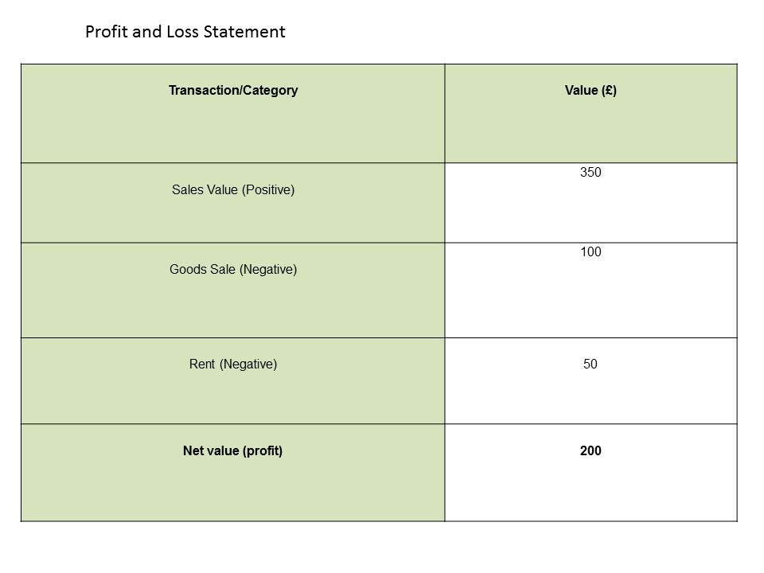

TASK 2: PENDO

Ledger Account

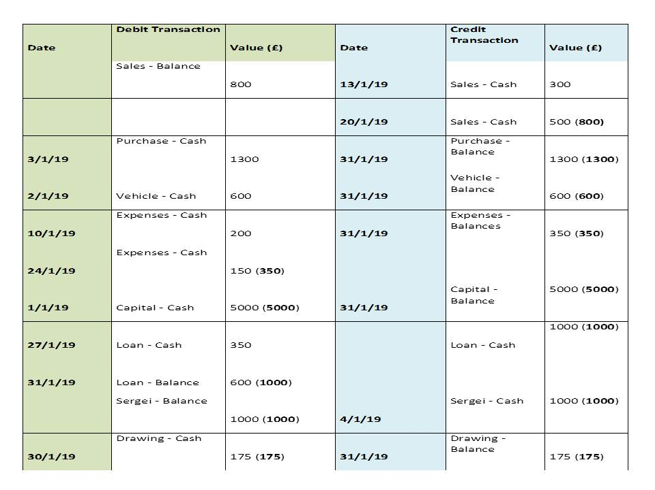

Cash

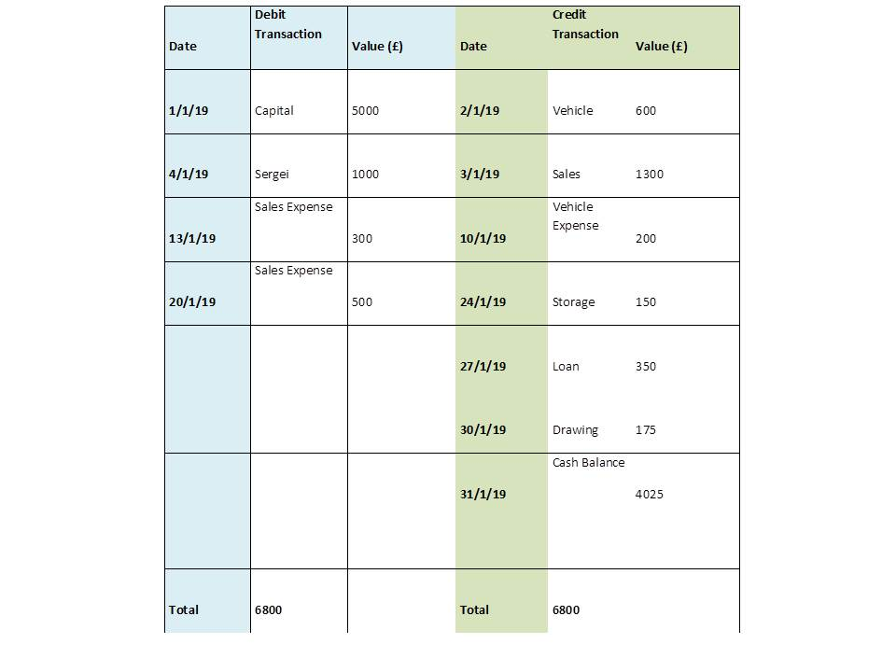

Trial Balance for- 31st of January

Profit and Loss Statement

Statements | £
Sales (Positive) | 800
Cost (Negative) | 500
Profit | 300
Operation (-) | -350
Vehicle (-) | 200
Storage (-) | 150
Net (-) | -50

Stock | £
Opening
Sales | 1300
Closing | -800
End | 500

Financial Positioning

Category | £
Vehicle Asset (non-current) | 600
Cash Asset (Current) | 800
Closing Stock (Current) | 4025
Assets in total | 5425
Capital | 5000
Loss (Liability) | 50
Withdrawal(Liability) | 175
Loan (Liability) | 650
Total Liabilities | 5425

TASK 3: MUTAFA

Task 4: Ricardo

Ledger account and trial balance

Trial Balance – 27th of June

Category Debit (£) Credit (£)
Sales (Positive) 28500
Purchase (Negative) 16500
Cash (Negative) 6555
Sales (Negative) 1000
Mandy (Negative) 5000
Discount (Positive) 930
Discount (Negative) 375
Total Value 29430 29430

