The Rise of Sharing Economy – Travelers' Repurchase Intention of Airbnb and the Impact on the Hotel Industry
By
Ed Tsui

A dissertation
submitted to the University of Wales Trinity Saint David
in fulfillment of the
dissertation requirements for the degree of
Master of Business Administration

Student Name | ： | Ao Cheung Ed Tsui
Student ID Number | ： | 1921900
Supervisor | ： | Dr. Kathreine Mo

Declaration and Statements

DECLARATION
This work has not previously been accepted in substance for any degree and is not being concurrently submitted in candidature for any degree.

Signature
Date

STATEMENTS
This dissertation is the result of my own investigations, except where otherwise stated. Where correction services have been used, the correction's extent and nature are clearly marked in a footnote(s).

Signature
Date

Abstract

Acknowledgments

I want to express my gratitude to my dissertation supervisor, Dr. Katherine Mo, for her unwavering encouragement and advice for this dissertation. I appreciate your faith in me and your ability to keep me focused on the mission at hand while subtly steering me in the right direction as the dissertation progress. Being supervised by Dr. Mo has been an utter honor.

Additionally, I would like to express my gratitude to Dr. Arion Wong, Dr. Joe Leung, Dr. Poon, Dr. Leo Ho, and Dr. Terence Li for all of their lectures and guidance throughout my MBA modules. I learned a lot from the topics they discussed and the experiences they shared during class, and I would not be where I am today without their assistance and advice.

I also wish to thank the hundreds of people who completed my survey, as well as those who helped me distributing it. This dissertation would not be possible without your participation and help, and I am grateful for what you have done. I sincerely hope you find the study's results fascinating and valuable.

Table of Contents

Declaration and Statements ii
Abstract iii
Acknowledgments iv
Table of Contents v
List of Tables vii
List of Figures viii
Abbriviations ix
Chapter 1: Introduction 1
1.1 Research background 1
1.2 Research motivation 2
1.3 Research aim and objectives 5
1.4 Summary 8
Chapter 2: Literature Review 11
2.1 Repurchase intention (RI) 11
2.1.1 RI Construction and measurement 14
2.2 Trust (T) 16
2.2.1 T Construct and measurement 18
2.3 Perceived risk (R) 20
2.3.1 R Construct and measurements 21
2.4 Service quality (SQ) 22
2.4.1 SQ Construct and measurements 25
2.5 Information quality (IQ) 26
2.5.1 IQ Construct and measurements 28
2.6 eWOM 29
2.6.1 eWOM Construct and measurements 31
2.7 Economic benefits (EB) 31
2.7.1 EB Construct and measurements 33
2.8 Demographic factors 33
Chapter 3: Research Methodology 35
3.1 Research model with hypotheses 36
3.1.1 Trust and perceived risk 38
3.1.2 Service quality 39
3.1.3 Information quality 39
3.1.4 eWOM 40
3.1.5 Economic benefits 40
3.1.6 Demographic factors 41
3.2 Triangulation 41
3.3 Quantitative and qualitative research 43
3.4 Focus group 44
3.5 Questionnaire survey method 45
3.5.1 Pilot test 46
3.6 Final Survey 49
3.6.1 Target population 50
3.6.2 Sampling method 50
3.6.3 Sampling size 50
3.7 Data analysis techniques 51
3.8 Research Method Limitations 56
3.9 Research Ethics 57
Chapter 4: Data Description and Analysis 58
4.1 Data from the final survey 58
4.1.1 Demographic data 58
4.2 Cross-Tabulation of Demographic Factors on Repurchase Intention 62
4.2.1 Repurchase intention and gender 63
4.2.2 Repurchase intention and number of children in family 65
4.3 Each factor's highest and lowest averages 66
4.4 Reliability test 69
4.5 Factor analysis 69
4.6 Correlation test 73
4.7 Regression model 74
4.7.1 Single linear regression for Trust and Perceived risk 74
5.3 One-way ANOVA Result 78
4.7.2 Multiple linear regression for repurchase intention on Airbnb 84
4.8 Using regression analysis to test hypotheses 87
4.9 Independent T-test 89
4.10 One-way Analysis of Variance (ANOVA) 89
Conclusion 89
Appendix 1 Focus Group Discussion 89
Appendix 2 Questionnaire for pilot test 95
Appendix 3 Questionnaire for final survey 99

List of Tables

Table 1: Key findings from the reviewed scholars on Repurchase Intention 11
Table 2: Measurements of Repurchase Intention 12
Table 3: Key findings from the reviewed scholars on Trust 14
Table 4: Measurements of Trust 15
Table 5: Key findings from the reviewed scholars on Perceived Risk 17
Table 6: Measurements of Perceived Risk 18
Table 7: Key findings from the reviewed scholars on Service Quality 20
Table 8: Measurements of Service Quality 22
Table 9: Key findings from the reviewed scholars on information quality 23
Table 10: Measurements of Information Quality 25
Table 11: Key findings from the reviewed scholars on eWOM 26
Table 12: Measurements of eWOM 27
Table 13: Key findings from the reviewed scholars on economic benefits 28
Table 14: Measurements of Economic Benefits 29
Table 15: Questionnaire Design Structure 42
Table 16: Pilot test output for 40 data 44
Table 17: Survey questions adopted 45
Table 18: Successful rate for question RI4 47
Table 19: Sample size calculation under simple random sampling 47
Table 20: Cronbach's alpha 48
Table 21: Factor analysis 49
Table 22: Correlation Test 49
Table 23: Linear Regression 50
Table 24: A summary of the demographic data collected from 400 respondents 55
Table 25: Factor for D1*RI1 60
Table 26: Factor for D7*RI2 61
Table 27: Descriptive Statistics 62
Table 28: Reliability Statistics 63
Table 29: KMO and Bartlett's Test 64
Table 30: Total Variance Explained 64
Table 31: Rotated Component Matrix 66
Table 32: Correlation analysis of factors in comparison to other research 67
Table 33: Correlations among the variables. 68
Table 34: Model summary for single linear regression model 69
Table 35: ANOVA for single linear regression model 69
Table 36: Coefficients table for single regression model 70
Table 37: Model summary for multiple linear regression model 78
Table 38: ANOVA for multiple linear regression model 79
Table 39: Coefficients table for multiple regression model 80

List of Figures

Figure 1: Hotel industry monthly average daily rate from 2018 to 2020Source: (STR Global, 2020) 1
Figure 2: Airbnb revenue worldwide in 2019 (in U.S. Dollars), by region 3
Figure 3: Bookings of Airbnb nights and experiences worldwide in 2019, by region 4
Figure 4: Sales revenue of leading hotel companies in 2019 (in billion U.S. dollars) 5
Figure 5: Flowchart of the Research 9
Figure 6: Gantt Chart for Research Timetable 9
Figure 7: Conceptual model of the study with hypotheses 33
Figure 8: Qualitative and Quantitative Research Methodologies 38
Figure 9: Primary Data Collection Process 40
Figure 10: Graph of respondents' gender 56
Figure 11: Graph of respondents' ages 56
Figure 12: Graph of respondents' education level 57
Figure 15: Graph of respondents' marital status 58
Figure 16: Graph depicting the number of children in each respondent's family. 58
Figure 17: Repurchase intention and gender 59
Figure 18: Repurchase intention and number of children in family 60
Figure 19: Each factor's highest and lowest averages 61
Figure 20: Screen plot for Eigenvalues 65
Figure 21: Histogram of Perceived Risk 71
Figure 22: Scatterplot of Perceived Risk 71
Figure 23: Histogram of Repurchase Intention 81
Figure 24: Scatterplot for Repurchase Intention 81

Abbriviations

Abbriviations | Definition
CLT | central limit theorem
EB | economic benefits
EMEA | Europe, the Middle East, and Africa
eWOM | electronic word of mouth
GDP | gross domestic product
IPO | initial public offering
IQ | information quality
R | perceived risk
RI | repurchase intention
SERVQUAL modle | service quality model
SQ | service quality
T | trust
VIF | variance inflation factor

Chapter 1: Introduction
The dissertation's overarching objective is outlined in this chapter. To begin, the research's background will be described. Second, the research motivation will be presented in relation to the sharing economy and the performance of Airbnb. Third, the rationale for selecting this specific subject will be discussed. Finally, the research objectives and goals will be specified.

Research background
The novel coronavirus pandemic had a significant impact on the hotel industry. The travel and tourism industry's global revenue was projected to be 396.37 billion US dollars in 2020, a 42.1 percent decrease from 2019 (Lock, 2020). Travel restrictions in various countries make it impossible for travelers to cross borders; even domestic travel is difficult due to city lockdowns in many areas. Because most hotels have a low occupancy rate, the hotel industry must lower the daily transient rate to attract more tourists (Figure 1).

Figure 1: Hotel industry monthly average daily rate from 2018 to 2020Source: (STR Global, 2020)
As illustrated in Figure 1, several hotels saw a significant drop in revenue in 2020 due to changes in travel conditions. The cost of a daily room has plummeted, particularly in Asia, the Middle East, and Africa. Despite the industry's sustainability issues, Airbnb listed on the Nasdaq at USD 146 per share, a significant increase from the company's initial public offering (IPO) price of USD 68 per share, which raised USD 3.5 billion (Hussain & Franklin, 2020). The IPO represents a turnaround in Airbnb's fortunes after the COVID-19 pandemic severely harmed the company.

The sharing economy has ushered in a new era. One of the most well-known examples of the shared economy model is Airbnb. Uber is another well-known company that uses this model. Underutilized assets can be designated as peer-to-peer providers, appealing to the internet and mobile platforms, allowing peer-to-peer networks to grow even more (Cusumano, 2015).

Research motivation
The concept of sharing economy is rising. Companies in the economic sharing industry match asset owners with people who want to use that asset. In exchange for a fee, the owners provide access to the items for a limited time via the service. The three most common types of sharing services are home-sharing, ride-sharing, and office coworking spaces.

Home-sharing platforms offer an alternative to traditional hotel accommodations by connecting users with people who are willing to share their homes for a fee on a short-term basis. Airbnb is the most well-known company that has put this concept into action, providing an online platform for individuals to rent out space in their homes to those in need of overseas accommodation. Because the accommodation is temporary, the service is comparable to that of a traditional hotel, except that it is provided in a private residence.

Customers are seeking more authentic experiences and lower travel costs, which has fueled the global growth of the home-sharing economy. Airbnb is currently the market leader in the home-sharing industry. Since the company's globalization activities began in 2011, it has penetrated the accommodation market in nearly every country on the planet. North America accounted for most of Airbnb's global revenue in 2019, totaling two billion US dollars. Meanwhile, the EMEA region (Europe, the Middle East, and Africa) absorbed nearly as much as North America (Figure 2).

Figure 2: Airbnb revenue worldwide in 2019 (in U.S. Dollars), by region

Source: (Airbnb, 2020, p. 146)

With 139 million bookings, the EMEA region led the way in terms of Airbnb nights and experiences booked globally in 2019, 43.2 million more than North America (Figure 3). Airbnb may investigate strategies for sustaining its business in EMEA and North America while expanding in Asia Pacific and Latin America.

Figure 3: Bookings of Airbnb nights and experiences worldwide in 2019, by region

Source: (Airbnb, 2020, p. 146)

The COVID-19 pandemic impacted the majority of businesses worldwide, including the world's largest hotel chains, such as Marriott International, Hilton Worldwide, Hyatt Hotel, and Accor Hotel Group (Andrea, et al., 2020). In Figure 4 below, the revenue of Airbnb in 2019 (Airbnb, 2020, p. 21) is compared to that of the world's largest hotel chains.

Figure 4: Sales revenue of leading hotel companies in 2019 (in billion U.S. dollars)

Source: Constructed by the author

With the growth of Airbnb's revenue and bookings, it may become a competitor to the traditional hotel industry. Indeed, in terms of revenue, Airbnb outperformed the Accor group in 2019, trailing only Hyatt Hotels. According to a recent Chang (2020) report, luxury hotels can attract high-end customers by offering superior service and charging a premium, whereas low-quality hotels can compete with Airbnb by offering lower rates. However, due to the effects of the virus pandemic, travelers' preferences may have shifted, and previous research may no longer be valid. The purpose of this study is to determine Airbnb repurchase intentions after the travel industry has recovered from the COVID-19 pandemic.

1.3 Research aim and objectives
Despite its success, Airbnb is widely regarded as a problematic business venture. While some studies have highlighted the disadvantages of Airbnb, others have shown its potential. Studies have shown that Airbnb has boosted housing prices and evicted residents from tourist areas (Mody, et al., 2017). It has also impacted traditional lodging, with studies indicating that Airbnb reduces traditional hotel rooms’ revenue (Zervas, et al., 2017). Several doubts have been raised due to regulatory problems worldwide (Honan, 2021), and Airbnb is considered illegal in some locations (Zaw, 2020). Neighbors have recently complained about the drawbacks of living near an Airbnb host, including noise (Downes, 2021) and safety issues (Radio New Zealand, 2021).

However, a different viewpoint has demonstrated Airbnb's beneficial effects. While Airbnb may drive some customers away from hotels, other scholars believe it may create new demand (Zervas, et al., 2017). Airbnb has been shown to provide significant economic, financial, and social benefits. According to a study published by Airbnb on the economic impact of its operations in Australia, the company contributed $10.38 billion to Australia's GDP in 2019 and supported around 90,000 jobs (Airbnb, 2020a). Furthermore, in 2019, it contributed around RM3.9 billion to Malaysia's GDP, supporting 52,100 local jobs (Airbnb, 2020b).

Given Airbnb's importance and popularity and its controversy, it is vital to research which factors impact people's intent to rebook from Airbnb. As a result, this study creates an integrated model based on a modified Service Quality (“SERVQUAL”) model to analyze the factors that influence travelers to repurchase from Airbnb. The model also includes important variables produced and adapted from literature, such as trust, perceived risk, economic benefits, eWOM, information quality and service quality.

Strangers from all over the world are welcome to stay at Airbnb hosts' homes. It's an excellent topic for us to dig deeper into the variables that influence travelers' willingness to use and repurchase from Airbnb. The following are the questions that need to be investigated and answered in this study:
- What are the most important factors that could influence travelers' intention to repurchase on Airbnb?
- What aspects are influenced by those factors, and what are the implications for travelers' intention to repurchase on Airbnb?
Additionally, domestic and international tourism came to a halt as countries imposed severe travel restrictions to stem the spread of COVID-19. The pandemic has had the greatest impact on Europe's tourism industry, with overall revenue falling from USD 211.97 billion in 2019 to USD 124 billion in 2020 (Statista, 2020). On the other hand, Asia saw a massive loss of tourism jobs, totaling 63.4 million (World Travel & Tourism Council, 2020). Therefore, another research question is related to the pandemic:
- Will travelers' behavior change as a result of the COVID-19 pandemic?
- Is Airbnb a threat to the traditional hotel industry?
- How would Airbnb increase the repurchase from the existing users?
This study analysis focuses on Airbnb's repurchase intention in order to address these research questions. Travelers use Airbnb for a variety of factors, including trust, perceived risk, service quality, information quality, eWOM, economic benefits, and demographics. As such, the study's objectives are as follows:
i. To ascertain the seven factors: Trust, Perceived Risk, Service Quality, Information Quality, eWOM, Economic Benefits, and demographics that influence Airbnb users' repurchase intentions;

ii. To interpret critical seven factors relationship with repurchase intention of Airbnb which is affecting the hotel industry's sustainability based on focus group and survey for qualitative and quantitative respectively; and

iii. To assess the impact of Airbnb on the hotel industry in order to provide the findings of this study have practical implications for hotel operators, online travel agencies, and hospitality providers in the areas of developing efficient marketing strategies as Airbnb continues to gain in market share with an expanding rivalry.

1.4 Summary
Since its globalization, Airbnb has thrived as a leading example of the sharing economy model. Despite the impact of COVID-19 on tourism, Airbnb's network has expanded to many countries and with an increasing number of users. In comparison to the traditional hotel industry, they would require more time to recover from the COVID-19 due to employee loss and revenue loss for future growth. Airbnb is a rival to the hotel industry, and this study will examine the factors influencing Airbnb user intentions.

With the rapid rise in popularity of the sharing economy, the purpose of this research is to create a conceptual framework that empirically investigates the antecedents of users' continued usage intentions toward Airbnb. This study focuses on the impact of utilitarian and hedonic value on users' intentions to use Airbnb indefinitely. Furthermore, the effects of perceived risk, eWOM, service quality, information quality, economic benefits, and demographic factors are investigated. This study should be useful to the hotel industry because it offers suggestions for developing an effective marketing strategy to remain competitive with potential Airbnb users while increasing the level of continued usage of traditional hotel accommodations. The research structure is depicted in Figure 5 below, along with the research workflow timetable in Figure 6.

Figure 5: Flowchart of the Research
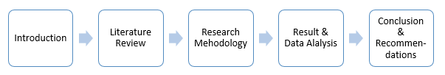
Source: Constructed by the author

Figure 6: Gantt Chart for Research Timetable
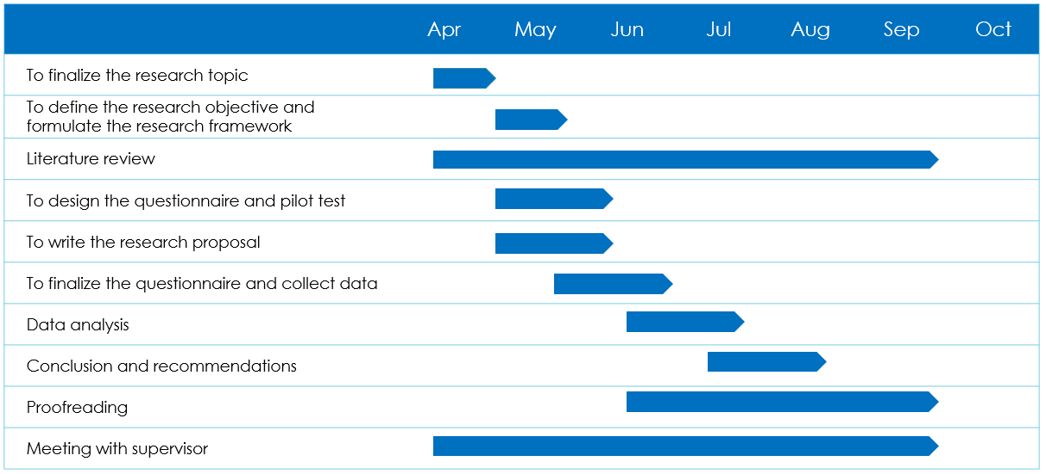
Source: Constructed by the author

Chapter 2: Literature Review
This chapter summarizes the state of the literature on the aspects that can influence an individual's repurchase intention, including trust, perceived risk, service quality, information quality, eWOM, and economic benefits. Additionally, the literature organizes and builds the theoretical framework that serves as the theoretical underpinning for this study.

2.1 Repurchase intention
Repurchase intention is the subjective possibility of a buyer purchasing a product or services from the same seller or company again (Lee, 2016, pp. 1674-1692). The relationship between attitude and behavior influences individuals' intentions to reuse a service or repurchase a product (Davis, 1989). According to Fishbein and Ajzen (1975), behavioral intentions measure people's interests, which causes behavior or connects people's attitudes and recognition of service contributions.

Repeat consumers bring in more revenue for businesses (Otim & Grover, 2006) and spread positive word of mouth through social networks (Mao & Lyu, 2017). According to Lian. et al. (2018a), Airbnb should retain existing clients because these customers can simply return to the traditional hotel business. Airbnb's long-term growth will most certainly be aided by a better understanding of the elements that influence traveler's repurchase intention (Tussyadiah, 2016). The key findings of the reviewed literature are summarized in Table 1 below; the current high demand in the sector necessitates the urgent discovery of context-specific antecedents or causes of Airbnb repurchase desire (Mao & Lyu, 2017).

Table 1: Key findings from the reviewed scholars on Repurchase Intention
Literature | Key findings
Mao and Lyu (2017) | Both attitudes and subject norms have a considerable impact on repurchase intention, but perceived behavioral control does not. Furthermore, perceived value and risk only directly affect attitude, which indirectly affects repurchase intention. Finally, expectations for a unique experience, familiarity, and electronic word of mouth impact repurchase intention, both directly and indirectly.
Birinci, et al (2018) | Customer satisfaction and repurchase intention are inextricably linked. Perceived authenticity was found to be a statistically significant predictor of satisfaction. Safety and security risk appear to be statistically significant drivers of customer satisfaction, whereas time/convenience and product performance risks were shown to be insignificant predictors.
Guttentag, et al. (2018) | The main motives are usually cost and other practical factors, with experiencing motivations coming in second.
Liang, et al (2018a) | Trust was found to exist as a mediator between transaction-based satisfaction and intention to repurchase. However, statistically, trust in Airbnb does not affect host trust.
Liang, et al (2018b) | Customers' perceived risk has a negative effect on their perceived value and repurchase intention, whereas perceived value has a positive impact on their perceived value and repurchase intention. It was discovered that price sensitivity does not reduce customers' perceived risk but instead increases their perceived value and encourages them to repurchase Airbnb products. Perceived authenticity was found to significantly lower the perceived risk of Airbnb clients and positively influence their perceived value. eWOM increases repurchase intention and perceived value but decrease perceived risk.
Hurang and Yu (2019) | According to structural equation modeling (SEM) analyses for Airbnb and traditional hotels, all variables had significant positive influences on satisfaction, significantly positively impacting repurchase intention.
Moon, et al (2019) | Overall interaction experiences are rated higher by guests than by hosts. Furthermore, distinct interaction aspects that contribute to visitors' happiness and behavioral intentions are given weight by both guests and hosts.
Mao, et al (2020) | Trust-in-hosts and trust-in-platform are two separate trust constructs that influence travelers' repurchase intentions independently and favorably. Furthermore, perceived risk moderates the effects of these two trust constructs on repurchase intention.
Jung, et al (2021) | It is necessary to account for network externalities to understand trust and interaction. The usability and utility of a system are also significantly impacted by interaction. Usefulness is also influenced by trust and interaction. Usefulness and the likelihood of repurchasing are also related.
So, et al (2021) | Perceived authenticity indirectly improves repurchase intentions of Airbnb consumers by lowering perceived risk and increasing perceived value; but, perceived authenticity has no direct impact on repurchase intentions.
Source: Constructed by the author

2.1.1 Construction and measurement on repurchase intention
Mao and Lyu (2017) asserted that repurchase intention on Airbnb is influenced by attitude, subjective norms, perceived behavioral control, perceived value, perceived risk, unique experience expectation, familiarity, and eWOM. According to Guttentag, et al. (2018), Airbnb users are divided into five groups: money savers, home seekers, collaborative consumers, pragmatic novelty seekers, and interactive novelty seekers; and their repurchase behavior is influenced by six factors: motivation, interaction, home benefits, novelty, sharing economy ethos, and local authenticity. While Liang, et al (2018a) proposed that travelers choose to use Airbnb again due to the impact of their trust in Airbnb, trust in hosts, transaction-based satisfaction, experience-based satisfaction, and switching intention.

According to the reviewed literature (Table 2), this study adopted the research model by stating that repurchase intention is strongly related to trust (Liang, et al., 2018a; Moon, et al., 2019; Mao, et al., 2020; Jung, et al., 2021), perceived risk (Mao & Lyu, 2017; Liang, et al., 2018b), service quality (Priporas, et al., 2017; Lalicic and Weismayer, 2018), information quality (Lee, et al., 2019), eWOM (Liang, et al., 2018b; Moon, et al., 2019), and economic benefits.

Table 2: Measurements of Repurchase Intention
Literature | Measurements
Mao and Lyu (2017) | 1) Attitude 2) Subjective norms 3) Perceived behavioral control 4) Perceived value 5) Perceived risk 6) Unique experience expectation 7) Familiarity 8) eWOM
Birinci, et al (2018) | 1) Perceived authenticity 2) Time/ Convenience risk 3) Product performance risk 4) Safety and security risk 5) Customer satisfaction
Guttentag, et al. (2018) | 1) Motivation 2) Interaction 3) Home benefits 4) Novelty 5) Sharing economy ethos 6) Local authenticity
Liang, et al (2018a) | 1) Trust in Airbnb 2) Trust in Host 3) Transaction-based satisfaction 4) Experience-based satisfaction 5) Switching Intention
Liang, et al (2018b) | 1) Perceived authenticity 2) eWOM 3) Price sensitivity 4) Perceived value 5) Perceived risk
Hurang and Yu (2019) | 1) Network platform's service quality 2) Lodging service quality 3) Experience 4) Satisfaction
Moon, et al (2019) | 1) Host's profile 2) Privacy 3) Communicative 4) Face-to-face interaction 5) Rapport 6) Trust 5) Satisfaction 6) WOM
Mao, et al (2020) | 1) Trust in host 2) Trust in platform 3) Perceived risk
Jung, et al (2021) | 1) Network externalities 2) Interactivity 3) Trust 4) Ease of use 5) Usefulness
So, et al (2021) | 1) Authenticity 2) Home benefits 3) Social interaction 4) Perceived enjoyment
Source: Constructed by the author

2.2 Trust
Trust is described as the expectation that an entity will rely on another person's or entity's word, commitment, or written disclaimer (Rotter, 1967). It is a metric used to assess an individual's resilience compared to another (Zand, 1972). Trust is particularly critical in times of uncertainty or conjecture on the unanticipated actions of others (Kim, et al., 2008).

Trust is a set of implicit assumptions that the other party will not engage in opportunistic behavior or take advantage of the situation (Gefen, 2002). In business environments, this behavioral assumption demonstrates itself in the presumption that the trusted party can act ethically (Hosmer, 1995) and consistently (Kumar, 1996). Therefore, confidence is concerned with people's prevailing thinking about the trusted party, on which people base their potential relationship with the trusted party (Gefen, 2002). Customers in trust and confidence with the company are more likely to use the services (Namahoot & Laohavichien, 2018).

The key findings of the reviewed literature are summarized in Table 3 below, which supported this study's assumption that trust is a critical factor associated with repurchase intention, and perceived risk as a mediator.

Table 3: Key findings from the reviewed scholars on Trust
Literature | Key findings
Yang, et al (2018) | The findings highlight the importance of rich interaction between users and hosts in fostering trust in the sharing economy. The established role of hosts' interactions with their guests demonstrates the substantial advantages of gaining user trust. Hosts should remember that prompt and frequent responses to guest inquiries improve effective communication, persuading users and earning their trust.
Liang, et al (2018a) | It should be acknowledged whether or not guests and hosts can or will trust one other, regardless of whether or not one believes in the Airbnb platform or the company. The result showed that trust was an essential factor in this relationship.
Zamani (2019) | The findings imply that the volume of information and communication are crucial in forming trust perceptions.
Yang, et al (2019) | Security, privacy, and IT quality are the three cognitive traits that help users trust the Airbnb platform. Consumers are more likely to focus on the transaction process or personal information security during the Airbnb booking process than other cognitive-based trust criteria. While cognitive-based trust variables focus on Airbnb, affective-based trust factors focus on user-host trust. As a result of the research, all three emotive qualities (reputation, interaction, and familiarity) are essential in increasing users' trust in Airbnb hosts.
Arvanitidis, et al (2020) | Airbnb, as an institution, should adequately understand the importance of 'institutional trust,' which both host groups place on the system, reinforcing existing procedures and even establishing new ones to increase institutional trustworthiness, reliability, and credibility.
Mao, et al (2020) | The study revealed a bidirectional picture of risk and trust, emphasizing the interaction effects between both. It expands on the trust literature by shedding light on the importance of these two trust dimensions and perceived risk on repurchase intention in the sharing economy.
Su and Mattila (2020) | Affective trust mediates the gender congruity effect on consumer Airbnb booking intention, and this effect is stronger among female customers than male consumers. The findings, however, do not support cognitive trust's mediating influence. Gender likeness tends to have a higher effect on consumers' affective trust in an Airbnb host (rather than a cognitive trust).
Wang, et al (2020) | The technical quality and social benefits of using the Airbnb platform both contribute to building trust.
Zhang, et al (2020) | The study suggested that a clear self-description can help build trust. Proving oneself is compelling, yet the words and sentences used can be complex. In addition, the study found that overly enthusiastic hosts score lower trust ratings.
Jung, et al (2021) | The study discovered that Airbnb platform characteristics affect the ease of use and usefulness of the Technological Acceptance Model (TAM), particularly network externality, which affects perceived ease of use via trust.
Source: Constructed by the author

2.2.1 Construct and measurement on trust
Ridings (2002) presented three criteria for determining trustworthiness: the disposition to trust, perceived responsiveness, and confiding personal information. McKnight and Chervany (2001) defined five types of trust in e-commerce: experience-based, calculative-based, cognitive-based, personality-based, and institution-based trust. McKnight et al. (2002) defined institution-based trust as the expectation of a satisfactory outcome from a transaction based on a previously defined structural factor; it refers to an individual's perception of the institutional framework – in their study, an experimental website that provided legal advice.

By adopting these ideas for this study on Airbnb, institution-based trust refers to an individual's perception of the institutional environment, including its structures and rules, that contributes to a traveler's sense of security when transacting via the Airbnb website. According to the reviewed literature (Table 4), this study adopted the measurement of trust in the Airbnb platform and trust in hosts (Liang, et al., 2018a; Yang, et al., 2019; Su and Mattila, 2020).

Table 4: Measurements of Trust
Literature | Measurements
Yang, et al (2018) | 1) Interactivity 2) Credibility 3) Emotional bonding 4) Accommodation characteristics
Liang, et al (2018a) | 1) Institution-based trust (trust in Airbnb platform) 2) Disposition to trust (trust in hosts or guests)
Zamani (2019) | 1) Level of interaction 2) Information asymmetry 3) Support provision
Yang, et al (2019) | 1) cognitive-based trust (trust in Airbnb platform) 2) affective-based trust (trust in hosts)
Arvanitidis, et al (2020) | 1) Interpersonal trust 2) Institutional trust
Mao, et al (2020) | 1) Experience-based trust 2) Calculative-based trust 3) Cognition-based trust 4) Personality-based trust 5) Institution-based trust (trust in Airbnb platform)
Su and Mattila (2020) | 1) cognitive-based trust (trust in Airbnb platform) 2) affective-based trust (trust in hosts)
Wang, et al (2020) | 1) Social antecedents: User experience, Social utility of sharing, Social value orientation 2) Technical antecedents: System quality, Service quality, Information quality 3) Economic antecedents: Extrinsic rewards 4) Privacy assurance antecedents: Perceived effectiveness of privacy policy, Perceived effectiveness of industry self-regulation
Zhang, et al (2020) | 1) Readability 2) Sentiment intensity 3) Perspective taking
Jung, et al (2021) | Technological Acceptance Model: 1) Perceived ease of use 2) Perceived usefulness 3) Intention to repurchase
Source: Constructed by the author

2.3 Perceived risk
Perceived risk is defined as a trait that is influenced by the stimuli of the digital environment (Chang & Chen, 2008). It is critical to the firm when consumers view of the unclear adverse effects of an online transaction (Kim, et al., 2008). It represents the consumer's perception of the unpredictability of outcomes, particularly while browsing for and selecting a product and/or service information before making any purchase decision (Roy, et al., 2012).

Perceived risk and trust are prevalent concepts that affect repurchase intention (Martins, et al., 2014). Namahoot and Laohavichien (2018) revealed that trust has a greater mediating impact on repurchase intentions than perceived risk. It is a powerful predictor of consumer behavior, as consumers are more concerned with avoiding errors than maximizing utility in purchasing (Mitchell, 1999). The perceived risk of Internet shopping is higher than traditional shopping, which is also implied to the Airbnb platform under the sharing economy business model.

Airbnb is rapidly growing, but its unusual operational structure has raised concerns. Because Airbnb lodging is a private space provided by individual hosts, adhering to the handbook's quality standards is difficult. As a result, Airbnb users will face significant uncertainty in addition to a variety of risk factors, even if they are seasonal Airbnb users who are staying with a new host. The key findings of the reviewed literature are summarized in Table 5 below,
Table 5: Key findings from the reviewed scholars on Perceived Risk
Literature | Key findings
Yang, et al. (2015) | While perceived total risk is adversely associated with trust, perceived risk may be categorized into two categories: system-dependent risk, which is positively associated with trust, and transactional risk, which is negatively associated with trust.
Mao and Lyu (2017) | Value and risk perceptions have a direct and significant impact on attitude, which in turn influences repurchase intention. This means Airbnb and its hosts must boost travelers' positive views by enhancing the effects of positive antecedents (perceived value and unique experience expectation) and decreasing negative antecedents (perceived risk).
Stollery and Jun (2017) | Psychological risk has a significant negative effect on perceived value. This implies that when guests utilize Airbnb, they encounter anxiety, which has an effect on their opinion of the service's value. Other types of risk were discovered to have no effect on perceived value (performance, physical, and time). Almost 75% of respondents said that they had used Airbnb twice or more, which may have influenced their risk rating. Previous research has discovered that as customers gain experience, their perception of risk decreases.
Lee, et al. (2018) | Trust in the platform minimizes users' perceptions of risks while increasing users' perceptions of benefits from engaging in the sharing economy.
Amaro, Andreu and Huang, (2019) | The data reveal that perceived risk has a negligible impact on the intention to use Airbnb, which may be attributed to the features of millennials. When it comes to online purchases, they do perceive fewer risks than the older generations. Previous research had found that confidence and security in computer systems were increasing. When Internet use and online travel purchases are becoming more common, the perceived risk appears to play a minor influence, particularly among millennials who have grown up with technology as a fundamental part of their lives.
Jun (2020) | Airbnb users assess more particular risks based on their prior Airbnb experiences.
Yi, et al. (2020) | Physical risk influenced behavioral intention, while performance risk influenced desire. This conclusion contradicts classic risk theory and consumer behavior literature, yet it is compatible with the phenomena known as the "privacy paradox" or "risk perception paradox".
Yuliati, et al. (2020) | Online trust is unaffected by perceived risk. It was perceived performance risk that dominated. Institutional trust influenced online trust. Perceived privacy was the most important dimension. Perceived risk had a negative impact on service usage.
Lee and Deale (2021) | During the pandemic, consumers had greater social, physical, performance, and convenience risk perceptions. Respondents who were more aware of the pandemic in terms of fear and anxiety experienced greater shifts in their risk assessments. Furthermore, variations in risk perception varied according to customers' usage experience.
Qalati, et al. (2021) | This study found a substantial moderating effect of perceived risk between trust in online shopping and purchase intention. This result suggests that perceived risk significantly mediates the relationship between trust and purchase intention.
Source: Constructed by the author

2.3.1 Construct and measurements on perceived risk
As Selnes (1998) suggested, trust reduces perceived risk in a buyer-seller relationship. Previous scholars have established a strong relationship between risk and trust; the same applies to the sharing economy studies that financial and physical risk influence consumers' perceptions of risk (Table 6).

This study focused on the financial risk (intangible) (Mao and Lyu, 2017; Amaro, et al., 2019; Jun, 2020; Qalati, et al., 2021) and physical risk (tangible) (Jun, 2020; Yi, et al., 2020; Yuliati, et al., 2020; Lee and Deale, 2021) as well while exploring the relationship between trust and perceived risk on the repurchase intention of Airbnb.

Table 6: Measurements of Perceived Risk
Literature | Measurements
Yang, et al. (2015) | 1) Overall risk 2) Economic risk 3) Functional risk 4) Security risk 5) Privacy risk 6) Time risk 7) Service risk 8) Psychological risk 9) Social risk 10) Perceived usefulness 11) Perceived ease of use
Mao and Lyu (2017) | 1) Attitude 2) Considerable risk 3) Financial risk 4) Overall risk
Stollery and Jun (2017) | 1) Performance risk 2) Physical risk 3) Psychological risk 4) Time risk
Lee, et al. (2018) | 1) Privacy risk 2) Security risk
Amaro, Andreu and Huang, (2019) | 1) Performance risk 2) Privacy risk 3) Financial risk
Jun (2020) | 1) Performance risk 2) Financial risk 3) Physical risk 4) Social risk 5) Psychological risk 6) Time risk 7) Past experience
Yi, et al. (2020) | 1) Physical risk 2) Financial risk 3) Privacy risk 4) Performance risk 5) Desire
Yuliati, et al. (2020) | 1) Financial risk 2) Performance risk 3) Physical risk 4) Time risk 5) Psychological risk
Lee and Deale (2021) | 1) Social risk 2) Physical risk 3) Performance risk 4) Convenience risk
Qalati, et al. (2021) | 1) Financial risk 2) Product risk 3) Security risk 4) Time risk 5) Social risk
Source: Constructed by the author

2.4 Service quality
Service quality is the primary indicator of client happiness (Taylor & Baker, 1994). It is described as the standard of service people anticipate (Shao, et al., 2004). The gap between what customers expect from a service and how they perceive it to perform (Kuo, et al., 2009). When offering a service, adherence to consumer requirements is required (Wu, et al., 2011), so service quality is an essential factor in evaluating an industry's viability (Huang, et al., 2014), where it is the majority of what determines customer contentment and behavioral intentions (Lalicic & Weismayer, 2018).

The Airbnb website acts as a critical service platform, allowing guests to simultaneously consume and evaluate critical service quality attributes (Ju, et al., 2019). Customer relationship management's (CRM) strategic value affects a customer's proclivity to repurchase (Sulman & Ayyub, 2019). The buyer-seller transaction involves the exchange of a physical item (Chen, et al., 2019). Excellent pre-sale and after-sale service can boost perceived benefits while reducing non-monetary elements such as time, energy, and psychological stress for the buyer. Multi-channel integration service quality is determined by the channel service configuration and integrated interactions (Qi & Yao, 2020).

Table 7: Key findings from the reviewed scholars on Service Quality
Literature | Key findings
Priporas, et al. (2017) | Convenience and assurance are important factors in measuring service quality in remote Airbnb properties. The research also indicated that Airbnb guests value convenient access to tourist attractions, easy access to information, and quick resolution of issues. The authors discovered that guests value Airbnb's convenience and flexibility, as well as the homeowners' genuine friendliness. Finally, Airbnb customers have low expectations of the accommodations' features and services.
Cheng, et al. (2018) | In the context of a sharing economy firm, two elements of online service quality and three factors of offline service quality were developed and validated. It was discovered that structural assurance and platform responsiveness are crucial measures of online service quality that influence satisfaction and loyalty. Congruence of information, competence, and empathy were discovered to be important measures of offline service quality that influence satisfaction and loyalty.
Lalicic and Weismayer (2018) | According to the findings of this study, SQ and the value of having social and authentic experiences are major predictors of travelers' loyalty to Airbnb hosting services. Aside from the interactive aspect of the hosting experience, hosts should be aware that visitors desire a specific standard. Airbnb provides excellent customer service; however, hosts must also be informed and mentored in order to meet these SQ expectations.
Fransi, et al (2019) | According to the study's findings, efficiency, reliability, and privacy all positively enhance the perceived quality of a collaborative accommodation portal, but communication does not. In addition, it is a more sustainable kind of consumption for consumers who use collaborative accommodation platforms since they are utilizing resources that would otherwise be unused.
Ju, et al. (2019) | The findings give empirical proof that website functionality, design, usability, and responsiveness are essential SQ qualities for Airbnb users.
Sun, et al. (2019) | According to the findings, competitive advantage may be maintained by strengthening target group-related service quality, the accuracy and relevance of information offered, flexible check-in and check-out slots and services, and the scheduling of excursions and events for guests.
Ding, et al. (2020) | The importance of hosts in the lodging experience of Airbnb users, particularly in establishing effective communication with Airbnb customers, which can contribute to developing an initial trusting relationship The retrieved variables under the dimension of convenience are unrelated to the hotel experience, but are more related to the local experience, such as visiting nearby tourist attractions and partaking in water sports.
Shao, et al. (2020) | our study examines the effects of five service qualities, specifically location reliability, prompt response, transaction assurance, customization and vivid appearance, on customers' satisfaction and continuance intention
Ranjbari, et al. (2020) | The most essential service attribute of Airbnb for visitors was "price reasonableness," while "check-in flexibility" was the best executed. As a managerial implication, this study suggests four strategies: "Keep up the good job," "Concentrate here," "Low priority," and "Possible overkill." These tactics assist managers, decision makers, and Airbnb hosts in making better decisions for the development and enhancement of their SQ and prioritizing work on areas that require greater attention, allowing them to use their resources more efficiently.
Meijerink and Schoenmakers (2021) | The findings reveal that customers' views of service quality are positively and linearly associated to submitting an online review of an Airbnb stay. In other words, satisfied customers are more likely than disappointed customers to post a review after an Airbnb stay.
Source: Constructed by the author

2.4.1 Construct and measurements service quality
The Service Quality ("SERVQUAL") model (Parasuraman, et al., 1985) is divided into five attributes: i) Tangibility, ii) Reliability, iii) Assurance, iv) Responsiveness, and v) Empathy. When it comes to lodging options, Airbnb has established itself as a significant challenger to traditional hotels. However, there have been few investigations on the quality of Airbnb's service. Airbnb customers rate service quality based on the quality of their accommodations as well as their experience with the host during the booking process. Customers rent the apartment from an Airbnb host, who owns the accommodation.

As a result, this study uses the modified SERVQUAL model as a theoretical foundation to construct the five aspects of service quality in the context of Airbnb usage (Table 8), with a focus on Airbnb hosts' responsiveness (Cheng, et al., 2018; Shao, et al., 2020) and empathy (Cheng, et al., 2018; Shao, et al., 2020), as well as the Airbnb platform's reliability (Lalicic and Weismayer, 2018; Shao, et al., 2020).

Table 8: Measurements of Service Quality
Literature | Measurements
Priporas, et al. (2017) | 1) Tangibles 2) Convenience 3) Assurance 4) Understanding and caring 5) Adequacy service supply
Cheng, et al. (2018) | 1) Structural assurance 2) Platform responsiveness 3) Information congruity 4) Competence 5) Empathy
Lalicic and Weismayer (2018) | 1) Host's responsiveness 2) Host's assurance 3) Host's empathy 4) Host's reliability
Fransi, et al (2019) | 1) Efficiency 2) Reliability 3) Privacy/ Security 4) Communication
Ju, et al. (2019) | 1) Host service quality 2) Web responsiveness quality 3) Web efficiency quality 4) Facility service quality
Sun, et al. (2019) | 1) the accuracy of diverse information provided by Airbnb 2) Location 3) Personalized service 4) Rooms and Facilities 5) Authenticity
Ding, et al. (2020) | Modified SERVQUAL Questionnaire (MSQ): 1) Tangibles 2) Adequacy in service supply 3) Understanding and caring 4) Assurance 5) Convenience
Ranjbari, et al. (2020) | 1) Accommodation and facilities 2) Pleasure and joy 3) Neighbourhood 4) Hosting 5) Value
Shao, et al. (2020) | 1) Reliability 2) Responsiveness 3) Assurance 4) Empathy 5) Tangibles
Meijerink and Schoenmakers (2021) | 1) Quality of good/accommodation 2) Quality of host
Source: Constructed by the author

2.5 Information quality
The persuasive strength of the arguments contained inside the message's contents is characterized as the information quality (Atika, et al., 2016). Since Airbnb's user platform is its website, so websites rely heavily on information. The quality of that information is considered a marketing tool for assuring the seamless execution of online purchasing transactions (Kim & Niehm, 2009). Perceptions of a website by the general audience (Almahamid, et al., 2010) may influence the extent to which users trust that information is current, accurate, and extensive (Ramayah, et al., 2010). Information quality increases an individual's evaluation of the system's ability to provide information based on their personal use of the system (Zheng, et al., 2013).
Table 9 summarizes the service-related attributes of Airbnb which have been reviewed through analysis of the available literature to date.
Table 9: Key findings from the reviewed scholars on information quality
Literature | Key findings
Kim and Niehm (2009) | In the study, perceived information quality influenced perceived value favorably. Consumers who thought the website's material was of excellent quality tended to think the website's products were good value for money. Online clothing retailers can boost the perceived value of their products/services by displaying and keeping accurate, up-to-date, and timely information on their websites.
Almahamid, et al. (2010) | Information that is accurate, legitimate, current, error-free and clearly presented on a website will be used by users to complete their duties. The relationship between a firm and its consumers will improve as soon as clients are satisfied with the information quality given on the website.
Ramayah, Ahmad and Lo (2010) | Enough and up-to-date information offered by the website will result in a more positive attitude towards the site.
Zheng, Zhao and Stylianou, (2013) | An individual's assessment of the system's performance in supplying information based on his own use of the system. Information reliability and format are the two most impor-tant dimensions of information quality perceived by users.
Atika, Kusumawati and Iqba, (2016) | A measure of the persuasiveness of a message's argumentation This shows that an increase in the quality of information will result in a greater improvement in the brand image variable. The perceived quality of the information that customers get can be used to measure their decision-making process for products or services. Customer buying behavior is influenced by customers' judgments about the quality of information on the internet. After a consumer is satisfied with the information, they will evaluate the worth of any products or services based on their purchasing criteria.
Erkan and Evans (2018) | Information quantity is one of the explicit reasons which enable shopping websites to be more advantageous and ultimately more influential to consumers.
Chen and Chang (2018) | It has been discovered that information quality has a favorable and considerable impact on contentment. The quality of information influences user happiness, which in turn influences purchase intention.
Phuong and Trang (2018) | The findings demonstrate the importance of service quality, system quality, and information quality in determining overall perceived service quality.
Hanjaya, Kenny and Gunawan (2019) | Online purchasing intent is influenced by usefulness and information quality. Also, good information quality allows customers to readily research their chosen products. Consumers today demand personalization and customization. In the absence of this superior experience, clients will go elsewhere. It can also improve the customer experience on a retailer's mobile app, raising purchase intent. Increasing consumer happiness through enhancing mobile app performance, efficacy, and productivity in terms of product search, purchase, and information provided.
Lee, Sung and Jeon (2019) | A system provides the user with rapid and accurate access to critical information. The quality of information was discovered to have a beneficial relationship on continued usage intention with performance. The user's intention to use an app is influenced by the app's perceived information quality and performance expectancy, as well as social influence and habit. Furthermore, information quality was discovered to have no direct effect on ongoing use intention, meaning that the correctness and reliability of information has no effect unless the user perceives its usefulness.
Source: Constructed by the author

2.5.1 Construct and measurements information quality
The degree to which a website's content is current, accurate, and complete is referred to as information quality (Almahamid, et al., 2010; Lee, et al., 2019). Users would feel more confident with the institution behind the website if it presented accurate and comprehensive information (Ramayah, et al., 2010). A previous study found that the quality of information is the most important factor of travelers' trust in travel e-commerce websites (Erkan & Evans, 2018). Furthermore, it has been demonstrated that the quality of information is a strong determinant of the usefulness and acceptance of online consumer evaluations (Chen & Chang, 2018).

In this study, the information quality metric is based on how tourists interpret the information listed by the host on the Airbnb platform (Table 10). Platforms for the sharing economy may collect information about hosts such as reviews, ratings, profile images, and social network account information. These details may help travelers decide which hosts to choose. As a result, it is reasonable to conclude that information quality will influence travelers' propensity to repurchase from Airbnb as a component of website quality.

Table 10: Measurements of Information Quality
Literature | Measurements
Kim and Niehm (2009) | 1) Interactivity 2) Online completeness 3) Ease of use 4) Entertainmnt 5) Trust
Almahamid , et al. (2010) | 1) Accessibility 2) Timeliness 3) Relevancy 4) Understandability 5) Quantity 6) Validity  7) Objectivity 8) Security 9) Completeness 10) Free of error 11) Concise presentation
Ramayah, Ahmad and Lo (2010) | 1) Relevant 2) Timely 3) Accurate 4) Complete
Zheng, Zhao and Stylianou, (2013) | 1) Reliabilty 2) Objectivity 3) Added value 4) Timeliness 5) Richness 6) Format
Atika, Kusumawati and Iqba, (2016) | 1) Completeness 2) Format 3) Accuracy 4) Currency
Erkan and Evans (2018) | 1) Have enough justifications 2) Objective 3) Comprehensible 4) Clear
Chen and Chang (2018) | 1) Reliabile informaiton 2) Attuned to the reality of the situation
Phuong and Trang (2018) | 1) Usefulness 2) Adequacy
Hanjaya, Kenny and Gunawan (2019) | 1) Information that is pertinent 2) Valuable and verifiable information 3) Information of the highest calibre 4) Current information
Lee, Sung and Jeon (2019) | 1) Accurate data 2) Facts that can be relied upon 3) An appropriate degree of detail 4) Presents in a format that is appropriate
Source: Constructed by the author

2.6 eWOM
Electronic Word Of Mouth ("eWOM") is an effective marketing strategy for encouraging the sale of a product (Wang, et al., 2018). Before purchasing things or services, consumers research previous customers to establish confidence (Erkan & Evans, 2016). In the consumer–supplier relationship, previous consumers voice their opinions or even evaluate a company's performance and behavior (See-To & Ho, 2014). Potential customers generally utilize eWOM to decide whether they should trust a company in an online transaction. Any favorable or negative statements or debates on the internet regarding a certain product, service, or organization would influence to the customers' decision (Liang, et al., 2018).

Table 11: Key findings from the reviewed scholars on eWOM
Literature | Definition
Matute, et al. (2016) | Consumers like the idea of other users' reviews being published on the seller's website since it adds value and functionality to the site. Quality and quantity do not influence trust in an online merchant, but credibility and quality do. Moreover, eWOM quality influences buyers' online repurchase intent. Consumers are more likely to return to an online store for future purchases if they believe other users' reviews are credible. In this sense, buyers may see the vendor's efforts as providing current, relevant information on the website.
Mao and Lyu (2017) | eWOM directly and indirectly influences repurchase intent via subjective norms. This study also acknowledges the role of eWOM and familiarity in repurchase intent. eWOM has a substantial direct and indirect impact on customer behavior intentions. High online review scores are critical to individual host success since they influence score-based ranking and user selection. Airbnb hosts should take extra precautions to avoid bad reviews or minimize their impact. Airbnb hosts should provide excellent service recovery.
Yang (2017) | Businesses can take advantage of this opportunity to be more receptive to client needs, to market their products and services, and to establish a brand through imagery.
Bulut and Karabulut (2018) | Receiving or distributing positive messages increases purchasing intentions. The "message quality," "message quantity," "content variety," and "intensity" of eWOM communications can improve online buying sustainability. Customers should be encouraged to find and share eWOM messages. Positive online remarks can be disseminated to other social media channels. Quality and quantity of eWOM communications had greater direct impacts on customers' repurchase intention than the etrust model.
Anaya-Sánchez, et al. (2020) | Among the antecedents of positive eWOM intention, repurchase intention is significant. Repeat purchases increase the likelihood of a consumer recommending the brand.
Tabassum, Khwaja and Zaman (2020) | The behavior of consumers in various digital networks in exchanging the product or service-related information with other consumers. Digital presence and positive image are important to capture the attention of Generation Z consumers.
Tandon, et al. (2020) | Higher Website Quality, eWOM, and Product Satisfaction tend to positively impact both Customer satisfaction and Repurchase Intention. To satisfy online customers, e-tailers should focus on improving Website Quality and eWOM.
Maduretno and Junaedi (2021) | According to this study, eWOM credibility and quality positively influence customer repurchase intent, while quantity has a negative impact. Repurchase intention was successfully mediated by trust in the online vendor. However, perceived website utility only moderates the impact of eWOM quality on online repurchase intent.
Mansourimoayyed, et al., (2021) | eWOM can have an impact on satisfied customers and their intentions. As the results show, eWOM moderates this relationship in a positive way. This finding adds to the existing literature by addressing the fact that eWOM has a greater impact on repurchase intention.
Sanyal, et al. (2021) | eWOM influences satisfied customers' intentions. This relationship is positively moderated by eWOM. As a result of this finding, eWOM has a greater impact on repurchase intention.
Source: Constructed by the author

2.6.1 Construct and measurements on eWOM
Quantity, quality, and credibility are widely used to measure the performance of eWOM. Which we applied the same in this study.

Table 12: Measurements of eWOM
Literature | Measurements
Matute, et al. (2016) | 1) Quantity 2) Credibility 3) Quality
Mao and Lyu (2017) | 1) Refer to online review 2) reviews are credible 3) reviews will affect my purchase intention
Yang (2017) | 1) Experience factors 2) Knowledge sharing factors 3) Technology acceptance factors
Bulut and Karabulut (2018) | eWOM receiving: 1) Quality 2) Quantity  eWOM participating: 1) Content 2) Intensity
Anaya-Sánchez, et al. (2020) | 1) Willingness to spread positive eWOM 2) Willingness to recommend 3) Willing to point out positive aspects if anybody is criticizing
Tabassum, Khwaja and Zaman (2020) | 1) Convincing 2) Persuasive 3) The reviewer is credible 4) The reviewer is reliable 5) Contradicted what I had previously known 6) Supported my opinion of the product 7) Consistent with other reviews 8) In the same vein as previous reviews 9) Educational 10) Comprehensive
Tandon, et al. (2020) | 1) Comprehensibility 2) Reliability 3) Specificity
Mansourimoayyed, et al., (2021) | 1) Quality 2) Quantity 3) Credibility
Sanyal, et al. (2021) | 1) Quality 2) Quantity 3) Credibility
Maduretno and Junaedi (2021) | 1) Quality 2) Quantity 3) Credibility
Source: Constructed by the author

2.7 Economic benefits
A study defined benefits as improved conditions or ameliorating a worse state for individuals and groups, including physical, psychological, social, economic, and environmental benefits (Besculides, et al., 2002). In the context of tourism, it is suggested that the anticipated economic benefits include increased employment, investment, increased business and income (Nunkoo & Ramkissoon, 2011). The economic benefit is defined as the return on service consumption and performance predictive of customer happiness and future proclivity to use or purchase (Santoso & Nelloh, 2017). It reflects consumers' opinions of the benefits of online purchasing (Dabbous, et al., 2020). People are more fiscally responsible and continually attempt to be more resourceful (Tussyadiah & Pesonen, 2016).
Users' motivations for continuing to engage in social commerce are diverse and frequently motivated by their views of personal joy and economic benefits (Hamari, et al., 2016). Economic benefits are typically touted as collaborative consumption's most persuasive qualities (Amaro, et al., 2019). When strong social and economic benefits are combined with low risks, costs, and trust, tourists who use peer-to-peer lodging may have stronger purchasing intentions (Pappas, 2017).

Table 13: Key findings from the reviewed scholars on economic benefits
Literature | Definition
Lai, et al. (2015) | The perception of economic benefit is a significant element influencing consumer behavior in the direction of purchasing.
Tussyadiah and Pesonen (2016) | People are more conscientious of their expenditure and are constantly striving to be more resourceful.
Tussyadiah (2016) | On satisfaction and intention to utilize P2P housing, there are significant positive effects of enjoyment and economic gains.
Hamari, Sjöklint and Ukkonen (2016) | Users' desire to continue participating in social commerce is complex and frequently based on their perceptions of personal delight (including through relatedness) and economic gains.
Pappas (2017) | Strong social and economic benefits combined with minimal risks, costs, and trust can result in high purchasing intentions for holidaymakers using peer-to-peer lodging.
Santoso and Nelloh (2017) | Return on service consumption and performance serve as predictors of satisfaction and future propensity to use services.
Amaro, Andreu and Huang (2019) | The economic benefits of participation in collaborative consumption are frequently cited as one of its most compelling features.
Lv, Xie and Li (2019) | A favorable effect on tourism-related support.
Dabbous and Tarhini (2019) | Economic advantages are necessary to motivate individuals to engage in sustainable consumption through sharing economies and to establish the role of attitude and trust as mediators.
Dabbous, Aoun and Sayegh (2020) | Represent consumers' perceptions of the degree to which they will benefit from engaging in an online transaction with a certain website.
Source: Constructed by the author

2.7.1 Construct and measurements on economic benefits
Perceived personal economic benefit was measured mainly based on the suggestions from the majority of scholars with lower cost (Lai, et al., 2015; Tussyadiah & Pesonen, 2016), save money (Pappas, 2017; Santoso & Nelloh, 2017), more affordable (Dabbous and Tarhini, 2019; Dabbous, et al., 2020) and higher quality/ unique accommodations (Amaro, et al., 2019)

Table 14: Measurements of Economic Benefits
Literature | Measurements
Lai, et al. (2015) | 1) Save money 2) Efficiency 3) Lower cost
Tussyadiah and Pesonen (2016) | 1) Save money 2) Lower cost 3) Higher-quality lodging at a lower cost
Tussyadiah (2016) | 1) Save money 2) Lower travel cost 3) Reasonably priced 4) Financial advantages
Hamari, Sjöklint and Ukkonen (2016) | 1) Save money 2) Financial advantages 3) Enhance economic conditions 4) Save time
Pappas (2017) | 1) Save money 2) Lower travel cost 3) Higher-quality lodging at a lower cost
Santoso and Nelloh (2017) | 1) Save money 2) Lower cost 3) Reasonably priced 4) Financial advantages
Amaro, Andreu and Huang (2019) | 1) Save money 2) Lower cost
Lv, Xie and Li (2019) | 1) Boost your ability to pay 2) Economic gain 3) Economic prospects
Dabbous and Tarhini (2019) | 1) Save or earn money 2) Enhance economic conditions 3) More affordable than competing products on the market
Dabbous, Aoun and Sayegh (2020) | 1) Save money 2) Enhance economic conditions 3) More affordable than competing products on the market
Source: Constructed by the author

2.8 Demographic factors
When a company works with a variety of customers, demographic segmentation allows it to more readily classify the needs of its customers (Scott & Shieff, 1993). According to Donthu and Garcia (1999), customers exposed to infomercials did not modify their purchasing frequency based on demographic criteria such as gender, race, level of education, or wealth, according to a prior study, but their assessment of risks and benefits did.

The conceptual framework was constructed in this study to explore the relationship of perceived trust, perceived risk, eWOM, economic rewards, service quality, information quality, and repurchase intention among Airbnb users. Furthermore, this study will investigate whether any demographic traits have an effect on the aforementioned elements. As a result, the conceptual framework, study hypotheses, and research techniques will be discussed after examining the literature on all of the topics under discussion. Age, education level, marital status, ethnic origin, family size, and customary purpose of travel were chosen as demographic criteria to quantify individual characteristics.

Chapter 3: Research Methodology

This chapter will examine the elements that affect tourists' decision to utilize Airbnb. A study would be conducted to examine the hypothesized links between independent and dependent variables in the proposed research model.

To begin, references to pertinent literature were used to analyze the research aspects of this study, which included perceived risk associated with a peer-to-peer network, service quality, information quality, electronic word of mouth ("eWOM"), economic benefits, trust, and demographic factors. This chapter illustrates the research methods used in this study based on the findings from the literature review. This chapter explains the research framework, the research steps, the research tools, and the methods for data analysis.

We convened a focus group and conducted interviews to elicit participants' perspectives and evaluations of the study, followed by a pilot test and amendments to the questionnaire for a large-scale survey. The large-scale survey will be conducted on an online data collection platform. SPSS will be used to analyze the data for the study, which will include reliability tests, regression analyses, independent T-tests, correlation analyses, and one-way ANOVA analyses. Finally, recommendations and conclusions will be made based on the research findings.

3.1 Research model with hypotheses
The peer-to-peer economy is garnering increased interest in tourist studies (Tussyadiah & Pesonen, 2016). To date, the majority of research has concentrated on the motivations of hosts and guests, as well as their satisfaction with the experience, with little attention paid to tourism-related factors associated with online peer-to-peer repurchasing behaviors, such as perceived authenticity, a characteristic not commonly associated with general online repurchasing behaviors.
The purpose of this study is to provide a conceptual framework for investigating the relationship between perceived risk, trust, and travelers' intention to repurchase Airbnb. Furthermore, to determine the relationships between repurchase intention and service quality, information quality, eWOM, economic benefits, and demographic factors. The model depicted in Figure 7 illustrates the relationship of the conceptual model.

Figure 7: Conceptual model of the study with hypotheses
$$H_{3}$$

$$H_{5}$$

$$H_{6}$$

$$H_{2}$$

$$H_{1}$$
$$H_{7}$$

$$H_{8}$$

$$H_{4}$$

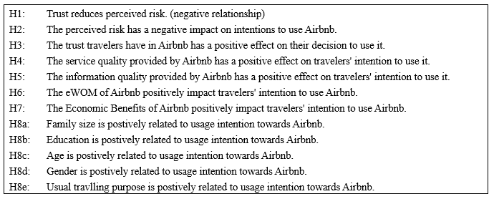
Source: Constructed by the author

3.1.1 Trust and perceived risk
According to the conceptual model, various factors influence perceived risk, the form of online peer-to-peer platform used by Airbnb hosts and travelers brings concerns about privacy and protection. Additionally, the model proposes that perceived risk has a negative impact on trust, which in turn has a positive effect on online purchasing behavior, and that trust has a positive impact on online transactions.

People are less likely to partake in risk judgments and subjective perceptions of failure if they have more satisfying encounters (Amaro, et al., 2019). Many consumers are hesitant to conduct online transactions because they are worried about potential threats to their privacy (Johnson, et al., 2008; Kim, et al., 2008; Mittendorf, 2017; Amaro, et al., 2019). These studies suggest that resolving privacy issues fosters greater confidence in online shopping, lowering the perceived risk associated with the transaction. Other studies also found contradictory data about whether privacy issues raise the perceived risk of online shopping (Foxman & Kilcoyne, 1993; Miyazaki & Fernandez, 2001). Apart from privacy issues, travelers may have concerns regarding the practice of home-sharing, which involves living with a stranger (Amaro, et al., 2019).

In fact, Airbnb users cannot experience the actual service before arriving at the house, so they have little choice but to evaluate the risk of this transaction based on the available information and communications. In this way, the perceived risk of Airbnb customers is critical in their repurchasing decisions. This controversy seems to justify further investigation, which leads to the following hypothesizes:

Hypothesis-1 ("$H_{1}$"): | Trust reduces perceived risk. (negative relationship)
Hypothesis-2 ("$H_{2}$"): | The perceived risk has a negative impact on intentions to use Airbnb. (negative relationship)
Hypothesis-3 ("$H_{3}$"): | The trust travelers have in Airbnb has a positive effect on their decision to use it. (positive relationship)

3.1.2 Service quality
Studies conducted in an Airbnb setting demonstrate that the role of facilities is highly subjective when it comes to visitors' willingness to return (Tussyadiah & Pesonen, 2016). Given Airbnb's recently listed, the framework should be further improved and, ideally, evaluated against established service theories. Thus, in order to comprehend consumers' behavioral intents toward peer-to-peer accommodation, the idea of service quality cannot be overlooked but must be evaluated for its applicability. Furthermore, consumers' service quality assessments should have a beneficial effect on travelers' loyalty to Airbnb. As a result, the following hypothesis is formed:
Hypothesis-4 ("$H_{4}$"): | The service quality provided by Airbnb has a positive effect on travelers' intention to use it.

3.1.3 Information quality
According to certain studies, high perceived information quality may result in increased intention to use, as it may lessen the risk of possible loss (Kim & Niehm, 2009). As a result, customers who believe that the website's content is simple to read and understand and that the website's format is simple to follow, may assume that the information offered by the website is of high quality. As so, the following theory is presented.
Hypothesis-5 ("$H_{5}$"): | The information quality provided by Airbnb has a positive effect on travelers' intention to use it.

3.1.4 eWOM
Scholars had mentioned that the review mechanism on Airbnb is the cornerstone of transaction trust (Woon and Chng, 2019). As a result, eWOM is a source of travel information for visitors to consult in order to gain a more thorough perspective of peer-to-peer lodgings prior to making an online reservation, which leads to the creation of the following hypothesis.
Additionally, there were evidences demonstrating the favorable relationship between eWOM and repurchase intention (Mansourimoayyed, et al., 2021; Sanyal, et al., 2021). As a result of these findings, the following eWOM hypothese was proposed:
Hypothesis-6 ("$H_{6}$"): | The eWOM of Airbnb positively impact travelers' intention to use Airbnb.

3.1.5 Economic benefits
According to scholars, one of the main reasons travelers book from Airbnb is budgetary reasons (Zervas, et al., 2017; Amaro, et al., 2019). Price is seen as a dissuasive element in selecting activities, albeit its effect varies according tohe traveler (Tussyadiah & Pesonen, 2016). As a result, one may argue that the cost savings associated with peer-to-peer accommodation rents enable the spread of extra expenditures on other trip components, such as on-site activities.
There is little question that being price-sensitive may affect repurchase intention. For instance, one scholar proposed that purchasers would be more likely to choose a less expensive product than one with the same function but a greater price (Chen, et al., 1998). So, will it be possible for travelers to repurchase from Airbnb rather than regular hotels due to the lower price from Airbnb? Therefore, the following hypothesis was proposed:
Airbnb leverages its marketing efforts to promote a diverse range of unusual places to stay, including treehouses (Airbnb, 2021) and castles (Airbnb, 2021b; Ceaser, 2021). Research has found that certain types of personalities respond to this unique feature (Amaro, et al., 2019).

Hypothesis-7 ("$H_{7}$"): | The Economic Benefits of Airbnb positively impact travelers' intention to use Airbnb.

3.1.6 Demographic factors
In this study, demographic variables such as gender, age, family size, education, and travelling purpose were examined to determine whether there are differences in repurchase intention between groups.

Hypothesis-8a ("$H_{8a}$"): |  | Family size is positively related to repurchase intention towards Airbnb.
Hypothesis-8b ("$H_{8b}$"): |  | Education is positively related to repurchase intention towards Airbnb.
Hypothesis-8c ("$H_{8c}$"): |  | Age is positively related to usage repurchase towards Airbnb.
Hypothesis-8d ("$H_{8d}$"): |  | Gender is positively related to usage repurchase towards Airbnb.
Hypothesis-8e ("$H_{8e}$"): |  | The usual traveling purpose is positively related to repurchase intention towards Airbnb.

3.2 Triangulation
Triangulation (Denzin, 1978) is a technique for achieving more accurate answers to research questions by combining data from many distinct methods, each of which has distinct primary sources of possible bias that are unrelated to the others (Figure 8).

Figure 8: Qualitative and Quantitative Research Methodologies
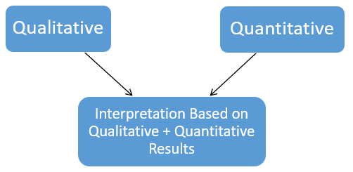
Source: Creswell (2009)

Denzin (1978) pioneered the development of four distinct forms of triangulation. First, methodological triangulation is the process of examining a phenomenon using various methodologies (e.g., quantitative and qualitative methodologies) and data collection techniques (e.g., interviews, surveys, observations). Second, data triangulation is the process of obtaining data from multiple individuals or stakeholders over time. The third type is the triangulation of investigators, which entails more than one investigator collecting, analyzing, and interpreting data to ascertain the extent to which the investigators reach similar conclusions. Finally, theoretical triangulation refers to the application of multiple theories to the study of a specific phenomenon.
Since no single method is always superior (Yin, 2003) and each method has its own unique set of strengths and weaknesses (Denzin, 1978), some form of triangulation in almost all social research has become a practice over the years.

3.3 Quantitative and qualitative research
The quantitative research process entails the collection and analysis of numerical data. It is beneficial for looking for patterns and averages, making predictions, as well as conducting research on cause and general statistical concepts for testing causal relationships. The findings are interpreted as representing a widespread and sufficiently comprehensive view of the entire population (Martin & Bridgmon, 2012). Mathematics and statistics also play a critical role in analyzing and generalizing the results obtained (Queirós, et al., 2017).

The primary quantitative data (Queirós, et al., 2017) in this study refer to questionnaires designed and collected from global travelers who used online platforms to book their accommodations, including but not limited to travelers who booked through Airbnb (Martin & Bridgmon, 2012). Secondary quantitative data are analyzed using the same type of questionnaires or market surveys obtained from questionnaires conducted in other journals, government reports, or research reports from other constitutions.

The qualitative study entails collecting and analyzing qualitative data that are not numerical to understand concepts, opinions, or experiences better; data include text, video, or audio. It can be used to elicit detailed information about a problem or to generate new research ideas. Qualitative research seeks to answer questions about the meaning and experience dimensions of human lives and social worlds. A critical component of effective qualitative research is illuminating the research participants' subjective meanings, actions, and social contexts as they perceive them (Fossey, et al., 2002).
The primary qualitative data in this study (Fossey, et al., 2002) refer to a focus group discussing the study's needs with travelers who used the Airbnb platform to book their accommodations.
This study applies a combination of qualitative and quantitative research that allows for an overall, and negotiated account of the findings, so quantitative and qualitative methods will complement one another, which will converse or debate with each other to construct a negotiated account of what they mean collectively. Mixed methods can also help to show the similarities and differences between specific trends (Bernardi et al., 2007).

Figure 9: Primary Data Collection Process
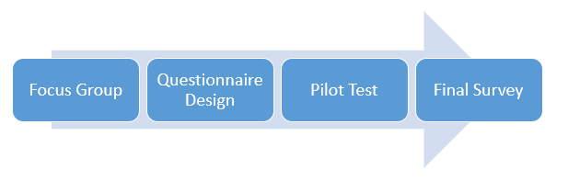
Source: Constructed by the author

3.4 Focus group
Sociologists and psychologists have been conducting focus groups for over a half-century (Merton & Kendall, 1946). A focus group is a select group of people who have been carefully selected to engage in open conversations to conduct research. The hosting organization selects study participants with care to represent the population they are attempting to reach accurately. The research question and research design ultimately dictate the structure of the focus group. Well-designed focus groups typically last between one and two hours (Morgan, 1997) and have six and twelve participants (Baumgartner & Hensley, 2002).
As a result, we used the focus group method in this qualitative study. We discussed with ten respondents on 17 April 2021, with notes taken and logistical considerations such as the briefing privacy protection. The focus group was held in Hong Kong for approximately 60 minutes and was conducted in English and Cantonese. The session was recorded on paper and transcribed for analysis. During the focus group session, a series of open-ended questions were used to determine the repurchase intention of Airbnb or other hotel's online reservation platforms. We specifically asked the participants at the end of the session if their repurchase intention would change due to the COVID-19 pandemic. Data collection continued until saturation was reached, which happened when we heard similar patterns and no new information was shared (Appendix 1)

3.5 Questionnaire survey method
Due to the firm's data privacy, it is entirely impossible to obtain a list of all Airbnb users from the sampling frame. As a result, this study will employ non-probability sampling, a form of convenience sampling, and will account for potential systemic errors. A survey is presented on a digital platform distributed to travelers who matched the target population. An online self-administered questionnaire will be used to collect data for this study.

Numerous rating scales have been developed to assess attitudes, with the Likert scale (1932) being the most widely used. The Likert scale is a five- or seven-point scale that allows individuals to express their level of agreement or disagreement with a particular statement. It enables respondents to describe both the direction and intensity of their opinion about an aspect (Garland, 1991). This study's questionnaire will be graded on a six-point Likert scale. A six-point scale forces respondents to choose between the level of agreement, preventing them from selecting the neutral alternative (Edwards & Smith, 2014). The six-point Likert scale (Chomeya, 2010) response is based on the likelihood range. It includes the following options: 1) Strongly Disagree, 2) Disagree, 3) Slightly Disagree, 4) Slightly Agree, 5) Agree, and 6) Strongly Agree.

The questionnaire for this research is divided into two sections. The first section discussed the factors that influence Airbnb users' repurchase intentions to use the service. The second section contains basic demographic information about the respondents, such as gender, age, family size, education, and usual traveling purpose.
Table 15: Questionnaire Design Structure
Question Category | Dependency | Variables | Symbol | Data Type | Researcher
Target Question | Independent | Trust | T | 6-Point Likert scale  (Chomeya, 2010) | (Liang, et al., 2018a)
Target Question | Independent | Service Quality | SQ | 6-Point Likert scale  (Chomeya, 2010) | (Ju, et al., 2019)
Target Question | Independent | Information Quality | IQ | 6-Point Likert scale  (Chomeya, 2010) | (Kim & Niehm, 2009)
Target Question | Independent | eWOM | eWOM | 6-Point Likert scale  (Chomeya, 2010) | (Liang, et al., 2018)
Target Question | Independent | Economic Benefits | EB | 6-Point Likert scale  (Chomeya, 2010) | (Amaro, et al., 2019)
Target Question | Independent & Dependent | Perceived Risk | R | 6-Point Likert scale  (Chomeya, 2010) | (Ling, et al., 2011)
Target Question | Dependent | Repurchase Intention | RI | 6-Point Likert scale  (Chomeya, 2010) | (Hong, 2015)
Classification question |  | Demographic Factors – gender, age, family size, miratal status, education, usual traveling purpose |  | Categorical Data  (Nishisato, 2019) | (Santhanamery & Ramayah, 2015)
Source: Constructed by the author

3.5.1 Pilot test
A pilot test was undertaken (Appendix 2) to confirm that the questionnaire adequately addressed the study's target information. A pilot test is used to develop the design of the full-scale experiment, which can then be adjusted; it can provide additional insight to increase the effectiveness of assessing the study's hypothesis (Thabane, et al., 2010). According to the central limit theorem (“CLT”), as sample size grows, the distribution of sample means approaches normality, regardless of the population distribution . Frequently, sample sizes of 30 or more are believed to be sufficient for the CLT to hold (Kwak & Kim, 2017). Therefore, 40 participants is adopted, in line with other scholar (Hertzog, 2008) to generate a correlation matrix with lower limits that can be used to determine the distribution of possible variables for corresponding statistical tests. We invited 40 participants who have used Airbnb in the past to participate in a pilot test of the initial questionnaire to evaluate its structure and definitions, scale reliability, logical flow, and focus primarily. Furthermore, this is in line with the suggestion from Connelly (Connelly, 2008) who indicated that the sample size for a pilot study should be 10% of the sample size planned for the bigger parent study.

Between 4 and 21 May 2021, a pilot test (Appendix 2) was conducted. The overall sample size is 40, and the responses were incorporated into the final survey. After the pilot test was completed, some modifications were made (Table 16). Because the reliability of the Perceived Risk questions did not match the reliability, questions R4 and R5 were added, and participants were asked to respond to the new questions, whereas question SQ4 for Service Quality was eliminated. All adjustments have been made to ensure that responders can complete the questionnaire more easily and accurately.

Table 16: Pilot test output for 40 data
Pilot Test (Number of respondents: 40)
Variable | Before Amendment |  | Action | After Amendment
Variable | Cronbach's Alpha | Number of questions | Action | Cronbach's Alpha | Number of questions
Trust | 0.780 | 4 | Nil | no amendment
Perceived Risk | 0.670 | 3 | Added questions  R4 & R5 | 0.892 | 5
Service Quality | 0.664 | 4 | Removed question SQ4 | 0.784 | 3
Information Quality | 0.854 | 4 | Nil | no amendment
eWOM | 0.824 | 4 | Nil | no amendment
Economic Benefits | 0.867 | 5 | Nil | no amendment
Repurchase Intention | 0.925 | 4 | Nil | no amendment
Total |  | 28 |  | 0.895 | 29
Source: Constructed by the author

3.6 Final Survey
After developing the study instrument and conducting a pilot test, the final survey was done between 23 May and 19 June 2021 (Appendix 3).

Table 17: Survey questions adopted
Survey Questions |  |  | Adopted from
Trust (T) | T1 | Airbnb creates the impression that it adheres to its commitments and promises. | (Liang, et al., 2018a)
Trust (T) | T2 | I believe Airbnb will keep its promises to me. | (Liang, et al., 2018a)
Trust (T) | T3 | I trust that Airbnb has sufficient safeguards in place to protect me from liability for damage that is not my fault. | (Priporas, et al., 2017)
Trust (T) | T4 | Overall, Airbnb is trustworthy. | (Liang, et al., 2018a)
Perceived Risk (R) | R1 | I am concerned about the privacy of my personal information during a transaction with Airbnb. | (Ling, et al., 2011)
Perceived Risk (R) | R2 | Using Airbnb would be risky. | (Mao & Lyu, 2017)
Perceived Risk (R) | R3 | I need a lot more information about the host before I would book from Airbnb. | (Jin, et al., 2016)
Perceived Risk (R) | R4 | Booking through Airbnb would put me in danger of physical harm. | (Mao & Lyu, 2017)
Perceived Risk (R) | R5 | Booking via Airbnb would result in a financial loss for me. | (Choi & Ji, 2015)
Service Quality (SQ) | SQ1 | I am pleased with my experience of staying in Airbnb accommodations. | (Ju, et al., 2019)
Service Quality (SQ) | SQ2 | The design of Airbnb's app or website is appealing to me. | (Ju, et al., 2019)
Service Quality (SQ) | SQ3 | Airbnb's host is helpful. | (Ju, et al., 2019)
Information Quality (IQ) | IQ1 | When I attempt to make a transaction through the Airbnb app or website, I receive sufficient information. | (Kim, et al., 2008)
Information Quality (IQ) | IQ2 | I am satisfied with the information provided by the Airbnb app and website. | (Kim, et al., 2008)
Information Quality (IQ) | IQ3 | The information on the Airbnb app and website is well organized. | (Ju, et al., 2019)
Information Quality (IQ) | IQ4 | The Airbnb app and website are easy to use. | (Ju, et al., 2019)
eWOM | eWOM1 | To ensure that I choose the best Airbnb host, I frequently read online reviews from other tourists. | (Mao & Lyu, 2017)
eWOM | eWOM2 | Before I choose to book an Airbnb, I frequently gather information from tourist reviews online. | (Mao & Lyu, 2017)
eWOM | eWOM3 | Based on the high rating a host has received from travelers, I believe the host is trustworthy. | (Sidra, et al., 2020)
eWOM | eWOM4 | Social media has influenced my perceptions and experiences with Airbnb. | (Alhidari, et al., 2015)
Economic Benefits (EB) | EB1 | I could save money by booking accommodations through Airbnb from local hosts. | (Amaro, et al., 2019)
Economic Benefits (EB) | EB2 | Airbnb enables me to book travel accommodations at a lower cost than other travel accommodation websites. | (Amaro, et al., 2019)
Economic Benefits (EB) | EB3 | I can book unique accommodations from Airbnb that are not available on other travel websites. | (Amaro, et al., 2019)
Economic Benefits (EB) | EB4 | Airbnb assisted me in reducing my travel expenses. | (Tussyadiah & Pesonen, 2016)
Economic Benefits (EB) | EB5 | Airbnb enables me to have higher-quality lodging while spending less money. | (Tussyadiah & Pesonen, 2016)
Repurhcase Intention (RI) | RI1 | I would rather book my accommodations from Airbnb rather than other hotels' reservation platforms. | (Hong, 2015)
Repurhcase Intention (RI) | RI2 | The next time, I'm likely to choose Airbnb or another similar sharing option. | (Möhlmann, 2015)
Repurhcase Intention (RI) | RI3 | It's a good idea to use Airbnb to book unique accommodations from local hosts. | (Amaro, et al., 2019)
Repurhcase Intention (RI) | RI4 | After the COVID-19, I will continue to book my accommodations through Airbnb. | (Jin, et al., 2016)
Source: Constructed by the author

3.6.1 Target population
The target population is defined as the totality of respondents who meet a specified set of criteria (Burns & Grove, 1997). The target population for this study is the global travelers using Airbnb or other hotel reservations online platforms at least once before the COVID-19 pandemic. According to Statista (2020) research, 1,118 million active travelers placed their hotel reservations online in 2019.

3.6.2 Sampling method
The demographic profile (gender, age, occupation, education, income, and purpose of travel) was analyzed to determine differences in the groups' intentions to use Airbnb. The cross-sectional design was adopted because this research entailed gathering data from the target population. Due to the lack of a sample frame (Taherdoost, 2016), this research employed a non-probability sampling technique (Schillewaert, et al., 1998). After the pilot test was completed, the final questionnaire was extensively distributed using the snowball method (Biernacki & Waldorf, 1981) to groups of individuals.

3.6.3 Sampling size
The sample size ("n") is calculated according to the following equation (Chirayath, 2005):
$$n = \frac{N{\left(\frac{z}{e}\right)}^{2}pq}{N -1 + {\left(\frac{z}{e}\right)}^{2}pq}$$

By looking at the data from the pilot test, the success rate for the question RI4 is (5+13+14=32) / 40 = 0.80 (Table 18).

Table 18: Successful rate for question RI4
RI4_After the COVID-19, I will continue to book my accommodations through Airbnb. |  | Frequency | Percent | Valid Percent | Cumulative Percent
Valid | Strongly Disagree | 1 | 2.5 | 2.5 | 2.5
Valid | Disagree | 4 | 10.0 | 10.0 | 12.5
Valid | Slightly Disagree | 3 | 7.5 | 7.5 | 20.0
Valid | Slightly Agree | 5 | 12.5 | 12.5 | 32.5
Valid | Agree | 13 | 32.5 | 32.5 | 65.0
Valid | Strongly Agree | 14 | 35.0 | 35.0 | 100.0
Valid | Total | 40 | 100.0 | 100.0
Source: Constructed by the author

A new sample size of at least 385 respondents is necessary for the final survey with 95% confidence level, as calculated in Table 19.

Table 19: Sample size calculation under simple random sampling
Equation | Variable | Data | Description
$$n = \frac{N{\left(\frac{z}{e}\right)}^{2}pq}{N -1 + {\left(\frac{z}{e}\right)}^{2}pq}$$ | N | 118,000,000 | target population
 | z | 1.96 | confidence level 95%
 | e | 4.0% | tolerated level of sampling error
 | p | 0.80 | successful rate; from pilot test (p=32/40)
 | q | 0.20 | failure rate
n = 385
Source: Constructed by the author

3.7 Data analysis techniques
SPSS version 26 is utilized to analyze the data in this research. This session listed down the analysis methodologies used in this study:

i) Descriptive statistics: the fundamental objective of characterizing data, most commonly by describing the coefficients for a particular data set to estimate the frequency distribution table, cross tablation, scatter plot, mean and standard deviation (Choi, et al., 2020, p. 342).

ii) The reliability test: Cronbach's alpha ("$α$") was used to determine reliability (Cronbach, 1951). Our pilot test involved 40 participants and a Cronbach's alpha of 0.895 (Table 16). Cronbach's alpha scores ranging above 0.7 indicate that the measures are internally consistent and trustworthy, with our pilot test reliability being good (Hair, et al., 2014).

Table 20: Cronbach's alpha
$$α = \frac{k}{k-1} × \left(1-\frac{\sum{σ_{i}^{2}}}{σ_{x}^{2}}\right)$$
k: number of items on the measure
$σ_{i}^{2}$: variance of each individual
$σ_{x}^{2}$: variance of the total of all items on the index
Cronbach's alpha | Internal Consistency
$$α≥0.9$$ | Excellent
$$0.8 ≤α<0.9$$ | Good
$$0.7 ≤α<0.8$$ | Acceptable
$$0.6 ≤α<0.7$$ | Questionable
$$0.5 ≤α<0.6$$ | Poor
$$α<0.5$$ | Unacceptable
Source: (Cronbach, 1951)

iii) Factor analysis: a statistical technique for explaining the variability of observed, associated explanatory variables in terms of a smaller number of unknown variables called factors. Kaiser-Meyer-Olkin ("KMO") analysis assesses whether your data is acceptable for factor analysis (Kaiser, 1974).

The test examines the sampling appropriateness of both individual variables and the entire model. The statistic is a way of expressing the variance that exists between two variables. The smaller the fraction, the more data is appropriate for factor analysis. KMO returns values between 0 and 1. The following is a typical rule of thumb for comprehending the statistic (Hadi, et al., 2016):
Table 21: Factor analysis
$$KMO = \frac{{∑∑}_{j≠k} {r^{2} }_{jk}}{{∑∑}_{j≠k} {r^{2}}_{jk}+{∑∑}_{j≠k} {a^{2}}_{jk}}$$
$r_{jk}$: simple correlation coefficient between variables j and k
$a_{jk}$: partial correlation coefficient between variables j and k
KMO Value | Level of Acceptance
Above 0.90 | Marvelous
0.80 to 0.89 | Meritorious
0.70 to 0.79 | Middling
0.60 to 0.69 | Mediocre
0.50 to 0.59 | Miserable
Below 0.50 | Unacceptable
Source: (Kaiser, 1974).

Additionally, an eigenvalue of 1.00 or greater appears to be a suitable factor for determining the number of factors that can be extracted using factor analysis. (Larsen & Warne, 2010).
iv) Correlation Test: The Pearson Correlation Coefficient ("r") is used to test and quantify the correlation between variables (Pearson, 1895). If the Significance value ("Sig.") is 0.05, it indicates that a link exists (Lai, et al., 2019). If Sig. is more than 0.05, there is no correlation between the two attributes. If Sig. is less than 0.05, the link between them can be deduced by evaluating the r-value, where r is a positive integer between -1 and 1. When r approaches 1, a high positive correlation is implied; when r approaches -1, a strong negative correlation is implied (Table 22).

Table 22: Correlation Test
$$r= \frac{\sum{\left(x_{i}-\overline{x}\right)\left(y_{i}-\overline{y}\right)}}{\sqrt{\sum{{\left(x_{i}-\overline{x}\right)}^{2} \sum{{\left(y_{i}-\overline{y}\right)}^{2}}}}}$$
r: correlation coefficient
$x_{i}$: values of the x-variable in a sample
$\overline{x}$: mean of the values of the x-variable
$y_{i}$: values of the y-variable in a sample
$\overline{y}$: mean of the values of the y-variable
Correlation Range | Interpretation
.90 to 100 (-.90 to -1.00) | Very high positive (negative) correlation
.70 to . 90 (-.70 to -.90) | High positive (negative) correlation
.50 to .70 (-.50 to -.70) | Moderate positive (negative) correlation
.30 to .50 (-.30 to -.50) | Low positive (negative) correlation
.00 to .30 (.00 to -.30) | Negligible correlation
Source: (Pearson, 1895)
v) Linear Regression Analysis: a statistical technique that uses several explanatory variables to forecast the result of a response variable, ascertain the existence of hypotheses, and determine the linear relationship between specified variables (Gefen, et al., 2000).

Table 23: Linear Regression
Single Linear Regression | $$y= α+ βx$$  $β$: slope  $α$: y-intercept  y: dependent variable  x: independent variable
Multiple Linear Regression | $$y =β_{0} + β_{1}x_{1}+ β_{2}x_{2 }+ β_{3}x_{3}+… +β_{i}x_{i}$$  y: dependent variable  $β_{0}$: intercept  $β_{i}$: slope for $x_{i}$  x: independent variable
Source: (Gefen, et al., 2000)

Adhering to the formulas for this research, both Linear Regression will be as follows:
R = $α+ βT$
RI = $β_{0}+ β_{1}T+ β_{2}R+ β_{3}$SQ + $β_{4}$IQ + $β_{5}$eWOM + $β_{6}$EB

The coefficient of determination ("$R^{2}$") and the variance inflation factor ("VIF") will be used to analyze the regression models in this study. The value of $R^{2}$ between 0 and 100%, indicating the extent to which the combined independent variables explain the dependent variables. It is a statistic used in conjunction with statistical models. The primary goal is either predicting future events or testing hypotheses using more relevant data. It calculates the fraction of the observed variation explained by the model to assess its ability to replicate observed outcomes (Glantz & Slinker, 2000, p. 248). $R^{2}$ near 0.19 indicate a weak correlation, while 0.33 is a moderate indication, whereas the value above 0.67 indicates a substantial correlation (Chin, 1998).

VIF measures the degree of multicollinearity among a set of multivariate regression variables. The VIF of a regression model variable is the ratio of overall model variance with that single variable (Belsley, 1991). This ratio is calculated for each independent variable; when the VIF is less than 5, the independent variable does not exhibit multicollinearity. Conversely, a high VIF indicates that the independent variable with which it is correlated is considerably collinear with other variables. If it exceeds 5, it is prudent to exclude that variable from consideration or to reconstitute the set of independent variables in some other way (Shrestha, 2020).

vi) Independent T-test: it examines the means of two independent groups to see if statistical evidence shows that the corresponding population means differ significantly. The t-test mathematically establishes the research questions by assuming that the two means are equal (Meyers, et al., 2006, pp. 316-319). Certain values are calculated and compared to the standard values using the applicable formulas, and the presumed null hypothesis is accepted or rejected accordingly.
$$H_{0}: μ_{1}=μ_{2}$$
If the null hypothesis is rejected, the data readings are likely to be resilient and not random.
$$H_{A}: μ_{1}≠μ_{2}$$
We can start by determining a threshold of significance to reject or accept the alternative hypothesis. This value is commonly set at 0.05. If the result is less than or equal to the 5% level of significance, the null hypothesis that the variances of the two groups are equal can be rejected, indicating that the variances are dissimilar (D'agostino, et al., 1988).

vii) One-way Analysis of Variance ("ANOVA"): a way for comparing three or more data sets. And then compare what each means. This is commonly used to examine the impact of age, income level, occupation, and education level on consumer behavior (Kim, 2017). It specifically examines the null hypothesis, In the below formula, $μ$ refers to group mean, and K refers to the number of groups:
$$H_{0}: μ_{1}=μ_{2}=μ_{3}=…=μ_{K}$$
$$H_{A}: μ_{1}≠μ_{2}≠μ_{3}≠…≠μ_{K}$$

3.8 Research Method Limitations
This study offers a comprehensive quantitative cross-comparison of motivations to participate in the sharing economy, specifically Airbnb versus traditional hotels. However, the broad scope of this study has some limitations that will need to be addressed in future research. First, as the sharing economy expands, more cross-sectional research could compare the motivations of actual sharing economy participants and possibly triangulate these with stated motivations for those interested in the general population.

Moreover, because this research was conducted during a period when most countries' borders were closed, it is possible that people's motivation was affected when they responded to the survey. It would be interesting to compare again in the future to see if there are any differences in repurchase intentions after most of the countries' borders have been opened. Third, the online survey's short data collection period is a limitation of this study. This is a small list of motivations. Future research should collect data throughout the year to account for potential seasonality effects and investigate seasonal differences. Furthermore, the focus group was held within the Hong Kong region, thus the input may not be broad enough for the macro-view in determining the actual elements that influence repurchase intention.

3.9 Research Ethics
This research maintains the confidentiality and privacy of the information gathered from the interviews, and all information is utilized solely to conduct this academic research project. Therefore, to protect the confidentiality of the information given by the interviewers, this research does not divulge personal data, and no identifying data is necessary in the interviews, such as name, company, and contact information, are not necessary in the focus group interviews.

Chapter 4: Data Description and Analysis
This chapter discusses the findings from the primary research. Tables and graphs depict the characteristics of the collected data, summarizing the descriptive statistics and providing basic information about variables. Additionally, this chapter will analyze the data and determine the correlations between variables using the collected statistics.

4.1 Data from the final survey
A survey was conducted to ascertain the influence of trust, perceived risk, service quality, information quality, eWOM, and economic benefits on Airbnb repurchase intention. Seven factors were included in the demographic portion of the questionnaire: age, gender, level of education, ethnic origin, the purpose of travel, marital status, and family size. The final survey collected 431 replies between 23 May and 19 June 2021.

A total of 31 responses were excluded from the analysis due to their lack of experience with the Airbnb platform. Therefore, this study contains a total of 400 valid data points. In addition, each of the 400 respondents was at least 18 years old and had previously used the Airbnb site. As a result, the online survey achieved a perfect response rate of 100 percent.

4.1.1 Demographic data
Table 24 provided a summary and breakdown of the 400 survey respondents based on the seven demographic characteristics. The full details are as below:

Table 24: A summary of the demographic data collected from 400 respondents
Variables | Information | Frequency | Percent (%)
Gender | Male  Female | 107  293 | 26.8  73.3
Gender | Subtotal | 400 | 100
Age | 18-24  25-34  35-44  45-54  55-64  65 or above | 86  91  118  71  31  3 | 21.5  22.8  29.5  17.8  7.8  0.8
Age | Subtotal | 400 | 100
Education level | High school or equivalent  Associate degree  Bachelor’s degree  Master’s degree  Doctorate degree | 53  21  195  124  7 | 13.3  5.3  48.8  31.0  1.8
Education level | Subtotal | 400 | 100
Ethnic origin | Asian/ Pacific Islander  Black or African American  Hispanic or Latino  Native American or American Indian  White  Others | 254  4  6  5  125  6 | 63.5  1.0  1.5  1.3  31.3  1.5
Ethnic origin | Subtotal | 400 | 100
Traveling purpose | Leisure  Business | 389  11 | 97.3  2.8
Traveling purpose | Subtotal | 400 | 100
Marital status | Single  Married or domestic partnership  Windowed/ Divorced/ Separated | 172  204  24 | 43.0  51.0  6.0
Marital status | Subtotal | 400 | 100
Number of kids in the family | 0  1  2  3  4  5 or above | 279  35  51  20  7  8 | 69.8  8.8  12.8  5.0  1.8  2.0
Number of kids in the family | Subtotal | 400 | 100
Source: Constructed by the author

Figure 10: Graph of respondents' gender
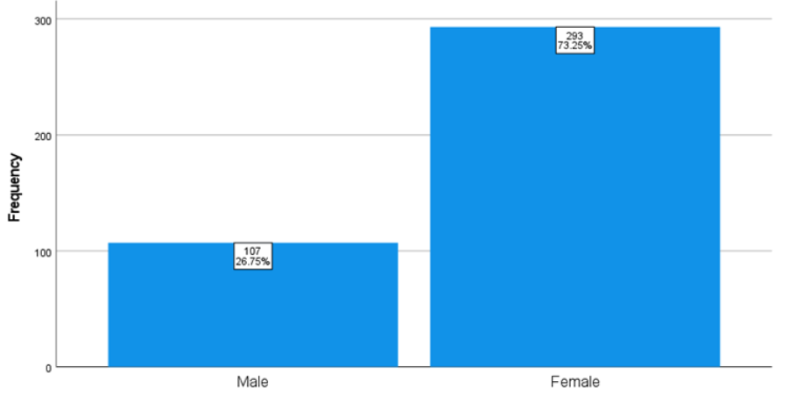
Source: Constructed by the author

Figure 10 shows that the bulk of responders (73.25 percent) are female, with only 26.75 percent male. Abubakar (2017) and Dwyer (2002) have revealed that females have a greater risk perception and are more risk-tolerant than males in various situations. Abubakar (2017) proved that there is a positive relation between eWOM, destination trust, and repurchase intention that varies by gender.

Figure 11: Graph of respondents' ages
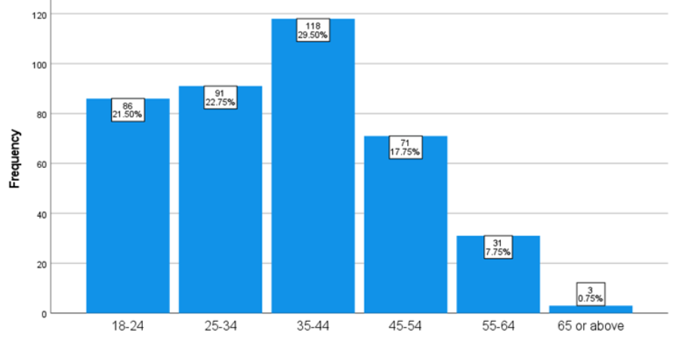
Source: Constructed by the author
The distribution of six age groups among 400 respondents is depicted in Figure 11. The group between the ages of 35 and 44 received the greatest number of responses, with a total of 118 respondents (29.5%). The over-65 age category received the fewest responses, with only three people responding (0.75%). Additionally, academic research reveals that Airbnb customers are more prevalent in highly educated demographic groups, indicating a median age of 30s (Cansoy & Schor, 2016).

Figure 12: Graph of respondents' education level
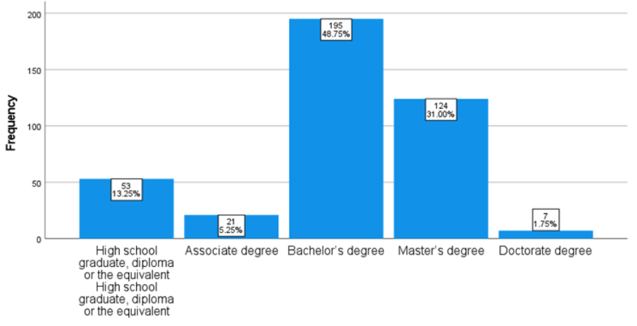
Source: Constructed by the author

The distribution of five education level groupings among the 400 respondents is depicted in Figure 12. With 195 respondents, the most frequent level of education among those who responded to the survey questions is a bachelor's degree (48.75%). Respondents with a PhD have the lowest response rate, with only seven individuals responding to the survey (1.75%)

Figure 13: Graph of respondents' marital status
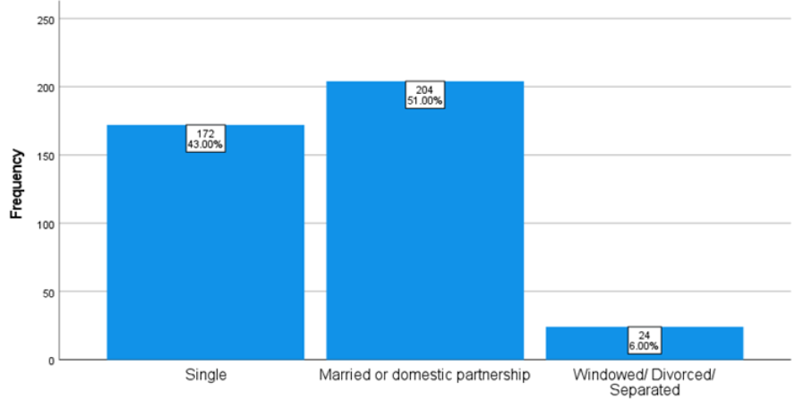
Source: Constructed by the author

According to Figure 15, 204 of 400 respondents (51%) are married or in a domestic partnership. 172 (43%) of the group are unmarried. As illustrated in Figure 16, 279 respondents (75% ) do not have children.

Figure 14: Graph depicting the number of children in each respondent's family.
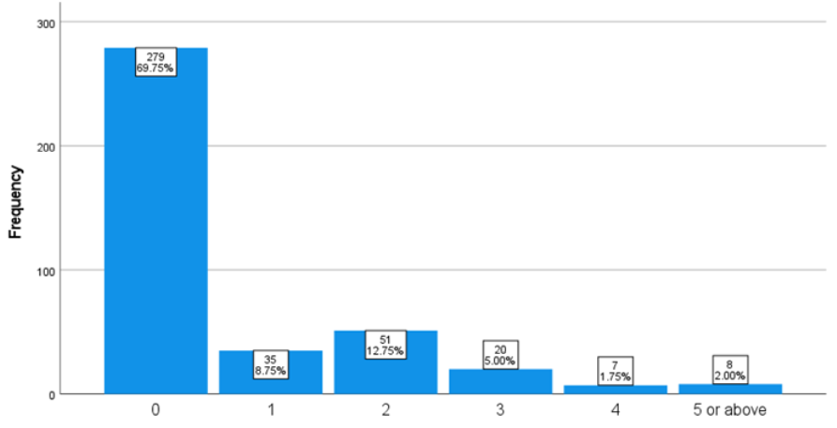
Source: Constructed by the author

4.2 Cross-Tabulation of Demographic Factors on Repurchase Intention

Cross-tabulation is a quantitative technique used to investigate the relationship between many variables (Kamakura & Wedel, 1997). Additionally, it demonstrates how correlations vary according to variable grouping. It is frequently used in statistical analysis to deduce patterns, trends, and probabilities from unstructured data (Carroll Mohn, 1990). Cross-tabulation was used in this study to determine whether age, gender, ethnic origin, education level, marital status, trip purpose, and the number of children in the household are associated with Airbnb repurchase intention.

4.2.1 Repurchase intention and gender
Many academics have proven the moderating influence of men and women having different views on hotels, brand perceptions, and choices (Lee & Kim, 2018a). Figure 17 and Table 25 illustrat 196 out of 293 female respondents (66.4%) indicated a preference for Airbnb over other hotel reservation platforms. In contract, 72 male respondents out of 107 (67.3%) responded positively. As a result, the choice for both genders is comparable, with 67.1% of respondents favoring Airbnb over other hotel reservation sites.

Figure 15: Repurchase intention and gender
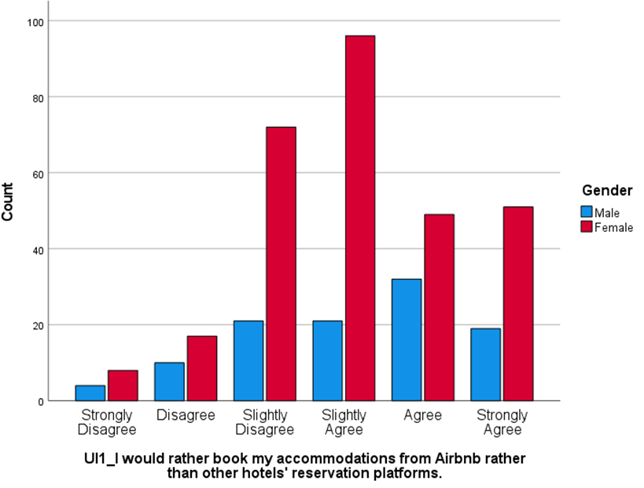 Source: Constructed by the author

Table 25: Factor for D1*RI1
D1_Gender * RI1_ I would rather book my accommodations from Airbnb rather than other hotels' reservation platforms.
 |  |  | RI1_I would rather book my accommodations from Airbnb rather than other hotels' reservation platforms.
 |  |  | Strongly Disagree | Disagree | Slightly Disagree | Slightly Agree | Agree | Strongly Agree | Total
D1_Gender | Male | Count | 4 | 10 | 21 | 21 | 32 | 19 | 107
D1_Gender | Male | % within D1_Gender | 3.7% | 9.3% | 19.6% | 19.6% | 29.9% | 17.8% | 100%
D1_Gender | Female | Count | 8 | 17 | 72 | 96 | 49 | 51 | 293
D1_Gender | Female | % within D1_Gender | 2.7% | 5.8% | 24.6% | 32.8% | 16.7% | 17.4% | 100%
Total |  | Count | 12 | 27 | 93 | 117 | 81 | 70 | 400
 |  | % within D1_Gender | 3% | 6.8% | 23.3% | 29.3% | 20.3% | 17.5% | 100%
Source: Constructed by the author

4.2.2 Repurchase intention and number of children in family

Figure 18 and Table 26 show that families with children are more likely to favor utilizing Airbnb. 60% of families with three children strongly agree, and 62.5% of families with five or more children strongly agree.
Figure 16: Repurchase intention and number of children in family
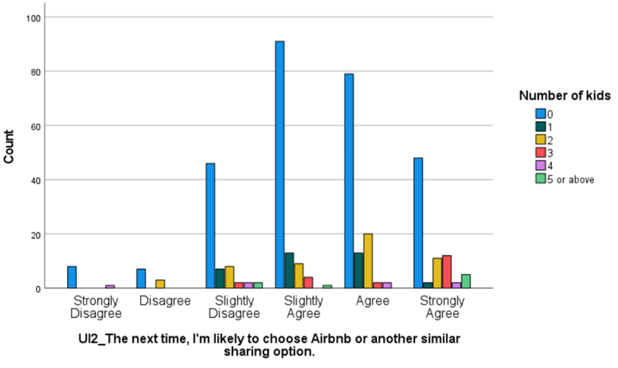
Source: Constructed by the author
Table 26: Factor for D7*RI2
D7_ How many kids do you have? * RI2_ The next time, I'm likely to choose Airbnb or another similar sharing option.
 |  |  | RI2_ The next time, I'm likely to choose Airbnb or another similar sharing option.
 |  |  | Strongly Disagree | Disagree | Slightly Disagree | Slightly Agree | Agree | Strongly Agree | Total
D7_How many kids do you have? | 0 | Count | 8 | 7 | 46 | 91 | 79 | 48 | 279
D7_How many kids do you have? | 0 | % within D7 | 2.9% | 2.5% | 16.5% | 32.6% | 28.3% | 17.2% | 100%
D7_How many kids do you have? | 1 | Count | 0 | 0 | 7 | 13 | 13 | 2 | 35
D7_How many kids do you have? | 1 | % within D7 | 0.0% | 0.0% | 20.0% | 37.1% | 37.1% | 5.7% | 100%
D7_How many kids do you have? | 2 | Count | 0 | 3 | 8 | 9 | 20 | 11 | 51
D7_How many kids do you have? | 2 | % within D7 | 0.0% | 5.9% | 15.7% | 17.6% | 39.2% | 21.6% | 100%
D7_How many kids do you have? | 3 | Count | 0 | 0 | 2 | 4 | 2 | 12 | 20
D7_How many kids do you have? | 3 | % within D7 | 0.0% | 0.0% | 10.0% | 20.0% | 10.0% | 60.0% | 100%
D7_How many kids do you have? | 4 | Count | 1 | 0 | 2 | 0 | 2 | 2 | 7
D7_How many kids do you have? | 4 | % within D7 | 14.3% | 0.0% | 28.6% | 0.0% | 28.6% | 28.6% | 100%
D7_How many kids do you have? | 5 or above | Count | 0 | 0 | 2 | 1 | 0 | 5 | 8
D7_How many kids do you have? | 5 or above | % within D7 | 0.0% | 0.0% | 25.0% | 12.5% | 0.0% | 62.5% | 100%
Total |  | Count | 9 | 10 | 67 | 118 | 116 | 80 | 400
 |  | % within D7 | 2.3% | 2.5% | 16.8% | 29.5% | 29.0% | 20.0% | 100%
Source: Constructed by the author

4.3 Each factor's highest and lowest averages

The mean scores for each factor are depicted in Figure 19, along with their highest and lowest values. Table 27 contains the mean, standard deviation, minimum and maximum values for each variable.

Figure 17: Each factor's highest and lowest averages

Source: Constructed by the author
Table 27: Descriptive Statistics
 | Minimum | Maximum | Mean | Std. Deviation
T1_Airbnb creates the impression that it adheres to its commitments and promises. | 1 | 6 | 4.87 | 0.896
T3_I trust that Airbnb has sufficient safeguards in place to protect me from liability for damage that is not my fault. | 1 | 6 | 4.16 | 1.337
R3_I need a lot more information about the host before I would book from Airbnb. | 1 | 6 | 4.36 | 1.443
R5_Booking via Airbnb would result in a financial loss for me. | 1 | 6 | 2.26 | 1.194
SQ1_I am pleased with my experience of staying in Airbnb accommodations. | 1 | 6 | 5.04 | 0.852
SQ3_Airbnb's host is helpful. | 1 | 6 | 4.78 | 0.996
IQ4_The Airbnb's reservation platform is easy to use. | 1 | 6 | 5.01 | 0.895
IQ1_When I attempt to make a transaction through the Airbnb's reservation platform, I receive sufficient information. | 1 | 6 | 4.79 | 0.895
EWOM1_To ensure that I choose the best Airbnb host, I frequently read online reviews from other tourists. | 2 | 6 | 5.49 | 0.791
EWOM3_Based on the high rating a host has received from travelers, I believe the host is trustworthy. | 3 | 6 | 5.39 | 0.703
EB3_I can book unique accommodations from Airbnb that are not available on other travel websites. | 1 | 6 | 5.03 | 1.021
EB2_Airbnb enables me to book travel accommodations at a lower cost than other travel accommodation websites. | 1 | 6 | 4.68 | 1.163
RI3_It's a good idea to use Airbnb to book unique accommodations from local hosts. | 1 | 6 | 4.96 | 1.008
RI1_I would rather book my accommodations from Airbnb rather than other hotels' reservation platforms. | 1 | 6 | 4.10 | 1.292
Valid N (listwise) = 400
Source: Constructed by the author

The mean of Electronic Word of Mouth (eWOM) was the highest at 5.49, with a standard deviation of 0.791. According to the data, Airbnb's eWOM is crucial for travelers and has a substantial impact on their intention to use the service. Perceived risk (R), on the other hand, has a lower mean score of 2.26 and a standard deviation of 1.194. The study's findings indicate that eWOM appears to play a role in travelers' intention to use Airbnb. Additionally, customers would consider the service quality provided by the Airbnb host while making a booking decision.

4.4 Reliability test
A reliability test in terms of Cronbach's Alpha coefficient was used to analyze the internal consistency of the study to ensure that the information obtained from the questionnaire is reliable.

Table 28: Reliability Statistics
Factoes | N of items | Cronbach's Alpha |  | Researcher
Factoes | N of items | This research (N=400) | Other research | Researcher
T | 4 | 0.860 | 0.849 | (Namahoot & Laohavichien, 2018)
R | 5 | 0.785 | 0.890 | (Amaro, et al., 2019)
SQ | 3 | 0.831 | 0.926 | (Namahoot & Laohavichien, 2018)
IQ | 4 | 0.890 | 0.874 | (Hanjaya, et al., 2019)
eWOM | 3 | 0.705 | 0.834 | (Woon & Chng, 2019)
EB | 5 | 0.868 | 0.840 | (Amaro, et al., 2019)
RI | 4 | 0.880 | 0.860 | (Amaro, et al., 2019)
Total | 28 | 0.884
Source: Constructed by the author

The reliability test results for each factor in the research model are shown in Table 28. The reliability test conducted on the questionnaire's 28 items got a Cronbach's coefficient of 0.884, which is significantly greater than the specified minimal value of 0.7 (Table 20). Thus, it may be stated that measurement reliability is quite excellent. When compared to other studies, most components are roughly the same at over 0.85, with the exception of SQ, R, and eWOM, which are slightly lower.

4.5 Factor analysis
Table 29 shows the results of the analysis in respect to the KMO sampling method and the Bartlett's sphericity test. The KMO matrix value in this study is 0.880, which is higher than the permissible index of 0.5 (Table 21) and falls within the Meritorious zone.
Table 29: KMO and Bartlett's Test
Kaiser-Meyer-Olkin Measure of Sampling Adequacy. |  | .880
Bartlett's Test of Sphericity | Approx. Chi-Square | 6279.603
Bartlett's Test of Sphericity | df | 300
Bartlett's Test of Sphericity | Sig. | .000
Source: Constructed by the author

Each component has an eigenvalue larger than 1 (Table 30), demonstrating its significance. The eigenvalue represents the proportion of total variation explained by each factor. Any factor with an Eigenvalue less than 1 does not explain enough total variance to be considered a unique factor and is thus ignored. The cumulative percent is less than 100% since not all variation is explained when only a subset of factors is considered in the final analysis (Amerioun, et al., 2018). The degree of confidence is set to 99% when the significance level is set to 0.01. The significance level of Bartlett's test of sphericity is low (less than 0.01), indicating that factor analysis is possible in this study (Kaiser, 1974).

Table 30: Total Variance Explained
No. |  | Initial Eigenvalues  Extraction Method: Principal Component Analysis
No. | Factor | Total | Variance (%) | Cumulative variance (%)
1 | Information Quality (IQ)  Service Quality (SQ) | 9.028 | 36.111 | 36.111
2 | Economic Benefits (EB) | 2.675 | 10.701 | 46.812
3 | Trust (T) | 2.117 | 8.466 | 55.279
4 | Perceived Risk (R) Tangible | 1.706 | 6.824 | 62.103
5 | Perceived Risk (R)  Intengible | 1.139 | 4.556 | 66.659
6 | eWOM | 1.009 | 4.035 | 70.694
Source: Constructed by the author

Figure 18: Screen plot for Eigenvalues
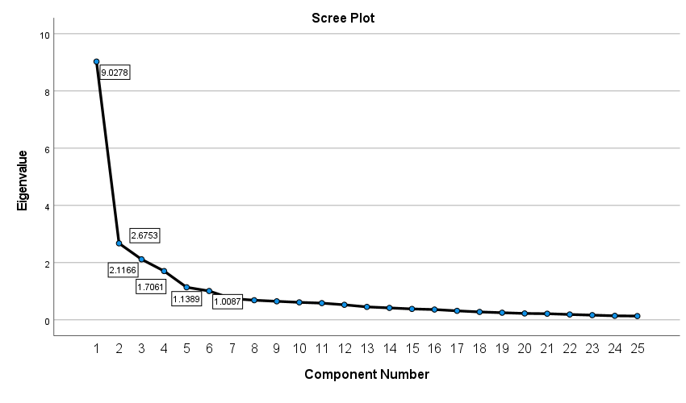
IQ & SQ
EB
T
R (Tangible)
R (Intangible)
eWOM
Source: Constructed by the author

Table 30 and Figure 20 are used to extract eigenvalues greater than one. Six factors account for 70,694 percent of the variance, as seen in Table 30. Each of the six factors has an eigenvalue of 9.028, 2.675, 2.117, 2.117, 1.706, and 1.1139. Note that the scree plot flattens out after the fifth component; however, since the Eigenvalues are more than 1, all the factors are significant. In this study approach, IQ and SQ are the most critical components.

Table 31: Rotated Component Matrix
 |  |  | Factor loading values
No. | Factors | Items | This research | Other research
1 | IQ & SQ | IQ4_ reservation platform is easy to use | 0.807 | 0.848 | (Ju, et al., 2019)
1 | IQ & SQ | SQ2_ reservation platform is appealing | 0.797 | 0.691 | (Ju, et al., 2019)
1 | IQ & SQ | IQ1_ I receive sufficient information | 0.764 | 0.880 | (Kim, et al., 2008)
1 | IQ & SQ | IQ2_I am satisfied with the information provided | 0.749 | 0.891 | (Kim, et al., 2008)
1 | IQ & SQ | IQ3_The information is well organized | 0.747 | 0.697 | (Ju, et al., 2019)
1 | IQ & SQ | SQ1_I am pleased with my experience | 0.684 | 0.562 | (Ju, et al., 2019)
1 | IQ & SQ | SQ3_Airbnb's host is helpful | 0.649 | 0.919 | (Ju, et al., 2019)
2 | EB | EB2_lower cost than other websites | 0.849 | 0.94 | (Amaro, et al., 2019)
2 | EB | EB1_I could save money | 0.806 | 0.92 | (Amaro, et al., 2019)
2 | EB | EB4_ reducing my travel expenses | 0.790 | 0.89 | (Tussyadiah & Pesonen, 2016)
2 | EB | EB5_higher-quality lodging while spending less | 0.745 | 0.72 | (Tussyadiah & Pesonen, 2016)
2 | EB | EB3_ unique accommodations | 0.643 | 0.79 | (Amaro, et al., 2019)
3 | T | T3_sufficient safeguards in place | 0.959 | 0.917 | (Priporas, et al., 2017)
3 | T | T4_trustworthy | 0.707 | 0.83 | (Liang, et al., 2018a)
3 | T | T2_keep its promises | 0.679 | 0.85 | (Liang, et al., 2018a)
4 | R (Tangible) | R4_danger of physical harm. | 0.891 | 0.93 | (Mao & Lyu, 2017)
4 | R (Tangible) | R5_financial loss | 0.884 | 0.71 | (Choi & Ji, 2015)
5 | R (Intangible) | R1_privacy of my personal information | 0.883 | 0.79 | (Ling, et al., 2011)
5 | R (Intangible) | R2_risky | 0.694 | 0.93 | (Mao & Lyu, 2017)
5 | R (Intangible) | R3_I need a lot more information | 0.594 | 0.90 | (Jin, et al., 2016)
6 | eWOM | EWOM2_gather information from tourist reviews | 0.868 | 0.94 | (Mao & Lyu, 2017)
6 | eWOM | EWOM1_online reviews | 0.862 | 0.92 | (Mao & Lyu, 2017)
Extraction Method: Principal Component Analysis.
Rotation Method: Varimax with Kaiser Normalization.
a. Rotation converged in 7 iterations.
Source: Constructed by the author

The factors are rotated to make them more comprehensible. Rotation guarantees that as many variables as possible are explained or predicted by a variety of underlying factors, and that each component explains several items. This is what is meant by simple structure. One characteristic to examine in the Rotated Matrix of Factor Loadings is the degree to which simple structure is obtained, as seen in Table 31, utilizing principal component analysis and the Varimax with Kaiser Normalization rotation approach. The factor analysis technique aided in the identification of component factors from 28 elements associated with antecedents of Airbnb repurchase intention.

4.6 Correlation test
Correlation coefficients are used to represent the strength of a relationship between two variables. The following table compares the findings of this study to those of previous studies.

Table 32: Correlation analysis of factors in comparison to other research
 | This research |  | Other research
 | N | $$r^{**}$$ | N | $$r^{**}$$ | Researcher
$H_{1}$ (T R) | 400 | -0.360 | 468 | -0.220 | (Kim, et al., 2008)
$H_{2}$ (R RI) | 400 | -0.380 | 356 | -0.253 | (Qalati, et al., 2021)
$H_{3}$ (T RI) | 400 | 0.509 | 606 | 0.440 | (Wang, et al., 2020)
$H_{4}$ (SQ RI) | 400 | 0.533 | 360 | 0.500 | (Wu, et al., 2011)
$H_{5}$ (IQ RI) | 400 | 0.575 | 171 | 0.316 | (Kim & Niehm, 2009)
$H_{6}$ (eWOM RI) | 400 | 0.355 | 604 | 0.426 | (Tarkang, et al., 2020)
$H_{7}$ (EB RI) | 400 | 0.655 | 656 | 0.473 | (Tussyadiah & Pesonen, 2016)
** Correlation is significant at the 0.01 level (1-tailed).
Source: Constructed by the author

According to Table 22, the closer the Pearson correlation coefficient (r) value is near +1 or -1, the stronger the degree of correlation between two variables is deemed. The hypothesis $H_{7}$ which pertains to Economic Benefits (EB) exhibits a substantial positive correlation with the repurchase intention on Airbnb in this study; it had the highest positive correlation coefficient, 0.655 at 99% confidence level, which is greater than that of a previous study conducted by another researcher.

Table 33: Correlations among the variables.
 | T | R | SQ | IQ | eWOM | EB | RI
Trust (T) | $$-$$
Perceived Risk (R) | $${-0.360}^{**}$$ | $$-$$
Service Quality (SQ) | $${0.677}^{**}$$ | $${-0.423}^{**}$$ | $$-$$
Information Quality (IQ) | $${0.643}^{**}$$ | $${-0.429}^{**}$$ | $${0.681}^{**}$$ | $$-$$
eWOM | $${0.286}^{**}$$ | $${-0.313}^{**}$$ | $${0.408}^{**}$$ | $${0.412}^{**}$$ | $$-$$
Economic Benefits (EB) | $${0.444}^{**}$$ | $${-0.272}^{**}$$ | $${0.457}^{**}$$ | $${0.406}^{**}$$ | $${0.365}^{**}$$ | $$-$$
Repurchase Intention (RI) | $${0.509}^{**}$$ | $${-0.380}^{**}$$ | $${0.533}^{**}$$ | $${0.575}^{**}$$ | $${0.355}^{**}$$ | $${0.655}^{**}$$ | $$-$$
** Correlation is significant at the 0.01 level (1-tailed).
Source: Constructed by the author

Because the significant value is less than 0.01 for all variables designated with **, the outcome of the variables in this study may be predicted with a high degree of confidence level (99%).

4.7 Regression model
Regression analysis is a collection of statistical techniques used to determine the connection between one or more independent variables and a dependent variable. It is useful for determining the strength of the relationship between variables and forecasting their future relationship. Single and multiple linear regression analyses, together with the stepwise approach were utilized in this work to determine the relationship between variables.

4.7.1 Single linear regression for Trust and Perceived risk

A statistical strategy for identifying the relationship between a dependent and an independent variable is simple linear regression. The simple linear model adopted for this research identified a link between the dependent variable: Perceived risk (R), and the independent variable: Trust (T)

Table 34: Model summary for single linear regression model
Model Summary^{c}
Model | R | R Square | Adjusted R Square | Std. Error of the Estimate
2 | 0.377^{b} | 0.142 | 0.137 | 1.272
b. Predictors: (Constant), T2_I believe Airbnb will keep its promises to me., T4_Overall, Airbnb is trustworthy.
c. Dependent Variable: R2_Using Airbnb would be risky.
Source: Constructed by the author

R-squared ($R^{2}$) is the proportion of dependent variable variation explained by a linear model.
$$R^{2}=\frac{Variance explained by the model}{Total variance}$$
Table 34 summarizes the model. $R^{2}$ accounts for 14.2% of the variation in Perceived Risk of using Airbnb, indicating that the model can only be explained a small portion of the variation in the response variable Trust around its mean; however, since the independent variable (Trust) is statistically significant (Table 35), we can still draw important conclusions about the variables' relationships at 95% confidence level.

Table 35: ANOVA for single linear regression model
ANOVAª
Model |  | Sum of Squares | df | Mean Square | F | Sig.
2 | Regression | 106.204 | 2 | 53.102 | 32.797 | .000^{c}
2 | Residual | 642.794 | 397 | 1.619
2 | Total | 748.997 | 399
a. Dependent Variable: R2_Using Airbnb would be risky.
c. Predictors: (Constant), T2_I believe Airbnb will keep its promises to me., T4_Overall, Airbnb is trustworthy.
Source: Constructed by the author

To determine the variance of a model, the Analysis of Variance (ANOVA) technique is utilized. In our regression model, the degrees of freedom (df) refer to the number of independent variables, which correspond to questions T2 and T4. The residual df value equals the sum of the dataset's observations minus the number of variables to be estimated. The total degree of freedom equals the sum of the regression and residual degrees of freedom, which is one less than the dataset size. According to Table 35, F=32.797 is obtained by dividing the Mean Square Regression (53.102) by the Mean Square Residual (1.619). This F value is associated with a negligible p-value (0.000). Due to the fact that the p-value is smaller than the alpha level of 0.05, the independent factor (Trust) predict the dependent variable (Perceived Risk) consistently at 95% confidence level.

Table 36: Coefficients table for single regression model
Coefficientsª
Model |  | Unstandardized Coefficients |  | Standardized Coefficients | t | Sig. | Collinearity Statistics
 |  | B | Std. Error | Beta | t | Sig. | Tolerance | VIF
2 | (Constant) | 5.494 | .314 |  | 17.481 | .000
2 | T2_I believe Airbnb will keep its promises to me. | -.320 | .100 | -.231 | -3.187 | .002 | .413 | 2.422
2 | T4_Overall, Airbnb is trustworthy. | -.218 | .093 | -.169 | -2.342 | .020 | .413 | 2.422
a. Dependent Variable: R2_Using Airbnb would be risky.
Source: Constructed by the author

According to Table 36, the indicator B represents the coefficients of the regression equation used to predict the dependent variable, Perceived Risk (R), from the independent variable, Trust (T). The regression equation can be presented as follows:
$$R=5.494-0.320×T2-0.218×T4$$
The coefficients for question T2 and T4 is -0.320 and -0.218 respectively, meanning for every unit increase in T2 or T4, a -0.320 or -0.218 unit decrease in Perceived Risk, holding all other variables constant. The standard error in Table 36 is used for testing whether the parameter is significantly different from 0 by dividing the parameter estimate by the standard error to obtain a t-value. Beta are the coefficients that the research would obtain if standardizing all of the variables in the regression. It is used to compare the magnitude of the coefficients to see which one has more of an effect, the larger betas are associated with the larger t-values.

4.7.1.1 Variance Inflation Factor
VIF measures the degree of multicollinearity among a set of multivariate regression variables, as discussed in Chapter 3.7. When the VIF is less than 5, the independent variable does not exhibit multicollinearity. In our study, the multicollinearity issue appeared to be absent as the values of VIF 2,422 were well below the threshold of 5 (Table 36).

4.7.1.2 Histogram and Scatterplot

Each variable had a normal distribution based on a visual examination of the histogram (Figure 21), the residuals follow a normal standardized with an average zero.

Figure 19: Histogram of Perceived Risk
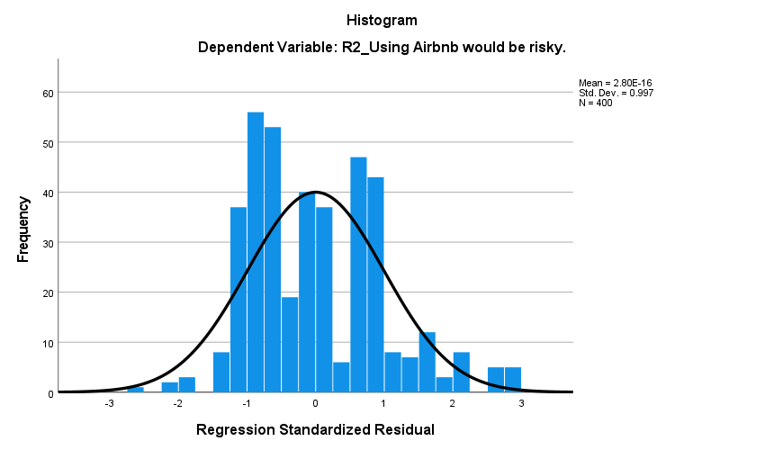
Source: Constructed by the author

Figure 20: Scatterplot of Perceived Risk
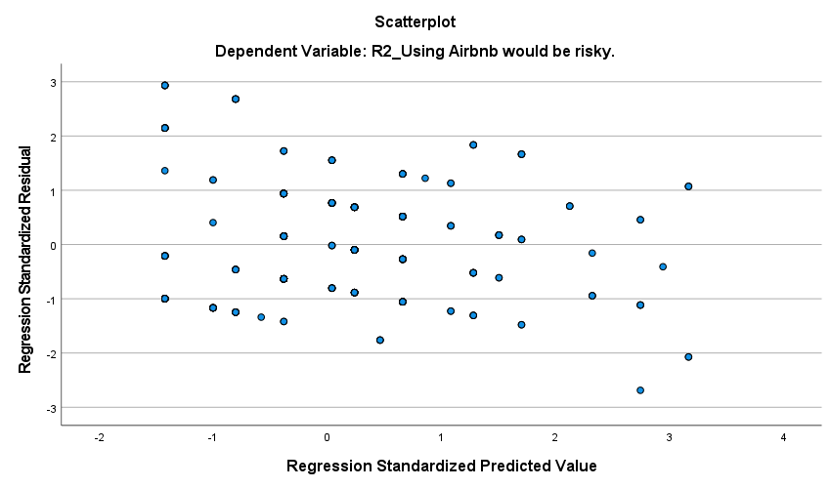
Source: Constructed by the author

The relationship is non-linear, with the slope of the scatterplot in Figure 22 being negative, indicating a negative relationship between Perceived Risk and Trust.

4.7.2 Multiple linear regression for repurchase intention on Airbnb
Multiple linear regression is similar to simple linear regression except that it involves multiple independent variables. The multiple linear model adopted for this research identified a link between the dependent variable: Repurchase Intention (RI), and the independent variables: Economic Benefits (EB), Information Quality (IQ), Perceived Risk (R), Trust (T) and Service Quality (SQ)

Table 37: Model summary for multiple linear regression model
Model Summary^{j}
Model | R | R Square | Adjusted R Square | Std. Error of the Estimate
9 | 0.795^{i} | 0.632 | 0.624 | 0.618
i. Predictors: (Constant), EB3_I can book unique accommodations from Airbnb that are not available on other travel websites. , IQ3_The information on the Airbnb's reservation platform is well organized. , EB2_Airbnb enables me to book travel accommodations at a lower cost than other travel accommodation websites. , EB5_Airbnb enables me to have higher-quality lodging while spending less money. , R4_Booking through Airbnb would put me in danger of physical harm., T1_Airbnb creates the impression that it adheres to its commitments and promises., R5_Booking via Airbnb would result in a financial loss for me., IQ1_When I attempt to make a transaction through the Airbnb's reservation platform, I receive sufficient information. , SQ1_I am pleased with my experience of staying in Airbnb accommodations.
j. Dependent Variable: RI3_It's a good idea to use Airbnb to book unique accommodations from local hosts.
Source: Constructed by the author

Table 37 summarizes the model. $R^{2}$ accounts for 63.2% of the variation in Repurchase Intention for using Airbnb, indicating that the model explain strongly of the variation in the response variable around its mean. Ee can still draw important conclusions about the variables' relationships at 95% confidence level.

Table 38: ANOVA for multiple linear regression model
ANOVAª
Model |  | Sum of Squares | df | Mean Square | F | Sig.
9 | Regression | 256.374 | 9 | 28.486 | 74.568 | .000^{j}
9 | Residual | 148.986 | 390 | .382
9 | Total | 405.360 | 399
j. Predictors: (Constant), EB3_I can book unique accommodations from Airbnb that are not available on other travel websites. , IQ3_The information on the Airbnb's reservation platform is well organized. , EB2_Airbnb enables me to book travel accommodations at a lower cost than other travel accommodation websites. , EB5_Airbnb enables me to have higher-quality lodging while spending less money. , R4_Booking through Airbnb would put me in danger of physical harm., T1_Airbnb creates the impression that it adheres to its commitments and promises., R5_Booking via Airbnb would result in a financial loss for me., IQ1_When I attempt to make a transaction through the Airbnb's reservation platform, I receive sufficient information. , SQ1_I am pleased with my experience of staying in Airbnb accommodations.
Source: Constructed by the author

In our regression model, the degrees of freedom (df) refer to the number of independent variables, which correspond to questions EB3, IQ3, EB2, EB5, R4, T1, R5, IQ1 and SQ1. The residual df value equals the sum of the dataset's observations minus the number of variables to be estimated. The total degree of freedom equals the sum of the regression and residual degrees of freedom, which is one less than the dataset size. According to Table 38, F=74.568 is obtained by dividing the Mean Square Regression (28.486) by the Mean Square Residual (0.382). This F value is associated with a negligible p-value (0.000). Due to the fact that the p-value is smaller than the alpha level of 0.05, the independent factor (Repurchase Intention) predict the multiple dependent variables consistently at 95% confidence level.

Table 39: Coefficients table for multiple regression model
Coefficientsª
Model |  | Unstandardized Coefficients |  | Standardized Coefficients | t | Sig. | Collinearity Statistics
 |  | B | Std. Error | Beta | t | Sig. | Tolerance | VIF
9 | (Constant) | .075 | .240 |  | .310 | .756
9 | EB3_I can book unique accommodations from Airbnb that are not available on other travel websites. | .334 | .041 | .338 | 8.226 | .000 | .557 | 1.796
9 | IQ3_The information on the Airbnb's reservation platform is well organized. | .319 | .047 | .299 | 6.850 | .000 | .494 | 2.022
9 | EB2_Airbnb enables me to book travel accommodations at a lower cost than other travel accommodation websites. | .136 | .035 | .157 | 3.851 | .000 | .570 | 1.755
9 | EB5_Airbnb enables me to have higher-quality lodging while spending less money. | .116 | .035 | .142 | 3.292 | .001 | .506 | 1.977
9 | R4_Booking through Airbnb would put me in danger of physical harm. | -.159 | .038 | -.194 | -4.216 | .000 | .443 | 2.258
9 | T1_Airbnb creates the impression that it adheres to its commitments and promises. | .151 | .050 | .135 | 3.012 | .003 | .472 | 2.120
9 | R5_Booking via Airbnb would result in a financial loss for me. | .102 | .039 | .121 | 2.589 | .010 | .435 | 2.301
9 | IQ1_When I attempt to make a transaction through the Airbnb's reservation platform, I receive sufficient information. | .115 | .045 | .102 | 2.566 | .011 | .592 | 1.688
9 | SQ1_I am pleased with my experience of staying in Airbnb accommodations. | -.134 | .057 | -.113 | -2.337 | .020 | .404 | 2.476
a. Dependent Variable: RI3_It's a good idea to use Airbnb to book unique accommodations from local hosts.
Source: Constructed by the author

According to Table 39, the indicator B represents the coefficients of the regression equation used to predict the dependent variable, Repurchase Intention (RI), from the multiple independent variables. The regression equation can be presented as follows:
$$RI=0.075+0.334×EB3+0.319×IQ3+0.136×EB2+0.116×EB5-0.159×R4+0.151×T1+0.102×R5+0.115×IQ1-0.134×SQ1$$

4.7.2.1 Variance Inflation Factor
VIF measures the degree of multicollinearity among a set of multivariate regression variables, as discussed in Chapter 3.7. When the VIF is less than 5, the independent variable does not exhibit multicollinearity. In our study, the multicollinearity issue appeared to be absent as the values of VIF were well below the threshold of 5, ranging from 1.688 to 2.476 (Table 39).

4.7.2.2 Histogram and Scatterplot

Each variable had a normal distribution based on a visual examination of the histogram (Figure 23), the residuals follow a normal standardized with an average zero.

Figure 21: Histogram of Repurchase Intention
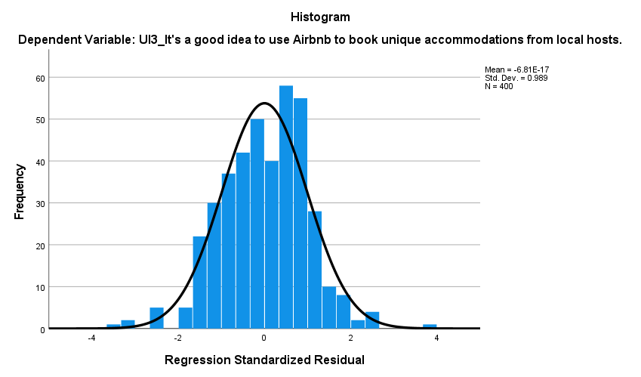
Source: Constructed by the author
Figure 22: Scatterplot for Repurchase Intention
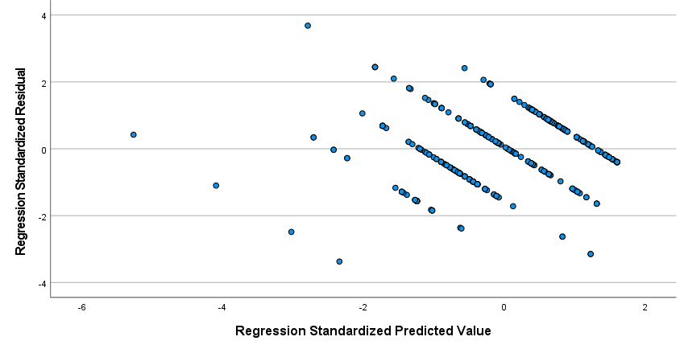
Source: Constructed by the author

The relationship is non-linear; the slope of the scatterplot in Figure 24 is negative, indicating that the variables and repurchase intention are negatively related.

4.8 Using regression analysis to test hypotheses
The standard coefficients ($β$) and R square ($R^{2}$) from the regression analysis are displayed below.

Figure 23: Standard coefficients ($β$) and R square
$$H_{3}:0.135$$

$$H_{5}:0.299$$

$H_{6}$: NS
:
$$H_{2}: -0.194$$

$H_{1}$: -0.231
$$H_{7}:0.338$$

$$H_{8}$$

$$H_{4}: -0.113$$

Source: Constructed by the author

4.9 Independent t-test
Independent t-test that introduced by William S. Gosset in 1908 is a method which compares two independent sample’s means (Iqbal, et al., 2021). The t-test can be used to determine whether two sets of data differ statistically (Rock, 2007). It is commonly employed when the value of a scaling term in the test statistic is known, and this study use the t-test to examine the effect of gender on repurchase behavior. The formula is as follows:

$$t=\frac{\sqrt{n}×\left(x-μ\right)}{σ}$$
n: sample size
x: the sample being examined
μ: mean of all samples
σ: standard deviation

Group Statistics
 | D1_Which gender are you? | N | Mean | Std. Deviation | Std. Error Mean
RI3_It's a good idea to use Airbnb to book unique accommodations from local hosts. | Male | 107 | 4.70 | 1.159 | .112
 | Female | 293 | 5.05 | .931 | .054

4.10 One-way Analysis of Variance (ANOVA)

One-way ANOVA is method to compare three or above data. One of the primary purposes of an ANOVA is to determine whether a number of groups (e.g., demographic characteristics, experimental circumstances) differ in relation to some variable of interest, by comparing each means (Grund, et al., 2016). The below formula shows µ is the mean and p are the values of group:
$$H_{0}: μ_{1}=μ_{2}=…=μ_{p}$$

This study uses this method to analyze the result of age, education level, marital status, ethnic origins, and the number of kids in the family with repurchase intentions.

4.10.1 One-way ANOVA test for age
The descriptive statistics table (Table 40) includes the mean, standard deviation, and 95 percent confidence intervals for the dependent variable (Repurchase Intention) for each age group (18-24; 25-34; 35-44; 45-54; 55-64; 65 or above), as well as when all groups are combined (Total).

Table 40: Descriptive table for age
Descriptives
 |  | N | Mean | Std. Deviation | Std. Error | 95% Confidence Interval for Mean |  | Minimum | Maximum
 |  |  |  |  |  | Lower Bound | Upper Bound | Minimum | Maximum
RI4_After the COVID-19, I will continue to book my accommodations through Airbnb. | 18-24 | 86 | 4.93 | 1.027 | .111 | 4.71 | 5.15 | 3 | 6
 | 25-34 | 91 | 4.24 | 1.493 | .157 | 3.93 | 4.55 | 1 | 6
 | 35-44 | 118 | 4.86 | 1.226 | .113 | 4.64 | 5.09 | 1 | 6
 | 45-54 | 71 | 4.70 | 1.335 | .158 | 4.39 | 5.02 | 2 | 6
 | 55-64 | 31 | 4.97 | .752 | .135 | 4.69 | 5.24 | 3 | 6
 | 65 or above | 3 | 6.00 | .000 | .000 | 6.00 | 6.00 | 6 | 6
 | Total | 400 | 4.72 | 1.268 | .063 | 4.60 | 4.85 | 1 | 6
Source: Constructed by the author

Table 41 displays the ANOVA analysis results as well as whether or not there is a statistically significant difference between our group means. The significance level is less than 0.05, as a result, the mean time to complete the spreadsheet problem differs statistically significantly between the various age group. Multiple Comparisons table will be used to identify specific groups differed which includes the Tukey post hoc test results.

Table 41: ANOVA table for age
ANOVA
 |  | Sum of Squares | df | Mean Square | F | Sig.
RI4_After the COVID-19, I will continue to book my accommodations through Airbnb. | Between Groups | 33.900 | 5 | 6.780 | 4.395 | .001
 | Within Groups | 607.850 | 394 | 1.543
 | Total | 641.750 | 399
Source: Constructed by the author

The Tukey HSD ("honestly significant difference") test is a statistical technique used to determine the statistical significance of a relationship between two sets of data, specifically whether there is a strong likelihood that an observed numerical change in one value is causally related to an observed numerical change in another.
The Multiple Comparisons table below (Table 42) demonstrates how the groups differed from one another. It shows that there is a statistically significant difference in repurchase intention between the age groups of 25-34 and 18-24 (p = -0.688), as well as between the age group 25-34 and 35-44 (p = -0.623).
Table 42: Multiple comparisons of age
Multiple Comparisons
Tukey HSD
Dependent Variable | (I) D2_What age group do you belong to? | (J) D2_What age group do you belong to? | Mean Difference (I-J) | Std. Error | Sig. | 95% Confidence Interval
 |  |  |  |  |  | Lower Bound | Upper Bound
RI4_After the COVID-19, I will continue to book my accommodations through Airbnb. | 25-34 | 18-24 | -.688* | .187 | .004 | -1.22 | -.15
 | 25-34 | 35-44 | -.623* | .173 | .005 | -1.12 | -.13
 | 25-34 | 45-54 | -.462 | .197 | .176 | -1.03 | .10
 | 25-34 | 55-64 | -.726 | .258 | .058 | -1.47 | .01
 | 25-34 | 65 or above | -1.758 | .729 | .154 | -3.85 | .33
*. The mean difference is significant at the 0.05 level.
Source: Constructed by the author

Figure 24: Mean Plot of Age
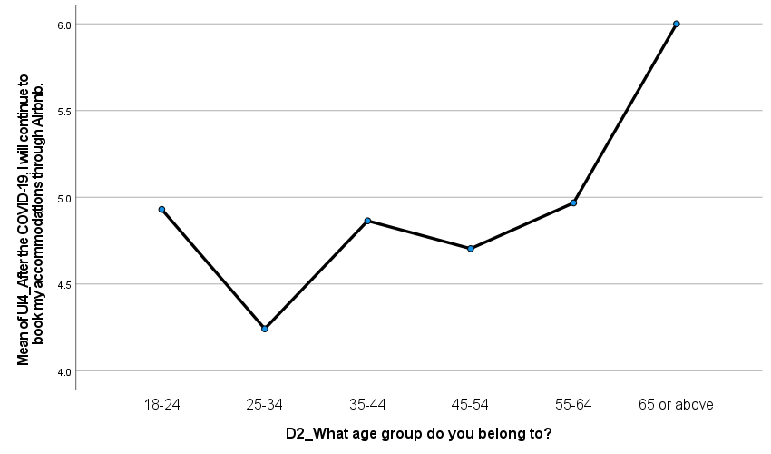
I Group
J Group
RI4_After the COVID-19, I will continue to book my accommodations through Airbnb.
Source: Constructed by the author

4.10.2 One-way ANOVA test for ethnicity
The descriptive statistics table (Table 43) includes the mean, standard deviation, and 95 percent confidence intervals for the dependent variable (Repurchase Intention) for each ethnicity group (Asian/Pacific Islander; Black/African American; Hispanic or Latino; Native American/ American Indian; White; Others), as well as when all groups are combined (Total).

Table 43: Descriptive table for ethnicity
Descriptives
 |  | N | Mean | Std. Deviation | Std. Error | 95% Confidence Interval for Mean |  | Minimum | Maximum
 |  |  |  |  |  | Lower Bound | Upper Bound | Minimum | Maximum
RI2_The next time, I'm likely to choose Airbnb or another similar sharing option. | Asian/ Pacific Islander | 254 | 4.32 | 1.095 | .069 | 4.19 | 4.46 | 1 | 6
 | Black or African American | 4 | 4.25 | 1.500 | .750 | 1.86 | 6.64 | 3 | 6
 | Hispanic or Latino | 6 | 6.00 | .000 | .000 | 6.00 | 6.00 | 6 | 6
 | Native American or American Indian | 5 | 6.00 | .000 | .000 | 6.00 | 6.00 | 6 | 6
 | White | 125 | 4.45 | 1.310 | .117 | 4.22 | 4.68 | 1 | 6
 | Others | 6 | 4.17 | .983 | .401 | 3.13 | 5.20 | 3 | 5
 | Total | 400 | 4.41 | 1.183 | .059 | 4.29 | 4.52 | 1 | 6
Source: Constructed by the author

Table 44 displays the ANOVA analysis results as well as whether or not there is a statistically significant difference between our group means. The significance level is less than 0.05, as a result, the mean time to complete the spreadsheet problem differs statistically significantly between the various enthnicity. Multiple Comparisons table will be used to identify specific groups differed which includes the Tukey post hoc test results.

Table 44: ANOVA table for ethnicity
ANOVA
 |  | Sum of Squares | df | Mean Square | F | Sig.
RI2_The next time, I'm likely to choose Airbnb or another similar sharing option. | Between Groups | 30.367 | 5 | 6.073 | 4.532 | .000
 | Within Groups | 528.023 | 394 | 1.340
 | Total | 558.390 | 399
Source: Constructed by the author

The Multiple Comparisons table below (Table 45) demonstrates how the groups differed from one another. It shows that there is a statistically significant difference in repurchase intention between the ethnicity groups of Asian/ Pacific Islander and Hispanic/ Latino (p = -1.677), the same as comparing with Narive American/ American Indian (p = -1.677).

Table 45:Multiple comparisons of ethnicity
Multiple Comparisons
Tukey HSD
Dependent Variable | (I) D4_Ethnic origin: Please specify your ethnicity | (J) D4_Ethnic origin: Please specify your ethnicity | Mean Difference (I-J) | Std. Error | Sig. | 95% Confidence Interval
 |  |  |  |  |  | Lower Bound | Upper Bound
RI2_The next time, I'm likely to choose Airbnb or another similar sharing option. | Asian/ Pacific Islander | Black or African American | .073 | .583 | 1.000 | -1.60 | 1.74
 | Asian/ Pacific Islander | Hispanic or Latino | -1.677* | .478 | .007 | -3.05 | -.31
 | Asian/ Pacific Islander | Native American or American Indian | -1.677* | .523 | .018 | -3.17 | -.18
 | Asian/ Pacific Islander | White | -.125 | .126 | .921 | -.49 | .24
 | Asian/ Pacific Islander | Others | .156 | .478 | 1.000 | -1.21 | 1.53
*. The mean difference is significant at the 0.05 level.
Source: Constructed by the author

Figure 25: Mean Plot of ethnicity
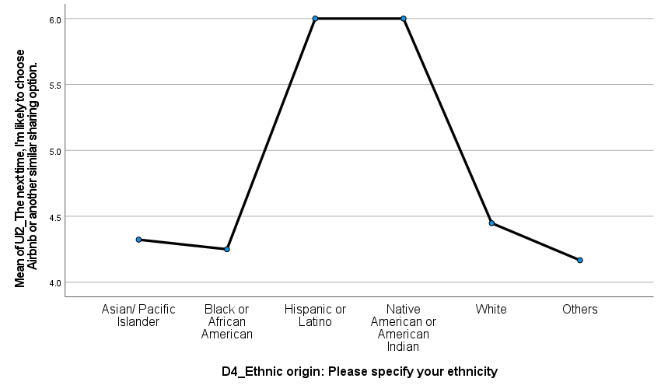
RI2_The next time, I'm likely to choose Airbnb or another similar sharing option.
I Group
J Group
Source: Constructed by the author

4.10.3 One-way ANOVA test for number of kids in the family
The descriptive statistics table (Table 46) includes the mean, standard deviation, and 95 percent confidence intervals for the dependent variable (Repurchase Intention) for the different number of kids in the family (0; 1; 2; 3; 4; 5 or above), as well as when all groups are combined (Total).

Table 46: Descriptive table for number of kids in the family
Descriptives
 |  | N | Mean | Std. Deviation | Std. Error | 95% Confidence Interval for Mean |  | Minimum | Maximum
 |  |  |  |  |  | Lower Bound | Upper Bound | Minimum | Maximum
UI4_After the COVID-19, I will continue to book my accommodations through Airbnb. | 0 | 279 | 4.67 | 1.303 | .078 | 4.51 | 4.82 | 1 | 6
 | 1 | 35 | 4.43 | 1.037 | .175 | 4.07 | 4.78 | 2 | 6
 | 2 | 51 | 4.82 | 1.228 | .172 | 4.48 | 5.17 | 3 | 6
 | 3 | 20 | 5.55 | .826 | .185 | 5.16 | 5.94 | 3 | 6
 | 4 | 7 | 4.71 | 1.704 | .644 | 3.14 | 6.29 | 1 | 6
 | 5 or above | 8 | 5.38 | .916 | .324 | 4.61 | 6.14 | 4 | 6
 | Total | 400 | 4.72 | 1.268 | .063 | 4.60 | 4.85 | 1 | 6
Source: Constructed by the author

Table 44 displays the ANOVA analysis results as well as whether or not there is a statistically significant difference between our group means. The significance level is less than 0.05, as a result, the mean time to complete the spreadsheet problem differs statistically significantly between the various enthnicity. Multiple Comparisons table will be used to identify specific groups differed which includes the Tukey post hoc test results.

Table 47: ANOVA table for number of kids in the family
ANOVA
 |  | Sum of Squares | df | Mean Square | F | Sig.
UI4_After the COVID-19, I will continue to book my accommodations through Airbnb. | Between Groups | 21.513 | 5 | 4.303 | 2.733 | .019
 | Within Groups | 620.237 | 394 | 1.574
 | Total | 641.750 | 399
Source: Constructed by the author

The Multiple Comparisons table below (Table 45) demonstrates how the groups differed from one another. It shows that there is a statistically significant difference in repurchase intention between the family with 3 kids and no kids (p = 0.883), as well as the family with 3 kids and 1 kid (p = 1.121).

Table 48: Multiple comparisons for number of kids in family
Multiple Comparisons
Tukey HSD
Dependent Variable | (I) D7_How many kids do you have? | (J) D7_How many kids do you have? | Mean Difference (I-J) | Std. Error | Sig. | 95% Confidence Interval
 |  |  |  |  |  | Lower Bound | Upper Bound
RI4_After the COVID-19, I will continue to book my accommodations through Airbnb. | 3 | 0 | .883* | .290 | .030 | .05 | 1.72
 | 3 | 1 | 1.121* | .352 | .019 | .11 | 2.13
 | 3 | 2 | .726 | .331 | .243 | -.22 | 1.67
 | 3 | 4 | .836 | .551 | .654 | -.74 | 2.41
 | 3 | 5 or above | .175 | .525 | .999 | -1.33 | 1.68
*. The mean difference is significant at the 0.05 level.
Source: Constructed by the author

Figure 26: Mean Plot of ethnicity
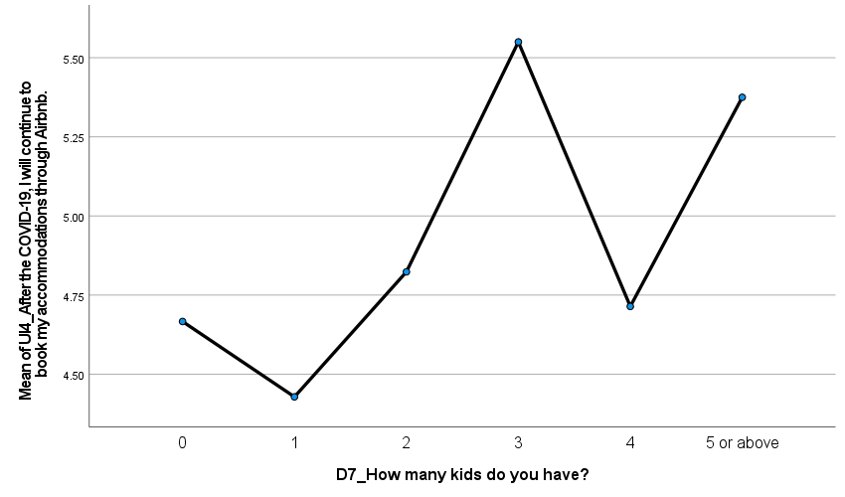
RI4_After the COVID-19, I will continue to book my accommodations through Airbnb.
I Group
J Group
Source: Constructed by the author

Chapter 5: Conclusion
Airbnb has drastically altered the entire tourism accommodation environment by providing a novel new product to the market. Nonetheless, there is a lack of understanding as to why so many travelers prefer this unique service over typical lodging options. This research gives some significant information on this subject by demonstrating…

Appendix 1 Focus Group Discussion
A focus group was held with ten respondents who were 18 or older and had previously used Airbnb while traveling abroad. Participants must have prior experience with Airbnb usage because the goal was to discuss some important factors influencing Airbnb repurchase intention, with the questions asked below:
Date | Venue | Duration
17 Apr 2021 | Microsoft Teams | 1 hour
Q1. What are the primary factors that motivate you to use Airbnb, and why?
Q2. Why did you choose Airbnb over a traditional hotel?
Q3. What are your primary concerns when it comes to selecting an Airbnb host?
Q4. What are your primary concerns when you use the Airbnb booking platform?
Q5. What are your reasons for using Airbnb again?
Q6. Will you continue to use Airbnb after the COVID-19 pandemic, and why?

Respondent | Opinions | Signature
#1  Name: Terrence  Age: 49  Gender: M  Occupation: Risk Manager | Q1 - Airbnb offers a diverse selection of locations and accommodations of varying quality; I found the booking platform user-friendly and informative.  Q2 - As a family of four, it is more cost-effective for me to book a larger unit through Airbnb than to book two rooms in a traditional hotel, which is significantly more expensive.  Q3 - Data privacy would be a concern, as I am unsure whether the Airbnb host will obtain my personal information from the booking.  Q4 - In general, the booking platform appears to be trustworthy; I have no specific concerns.  Q5 - I found that Airbnb helps me save money on travel expenses compared to a traditional hotel, and I have more options for unique accommodations.  Q6 - Yes, the benefits I found from Airbnb far outweigh those of a traditional hotel, and my preference will not change even after the COVID-19 pandemic.
#2  Name: Ivan  Age: 35  Gender: M  Occupation: Graphic Designer | Q1 - Airbnb accommodations are always closer to downtown or residential areas, where I enjoy spending time with the locals.  Q2 - Traditional hotels are too commercial for me, and they can be overcrowded and noisy when full of travelers. That is why I prefer Airbnb because each experience is unique.  Q3 - I will read the comments left by other travelers before deciding which Airbnb host to book; I believe those reviews are important.  Q4 - I believe in the Airbnb booking platform; data privacy is important; however, I think the Airbnb platform is similar to other hotels.  Q5 - The unique experience from Airbnb is something that other hotels cannot provide for me, and there are many more options from Airbnb, so I don't see any reason not to use it again in the future.  Q6 - Yes, I prefer Airbnb to traditional hotels in terms of selection and unique experience, and I intend to continue using Airbnb after COVID-19.
#3  Name: Alison  Age: 52  Gender: F  Occupation: Project Manager | Q1 - Booking on Airbnb is less expensive, and the quality is not bad at all; sometimes, the room view and location are even better than in traditional hotels.  Q2 - For business travel, I would still book a traditional hotel, but for leisure travel, I would book through Airbnb because it is less expensive and usually includes a kitchen, which a traditional hotel rarely provides.  Q3 - When I travel alone, I am concerned about my personal safety.  Q4 - In general, the booking platform appears to be reliable.  Q5 - There are a lot of positive reviews from other travelers about Airbnb, and I'm hoping to have a similar experience.  Q6 - Yes, some Airbnb accommodations are close to the local friends I intend to visit; I will continue to use Airbnb even after COVID-19.
#4  Name: Cathy  Age: 37  Gender: F  Occupation: Bulter | Q1 - When I travel with my friends and family, we can book a larger unit or a house on Airbnb rather than booking multiple rooms in hotels. Staying together in a house is much more enjoyable.  Q2 - When I book a house on Airbnb, we usually have a kitchen, which is convenient because local food can be expensive or not to our taste; we can then cook a meal in the kitchen. We absolutely cannot do the same in a traditional hotel room.  Q3 - I would check if the Airbnb host has received positive feedback from previous travelers.  Q4 - I trust the Airbnb booking platform because they only need my basic information and a credit card to complete the transaction. I can also write to the Airbnb host with my request, and there is a hotline I can call if I need immediate assistance.  Q5 - It's much cheaper to book a house through Airbnb than to book multiple hotel rooms, and having a kitchen is also important.  Q6 - Yes, traditional hotels are unsuitable for our travel habits; I intend to continue using Airbnb after COVID-19.
#5  Name: Stephanie  Age: 36  Gender: F  Occupation: Human Resources Manager | Q1 - The number of locations available on Airbnb exceeds that of traditional hotels, making it easier for me to visit various tourist attractions. Most importantly, if I am looking to those prime locations, it is less expensive to book through Airbnb.  Q2 - In terms of economic benefits, I would say it is cheaper for me to book through Airbnb rather than a traditional hotel in the same location.  Q3 - Location, price, amenities, cleanliness, and other travelers' reviews are all important to me.  Q4 - I will only choose Airbnb hosts who have received a higher rating from other travelers. I'll do some research before making a reservation.  Q5 - I don't see any reason why I shouldn't use Airbnb again if I'm not looking for luxury service. Airbnb has a better location with a lower price offer, and the unit size is generally larger than that of a hotel room.  Q6 - Yes, staying at Airbnb after COVID-19 is even better because it is more exclusive; the unit is exclusively for us. Rather than staying in a hotel, we will interact with other travelers and hotel staff.
#6  Name: Angus  Age: 37  Gender: M  Occupation: Property Manager | Q1 - Staying at Airbnb provides me with a more unique and exclusive experience. It truly gives me the feeling of being at home; I don't have to interact with as many hotel employees, and their service is not always up to my standards.  Q2 - I can book palace-like houses through Airbnb, allowing me to stay with my family. Which I doubt I'd be able to find in a traditional hotel experience.  Q3 - I will only choose Airbnb hosts who have received a higher rating from other travelers. I'll do some research before making a reservation.  Q4 - I trust the Airbnb platform overall because it has all of the data consent and privacy guidelines.  Q5 - Airbnb has a plethora of options and offers, all of which are of high quality and offer a one-of-a-kind experience.  Q6 - Yes, after the COVID-19, the only concern is the cleanliness of the Airbnb unit. If the Airbnb host can provide information about the unit's cleaning measurements, I don't see why it shouldn't be a problem.
#7  Name: Sandy  Age: 45  Gender: M  Occupation: Senior Director of Marketing Distribution | Q1 - It depends on where I am traveling to. If I'm going to a developed country, I'd say Airbnb is preferable because the house on Airbnb is larger for my family. However, if I'm traveling to a developing country, I'd rather stay in a traditional hotel because I feel more secure.  Q2 - Airbnb is close to the neighborhood in general, making it easier for us to travel around. Of course, we can book hotels in prime locations as well, but the cost will be higher.  Q3 - Our safety is our primary concern when staying at Airbnb, so I will read all of the previous travelers' reviews as well as the information provided by the host to determine whether or not this host is trustworthy.  Q4 - In general, the booking platform appears to be trustworthy; I have no specific concerns.  Q5 - I found that Airbnb helps me save money on travel expenses compared to a traditional hotel, and I have more options for unique accommodations.  Q6 – Yes, the benefits I found from Airbnb far outweigh those of a traditional hotel, and my preference will not change even after the COVID-19 pandemic.
#8  Name: Paul  Age: 46  Gender: M  Occupation: Senior Marketing Manager | Q1 - Airbnb offers a diverse selection of locations and accommodations of varying quality; I found the booking platform user-friendly and informative.  Q2 - As a family of four, it is more cost-effective for me to book a larger unit through Airbnb than to book two rooms in a traditional hotel, which is significantly more expensive.  Q3 - Data privacy would be a concern, as I am unsure whether the Airbnb host will obtain my personal information from the booking.  Q4 - In general, the booking platform appears to be trustworthy; I have no specific concerns.  Q5 - I found that Airbnb helps me save money on travel expenses compared to a traditional hotel, and I have more options for unique accommodations.  Q6 - Yes, the benefits I found from Airbnb far outweigh those of a traditional hotel, and my preference will not change even after the COVID-19 pandemic.
#9  Name: Benjamin  Age: 39  Gender: M  Occupation: Financial Planner | Q1 – Airbnb appears to be more affordable than traditional motels, and the unit size is larger.  Q2 – I can cut down on my trip expenses.  Q3 – I would check to see whether this host has any positive feedback.  Q4 – Normally, if the review online is good, I don't have any concerns.  Q5 – I've had excellent experiences with Airbnb thus far; until I require the premium service offered by hotels on a particular occasion, I'll continue to use Airbnb.  Q6 - Yes, I have enjoyed using Airbnb thus far; it is simple to book and costs less than reserving a hotel; I intend to continue booking with them in the future.
#10  Name: Claudia  Age: 43  Gender: F  Occupation: Business Development Manager | Q1 – Because Airbnb units are larger, and I always travel in groups, Airbnb is a better option for us.  Q2 – Hotels will split us into separate rooms, maybe on separate floors.  Q3 – I would select hosts who have a positive rating from past guests; if the review is negative, I may choose another host.  Q4 – I trust the platform, so I do not have concerns.  Q5 – Traditional hotels just cannot meet my needs, unless I choose for suite rooms, which are more expensive than Airbnb.  Q6 - Yes, the benefits I found from Airbnb far outweigh those of a traditional hotel, and my preference will not change even after the COVID-19 pandemic.

Appendix 2 Questionnaire for pilot test
Travelers' repurchase intention of Airbnb
Hello, everyone! I'm looking for people to participate in my dissertation. You can participate if you have previously used Airbnb.

The study is looking into Airbnb's repurchase intentions and will take about 5-6 minutes to complete. Thank you for your time!

The questionnaire is completely voluntary and anonymous, and participants may withdraw at any time. The responses provided will be used solely for the purposes of this research and will then be deleted.

Have you ever booked accommodation through Airbnb?
☐ Yes
☐ No
Variable | Item | Description | Extent
Trust | T1 | Airbnb creates the impression that it adheres to its commitments and promises. | 1 | 2 | 3 | 4 | 5 | 6
Trust | T2 | I believe Airbnb will keep its promises to me. | 1 | 2 | 3 | 4 | 5 | 6
Trust | T3 | I trust that Airbnb has sufficient safeguards in place to protect me from liability for damage that is not my fault. | 1 | 2 | 3 | 4 | 5 | 6
Trust | T4 | Overall, Airbnb is trustworthy. | 1 | 2 | 3 | 4 | 5 | 6
Perceived Risk | R1 | I am concerned about the privacy of my personal information during a transaction with Airbnb. | 1 | 2 | 3 | 4 | 5 | 6
Perceived Risk | R2 | Using Airbnb would be risky. | 1 | 2 | 3 | 4 | 5 | 6
Perceived Risk | R3 | I need a lot more information about the host before I would book from Airbnb. | 1 | 2 | 3 | 4 | 5 | 6
Service Quality | SQ1 | I am pleased with my experience of staying in Airbnb accommodations. | 1 | 2 | 3 | 4 | 5 | 6
Service Quality | SQ2 | The design of Airbnb's reservation platform is appealing to me. | 1 | 2 | 3 | 4 | 5 | 6
Service Quality | SQ3 | Airbnb's host is helpful. | 1 | 2 | 3 | 4 | 5 | 6
Service Quality | SQ4 | If there is a problem, Airbnb's reservation platform provides the option to speak with a live person. | 1 | 2 | 3 | 4 | 5 | 6
Information Quality | IQ1 | When I attempt to make a transaction through Airbnb's reservation platform, I receive sufficient information. | 1 | 2 | 3 | 4 | 5 | 6
Information Quality | IQ2 | I am satisfied with the information provided by Airbnb's reservation platform. | 1 | 2 | 3 | 4 | 5 | 6
Information Quality | IQ3 | The information on Airbnb's reservation platform is well organized. | 1 | 2 | 3 | 4 | 5 | 6
Information Quality | IQ4 | Airbnb's reservation platform is easy to use. | 1 | 2 | 3 | 4 | 5 | 6
eWOM | eWOM1 | To ensure that I choose the best Airbnb host, I frequently read online reviews from other tourists. | 1 | 2 | 3 | 4 | 5 | 6
eWOM | eWOM2 | Before I choose to book an Airbnb, I frequently gather information from tourist reviews online. | 1 | 2 | 3 | 4 | 5 | 6
eWOM | eWOM3 | Based on the high rating a host has received from travelers, I believe the host is trustworthy. | 1 | 2 | 3 | 4 | 5 | 6
eWOM | eWOM4 | Social media has influenced my perceptions and experiences with Airbnb | 1 | 2 | 3 | 4 | 5 | 6
Economic Benefits | EB1 | I could save money by booking accommodations through Airbnb from local hosts. | 1 | 2 | 3 | 4 | 5 | 6
Economic Benefits | EB2 | Airbnb enables me to book travel accommodations at a lower cost than other travel accommodation websites. | 1 | 2 | 3 | 4 | 5 | 6
Economic Benefits | EB3 | I can book unique accommodations from Airbnb that are not available on other travel websites. | 1 | 2 | 3 | 4 | 5 | 6
Economic Benefits | EB4 | Airbnb assisted me in reducing my travel expenses. | 1 | 2 | 3 | 4 | 5 | 6
Economic Benefits | EB5 | Airbnb enables me to have higher-quality lodging while spending less money. | 1 | 2 | 3 | 4 | 5 | 6
Repurchase Intention | RI1 | I would rather book my accommodations from Airbnb rather than other hotels' reservation platforms. | 1 | 2 | 3 | 4 | 5 | 6
Repurchase Intention | RI2 | The next time, I'm likely to choose Airbnb or another similar sharing option. | 1 | 2 | 3 | 4 | 5 | 6
Repurchase Intention | RI3 | It's a good idea to use Airbnb to book unique accommodations from local hosts. | 1 | 2 | 3 | 4 | 5 | 6
Repurchase Intention | RI4 | After the COVID-19, I will continue to book my accommodations through Airbnb. | 1 | 2 | 3 | 4 | 5 | 6
Demographic
Which gender are you?
☐ Male
☐ Female

What age group do you belong to?
☐ 18-24
☐ 25-34
☐ 35-44
☐ 45-54
☐ 55-64
☐ 65 or above

What is the highest degree or level of school you have completed?
☐ High school graduate, diploma, or the equivalent
☐ Associate Degree
☐ Bachelor's Degree
☐ Master's Degree
☐ Doctorate Degree

Ethnic origin: Please specify your ethnicity
☐ Asian/ Pacific Islander
☐ Black or African American
☐ Hispanic or Latino
☐ Native American or American Indian
☐ White
☐ Others

Typically, what is the reason for your travel?
☐ Leisure
☐ Business

What is your marital status?
☐ Single
☐ Married or domestic partnership
☐ Windowed/ Divorces/ Separated

Family size: How many kids do you have?
☐ 0
☐ 1
☐ 2
☐ 3
☐ 4
☐ 5

-End-
We appreciate your time in responding to this questionnaire.

Appendix 3 Questionnaire for final survey
Travelers' repurchase intention of Airbnb
Hello, everyone! I'm looking for people to participate in my dissertation. You can participate if you have previously used Airbnb.

The study is looking into Airbnb's repurchase intentions and will take about 5-6 minutes to complete. Thank you for your time!

The questionnaire is completely voluntary and anonymous, and participants may withdraw at any time. The responses provided will be used solely for the purposes of this research and will then be deleted.

Have you ever booked accommodation through Airbnb?
☐ Yes
☐ No
Variable | Item | Description | Extent
Trust | T1 | Airbnb creates the impression that it adheres to its commitments and promises. | 1 | 2 | 3 | 4 | 5 | 6
Trust | T2 | I believe Airbnb will keep its promises to me. | 1 | 2 | 3 | 4 | 5 | 6
Trust | T3 | I trust that Airbnb has sufficient safeguards in place to protect me from liability for damage that is not my fault. | 1 | 2 | 3 | 4 | 5 | 6
Trust | T4 | Overall, Airbnb is trustworthy. | 1 | 2 | 3 | 4 | 5 | 6
Perceived Risk | R1 | I am concerned about the privacy of my personal information during a transaction with Airbnb. | 1 | 2 | 3 | 4 | 5 | 6
Perceived Risk | R2 | Using Airbnb would be risky. | 1 | 2 | 3 | 4 | 5 | 6
Perceived Risk | R3 | I need a lot more information about the host before I would book from Airbnb. | 1 | 2 | 3 | 4 | 5 | 6
Perceived Risk | R4 | Booking through Airbnb would put me in danger of physical harm. | 1 | 2 | 3 | 4 | 5 | 6
Perceived Risk | R5 | Booking via Airbnb would result in a financial loss for me. | 1 | 2 | 3 | 4 | 5 | 6
Service Quality | SQ1 | I am pleased with my experience of staying in Airbnb accommodations. | 1 | 2 | 3 | 4 | 5 | 6
Service Quality | SQ2 | The design of Airbnb's reservation platform is appealing to me. | 1 | 2 | 3 | 4 | 5 | 6
Service Quality | SQ3 | Airbnb's host is helpful. | 1 | 2 | 3 | 4 | 5 | 6
Information Quality | IQ1 | When I attempt to make a transaction through Airbnb's reservation platform, I receive sufficient information. | 1 | 2 | 3 | 4 | 5 | 6
Information Quality | IQ2 | I am satisfied with the information provided by Airbnb's reservation platform. | 1 | 2 | 3 | 4 | 5 | 6
Information Quality | IQ3 | The information on Airbnb's reservation platform is well organized. | 1 | 2 | 3 | 4 | 5 | 6
Information Quality | IQ4 | Airbnb's reservation platform is easy to use. | 1 | 2 | 3 | 4 | 5 | 6
eWOM | eWOM1 | To ensure that I choose the best Airbnb host, I frequently read online reviews from other tourists. | 1 | 2 | 3 | 4 | 5 | 6
eWOM | eWOM2 | Before I choose to book an Airbnb, I frequently gather information from tourist reviews online. | 1 | 2 | 3 | 4 | 5 | 6
eWOM | eWOM3 | Based on the high rating a host has received from travelers, I believe the host is trustworthy. | 1 | 2 | 3 | 4 | 5 | 6
eWOM | eWOM4 | Social media has influenced my perceptions and experiences with Airbnb | 1 | 2 | 3 | 4 | 5 | 6
Economic Benefits | EB1 | I could save money by booking accommodations through Airbnb from local hosts. | 1 | 2 | 3 | 4 | 5 | 6
Economic Benefits | EB2 | Airbnb enables me to book travel accommodations at a lower cost than other travel accommodation websites. | 1 | 2 | 3 | 4 | 5 | 6
Economic Benefits | EB3 | I can book unique accommodations from Airbnb that are not available on other travel websites. | 1 | 2 | 3 | 4 | 5 | 6
Economic Benefits | EB4 | Airbnb assisted me in reducing my travel expenses. | 1 | 2 | 3 | 4 | 5 | 6
Economic Benefits | EB5 | Airbnb enables me to have higher-quality lodging while spending less money. | 1 | 2 | 3 | 4 | 5 | 6
Repurchase Intention | RI1 | I would rather book my accommodations from Airbnb rather than other hotels' reservation platforms. | 1 | 2 | 3 | 4 | 5 | 6
Repurchase Intention | RI2 | The next time, I'm likely to choose Airbnb or another similar sharing option. | 1 | 2 | 3 | 4 | 5 | 6
Repurchase Intention | RI3 | It's a good idea to use Airbnb to book unique accommodations from local hosts. | 1 | 2 | 3 | 4 | 5 | 6
Repurchase Intention | RI4 | After the COVID-19, I will continue to book my accommodations through Airbnb. | 1 | 2 | 3 | 4 | 5 | 6
Demographic
Which gender are you?
☐ Male
☐ Female

What age group do you belong to?
☐ 18-24
☐ 25-34
☐ 35-44
☐ 45-54
☐ 55-64
☐ 65 or above

What is the highest degree or level of school you have completed?
☐ High school graduate, diploma, or the equivalent
☐ Associate Degree
☐ Bachelor's Degree
☐ Master's Degree
☐ Doctorate Degree

Ethnic origin: Please specify your ethnicity
☐ Asian/ Pacific Islander
☐ Black or African American
☐ Hispanic or Latino
☐ Native American or American Indian
☐ White
☐ Others

Typically, what is the reason for your travel?
☐ Leisure
☐ Business

What is your marital status?
☐ Single
☐ Married or domestic partnership
☐ Windowed/ Divorces/ Separated

Family size: How many kids do you have?
☐ 0
☐ 1
☐ 2
☐ 3
☐ 4
☐ 5

-End-
We appreciate your time in responding to this questionnaire.

