Organisational Report

Hyatt Hotels Corporation
Student name: | Fruzsina Valoczki
Student number: | 2223630
Lecturer’s name: | Lola Villard-Coles
Module code: | BMIH5004
Module name: | Management and Organisational Behaviour
Word Count | 2156
Submission date: | 05/11/2024
I confirm that I have not presented any AI generated text as my own work. I confirm I have copies of my drafts, notes, and other resources I used before, and after the use of AI tools which I may be asked to provide in evidence.

Executive summary
This report examines the structure, culture, and objectives of Hyatt Hotels at both the corporate and individual hotel levels. Hyatt functions as an international hotel brand with a hierarchical structure and centralised decision-making, while Alila Villas Uluwatu, a sustainable hotel under Hyatt's corporation, follows a comparable structure but utilises a decentralised decision-making approach.
The culture at Hyatt is grounded in traditional values and a human-centric approach, while the Hyatt Regency Dongguan Songshan Lake operates solely within a hierarchical culture, which has demonstrated drawbacks in case studies.
The company’s objectives include growth, profitability, sustainability, and the development of individual hotel units. The aim of Hyatt Regency Sha Tin is to provide practical experience for students. However, concerns have been raised regarding the programme's effectiveness.
Recently, Hyatt transitioned to dynamic pricing and implemented a new organisational structure in the United States. The strategic analysis follows Mintzberg's 5 P model, highlighting Hyatt's strengths and weaknesses, particularly in comparison to the loyalty programmes of competitors such as Marriott and Hilton.
At the conclusion of the report, recommendations are presented, focusing on entering the mid-market segment and integrating digital technologies to enhance the guest experience. The objective is to provide a comprehensive overview of Hyatt Hotels’ current situation, along with future development opportunities to increase competitiveness.

Table of Contents
Executive summary 2
Introduction 4
Structure 4
Organisational 4
Individual Hotel Unit 5
Culture 6
Organisational 6
Individual Hotel Unit 6
Goals 7
Organisational 7
Individual Hotel Unit 7
Recent Change Initiative 8
Strategic Direction 9
Conclusion 11
Recommendations 11
References 12

Introduction
Jay Pritzker purchased the Hyatt House motel in Los Angeles in 1957, marking the beginning of Hyatt Hotels Corporation in the hospitality industry (Cohen, 2023). Initially starting in the United States, Hyatt has since expanded its global footprint, with operations in the Asia Pacific and EAME regions. It currently operates hotels in 77 countries and offers various brands for luxury and mid-range travellers. Hyatt's locations mainly exist in urban areas and popular tourist spots, providing a wide variety of services designed for both business and leisure guests. Approximately 206,000 individuals are employed by the company globally, with 51,000 working directly for them and the rest working for independent owners and franchisees (Hyatt, 2023a).
The goal of this report is to offer a thorough presentation of Hyatt Hotels' culture, organisation, recent developments, and elements of its strategies at both the corporate and individual hotel levels. It reveals the organisation's potential weaknesses and areas for improvement and makes recommendations that can contribute to maintaining competitiveness in the dynamically changing global hotel market.

Structure

Organisational
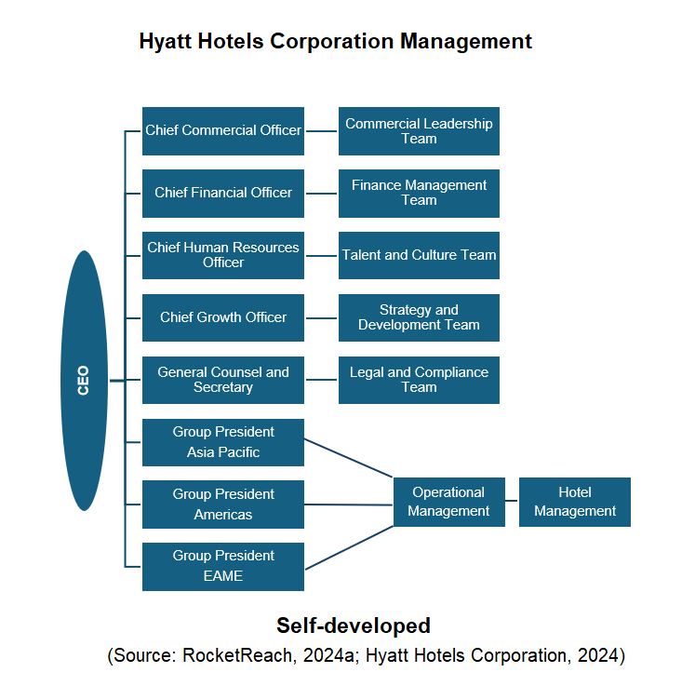
Hyatt Hotels Corporation operates with a layered hierarchical structure. Leading this structure is Mark S. Hoplamazian, the Chief Executive Officer, who oversees the company’s strategic direction and overall management (Hyatt Hotels Corporation, 2024). Directly reporting to him are the functional leaders, and the regional presidents, who oversee hotels operating in various regions of Hyatt. The managers of each hotel report to the operational management. This indicates a centralised decision-making process, which helps maintain brand consistency. However, this decision-making can limit the hotel's ability to respond to local needs (Johansson, 2023).

Individual Hotel Unit
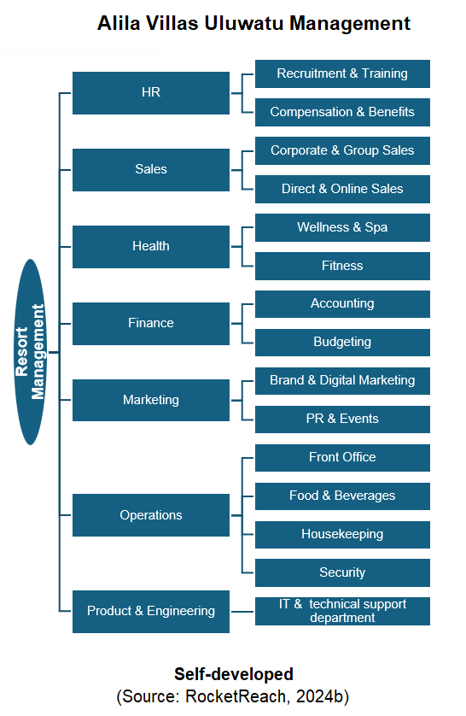
Alila Villas Uluwatu, a premium resort located in Bali and part of the Hyatt brand, illustrates Hyatt's distinct hotel framework. The resort employs a decentralised decision-making process, which facilitates a prompt response to guest requests and allows staff greater freedom in their roles. The resort manager runs the hotel’s operations and oversees the operational managers (RocketReach, 2024b). Its hierarchical structure defines clear roles, but the rigidity may slow down the decision-making process.

Culture

Organisational
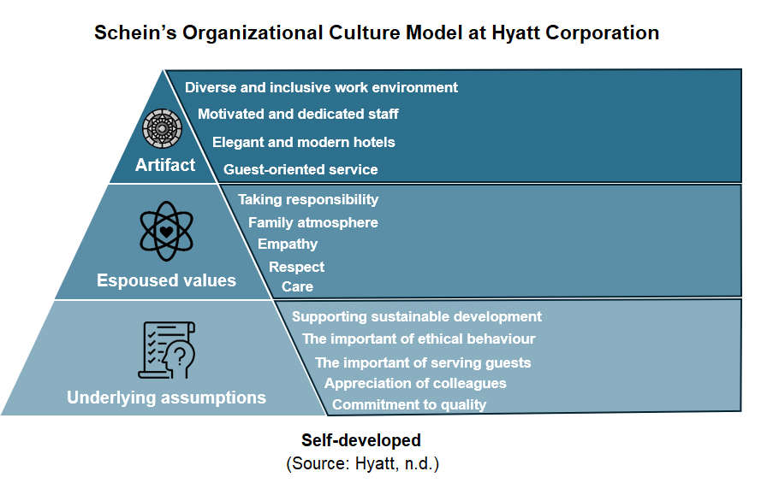
Hyatt emphasises traditional values like respect, accountability, and punctuality, which align with its hierarchical culture. The company provides numerous training opportunities for its employees, fostering their development and enhancing job satisfaction (Hogan, 2023). Additionally, Hyatt is committed to sustainability and utilises several eco-friendly technologies. The organisation continuously develops these initiatives for long-term success. Research by Hosen et al. (2023) supports the idea that emphasising traditional values and training opportunities strengthens employee commitment. However, Osei et al. (2023) warn that the limitations of the hierarchical culture and sustainability measures can hinder progress, highlighting the need for ongoing innovation and improvement of the workplace environment.
Another key element of Hyatt's corporate culture is its clan culture, which focuses on a people-centred approach, empathy, and a family-like atmosphere. According to Chief Executive Officer Mark Hoplamazian, empathy is essential for employee satisfaction (O’Neill, 2023). The clan culture is also an important part of their ethical code, which is based on care, ethical behaviour, and accountability (Hyatt Hotels Corporation, 2023a). However, the family-like atmosphere can sometimes lead to a lack of openness, making it difficult for opinions to be expressed.

Individual Hotel Unit
The Hyatt Regency Dongguan Songshan Lake is a particularly interesting example of Hyatt's unique hotel culture, as it operates in a technologically advanced environment and is visited by both business guests and tourists. Its hierarchical culture is based on stability and the standardisation of processes (Chen and Lai, 2021). The roles and responsibilities for all staff are clear, which helps with efficient work and consistent service quality. The management's direction and decision-making process follow hierarchical principles, while the use of modern technology, such as the OPERA system, ensures effective communication and data sharing among different departments.
However, the hierarchical structure can also have drawbacks. According to a study by Yanzhang, Shia, and Badiane (2023), there is no proper promotion system at the Hyatt Regency Dongguan Songshan Lake that provides clear and realistic career opportunities for employees. The current structure has a saturation of mid-level and senior positions, making it difficult for those at lower levels to advance. The lack of a suitable promotion system can negatively affect employee motivation, which could also impact the hotel's performance.

Goals

Organisational
Increase in Profit and Creation of Shareholder Value
Hyatt is focused on increasing its profit by finding new ways to generate revenue and improving its loyalty program. The company will sell certain properties to raise funds for growth and increase shareholder value, aiming to achieve a revenue target of $2 billion by 2024 (Taiwo, 2023). However, Hyatt must ensure that its actions to enhance shareholder value align with its sustainability goals to avoid any harm to its reputation. The company's commitment to sustainable practices is shown through programs like the World of Care program (Hyatt, 2023b). Hyatt needs to clearly communicate its sustainability efforts to prevent the perception that sustainability is only used for marketing purposes and ensure credibility.
Human Resource Development and Diversity
Hyatt regards its staff as the most important resource, supporting diversity, inclusion, and professional development. Since 2020, it has increased the percentage of employees from diverse backgrounds by 10% and has filled 360 women’s leadership roles (Hertzfeld, 2023). However, achieving true diversity is not always a straightforward task, and it is uncertain whether the rising figures truly impact the company culture. Maintaining diversity and inclusion requires ongoing effort, so Hyatt should develop long-term strategic plans. These factors can be aligned with Maslow's hierarchy of needs theory, which emphasises the necessity of self-actualisation, but it is essential that the various needs of employees are genuinely considered in the decision-making process (Mullins and McLean, 2019, p. 257).

Individual Hotel Unit
The Hyatt Regency Sha Tin is a prime example of a unique hotel analysis. In partnership with the University of Hong Kong, it offers a program that allows students to gain hands-on experience in hospitality (King and Tang, 2019). Participants can gain experience in reception, housekeeping, restaurant, and kitchen areas. The aim is to give students a wide range of knowledge, introduce them to the difficulties of the hospitality sector, and get them ready for their future careers. By doing this, Hyatt is helping to develop skills and ensure a future workforce.
However, a critical evaluation of the programme raises some concerns. Participants often carry out routine tasks that may not provide sufficient depth of knowledge. Furthermore, the quality of training and mentoring is not always adequate for the genuine development of the students. Regular assessment and improvement based on student feedback is key to enhancing the programme’s effectiveness and can contribute to Hyatt's long-term goals.

Recent Change Initiative
Market Adaptation and Pricing Strategy
Hyatt is constantly adjusting to the evolving market conditions, with an emphasis on enhancing the guest experience and upholding its competitive edge. The company recently changed its pricing strategy from fixed to dynamic. This adjustment allows Hyatt to respond more effectively to variations in demand and optimise its revenue streams (Horbrook, 2022). Lewin's change model offers a helpful structure for comprehending the transition, highlighting the steps of unfreezing, changing, and refreezing (Mullins and McLean, 2019, p. 583).
During the unfreezing phase, the fixed pricing strategy was a common practice that Hyatt's customers were already familiar with and accepted. However, the COVID-19 pandemic and market demand fluctuations highlighted the limitations of fixed pricing, prompting Hyatt's management to recognise the need for dynamic pricing. The management informed customers about the change and began preparing for the introduction of the new pricing model.
In the changing phase, Hyatt transitioned to the dynamic pricing model. Initial communication shortcomings raised some concerns among travellers participating in the loyalty programme (Zhang, 2022). However, Hyatt aimed to address these doubts through proactive communication and by considering customer feedback.
In the refreezing phase, customers accepted dynamic pricing, the change became established, and it positively affected the popularity of the loyalty programme. However, this could reduce the programme's appeal in the long term, making the redemption of points less valuable for some customers.
Organisational Structure Change
In February 2024, Hyatt reorganised its operations in the United States to better meet market demands and increase competitiveness (Perkowsky, 2024). This modification split the area into two sections, with one in charge of the United States and Canada while the other concentrated on Latin America and the Caribbean. The change was justified by increasing market competition and cultural differences between the regions. This decision aligns with contingency theory, which states that organisational structure should be tailored to environmental factors (Mullins and McLean, 2019, p. 343). The new structure enables Hyatt to make decisions more quickly, adapt better to local markets, and provide services tailored to local needs. Additionally, the reorganisation may enhance employee motivation, as they will take on more responsibility and be closer to decision-making.
The initiative is expected to lead to more efficient operations, better decision-making, and better adaptation to local markets. However, operational disruptions and communication challenges are anticipated during the initial period. Moreover, collaboration between the two sub-regions and the maintenance of local leaders' autonomy are also important considerations. Successfully implementing the reorganisation presents a complex challenge for Hyatt.

Strategic Direction
Hyatt focuses on sustainable growth and profitability, aiming to expand its market presence and improve customer experiences. Their strategy can be examined using Mintzberg's 5 P model.
Plan
Hyatt has set ambitious plans to expand in the American luxury and lifestyle segments by introducing new brands that enhance the effectiveness of its loyalty programmes (Ozan, 2023). The company focuses on innovative services to meet the constantly changing needs of travellers. While Hyatt employs unique strategies, Marriott and Hilton have stronger loyalty programmes, having built long-term, stable relationships with their guests (Hostetler and Craft, 2024).
Ploy
Hyatt uses a competitive pricing policy and expands its portfolio through the acquisition of hotel chains. By purchasing the Apple Leisure Group, Hyatt has already achieved positive financial results (McCracken, 2023). The company is currently focusing on future acquisitions to strengthen its market position against Hilton and Marriott, who can achieve goals more effectively through continuous growth.
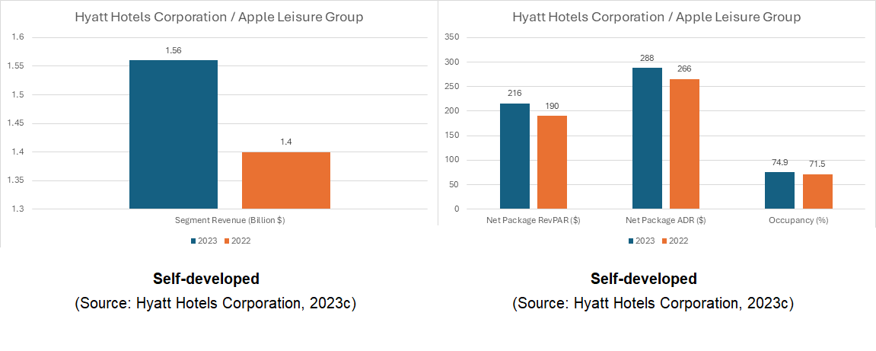
Pattern
During the COVID-19 pandemic, Hyatt concentrated on improving guest experiences and quickly meeting market demands (Goldman, 2021). They introduced digital solutions, such as mobile ordering and scheduling cleaning services, which increased guests' sense of safety. Hyatt adapted particularly quickly to market changes while competitors like Marriott and Hilton implemented similar solutions. However, Hyatt used more innovative technological solutions, which not only strengthened its market position but also enhanced guest loyalty (Sharma et al., 2021).
Position
Hyatt's strong brand and extensive presence provide it with a leading position in the luxury and premium market, reflecting stable and profitable performance, including a 13.4% annual growth in EBITDA (Hyatt Hotels Corporation, 2023b). However, Marriott and Hilton hold stronger market positions, allowing them to respond to market challenges more effectively.
Perspective
Hyatt employs a business model that requires less capital investment, considering the demand for unique experiences from travellers (Kolesnik, 2024). The company focuses on innovation and differentiation while paying attention to employee well-being. While this approach is appealing, Marriott's more sustainable strategies enhance its competitiveness against Hyatt.
In summary, Hyatt's strengths include a focus on sustainable growth and innovative services, as well as a quick improvement in guest experiences, which help maintain its leading position in the luxury and premium market. In contrast, Marriott and Hilton have stronger loyalty programmes and more stable market positions, enabling them to respond more effectively to market challenges and maintain their competitiveness.

Conclusion
Hyatt Hotels Corporation is a dynamically evolving hotel chain with a significant global presence. Its centralised decision-making ensures brand consistency and cost-effectiveness, but its slow response to local demands may limit innovation. The corporate culture focuses on employee development, but a lack of openness presents challenges in expressing opinions. Its objectives aimed at growth and sustainability, strengthen its competitiveness. Pricing changes are intended to enhance the guest experience, although communication difficulties also emerge. Hyatt must address these challenges while preserving the values of its brand and maintaining its global competitiveness.

Recommendations
1. Hyatt is currently focused on the luxury market, which poses risks during economic downturns as demand may decrease. Expanding into the mid-range market could broaden Hyatt's offerings and attract new customers. This would involve developing existing mid-range brands, for instance, by building new hotels or renovating existing ones. To successfully execute the plan, management could carry out extensive market research, put into action specific marketing strategies, or establish collaborations with local companies. Marriott's achievement in the mid-range category shows that growth can be driven by strategic market engagement (Walters, 2023)
2. Further integrating digital technologies could enhance the guest experience and create new revenue streams. Hyatt could improve its mobile app, introduce new digital services, and utilise data analytics to better understand guest needs. The IT department and hotel management could collaborate during this digital transformation, like Hilton's 'Connected Room' programme, which allows guests to personalise their rooms (Tymoshchenko, 2024).

References
Chen, X. and Lai, W. (2021). Research on Employee Relationship Management from the Perspective of Internet. Taking Dongguan Songshan Lake Hyatt Regency Hotel as a Case, [online] 2, pp.3–4. Available at: https://www.allmultidisciplinaryjournal.com/uploads/archives/6131CF23670D51630654243.pdf [Accessed 1 Nov. 2024].
Cohen, B. (2023). After Whom Was Hyatt Hotels Corporation Named? [online] The Gate. Available at: https://thegatewithbriancohen.com/after-whom-was-hyatt-hotels-corporation-named/ [Accessed 25 Oct. 2024].
Goldman, S. (2021). The Technology Innovation behind Hyatt’s Pandemic Pivot Indicates a long-lasting Change in the Hotel Industry. [online] Business Insider. Available at: https://www.businessinsider.com/hyatt-cco-on-how-technology-changed-hotel-business-marketing-model-2021-9 [Accessed 2 Nov. 2024].
Hertzfeld, E. (2023). Hyatt Shares DEI, ESG Progress in Annual Report. [online] Hotel Management. Available at: https://www.hotelmanagement.net/operate/hyatt-publishes-dei-report [Accessed 30 Oct. 2024].
Hogan, B. (2023). With a Focus on Progressive Culture and Individual Growth, Working at Hyatt Feels like a Much-Needed Vacation. [online] Built in. Available at: https://www.builtinchicago.org/articles/progressive-culture-and-individual-growth-hyatt-vacation [Accessed 25 Oct. 2024].
Horbrook, S. (2022). Why Hyatt’s Award Pricing Update Was My Favorite Loyalty Program Change in 2022. [online] The Points Guy. Available at: https://thepointsguy.com/loyalty-programs/hyatt-award-pricing-update-favorite-loyalty-program-change/ [Accessed 1 Nov. 2024].
Hosen, S., Hamzah, S.R., Arif Ismail, I., NoormiAlias, S., Faiq Abd Aziz, M. and Rahman, M.M. (2023). Training & development, Career development, and Organizational Commitment as the Predictor of Work Performance. Heliyon, 10(1), pp.1–6. DOI: https://doi.org/10.1016/j.heliyon.2023.e23903.
Hostetler, S. and Craft, R. (2024). Best Hotel Rewards programs: How to Decide Which Is Right for You. [online] The Points Guy. Available at: https://thepointsguy.com/loyalty-programs/best-hotel-loyalty-programs/ [Accessed 1 Nov. 2024].
Hyatt (2023a). 2023 Global Reporting Initiative (GRI). [online] Hyatt World Care. Available at: https://about.hyatt.com/content/dam/hyatt/woc/Hyatt2023GRIIndex.pdf [Accessed 28 Oct. 2024].
Hyatt (2023b). World of Care: Hyatt’s Commitment to Caring for the Planet, People and Responsible Business. [online] YouTube. Available at: https://www.youtube.com/watch?v=r0S_4QFqzdY [Accessed 29 Oct. 2024].
Hyatt (n.d.). Corporate Culture | Hyatt World of Care. [online] Hyatt. Available at: https://about.hyatt.com/en/world-of-care/caring-for-people/culture.html [Accessed 31 Oct. 2024].
Hyatt Hotels Corporation (2023a). Hyatt Hotels Corporation Code of Business Conduct and Ethics Doing What’s Right. [online] Hyatt. Available at: https://about.hyatt.com/content/dam/hyatt/woc/CodeofBusinessConductandEthics.pdf [Accessed 26 Oct. 2024].
Hyatt Hotels Corporation (2023b). Hyatt Reports Fourth Quarter and Full Year 2023 Results. [online] Hyatt. Available at: https://investors.hyatt.com/news/investor-news/news-details/2024/Hyatt-Reports-Fourth-Quarter-and-Full-Year-2023-Results/default.aspx [Accessed 31 Oct. 2024].
Hyatt Hotels Corporation (2023c). 2023 Financial Report. [online] p.85. Available at: https://s203.q4cdn.com/249399152/files/doc_financials/2023/ar/311c84ef-5bee-4d6d-8008-eb562790019e.pdf
Hyatt Hotels Corporation (2024). Hyatt Organisation Chart. [online] THE ORG. Available at: https://theorg.com/org/hyatt/embed [Accessed 24 Oct. 2024].
Johansson, A. (2023). Centralized or decentralized? [online] Demand/Calendar. Available at: https://www.demandcalendar.com/blog/centralized-or-decentralized [Accessed 29 Oct. 2024].
King, B. and Tang, C.M.F. (2019). Training Hotels in Asia: An Exploration of Alternative Models. Journal of Hospitality & Tourism Education, 32(1), pp.43–54. DOI: https://doi.org/10.1080/10963758.2019.1654883.
Kolesnik, A. (2024). A Hyatt Insider’s Perspective on the Company’s Strategic Shift. [online] Linkedin. Available at: https://www.linkedin.com/pulse/hyatt-insiders-perspective-companys-strategic-shift-kolesnik-nnf5c/ [Accessed 1 Nov. 2024].
McCracken, S. (2023). Hyatt CEO Points to Strategic Shifts to Explain Strong 2022. [online] CoStar. Available at: https://www.costar.com/article/1704112071/hyatt-ceo-points-to-strategic-shifts-to-explain-strong-2022 [Accessed 31 Oct. 2024].
Mullins, L.J. and McLean, J.E. (2019) Organisational behaviour in the workplace. Twelfth edition. Harlow, United Kingdom: Pearson Education Limited.
Osei, M.B., Papadopoulos, T., Acquaye, A. and Stamati, T. (2023). Improving sustainable supply chain performance through organisational culture: A competing values framework approach. Journal of Purchasing and Supply Management, 29(2), pp.6–16. DOI: https://doi.org/10.1016/j.pursup.2023.100821.
Ozan, S. (2023). Hyatt’s Strategic Blueprint: Pioneering Growth in the Luxury and Lifestyle Segments. [online] ReportLinker. Available at: https://www.reportlinker.com/article/2177 [Accessed 29 Oct. 2024].
O’Neill, S. (2023). Hyatt CEO Mark Hoplamazian Links Empathy with Hotel Growth — Full Video. [online] Skift. Available at: https://skift.com/2023/10/05/hyatt-ceo-mark-hoplamazian-links-empathy-with-hotel-growth-full-video/ [Accessed 26 Oct. 2024].
Perkowsky, A. (2024). Hyatt reveals new Americas organizational structure. [online] Hotel Business. Available at: https://hotelbusiness.com/hyatt-reveals-new-americas-organizational-structure/ [Accessed 31 Oct. 2024].
RocketReach (2024a). Hyatt Hotels Corporation Management Team. [online] RocketReach. Available at: https://rocketreach.co/hyatt-hotels-corporation-management_b5c54562f42e0e03 [Accessed 26 Oct. 2024].
RocketReach (2024b). Alila Villas Uluwatu Management Team. [online] RocketReach. Available at: https://rocketreach.co/alila-villas-uluwatu-management_b546da5ef9c39e43 [Accessed 29 Oct. 2024].
Sharma, A., Shin, H., Santa-María, M.J. and Nicolau, J.L. (2021). Hotels’ COVID-19 Innovation and Performance. Annals of Tourism Research, 88(1), p.103180. DOI: https://doi.org/10.1016/j.annals.2021.103180.
Taiwo, I. (2023). Hyatt Progresses on Plans to Sell $2bn of Assets by 2024-end. [online] Hospitality Investor. Available at: https://www.hospitalityinvestor.com/asset-management/hyatt-progresses-plans-sell-2bn-assets-2024-end [Accessed 27 Oct. 2024].
Tymoshchenko, D. (2024). Smart Hotel Solutions Reimagining Guest Experiences in 2024. [online] Acropolium. Available at: https://acropolium.com/blog/top-impactful-smart-hotel-solutions-to-employ-for-modern-hoteliers/ [Accessed 2 Nov. 2024].
Walters, J. (2023). Marriott unveils strategic growth plans for midscale, luxury brands. [online] Hotel Dive. Available at: https://www.hoteldive.com/news/marriott-strategic-growth-midscale-luxury-brands/695035/ [Accessed 1 Nov. 2024].
Yanzhang, Q., Shia, A.-S. and Badiane, K. (2023). Research on the Incentive Mechanism of Front-line Employees of Hyatt Regency Dongguan Songshan Lake. International Journal of Advances in Engineering and Management, [online] 5(1), p.379. Available at: https://ijaem.net/issue_dcp/Research%20on%20the%20Incentive%20Mechanism%20of%20Front%20line%20Employees%20of%20Hyatt%20Regency%20Dongguan%20Songshan%20Lake.pdf [Accessed 4 Nov. 2024].
Zhang, R. (2022). World of Hyatt Announces 2022 Category Changes. [online] Prince of Travel. Available at: https://princeoftravel.com/news/world-of-hyatt-announces-2022-category-changes/ [Accessed 1 Nov. 2024]

