Qualification: CIPD Diploma in Applied Human Resources

Module Name:

Contributing to improving organizational performance

Word Count:

2260

Student Name: Sarah Mason
Student Number: 2005783
CIPD Membership Number: 5599128

By signing below, I confirm that the work/evidence presented is my own, unaided work. I understand the regulations pertaining to candidate malpractice and the action that may be taken as a result.

Signed: Sarah Mason Date: 12/09/2021


Contributing to improving organisational performance by Sarah Mason

Contents
- Evidence matrix
- L01
- Evidence
- Reference
- L02, L03
- Evidence
- Reference

Evidence Matrix
Candidate name: Sarah Mason |  |  |  |  | CIPD Membership/registration No.:  55991280
Qualification title: Contributing to Improving Organisational Performance |  |  |  |  | Unique Learner No. (ULN):2005783
Unit code | Unit title |  | Assessment criteria no. | Evidence description | Evidence reference number |  | Assessor  initials | I/V initials if sampled
5AIOP | Contributing to organizational performance |  | 1.1,1.2,1.3 | One to One | EV1
5AIOP | Contributing to organizational performance |  | 1.1,1.2,1.3 | The how & the what | EV2
5AIOP | Contributing to organizational performance |  | 1.1,1.2,1.3 | PIP process | EV3
5AIOP | Contributing to organizational performance |  | 1.1,1.2,1.3 | Performance Cycle | EV4
5AIOP | Contributing to organizational performance |  | 1.1,1.2,1.3 | Protected characteristics | EV5
5AIOP | Contributing to organizational performance |  | 2.1,2.2,2.3 | One to one | EV6
5AIOP | Contributing to organizational performance |  | 2.1,2.2,2.3 | Recruitment | EV7
5AIOP | Contributing to organizational performance |  | 3.1,3.2,3.3 | Probation review | EV8
5ADCM | Contributing to organizational performance |  | 3.1,3.2,3.3 | Email | EV9
Candidate declaration:
- I confirm that the work/evidence presented for assessment is my own unaided work.
- I have read the assessment regulations and understand that if I am found to have ‘copied’ from published work without acknowledgement, or from other candidate’s work, this may be regarded as plagiarism which is an offence against the assessment regulations and leads to failure in the relevant unit and formal disciplinary action.
- I agree to this work being subjected to scrutiny by textual analysis software if required.
- I understand that my work may be used for future academic/quality assurance purposes in accordance with the provisions of the Data Protection Act 1998.
- I understand that the work/evidence submitted for assessment may not be returned to me and that I have retained a copy for my records.
- I understand that until such time as the assessment grade has been ratified through internal and external quality assurance processes it is not final.
Signature: |  | Sarah Mason |  |  |  | Date: | 12/09/2021

LO1
1.1, 1.2, 1.3
Andrews Property Group is a trust run property business. The group covers all processes for buying or selling your property including arranging a solicitor, mortgage services to house insurance. Andrews property groups ‘Jewel in the crown’ is their lettings side to the business from managing large blocks of flats to an individual property.
I started with Andrews property group in January 2021, I feel that the COVID-19 pandemic has impacted the progression of the organisation and the focus on the direction the business was going has been lost.
One to one are a key part of everyone understanding the objectives targets of business (EVI).
These are completed as regularly as the employee or line manager requires. The one to one is completed on a form in the same format used across all levels, once completed all have copies and it is stored on their personal file. Annual appraisal is completed by their direct report (EV2). The format used is about the ‘what and the How ‘is the objective/target-the how is the behaviour. This style is good for Andrews as it’s a sales-based business the target objective is heavily focused, this will be where the individual will gain commissions and bonuses. However, if they were to also focus on behaviours heavily and how they build a relationship with the customer, this would increase the bottom line. The review would be kept on their personal file for future reference if required.
Annual reviews would support succession within the business. We can determine from them who is capable of potential promotion or build a robust PDP for future development. They can also give the individual the opportunity for improvement and long with the one to one would be the correct process to lead to performance management if required. Performance improvement process or pip (EV3) is a detailed process to support improvement. These are stages that must be completed in correct way. These are completed by the line manager and a people operations partner for notetaking and support. The outcomes would be improvement, demotion, or dismissal.
The key source of information that underpins performance activities are:
- More focus on teams, less on individual goals – Performance management must start with the team
- More joint negotiation of strategy, less rigid on cascaded goals- The strategy process is opened up for employee’s input.
- A more iterative approach, less waterfall-Goals must be regularly reviewed and if required adjustment.
- More interdepartmental cooperation, less silos- Incentivising departmental thinking encouraging teamwork.
- More transparency-Every employee must have the necessary information at their disposal.
- More regular and multi perspective feedback-Receiving regular honest feedback.
- More self-directed learning-continuous learning and development must be a priority.
- Changing roles and promotion-Performance management must actively promote this.
- Focus on value creation-All activities completed adds value.
(Johannes Muller 2020).
Claims could be made in any stage of performance management process and the most common claim is unfair dismissal. At Andrews to avoid this e need to demonstrate that we have:
- A reason for dismissal falls into a category of potential fair reasons.
- Honest and reasonable belief they are incapable of doing the job to level required.
- Carried out the PIP process in a fair reasonable way.
Other legal risks that we have to consider are the protected characteristics and a potential breach of contract claim.
(Toby Pochron)
(EV4)
Work planning is to take place in the April, quarter one. This is about ensuring all employees are engaged, the plan is to have continual real time check in, one to one reviews and feedback. Monitor and review regularly, adjusting if necessary. These meeting are to discuss performance, solve issues, and deliver training. At all points of continual performance management, development within is key. Recruitment costs are high, by developing leaders from within gives us a cultural fit and training and resources spent on a developing individual is an asset. Through all processes consistent feedback is key, also reviewing and adapting if required.

Evidence
Ev1

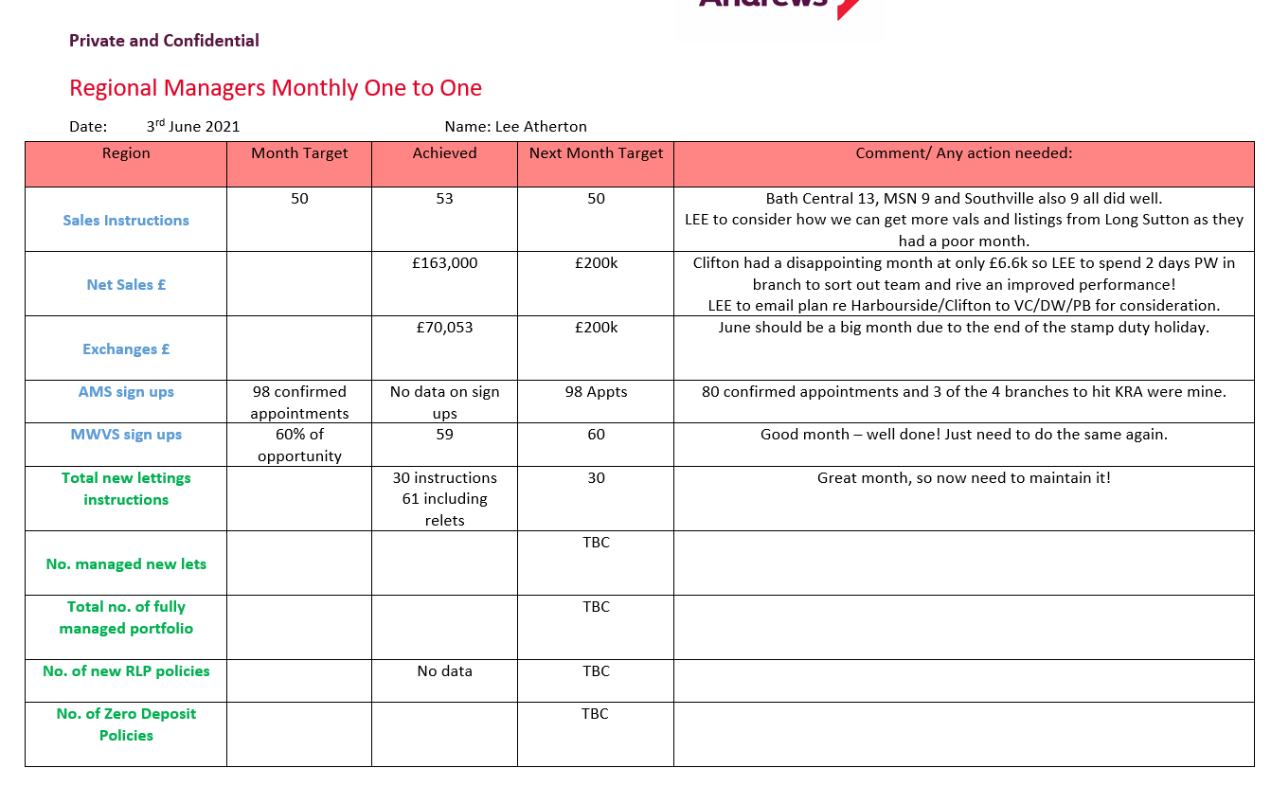

3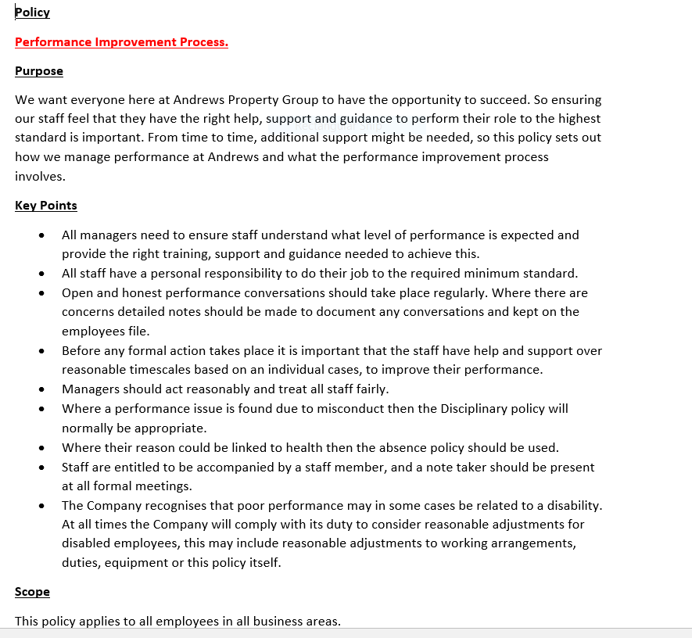
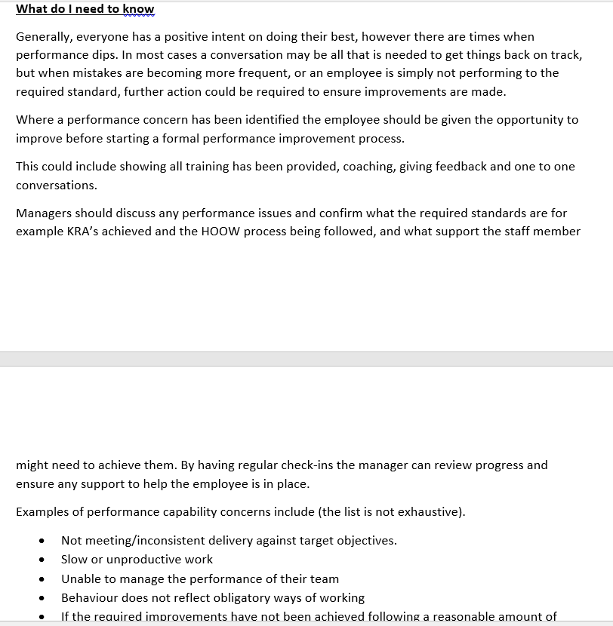

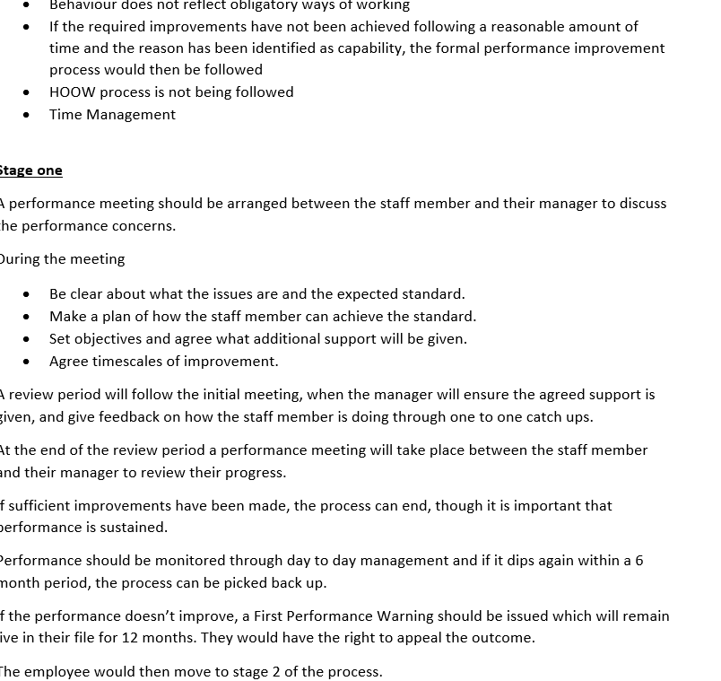
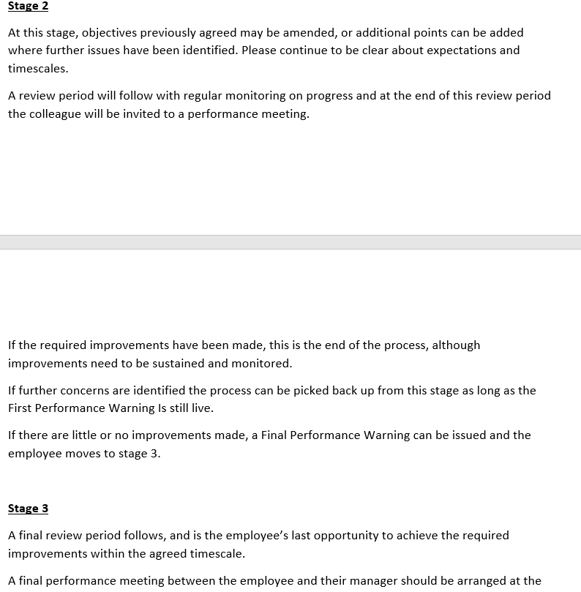
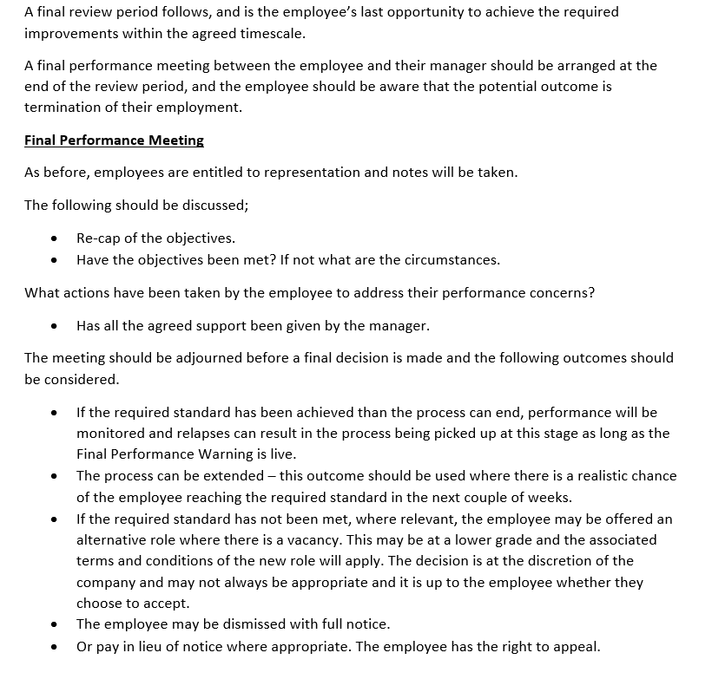
EV4

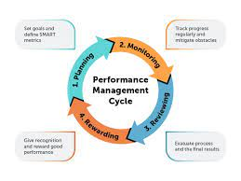

EV5
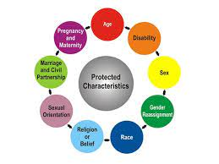
References

Protected Characteristics
https://www.equalityhumanrights.com/en/equality-act/protected-characteristics
Johannes Muller Aug 3 2020
https://www.workplace.com/magazine/performance-managemnt-principles
Toby Pochron Senior associate in the freeths LLP employment law department 22 March 2021
https://myhrtoolkit.com/blog/performance-management

LO2
2.1, 2.2, 2.3
The types of support the line mangers require is very much a coaching style. Andrews has some new to role line managers also some with more experience than others. The performance management process is a communication-based, collaborative process where HR and line managers work closely to plan, monitor, and review objectives, job trajectory, long term goals and contributions to the business (Valamis Group).
This process is continual with sessions between the people team and the line managers with opportunities for regular feedback.
According to the gallop state of the American workplace study, only 22% of employees are engaged and thriving. Employees that are engaged and thriving are more likely to maintain strong work performance even during difficult times.
Some of the feedback received is that people are promoted even if they may not be the right fit, lack of actionable feedback and they are not involved in goal setting. By Hr being involved in the process with line mangers, it’s about setting them up with success in achieving their goals and the companies’ objectives.
The first step of the support process is the planning stage. HR supports setting SMART goals, identifying key objectives and how these will be assessed.
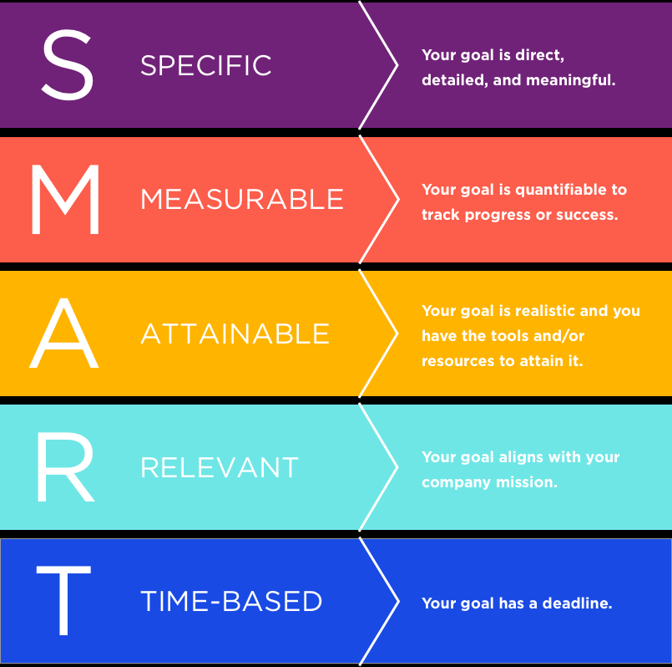

(Doran G, Miller A, Cunningham J Clearview).
The line manager will always be given the opportunity to feedback, they will have the best insight into what skills and goals are required. By making the planning stage collaborative the line manger feels involved.
Coaching is the next stage of the support; coaching is important and must be completed as regular as possible. These are focused on solutions and coaching opportunities. The HR team give honest feedback. The performance review should be revisited to see if any adjustments need to be made. This will involve reviewing the whole process as well as the individual. How well it worked as well as discussing.
(EV5).
The final stage that the HR support is the employee review which happens yearly. This allows us to review how the employee performed. (EV6) However regular one to one’s should take place with HR support on problem solving, goals and future tasks.
A key part of the HR involvement is giving and also receiving feedback. Actionable feedback is given so the line manager is aware of what they need to improve on, whilst also allowing the line manager to give feedback on all the processes and how we can improve.
Reward and recognition are also key this does not have to be monetary it could also be leadership opportunities or new projects.
I work closely with the regional managers to support with and prepare them for many leadership tasks including performance management. I do this with the support of my team, we do this by holding leadership days or working with an individual. This is done in line with the businesses coaching ethos, giving continual live feedback and how to give an employee a fair unbiased view of their performance. We work together to give a consistent approach (small business).
I am currently introducing a new recruitment process to Andrews Property Group (EV7). This will support with an unbiased view to ensure a fair and consistent approach. I held a meeting with an outside consultant Nick Coburn to deliver this method. We are piloting this within three areas of the business and I believe this will deliver high performance within Andrews. On long with learning and development team we will deliver this to the whole business by holding coaching sessions, with actors to support with role playing the interview process (EV8).

3, 3.1, 3.2, 3.3
When I started with Andrews in January, I evaluated the business performance management. I felt it was very inconsistent. The business would definitely complete a probation review (EV9) however this was predominantly to terminate employment due to failed probation. This is why I have looked at the recruitment process to ensure that we employ and retain the right people.
I and my team are working with the director and the regional team to deliver regular one to one meeting with their direct reports (EV5). This will ensure they are aware and have an input in their objectives and how to achieve them. By ensuring they are aware of the targets and what is expected they will have clear direction of where to go and how to achieve currently I don’t believe that we utilise high performance working processes enough and if we were more consistent, we can improve. This will improve our staff retention the staff will fell more valued.
EV6
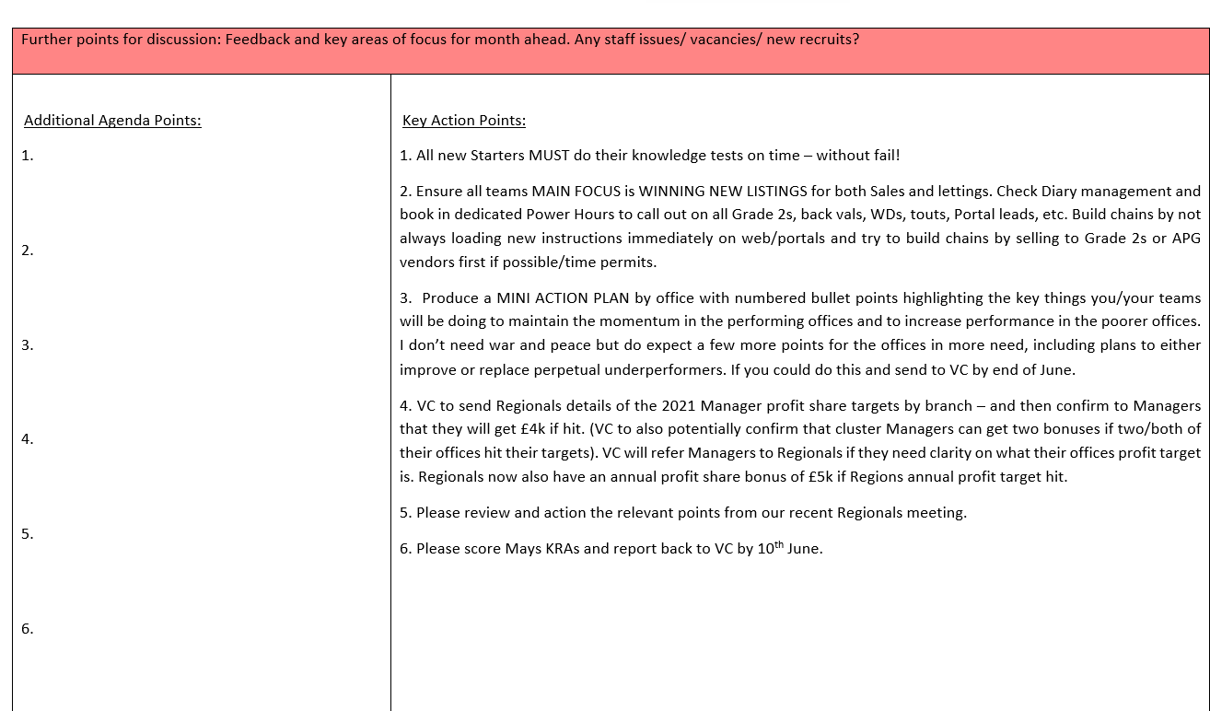

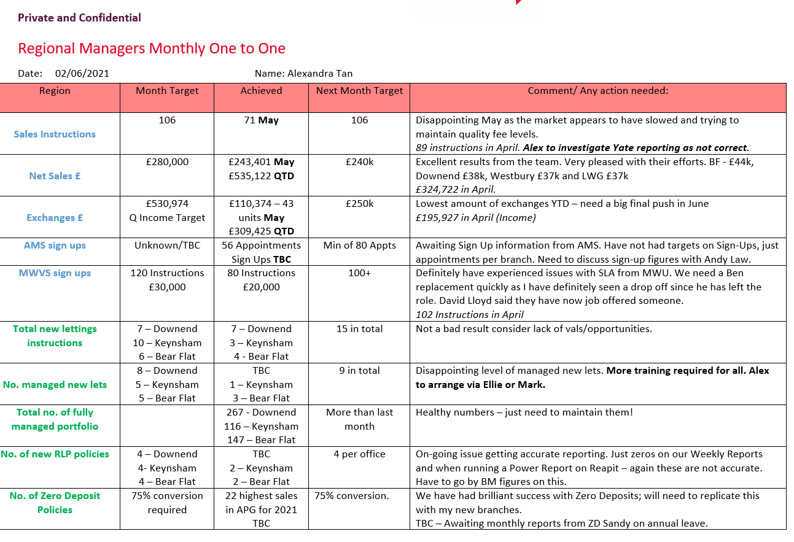

EV7
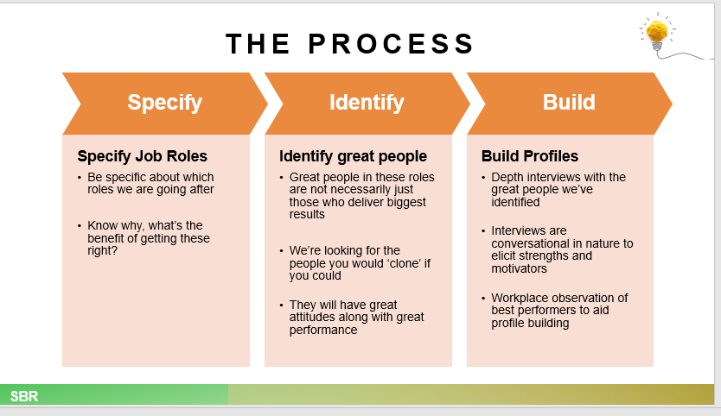

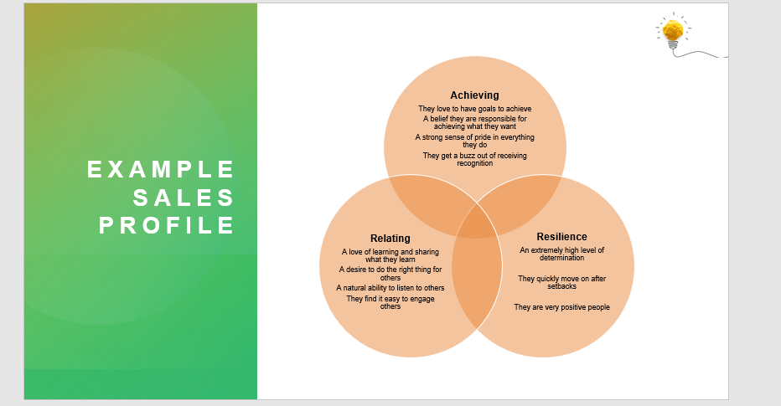

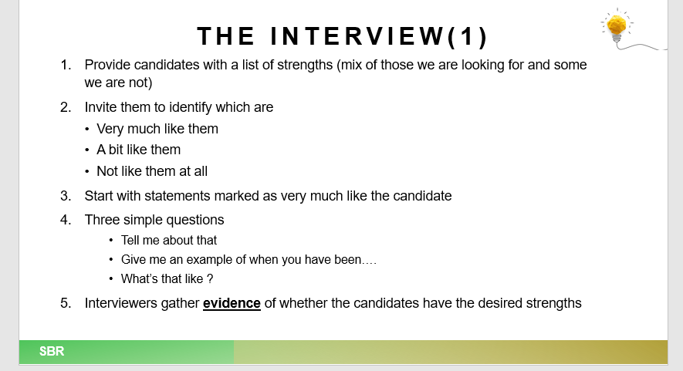

EV8
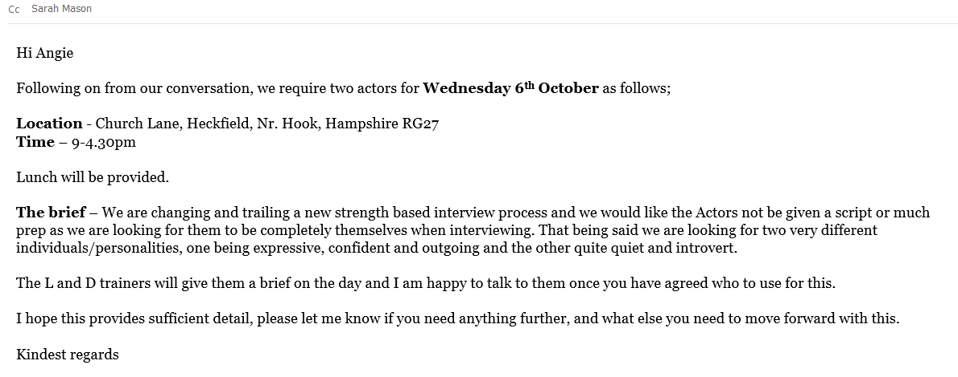

EV9
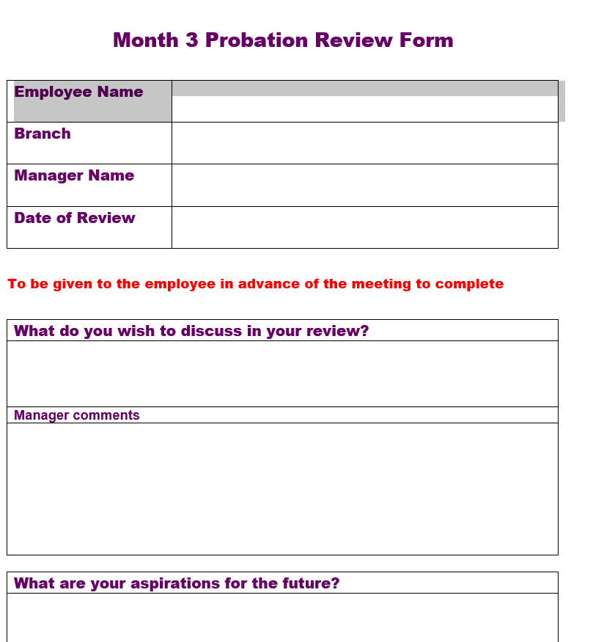

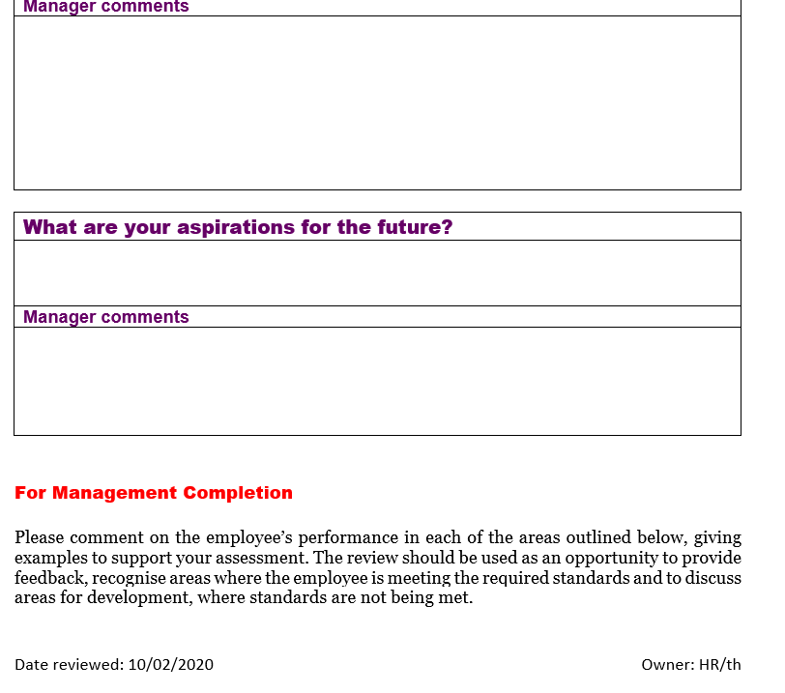

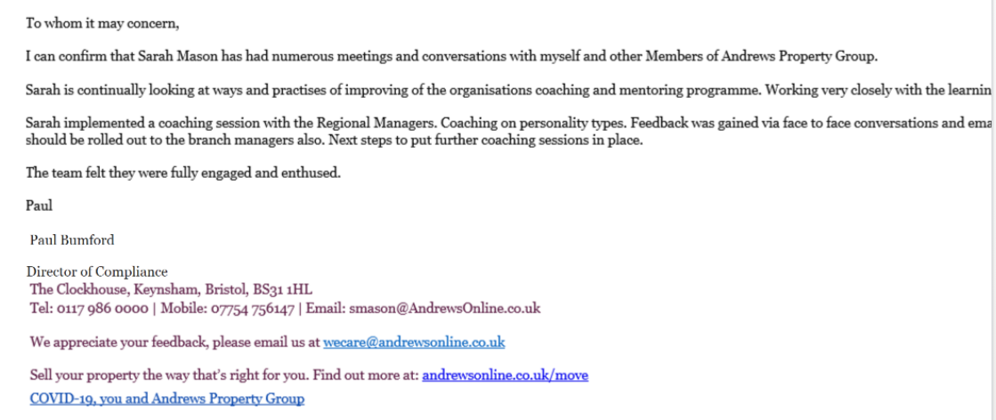
References
Https://www.valamis.com/hub/performancemanagmentprocess
George Doran, Arthur Miller. James Cunningham
https://www.clearview.com
Small Business
https://www.smallbusiness.chron.ccn/should-hr-line-managers-work-together

