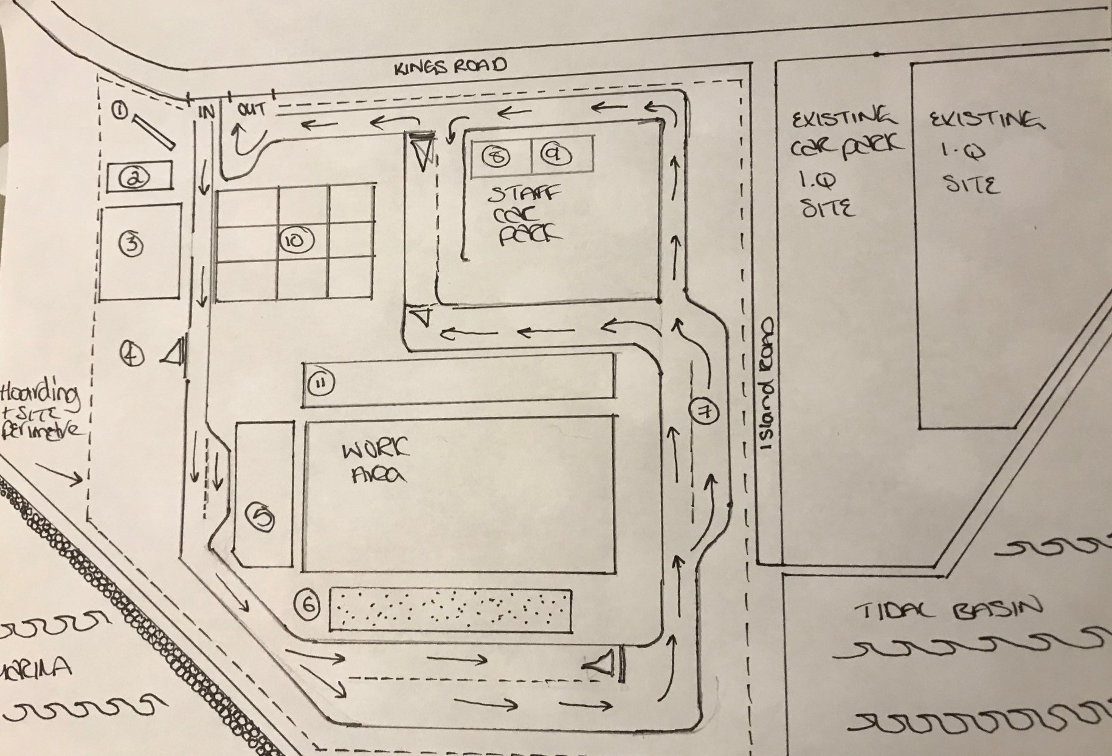


Key*

1 – Info Board
2 – Security
3 – Visitor car park
4 – Plant storage area
5 – Material compound
6 – Spoil heap/muck away
7 – Wheel wash
8 – Security
9 – Workshop
10 – Linked cabins to include:
Welfare
Drying room
Canteen
Toilets shower
Offices
Meeting room
First aid room
11 – Overflow material compound

*Not to scale.

