Ways of Thinking

Name: Freya Henderson-Wright
Student: 2205170
Tutor: Julia Lockheart

Task 1: 520
Task 2: 567
Task 3: 461

Contents
Table of Figures 2
Task 1: Manifesto 3
References for task 1 5
Task Two: Semiotic Analysis 7
References for task 2 9
Task 3: Observational Writing 10
References for Task 3 12

Table of Figures

Figure 1: Alexander McQueen Fall 1998, photo from Vogue 4
Figure 2: Maudeline, Lady Everglot from Corpse Bride (2005) 5
Figure 3: Build a Bear Rosie Poster 7
Figure 4: Rosie the Riveters Poster 8
Figure 5: Red roses, own photo (2022) 11

Task 1: Manifesto

- I like to use mixed media such as paper, fabrics and digital for creative results.
- Sustainability is important in my work. I use recycled fabric, fabric scraps, and paper cut-offs in my work.
- I would rather upcycle old pieces to create original ones than buy new. Bucket hats, tote bags and teddy bears can be made from old material.
- I let creativity come to me organically.
- The world around me is a constant source of inspiration. Details from florals and colours inform my work.
- I like to create for a purpose without limiting myself. I am free to create for the purpose of creating.
- I keep my sketches loose and free flowing, using lots of black, bold details. I don’t work with delicate details. This is an important aspect of my signature style as an artist.
- My work is genderless. The response from peers of all genders has been positive. This keeps my wearable pieces inclusive and not limited to a certain client base.

My first key statement is statement 2 as I am sustainable within my work. I use recycled fabric and fabric scraps in my fashion items and accessories. I do my sampling and experimenting on fabric scraps to avoid wasting good fabric when testing out techniques in case it goes wrong. This is important to me because of the impact of waste on the environment. Waste that goes to landfill produces toxins and greenhouse gasses which contribute to global warming (Prasad & Shih, 2016). In the UK, waste sent to landfill decreased from 12.9 million tonnes in 2010 to 6.1 million in 2022 (Frith 2022). This is because more people are aware of environmental issues and are recycling and re-using.

Statement number 5 is key to my work as inspiration comes from my environment. The world around me is a constant source of inspiration. I find things around me inspire me, whether it is the colours and patterns and see in nature or in the built environment, or current topics I can use as a theme for my work. Alexander McQueen is a designer who resonates with me because he also takes inspiration from various sources. His 1998 Joan Collection (fig 1.) was inspired by a statue of Joan of Arc, which he used to walk past every day (Wilson, 2015). His collection used materials inspired from Joan of Arc, such as metal mesh and the layers in his collection represent ‘tragedy on top of tragedy’ (Vogue Runway, 1998).
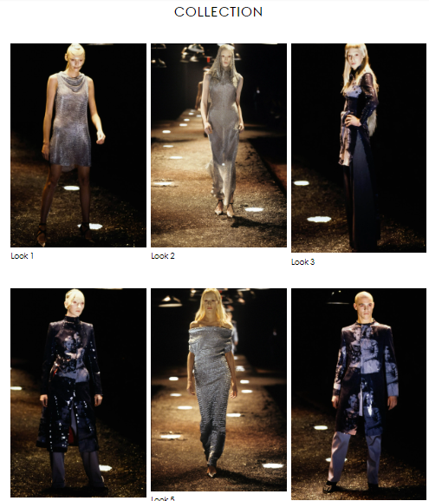
Figure 1: Alexander McQueen Fall 1998, photo from Vogue

The final key statement is 7. I feel it is important to be recognised for having a key signature style. A benefit of having a recongnisable style is that it can help hiring companies undertsand what they are getting and know what to expect. It is also important as it allows you to have an identity as an artist, put emtion behind the work and allow the individal personailty to shine through (Phillips, 2020). This can help the artist to feel acomplised within yourself and your work.
Having a signatue style means that “you are able to discern an iconic Monet painting from one by O’Keeffe or Kandinsky. This power of observation is possible because each of the artists has developed their instantly recognizable ‘signature style’” (Phillips, 2020). One artist that has achieved this is Tim Burton.
Tim Burton is an iconic film director and animator. His animation style is characterised by drastic proportions that emphasis their key physical feature. For instance, slim characters are twig-like whereas fat characters are disproportionately round like a bowling ball. Some characters are also depicted with huge noses or eyes. The character Maudeline, Lady Everglot from Corpse Bride (2005) has an exaggerated chin to emphasise her as a villain.

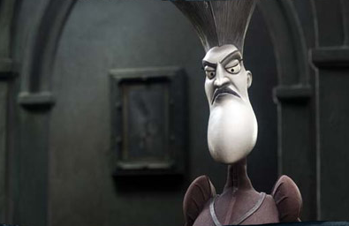
Figure 2: Maudeline, Lady Everglot from Corpse Bride (2005)
As well as animation, Tim Burton has directed films such as Alice In Wonderland, Beetlejuice and Edward Scissorhands (Nathan, 2019). His films are usually recognised by their gothic theme. Later Burton films often cast actors Johnny Depp and Helena Bonham Carter, which is another recognisable feature of his work.

References for task 1

Frith, L. (2022) How much waste goes to landfill in the UK - and why is it a problem? [online] Available at: https://thefirstmile.co.uk/the-big-picture/how-much-waste-goes-to-landfill-in-the-uk-and-why-is-it-a-problem [accessed 15.11.2022]
Jayawardhana,Y., Kumarathilaka, P. Herath, I & Vithanage. M. (2016) ‘Municipal Solid Waste Biochar for Prevention of Pollution from Landfill Leachate’ in Prasad, M.N.V. & Shih, K. (2016) Environmental Materials and Waste: Resource Recovery and Pollution Prevention pp.117 – 148 London: Elsevier Science
Nathan, I. (2019) Tim Burton: The Iconic Filmmaker and His Work, London: White Lion Publishing
Phillips, R. (2022) What Is an Artist’s “Signature Style” and Why Is It Important? [online] available at: https://renee-phillips.com/what-is-an-artists-signature-style-and-why-is-it-important/ [accessed 15.11.2022]
Prasad, M.N.V. & Shih, K. (2016) Environmental Materials and Waste: Resource Recovery and Pollution Prevention Amsterdam: Elsevier Science
Vogue Runway (2015) Alexander McQueen Fall 1998 Ready-to-wear [online] available at: https://www.vogue.com/fashion-shows/fall-1998-ready-to-wear/alexander-mcqueen [accessed 15.11.2022]
Wilson, A. (2015) Blood Beneath the Skin, New York: Scribner

Task Two: Semiotic Analysis

Semiotics refers to the meanings behind the things that we see. Semiotic analysis is about decoding those meanings (Paolucci, 2021). Some of the ways of decoding images is to look at the colours, or the positioning of key images on the page. Another way is to look at the text and decided if it has a literal meaning or if the words have a different meaning. The type of text used can also hint at the type of audience the piece is targeting, as playful fonts might be more suitable for children than a serious business (Berger, 2008).
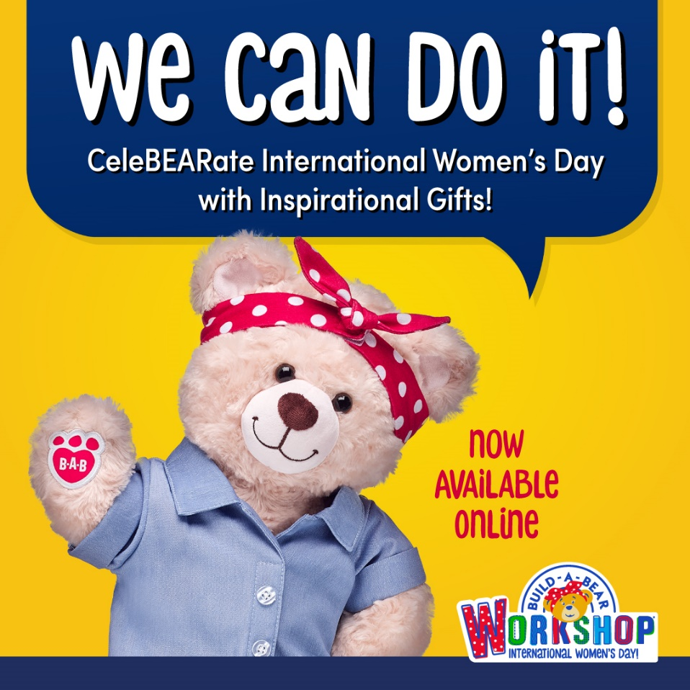
Figure 3: Build a Bear Rosie Poster
The poster for ‘Build a Bear’ (B.A.B.) can be interpreted using semiotic analysis. The most noticeable element of the poster is the teddy bear. The pose of the bear, the clothing, the colour of the poster and the text in the speech bubble are all designed to pay homage to be an icon to represent the World War Two poster (fig.4) encouraging women to enter the workforce when the men were away at war (National Archives, 2019). The ‘icon’ in semiotic analysis means the thing that resembles what it depicts (Boulton, 2005). The poster is an icon because it is reminiscent of the war poster without being an exact copy, whereas the individual elements such as the headband act as a symbol of the war poster, as this is a culturally learned connection (Yuki & Brewer, 2014). The link between the B.A.B. poster and the war poster would not be apparent if the war poster was unknown.
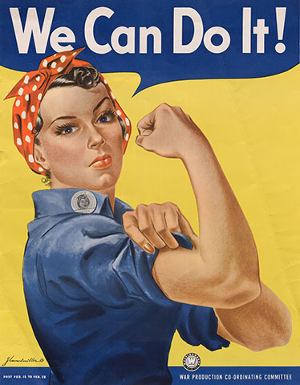
Figure 4: Rosie the Riveters Poster

The text has been chosen to imitate the original poster, but it has been altered to be more suited to its purpose. This is an index as it is the evidence of what is being represented (Boulton, 2005). They have kept the colours and the speech bubble, but changed the font to a more playful, bubbly font to show that it is an event for children. The words chosen link to the war poster because it is to celebrate international women’s day. The phrase ‘We Can Do It!’ can be seen as homage to the war poster, as the poster does not refer to anything to ‘do’, as it is selling a bear online. The smaller text provides the details whereas the most eye-catching text does not provide an information. The word CeleBearate has been used to incorporate the word ‘bear’ into celebrate to make it cuter.

The positioning of the aspects within the poster can also be seen as index. The body language of the bear is gentle, and it is also positioned to the left to allow the use of negative space to place the logo and extra information. The pose of the bear is not as powerful as the original pose, with a wave instead of a flexed arm, and the bear is front on instead of on the side to show more of the product being advertised. This is likely an intentional decision as the designers did not want to be as serious because it is aimed at children, so the body language needs to be more inviting and friendly. Additionally, the aim of the poster is to encourage people to visit ‘Build a Bear’, which is gentler than the message of the original poster so there is less need for a strong, powerful pose.

References for task 2
Berger, J. (2008) Ways of Seeing London: Penguin Books
Boulton, M. (2005) Icons, Symbols and a Semiotic Web [online] Available at: https://markboulton.co.uk/journal/icons-symbols-and-a-semiotic-web/ [accessed 10.12.2022]
National Archives (2019) Powers of Persuasion [online] Available at: https://www.archives.gov/exhibits/powers-of-persuasion [accessed 29.11.2022]
Paolucci, C. (2021) Cognitive Semiotics: Integrating Signs, Minds, Meaning and Cognition Bologna: Springer International Publishing
Yuki, M. & Brewer, M. (2014) Culture and Group Processes, Oxford: Oxford University Press

Task 3: Observational Writing

The Oxford Dictionary (2022) defines a rose as “a prickly bush or shrub that typically bears red, pink, yellow, or white fragrant flowers, native to north temperate regions and widely grown as an ornamental”. The red rose symbolises passion, love and romance. This symbolism goes back to the Roman poets (Daphne & Cloe, 2015). According to the Oxford Dictionary (2022) the definition of danger is “the possibility of suffering harm or injury”. Within the western world, the symbol of danger is red. This is because red is a highly visible colour on the colour spectrum and can grab people’s attention (Elliot et al., 2015).
The most recognisable correlation between the rose and danger is the colour red. Although both are linked to the colour red, they are on different ends of the spectrum with the red rose being a positive symbol of love, and red as a warning of danger denoting something negative. Another connection is thorns. Rose thorns are a danger to people and animals around them as they can hurt if touched, but the purpose of rose thorns is to prevent danger to the rose (Iseli, 2021).
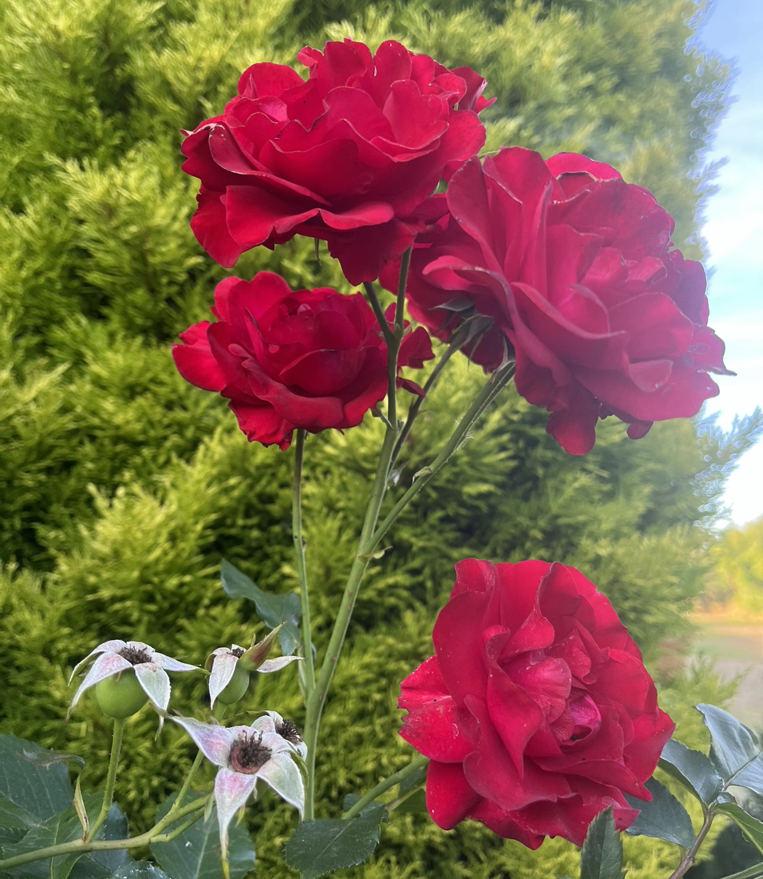
Figure 5: Red roses, own photo (2022)
The War of the Roses was fought between the House of Lancaster and the House of York over a period of 32 years in the 15th Century (Weir, 2011). The red rose was a symbol of the House of Lancaster who eventually won the war. The war was a series of bloody civil wars resulting in a lot of violence and death, which contrasts with the positive symbol of the rose, representing a dangerous war instead. The Tudor rose combined the white and red rose to signify unity and peace after the war (Weir, 2011). This then led to the rose being an emblem of England. As such, the rose is seen in England rugby shirts. This further connects the rose with danger as rugby is a dangerous sport as it can cause injuries. The average injury incidence in England Rugby is approximately 59 injuries er club each season (England Rugby, 2020).
I chose the red rose as my object because I was drawing a lot of florals for my artwork, and I wanted to find more information about the rose and its history and symbolism. I then thought about a word that would contradict the idea of a rose. I chose danger because I felt that the rose being a signifier of love represents being safe with the one you love, so I went with the opposite of safe. Although these are very different, there were a lot of connections with the rose and danger, manly the colour red. The War of the Roses and the sport rugby also linked danger with the rose.

References for Task 3

Daphne & Cloe (2015) Language and Meaning of Flowers, Rifreddo: REI
Elliot, A.J., Franklin, A., Fairchild, M.D. (2015) Handbook of Color Psychology, Cambridge: Cambridge University Press
England Rugby (2020) England Professional Rugby Injury Surveillance Project: Season Report 2019-20, The England Professional Rugby Injury Surveillance Project Steering Group
Oxford Dictionary (2022) Rose [online] available at: https://languages.oup.com/google-dictionary-en/ [accessed 6th December 2022]
Weir, A. (2011) Lancaster and York: The Wars of the Roses, London: Vintage Books

