Name: Lauren Kelly
Student number: 2114789

Donna Williams

Research in Practice (ADAD5004/C)

Word count: 2342

In this essay three keywords will be explored in depth to find an overall question within one of the chosen subjects. The three keywords are Fitness, semiotics, and manifestation. I have chosen these words as they all connect to my lifestyle and interest in learning more about the topic and how it connects to graphic design. Some of my thinkers and artist is Krissy Cela a well-known fitness influencer, Jose Luis Caivano a visual Semiotics researcher, Jon Jaylo a painter and Roxie Nafousi a self development coach in manifestation.

The word Fitness “the condition of being physically strong and healthy” (Cambridge Dictionary, 2019). It also has many different definitions to people depending on their goals or what they have taken in from social media and the environment around them. The word Fitness is very broad but keeping healthy and strong you can be done in multiple ways such as sports as running or swimming to lifting weights and walking outside. Within the word fitness I want to explore more in depth about what society deems acceptable inside the gym and how it has changed over the years.
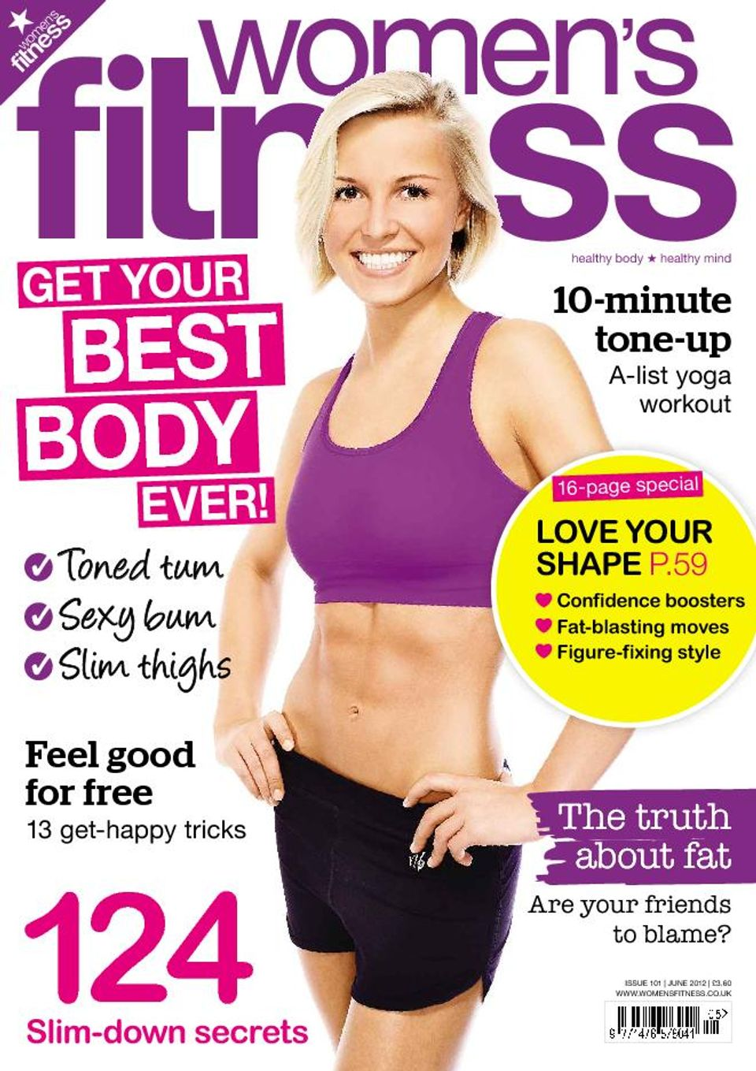
Figure 1 Womens Fitness, (2012)

Fitness has changed over many years from the 80’s with leg warmers and aerobics to now with modern gyms and online influencers. Media has had a massive impact to the fitness industry, while exploring this keyword I wanted to look at the visuals used to support and promote the industry these visuals are mainly from magazines and adverts. I came across the women’s fitness magazine see figure 1 this magazine cover portrays an ideal image of how women should look like, “Society has always emphasized the idea of the perfect woman. Our bodies are to be thin and curvy” (Dee, 2022) Also, the tone of words can be very impactful and hurtful to some women “figure- fixing style” and “get the best body ever” these words could be suggesting that their current body is not acceptable and they need to fix it to fit in, This could lead to unhealthy ways to lose weight such as dangerous surgeries such as liposuction “Cosmetic procedures are up 4% for women in their 30s, and 30% of all liposuction recipients are ages 19 to 34” (Goudreau, 2011). Furthermore, the image and words can be indicating that muscle on a woman is not expected by society, as the women shows no muscle and is very slim “Common myths about weight for women are that it's dangerous and will make them big and "bulky."” (Zarndt, 2021) For generations and still to this day we hear phrases like “don’t lift to heavy you’ll get bulky or “go careful girls aren’t meant to lift heavy weights”. That is because the media doesn’t portray Muscular women, Athlete Serena Williams is known for her tennis career but has also been criticised about her body image, in a interview Serena spoke about the impact she felt when growing up,

“When I was growing up, what was celebrated was different, Venus looked more like what is really acceptable: She has incredibly long legs, she’s really, really thin. I didn’t see people on TV that looked like me, who were thick. There wasn’t positive body image. It was a different age”. (Harmeyer, 2020)

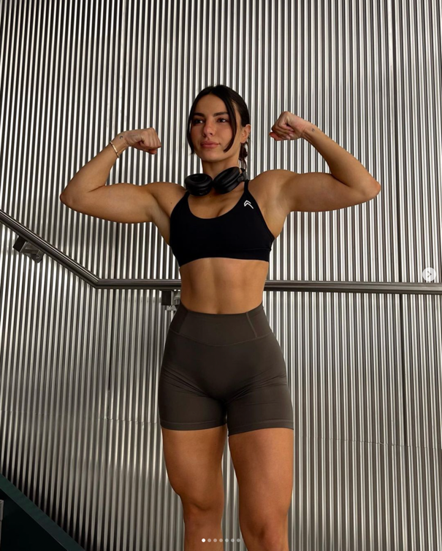

Figure 2, no title (Cela, 2023)

One of the main ways people can find tips and workouts is on social media. Krissy Cela seen in Figure 2 is one of the leading fitness influencer with over 3.2 million followers on Instagram and two profitable fitness businesses. Krissy Cela is a prime example of changing the stereotype on women in Fitness by being proud to be in the weight section, in Figure 2 Krissy is posing showing off her muscles which is a complete opposite image to which the media and advertising industry are prompting in the Women’s fitness magazine. On Krissy’s Instagram she is also showing the importance of balance between fitness and eating and not encouraging diets in an interview she stats “No one was telling me, 'Hey, it's okay to eat what you want to eat, and also to stick to your goals in a sustainable way'”. (Biggs, 2021)

Also sharing her real in-depth workouts involving lifting weights instead of workouts that get you toned up in 10 minutes like the Women’s fitness magazine promotes.

“A healthy body is the one that makes you happy, so I love that we’re seeing this huge transition in the fitness world where women are taking up space in the gym and keeping their heads held high” (Women’s Fitness, 2023)

As shown above there is a massive difference to what the media defines to be healthy in the fitness world compared to women who have spent many years training and also sharing their real life experiences.

Have you ever wondered why you see colours and objects the way you do? Everything you do in life you are using semiotics for example we associate arrows with directions “The relationship between the signifier and the signified is referred to as 'signification” (Chandler, 2019). Although semiotics is used in everyday life it is mainly associated with the art industry, Advertising and graphic designers use this discipline in their everyday work, “semiotics could be regarded as an essential discipline of the academic world”. (Hakim, 2013)

Colours, placement and type hierarchy can all be looked at within semiotics, for example when looking at an advert we can ask questions such as why a certain colour has been used or the reasoning behind certain text/ information being bigger than the rest. This also gives a good indication to who the target audience is and the main message the designer is trying to achieve. Everything in art and visuals has a deeper meaning.

Jon Jaylo artworks is a example of a deeper meaning, The art piece ‘Ascension’ below in figure 3 shows a cluster of clocks over a city or to the side but if we have a deeper look into the oil painting, the clocks are in the air maybe floating away from the city as we can see the city in the background. Additionally, clocks are associated with telling the time but also It could symbolize that time is getting away from us or we don’t have much time left.

Clocks are also thought to represent the passage of time, which moves forward relentlessly, and once gone can never be recovered. They can be viewed as a sign that each minute is precious, and that it’s important to live every minute of one’s life to the fullest. (Rhys, 2021)

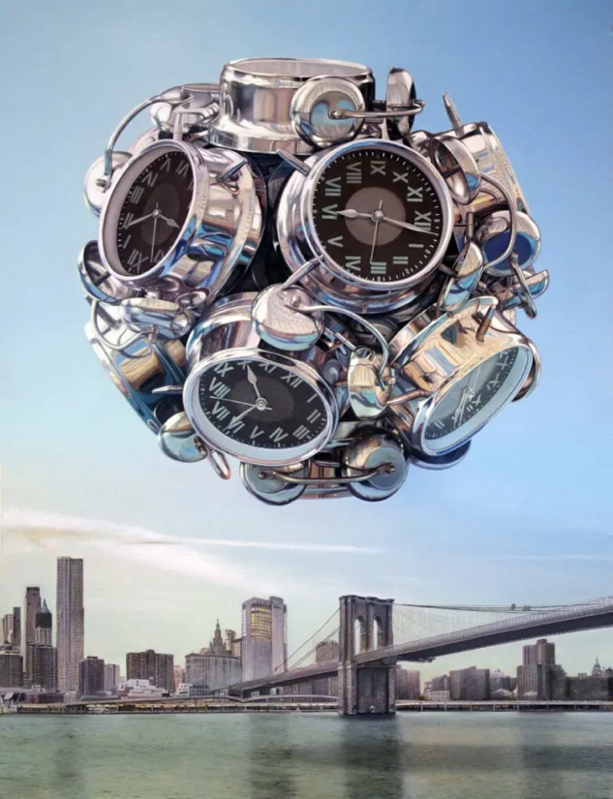

Figure 3, Ascension (Jaylo, 2016)

Jose Luis Caivano is a professor and director of the research program of colour and visual semiotics, (Caivano, 1998) stated “colour is considered as a sign that may substitute other things”. Graphic designers and artist use colours within symbols and signs to get across information without using text. Looking at the colour wheel reference in figure 4 it stats red is associated with danger while on the opposite side green represents safety. These are used in everyday situations such as traffic and road signs. Some road signs like a stop sign are outlined or fully red to warn road users if there is danger ahead. Also traffic lights use red and green to signify go and stop.

“Meanings are often assigned to colors independently of the object in which the color is seen. For instance, the associations green = safety, go, yellow = a warning, be careful, red = danger, stop”. (Caivano, 1998)

The use of colours in this way are very efficient to get the message across quicker as the human brain recognizes colours, symbols and shapes before text. “The child looks and recognizes before he can speak” (Berger, 1972)
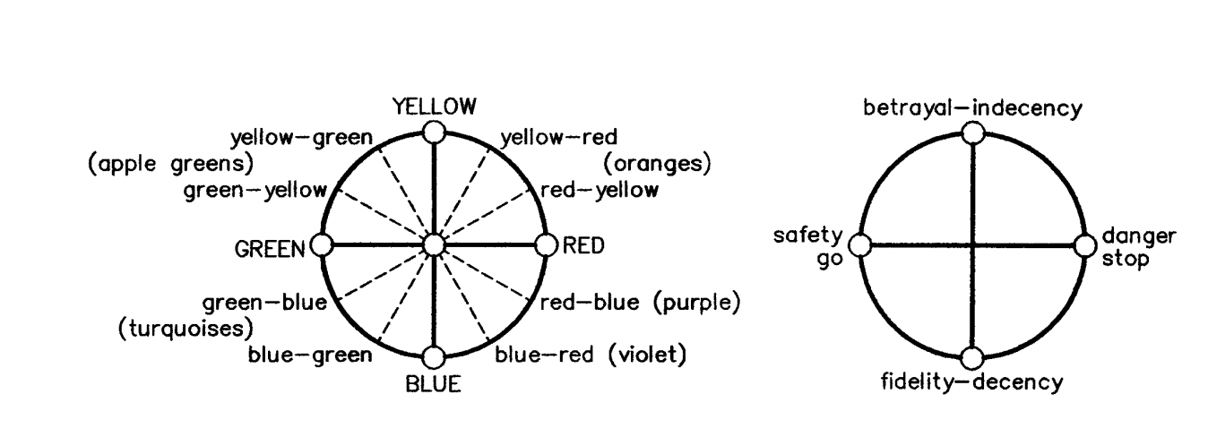
Figure 4, no title (Caivano, 1998)

As previously established red means danger and stop but it also has a different meaning, “red also symbolizes passion, love, and desire”. (Cherry, 2020) Within semiotics you must look at the bigger picture and other symbols around first to establish an overall meaning.

The topic of manifestation is widely spoken about as many speculate whether manifestation works or not. The four steps to manifestation is “ Be specific, visualize, talk your goals into existence and believe in your goals”. (Jane Modaragamage, 2023) For manifestation to work you need to be specific in the goals you want to achieve by writing and talking about your goals in loads of depth and as if you have achieved them already. Roxie Nafousi is a known a Self-Development Coach and a Manifesting Expert while having written two books about manifestation, Roxie Nafousi stats “Manifesting is a meeting of science and wisdom; it is a philosophy to live by and a self-development practice to help you live your best life” (Nafousi, 2022).

Manifestation is also associated with law of attraction “The law of attraction argues that positive thoughts and actions reap positive rewards and vice versa for negative one”. (Eatough, 2023). Putting positive energy and thoughts out in the world is important to creating and achieving goals, this practice can be used in every aspect of life.

While exploring this keyword it reminded me of the zander letter, we wrote to ourselves as part of a module in second year. This was a use of manifestation, writing out our goals and how we have achieved them, our feelings when we graduated with a first and reflecting on our work we have created. While doing this we used all four steps of manifestation.

"The world we live in is not always beautiful. But we may all possess the dream of being beautiful, still and peaceful. My works reflect what I want to see and feel." (Singulart, no date ) Eury Yeahgean Kim is a painter in Korea and has done a collection called manifestation, one piece is called Manifestation – Camellia wish as seen in figure 5.
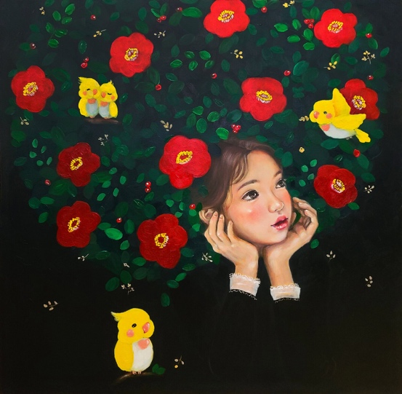

Figure 5, Manifestation – Camellia wish (Kim E, 2022)

Eury Yeahgean Kim uses her paintings to express her ideas and dreams about how she feels the world should look and feel. In the painting the girl’s hair is full of flowers and leaf’s, “flowers often symbolize various virtues, such as love, faith, and hope” (Thursd, 2023). The placement of the flowers is acting as her hair, suggesting that she is full of positive energy and thoughts. Also looking at the hair we can see little birds, birds can fly which could symbolise being free and a feeling of being on top of the world,

“Birds are often seen as a symbol of freedom, hope, and new beginnings. They may also symbolize joy, peace, and prosperity. They can also symbolize traits such as courage, strength, and intelligence.” (Mbuthia, 2023)

Eury Yeahgean Kim has many other paintings in the manifestation collection using flowers as the main message with fruit and flowers to symbolism youth and positive thoughts.

Looking at manifestation in the graphic design industry, Manifestos are “set of “artistic intentions,” they are a valuable insight into the mind of the artist,”(Baker, 2015) Artist and designers use Manifestos to outline their goals and their beliefs which can be seen in their artwork which is a type of manifestation. In the manifestos the language used is first person such as I and we, this is speaking the goals into the universe which is part of the four steps of manifestation.

“1. We intend to sing the love of danger, the habit of energy and fearlessness.

2. Courage, boldness, and rebellion will be the essential elements in our poetry.

3. Up to now, literature has extolled a comtemplative stillness, rapture and reverie. We intend to glorify aggressive action, a restive wakefulness, life at the double, the slap and the punching fist.” (Baker, 2015)

The above has been taken from a famous manifesto called the founding and manifesto of futurism by Filippo Tommaso Marinetti in 1909. Here we can see the use of first person being used speaking about himself and what he wants to achieve through his writing and art.

We use manifestation more often than we might realise in everyday life, anything we think or say whether its positive or negative is using one of the steps by talking about what we hope to achieve such as getting a job or hoping someone will pass an exam.

Overall, in each keyword I have explored they have all had a connection with each other. Fitness and semiotics can connect through looking at the visuals used in the industry such as adverts, magazines and how they impact the public. Manifestation and fitness connect through goals, when working out you will always have a goal in mind whether they want to lose a certain amount of weight or build up to lifting 10kg. This does not use all four steps of manifestation, but most people will keep track of the progress they have made or will talk to other people about what they want to achieve. Manifestations and semiotics connect through the use of the subconscious we are unaware that we use these methods in our everyday life.

For my final question I would like to look at or around how the different types of media portrays women in the fitness industry and the positive or negative impact it has on women. Mainly looking at magazines and adverts for mainstream media whose main objective is to make sales while comparing the contrasting side to that such as social media like Instagram and YouTube where women post workouts and gym vlogs purely to educate other woman and create a community who feels comfortable to ask gym questions and advice.

My ideas for the practice based project could be a campaign to promote the opposite side of the stereotypes of woman in gyms and to stop using words and methods to quickly create the ideal body image deemed acceptable by society. My second idea is creating a new magazine showing more real life woman of all body types in the fitness industry through pictures and stories to create a new normal within the industry.

Bibliography

Baker, H. (2015). 10 game-changing art manifestos | Blog | Royal Academy of Arts. [online] www.royalacademy.org.uk. Available at: http://royalacademy.org.uk/article/ten-game-changing-manifestos [Accessed 25 Apr. 2023].
Berger, J. (1972). Ways of seeing. Edmonton, Alta.: The Schools.
Biggs, J. (2021). Fitness influencer Krissy Cela on why we have to stop comparing our bodies to others online. [online] Cosmopolitan. Available at: https://www.cosmopolitan.com/uk/body/fitness-workouts/a37528470/krissy-cela-interview/.
Caivano, J. (1998). (PDF) Color and semiotics: A two-way street. ResearchGate, [online] 23(6). Available at: https://www.researchgate.net/publication/299014196_Color_and_semiotics_A_two-way_street.
Cambridge Dictionary (2019). FITNESS | meaning in the Cambridge English Dictionary. [online] Cambridge.org. Available at: https://dictionary.cambridge.org/dictionary/english/fitness.
Chandler, D. (2019). Semiotics for Beginners: Signs. [online] Princeton.edu. Available at: https://www.cs.princeton.edu/~chazelle/courses/BIB/semio2.htm.
Cherry, K. (2020). How Does the Color Red Impact Your Mood and Behavior? [online] Verywell Mind. Available at: https://www.verywellmind.com/the-color-psychology-of-red-2795821.
Dee, V. (2022). An Ideal Woman? Society’s Not-So-Perfect Definition. [online] Medium. Available at: https://aninjusticemag.com/an-ideal-woman-societys-not-so-perfect-definition-8c66942e156c.
Eatough, E. (2023). What Is the Law of Attraction, and Can You Use It to Change Your Life? [online] www.betterup.com. Available at: https://www.betterup.com/blog/what-is-law-of-attraction#:~:text=quality%20of%20life.- [Accessed 24 Apr. 2023].
Goudreau, J. (2011). The Hidden Dangers Of Cosmetic Surgery. [online] Forbes. Available at: https://www.forbes.com/sites/jennagoudreau/2011/06/16/hidden-dangers-of-cosmetic-surgery/?sh=f690617b2bca [Accessed 23 Apr. 2023].
Hakim, A. (2013). Semiotics as a Global Discipline. Chinese Semiotic Studies, [online] 9(1), pp.88–95. doi:https://doi.org/10.1515/css-2013-0108.
Harmeyer, C. (2020). Serena Williams Wishes She Was ‘Thankful’ for Her Muscular Body Sooner. [online] Hello Giggles. Available at: https://hellogiggles.com/serena-williams-body-image-interview/ [Accessed 12 Apr. 2023].
Jane Modaragamage, A. (2023). The Science of Manifestation. [online] Healthnews . Available at: https://healthnews.com/mental-health/self-care-and-therapy/the-science-of-manifestation/#:~:text=Manifestation%20works%20by%20using%20the,help%20you%20achieve%20them%20faster. [Accessed 21 Apr. 2023].
Mbuthia, M. (2023). Bird symbolism: 10 common birds and their spiritual meaning. [online] Legit.ng - Nigeria news. Available at: https://www.legit.ng/ask-legit/top/1321837-bird-symbolism-10-common-birds-meant-represent/#:~:text=What%20does%20a%20bird%20symbolize [Accessed 25 Apr. 2023].
Nafousi, R. (2022). Manifest. Penguin UK.
Rhys, D. (2021). Clock Symbolism – What Does it Mean? [online] Symbol Sage. Available at: https://symbolsage.com/clock-symbolism-and-meaning/.
Rosdahl, J. (2014). Why do we find muscular women wildly perplexing? [online] The Conversation. Available at: https://theconversation.com/why-do-we-find-muscular-women-wildly-perplexing-21846.
Singulart (n.d.). Eury (Yeahgean) Kim: contemporary South Korean Painter - SINGULART. [online] www.singulart.com. Available at: https://www.singulart.com/en/artist/eury-yeahgean-kim-8399 [Accessed 24 Apr. 2023].
Thursd (2023). 10 Significant Flowers in the Bible and Their Meanings. [online] Thursd. Available at: https://thursd.com/articles/flowers-in-the-bible-10-significant-varieties-and-their-meanings#:~:text=This%20appreciation%20for%20flowers%20extended [Accessed 25 Apr. 2023].
Womens Fitness (2023). Krissy Cela shares her health, fitness & wellbeing tips. [online] Women’s Fitness. Available at: https://womensfitness.co.uk/fitness/krissy-cela-interview/ [Accessed 12 Apr. 2023].
Zarndt, G.L., Jessica (2021). 5 weight lifting myths for women and the health benefits women who lift weights gain. [online] Insider. Available at: https://www.insider.com/guides/health/fitness/weight-lifting-myths-for-women.

Figures
Caivano, J. (1998). (PDF) Color and semiotics: A two-way street. ResearchGate, [online] 23(6). Available at: https://www.researchgate.net/publication/299014196_Color_and_semiotics_A_two-way_street.
Cela, K. (2023). Instagram post about workouts . https://www.instagram.com/p/CqlcI5MMHGL/?hl=en.

Jaylo, J. (2016). Ascension. https://beautifulbizarre.net/2021/11/25/jon-jaylo-interview/.

Kim, E. (2022). Manifestation: Camellia Wish. https://www.singulart.com/en/artworks/eury-yeahgean-kim-manifestation-camellia-wish-1703760.

Womens Fitness (2012). Front Page of Womens Fitness Magazine . https://www.magzter.com/GB/Kelsey-Media/Women’s-Fitness-UK/Women’s-Interest/4015?redirect=true.

