E-portfolio
Student: Iulia Costoiu
Student number :2021012
Module: Changemakers:Building your Personal Brand for Sustainable Employment
Module code:BMHP5015
Lecturer: Dr. Kennedy Obohwemu

Contents
Curriculum Vitae 3
Cover Letter 5
ADHD Pitch 8

Curriculum Vitae
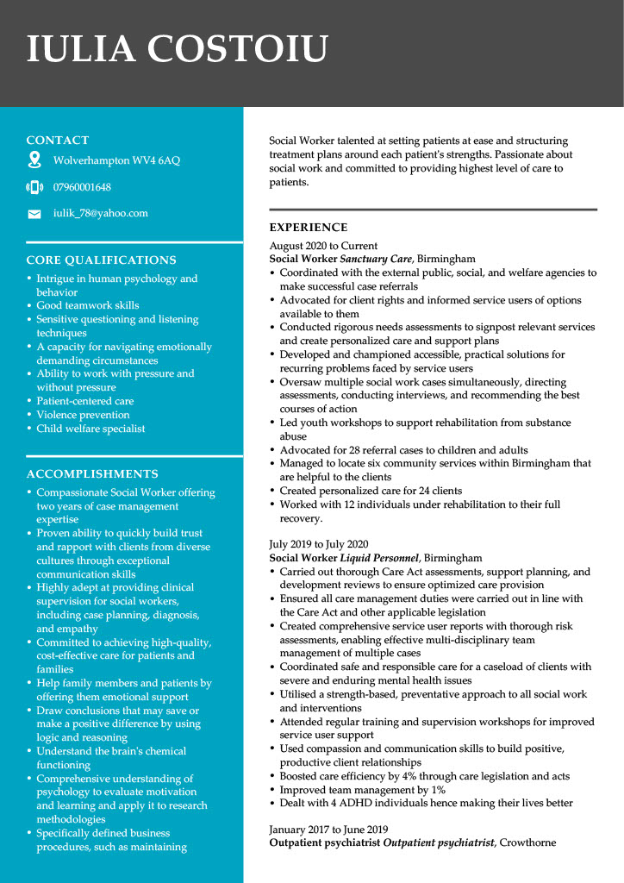
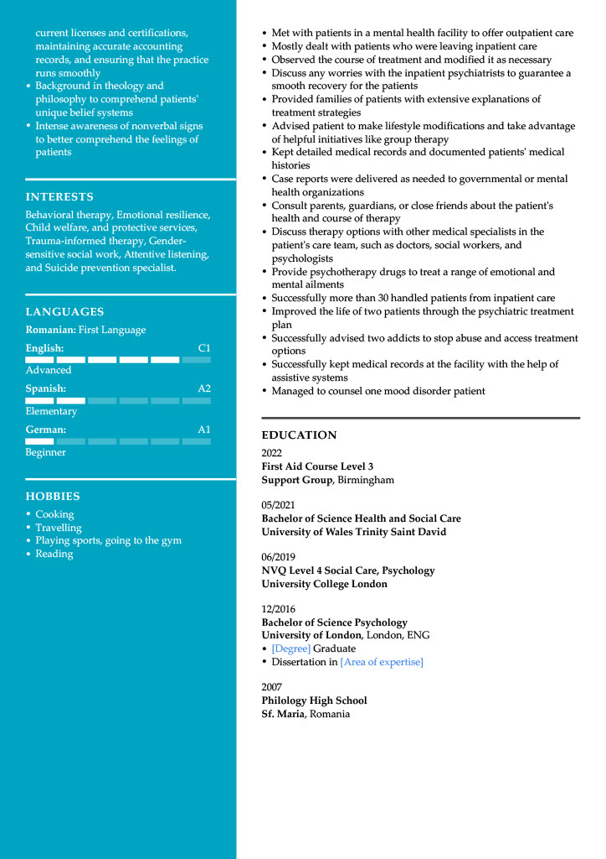

Cover Letter
Iulia Costoiu
Flat 8 Grafton House Olive Avenue, Wolverhampton
WV4 6AQ

October 24, 2022
The Managing Director,
Gill Heart & Vascular Institute,
Dear Sir,
I am writing this to apply for a consultant Psychiatrist job at your institution. I am an expert in general adult and development psychiatry with 10 years of working experience. I have been working at the Maudsley National Health foundation since 2013. I have extensive experience in development Psychiatry and general adult, having worked in many clinical settings with patients. My areas of specialization are the management and assessment of ADHD and ASD in young children and disorders associated with sleeping difficulties and health conditions affecting the mind. Through this role in the clinical sector, I can confirm my broad experience in your institution's development, design, and service delivery for ASD and ADHD.
I am a General Adult Psychiatry and Neuropsychiatry member at the University of Oxford. Also, I am a member of the country's medicine safety committee and participate in developing and implementing essential care, shared pathways care, and advanced services. I hold a Master's Degree from United Kingdome University college, and my educational role involves undergraduate and postgraduate teachings in medical fields and some master's Degree courses. I also serve as a supervisor in the University College London educational sector. Besides, I give out regular primary and secondary care training at the national and local levels. Some years ago, I joined the American Sleep Medicine Association. I am a daily speaker at the annual meetings of Sleep-in at national and international conferences covering the disorders in neurodevelopment, design, and sleep and the development of diagnostic services for children, ASD, and adults.
When I get a chance in your firm as an ADHD consultant, I will help with impulsivity and focus, thus reducing the struggle for time management and increasing the patient's self-esteem. I will also help both kids and adults with ADHD with proper management throughout their lives. My experience, having worked with many such firms, built confidence that I can manage the task ahead of me. I understand most adult clients in your institution are undergoing chronic disorganization, hurting their marriages. With my expertise and experience, I will help sort out that, and your institution's name will get higher in service delivery. Also, children affected by ADHD need our help with homework they get while in school; through my skills and experience, I will help them out, and they will manage ADHD appropriately.
My dream in your firm is to be an excellent coach to ADHD-affected clients. This will uprise the service delivery of your institution. I will help the clients with the skills of planning and managing the ADHD effects. Also, I will build healthy self-esteem and associations with affected clients and aid them in making explicit judgments. From experience, the vital purpose of ADHD management is finding the right and profitable way, depending on the age and nature of the client. The affected clients need education, and as a chief consultant, I will perform that appropriately. All these are my dreams, and I know I will perform to my capabilities. As a consultant, I know I am a coach, and as a coach, what I must and want to change is evident in my mind. I need an opportunity to exercise my capability. As an ADHD consultant with vast working experience, working with clients is my portion as their conditions are in my mind, hence a determination to succeed.
I will wait for your response so we can discuss in detail how to improve our service delivery as an institution and how I will help your clients feed with topmost and highly graded consultation services on ADHD health conditions.
Yours sincerely,
Iulia Costoiu

ADHD Pitch



