
BA Leadership and Management Skills for the Workplace
Level: 5
Name: Joynul Islam
Student Number: 1605529
Module Tittle: Knowledge and Information Management Skills for the Workplace
Module No: BMSK5006_LON

Table of Contents
Introduction 3
LO 1 4
Explain the relationship between data, information, and knowledge 4
b) Explain the relationship between individual knowledge and organisational knowledge 6
c) Apply analysis and modelling techniques to identify knowledge assets. 7
d) Evaluating actual and potential knowledge assets. 8
e) Provide a rationale for capturing and managing knowledge 9
LO 2 10
Important knowledge management processes in the context of organisational development 10
Explaining what is required to create, store, apply and integrate knowledge 11
Evaluating the impact of Intellectual Property rights 12
LO3 13
Provide a framework for establishing a knowledge management culture 13
Explaining the contribution knowledge assets have on an organisation 15
Evaluate the knowledge requirements for the organisation 16
Evaluate the organisation’s framework for enabling knowledge sharing 17
Recommend improvements to the current framework 18
Conclusion 19
References 20

Introduction
All of the organisations deal with lots of resources and one of the main considerations that the organisation should undertake is knowledge management. The knowledge asset as it is so vital for the organisation that all of the activities of the organization will be hampered if the knowledge base is not properly handled. For the purpose of completing the report, the Sollatek company has been selected which is a manufacturing company under small and medium-sized business category based in the United Kingdom. This report will evaluate how the management of Sollatek deals with its knowledge assets and capture the best knowledge base for the betterment of the organization. As the company always tries to innovate new products for increasing its sales, it needs to take the proper care of its knowledge base so that they could contribute to the development of new products. The company employs diversify employees from all over the world to create the most innovative and attractive product for the customers. For this reason, the company needs to take proper care of intellectual property rights. The organisation follows a dedicated process for managing the knowledge base and create a knowledge base in such a way that it will ensure organisational commitment. The report also demonstrates the importance of intellectual property rights by considering the Sollatek business in the UK as an example. It also explains how the management of Sollatek uses different modelling techniques to capture the knowledge base.

LO 1

Explain the relationship between data, information, and knowledge
The DIKW model shows that there is a hierarchical relationship between data, information, knowledge, and wisdom (Collinson and Parcell, 2004). Sollatek business also has to deal with lots of data and information needed for undertaking the right decision by applying the knowledge and wisdom of the managers. The following diagram and explanation will provide a basic idea regarding how these important factors are interrelated with each other:
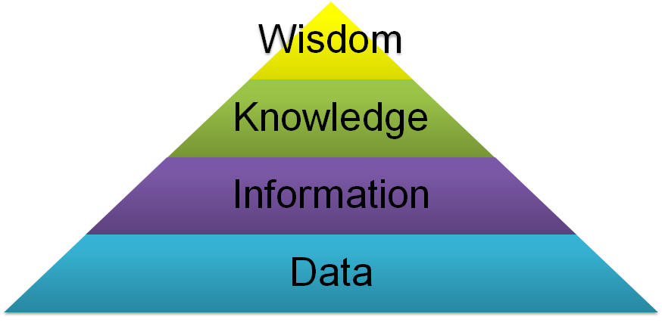
Figure: The DIKW Model (Bryson, 2017).

The interrelationship between data and information
Data refer to those facts which have no current value because that fact cannot be utilized without further processing. The data is transformed into information when it is properly processed for utilizing any new areas of business.
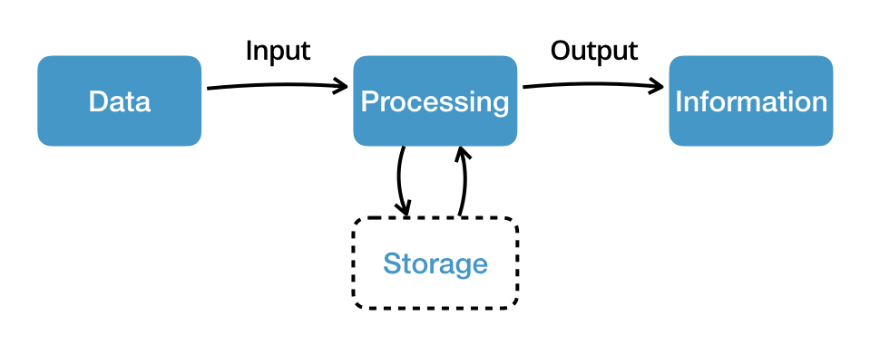
Figure: The process of data to information (Bryson, 2017)
Sollatek deals with lots of data and information regarding its products, customers, and stakeholders. It gathers lots of data from a variety of sources such as: from the customers, suppliers, and internet. Those data need to be processed to determine the most appropriate information to utilize that information for further business development (Kahwati et al., 2017).

Figure: Raw Data of Sollatek’s (Sollatek.com)

Explaining the relationship between information and knowledge

Although Sollatek collects lots of information from its various functions; it needs to apply the specific information which is called the knowledge. The information becomes knowledge when it can be applied in a specific subject and which provides value for the organisation. For example, Sollatek has lots of ideas regarding how to manufacture a certain tube but it should manufacture such kind of tube which is required by its existing customers. The knowledge about the customers and their preferences will make the company aware of which product is useful and required by the customer (Girard and Girard, 2015).

b) Explain the relationship between individual knowledge and organisational knowledge
The individual knowledge is considered as the basis point for starting or building the organisational knowledge the individual knowledge of Sollatek employees will be enriched if they get the best information from the organisation (Johnson and Smith, 2016). So here the organisation play a crucial role in providing the best information to the employees for increasing their knowledge base. The knowledge base of individuals is a combination of some factors that they get from the organisation and from the environment in which they are working. Sollatek creates a proper flow of information using sophisticated channels so that each and every employee get the right information at the right time and utilize that information for the development of the organisation.
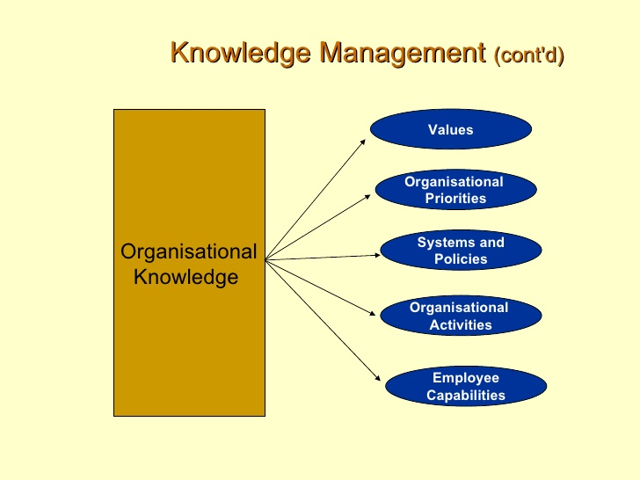
Figure: Factors of organizational knowledge (Kahwati et al., 2017)

The organisational knowledge could be built by influencing the individual knowledge of the organisation. There are several ways through which the organisation knowledge can be developed. For example, there should have extensive group learning environment and share of knowledge among the employees to develop a better understanding of the structure and culture of the organisation (Kennan, 2016). In other words, the organisation should focus on providing and implementing a proper structure for or developing the employee's skill of using the information in the organisation properly. The organisation could introduce the socialization process for developing the organisational knowledge of the employees. When there is established organisational knowledge it will increase the individual knowledge by providing the sufficient skills that are lacked by the employees. Although the employees could get the individual knowledge from a variety of sources the organisation should ensure that they get the most appropriate information which is essential for organisational success.

c) Apply analysis and modelling techniques to identify knowledge assets.
Knowledge assets are those sets of guidelines that are used by the management and the people in the organisation for creating value and resolving an existing problem in the organisation (Kahwati et al., 2017). For example, Sollatek uses several techniques and strategies for identifying the knowledge asset which is essential for having a competitive advantage over the other competitors. The knowledge assets could be accumulated from a variety of sources and the organisation must consider the strategies which are very effective for gathering the most appropriate knowledge asset. The following discussion will show how the knowledge assets can be identified in the organisation like Sollatek:
Focused groups: by using the focused group technique the organisation could identify the knowledge asset because in this process some people from the same background work together and share their beliefs and attitude to others for identifying the right solution for a current problem (Lawes, 2018). This is a useful technique for identifying the knowledge asset because all of the members in the focus Group are considering deeply for resolving a current problem and implement that new knowledge that they have gathered from the discussion.
Social knowledge asset: As Sollatek manufacture tubes, it requires a vast amount of tacit knowledge from the employees. Tacit knowledge of the employees can be improved by sharing knowledge with each other (Pugh, 2016). By sharing the tacit knowledge the individuals could understand how to resolve a current or specific problem by utilizing minimum resources.
Evaluating existing knowledge assets: Sollatek has some knowledge assets that it uses for bringing organisational success (Kennan, 2016). As the business environment is always changing, Sollatek should focus on identifying the problem with the current knowledge assets and possible ways through which the current knowledge asset can be improved.

d) Evaluating actual and potential knowledge assets.
Actual knowledge assets in Sollatek: Although Sollatek has existing knowledge assets there should have ways for improvement that will bring more value to the business. The existing knowledge assets come from the existing employees who are working in the business and manufacture valves and tubes regularly (Johnson and Smith, 2016). When the employees are recruited in the organization the management evaluated their existing knowledge to ensure whether that knowledge can be implemented in the organisation or not. Currently, the business has some existing technologies and strategies by implementing which the business ensure that it could manufacture the products perfectly.
Potential knowledge assets for Sollatek: As it has already been mentioned there are some ways through which Sollatek could employ new employees in its organisation and bring positive change to add value to the business. It could train up the existing employees so that they get some new knowledge and applied that knowledge in the manufacturing process and improve the overall condition of the business (Kennan, 2016). Sometimes the business needs to outsource some of its activities because it is not possible to focus on all of the activities of the business. So by doing outsourcing and merger and acquisition the business could gain some new knowledge and improve the overall condition of the business.

e) Provide a rationale for capturing and managing knowledge
It is necessary to capture new knowledge in the business because the existing knowledge becomes obsolete and the business needs to adapt with the turning situation otherwise it will be difficult for the business to continue its business operation and provide suitable values to the customers (Collinson and Parcell, 2004). For this reason, the business should search for newer ways for capturing knowledge in its business. After capturing the knowledge the business must ensure that the knowledge is available when necessary. The knowledge cannot be applied at a time and it will be required only when the business focus on any new strategies or function to continue its operation. While capturing the knowledge the Sollatek must ensure that they have gathered a sufficient amount of knowledge that could be applied efficiently in its operation. The management of knowledge must be flexible enough to ensure that it can be applied in every area of business. However, sometimes it may not be possible to do so. In this case, the management should identify the most appropriate area in which the knowledge can be applied properly. As there are lots of areas from which the knowledge can be captured, the business should identify the most relevant areas from which the most appropriate knowledge can be gathered and applied in the business.

LO 2

Important knowledge management processes in the context of organisational development
Knowledge management: The knowledge management is a combination of systems through which knowledge is gathered, retained and transformed in a way so that it can be used properly for the business development (Girard and Girard, 2015). The organisation should follow a proper way through which the knowledge can be implemented in such a way that it develops the overall business functions and add values to the business.
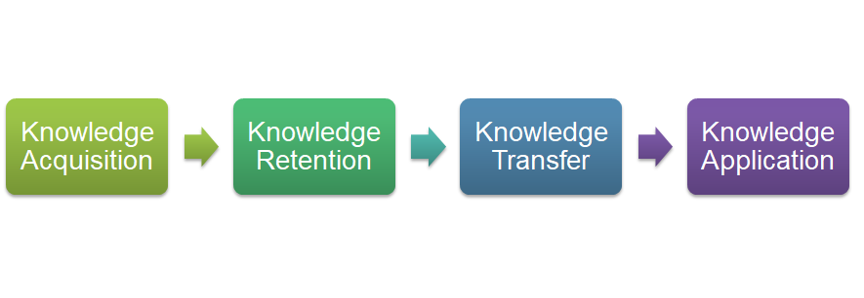
Figure: Knowledge management process (Kennan, 2016)

For acquiring the knowledge Sollatek has to undertake several activities because acquiring the most relevant knowledge for the business is the most crucial task and the success or failure of the business is dependent on how the business gathers the knowledge base for further functions. In Sollatek, the management acquires the knowledge base while recruiting the employees in its business. They focus on what are the prior experiences of the potential candidates and how they will respond to organisational activities. In order to retain those employees, the business tries to provide reward and sometimes motivate the employees so that they perform their stated jobs and responsibilities for properly (Pugh, 2016). The third phase in the knowledge management process is the knowledge transfer through which the business share, distribute or disseminate the reserved knowledge to different functional areas of the business so that the usage of the knowledge is ensured properly. The knowledge can be transformed both in a formal or informal way depending on what are the characteristics of the knowledge and how the other employees will apply knowledge for further use.

Explaining what is required to create, store, apply and integrate knowledge
There are varieties of tactics by doing which the Sollatek could integrate the knowledge in its operation and promote the creativity and innovation in the business. The creation of knowledge depends on how the business or the management reacts with the innovation from its employees (Kennan, 2016). If there is a proper flow of information and if the employees are provided with proper authorities then they will find some ways through which they could perform the business operation perfectly. Sollatek incorporates external training sessions when it undertakes any new projects and that external training session enables the candidates to understand the new knowledge and adopt that new knowledge to their business. As the management has to take several decisions from time to time they have to deal with lots of new knowledge to undertake the right decision at the right time. The integration of new knowledge will be successful only when employees practice that knowledge on a regular basis and become accustomed to the pros and cons of every aspect of the new knowledge whether it will add value to the business or it will incur costs for the management. If there is a proper flow of information and sharing of knowledge in the business then it will be easier to communicate the new knowledge to the other employees and increase the knowledge base of the business.

Evaluating the impact of Intellectual Property rights
The success and failure of Sollatek business are dependent on how perfectly it could generate a business idea and apply those business ideas in its operation and achieved the goals and objectives of it. There are some intellectual property rights that enable the business to keep its idea of its own and prevent other parties copying the same idea of the business (Lawes, 2018). The management will find it impressive if you understand that they are Innovation and ideas will not be copied by some other third parties with whom the business has no official affiliation. In Sollatek, they have some established designs and patterns that the other businesses could not copy and implement in their business without the consent from the Sollatek. The products of the company are packaged based on their own ideas and the other business could not copy the same designs of their products. Sollatek has its own logo that other business could not use in their products. The company has some loyal customer base who purchase the products on a regular basis from the company and those loyal customers court select the products from this company by following their logo. The intellectual property rights enable the business to increase its brand awareness and develop the level of loyalty in the minds of the customers.
The intellectual property rights also ensure that the management should not copy the other businesses’ intellectual properties such as logo and design and should not train their employees to use that its intellectual properties to their own business (Pugh, 2016). It is not necessary that all the products of the business will be welcomed by the customers rather it has some products which have more acceptance in the minds of the customers from the other products. So the business will fall in a dicey situation if the popular products of the business are copied by the other competitors.

LO3

Provide a framework for establishing a knowledge management culture
There should have a proper structure and culture in the organisation through which the knowledge can be managed and engaged the employees to the knowledge management culture. If there is a proper set of ideas and knowledge in an organisation then the employees will feel motivated and work towards organizational goals and objectives (Lawes, 2018).
Sollatek could establish a knowledge management culture through the following ways:
First of all, the business should provide a good message regarding the benefits of proper knowledge so that they could understand its merits and search newer ways for achieving knowledge. If the business can attract and retain the proper knowledge base in the business, then it will get better ideas for maintaining that knowledge properly.
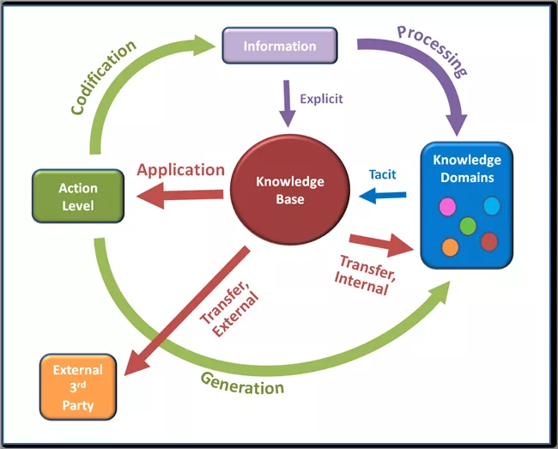
Figure: Knowledge management process (Girard and Girard, 2015)

Secondly, managing the knowledge is important for the Sollatek because it will ensure the establishment of proper knowledge in the business and the business could use those knowledge base for all kinds of the upcoming business situation (Lawes, 2018). There are various ways by using which the management could influence the subordinates to enrich their knowledge base and contribute to the business by applying that knowledge in different operational areas of the business.
If the employees of Sollatek are provided with a proper reward system for engaging innovative knowledge in the business, then they will be encouraged and motivated enough to solve the current problem of the business by applying their knowledge properly.
Sollatek could search for new machinery and equipment by using which the knowledge base of the business can be shared and applied in some other areas of business. Not only that, the proper database management system can be utilized for managing the knowledge in the business.
Sollatek could employ external training programs from time to time so that the employees get up-to-date knowledge regarding the activities of the business and implement that knowledge in their functional areas. Every employee has some knowledge gap and those training programs provide proper knowledge and information so that those gaps can be minimized.
Through proper socializing and mutual sharing, knowledge can be transferred from one area of business to another area (Girard and Girard, 2015). The employees could interact with each other purposefully and share their ideas with other employees. By doing so, they could come up with a better solution for the existing problem. If Sollatek provides better learning opportunities to the employees, they will be able to practice a lot and make themselves capable enough to solve the current problem of the business in a better way. Although it is very common that when employees do something new for the very first time, they made some mistakes. The business should be aware of this fact and give proper space to them so that they practice a lot and contribute to the organization.
The flow of information and knowledge should be established in such a way that the employees share their ideas to the top management instantly and get some feedback on their ideas so that they could search for newer ways to accomplish it (Pugh, 2016). As the lower level employees perform the core activity of the operation, it is probable that they will find newer and effective ways for solving the current problem.

Explaining the contribution knowledge assets have on an organisation
The decision-making capacity of the management becomes increased when it can accumulate knowledge assets in its business and apply those knowledge assets properly (Bryson, 2017). The knowledge assets enable Sollatek to make profit buy managing its resources in such a way that it could accomplish its stated goals and objectives without errors. The profitability of the organization will be increased only when it could satisfy the customers and increase the level of sales by providing better services to them. If the business could increase its market share by attracting the customers, it will be able to survive in the market for a longer period of time. Proper knowledge assets enable the business to implement its strategic goals and objectives effectively. High turnover of the business will be ensured if the business utilizes the codified strategy in its business. And if the personalized strategies are used it will ensure higher profit for the organisation.
The management needs to undertake both the structured and unstructured decision while performing business activities. The proper utilisation of knowledge assets ensures that the practices of the organisation will be directed towards achieving the goals and objectives of the organisation (Lawes, 2018). The successful practices of knowledge assets will also ensure a higher competitive advantage which will enable the business to compete with its competitors and provide superior values to the business. If the business performs its general activities properly then the stakeholders of the business will be satisfied.

Evaluate the knowledge requirements for the organisation
The competence of the people is one of the most crucial resources for the organisation because it ultimately controls and directs all of the other resources of the organisation. In order to increase the competencies of the people, the organisation should search for newer ways through which the knowledge base of the employees can be increased. Every practice of the business should be matched with the organisational goals and objectives and it will be achieved only when the organisation put greater emphasis is on the knowledge management (Collinson and Parcell, 2004). The following figure shows how the organisation initiates knowledge needs analysis and identify the strategic gap in their system:
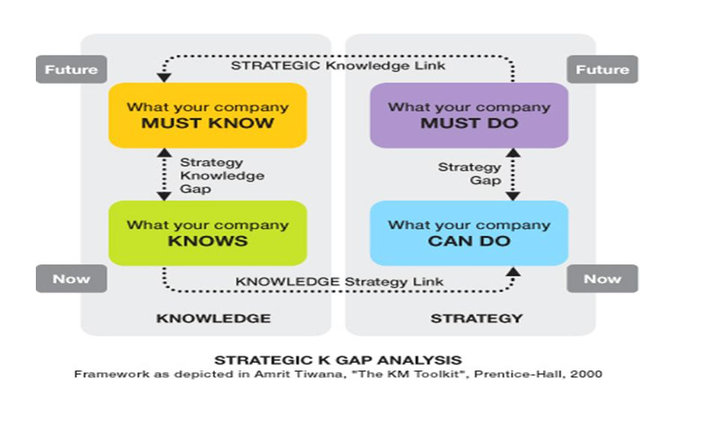
Figure: K-Needs Analysis (Johnson and Smith, 2016)

From the knowledge needs analysis the company can understand what it can do now and what it must do and what will be its feature actions based on the changing situation. After identifying the knowledge gap, Sollatek I will try to incorporate some external training activities through which the current level of knowledge of the employees can be improved.
As Sollatek deals with lots of competitive and dynamic situations, it should provide more efforts to the knowledge management to overcome those. The quality of the products and services of the organisation will be developed only if the organisation incorporate more knowledge and develop the knowledge base of the employees.

Evaluate the organisation’s framework for enabling knowledge sharing
Sharing of knowledge is an effective strategy through which Sollatek will be able to reduce the knowledge gaps among the employees and increase the level of effectiveness of the organization (Johnson and Smith, 2016). The sharing of knowledge will be effective if the organisation create a Framework by considering the internal or external environment of the business. While structuring the Framework Sollatek should consider how the information will flow to the organisation and how the different groups and functions captured information from other groups.
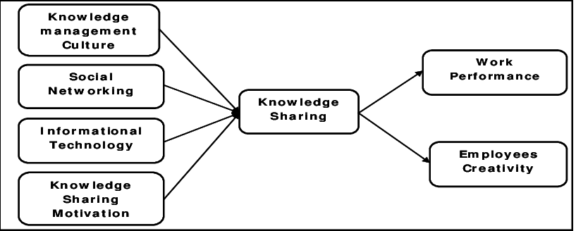
Figure: Knowledge sharing framework (Johnson and Smith, 2016)

The sharing of knowledge will enable the business to reduce the knowledge gap quickly and in a cost-effective way. There might have some experienced employees in the organisation who have proper knowledge regarding the operational activities of the business and they could share or distribute the knowledge so that the other parties of the business could understand about the operational activities (Lawes, 2018). If the organisational knowledge is shared with the employees by considering the information technology and some other important tools, it will increase the employee’s creativity and work performance which will ultimately increase the operational performance of the business. If the employees share the knowledge by using social networking sites or working with each other for different for operational activities and get the relevant knowledge from the other employees of the organisation.

Recommend improvements to the current framework
There are some ways through which the current framework of the business can be improved which will increase the knowledge sharing and enhance the operational effectiveness of the organisation. The management could focus on the updated technologies so that they could use that technology in their business and provide necessary training to the people of the organisation. The employees of the organisation should be encouraged to share their understanding with the other parties and ask any query if they find it difficult to solve the current problem using your own knowledge. The organisation should consider the feedback of the customers and implement those feedbacks in their operational areas so that customer satisfaction can be increased. The functional areas of the organization should be interconnected so that any particular function could get the proper information and knowledge from the other party (Lawes, 2018). If the organization could ensure that there is no gap in the whole process, then they will be able to increase the operational functions and contribute a lot to the organization.

Conclusion
This report covers all of the areas of information and knowledge management through which the organizational like Sollatek could perform its strategic activities by utilizing the knowledge resources. The knowledge asset as it is so vital for the organisation that all of the activities of the organization will be hampered if the knowledge base is not properly handled. This report has also described how the management of Sollatek deals with its knowledge assets and capture the best knowledge base for the betterment of the organization. As the company always tries to innovate new products for increasing its sales, it needs to take the proper care of its knowledge base so that they could contribute to the development of new products. The company employs diversify employees from all over the world to create the most innovative and attractive product for the customers. For this reason, the company needs to take proper care of intellectual property rights. The report has also demonstrated the importance of intellectual property rights by considering the Sollatek business in the UK as an example. It has also explained how the management of Sollatek uses different modelling techniques to capture the knowledge base.

References
Bryson, J., 2017. Effective library and information centre management. Routledge.
Collinson, C, and Parcell, G (2004) Learning to Fly: Practical Knowledge Management from Leading and Learning Organizations, Capstone, England.
Davenport, T.H. and Prusak, L (2000) Working Knowledge: How Organizations Manage What They Know, Harvard Business School Press; 2nd Edition.
Girard, J. and Girard, J., 2015. Defining knowledge management: Toward an applied compendium. Online Journal of Applied Knowledge Management, 3(1), pp.1-20.
Ichijō, K. and Nonaka, I. (2007). Knowledge Creation and Management New Challenges for Managers. Oxford: Oxford University Press.
Johnson, A.M. and Smith, S.M., 2016. Respiratory clinical guidelines inform ward-based nurses’ clinical skills and knowledge required for evidence-based care. Breathe, 12(3), pp.257-266.
Kahwati, L., Carmody, D., Berkman, N., Sullivan, H.W., Aikin, K.J. and DeFrank, J., 2017. Prescribers' knowledge and skills for interpreting research results: a systematic review. Journal of Continuing Education in the Health Professions, 37(2), pp.129-136.
Kennan, M.A., 2016. Data Management: Knowledge and skills required in research, scientific and technical organisations.
Laudon, K.C. and Laudon, J.P., 2015. Management Information Systems: Managing the Digital Firm Plus MyMISLab with Pearson eText--Access Card Package. Prentice Hall Press.
Laudon, K.C. and Laudon, J.P., 2016. Management information system. Pearson Education India.
Lawes, A. ed., 2018. Management skills for the information manager. Routledge.
O'Connor, S. ed., 2015. Library management in disruptive times: skills and knowledge for an uncertain future. Facet Publishing.
Peltier, T.R., 2016. Information Security Policies, Procedures, and Standards: guidelines for effective information security management. Auerbach Publications.
Pugh, L., 2016. Change management in information services. Routledge.
Sanchez, R. (2003) Knowledge management and organizational competence. (Online) Oxford University Press: New York
Thornley, C., Carcary, M., Connolly, N., O'Duffy, M. and Pierce, J., 2017. Getting better at Knowledge Management: Integrating individual skills and organisational capability.

