Leo Smith (2217998)
ACDA6020 – Advanced Chemistry of OME
30th December 2025
Purity Dtermination Through Melting Point Analysis

Table of Contents
Table of Figures 1
Table of Tables 1
Table of Equations 1
1.0 Introduction 2
2.0 Results and Discussion 3
2.1 Sample A: 3
2.2 Sample B: 4
2.3 Sample C: 4
2.4 Sample D: 5
3.0 Experimental Improvements 5
4.0 Conclusions 6
References 7

Table of Figures
Figure 1 - Microscopy results for Sample A 3
Figure 2 - Microscopy results for Sample B 4
Figure 3 - Microscopy results for Sample C 4
Figure 4 - Microscopy results for Sample D 5

Table of Tables
Table 1 - Visual observations and melting point data for each Methyl-3-nitrobenzoate sample. 3

1.0 Introduction
This laboratory report explores how the purity of crystalline chemical samples may be determined through melting point analysis. To achieve this four, student synthesised, samples of Methyl-3-Nitrobenzoate will be analysed. Conclusions regarding each sample’s purity will then be drawn, allowing for discussion regarding the quality of each sample and the broader analytical technique.
Pure samples have specific, reproducible melting points occurring sharply within a range of 0.5 to 1.5°C [1], [2]. The proximity of a samples melting point to literature values hence indicates purity, with small deviations greater than 1°C typically indicating unacceptable purity levels [3].
Impurities typically result in a depressed and broadened melting point region. This effect can be attributed to the impurity disrupting the perfect crystal lattice which, in turn, reduces the solids tendency to form as outlined in Rault’s Law [2]. This same effect also causes the solid to melt gradually increasing the melting point range [4].
Major impurities such as unreacted material or side products may also cause more drastic alteration in melting point with each constituent product melting at its own distinct value.
Methyl-3-Nitrobenzoate with purity >99% has a melting point range of 78 – 80°C [5]. This value will act as a reference for the presented analysis.
Understanding a materials purity is essential for the safe manufacture and use of all crystalline explosive materials, with impurities typically reducing both chemical and physical stability.
In TNT manufacture common impurities include 1,3-DNB, 2,4-DNT and 3,5-DNT. During casting these may pool in localised regions causing areas with a decreased melting point. This can cause TNT exudation with was common in poor quality fills in the early 1920’s and significantly increases the materials sensitivity to heat and shock [6].
Alternately in the manufacture of RDX via nitrolysis HMX commonly forms as a side product up to around 5-10% of the final yield. This impurity increases the sensitivity of the material and lowers the activation energy of the materials decomposition, reducing safety [7].
Finally, in PETN manufacture ionic metal impurities in the water used to crash precipitate PETN crystals is shown to alter the crystal growth and morphology. This again alters the sensitivity of the resultant material reducing safety [8].
Due to the influence impurities play on energetic materials it is important to be able to analyse impurity content as will be practically demonstrated within the remainder of this report.

2.0 Results and Discussion
The melting point data presented in Table 1 bellow was collected using the equipment and methodology outlined in Appendix A. The data was supplemented with crystallography images collected for each sample using an electronic optical microscope.

Table 1 - Visual observations and melting point data for each Methyl-3-nitrobenzoate sample.
Sample ID | Observations | Trial 1 | Trail 2
Sample ID | Observations | MP Range °C | MP Range °C
A | - Off White colour  - Caked together needle like crystals  - Damp feel | 76 - 77 | 77-78
B | - Off White colour  - Fine static needle like crystals  - Dry and powdery | 78 | 78-79
C | - Pale Yellow colour  - Fine needle like crystals  - Minor clumping | 77 | 78
D | - Dark Yellow colour  - Caked together clumpy irregular large crystals  - Pungent acrid smell  - Very wet feel | 73 - 74 | 74

2.1 Sample A:
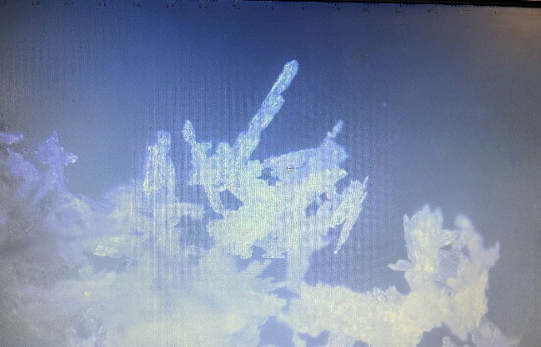 | 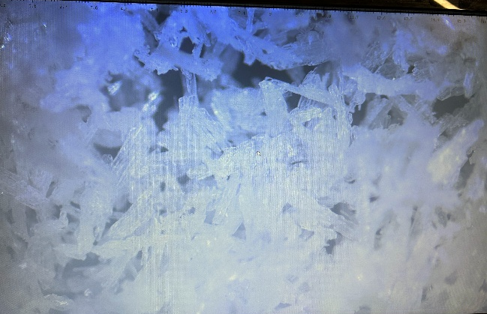
Figure 1 - Microscopy results for Sample A
The clean off-white colour and regular needle crystals shown in Figure 1 provided an initial indication that Sample A was of high purity. The melting point results however, contradict this with a total range of 2°C centred 2°C bellow the literature value of 79°C. During testing the crystals caked together and appeared damp suggesting the material was not fully dry. The addition of this moisture likely lowered the melting point skewing the results despite the good quality product.

2.2 Sample B:
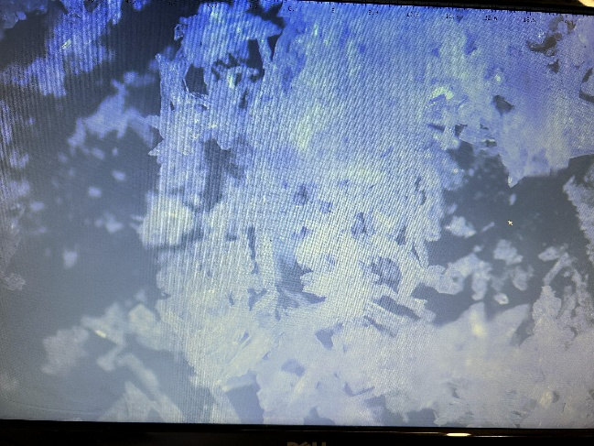 | 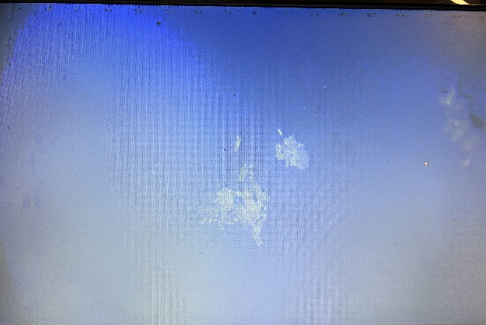
Figure 2 - Microscopy results for Sample B
Sample B, Figure 2, also presented a clean off-white colour with regular, albeit shorter, needle like crystals. During handling the sample was dry and powdery readily building up a static charge. These indicators of high purity and low moisture content translated to the melting point analysis with a 1°C melting point range within the region of the literature value. This product could be classed as pure.

2.3 Sample C:
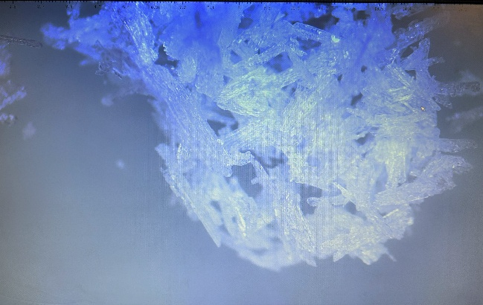 | 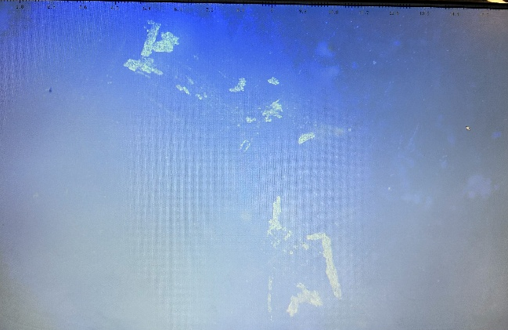
Figure 3 - Microscopy results for Sample C
Sample C, Figure 3, visually appeared with a pale-yellow tinge and experienced minor clumping suggesting potential acidic impurities and improper drying. This was supported partially by the melting point data which suggested a better purity than the visual analysis with a range of 1°C only 0.5°C bellow the literature value. This highlights challenges with the method which will be discussed further later in this report.

2.4 Sample D:
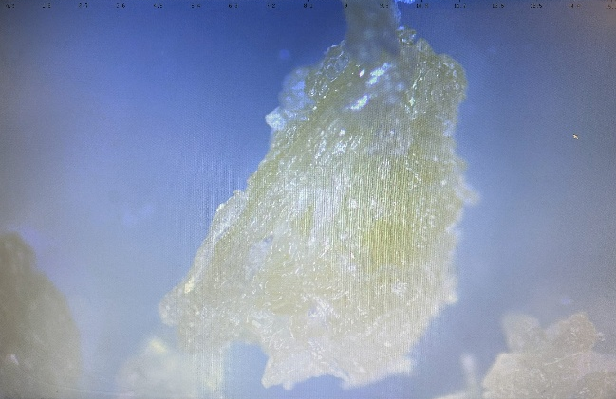 | 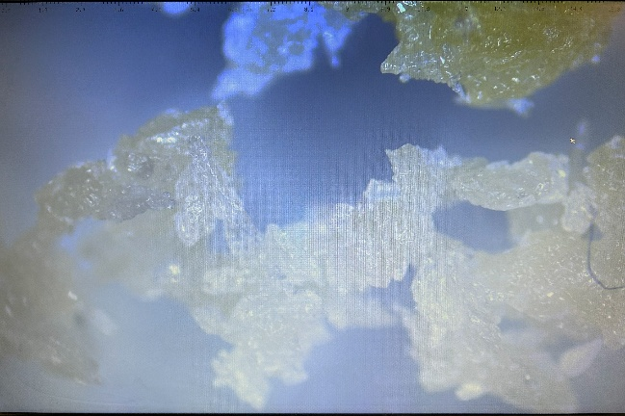
Figure 4 - Microscopy results for Sample D
Sample D, Figure 4, was clearly an impure product from the visual data collected. The product was made up of irregular amorphous crystals with a deep yellow colour. These crystals were wet clumping together and producing an acrid smell. This suggests poor control of the reaction conditions, insufficient washing of the product and hence very low purity. This is supported by the melting point data with a 1°C range that fell 4.5°C bellow the literature value. If this material was energetic, it would require immediate disposal as it would be chemically unstable and unsuitable for use.

3.0 Experimental Improvements
The discrepancy between the visual and melting point purity data demonstrates the potential for errors within the melting point results. The most significant error source being the subjective nature of determining the phase transition. This may be remedied by using either a more advanced instrument with automatic detection or running an increased number of trials to gain a more representative average. Running more trials also helps increase the likelihood that the analysed sample is representative of the bulk providing a more accurate picture of the whole sample’s quality.
The methodology used can also be improved by refining the sample preparation technique. Properly drying the sample and grinding it to reduce the particle size both reduces the effect of moisture, prevalent in Sample A, and improves inter crystal contact in the capillary. This improves heat transfer, producing a more homogenous melt and accurate melting point [2].
Finally, it is important to note that melting point is a rudimentary measure of purity and many more accurate quantitative methods such as High-Performance Liquid Chromatography (HPLC) may also be used. HPLC when ran against a known calibration standard allows a percentage purity to be calculated and can help in the identification of the impurities present. NMR and FTIR can also be used to identify impurities if required [9].

4.0 Conclusions
This laboratory report has clearly shown how the comparison of a samples melting point to known literature values can be effectively used to determine a samples purity. This was then applied to four samples of Methyl-3-nitrobenzoate showing that Sample D with its yellow colour, acrid smell and low melting point was clearly the least pure. Determining the purest sample was more complex due to moisture contamination in Sample A but, purely based on melting point results, Sample B was shown to be the purest. Improvements to the test methodology were discussed both in the form of sample preparation improvements and increasing the number of trials. Finally, the importance of purity analysis in energetic manufacturing was clearly shown through literature examples highlighting this importance of this work within the industry.

References

[1] | C. Boes, A-Level Chemistry Flash Notes AQA Year 2, Self Published, 2016.
[2] | J&K Scientific, “How Melting Point Determination Works,” [Online]. Available: https://www.jk-sci.com/blogs/learning-center/how-melting-point-determination-works. [Accessed 29 Decemeber 2025].
[3] | A. Sandtorv, “5.3: MELTING POINT ANALYSIS- IDENTITY AND PURITY,” Chemisty LibreTexts, [Online]. Available: https://chem.libretexts.org/Bookshelves/Organic_Chemistry/Book%3A_How_to_be_a_Successful_Organic_Chemist_(Sandtorv)/05%3A_HOW_TO_INTERPRET_YOUR_RESULTS/5.03%3A_MELTING_POINT_ANALYSIS-_IDENTITY_AND_PURITY. [Accessed 29 December 2025].
[4] | R. Boole, “Organic Techniques - Purity (Edexcel A Level Chemistry): Revision Note,” 4 January 2025. [Online]. Available: https://www.savemyexams.com/a-level/chemistry/edexcel/17/revision-notes/7-advanced-organic-chemistry/7-6-organic-chemistry-iii-organic-synthesis/7-6-6-organic-techniques---purity/. [Accessed 29 January 2025].
[5] | Sigma-Aldrich, “SAFETY DATA SHEET - Methyl 3-nitrobenzoate,” 25 April 2025. [Online]. Available: https://www.sigmaaldrich.com/GB/en/sds/aldrich/155977?userType=anonymous. [Accessed 29 Decemeber 2025].
[6] | T. X. Ma, “Chemical Aging and Influence of Manufacture on High Explosives,” Division of Graduate Studies of the Royal Military College of Canada, 2025.
[7] | H. Sinapour, S. Damiri, M. Ravanbod and H. Pouretedal, “The Effect of HMX Impurity and Irganox Antioxidant onThermal Decomposition Kinetics of RDX by TG/DSCNon-Isothermal Method,” Propellants, Explosives, Pyrotechnics, vol. 44, no. 4, pp. 389-523, 2019.
[8] | R. PITCHIMANI, L. J. HOPE-WEEKS, G. ZHANAG and B. L. WEEKS, “Effect of Impurity Doping on the Morphology of Pentaerythritol Tetranitrate Crystals,” Journal of Energetic Materials, vol. 25, pp. 203-212, 2007.
[9] | T. Lister and J. Renshaw, “Sections 31 to 33,” in AQA CHemistry A Level 2nd Edition, Oxford, Oxford University Press, 2015, pp. 470 - 502.

Appendix A – Methodology
Lab tools and supplies:
Cole-Parmer M200 Melting Point Microscope (MPM)
Glass capillaries
Samples of methyl-3-nitrobenzoate synthesised and purified in Cranfield.
Operating procedure will be discussed in the lab however the main points are:
- Set up the MPM device by placing it on a stable surface, connecting to power, and switching it on. The display will show the block temperature, and the sample chamber light will activate.
- Prepare samples for the analysis by filling a capillary tube with each sample .
- Set Plateau Temperature:
    - Press and hold the 'Plateau Set' button; adjust the temperature with arrow keys to 10°C below the expected melting point.
    - Release the button to confirm the setting.
- Place the capillary tube into a sample hole in the block and make sure that it is visible through the lens.
- Press 'Start' to heat quickly to the plateau temperature. The plateau light will turn on once stabilized.
- To observe melting point, press 'Start' again to begin slow ramping (2°C/min). Observe through the lens and record the temperature at the first sign of melting.
- Press 'Stop' after observation is completed. Allow the device to cool before the next use.
Safety Notes:
- Handle with care; the block becomes very hot and the glass capillaries can break.
- Use correct PPE.

