Marketing Management – Assessment 1 75%

Iva Pavlova
1919329
Table of Contents
Introduction 3
Background information about the company 4
Definition of communication 4
Explanation of a communication model with the help of a diagram 4
Definition of integrated marketing communications 5
What new promotional strategies of your company can use to raise awareness of the brand 5
Definition of branding and brand equity 6
Relationship of the Aaker’s Brand Equity Model with the selected company 7
Discussion of the Customer Journey and Customer Touch Points 9
Customer Journey Map of Cadbury: Poster 13
The application of the Total Engagement model 14
Conclusion 16
References 16

Introduction
This report will focus on a study of Cadbury and its business operations to increase brand awareness. It will highlight the concept of brand equity along with branding. It will highlight the customer journey mapping where a wide range of communication channels to ensure that current along with future stakeholders is feeling satisfied. It will make a proper application of the total engagement model in Cadbury. The main objective of the organisation is not only to satisfy the customer base but also to develop several promotional activities to stay updated in the market and maintaining proper communication with customers to know their expectation level.

Background information about the company
Cadbury is a multinational company in the UK that has been owned by Mondelez International since 2010. It is the second-largest confectionery brand in the world. The organisation has started its business operations in 1824 from Birmingham and Warwickshire. John Cadbury was the founder of this company. Cadbury has been internationally headquartered in Uxbridge and it has been operated in more than 50 countries around the world.
The mission statement of the company is Cadbury is known for its quality and this is their promise. The reputation of the organisation is built on quality and they are committed to making continuous improvements to make sure that the promise has been delivered. From the quality statement, it is clear that the organisation has focused on quality over quantity due to its inception. They have continued to follow the footsteps of its founder John Cadbury and follow his ideology (mission-statement, 2021). The incessant efforts of Cadbury are the main reason for its growth in the market.

Definition of communication
Communication is known as the act of transferring information from one place and person to another. In every action has involved one sender, a message and a recipient. It may look very simple but communication is a very complex process. It has been considered so desirable by employers around the world. For that reason, effective, ambiguous and accurate communication is extremely difficult (Waisbord, 2019).

Explanation of a communication model with the help of a diagram
Linear or transmission model of communication has been described the entire communication process as a linear and one process where the sender can transmit the message to the receiver. This model has concentrated on the message and sender within a communication encounter. However, this model of communication has focused on the sender and message within a communication encounter. The receiver has been included in the model and the role has been viewed as more of a target or endpoint instead of part of an ongoing process. It can be presumed that the receiver has received and understood the message. The scholars who have designed this model have extended on a linear model (Banks & de Graaf, 2020). It can be influenced by the advent and spread of the new communication technologies of the time like radio and telegraphy. In this case, radio is the sender who can encode a verbal message that has been transmitted by the radio tower with the help of electromagnetic waves and it has been reached to the ears of the receiver through an antenna. The creation of this communication model has allowed scholars to examine the communication process in an effective manner that can lead to more complex models and theories of communication.

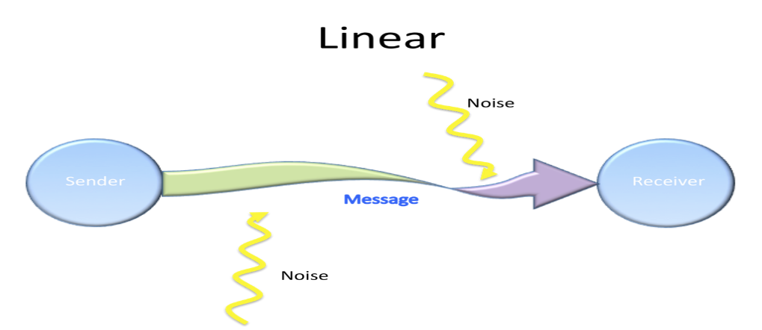
Source: ecampusontario.pressbooks.pub/

Definition of integrated marketing communications
Integrated marketing communications can be defined as an effective process that has been used to unify the marketing communication elements like public relations, advertising and social media into a brand message that has been remained consistent across the distant media channels. It has been allowed both public along with private companies as well as businesses for delivering and engaging as well as seamless customer experience for a specific product or services. Professionals with a background in integrated marketing can pursue employment throughout the marketing as well as communications industries. In the areas like social media marketing, journalism, digital media, public relations, entertainment and other fields are related to this concept. In addition, integrated marketing communications is a multidisciplinary field that has been combined with traditional along with new practices of the media. (Oluwafemi & Adebiyi, 2018)

What new promotional strategies of your company can use to raise awareness of the brand
Cadbury has a wide range of ways to promote its brand in front of customers. It can be noted that promotion strategy has been done with the help of posters, newspapers, radio and other online platforms. It has been observed that the company has given their best efforts to make its product reach the people and make the customers aware of its items. There are different types of taglines that are attached with multiple brands of Cadbury. The organisation has concentrated on building an emotional connection with its target audiences and chocolates can add happiness to the regular lives of the customers. Cadbury has some promotional lines that can highlight that the brand has tried to promote itself in the market of sweets and generate revenues by creating brand awareness. Apart from that, there are different brands such as Bournville where it has been observed that the company wants it to be something like the customers earn it. Cadbury has different brand ambassadors for multiple products (mbaskool, 2021). Each of them has been used to make an impression in the mind of the customers. However, the organisation has not left any stones unturned for promoting itself.

Definition of branding and brand equity
Branding is an effective process that can help to give meaning to a specific organisation, products or services by shipping and creating the brand in the minds of the customers. It is a strategy that can be designed by the organisation to help the people to quickly identify and experience its brand and give them a proper reason to choose the products over the competition by clarifying the particular things of the brand. The main objective of branding is to retain and attract loyal customers as well as other stakeholders by delivering a product that can be aligned with the brand premises. In other words, branding is in doing products as well as services with the power of a specific brand. It can be known as the marketing practice that can shape the brand actively. Branding is all about breaking through the clutter and grab the attention of the customers. If the business wants to achieve success, branding is non-negotiable (Hunt, 2019).
Brand equity has been referred to as a value premium where an organisation can generate from a product with a recognisable name when it has been compared to a generic equivalent. The organisations have created brand equity for their products by making them easily recognisable, memorable and superior in quality as well as reliability. Mass marketing campaigns have help for creating brand equity.
When the organisation has positive brand equity, the customers are ready to pay a high price for its products. The customers have paid a premium price to do the business that an organisation they know and admire. The business with brand equity does not include a higher expense instead of its competitors for producing the products and bring it to the market where the difference in price has gone through its margin. The brand equity of the organisation has enabled it to make a bigger profit on every sale (Mohammad, 2017).

Relationship of the Aaker’s Brand Equity Model with the selected company
Aaker’s Brand Equity Model emphasises the brand identity and also offers a unique solution to create a strong brand in the market (Wheeler, 2017). Brand Equity signifies the value premium that a brand is offering to the customers that help to recognise and relate during the final purchase. The customers preferring such brands having high brand equity can be observed in the final purchase stage. The consistent value provided by the brand to the people helps to create positive Brand Equity. Moreover, brands having high Brand Equity in the market can influence the customers to pay a premium price for a concerned product. The repeat purchase and referrals are the key outcomes of the High Brand Equity. Therefore, Brand Equity signifies the value of the brand determined by the perception of the customers.
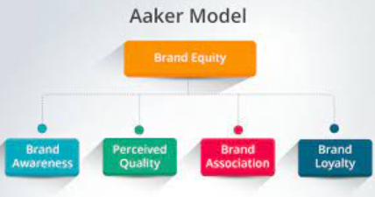
Aaker’s Brand Equity Model, Source: https://www.canto.com/
As per Aaker’s Brand Equity Model, the four different perspectives of Brand Equity are Brand awareness, Brand Loyalty, Perceived Quality, and Brand Associations. The purpose of the Aaker Model is to offer unique strategies in enhancing Brand Equity. Moreover, the model provides a foundation to the brand identity and helps to construct the strategies to stimulate Brand Equity in the selected market. For example, the performance of the brand Cadbury in comparison with the competitor’s brand can be analysed efficiently with the Aaker’s Brand Equity Model. The current position of the brand can also be evaluated from the four dimensions of the Aaker’s Brand Equity Model. However, the limitation of such a model is the ignorance of the equity of the manufacturer's brand name in comparison to the individual product brand.
- Brand Awareness underlines the degree to which the customers can recognised the product during the final purchase (De Vries, et al., 2017). The creating of Brand Awareness is a fundamental step in promoting the new product or revives the older brand. Moreover, Brand Awareness includes qualities that differentiate the product from its competition. In the context of Cadbury, chocolate, and confectionery items are widely accepted in the world. The product line of Cadbury includes the single bar, boxes, chocolate drinks, biscuits, and blocks. It has been observed that Cadbury is leading the chocolate confectionery business in the UK with 70% of the total market share (Chrystal, 2019). The chocolate bars of Cadbury with fruits and nuts or cereals show an increase in demand of around 4% in the year 2020.
- Brand Loyalty refers to the positive association of the customers attached to the specific product/brand (Kelley, et al., 2015). The customers that are devoted to the product/service can be observed from the repeat purchase despite the competitor’s offering. In the case of Brand Loyalty, the customer chooses the specific product repeatedly during the final purchase considerations. The consumers used to relate the brand Cadbury during the chocolate purchase. Furthermore, Cadbury has invested continuously in the product innovation mix and core lines in raising the sales and enhance the purchase intent.
- Perceived Quality reflects the impression of excellence that a customer encounters about the product, brand, and derived quality (Ferguson, et al., 2016). The reliability of the product and robustness can be observed under the Perceived Quality. In the context of Cadbury, the brand is committed to maintaining quality and taste to enhance preferential consumption. The premium quality of the Cadbury products reflects the positive perception of the customers. Moreover, the high demand of the Cadbury bars around 4% in the year 2020 is reflecting the positive perceived quality.
- Brand Association underlines the aspect that is deeply seated in the mind of the customers (Veloutsou & Guzman, 2017). The customers used to relate the specific brand during the purchase consideration for a close brand association. The attributes of the brand are used to create favourableness in the market due to the premium quality and customer satisfaction. For example, consumers used to relate the brand Cadbury while considering the purchase of chocolates or other confectionery items. The close association between the chocolate and Cadbury has enhanced the Brand Association. For example, Cadbury in the UK has once again retained the leading position that is valued at around £1,682.1m in the year 2020.

In the context of advantages, Aaker’s Model is dynamic and helps to create an adaptable brand in the target market (Lee, et al., 2017). From the analysis, it is clear that Aaker’s Model With the model supports the organisation to undertake a long-term growth plan by focusing on customer satisfaction. The requirement of the expansion in the product line or revising the promotional strategy can be analysed from the Aaker’s Model. Furthermore, a marketer can evaluate the favourableness of the brand in the mind of the customers through Brand Associations and Brand Loyalty. The Aaker model emphasises on the importance of the Brand Identity by offering unique solutions in building a strong brand. It can be spotted that Aaker model is a foundation for developing the brand strategies and also construct the vision for the brand. The ‘Brand Persona’ can be enhanced with the Aaker model by creating the personification of a brand (Fulgoni, 2019). Therefore, the human emotions and feeling can be generated with the Brand Persona under the Aaker’s Model. Moreover, Aaker’s Model helps to measure market perception of the product by focusing on the brand identity. The through examination like way the product is perceived in the concerned market, characteristics and reaction of the market.
On the contrary, the disadvantages of Aaker’s model is the complicated task in real practice as it is difficult to capture the impact of the building blocks and Brand Equity on a multi-dimensional level. The brand itself cannot determine its brand equity due to the involvement of the consumer purchase behaviour. Therefore, multipliers in the marketplace and consumer mindset used to hold a significant importance in the process of Brand Evaluation.

Discussion of the Customer Journey and Customer Touch Points
Customer Journey reflects the process of interaction between the customers and company in pursuing the desired goal (De Vries, et al., 2017). Customer journey signifies the complete experiences of the customers while interacting with the specific brand or organisation. The customer journey can be reflected as a story in understanding the customers regarding their behaviour during their consideration towards the final purchase. The interaction of the brand/organisation with the customers in the purchase process can be reflected as the Customer Journey. The interactions of the customer across the channel, touchpoints, and devices at all the stages of the customer lifecycle can be observed under the Customer Journey. From the awareness stage to loyalty, the entire phase of the customer is contemplated by the customer journey. A customer-centric organisation always prefers to map and document the customer journey to enhance the positive experience. The organisation failed to interact with the customers cannot anticipate the ales figure. It is the Customer Journey that reflects the ‘what they do’ aspect of the target audience in each stage of the customer life cycle. The key benefit in developing the Customer Journey is to reduce the customer service cost and to ensure sound Return on Investment (ROI).
Customer Journey Map is the strategic approach to analyse the expectations of the customer and the related buying process (MacInnis & Park, 2019). According to Cheung (2018), the experiences gathered by the customer in purchasing a product from the organisation are reflected in the Customer Journey Map. The Customer Journey Map is constructed to deliver a seamless experience to the customers regarding the product purchase. Customer Loyalty can be attained by drawing the phases of the Customer Journey Map. Furthermore, the organisation can undertake a plan to deliver the superior value proposition to the target customers.
The Customer Journey of the brand Cadbury can be classified into three broad phases that are mentioned below:
- Before the Purchase: The customer will directly come in contact with the customer through a variety of communication channels like direct marketing, online advertisement, television advertisement, in-store visuals, etc. For example, in the case of the new product of Cadbury, the customer will be in touch with the brand through television advertisements and in-store visuals. The in-store visuals stating the offers in the retail stores will create awareness among the shoppers regarding the new product of Cadbury. However, in the case of the existing product, the customer will consider the perceived quality and Brand Association. The customer will recall the brand Cadbury due to high Brand Equity during the purchase of chocolate and confectionery items. Therefore, in the first phase of the Customer Journey of the brand Cadbury, the customer will be in contact with the brand through communication channels like television advertisements and in-store visuals.
- During the Purchase: The role of the sales personnel in the retail stores is an effective interaction point in the second phase of the customer journey. The well-trained staff of the retail stores will assist the shoppers by providing updated product information. In the case of Cadbury, the pull marketing strategy can be observed. Pull marketing strategy shares the fact of attracting the customers towards the brand/product with the help of the integrated marketing communication channel like a television advertisement. The potential prospects are converted into potential customers through the pull marketing strategy. In the context of Cadbury, the brand is committed to maintaining quality and taste to enhance preferential consumption. It has been observed that Cadbury is leading the chocolate confectionery business in the UK with 70% of the total market share (Chrystal, 2019). The chocolate bars of Cadbury with fruits and nuts or cereals show an increase in demand of around 4% in the year 2020 (Statista, 2020). The customers that are devoted to the product/service can be observed from the repeat purchase despite the competitor’s offering.
- After a purchase: The post-purchase phase has been identified in the Customer Journey. The product complaint-related issues can be communicated to the organisation after the post-purchase phase. In the context of Cadbury, the customers purchasing the product can share their feedback and complaints with the organisation. The product grievance team of Cadbury used to manage the post-purchase process. Furthermore, the retail point where the customer has purchased the product of Cadbury will receive a bill for their payments. Therefore, the retail point and grievance handling team of Cadbury is the last interaction point of the Customer Journey.
Customer Touch Points is the brand’s point of customer contact (Brassington, 2019). A customer comes in contact with the brand in different purchase phases and that needs to be analysed under Customer TouchPoints. The following customer points can be observed while purchasing the product of Cadbury from a retail point.
Customer Journey | TouchPoints | Analysis
Before the purchase | Social media advertisement | Social media is a computer-based technology that supports the users to share messages, information, and ideas within the virtual network (Fulgoni, 2019). The social media platform can be accessed from multiple devices like computers, smartphones, laptops, tablets, etc.  The wider application of digital marketing campaigns can be observed in the current business perspective. Currently, in the UK, there are 45m active social media users in the year 2020. Furthermore, the smartphone penetration has reached 92% in the year 2020 (Statista, 2020). Therefore, considering the rapid development of the technology and rapid proliferation of the internet, organisations are focusing on the social media platform to advertise the new products. Cadbury used to share the image of the new product on their official Facebook page and short videos on the YouTube platform as a part of the social media strategy. The social media advertisement is effective in enhancing the reach of the advertisement.
 | Word-of-mouth | Word-of-mouth marketing is an effective communication strategy implemented by the organisation to create interest among the customers through dialogue sharing (Cheung, 2020). From a study, it can be spotted that 74% of the customers used to influence by the word-of-mouth marketing technique. Cadbury utilises the customers as a key influencer to influence other people.
 | TV Advertisement | The Television commercials of Cadbury also create awareness among the people regarding the new products (CadburyUK, 2020). The pull marketing strategy focused by Cadbury helps to attract the customers in the final purchase. The customers under the pull marketing strategy are already convinced with the TV commercials and perceived quality from the previous purchase.
During the Purchase | Sales personnel’s efficiency | The sales personnel working in the different retail stores used to assist the shoppers in purchasing the product. The shoppers used to share queries regarding the offers. Therefore, a close interaction between the shoppers and front-line sales staff of the retail point can be observed during the purchase phase of the customer journey.
After the Purchase | Customer feedback | The feedback of the customers regarding the current purchase can be shared through e-mail. The grievance team will address the issues like faulty packaging, damaged or expired products encountered by the consumer while consuming the products.

Customer Journey Map of Cadbury: Poster

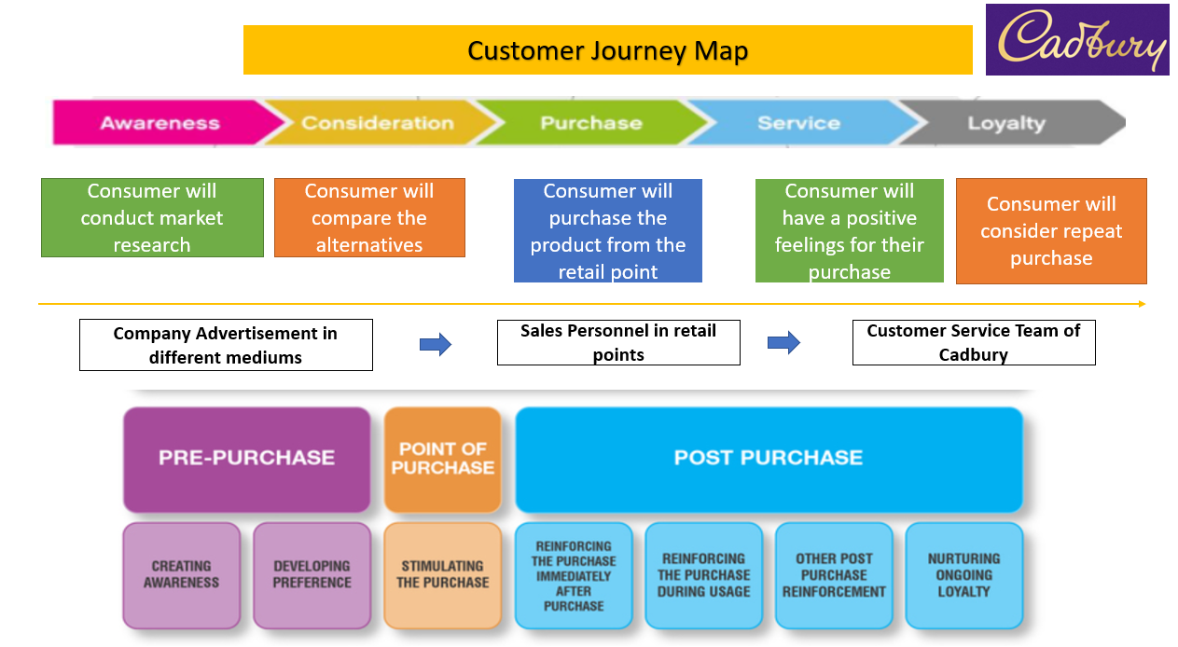
Source: Author
The relative strengths of the Customer Journey map of Cadbury are the dedicated strategic approach that helps to understand the customer expectation efficiently and eventually optimise the customer experience. The personalised experience can be created with the Customer Journey Map developed for Cadbury. The generalised onboarding process of the customer has been mapped and that will facilitate to deliver personalised experience (Brassington, 2019). The benchmark can be set by plotting the customer experience from the post-purchase phase of the Customer Journey mapping. With the mapping, the difference in the buyer’s personas can be moved from the prospect to conversion. Therefore, the logical order of the buyer’s journey can be created with the Customer Journey map of Cadbury.
However, the weakness of the Customer Journey map of Cadbury is the determination of the actual mind set of the customers. It can be observed from multiple studies that customer expectations are frequently changing for all the businesses irrespective of the size. The creation of the customer touch points is deemed to be static as the consumer behaviour is dynamic in the current business perspective. However, the options in determining the demand of the specific customer segment cannot be mapped correctly. As a consequence, the outcome of the mapping can be negative as it may failed to analyse the exact customer expectations.

The application of the Total Engagement model
The total Engagement model underlines the integrated approach in associating the customers, employees, and organisation to generate Customer Value Proposition (CVP). The CVP signifies the sum of benefits promised by the brand to its customers (Freytag, 2020).
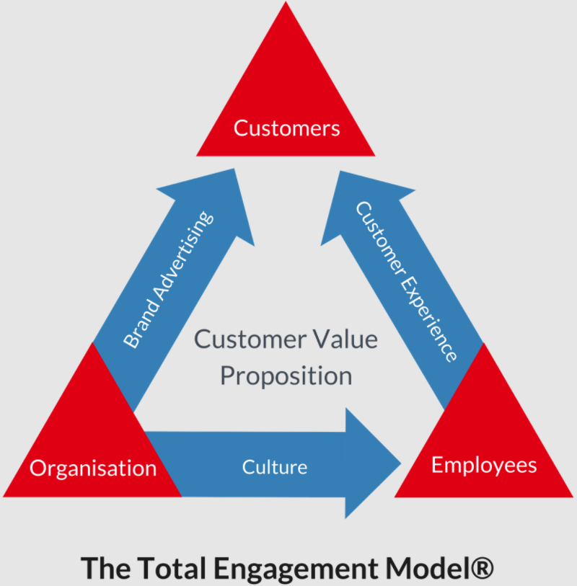
Total Engagement Model, Source: https://www.engagedstrategy.com
In the context of Cadbury, chocolate and confectionery items are widely accepted in the world. The product line of Cadbury includes the single bar, boxes, chocolate drinks, biscuits, and blocks. Moreover, Cadbury is leading the chocolate confectionery business in the UK with 70% of the total market share. Customer Experience, Culture, and Brand Advertisement are also the key areas of the Total Engagement model. In a year, Cadbury used to spend €7.5million for advertising campaigns in the UK (Mortimer, 2020). Each advertisement of the company is innovative and focused on a specific product line. Cadbury used to share the image of the new product on their official Facebook page and short videos on the YouTube platform as a part of the social media advertisement strategy. The social media advertisement is effective in engaging the customers with the brand. The customers can share their feedback and opinions on social media platforms in a convenient way (Kilgour, 2019). So, brand advertisement is also an effective channel that enhances customer engagement. The popularity of the brand Cadbury in the chocolate and confectionary items reflects the positive customer experience. Cadbury is committed to maintaining the quality and taste to enhance preferential consumption. The premium quality of the Cadbury products reflects the positive perception of the customers. Moreover, the high demand of the Cadbury bars around 4% in the year 2020 is reflecting the positive perceived quality. The role of the organisation couture is also impactful in enhancing the CVP. The ‘learning organisation culture’ of Cadbury supports employee engagement with its diversity and work flexibility policy. As a consequence, the employees used to emphasis trustworthiness by promoting a sense of belonging.

Conclusion
To conclude, the report has demonstrated the communication model of the brand by associating with the Integrated marketing communication. The promotional strategies like Digital marketing campaigns, utilisation of Artificial Intelligence, etc. are analysed in the present report. The application of the Aaker’s Model to enhance Brand Equity can be evaluated from the report. The customer touchpoints are identified in the report based on the brand Cadbury.

References
Banks, J. & de Graaf, M., 2020. Toward an agent-agnostic transmission model: synthesizing anthropocentric and technocentric paradigms in communication.. Human-Machine Communication, 1(1), p. 2.
Brassington, F. a. P. S., 2019. Principles of marketing. In: London: Prentice Hall.
CadburyUK, 2020. [Online]
Available at: https://www.cadbury.co.uk/cocoa-life
[Accessed 07 06 2021].
Cheung, J. a. V. D., 2020. An exploratory study to understand online consumers' experiential responses towards fashion visual content. Academy of Marketing 2015: The Magic in Marketing., 34(6), pp. 222-228.
Chrystal, P., 2019. Chocolate: The British Chocolate Industry. London : Bloomsbury Publishing.
De Vries, L., Gensler, S. & Leeflang, P., 2017. Effects of traditional advertising and social messages on brand-building metrics and customer acquisition. Journal of Marketing, 81(5), pp. 1-15.
Ferguson, G., Lau, K. & Phau, I., 2016. Brand personality as a direct cause of brand extension success: does self-monitoring matter?. Journal of Consumer Marketing, 33(5), pp. 343-353.
Freytag, P. a. C. A., 2020. Business to business market segmentation. Industrial marketing management, 30(7), pp. 473-486.
Fulgoni, G., 2019. How brands using social media ignite marketing and drive growth: Measurement of paid social media appears solid but are the metrics for organic social overstated?. Journal of Advertising Research, 55(6), pp. 232-236.
Hunt, S., 2019. The ethics of branding, customer-brand relationships, brand-equity strategy, and branding as a societal institution.. Journal of Business Research, Volume 95, pp. 408-416..
Kelley, L., Sheehan, K. & Jugenheimer, D., 2015. Advertising media planning: a brand management approach.. s.l.:Routledge.
Kilgour, M. S. S. a. L. R., 2019. The social media transformation process: curating content into strategy. Corporate Communications: An International Journal, 17(4), pp. 245-258.
Lee, W., O’Cass, A. & Sok, P., 2017. Unpacking brand management superiority: Examining the interplay of brand management capability, brand orientation and formalisation. European Journal of Marketing, 51(1), pp. 177-199.
MacInnis, D. & Park, C. P. J., 2019. Handbook of brand relationships. s.l.:Routledge.
mbaskool, 2021. Cadbury Marketing Strategy & Mix (4Ps). [Online]
Available at: https://www.mbaskool.com/marketing-mix/products/16751-cadbury.html
[Accessed 2021].
mission-statement, 2021. Cadbury Mission Statement. [Online]
Available at: https://mission-statement.com/cadbury/
[Accessed 2021].
Mohammad, A., 2017. The impact of brand experiences, brand equity and corporate branding on brand loyalty: Evidence from Jordan.. International journal of academic research in accounting, finance and management sciences, 7(3), pp. 58-69..
Mortimer, N., 2020. Cadbury invests £7.5 million in ad campaign. [Online]
Available at: https://www.thedrum.com/news/2014/02/27/cadbury-invests-75-million-ad-campaign-biggest-innovation-2014
[Accessed 25 08 2021].
Oluwafemi, O. & Adebiyi, S., 2018. Customer loyalty and integrated marketing communications among subscribers of telecommunication firms in Lagos Metropolis, Nigeria.. Journal of Competitiveness, 10(3), p. 101.
Statista, 2020. [Online]
Available at: https://www.statista.com/statistics/481691/chocolate-bars-value-sales-in-the-united-kingdom-uk/
[Accessed 07 06 2021].
Statista, 2020. Global smartphone penetration rate as share of population from 2016 to 2020. [Online]
Available at: https://www.statista.com/statistics/203734/global-smartphone-penetration-per-capita-since-2005/
[Accessed 25 05 2021].
Veloutsou, C. & Guzman, F., 2017. The evolution of brand management thinking over the last 25 years as recorded in the Journal of Product and Brand Management. Journal of Product & Brand Management, 26(1), pp. 2-12.
Waisbord, S., 2019. Communication: A post-discipline.. s.l.: John Wiley & Sons..
Wheeler, A., 2017. Designing brand identity: an essential guide for the whole branding team.. John Wiley & Sons ed. s.l.:s.n.

