Kate Kolowrocka (1805961)
UWTSD 2022
IMPlementation plan –
Special Constables’ retention at gwent police

1.0 Implementation plan
Table 1 includes the Implementation plan of the recommendations
 | RECOMMENDATION 1 -IMPROVEMENT OF TRAINING. | RECOMMENDATION 2 – INVOLVE THE INVOLVEMENT OF VOLUNTEERS IN REGULAR CONSTABLES TRAINING. | RECOMMENDATION 3 – MENTORING SHAME FOR SPECIAL CONSTABLES.
WHAT | Increasing scenarios-based practical activities during initial training. | Contribution of Special Constables to Regular Officer’s practical exams. | Dedicated mentors from the paid Regular Police Constables.
WHY | Increase the development and confidence of volunteers. Increase value for money and return of investment. | Builds integration and teamwork; increases training efficiency; reduces the Regular Officers’ training cost, and increases value for money (Vani, 2014). | On-the-job training is cost-effective (Tschool, 2017).
WHOM | Trainer of Police Constables. | Trainer of Police Constables. | Middle Management – Sergeants.
WHERE | Learning and Development Department | Learning and Development department | Front line
HOW | Prepare additional scenarios, and advertise the events. | Establish the dates | As suggested by Lewin (Bakari et al, 2017), effective workplace communication should be utilised by champions of change.  After implementation, the change should be reviewed (Kottler, 1997).
WHEN | 03.01.2023 – Initial Training of the Special Constables. | 28.01.2023 first practical exam for the Regular Officers. | 06.03.2023 – Special Constables’ deployment to the stations after initial training.
COST | Tutor hours ( min 4 hours) around £ 80.  Mileage allowance for role players. £90 - £120 per session.  Total cost- £200 per additional practical session. | Mileage allowance for role players. £90 - £110 per session. | Phase one – an effort and time of the Regular Officers.  Phase two - £ 200 of incentive payment.

2.0 Cost-benefit analysis.
In 2021 the Special Constables at Gwent Police worked 35,531 hours (Figure 1).
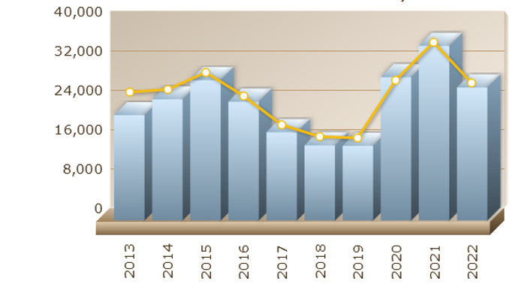
Figure 1 Annual Total Hours of Special Constables at Gwent Police (Gwent Police, 2022)
The hourly initial rate of the police officers is £13.67 per hour. The calculation indicates that Special Constables saved nearly 486 thousand pounds in 2021. Savings from Regular Officer training could be donated towards additional hours of the practical sessions of the Special Constables and to pay for mentors for supporting Specials in their development.

3.0 References.
Bakari, H., Hunjra, A., I., Niazi, G., K., (2017), ‘How Does Authentic Leadership Influence Planned Organizational Change? The Role of Employees' Perceptions: Integration of Theory of Planned Behaviour and Lewin's Three-Step Model’. Journal of change management, 17(2), pp.155–187.
Gwent Police (2022) ‘Statistics’. Gwent Police Duty Sheet.

Home Office (2014) Home Office Guidance on Special Constable expense and allowance rates. Available at: https://assets.publishing.service.gov.uk/government/uploads/system/uploads/attachment_data/file/304488/GuidanceSpecialConstableExpenseAllowanceRates.pdf (accessed 25.09.2022).

Talent.com (2022) ‘Police Officer average salary in the United Kingdom.’ Available at: https://uk.talent.com/salary?job=police+officer (accessed 07.10.2022).
Tschool, J., (2017), Standing Still Can Kill Your Business: The importance of ongoing training!, Aurora: HR.COM
Vani G., (2014), Use of Role Play and Case Study in Off the Job Training: A Comparative Analysis, Vol 3, New Delhi: Review of HRM

