Changemakers: Creativity and Value Creation
Professions (BMHP5014)

Component 1: Online portfolio of set exercises

Student name: Diyana Vasileva
Student number:2328440
Lecturer’s name: Caroline Salami

Table of contents
Key Concepts in health and social care…………………………………………….2
Innovation……………………………………………………………………...3,4
Creativity…………………………………………………………………………5
Value creation …………………………………………………………………..6
Changes …………………………………………………………………………7
How useful is the mind map in health and social care…………………………….8
Self-Reflection………………………………………………………………………….9
UK innovation -continuous glucose monitor……………………………………….10
Key issues facing the NHS-Staff burnout in social care…………………………..11
Digital Innovation in Health and Social Care ……………………………………..12
Digital technology…………………………………………………………….12
Wearable health technologies ………………………………………………12
Electronic health records (EHRs) …………………………………………..12
The main components and behaviours in the NHS leadership framework…….13
Reflective journal entry……………………………………………………………….13
References……………………………………………………………………………..14

In social care, progress is dependent on the capacity to adapt and enhance perpetually. Key ideas like innovation, creativity, value creation, and change are very important for making care services that are effective and responsive. These ideas work together to make social care better.
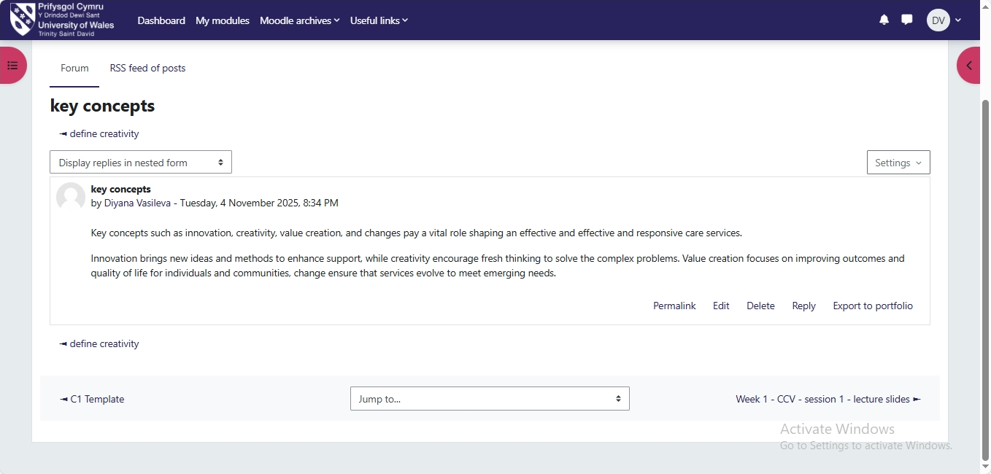

Innovation in health and social care means bringing in and using new ideas, methods, technology, or ways of providing care that help patients, service users, and professionals get better results. The NHS Innovation Accelerator (2023) says that innovation is "an idea, service, or product that is new to the NHS or used in a new way that greatly improves quality of care, efficiency, or patient experience." In this field, innovation is both a clinical and organisational process that responds to rising demands, limited resources, and complicated social needs. 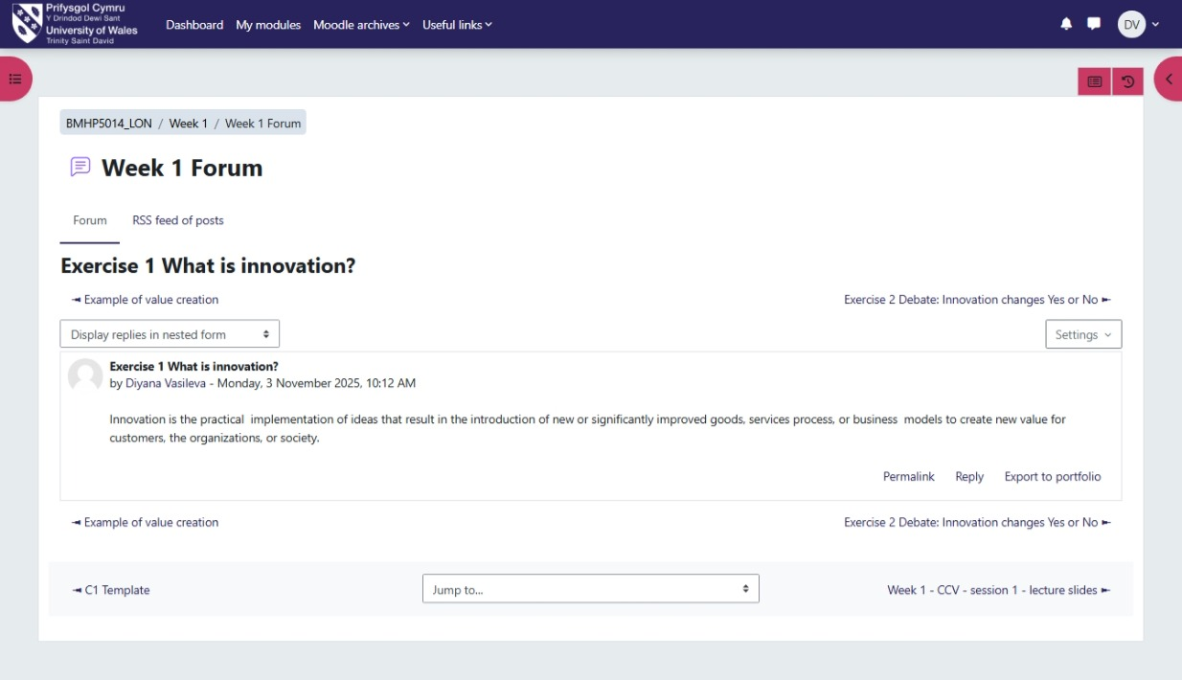

“Telemedicine, electronic health records, and AI-driven diagnostics make care more efficient, easier to get, and better overall.” (WHO, 2020).
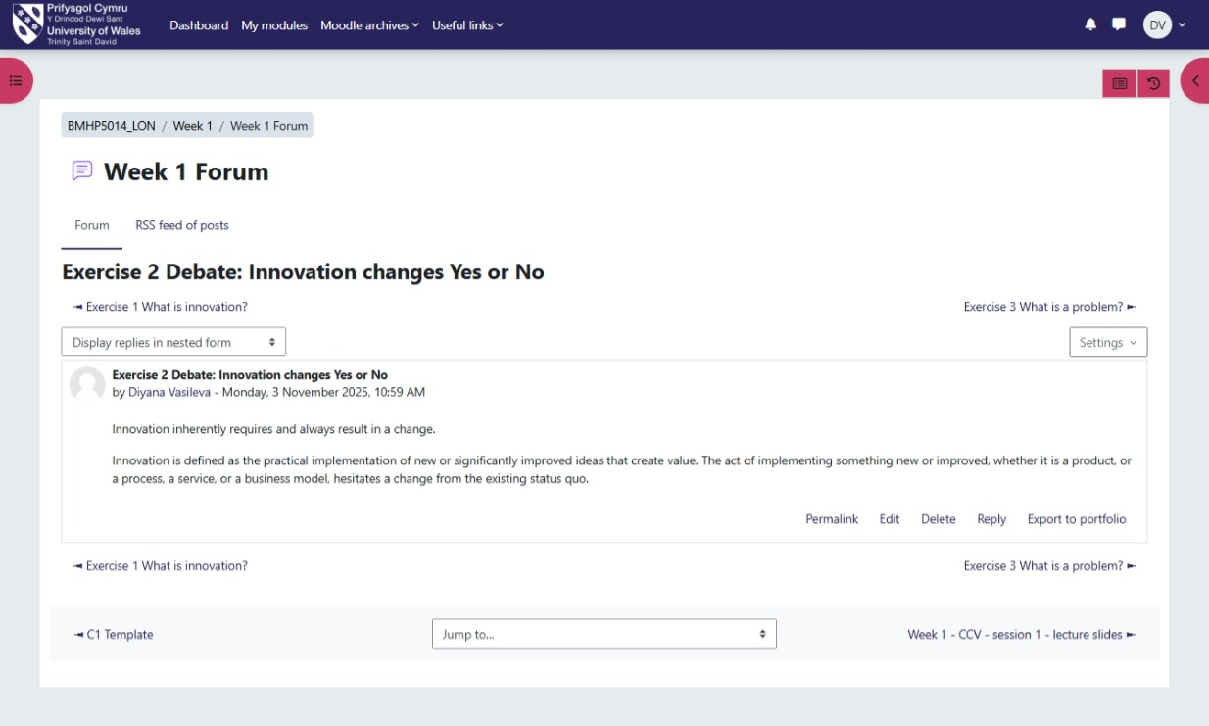
“Creativity in health and social care is necessary for enhancing the quality, efficiency, and compassion of care provision. It entails the creation of novel ideas, methodologies, or practices that improve outcomes for patients and service users.” (Runco and Jaeger, 2012).
Creativity is “the ability to think differently and act innovatively to improve care practices, communication, and decision-making” (Anderson, 2014).
"Creativity in social care also means working together, thinking about things, and being emotionally smart. It gives staff the power to think of new ways to do things and encourages service users to take an active role in designing their care. "(DHSC, 2022).
"Professionals need to find a balance between being creative and being responsible, providing evidence, and giving everyone the same level of attention". (NHS, 2019). It lets professionals use both empathy and evidence-based knowledge to fulfil the requirements of different patients.
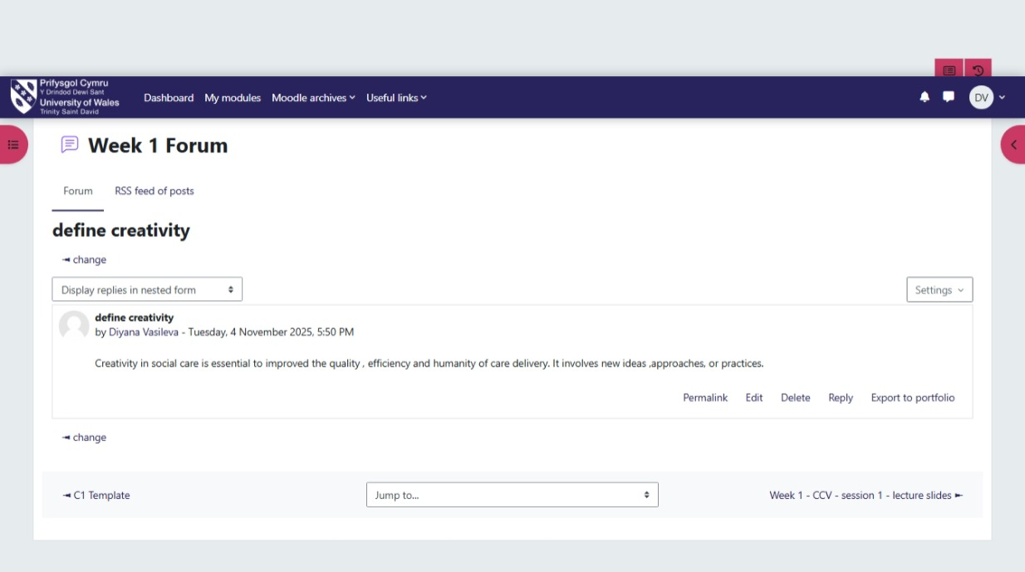

Value creation is getting better results for patients, service users, and communities while also making the best use of resources. It includes things like clinical effectiveness, patient experience, safety, and fairness. Value creation includes not only providing services that are cost-effective but also those that are fair, ethical, and long-lasting.
Change in health and social care means changing services, policies, practices, or organisational structures to improve quality, efficiency, and patient outcomes. Understanding change is essential for preserving the efficacy, fairness, and longevity of services in a complex and resource-constrained environment. This field is always changing because of new patient requirements, new technologies, new policies, and changes in the population. The NHS Long Term Plan and other national frameworks and strategies require changes to how care is delivered and services are integrated (NHS England, 2019).
A mind map usually has a centre topic and lines that flow out from the centre to show important themes or groups. The patient or service user is at the centre of social care. A mind map shows the whole picture of the problem, including the patient's life, needs, circumstances, medical history, symptoms, social aspects, status of the service's user, wishes, values, care plan, and more. It is a great way for all professionals, such as doctors, social workers, nurses, and therapists, to work together to exchange and interpret information about the case. It helps by showing all the factors and how they are linked.
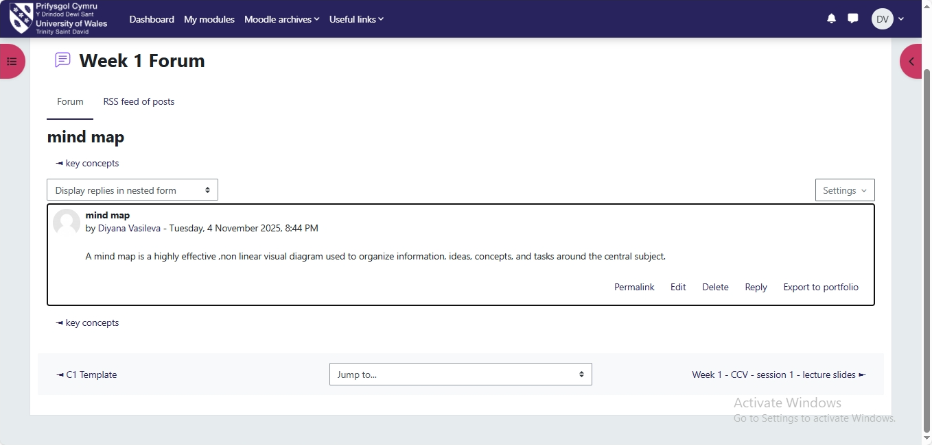

We worked in small groups in class to come up with creative ways to solve a problem in social care. During the divergent phase, we had to think freely and come up with a lot of ideas. During the convergence phase, we had to focus on narrowing things down. At first, I wasn't sure if I wanted to share my opinions, but as the talk went on, I felt more confident. I really enjoyed how every concept was treated with respect. The activity really emphasised how vital it is to be creative while trying to solve difficulties. Divergent thinking helps to come up with new ideas, and convergent thinking helps to turn those ideas into solutions that work. I learnt that both types of thinking are important: divergent thinking helps you be creative, and convergent thinking makes sure things are useful. It's necessary to create a balance between the two because both innovation and evidence-based approach are important. I intend to utilise these strategies more deliberately in the future by integrating brainstorming and assessment techniques into my problem-solving methodologies. This balanced approach will help me come up with solutions that are more complete, focused on the person, and long-lasting in my work.
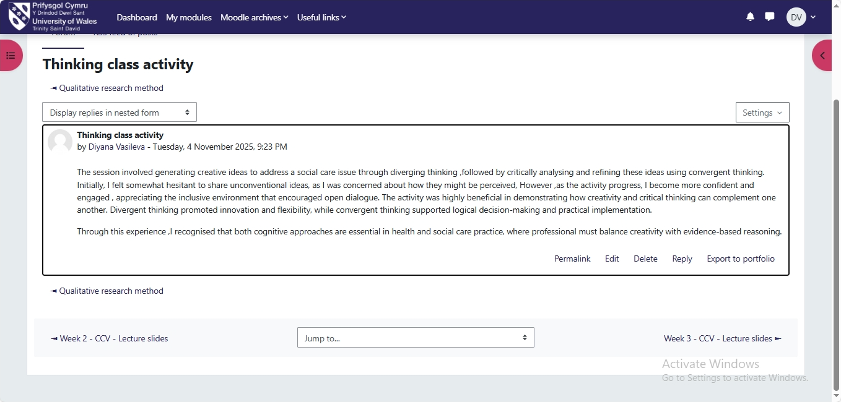

The UK Innovation CGM
What is CGM and why is it important? A continuous glucose monitor is a wearable sensor system that constantly checks glucose levels and sends the information to a display device, like a smartphone. It makes it easier to find hypoglycaemia or hyperglycaemia earlier, which may assist alter treatment more quickly. (NHS, 2024) It employs a small, disposable sensor that goes under the skin and keeps track of blood sugar levels all the time. There is an area on the skin with a small wire in it. A tiny element that sits on top of the sensor and communicates the glucose reading wirelessly. They are sent to another device or a smart phone app. The app shows what your blood sugar level is right now. It's easy to share the data with family, carers, or your doctor. For a lot of people with type 1 diabetes who need insulin, CGM has become a normal component of how they take care of themselves and keep track of their diabetes. The choice of device depends on things like personal needs, insulin regimen, risk of hypos, capacity to utilise technology, data sharing, cost, etc.
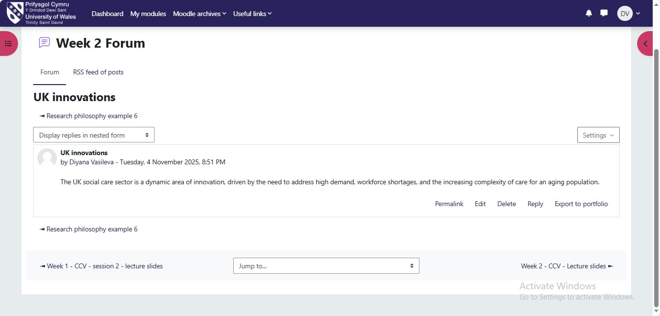

Burnout" affects nurses' health and brain structures and functions, including cognitive function. This could cause problems with their work performance and the safety of their patients. Nonetheless, limited organisational elements associated with patient safety have been discovered. "(Mongomery, 2022)
Staff burnout in social care is a major problem that is caused by both personal and structural issues. There needs to be a mix of self-care, help from the organisation, and changes at the policy level. Identifying problems early and taking proactive steps can help keep staff, maintain high standards of care, and protect the health and safety of both employees and clients. This syndrome results from extended exposure to occupational pressures, resulting in significant repercussions for healthcare practitioners and their organisations. Burnout is linked to not getting enough sleep, making more medical mistakes, giving less care, and getting lower ratings from patients. Burnout in social care is a big and complicated problem that affects those who work in health and social care settings. It happens when someone is under a lot of stress for a long time, has a lot of emotional demands, and is under a lot of pressure from the system.
Digital technology
Digital technology can help with preventative care and health promotion by giving people tools that encourage healthy habits, keep track of risk factors, and allow for early intervention. For instance, a smartphone app could encourage people to work out regularly, keep an eye on their nutrition, and keep track of their blood pressure. It could also provide them personalised feedback and alarms if their numbers are too high.
"This ongoing involvement helps people make healthier decisions and gives healthcare experts the chance to step in before issues like obesity or hypertension turn into more serious diseases."(WHO, 2020).
Wearable health technologies
Wearable health technologies are sensors or devices that people can wear to keep an eye on, measure, and sometimes control different aspects of their health and well-being. These technologies are becoming very common in everyday life and healthcare since they provide real-time data, encourage preventive care, and make it easier to control one's own health. One of the main benefits of using wearable health devices like smartwatches to manage chronic health problems is that they constantly monitor vital signs, which makes it easier to spot health problems early. They can track heart rate, activity levels, and sleep patterns in real time. This lets patients and healthcare practitioners see changes from normal patterns that could mean that conditions like diabetes, high blood pressure, or heart disease are getting worse, and can help people manage their own health better, make it easier to follow treatment plans, and maybe even lower the number of hospitalisations.
EHRs, or electronic health records
Electronic Health Records make it easier for healthcare providers to talk to and work with each other by giving them a central place to store and retrieve patient information. EHRs make it easier for healthcare providers to talk to each other and work together by giving all physicians access to up-to-date patient information in one place. "This makes care more coordinated and cuts down on mistakes" (HealthIT.gov, 2023).

The NHS Leadership Framework sets up training for leaders in health and social care. Personal traits, working with others, running and improving services, and setting a course are all very important. These things help people become more aware of themselves, talk to each other better, work together well. Strong leadership makes sure that care is safe, effective, and focused on the patient, and it also helps professionals move up in their careers. Consistent leadership encourages accountability, ongoing improvement, and a shared vision, all of which are necessary to solve the complex problems facing modern healthcare. The NHS Leadership Framework can help people at all levels of health and social care become great leaders. Being a leader means showing personal qualities, working with others, running services, improving services, and giving people direction. These actions show that you are aware of yourself, honest, able to communicate, work as a team, and plan. The framework helps healthcare workers be good leaders, make good choices, and improve patient care. The framework helps professionals figure out what they're good at, what they need to work on, and how to move up in their careers. It encourages ongoing growth, responsibility, and a shared vision to meet the needs of today's complicated health and social care systems. A leader who inspires a common vision can come up with new ideas and make patient care better. The leader encourages new ideas like getting patients involved and improving care delivery by including workers in setting goals and recognising their work. This way of working together makes staff care about results, which leads to proactive problem-solving and personalised service. A leader who promotes a shared purpose can inspire fresh ideas and improve patient care by getting everyone on the same page. By involving staff in setting goals and rewarding their achievements, the leader fosters an environment that encourages new ideas, including innovative methods to deliver care and get patients interested. This way of working together makes personnel care about the results, which means they are more likely to solve problems on their own and give each customer individualised service.
I used to think creativity was something only one person could accomplish, but now I see it as something that needs to be done jointly to improve patient care and service delivery. Digital health technology and the NHS Leadership Framework showed how innovative ideas can improve patient control, operations, and risk. Through wearable technologies and preventative care apps, I learnt how new solutions can improve health outcomes. According to leadership qualities tasks, creativity requires efficient communication, collaboration, and appreciation of other opinions. This lesson will make me try new things, include coworkers in problem-solving, and focus on patient-benefitting solutions. It also motivates me to lead healthcare organisations that promote constant progress and change.

Reference:
Anderson, N., Potočnik, K. and Zhou, J. (2014) ‘Innovation and creativity in organizations: A state-of-the-science review, prospective commentary, and guiding framework’, Journal of Management, 40(5), pp. 1297–1333.
Department of Health and Social Care (DHSC) (2022) People at the Heart of Care: Adult Social Care Reform White Paper. London: DHSC.
HealthIT.gov, 2023. How EHRs improve care coordination. https://www.healthit.gov/faq/how-ehrs-improve-care-coordination
Montgomery, A. P., Patrician, P. A., & Azuero, A. (2021). Nurse burnout syndrome and work environment impact patient safety grade. Journal of Nursing Care Quality, 37(1), 87–93.
National Health Service Innovation Accelerator (NIA) (2023) What is Innovation? https://nhsaccelerator.com (Accessed: 25 October 2025).
National Health Service (NHS) (2019) The NHS Long Term Plan. London: NHS England.
NHS England, 2019. The NHS Leadership Framework. https://www.england.nhs.uk/leadership/nhs-leadership-framework
Runco, M. A. and Jaeger, G. J. (2012) ‘The standard define creativity’, Creativity Research Journal, 24(1),
World Health Organization (WHO), 2020. Digital health. https://www.who.int/health-topics/digital-health#tab=tab_1
World Health Organization (WHO) (2020) Global Strategy on Digital Health 2020–2025. Geneva: World Health Organization.

