

Student Name: Kitti Takacs
Student Number: 1906398
Lecture Name: Molly Jack
Modul No: BMSW5103
Module Title: Understanding and Engaging in the Customer Experience

Table of content

1. Introduce the organisation I have chosen to write about
2, Critically analyse the factors that influence your organisations quality systems and controls
for customers in times of crisis like COVID-19
3, Identify the systems that support your organisations quality processes and provide a critical
understanding of the extent to which you think those systems are effective in meeting
customer requirements and maintaining good customer relationships in times of crisis like
COVID-19.
A, Innovation Process
B, Employees
C, Customer behaviour
4, Analyse the customers ‘experience of an organisation
5, Segmentation
6, Customer Purchase Cycle
7. Identify systems that supports your organisations quality processes and provide a critical understanding of extent to which you think those systems are effective in meeting customer requirements.
8, Cost leadership
9, Differentiation
10, Focus
11, The Importance of Technology
12, Lowering costs, facilitating and identifying training opportunities
13, Engaging staff and setting organization-wide direction
14, Critically evaluates the benefits and challenges of developing and maintaining good customer relationships
15, Executive summary
16, CONCLUSION
Referencing

1, Introduction

Introduce the organisation that I have chosen to write about in my assignment. The organisation I will write about is my work place and it is called Dental Smiles London. Dental Smiles London based in central London, King Cross St Pancras. The company based across four practises. With the nonstop growing competition in the market, any organization not just healthcare must understand the customer experiences to identify their preferences and needs. Most people think health care is a different sector, but as all organization dental smiles London is facing the same problems and customer service issues as many other types of businesses and organizations. Most costumers will choose us regarding our dental care or hygienist care but also, they will come because our costumer service. This report will show, cover different aspects of customer experience regarding our treatment. This report will also summarize Dental Smiles London, including key competitors and the size of the market. The report will assess the marketing environment that Dental Smiles London operates within by focusing on the political, economic, social, technological, environmental, and legal factors. Furthermore, the assignment would assess the clinic current marketing strategy about how to deliver customer value. For every organisation it is essential to understand customers experience in effective manner so that they can engage with them for the long-term duration. Customers experience is considered as a product of an interaction among a company as well as a customer over a particular time duration of their relationship. (Adhikari, 2016)

2, Critically analyse the factors that influence your organisations quality systems and controls
for customers in times of crisis like COVID-19
Customer value is considered as the satisfaction level which is a feeling by a customer after purchasing particular products and services. It is also considered as satisfaction level of the customers towards a business which encourage people to pay for the products and services again and again. (Bagdare, 2013). It means there are many different factors which impact on the organization abilities in order to improve customer values, this kind of element or elements may affect operations either negative or positive way. There are many different types of customers for example, price buyer, relationship buyer, value buyer and many more. It means the company needs to identify their costumers so it will help to develop effective decisions. The company also need to evaluate customers value as it will be able to help in organizing about the products and services. Dental Smiles London or any other companies are not able to operate without customers. At Dental Smiles London customer service is one of the most important parts. To be able to provide healthcare the organization must provide high standard customer service. Regarding the global pandemic most of the company standard customer services had to change. Most of the changes what the company are going through is organised and controlled by the government. Dental Smiles London followed all the new systems such as patients must wait outside and also wear face covering all the time in reception area. However, our clinical team had to organise they’re safety and customer service. With the special ppt mask our clinical team had to face difficulties to communicate with our customers. In this organization we need to make sure the patient is able to understand us clearly. To be able to continue the high-quality system we had some training done. Also, we call every patient before there appointment to go through a couple of questions regarding Covid-19 and to explain about the changes, such as face covering, 2-meter distance or only card payment.

3, Identify the systems that support your organisations quality processes and provide a critical
understanding of the extent to which you think those systems are effective in meeting
customer requirements and maintaining good customer relationships in times of crisis like
COVID-19.

Quality management standards establish a framework for how a business manages it is main actions. They identify an agreed way of doing something, either making a product, managing a process or delivering a service.

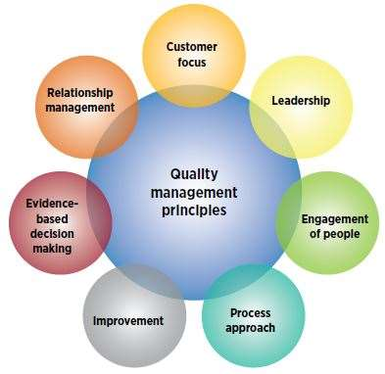
Quality Management System (QMS) Principles

Innovation Process
What does the innovation process mean: “Innovation is seeing what everybody has seen and thinking what nobody has thought.” –Dr. Albert, Szent- Györgyi
As Dr Albert said every organization it is important to accept innovation because it able to help solve issues, adopt innovation process and also introducing new innovative products and services. Able to adopt innovation procedure may the companies use theories such as Kurt Lewin’s Changed model which was developed by Kurt Lewin in 1939.
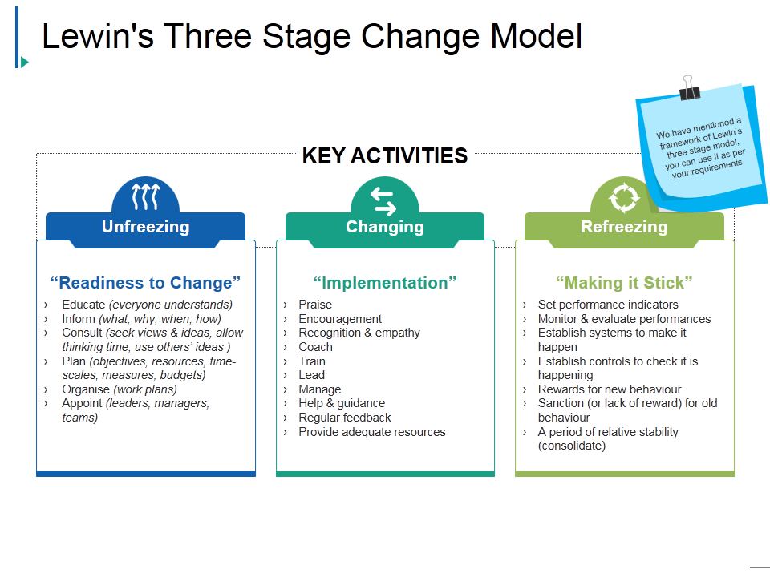

Lewin’s three stage change model there are three important steps as you can see as above. First step is unfreezing, second is changing and the third step is refereeing. Regarding the global pandemic, Dental Smiles London had to use Lewin’s model as the company needed to consult, plan, organise and appoint with the management team. The next step was to provide training for employees, help them and provide adequate resources. Dental Smiles London still in the last stage as we the management are monitoring and evaluate the performances, monitoring employee’s behaviour. The main training provided them understand about how to keep friendly costumer service and look after customers and follow the government guidelines.

Employees
Employees are considered as a person, this person who was hired by an employer for a specific job. As David Grossman, 2019 view point all firm it is important to develop and maintain effective employees’ engagement. Dental Smiles London the particular factor is able to positively influence their skills to maximise the customer value. According to Douglas McGregor, an American social psychologist, proposed his famous X-Y theory in his 1960 book which called 'The Human Side of Enterprise'. Theory X and Theory Y are still stated to usually in the field of management and motivation, even if new studies have questioned the inflexibility of the model, McGregor’s X-Y Theory stay as a valid basic principle from which to develop positive management style and techniques.
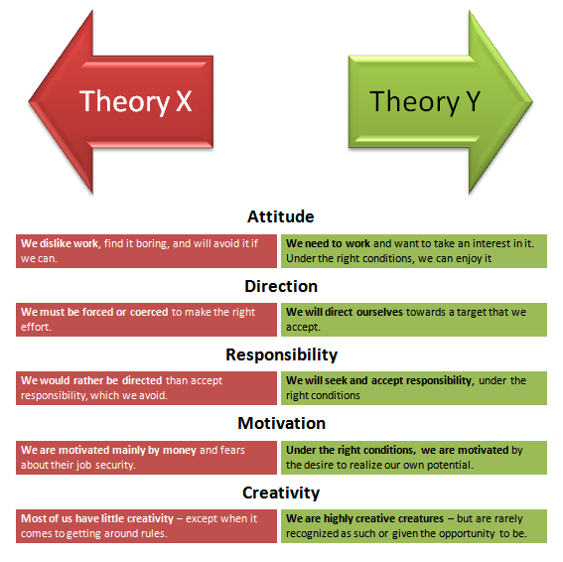
Regarding Theory X and Theory Y, Dental Smiles London is able to use this theory. As many different behaviour and attitude combine in the workplace, this theory is able to help separate negativity and positive work attitude.

Costumer behaviour
“As a business leader you have to ask yourself, “Am I creating a consumer environment that is conducive to loyalty?” If the answer is no, FIX IT!”― (Maraboli, 2013)
Along with Maraboli 2013 quote, there are many different factors which can impact on customers behaviours, for example age, lifestyle, education, income level, and many more. In Dental Smiles London since covid-19 I can confirm customer behaviour changed in many different ways. As an example, regarding for it for example patient less patient and also less understanding for following rules. It can be because not everyone believes about covid-19 or some patient just feel it is too long the restriction. Negative behaviour it can affect the business in negative ways such as bad review but also this pandemic has some positive changes for example the patient has more time and willingness to communicate as they are working from home and happy about any interaction.
4, Analyse the customers ‘experience of an organisation
Firs of all I would like to write about what is the difference between customer experience and customer service as many people are confused about. In one sentence, customer service is just one part of the whole customer experience. So, costumer experience became many different types of services.
Dental Smiles London customers experience is very important. Every single time even if the patient new or existing we focus on the customer experience and make sure they get high standard service every time. Regarding Covid-19 we changed some services it affected both in good and bad ways for our customers. The government guideline 2 meter apart and wear a mask did not help to build relationships easy if the patient first time with us. As our mimic or smiles is able to help for the patient and create a good experience. All in all, we are trying to focus on how to build the relationship and help customers to understand the situation. Regarding Dental Smiles London and my personal experience, I can say more training and explanation are able to help the business to provide better customer experiences.
5, The Importance about technology
“One machine can do the work of fifty ordinary men. No machine can do the work of one extraordinary man.” - Elbert Hubbard (Author) (Hubbard, 1998)
Technology is called methods and skills which used in a daily basis. There are many different types of technologies which can be used in the company for example power, communication, clinical technologies and many more. In Dental Smiles London technology is very important not just for the good customer service it also helps with our clinical team. For example, dental smiles London using new developed technology such as iTero scan, cerec machine, or soe system. Without technology Dental Smiles London would face big communication problem. Between administration and clinical team, we are only able to communicate via a secure system. Regrading this global pandemic without technology would take more time inform patient about changes or cancelations. Technology are very important no matter how difficult a time we are facing.

6, Segmentation
Marketing segmentation is a very important concept in marketing and in marketing planning' - The Marketing Plan: A Practitioner's Guide, John Westwood said. Dental Smiles London recognises the customers and segments where they are ablet to create values relative to competitors in the market. For example, there are huge numbers of different treatments among dentistry such as like Invisalign. People choose the practice according to the experience, want and expectation.

7, Customer Purchase Cycle

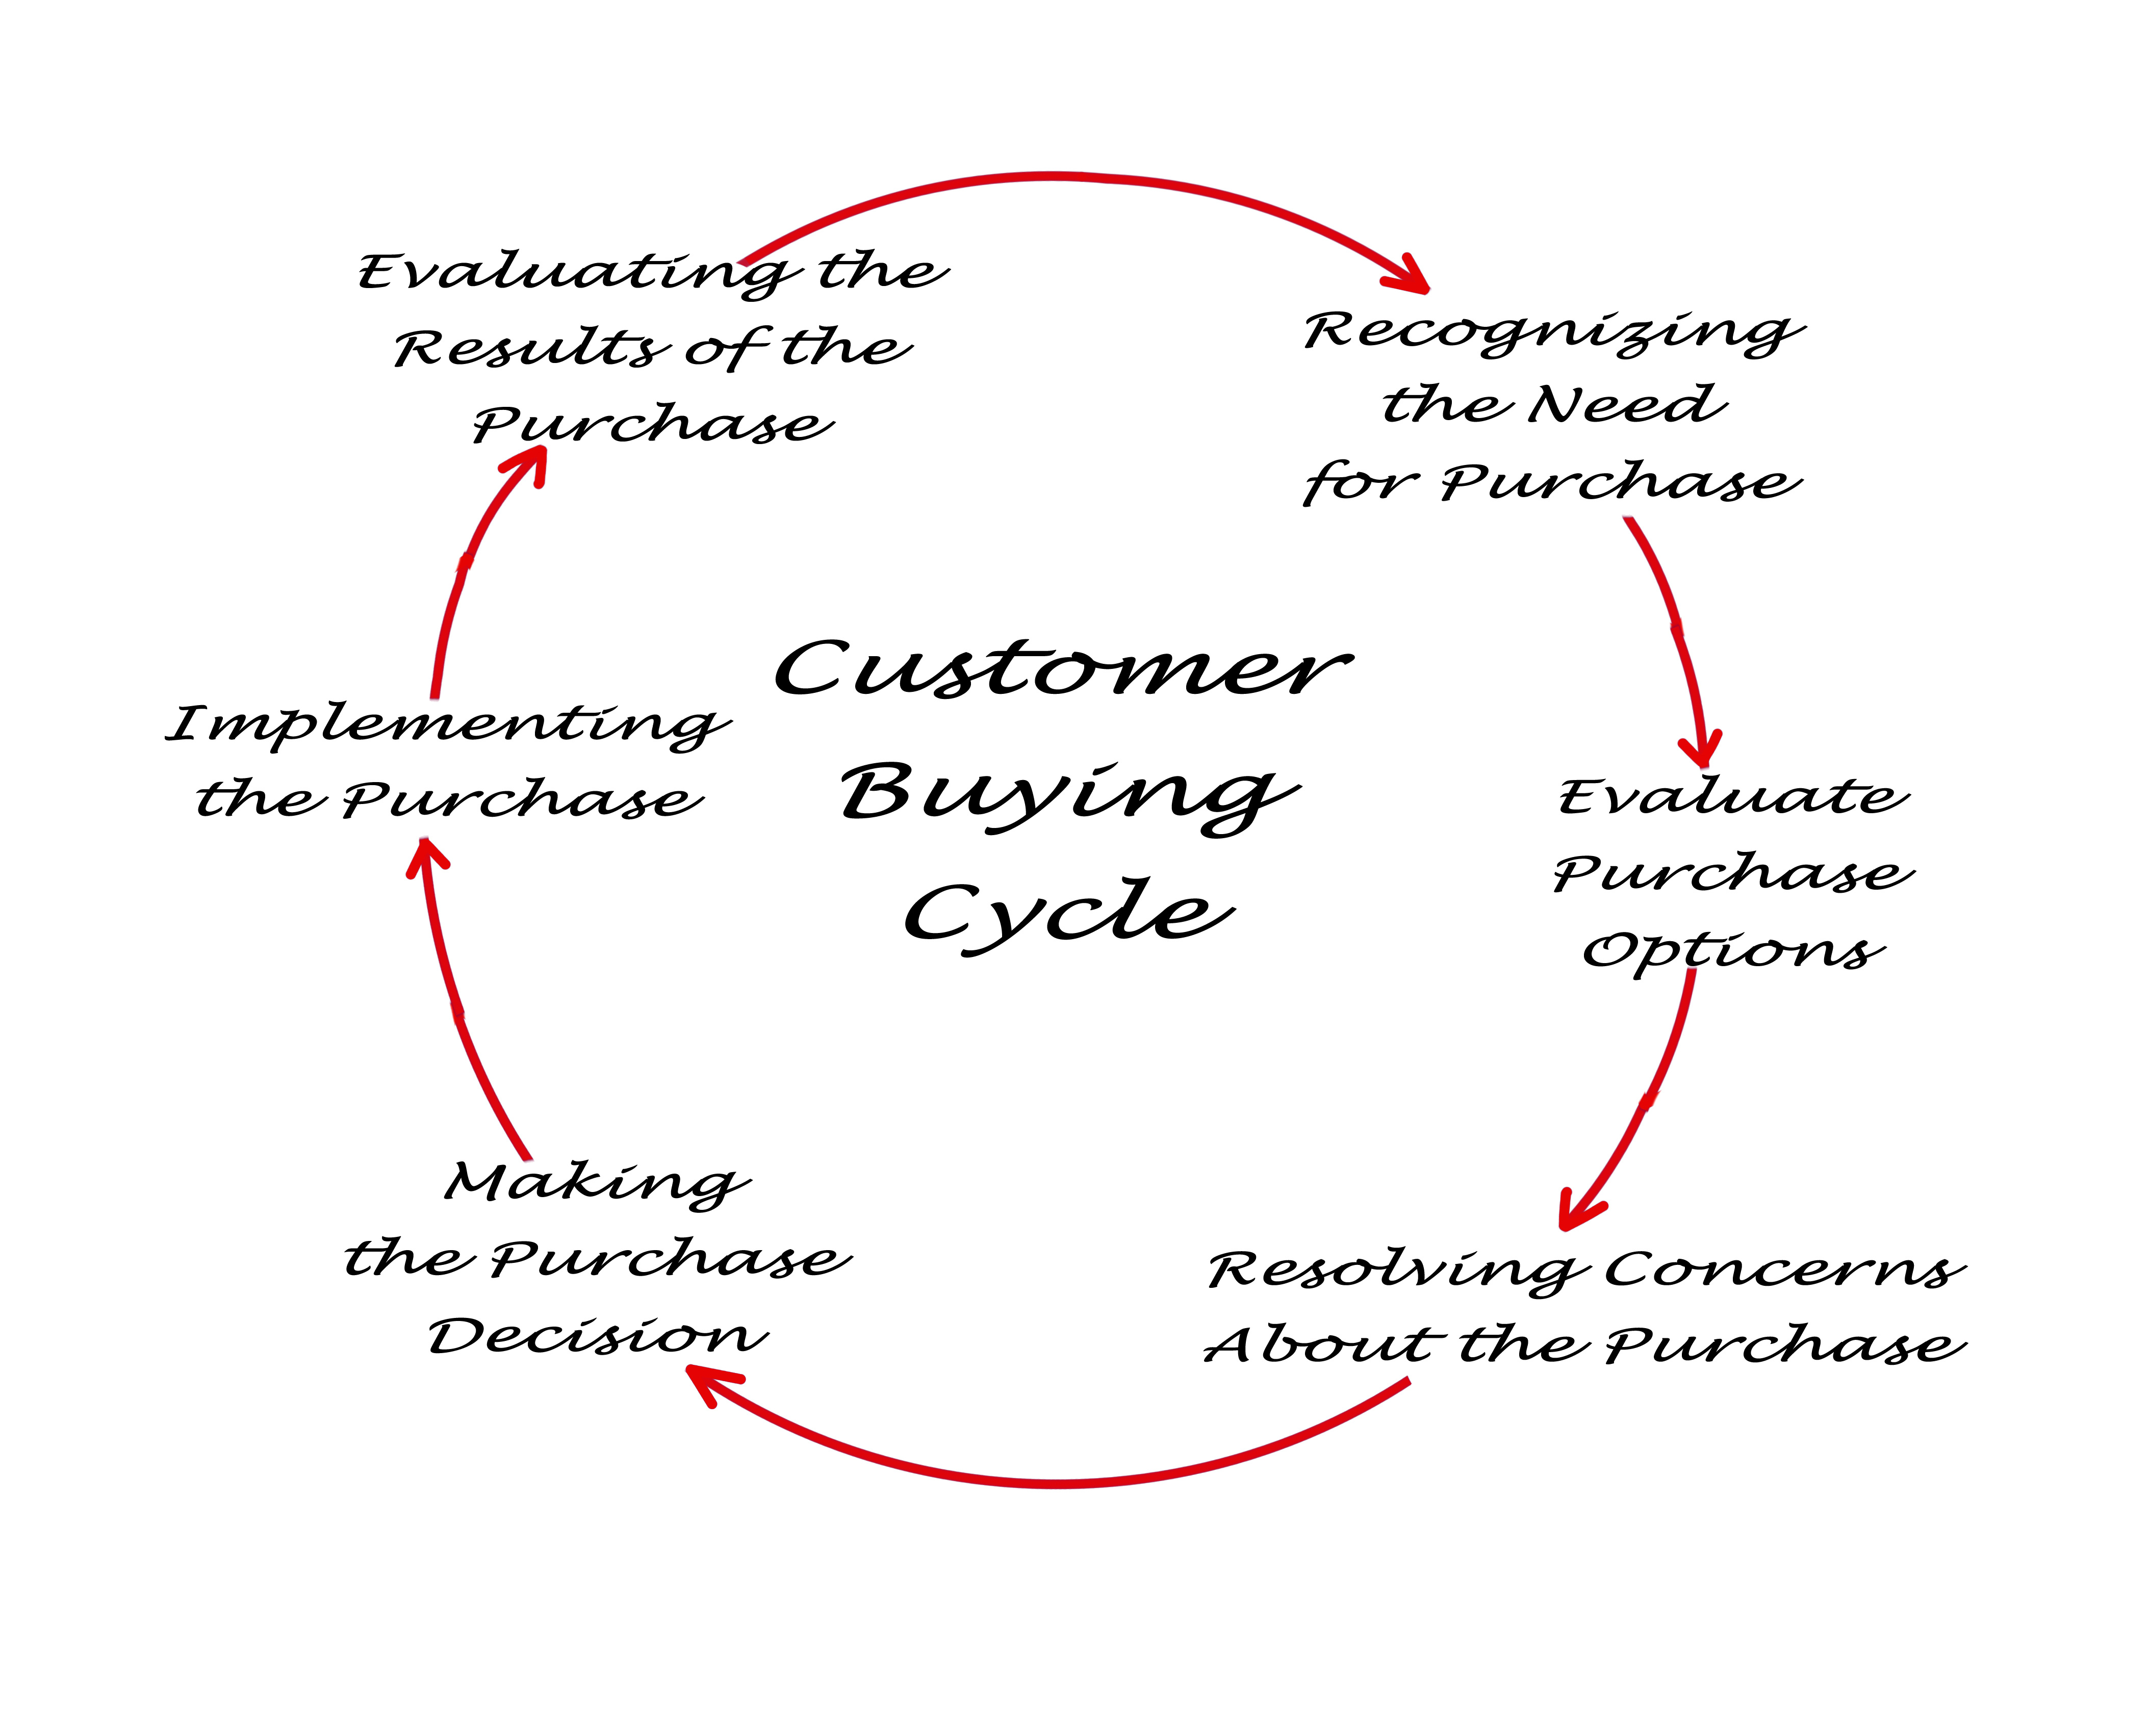
The easiest way to look at the customer buying cycle is to break into three main stages, such as awareness, consideration and purchase.

8. Identify systems that supports your organisations quality processes and provide a critical understanding of extent to which you think those systems are effective in meeting customer requirements.
“A management system is the framework of processes and procedures used to ensure that an organization can fulfil all tasks required to achieve its objectives.” / wikipedia.org
Why is quality process so important to any organization? It is known fact that company or business are a complex system. Most organization uses a management system to help them with resources to able to grow the business. Does not matter of the size or the activities of the organization need to manage internal processes in order to get the service what was requested by the patient, client to achieve the established objects. Dental Smiles London has the own Management system so it can be used and continuously improve. At dental Smiles London we are focusing on our customer service improvement however all management meeting we are analysing the process and the results as well

9, Cost leadership
A cost-leadership strategy focuses on lowering service or practice costs. It is important to highlight that cost leadership need not necessarily lead to lower than average prices. A practice which adopts a cost leadership stance can charge lower prices) or it can charge the same prices as other dentists in the area and enjoy larger profits. Since most dentists comply with their local fee guide, focusing on costs is the main way for dentists to earn larger profits. However, this does not mean that dentists should not follow a differentiation or mixed strategy, because referral rates and switching costs are essentially linked to quality. Dentists can reduce costs by capturing economies of scale, achieving economies of scope, capitalizing on economies of learning, lowering coordination and organization costs, reducing input costs and, perhaps most importantly, improving operational efficiency.
10, Differentiation
Differentiation is another strategy that is used regularly by organisations to improve benefit over their competitors. Dental Smiles London uses this strategy with cost leadership together to gain and achieve more. The importance of Dental Smiles London behind using differentiation strategy is to differentiate. Dental smiles London has been effectively using this strategy for many years now in order to stand out and be different from other brands and reduce pressure on itself. For example, Dental Smiles London only use Invisalign from MiSmile. Many different brands came to the market but most of them are already gone or bankrupt. Our company focusing on costumers to be able to provide not just perfect care but able to finish any treatment as the company provider are running efficiently.
11, Focus
Dental Smiles London has adopted for this strategy in terms of both offering the best value as well as low cost. Dental Smiles London is using low-cost focus strategy as we offering three different type of hygienist session with affordable price. Dental Smiles London is constantly review focus strategy and regarding the global pandemic trying to help to our patient with a low-cost treatment as national health care are extremely busy. There are many different systems that can support the quality processes of an organisation.

12, Lowering costs, facilitating and identifying training opportunities
Improving processes and reducing cost in dental smile London is difficult as we are a healthcare provider organization. The company uses high standard materials to provide high quality service. To e able to lower any cost is to work with dental technicians outside of London. Also, we had to analyse our hygienist treatment. As we are providing 2 different cleaning options, and the difference between them is the length of the treatment. Our data analysing and focus theory helped us to manage and prove that the one-hour cleaning for the organisation is more beneficial. To be able to explain the new rules and systems to our patient we organised some training for the staff. Most training had to be done via zoom as the global pandemic does not allow us to be in the same room. Training is one of the most important opportunities for employees to improve they customer service. Able to provide high standard costumer service at dental smiles London has training every week. Understand the importance of the treatment and to be able to explain to the patient is very important.

13, Engaging staff and setting organization-wide direction
“Employees who believe that management is concerned about them as a whole person – not just an employee – are more productive, more satisfied, more fulfilled. Satisfied employees mean satisfied customers, which leads to profitability.” – (Mulcahy, 1952)

14, Critically evaluates the benefits and challenges of developing and maintaining good customer relationships
Giving good customer service is the most important for business even now when people in under physiological pressure by this covid-19. “Customer service is everything and anything that touches a customer ― directly or indirectly. Customer service means servicing customers, and it’s so much more than just solving problems or addressing complaints. Customer service is part of a holistic customer experience that is capable of providing a critical competitive advantage in today’s increasingly cluttered and commoditized marketplace.” – (Jaffe, 2007)
There are many ways to give good customer service I will be focusing on seven advantages of giving good customer service in dental smiles London perspective. One of the main reasons how to become a great business rather than just good is because of the loyalty for the patient or customers. This loyalty can help for the patient to stay back with the practice over years. To achieve loyalty from the patient we need to provide good customer service.
First of all one of the advantages of a good services is a brand. Dental Smiles London is working with one of the best Invisalign providers and top dental technicians. Using the best or the top brands helps to run the clinic smoothly and our clinical team are more relaxed because the are able to use the best quality even in technology not just material. Getting more references is one of the other advantages. Dental Smiles London uses review platforms to help new patient find the way to the clinic. Since I joined to the company, I never understood why it is so important to ask patient to write about, they experience. I had a chance to read about it and now we have weekly training how to build relationship with customer and be confident to ask them to write about they experience. Dental Smiles London also focusing on video testimonies. Video testimonies is the best way to show new patient through social media because they can see the face behind the words. However, to build this relationship with patient takes more time. These kinds of references mean more patient and that is bring more money to the business. More and more references the more customers who enter the clinic door without the management team spending time on marketing and advertises. The third part will be creating a word of mouth. In dental smiles London, we are able to create words of mouth as we provide treatment for tourist. Once we had a patient who needed an emergency appointment. He spent a week in London and found us through the good reviews and book an appointment. He was extremely satisfied with the dental care and customer service so he asked what treatment need to be done because he will come back and he would like to have it done with our clinic. Increasing profitability is when your customer service is good and references and world of mouth as well. Means, most companies spend thousand or hundreds on advertising and promotions. If you have a good customer service patient will return back. If you are able to provide customer service patient will tell their friends, family or work place. Dental Smiles London focusing on patient and if patient is satisfied with the service, they will bring more and more patient into the clinic without doing a huge budget of marketing and advertisement. Gives you and your employees confidence is the other advantage of a good customer service. When any patient or customer commenting or praises your business, it is also making us employees happy. Herve Humler said “I believe in the power of recognition and empowerment leading to great employee engagement. And employee engagement is critical to guest engagement. Employee empowerment and recognition is the core of our culture and how we achieve outstanding customer service.” – Herve Humler . The sixth point is to create a holistic marketing scenario. Employees motivation and with the happy customer the business able to become a holistic marketing scenario where everybody is doing their part for a final customer satisfaction. The last but not least, the competitive advantage. Competitive advantage when the employees are building relationship with the patient then the business has no competitive and difficult to beat because the business become sustainable. Dan Schulman said “If you want to have the best employees, there really needs to be a vision and a mission. Talent looks for a mission. And if you have the best talent, that's the single biggest competitive advantage any company can have.” Dental Smiles London focus on customer service but also focusing on employees. In many ways, leadership is about defining reality and inspiring hope, but if you have these great people around you and they know that what they do is going to be recognized, it can be incredibly powerful. – Dan Schulman

15, Executive summary
Summarizing my Understanding and Engaging in the Customer Experience. The company which I used in this assignment is Dental Smiles London and I am a practice manager in on of our brunch. Covid-19 effective every single companies’ organization not just Dental Smiles London. Facing with the global pandemic every organization needed strategies and theories to stabilise and improve the businesses. Dental Smiles London choose to focus on customer service as without patient we cannot operate. Also, on meeting we used some theories such as value, attitude and beliefs. Attitude is important in customer experience, when you are facing with covid-19 as most people do not believe and follow the guidelines. Customer service needed to improve and find strategies to provide the same customer experience level. Without face-to-face communication and mimic is very hard to build a relationship with new patient. Dental Smiles London used references to able to provide more information and existing patient helped us spread the word about our business. Luckily, we had a chance and technologies to inform and keep in touch with patient via email or phone. We were able to provide information and answers about how we operate. Technologies helped to keep in touch with patient and build relationship and continue good customer service. All in all, this year was the hardest year in my personal life regarding all the lockdowns. Mentally and physically, it was a hard year for any organizations and professions.

16, CONCLUSION
In my assignment I have discussed point can be analysed for every single company to achieve, prove and develop and maintain effective engagement and understand in customer experience. All the factors which I am covered in this essay is about Dental Smiles London customer service representative way. The company prior is to provide the best customer service and all the training is provided to achieve it. At this point this research and assignment helped me improve my way of thinking about some strategies, theories or facts. Many different way to improve customer experience but in my personal perspective is to treat every patient equally and respectfully. In dental care customer service can be hard as patient in pain. To provide the best customer service first you need to have knowledge to be able to explain what will happen. At least but not last, I think it is possible to provide good customer care just need to listen to the customer carefully and analyse the problem and solve it perfectly.

References
Adhikari, A. and Bhattacharya, S., 2016. Appraisal of literature on customer experience in tourism sector: review and framework. Current Issues in Tourism. 19(4). pp.296-321.
Bagdare, S. and Jain, R., 2013. Measuring retail customer experience. International Journal of Retail & Distribution Management. 41(10). pp.790-804
Unapologetically You: Reflections on Life and the Human Experience by Steve Maraboli, Published May 7th 2013 by A Better Today
Marketing Plan: A Practitioners Guide: A Step-by-step Guide (Professional Paperbacks) Paperback – 2 Jan. 2002 by John WESTWOOD (Author) A step guide professional paperbacks marketing plan
Why is Quality so important for an organization? | ICMCI (cmc-global.org)
Anne M. Mulcahy 1952— Biography - Leading by listening, sources for further information. www.referenceforbusiness.com. Retrieved 2017-11-15.
Market segmentation- Definition, Bases, Types & Example. 2019. [Online]. Available through: <https://www.feedough.com/market-segmentation-definition-basis-types-examples/>. What is Supply Chain Management (SCM)?. 2019. [Online]. Available through: aa<https://scm.ncsu.edu/scm-articles/article/what-is-supply-chain-management-scm>.
Joseph Jaffe, 6 Nov 2007Join the Conversation: How to Engage Marketing-Weary Consumers with the Power of Community, Dialogue, and Partnership how to engage marketing consumers with the power.
15 Great Customer Service Quotes to Inspire You (hubspot.com)
Executive Profile Daniel H. Schulman". Bloomberg Businessweek. 23 January 2015.

Elbert Hubbard, Love, Life and Work, Paperback, 156 pages, Published February 1st 1998 by Kessinger Publishing

