The role of Social Enterprise in today’s society
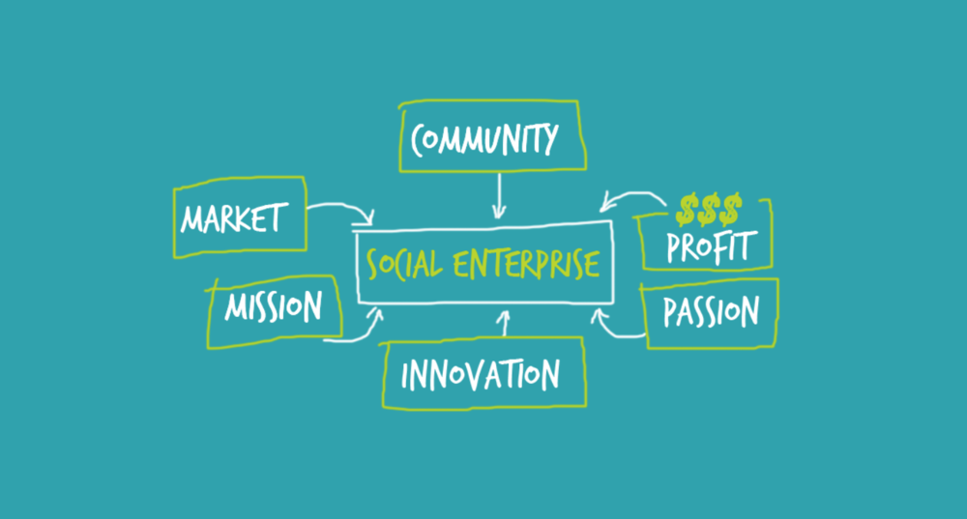

By: Katie Garside
Module: Developing Social Enterprise
Tutor: Jessica Shore
Assignment due date: 15th November 2019

The role of Social Enterprise in today’s Society

This essay will explore the role and growth of Social Enterprise in the 21st Century and why they are becoming more popular. The following research will discuss the differences a Social Enterprise can make in our Society today. This information has been gathered by researching credible authors and comparing existing social enterprises. Social Enterprises create a ripple effect in the local community and the aim of this essay is to discover the definition of ‘Social Enterprise’ and the reasons behind how and why society benefits from this. There is evidence that the government are not able to support things such as the Youth Service, Mental Health Provisions and smaller local businesses. There is a social need that has to be addressed and it is believed that if more social enterprises were to exist, this could be a viable solution.
Social Enterprise UK (2018) author Liam Kay conducted research in 2018 which demonstrates that Social Enterprise is worth 60 billion pounds when the government had originally estimated that it was only worth 24 billion to the UK economy. This makes the amount over more than double from the governments original estimate and expectations. To gain an understanding of the term ‘Social Enterprise’ – it was necessary to find out what defines a business as a Social Enterprise as opposed to a traditional profit-making business. Social Enterprise.org believe the definition of a Social Enterprise could be described as “they aim to make a profit but it’s what they do with their profits that sets them apart – reinvesting or donating them to create positive social change”. There are some similarities between a social enterprise and a traditional business. These similarities include staff, structure, purpose and profit. Both businesses have these similar traits, but both have a very different end goal. A traditional business will aim to make profit for the benefit of the owners or shareholders, whereas a Social Enterprise’s main goal is to also make profit but will then use this profit to benefit society and make a positive change in the community. This could be a society either at a local level, national level, international or global – which are all varying levels of society but all working together towards the same outcome. A society could be described as “a large group of people who live together in an organized way, This is how it is defined in the Cambridge dictionary.
It appears that there may be greater benefit to a society from a social enterprise than that from a traditional business in the local area. According to Ridley-Duff & Bull, they believe that the private economy is being heavily subsidised by the government which comes at a cost to the social economy. Particularly during the 2007-8 economic crisis (Ridley-Duff, M Bull, 2011). “The New Economics Foundation estimated that the UK’s ‘big four’ banks received subsidies to the value of £35 billion in 2012 in addition to the ‘bail out’ investments made by the government (Prieg, 2012). Since 2007, the cumulative additional banking subsidy was six times greater than the value of all grants and donations to the charity sector.
Whilst in a lecture it became clear that a social Enterprise could provide provisions to society, that society itself has observed is lacking. People are self-identifying, self-creating and becoming more self-sufficient. Social Enterprise has the potential to offer Society what it needs.
According to Maslow’s hierarchy of needs, the basic physiological needs include water, food, sleep and shelter (Maslow, 1943). The government are withdrawing funding and are now tending to focus on just the basic needs and tend to forget about the other hierarchical levels. As a result of this, naturally, communities seek to help and support each other to achieve more than just the basics and want to gain more fulfilment from life. New York Times best-selling author Mei Mei Fox (2016) believes that the young people of today are just as concerned about making a positive impact on the world as they are about making money. As much as 94% want to use their skills to help a cause.
If more communities came together to promote and support a social enterprise this could then help them, and others make more of a social impact and progress up the hierarchy levels. If a social enterprise is run well, this can then provide employment which helps people then move to the next level of safety and security on the hierarchy of needs pyramid. This also benefits the local community in a variety of ways. This creates a ripple effect through a chain of events such as by providing employment, there will be less people relying on government benefits which is then less strain on the economy. The Cambridge dictionary defines ‘A ripple effect’ as a situation where one event causes effects that multiply and generate additional effects. These ripple effects could begin with a social need in society of children and young adults having nowhere safe to go and possibly beginning to show nuisance behaviour. A local social enterprise could form a youth centre to provide somewhere safe for these children to go and then also teach them life skills and transferable skills which could help them fulfil their own needs.
DrM’z is a youth drop-in centre run by Carmarthen Youth Project for young people aged 11-25. They provide a comfortable, safe and informative place for young people to meet and learn new skills. This is a vital social enterprise as it will affect the ripple effect by the young people visiting here are less likely to commit crime and by learning new skills makes them more likely to gain the skills they need to secure employment in the future. DrM’z was created as the founders wanted to help the young people of Carmarthen and provide an alternative to drinking alcohol, causing nuisance behaviour as there was nowhere else safe to go.
Since 1997, DrM’z has provided opportunities for over 1,000 young people by giving them interesting activities to do, meet other people and make new friends. All of this is then teaching them social skills which can prevent their anti-social behaviours. Although DrM’z have high ambitions for the local community, they may benefit from employing a manager who is focused on raising money for them to achieve all of their aims as they rely too heavily on funding and grants and are often struggling with a potential threat of closure. Better management combined with an alternative source of income such as advertising to hire their kitchen out for events or hire the space out when not in use may be a far more sustainable option.
A great example of a well-run Social Enterprise is The Xcel Project in Carmarthen which is a social enterprise founded by Towy Community Church bringing investment, jobs and services to our local community in Carmarthen.
They have far exceeded their original expectations. They originally planned on running the excel project mostly with volunteers but after so much development, are now managing to be able to provide employment for 40 people as-well as around 100 volunteers. Their view of society is very different to that of a traditional business. The Excel Project’s main aim was to better the town and its people and get local business’s to support other local business’s. “bringing jobs and investment into Carmarthen as well as a community gathering space” They source the food used in the café from local stores, keeping the support going through the community which then helps the local economy. They also support the community through the foodbank and excel furniture recycling, they even provide a service where the disadvantaged can request items if they move into a new home and have nothing. They knew that the foodbank wouldn’t sustain itself alone and found a solution to this by having the bowling alley as a sustainable income. Although excel bowl is a business, the excel project ensures that this profit is then used to support the social need in the community and give back to the local society. This is the important difference between a Social Enterprise and a traditional business. A business run as a social enterprise sees a ‘social need’ and tries to find a solution to this. Both DrM’z and The Excel Project are very different social enterprises but both, as well as many others have the same goal – which is to help the local community and help people thrive.
Social Enterprises are progressively becoming more popular as the need for people to want to help others is becoming greater. They are almost becoming ‘fashionable’ as recycling and ‘feel-good’ mentality is becoming more popular in today’s society. Social Enterprises play a vital role in the community as they provide things the government forget about. A social enterprise tends to begin from a social need, something that’s missing. For instance – local children have nowhere safe to go, Dr M’s was founded to help children feel safe whilst teaching them new skills. Disadvantaged people struggling with money and not being able to afford food for their families or furniture for their homes – the excel project was founded for issues such as these. All Social Enterprises want to give back to the community and make a social change.

Professor Muhammed Yunus established the Grameen bank in Bangladesh in 1983. His belief was that poor people’s natural creativity would flourish if they were given a proper start and motivation. (Miriam Cosic,2017) His main objective was to give them an opportunity by offering them a small loan known as a micro loan so that they could then help themselves out of poverty rather than just being given the money to solve an immediate problem. It was found that approximately 99.6% paid back their loans in full and this was with no contract as they were completely based on trust. (David Roodman, 2010) Professor Yunus saw a social need and used his loans to the poor to help people support themselves out of the poverty they were in. Professor Yunus wanted to make a difference and he did. Bangladesh poverty percentage has dropped to 000% since these loans have been around. It made the poor be able to feed their families, start businesses and learn how to work together. By making the smallest of difference and giving someone the opportunity to thrive can change one person’s life that will set off a chain reaction to want to help others. (The guardian, 2017)
To conclude, Social Enterprises would be very beneficial to society at a local level as they would offer the support and services that the government were unable to provide. It would mean the local people would be finding ways to fulfil their own unmet social needs rather than relying on the government who only have the funds to focus on the basic needs of society. Local communities would come together, creating a support network and benefiting not only financially and socially but also emotionally creating a sense of wellbeing by finding solutions to local issues. One small change or opportunity can have such a massive impact on a community. The evidence has shown the possible strengths, weaknesses, opportunities and threats that Social Enterprises face. This essay illustrates the difference between a traditional business and a Social Enterprise and the structure of each business and their mission.

Reference Page
Cambridge dictionary, (2019)
https://dictionairy.cambridge.org/dictionairy/english/ripple-effect retrieved 10/11/19)
Cambridge Dictionary, (2019) https://dictionary.cambridge.org/dictionary/english/society.
David Roodman, (2010) https://www.cgdev.org/blog/grameen-bank-which-pioneered-loans-poor-has-hit-repayment-snag
DrMz Youth club, (2019)
https://www.drmz.co.uk/
Image from: http://www.lionessesofafrica.com/blog/2018/3/1/is-social-enterprise-the-new-face-of-business (2018)
Jessica Shore, (2019)
Liam Kay, (2018) https://www.thirdsector.co.uk/social-enterprises-contribute-60bn-economy-year/social-enterprise/article/1493336
Maslow, (1943).
Mei Mei Fox, (2016) https://www.forbes.com/sites/meimeifox/2016/08/08/5-reasons-why-social-entrepreneurship-is-the-new-business-model/#25c7403444ca.
Miriam Cosic, (2017) https://www.theguardian.com/sustainable-business/2017/mar/29/we-are-all-entrepreneurs-muhammad-yunus-on-changing-the-world-one-microloan-at-a-time
Ridley-Duff, M Bull, (2011) http://shura.shu.ac.uk/13691/1/Sample%20Chapter%20(The%20Politics%20of%20Social%20Enterprise).pdf
Social Enterprise, retrieved (2019) https://www.socialenterprise.org.uk/what-is-it-all-about/
Xcel Centre, (2019) https://www.xcelprojectcymru.co.uk/

