The title of the report: Strategic Planning and Delivery Considerations for “Winter Wonderland: Bring Your Kids to Work Day”

Student name: Melis Shaban

The module title and module code: BMIH6007 International Meetings Management for the Hotel Industry
Lecturer`s name: Kathryn Flynn
Wordcount: 2727



1. Introduction
This report examines strategic planning and delivery considerations for the "Winter Wonderland: Bring Your Kids to Work Day" event. The event is designed to enhance employee engagement and support work-life balance during the holiday season, aligning with [Hotel’s] values. By applying frameworks such as the Project Management Life Cycle (PMLC) (Allen, 2020), Contingency Theory (Fiedler, 1967), and Stakeholder Management Theory (Freeman, 1984), the report ensures a structured approach to both planning and risk management, preparing the event for unforeseen challenges.
By critically analyzing these aspects, this report will provide insights into how the event can be delivered successfully and how strategic planning enhances the ability to respond to unforeseen challenges. The focus will be on bridging theory with practical execution, with particular attention to risk mitigation, budgeting, and real-time evaluation.

2. Strategic Planning Framework
Strategic planning forms the backbone of any event and ensures that the objectives are met while efficiently managing resources and risks. For this event, we have employed a hybrid approach that combines the Event Planning Process (Getz, 2012) and the Project Management Life Cycle (PMLC) (Allen, 2020). These frameworks allow for flexibility while ensuring a structured approach to managing the complexities of event planning.

2.1. Defining Objectives and Scope
The SMART framework (Doran, 1981) is instrumental in clarifying the objectives. The specificity of the event’s objectives such as enhancing family engagement and increasing employee satisfaction ensures that there is a clear direction for planning. The relevance of the event lies in its alignment with the company’s core values of fostering community and enhancing work-life balance. The achievability of the event is grounded in the use of the hotel’s existing resources, reducing additional costs while delivering a high-quality experience.
Scope Management is equally critical in determining the event's parameters, such as target audience, duration, and key activities. According to Project Management Theory (Kerzner, 2017), defining scope helps prevent scope creeps, ensuring the event remains focused on its core objectives. This involves setting clear boundaries on what activities are included. The focus on scope management also ensures that the event stays within the budget and resources are efficiently allocated to essential activities.
SWOT Analysis
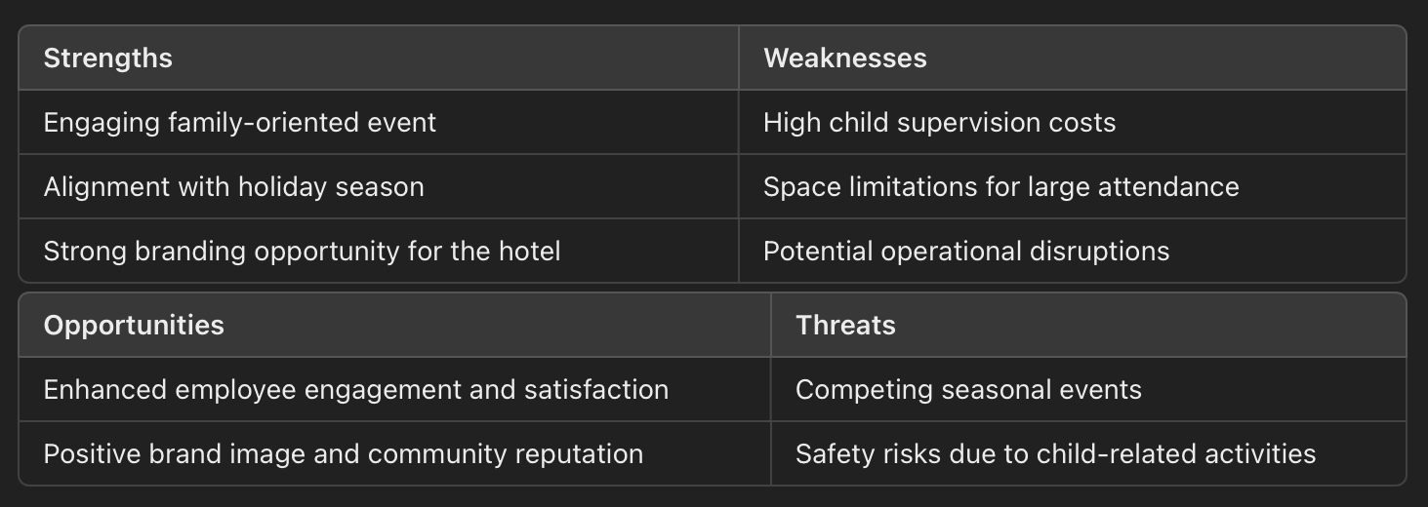

PESTLE Analysis
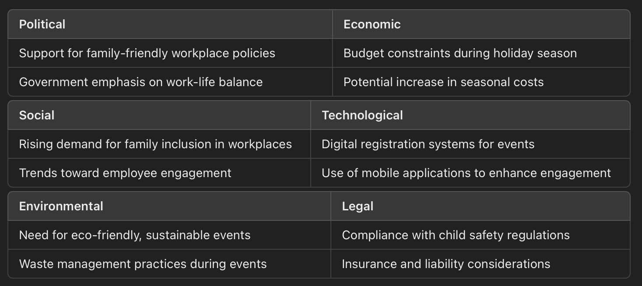

2.2. Strategic Risk Management
(See Appendix 2.2)
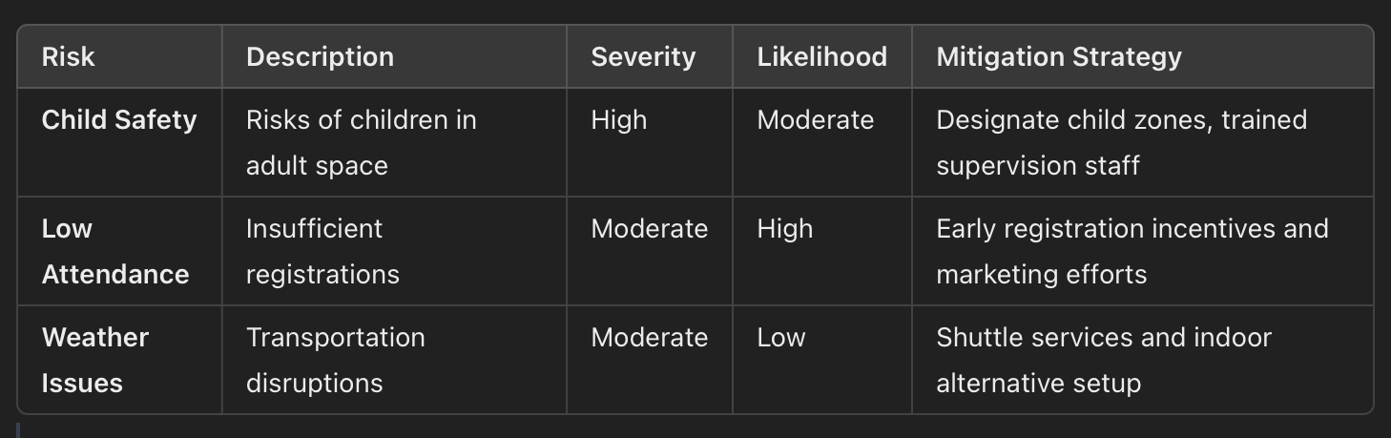

3. Resource Allocation and Budgeting

3.1. Human Resources
Human resource planning is central to the event’s success. Following Human Resource Planning Theory (Walker, 1990), staffing requirements are categorized based on key roles essential to the event's smooth operation. A dedicated event management team will be responsible for coordinating logistics, supervising activities, and ensuring that all aspects of the event run according to schedule.
For an event that involves children, specific roles such as child supervisors and activity facilitators are essential. Supervisors will be responsible for ensuring that children are safely engaged in activities and that any transitions between activities are managed smoothly. Given the need for close supervision, we anticipate hiring at least one supervisor for every 10 children, ensuring that all participants are closely monitored throughout the event.
Furthermore, hospitality staff will be tasked with managing catering, ensuring that snacks and beverages are available throughout the day. Given the hotel's existing catering infrastructure, much of the food preparation and service can be handled in-house, reducing the need for additional external vendors.
An important theoretical concept here is resource optimization (Nicholas, 2016), which involves leveraging the hotel’s existing resources (such as staff, catering equipment, and event spaces) to minimize costs. This allows for more efficient resource allocation while maintaining the high-quality experience expected for a family-friendly event.

3.2. Budget and Financial Planning
Budgeting is another critical element of event planning. The event will follow zero-based budgeting (Pyhrr, 1970), which ensures that every cost is justified based on its necessity and relevance to the event’s goals. This approach avoids unnecessary expenditures and helps allocate resources effectively.
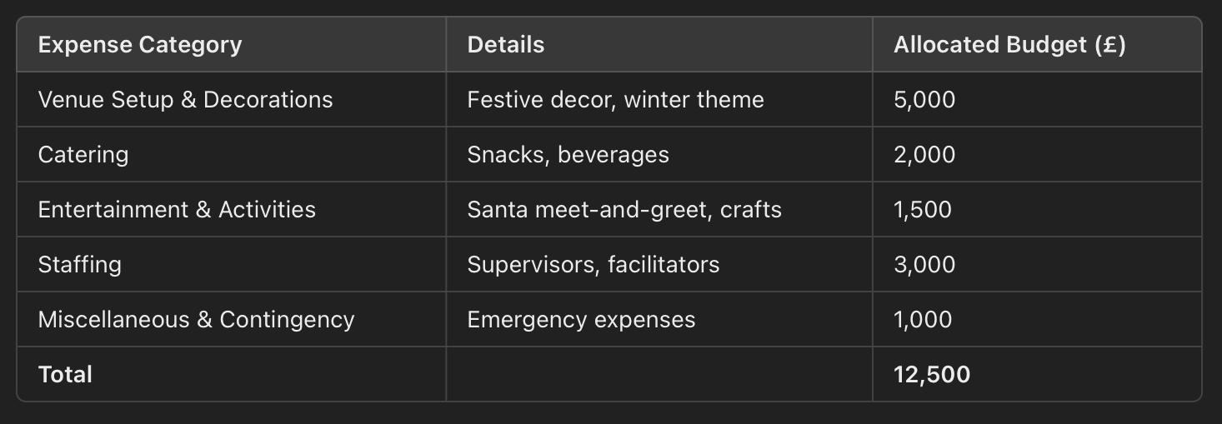
(Finance Table)
The budget incorporates a 10% contingency fund to cover unexpected costs, ensuring that the event can adapt to unforeseen challenges without compromising quality. Additionally, potential sponsorships from local businesses such as toy stores or catering companies will be pursued to offset costs. In exchange for sponsorship, businesses will be offered branding opportunities at the event, which could include logo placements on promotional materials and signage at key activity stations.
By utilizing Cost-Benefit Analysis (CBA) (Drummond, 1997), we ensure that the projected expenses provide tangible benefits, such as improved employee engagement and higher workplace satisfaction. The financial plan will be reviewed regularly during the planning phase to ensure the event remains within budget, and any adjustments will be made accordingly.

4. Venue and Logistics Planning

4.1. Venue Management
Venue selection and preparation are crucial for the smooth delivery of the event. The hotel is a prime location due to its capacity to accommodate large groups and the festive décor already in place for the Christmas season. This reduces the need for extensive additional decorations, allowing the event to take advantage of the existing winter-themed setup.
According to Venue Management Theory (Shone & Parry, 2019), the layout of the venue should facilitate smooth movement between different activity zones while maintaining safety. The venue will be segmented into three main areas:
- Activity Zone: For arts and crafts workshops, face painting, and interactive games. This zone will be heavily supervised, and child safety measures will be emphasized, such as keeping hazardous materials out of reach.
- Meet Santa Zone: A photo booth with Santa Claus, which will be a key highlight for children. This will be located in the hotel lobby, making it easy for parents to participate alongside their children.
- Parent Work Zone: An area where parents can briefly work or hold meetings, ensuring that the event doesn’t disrupt daily operations. This zone will be equipped with desks and internet access, allowing employees to work while their children are engaged in supervised activities.
Clear signage, pathways, and event personnel will help manage the flow of participants and minimize the risk of crowding. By utilizing Logistics and Flow Theory (Nicholas, 2016), we ensure that participants move smoothly through different areas without creating bottlenecks.

4.2. Logistics and Flow
Effective logistics planning is essential for ensuring that all aspects of the event, from transportation to activity scheduling, are executed seamlessly. Based on logistical best practices (Goldblatt, 2012), we have identified key logistical considerations that will support the event’s success.
Transportation: Employees will be encouraged to carpool or use public transportation. To support this, the hotel will offer shuttle services from nearby transport hubs. Additionally, a designated parking area will be reserved for families attending the event, with clear signage directing them to the appropriate entrance.
The success of any event depends on the efficiency of logistical arrangements, and this event is no different. The logistical flow will involve the coordinated movement of participants through different zones, ensuring that there are no bottlenecks or delays during key activities.
A detailed event schedule will be created to manage the timing of different activities. For example, the Santa meet-and-greet sessions will be scheduled in 15-minute intervals to ensure that all children get a chance to participate without creating long queues. Activity facilitators will manage transitions between zones, ensuring that groups of children move smoothly from one area to another.
Catering logistics will be another crucial element. Snacks and beverages will be provided at designated stations, and these will be positioned strategically to minimize disruption to the main activities. As the hotel already has a fully functioning kitchen and hospitality team, catering logistics can be easily managed without requiring significant external support.
By applying supply chain management principles (Mentzer et al., 2001), we can ensure that all resources (food, decorations, equipment) are delivered and set up in a timely manner, reducing the likelihood of logistical disruptions. Additionally, backup supplies of catering materials and event decorations will be on standby to account for any last-minute needs.

5. Marketing and Communication Strategy 7pcs
- Product: Family-friendly holiday event, with themed activities.
- Price: Complimentary for employees, incentivized with early registration gifts.
- Place: Held at hotel premises for convenient access.
- Promotion:
- Email Campaigns: Countdown newsletters with “Register Now” links.
- Intranet Page: Central event info and updates.
- Posters: Placed in common areas, showing event activities.
- People: Supervised by trained child supervisors, hospitality staff.
- Process: Streamlined registration, supported by marketing communications.
- Physical Evidence: Branded decor, signage, and themed setups enhancing the holiday feel.

5.1. Internal Communication
Internal communication is particularly important for ensuring that employees are aware of the event and feel motivated to participate. The following internal marketing tactics will be employed:
- Email Campaigns: A series of email newsletters will be sent to employees, highlighting key aspects of the event and providing a countdown to the registration deadline. Each email will include a “Register Now” button, linking directly to the event registration page.
- Intranet Announcements: A dedicated event page will be created on the company’s intranet, where employees can find detailed information about the event, including the schedule, FAQs, and safety guidelines. This page will be updated regularly to reflect any changes in logistics or activity plans.
- Posters and Signage: Posters will be placed in common areas within the workplace (e.g., break rooms, hallways, and lobbies), serving as visual reminders of the upcoming event. The posters will feature images of children participating in fun activities, creating a sense of excitement and anticipation.
- Incentives for Early Registration: To encourage early participation, employees who register by a specific date will receive a small gift, such as a holiday-themed voucher or a branded item from the company.
The communication strategy will also emphasize the event’s benefits to both employees and their families. Messages will highlight how the event allows employees to spend quality time with their children while also offering the kids a fun and educational experience. According to self-determination theory (Ryan & Deci, 2000), providing employees with a sense of autonomy will increase their intrinsic motivation to participate.

5.2. External Partnerships
Sponsorship and collaboration with external partners can significantly enhance the event while reducing costs. The theory of Stakeholder Management (Freeman, 1984) provides a framework for engaging with external stakeholders, such as local businesses, suppliers, and community organizations. In this context, partnerships can offer mutual benefits.
For example, a local toy store might sponsor the event by providing small gifts for the children, such as toys or holiday-themed merchandise. In return, the sponsor would receive brand visibility at the event, including signage and logo placement in promotional materials. Similarly, a catering company could offer discounted services in exchange for the opportunity to showcase their products to employees.
By fostering these partnerships, the event can deliver a higher quality experience without significantly increasing the budget. Additionally, partnerships with local businesses align the event with the community, enhancing the company’s reputation as a socially responsible organization.
Social media marketing can also play a role, though primarily as a post-event strategy. Highlighting key moments from the event (with permission from employees and parents) on platforms like LinkedIn or Twitter can help boost the company’s brand and demonstrate its commitment to family-oriented initiatives.

6. Risk and Contingency Planning
Risk management is crucial for any event, and a family-oriented event like this presents unique challenges. By applying Contingency Theory (Fiedler, 1967), we can prepare for various potential risks and develop strategic plans to mitigate them.

6.1. Risk Assessment
The main risks identified for this event include:
- Low Turnout: While the event is expected to draw significant interest, there is always the risk of low participation. This risk is mitigated by the robust internal marketing strategy discussed earlier. Additionally, by offering early registration incentives, we can encourage more employees to commit to attending well in advance.
- Child Safety Issues: Given that the event involves children in an office environment, safety is a top priority. A detailed Health and Safety Plan will be implemented, following guidelines from the Health and Safety Executive (HSE) (1999). This plan includes specific safety protocols for each activity, the designation of child-safe areas, and a comprehensive first-aid response plan.
- Weather-Related Disruptions: Although the event will take place indoors, weather conditions could still affect transportation and attendance. To address this, the event will include an indoor contingency plan, where all outdoor activities can be moved to the hotel’s ballroom if necessary.
- Staffing Shortages: Given the need for child supervision and event management, any shortage of staff could disrupt the event. To prevent this, an on-call list of additional supervisors and hospitality staff will be maintained, ensuring that there are always enough personnel on-site.

6.2. Contingency Measures
Contingency plans are developed based on the risks identified. For example, if low attendance becomes a reality, certain activities will be scaled down, and space allocations adjusted accordingly. This prevents the event from feeling empty or under-attended.
If transportation issues arise due to bad weather, the hotel will offer shuttle services from key transport hubs to ensure that families can still reach the event safely.
By applying Contingency Planning Theory (Mitroff, 1994), the event planning team will have detailed alternative scenarios mapped out for each identified risk, ensuring the event can adapt to changing circumstances without significant disruptions.

7. Monitoring and Evaluation
The success of the event can only be determined through comprehensive monitoring and evaluation processes. By applying Event Evaluation Theory (Getz, 2008), we can measure the event’s impact and gather data to inform future events.

7.1. Monitoring During the Event
Real-time monitoring will be conducted by the event coordinators, who will gather feedback from participants as the event progresses. Key indicators of success, such as participant engagement and satisfaction, will be tracked. For instance, if certain activities are not drawing enough participants, adjustments will be made on the spot to ensure that attendees are fully engaged.
Additionally, activity facilitators will collect anecdotal feedback from children and parents during the event, which will be used to make any necessary real-time changes, such as extending popular activities or shifting fewer engaging ones to later time slots.

7.2. Post-Event Evaluation
Post-event evaluation will be conducted using a combination of surveys and interviews. Kirkpatrick’s Four-Level Evaluation Model (1994) will guide this process, assessing the event’s success across four key areas:
- Reaction: Participant feedback will be gathered immediately after the event through short surveys. Questions will focus on participants’ overall satisfaction, enjoyment of activities, and their perceptions of the event’s organization.
- Learning: For children, the event also serves an educational purpose. Surveys will include questions designed to gauge how much the children learned about their parents’ jobs and whether they found the experience informative.
- Behavior: For parents, one long-term goal is to improve work-life balance and enhance employee satisfaction. A follow-up survey conducted a month after the event will assess whether employees feel more engaged and motivated at work.
- Results: Finally, the event’s overall impact on company culture will be evaluated. This includes measuring any improvements in employee retention, morale, and productivity following the event.

8. Conclusion

The "Winter Wonderland: Bring Your Kids to Work Day" event represents a strategic opportunity to enhance family engagement and improve employee satisfaction during the holiday season. By leveraging event management theories such as SMART objectives, Risk Management Theory, and Contingency Planning, the event has been planned with precision and care. Each aspect of the event, from resource allocation to marketing and risk management, has been strategically analyzed to ensure that it delivers a positive experience for employees and their families.
Post-event evaluations will be critical in determining the event's success, using frameworks like Kirkpatrick’s Evaluation Model to assess its impact on employee morale, engagement, and company culture. Detailed risk management and contingency plans will ensure that the event can adapt to any unforeseen challenges, providing a seamless experience for all participants.
Ultimately, the "Winter Wonderland" event is not only feasible but strategically sound. With careful planning and thorough preparation, it has the potential to become a recurring feature in The "Winter Wonderland: Bring Your Kids to Work Day" event represents a strategic opportunity to enhance family engagement and improve employee satisfaction during the holiday season. By leveraging event management theories such as SMART objectives, Risk Management Theory, and Contingency Planning, the event has been planned with precision and care. Each aspect of the event, from resource allocation to marketing and risk management, has been strategically analyzed to ensure that it delivers a positive experience for employees and their families.

Recommendation
- Strengthening Safety Measures: Hire additional trained supervisors and ensure dedicated child-safe areas.
- Enhancing Marketing: Increase incentives, such as family gift packages, for early registrants.
- Fostering Partnerships: Collaborate with local businesses for sponsorships, reducing costs and enriching the event experience.

References
Allen, J. (2020). Event planning: The ultimate guide to successful meetings, corporate events, fundraising galas, conferences, conventions, incentives, and other special events. Wiley. Available at: https://books.google.co.uk/books?hl=bg&lr=&id=6VKSzfku7ukC&oi=fnd&pg=PA1&dq=Allen [Accessed 25 Oct. 2024].

BIC, 3M (2024). Corporate event trends for 2024. [online] 3M Buckley Innovation Centre. Available at: https://3mbic.com/corporate-event-trends-for-2024/. [Accessed 25 Oct. 2024].

Burke, R. J., & Cooper, C. L. (2008). The long work hours culture: Causes, consequences, and choices. Emerald Group Publishing. Available at: https://books.google.co.uk/books?hl=bg&lr=&id=AJXnY9lqYvoC&oi=fnd&pg=PP1&dq=Burke [Accessed 25 Oct. 2024].
‌
Capper, T. (2023). Corporate Event Trends for 2023. [online] BE Event Hire. Available at: https://www.beeventhire.co.uk/corporate-event-trends-for-2023/. [Accessed 25 Oct. 2024].

George, W.R. (1990). Internal marketing and organizational behavior: A partnership in developing customer-conscious employees at every level. Journal of Business Research, 20(1), pp.63–70. doi:https://doi.org/10.1016/0148-2963(90)90043-d. [Accessed 25 Oct. 2024].

Getz, D. (2012) Event Studies: Theory, Research and Policy for Planned Events. Routledge.
Getz, D. (2012). Event studies: Theory, research and policy for planned events. Routledge. Available at: https://books.google.co.uk/books?id=-IKnHvefiusC&newbks=1&newbks_redir=0&printsec=frontcover&dq=Getz [Accessed 25 Oct. 2024].

Google Books. (2024). Event Planning. [online] Available at: https://books.google.co.uk/books?id=XuCtMFoEcIcC&pg=PR11&hl=it&source=gbs_selected_pages&cad=1#v=onepage&q&f=false [Accessed 25 Oct. 2024].

Health and Safety Executive (HSE). (1999). The event safety guide (2nd ed.). Huntingdonshire District Council. Available at: https://www.huntingdonshire.gov.uk/media/2746/hse-event-safety-guide.pdf [Accessed 14 Oct. 2024].
Health and Safety Executive The event safety guide (Second edition) HSE Books. (n.d.). Available at: https://www.aber.ac.uk/en/media/departmental/healthsafetyenvironment/hse_event_safety_guide_hsg195.pdf.

Hrhouston.org. (2021). SHRM News - HR Houston. [online] Available at: https://www.hrhouston.org/mpage/SHRMNews [Accessed 25 Oct. 2024].

Indeed Editorial Team. (2023). Take your child to work day: tips and benefits. Indeed. Available at: https://www.indeed.com/career-advice/career-development/take-your-child-to-work-day [Accessed 25 Oct. 2024].
‌Kerzner, H. (2009). PROJECT PROJECT MANAGEMENT MANAGEMENT. [online] Available at: https://ftp.idu.ac.id/wp-content/uploads/ebook/ip/BUKU%20MANAJEMEN%20PROYEK/project-management-harold-kerzner1.pdf. [Accessed 25 Oct. 2024].
‌Lambert, S.J. and Ellen Ernst Kossek (2005). Work and Life Integration: Organizational, Cultural, and Individual Perspectives. [online] ResearchGate. Available at: https://www.researchgate.net/publication/259782337_Work_and_Life_Integration_Organizational_Cultural_and_Individual_Perspectives. [Accessed 25 Oct. 2024].

Neves, M.F. (2006). Bowdin, G., Allen, J., O’Toole, W., Harris, R., McDonnell, I. (2006). Events management. www.academia.edu. [online] Available at: https://www.academia.edu/29403848/Bowdin_G_Allen_J_O_Toole_W_Harris_R_McDonnell_I_2006_Events_management.
‌
Silvers, J. R. (2012). Risk Management for Meetings and Events. Butterworth-Heinemann. Risk Management for Meetings and Events | Julia Rutherford Silvers | T (taylorfrancis.com) [Accessed 25 Oct. 2024].

Silvers, J.R. (2012) Risk Management for Meetings and Events. Butterworth-Heinemann.
Team, D. (2023). Corporate Events Planning in 2023: 5 Trends & Predictions. [online] 30 Euston Square. Available at: https://30eustonsquare.co.uk/2023/01/24/corporate-events-planning-in-2023-5-trends-predictions/. [Accessed 25 Oct. 2024].
‌
tmason (2022). Everything You Need to Know About Planning the Ultimate Company Retreat. [online] Outback Team Building & Training. Available at: https://www.outbackteambuilding.com/blog/everything-you-need-to-know-about-planning-the-ultimate-company-retreat/. [Accessed 25 Oct. 2024].

Wsu.edu. (2023). How to Plan a Corporate Event | Washington State University. [online] Available at: https://onlinemba.wsu.edu/blog/how-to-plan-a-corporate-event [Accessed 25 Oct. 2024].

www.linkedin.com. Corporate Event Trends for 2023. [online] Available at: https://www.linkedin.com/pulse/corporate-event-trends-2023-unbridled-2c. [Accessed 25 Oct. 2024].

Appendix A: SMART Objectives for “Winter Wonderland: Bring Your Kids to Work Day”
2.2 Strategic Risk Management condensed with risk matrix and appendix
Risk management plays a vital role in event planning. By applying Silvers' Risk Management Framework (Silvers, 2012), potential risks such as child safety issues, logistical failures, and reputational damage are identified and addressed early in the planning stages. Using a risk matrix, we categorize risks by severity and likelihood, allowing us to prioritize the most significant threats and develop tailored mitigation strategies.
For example, one key risk is related to child safety, particularly in a corporate environment where spaces are not designed for children. To mitigate this, specific areas within the venue will be designated as “kid zones” and monitored by trained staff members. Additionally, all participants will be briefed on emergency procedures, and a dedicated first-aid team will be on-site to handle any medical emergencies.
Another potential risk is poor attendance. To manage this, we have developed a robust internal marketing strategy (discussed in section 5), which will encourage early registrations and provide incentives for participation, such as free gifts for the first 50 registrants. Additionally, real-time adjustments (such as moving certain activities indoors if weather conditions deteriorate) are part of the contingency plan, allowing for flexibility in event delivery.
- Marketing and communication strategy
An effective marketing and communication strategy is essential to ensure high levels of employee participation. The internal promotion of the event will be aligned with Internal Marketing Theory (Berry, 1981), focusing on engaging employees through clear communication, incentives, and targeted messaging.

