Major Project Report
To begin this project for me did not the best due to personal reasons which have been discussed and covered. I’ll refrain from their mention here.
Overall;
The project was overall successful with showing off animation which is my chosen area of specialty. To ensure the better project within the time given I had to cut out sections and ideas from the initial plan established at the start which is a usual happening but in my circumstance I feel the project will benefit from this change established. The parts that I cut were the end part where the character after toppling over would collect another firearm and continue to finish the course. I’ve instead decided to have it just after the toppling instead. I feel this not only makes the scene more manageable in the time left but also allows for a more meaningful ending as the character would turn to be disappointed in one’s self due to the failure of completing the course.
Props used by character
These are firearms that the character used. They vary in visual quality based on the screen space they inhabit.
The first character model that I worked on was designated ‘start rifle’ due to its purpose being the rifle that the character begins with. The model was slowly worked on over a large amount of time due to Christmas and other events that to be expected slowed down the progress. The model was then considered ‘completed’ for about a month before I took the time to do a once over with it to clean up and smooth out some issues with the help of some peers as they assisted me in overlooking and picking out issues that I missed. The following screenshots will show my progress and I will discuss further beneath them.
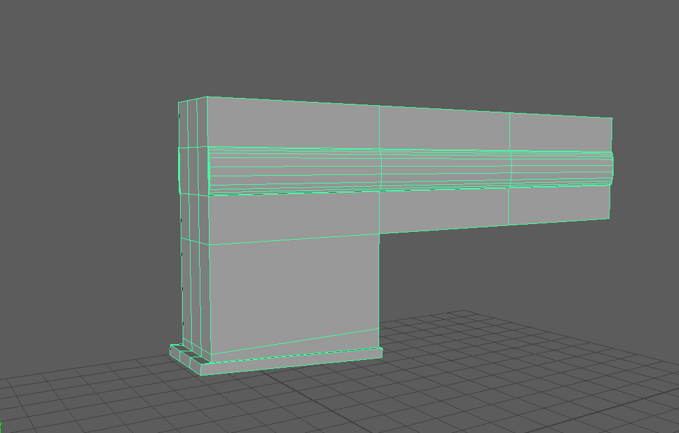
This was the first rendition of the ‘receiver’ of the rifle. The receiver is the essential heart of the rifle and I wanted to ensure I had the curves in the middle area like the real thing.
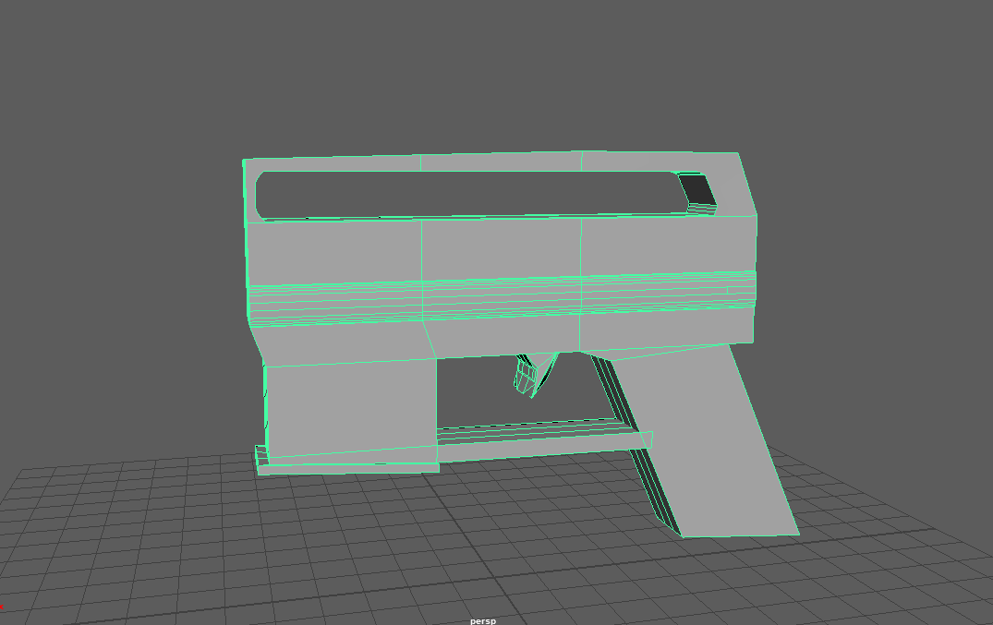
The next step in the receiver area was to make the rather well notable carry handle that the firearm platform is known for. After slightly struggling with the Booleans over simple mistakes that I feel quite funny at the time I was able to create a good outline of this carry handle area. I then went on to create a simple shape for the pistol grip and trigger by extruding from the base mesh area.
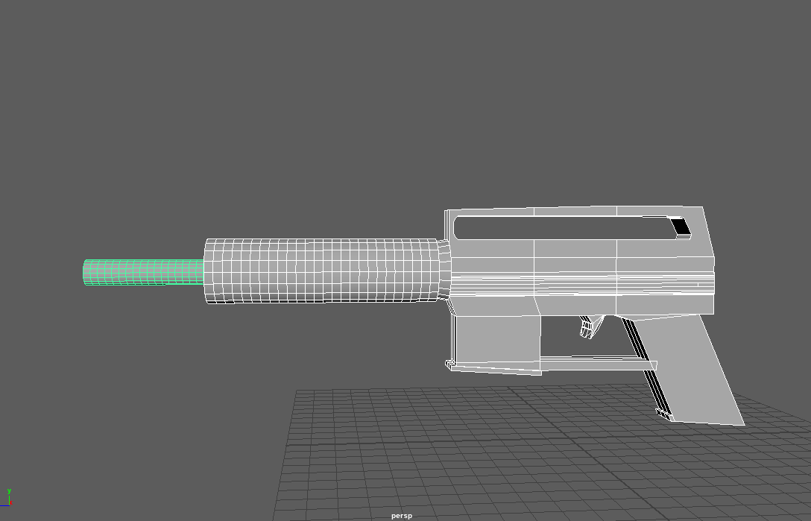
After creating the receiver area I went onto the barrel and handgrip. I tried to respect the length of the real life counterpart while also establishing a good surface area to accommodate different ways to hold the rifle in particular.
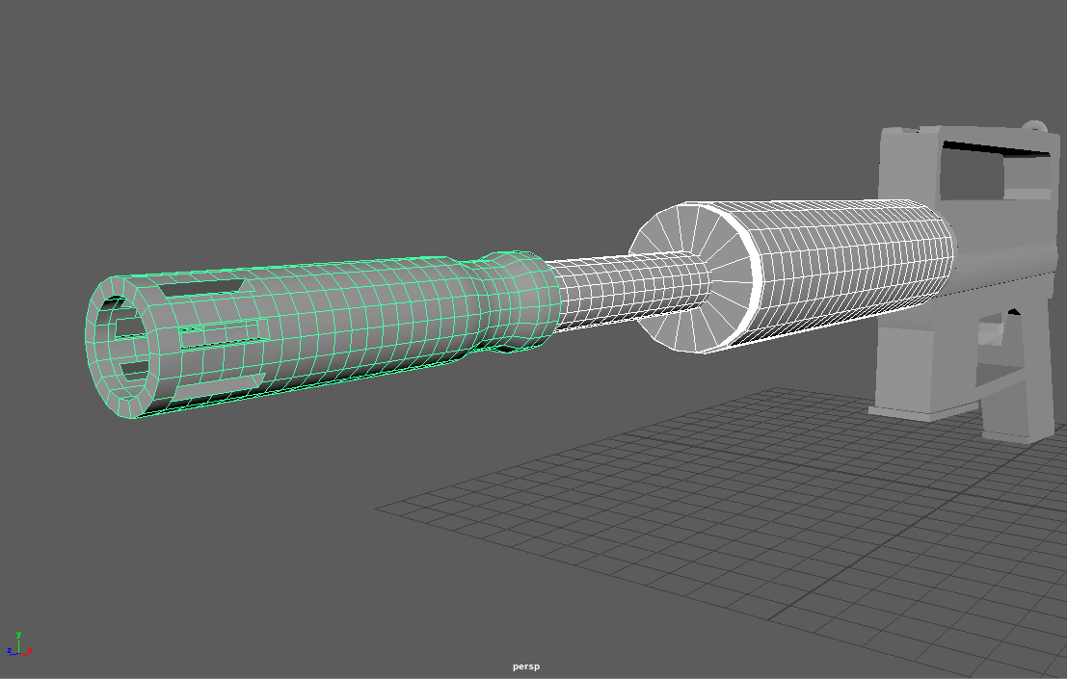
After establishing a good surface area for the handgrip I went on to make the ‘flash hider’ for the rifle. Utilizing the Booleans correctly this time around I was able to make the flash hider quickly and look good too. (It looks really good.) Personally out of the entire weapon I found creating this flash hider was the more rewarding just based on the close accuracy to the real thing.
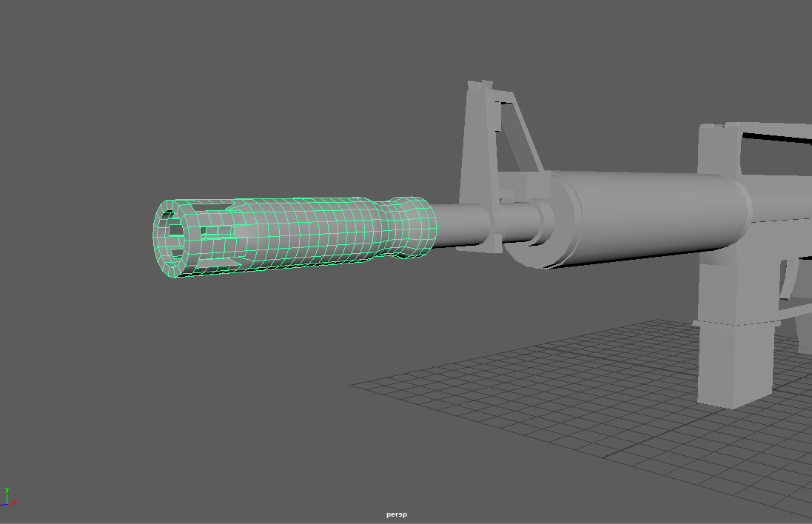
After the obvious joy of creating the flash hider I obviously decided to try and make it somewhat more accurate. I took the right side edge where the holes are located and moved them inwards to create a kind of slope from the gap to the rest of the item as a way to further make it accurate to the real thing again.
I also took the time to make the front sight as pictured to ensure accuracy. I also added in the weapon magazine as pictured below the receiver because if I didn’t do it at the time I would have probably forgotten to do it all together.
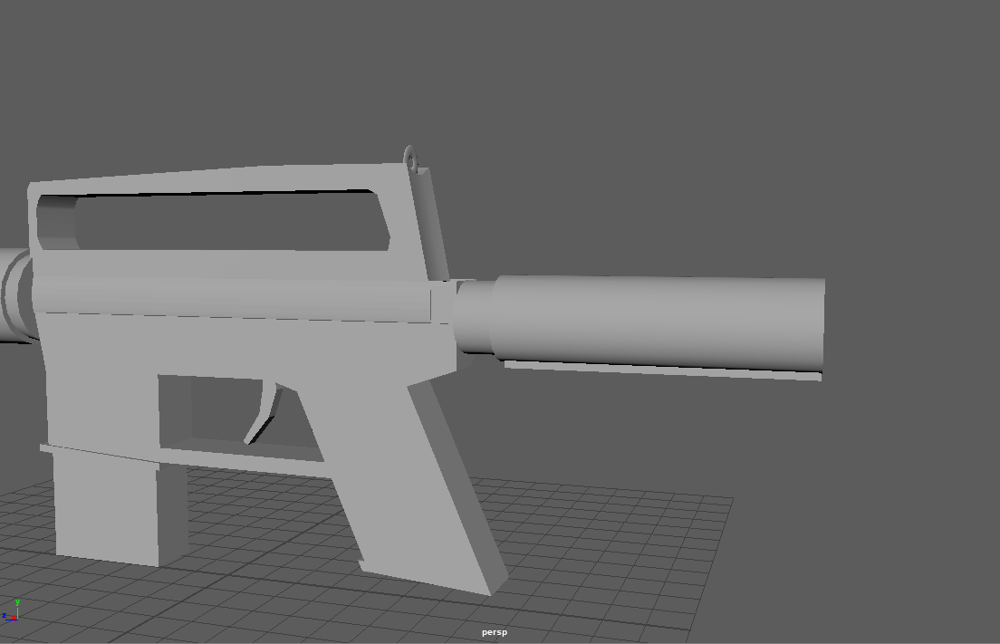
I also begun work on the weapons buttstock after obviously laughing at the word butt for 5 minutes. This part of the weapon would be the piece that gets dug into the persons shoulder to better control the vertical recoil given off by the weapon. I began with the simple ‘buffer tube’ design as well as beginning the bottom of the adjustable area.
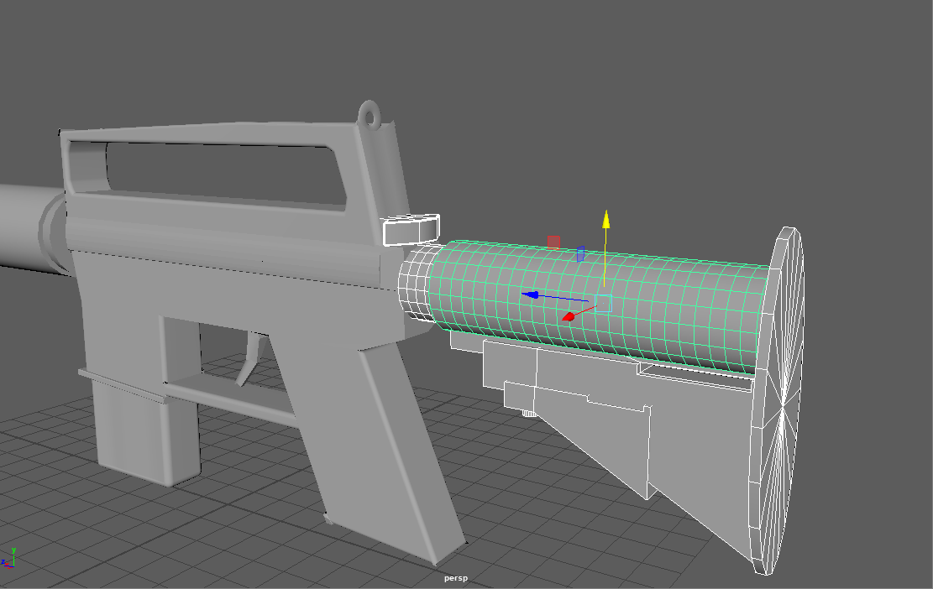
I went on to finish the buttstock which incorporated the adjustable look which the firearm has. I tried to keep it as to by as possible but I know that this area of the weapon wouldn’t be as prominent in the scene. I didn’t give into such detail as previous pieces. I also added the charging handle which is pictured just by the receiver. This isn’t usually the thing used when operating the weapon as a button on the left side would be the usual. It’s to be known that the left side button is known to be functionally unreliable sometimes so in a approach of a realistic choice and a personal preference in animation I wanted to ensure that this charging handle was capable of being pulled back to ‘charge the weapon.’ Things really explain themselves with the title.
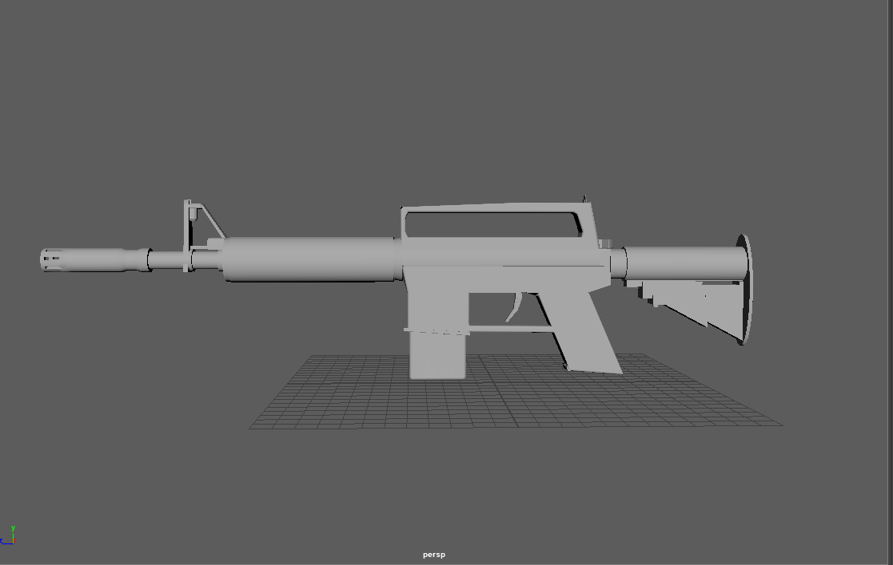
This was the end before the once over. I went though and bevelled the edges where appropriate so the model didn’t look so blocky. I wanted it to look good with no unnecessary sharp edges so I felt that if I went around the visibly noticeable sharp literal 90 degrees edges and had them be bevelled out to a good looking smooth curve that it be more visually pleasing.
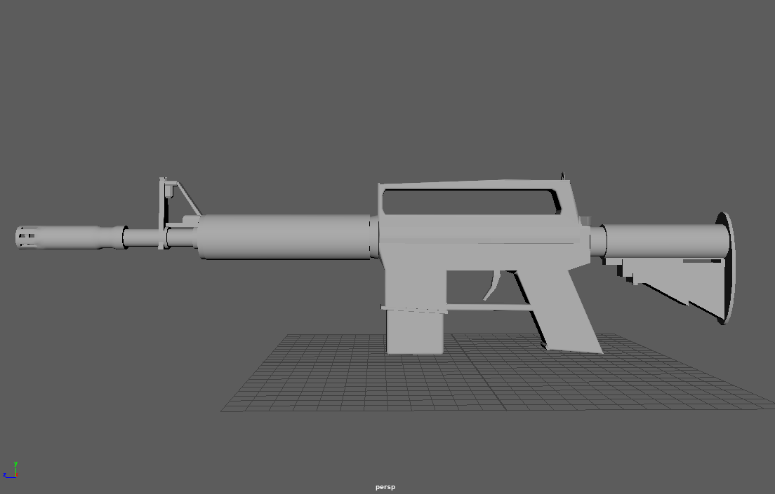
While not at first hand obvious. This came to be the final version. With the assistance of some peers a lot of unnecessary geometry was deleted. Some of it was internal which poses a little bit of a challenge removing. Overall this became a better prop. A lot of the issues with the model were around the barrel and the carry handle and I think this was due to me bevelling and at some point there was a difficult overlay between faces and the geometry went all funny on the interior.
The second prop that the character would use would be simply titled ‘shotgun.’
With a highly accurate file name the shotgun didn’t receive as much modelling time as the start rifle but it was more of a simple creation. Not much development history is visually available but I will best try to describe it.
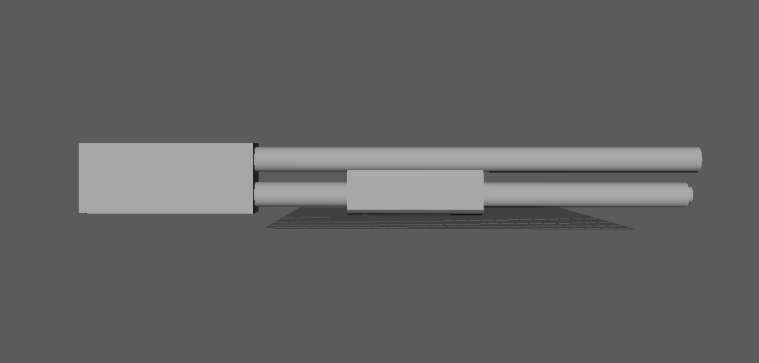
Starting off with two simple elongated cylinders and the established rectangle that would become the base of the weapon. I then used another cube in the centre of the two cylinders, bevelled the bottom side and made it have a slight curve to it to better try and represent a smooth handle or ‘pump’ for shotgun.
The upper cylinder is meant to represent the barrel of the shotgun so I made this longer than the lower to try and show this hierarchy. The lower barrel is meant to show the shell tube where the shotguns ammunition is internally carried. I added a small cylinder to the end of this tube to try and show it as a stopper. This is usually seen on most shotguns so I felt it appropriate to include it on mine.
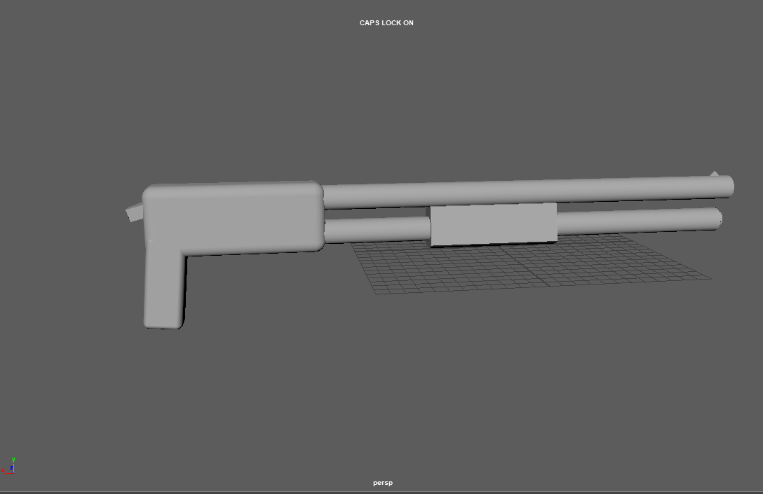
Here I added the pistol grip to the underside as such a thing would be expected of a shotgun. I decided to not go into too much detail as it doesn’t have a long screen time. The intended reference image and design for the weapon included a stock similar to the rifle but I felt that I would have a better time with it without it as I could have more opportunity for posing when it came to animating. So instead I added a simple latch type item where the stock would be as a way to show that one ‘could’ be attached but there hasn’t been. I bevelled out the edges of the left side box so that it wouldn’t be so blocky for the same reasons established with the start rifle. I also added a small cube at the end of the top barrel as a kind of ‘iron sight’ that wouldn’t be used and was added more out of a realism stance other than anything.
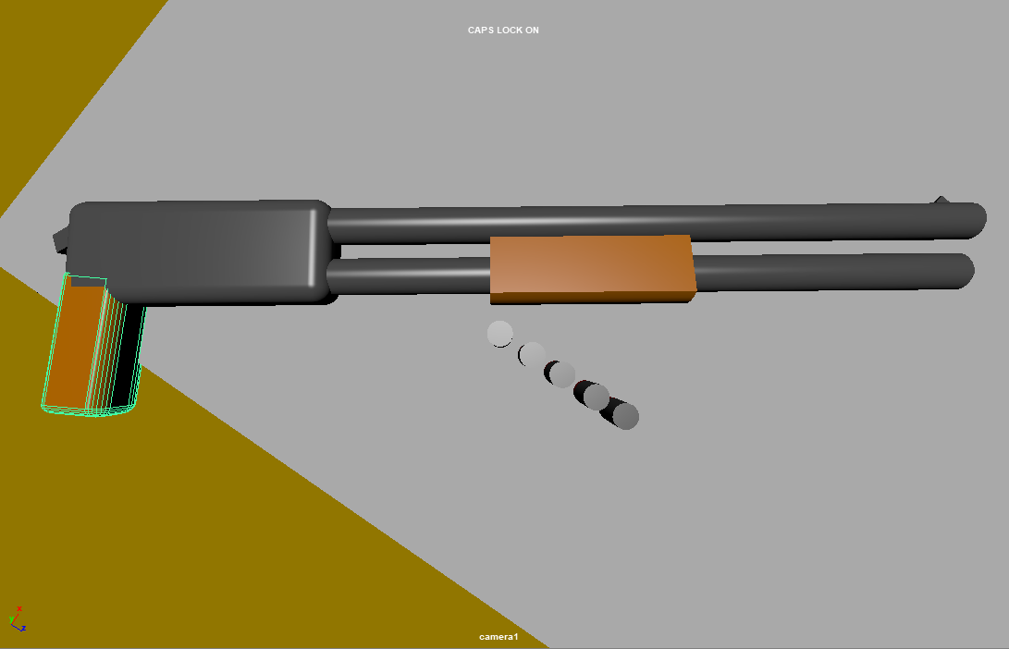
The idea in the beginning with the shotgun was to give it just a plastic and metal look but I felt this didn’t make it stand out so well. Instead I went for a more wooden or Bakelite appearance to it as this made it stand out better. This was the final rendition of the shotgun for my scene.
The handgun was honestly not made until last moment. There is no development history. 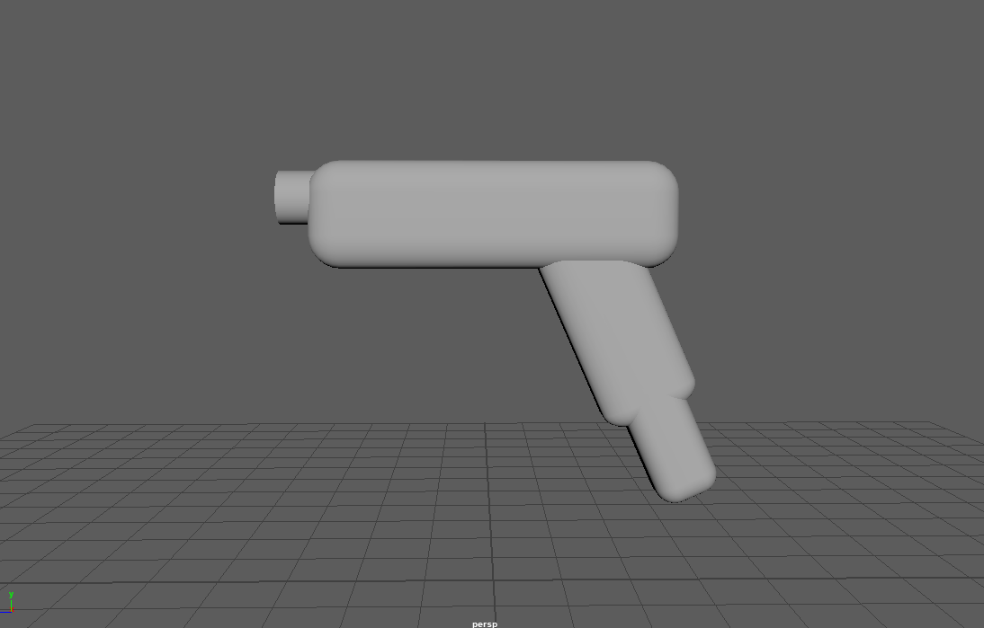
This was ones own fault. I had fallen behind and didn’t have enough time to go forth and do it properly so I done the next best thing. But less on that.
I wanted to get a simple look to it which would do one thing and one thing only. Say to the viewer ‘this is a small gun’ which I feel replicates those exact words.
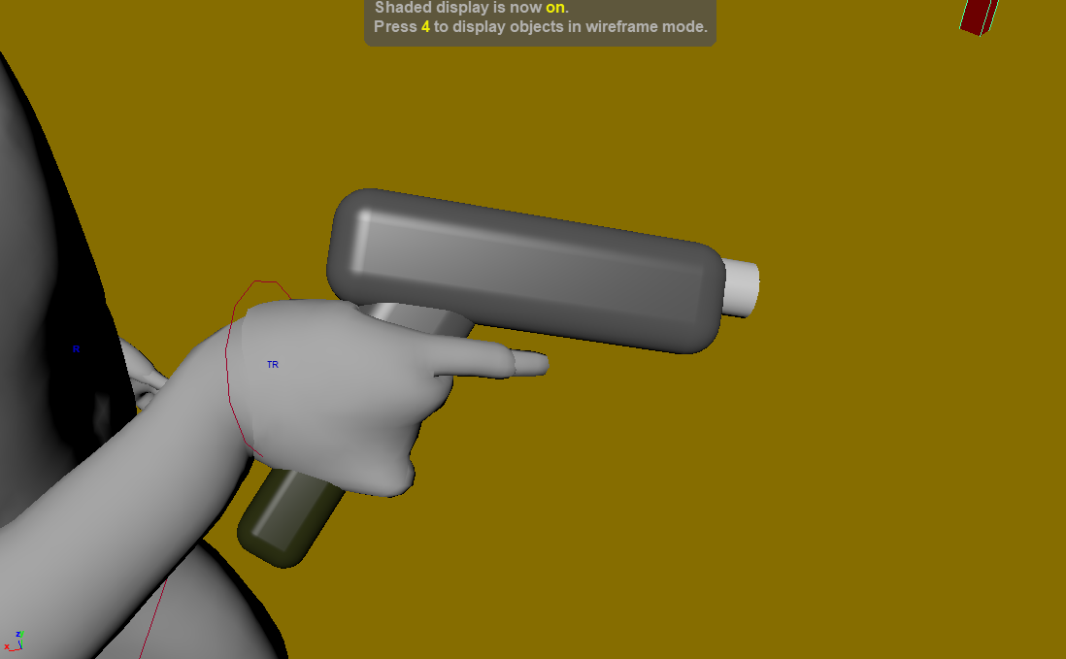
I made sure that the magazine on the bottom of the gun was a different colour to differentiate itself from the pistol grip. The barrel was also made a different colour so that it would become more noticeable as I animated it to have a visual recoil. Having it stand out I feel creates more impact with the movement.
Character Model
To begin as I struggle with anatomy I began with the basic human tool provided by ZBrush tools and began my work.
I used ‘Nickz’ basic human model for a base.
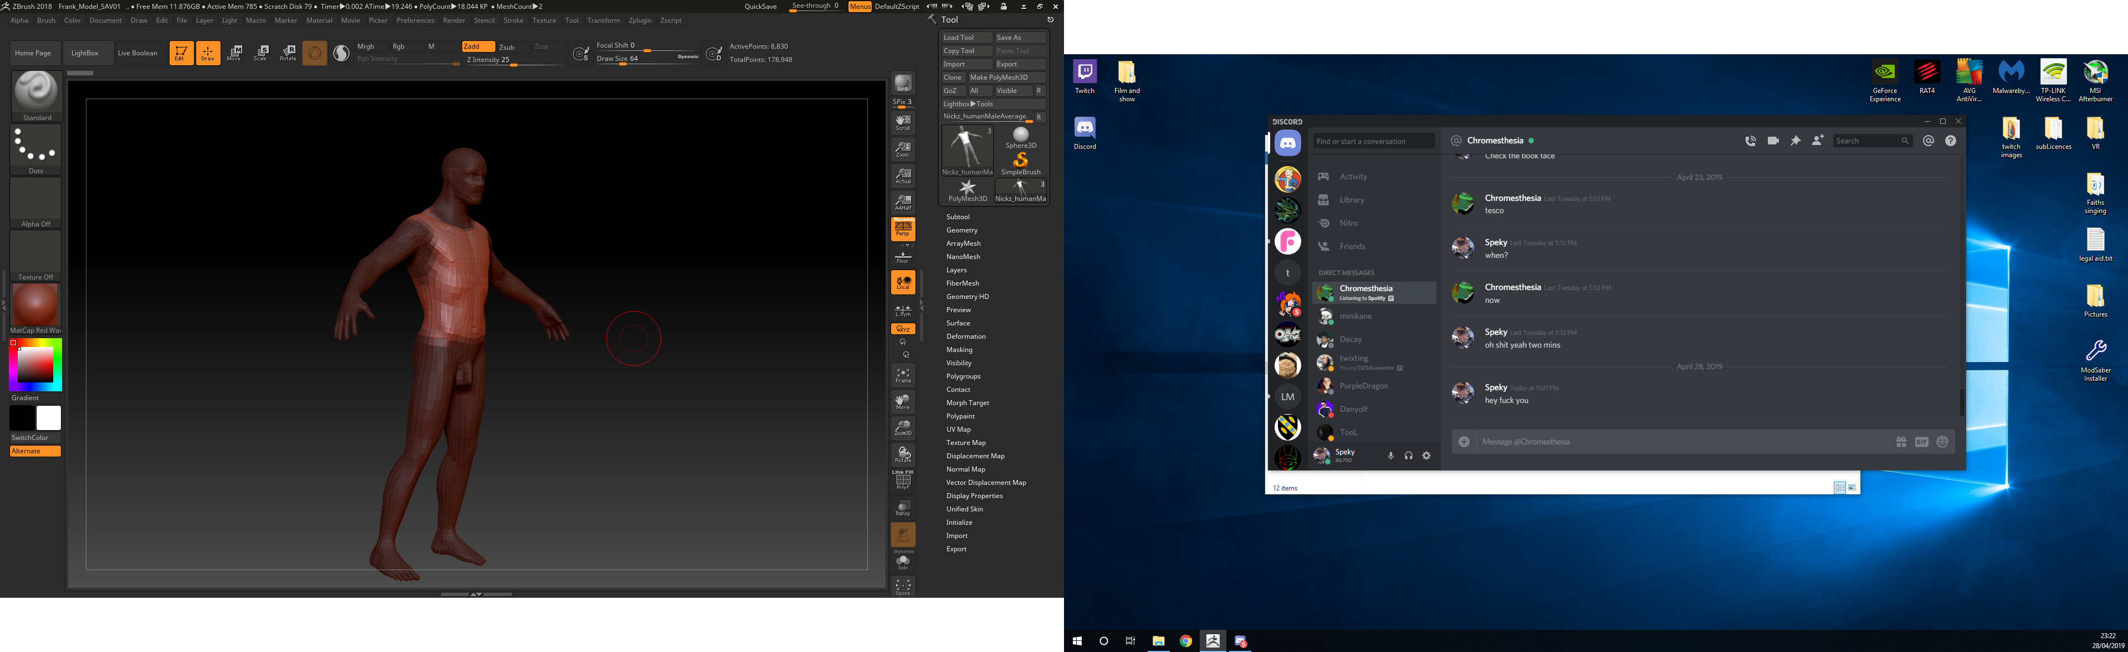
First I began on the centre so I could have good idea of the size of the characters chest. I was struck between making the character bigger as a person and then adding equipment. In the end I stuck with just adding equipment as I felt I would lose the anatomy that I used this pre-set for.
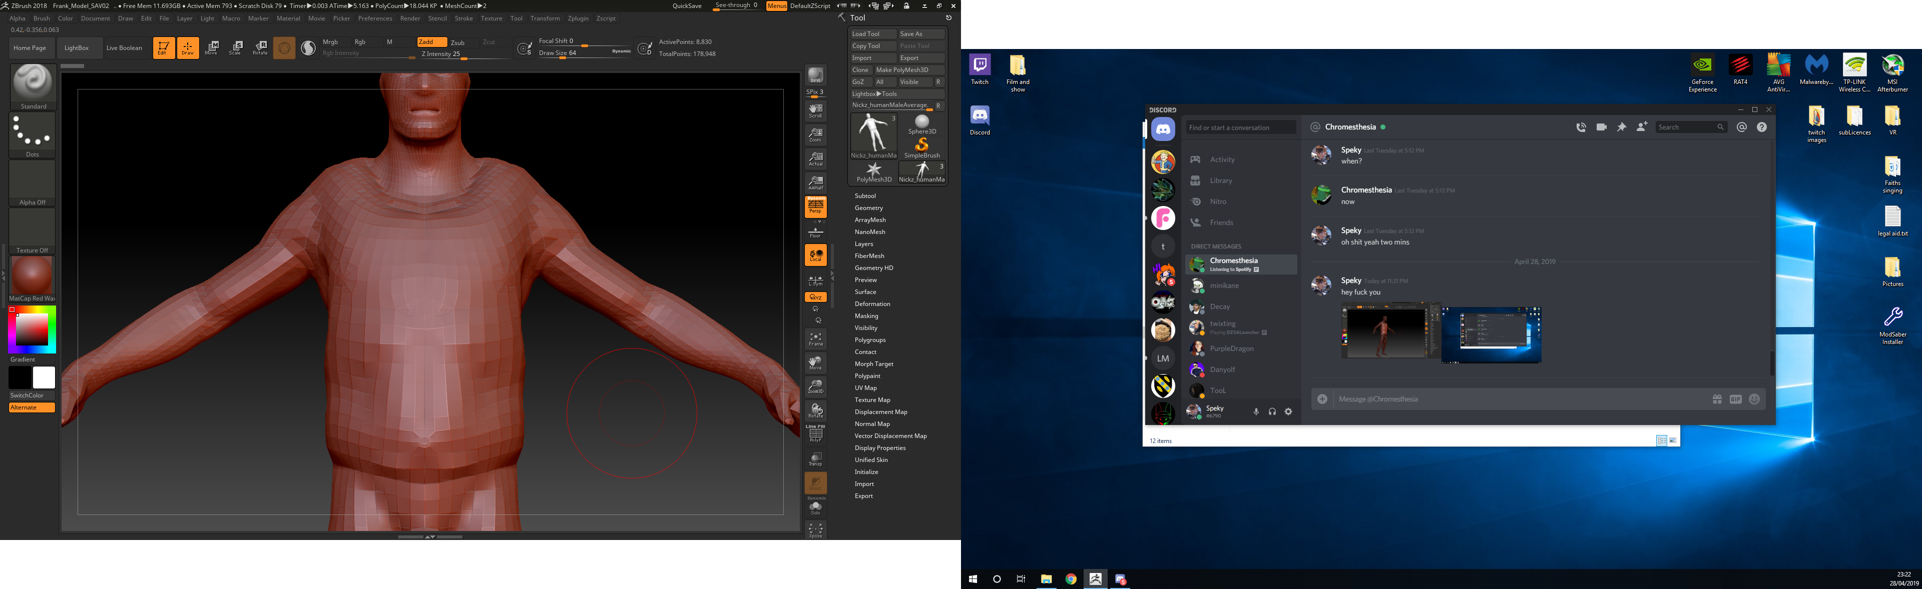
I bolstered up the chest size to better represent a plate carrier type of body armour around the chest. These usually have a thick size due to as the name suggests the large piece of ballistic plate within it. I also increased the general shoulder area slightly to try and show like a t-shirt.
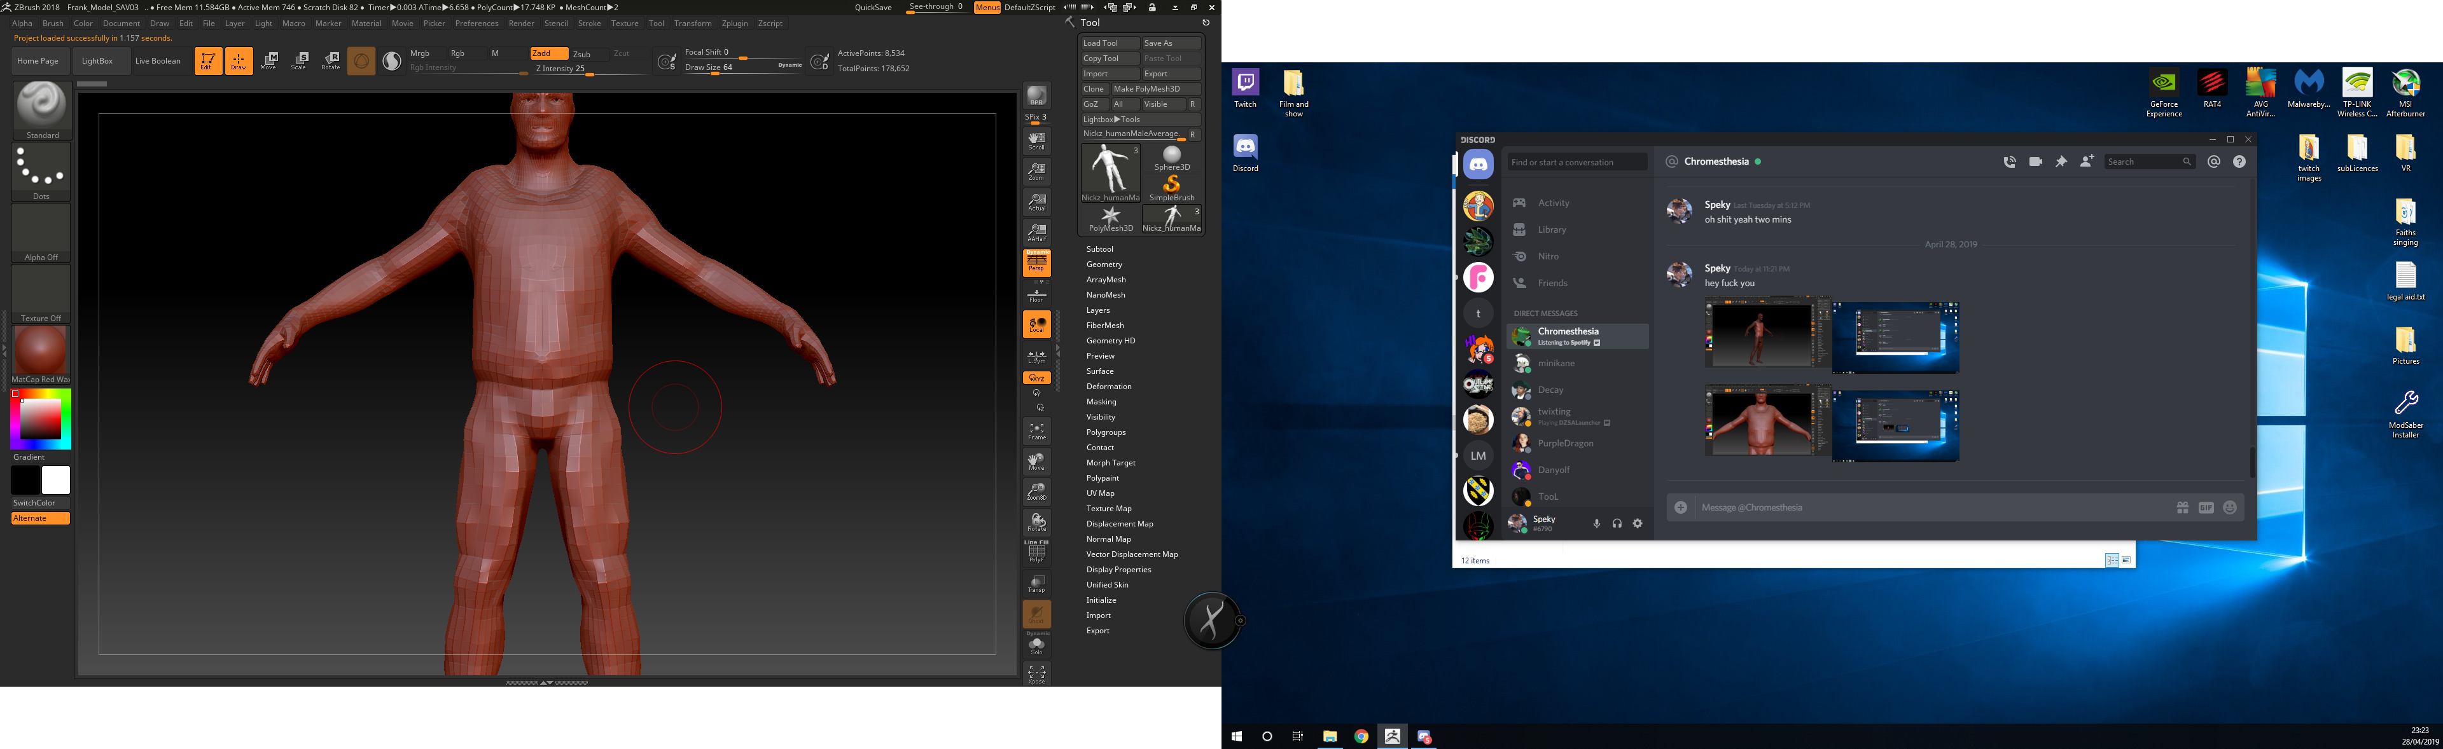
After the general chest area was bolstered up to a size I felt worked I then unfortunately castrate the fellow so I could make the trousers by increasing the leg width to fit the character and the story I had given them.
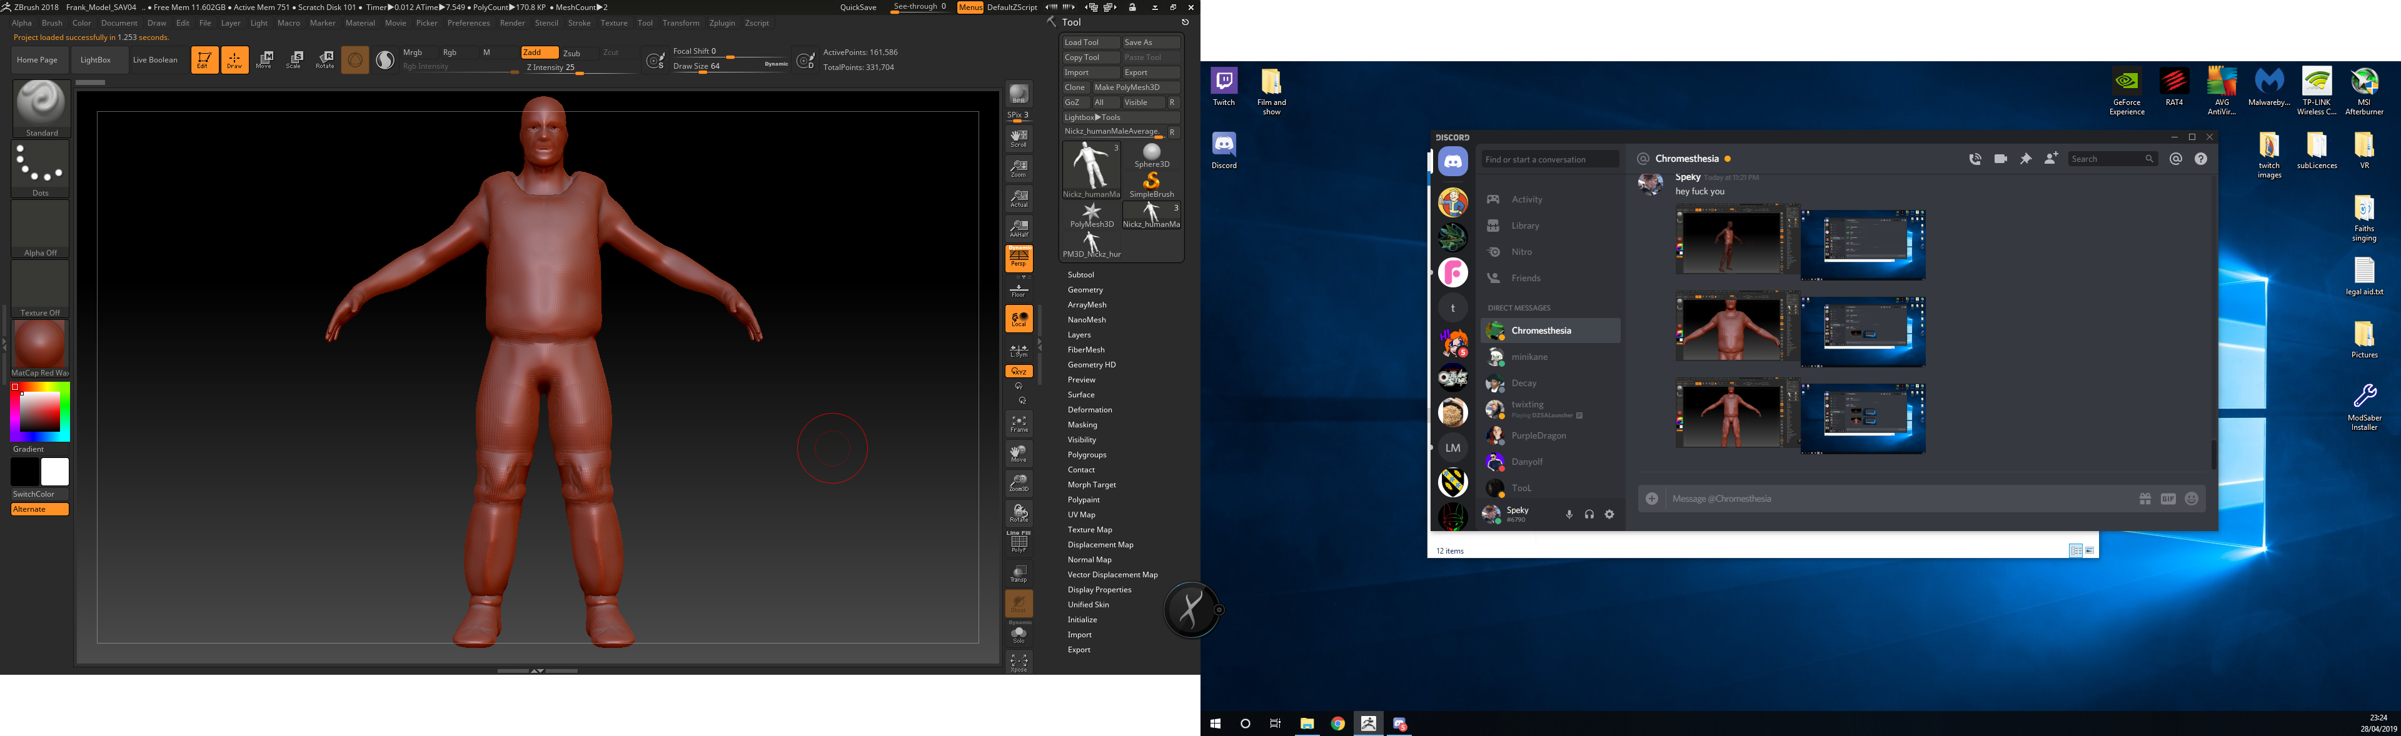
I smoothed the character out and increased the count so I could attempt a more detailed looking character. I attempted to try and replicate kneepads for the character but I don’t think they came out very well. I also castrated the gentlemen’s toes so I could make a standard base in which would become the man’s shoes.
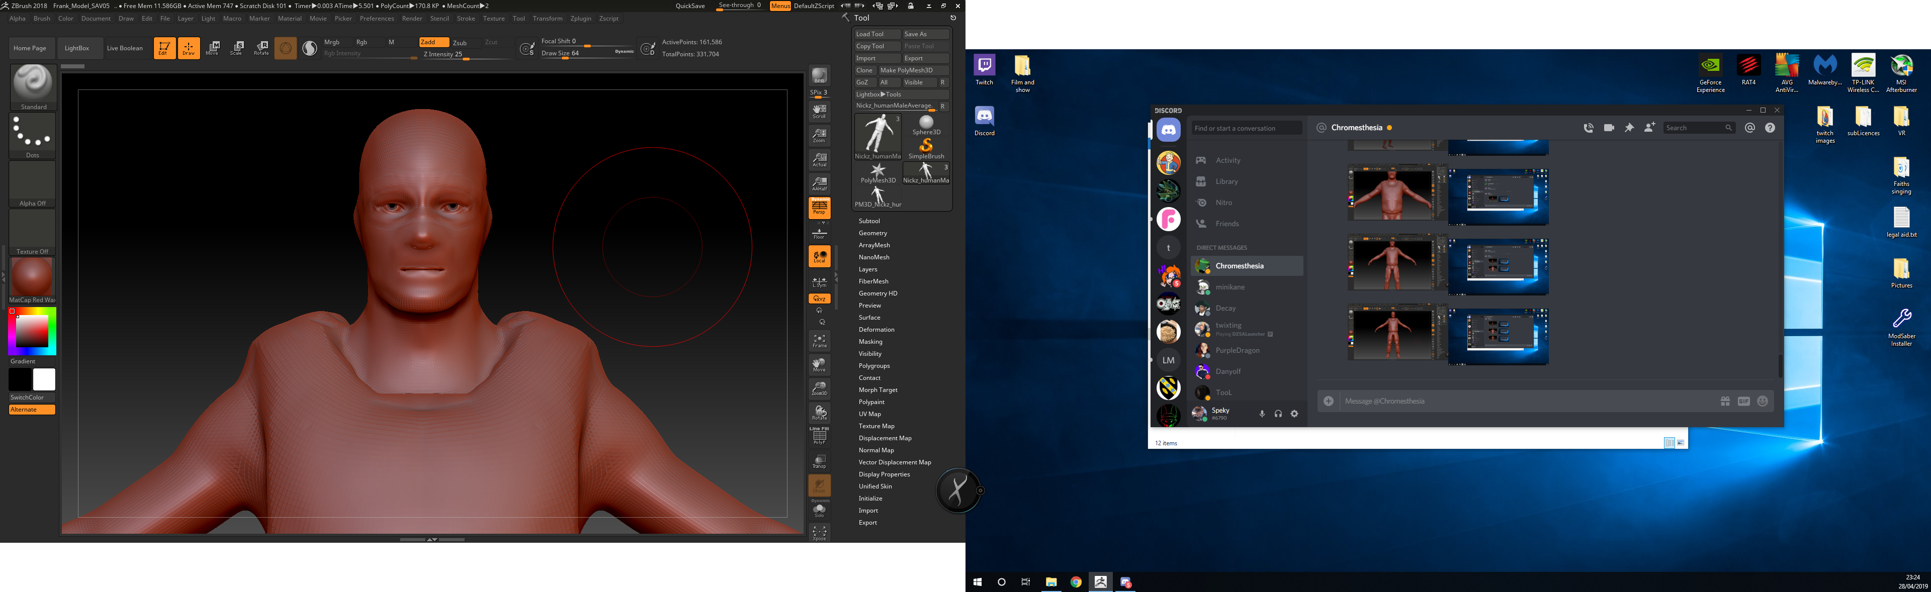
I then began work on the face area. I wanted the character have a balaclava over him to hide his facial features. For plot reasons this was done to make the characters training somewhat harder as the balaclava can if thick enough restrict breathing slightly and make the face somewhat warmer which could irritate them. I tried to smooth out the basic facial features so the character is less recognisable. I tried to avoid the eye area to keep the obvious element of the balaclava.
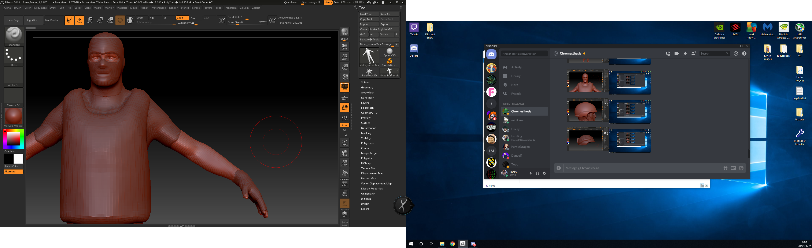
Once the areas were smoothed out I extracted out the particular areas that I wished to be separate colours as at the time I had no appeal to texturing the character and wished to just set blinns and colours in Maya. The balaclava was extracted out and I used the inflate tool to make it more visually prominent while also preserving its shape. I done the same with the chest area and the gloves so that the shape is preserved also but it has that extra bit of obvious bulk. In the end I cut out the kneepads as they were proving to be difficult to make.
At the early stages of quick rigging the character I had overlooked one of my peers using substance painter. I took interest and spectated for a bit before deciding to try it myself. I used Maya to unwrap the UV’s and resize them appropriately. I had difficulty during this as it wasn’t an area I had really gone into before. Taking advice from peers and following some tutorials I was able to soldier on and unwrap them.
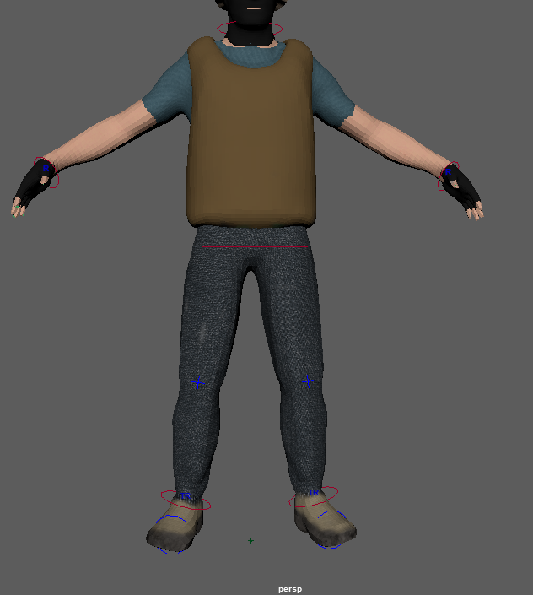
I took the character into substance painter and began my work. I do not have any work in progress screenshots so I will do my best to try and explain everything.
Starting from the top I wanted a cloth like appearance to the balaclava and utilizing smart materials I was able to use a ‘baseball cap’ smart material that I could change the colours of to fit the one I am trying to replicate. I then duplicated this particular smart material onto the gloves as they would be of similar material.
The blue shirt pictures in itself was its own piece of geometry due to the pre-established plan of just changing the colour in Maya. Using a cloth based smart material I applied it over the shirt and changed the colour to fit the previous illustrations done during the preparation phase of my project.
For the vest I applied a smart material that placed down a woodland type camouflage that could have fit my character but not the designs I had drawn out. However I used this as a base due to the normal that the smart material carried with it. I then done some digging on the internet to find the Hex number for the colour I am using. The colour is referred to as ‘Coyote Brown’ and is most prominent in (You’ll never guess) military style clothing and equipment. After finding the numbers I plotted them in as such and placed it over the previous woodland texture while keeping the normal and such intact.
The legs we’re actually part of the exposed arms, hands and feet seen in the above picture are one model due to a mistake during the ZBrush process where I forgot to separate them as their own pieces. This worked out well in my favour however as I was able to just directly paint multiple different smart materials and textures onto one piece of geometry. I used a basic skin type smart material for the obvious areas and then applied a denim smart material for the legs. These two areas came out somewhat well. There is a minor mistake on one of the legs where I missed a small area when applying the texture but I found this to work in my favour as it could be suggested that this is where the jeans have been worn out from continued use.
The feet however didn’t come out very well and honestly that was an issue from the start. I was having a bad time actually making a visually pleasing shoe looking deal and it got to the point where I found myself saying “I’ll just hide the feet” when it came to animating. However I felt like I could probably remedy this using substance painter but in the end it didn’t end up working out. I used a rubber base smart material on the bottom half of the shoe while using a burlap style smart material for the upper area as this would better show a type of desert style boot. These additions however didn’t really improve anything and I would say this is a fault from the start due to my modelling of the shoes. If anyone could really call them shoes anyway. They kind of look like hooves. I’d be laughing if I was making a horse.
Next on my list was making the helmet which I felt was a big part of the project. However I didn’t get many work in progress images as I kind of took the one then got carried away with the thing all together.
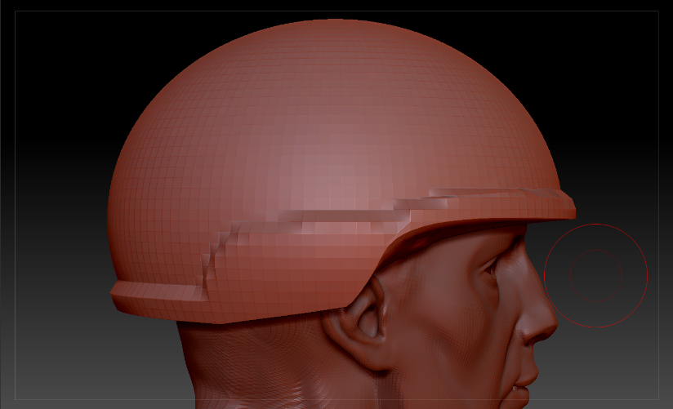
I started with a basic sphere which I then cut in half with the cut along the curve shown above. I used the basic head model for size comparison to make sure the helmet had a realistic size to it. I then used the clay build-up tool to make the exterior area more prominent like the helmet I was attempting to replicate.
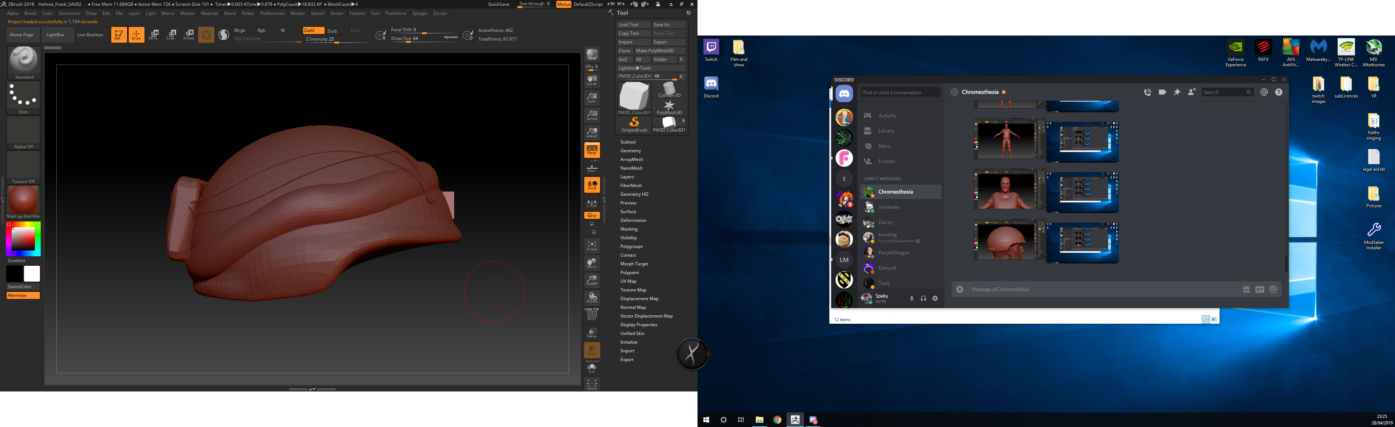
As explained. I didn’t take progression screenshots as I got too into the process. After smoothing out the edges from clay build up I began to squish down the top area and attempted to elongate it to fit the original helmets look. After then I took a basic box shape and attached it to the rear, I smoothed out the planes on each side to get a kind of cloth bag type look that I was going for while also maintaining the box like shape. Using a basic sphere again I again used the cut line tool for the bandana type cloth piece that goes around the helmet. After establishing the basic shape I went forth and began to give it a more uneven display so it wasn’t straight to give a more realistic look to it. I also smoothed down the sides to give it that cloth look. For the cables along the top I found a tool in ZBrush that allowed me to drag one side to the other to recreate a type of long item. This tool came with a bunch of different settings like train tracks and zippers to name a few. I used the obvious cable type one as this fit my initial helmet kit bash from the preproduction stage.
For the VR element of the headset I went into Maya as I found Maya better for making the more hard surface type things.
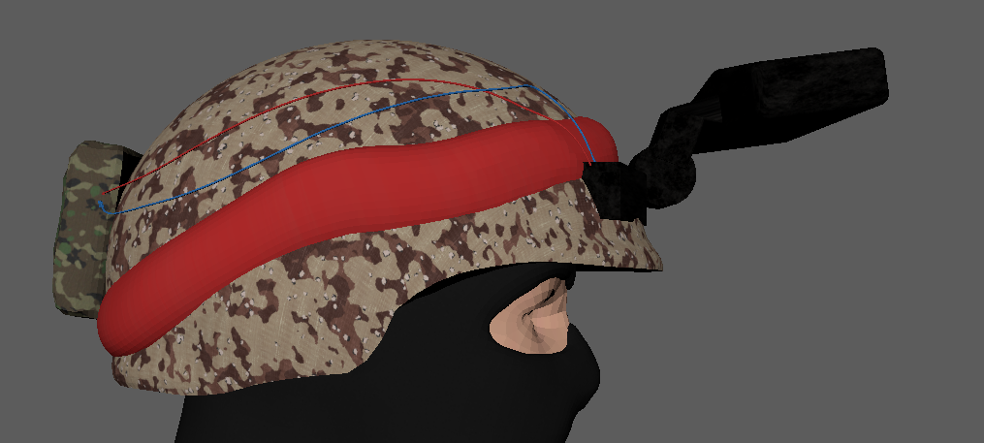
Using simple shapes I was able to make a good looking simple shaped headset using an extruded cube as the base on the helmet alongside a simple sphere and then another cube on the front in which I extended out the centre plane after diving it into a line. I then bevelled the front VR cube so it had a more of a rounded look so again it didn’t look so blocky. Upon completion I done the same with the character expanding out the UV for the texturing in substance.
For the base helmet and the camouflage I started with the woodland camo base as I felt this would work out. After being notified of entire libraries of smart materials like the woodland on the internet. I scoured around for the camouflage I intended which was a mid-90’s American camouflage. I couldn’t seem to find one but I did come along another 90’s American camo which is usually referred to as ‘Chocolate Chip’ which makes me chuckle but it also looks good. As it was from the era I decided to use it as thematically it would also be correct. I applied the camo and it came out well. I then moved onto the bandana which I simply used a brush on to make it red. I then applied the previously mentioned woodland camouflage for the battery bag on the end. For the cables I used a plastic smart material and changed the colour for the other cable.
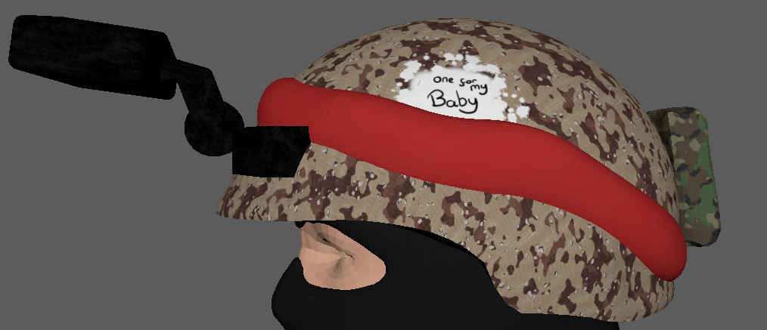
For this side of the helmet I wanted to include a Vietnam type message upon the side and decided to entail the idea of the entire animation plot from the start. After the basic base of the white paint I attempted to try and write the phrase directly into the helmet. My hand writing isn’t the best and I couldn’t get it to come out in a way that I liked so I employed the assistance of my peer Rhys, who came over and wrote the phrase down for me. It looked better for sure.
Animating
For the actual animation I encountered a few problems along the way and I will attempt to share them here.
In the beginning I was having an issue with the hands rotating out of function. It’s a bit hard to explain so here is a video link.
https://www.youtube.com/watch?v=LaCfkp5YnHw
As shown in the video. My rig first and the one I used for portfolio stuff.
The arm moved unusually and doesn’t keep the weapon in one place which made animating with it incredibly difficult. I found that to fix it all I needed to do was select ‘pin rotation’ in the quick rig settings for the arms which fixed my issue and allowed the weapon to be constantly aimed forward for a more realistic animation.
On multiple occasions I found that the rig would share key frames across all of the controls on the rig. After troubleshooting over and over I couldn’t seem to find a way to fix it so for the animation I had to ensure that every piece of movement that was connected on one timeline of key frames till maintained actual movement that was smooth. After a while of animating which proved stressful and unnecessarily difficult I found the fix which was annoyingly simple and required one small change in the quick rig area. For future animations I was mindful to ensure that change was made.
Another issue I encountered was on multiple occasions for no apparent reason an entire animation would spring off balance and would not be aiming in directions previously established. On each occasion of opening this file I have been unable to fix it and would have to personally try and rotate and key frame it to stay in the one angle that would allow it to stay on track with the aiming.

