Environmental Analysis of Automobile industry

IAVOR STANIMIROV

Date: 1-9-2020

Table of content

Introduction 2
PESTEL Analysis of Global automobile industry 4
Political 4
Economical 5
Porter diamond model 5
Social 6
Technological 6
Environmental 6
Legal 7
Swot Analysis 7
Strengths 7
Weaknesses 7
Opportunities 8
Threats 8
Five forces analysis 9
Competitive Rivalry between Existing Players: High 9
Threat of New Entrants: Medium 9
Threats of Substitutes: Low 9
Bargaining Power of Suppliers: Low 9
Bargaining Power of Customers: High 9
Automobile industry value chains 10
Conclusion: 10
References 11

Introduction

The international automobile industry is a multi-billion sector with many major companies varying for market share. This industry became a significant income component of the global economy after it was founded in the 19th century. The large scale, growth and many factors of the car industry influence sales (Fathali, 2016). Automotive industry's most significant divisions include freight vehicles and passenger cars. Global passenger car sales are expected to plummet to 59.6 million vehicles in 2020, down from 79.6 in 2017 (see appendix for more statistics). China is one of the world's biggest car markets, both consumption and development. Car prices in China first fell in 2018; the sector cratered in February 2020, however, showed signs of recovery (Statista, 2020).

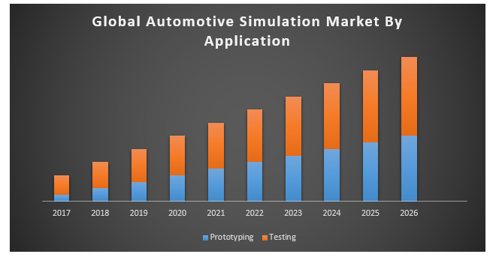

Figure 1: Annual growth of Automobile industry (Source: Maximize Market research, 2020).
Mass manufacturing of automobiles began in the early 1900s when Ford launched assembly line automotive development to mass-produce the Model T (Chu, 2011). Today, the Ford Motor Corporation still ranks among the top producers of passenger cars, the most common commercial light truck model being the Ford F-Series, becoming one of the best-selling electric trucks worldwide in 2019. Surprisingly, in 2019, only one American company made it into the list of major vehicle manufacturers, and European and Japanese players like Bosch, Continental, and Denso dominated the automotive supplier industry. Several countries across the world, inspired by multinational agreements such as the Paris Agreement, impose tighter pollution regulations on new car models. As such, manufacturers are starting to grow into the electric mobility market (Statista, 2020).
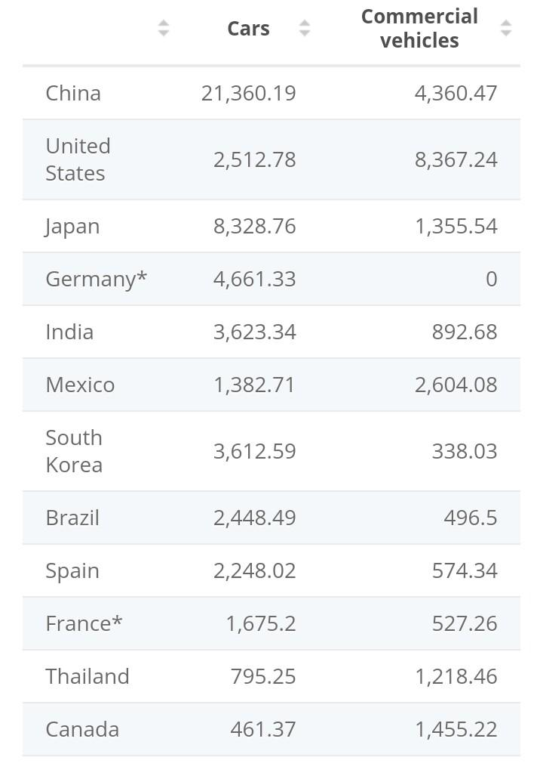

Figure 2: No of vehicle production according to country (Source: Statista, 2020).

PESTEL Analysis of Global automobile industry

Political

External dynamics play a significant role and significantly influence the car industry's profitability. Low emission cars are marketed by policymakers around the world. In addition, taxation has risen in luxurious cars and petrol prices. Government subsidies for low-emission vehicles are provided for markets such as the European Union and the United Kingdom. The worldwide market for electric vehicles has risen. They also gain extra federal grants for their low environmental impacts (Nagy and Jámbor, 2018). The laws and regulations of the government have a significant effect on car brand sales. Fuel-efficient and emission-low technologies will effectively comply with public regulations. In addition, import rules and taxes differ by region. In addition, the automotive sector is influenced by too many global considerations. Under transition political/administrative regimes and commercial economies control may trigger positive or negative variations from time to time (Levy and Rothenberg, 2002).

Economical
In the background of the automobile industry, economic factors are therefore particularly relevant. The recent economic crisis has hit this industry hard. In the absence of strong economic conditions, car purchases are declining (Wang, Tibo, and Nguyen, 2020). In weak economic circumstances, demand for lavish and expensive cars is always adversely impacted. In comparison, in many countries taxation and tariffs on high-priced automobiles are high. The sales of automobiles will remain consistent and stable if the economic environment is suitable and stable. In developed countries, generally higher sales are recorded. The economic size and economic conditions worldwide, therefore, have a major impact on automotive profitability in several markets (Uba and Salisu Alhaji. 2020).

Porter diamond model

This is the economic concept to elaborate on the characteristics of a strategically competitive country. It tries to explain why one nation in a particular industry is more competitive than another. According to the model, the national competitive edge is defined by four distinct variables. These four determinants were represented by Porter as a diamond (Imran, Jian, Urbański and Nair, 2018).

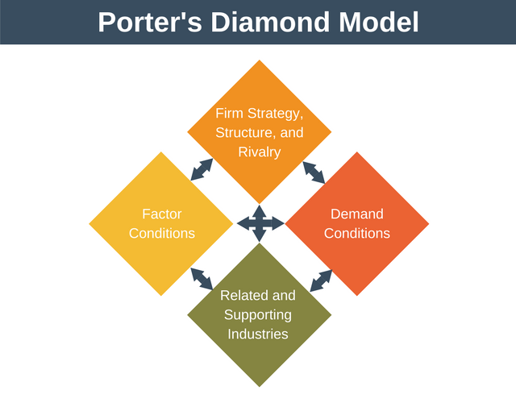

Source: (Porter, 1990).
Economic stability in China is appropriate for the automotive industry. It was ranked as the world's largest passenger car manufacturer, having manufactured over 21.3 million passenger cars in 2019, and almost a third of passenger car production worldwide (Uba and Salisu Alhaji. 2020).

Social

The socioeconomic and cultural factors affect the business environment deeply. The automobile industry also has a bearing on changing socio-cultural trends and preferences of people. These forces must be adopted by car manufacturers. New models are available annually that take into account people's preferences. Moreover, in certain cultures, certain styles are demanded by customers. In some markets, while the SUVs may be in increased demand, the saloon may be preferred in the other markets. An important factor for vehicle manufacturers when targeting consumers is also the distribution of ageing in different populations. The vehicles should be released based on their target population preferences (Wang, Tibo, and Nguyen, 2020).

Technological

In the automobile sector, innovations and competition have been primary market shares determinants. As the company is innovative, its market share will increase. In this respect, all of the major players invest heavily in R&D. Brands such as Toyota, Hyundai and Ford are investing in environmentally friendly, low-emission vehicles. In the coming years, Toyota plans to produce an autonomous vehicle. Not only is this, but the main players in technology also attempting to join this industry sector (Hashmi and Biesebroeck, 2016). The main basis for distinguishing auto-makers has been technological innovation in the last few years. That is because consumers have switched to fuel-friendly cars with large kilometres. Vehicle revenues are always strong with low environmental damage and fuel consumption. This indicates that technology is one of the key influences impacting the revenue and profitability of the automobile industry.

Environmental

The laws on ecological friendliness and emissions of carbon become increasingly strict worldwide. Because all major automotive players had to concentrate on vehicles with low carbon emissions (Levy and Rothenberg 2002). Emissions- and fuel-efficient vehicles are subject to tax subsidies and are favoured by government and law. Pollution controls have become increasingly stricter and only in certain markets, including the EU and the UK, vehicles which pass these tests are allowed. The eco-friendliness of car manufacturers has become an important test in the 21st century, with governments focusing heavily on environmental controls.

Legal

Regulatory policies are another significant aspect of influencing car manufacturers' revenues and results. The laws on consistency and protection of the goods regulate automobiles that are marketed on the foreign market. The regulations on emissions have been more rigorous. Strict pollution standards must be enforced for cars transported abroad. Next are the automotive protection laws which have a significant effect on car sales. Recently, because of its defective airbags, Toyota had to withdraw the cars. Related situations have been called into doubt in the past. Because of these incidents, governments have made passenger safety regulations more rigorous. In addition, financial, taxes and some other regulations have to be complied with by automobile industries during their foreign activities.

Swot Analysis

Strengths

- Industrial development: cars reflect mobility and economic growth. Cars help people to live, operate and fly unimaginably a hundred years ago. Cars have business entry, physician’s service and employment. About every car journey finishes with either a money exchange or some gain for the quality of life (Wang, Tibo, and Nguyen, 2020).
- Present product advancement and technical development: Automobile industries raise R&D investment in the next step of growth by utilising regenerative energy sources, such as sun, wind etc., with the introduction of hybrid cars and alternate fuels such as Shell gas, CNG, and others (law, 2017).
- Development change to Asian markets: While the central hub of this industry is the US & EU economy, the emphasis moves to the rapidly growing markets such as China, India & other Asian countries owing to rising disposable incomes, shifting lifestyles & healthy economies.
- Increased VFM vehicle demand: increasing rivalry has pushed carmakers to enter emerging economies in developed/established markets.

Weaknesses

- Cars recalled: controversies over the replacement of vehicles because of some mechanical faults or non-compliance with Govt's regulations. The rules lead are becoming quite famous (Bhasin, 2020).
- Consumers purchasing power: The vehicle industry moved from production to the supply sector in the last three or four decades. A huge range of models are available, and the rivalry among them and a long list of choices have allowed consumers to select what they want.
- The car industry's pace of development is in government hands because of legislative conditions such as excise tax, the non-entry to the state of foreign cars, the dwindling amount of registration times and fuel price fluctuations. This often affects the industry's progress.

Opportunities

- Implementation of fuel-efficient vehicles: optimisation and cost-effectiveness projects for fuel-driven combustion motors give positive prospects to the car industry. For a long time, emerging markets would be the key drivers of expansion, so fuel-efficient cars take an hour (law, 2017).
- Strategic Partnerships: Creating strategic alliances with carmakers may be a good move. They may distinguish their businesses by leveraging advanced technologies & collaborations with other firms (Bhasin, 2020).
- Lifestyle and consumer segments change: The automobile sector is powered by three strong factors. Customer market change improved protection and fuel efficiency regulatory standards and more advancement in information and knowledge access. Increased demand for two-wheel and compact cars has also occurred with the rise in nuclear families, and it will continue to grow (Hashmi and Biesebroeck, 2016).
- Global expansion: emerging markets such as Asia and BRIC countries would contribute to a rise in vehicle production (Wang, Tibo, and Nguyen, 2020).

Threats
- Intense rivalry: the existence of numerous automotive companies contributes to a pervasive market, leaving little space for new entrants in any sector.
- Fuel price volatility: The deciding factor for fuel development is at least variations in the passenger market. Government restrictions on renewable fuels such as CNG are also relevant. The inventories are often impaired by Shell Gas (Bhasin, 2020).
- Sluggish economy: macro-economic instability, stagnation, joblessness etc. would threaten the automotive sector for a long time.
- High capital expenditures and R&D activities: because developed markets are becoming overcrowded, the sector moves towards developing markets by constructing facilities and research and development centres in these regions. However, the ROI from these options must also be capitalised (law, 2017).

Five forces analysis

Competitive Rivalry between Existing Players: High
There is strong rivalry among established car manufacturers. While three large car firms in the USA, Toyota and Honda in Japan ruled the automotive industry, the condition has changed (Nagy and Jámbor, 2018). Developing rivals in China and India will improve price competitiveness with the rising demand in emerging markets. The rivalry may, however, also concentrate on defence, guarantees and financial services, etc. (Fathali, 2016).

The threat of New Entrants: Medium
While the entry barrier is large for the automotive industry due to the need for resources and technologies, economic growth and rising demand are prompting a growing number of car factories in China and Asia (Chu, 2011). However, the production status of these carmakers and the leading technologies in Japan and the USA cannot be reached, which renders the challenge from newcomers a modest one.

Threats of Substitutes: Low
Customers may move from motorcycles, taxis and subways to travel types other than cars. Despite the high cost of automobiles, though, the vehicle is still favoured owing to its versatility, comfort and efficiency (Maximize Market research, 2020).

Bargaining Power of Suppliers: Low
The product maker has no negotiating ability in the vehicle manufacturing sector, as it can quickly turn to other manufacturers. The parts are, though, usually of low value, which makes it impossible for vendors to work with car manufacturers (Maximize Market research, 2020).

Bargaining Power of Customers: High
As already stated, rivalry in the car industry is high. The consumers also have a range of options on labels and style (law, 2017). The specification, price, protection, comfort, the appearance of the car are of concern to consumers. Customers have lately often become deeply worried regarding the environmental effects of vehicles and energy usage. Thus, in the automotive sector, consumers are becoming steadily negotiation leverage (Nagy and Jámbor, 2018).

Automobile industry value chains

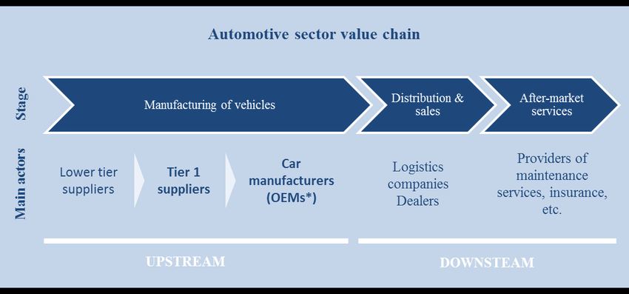

Source: Research gate, 2020.

Conclusion:

In the 21st century, the relative influence of the automobile industry's fiscal, environmental and legal influences has become more dominant. Most of global automotive producers are now paying heavy attention on reduced emission of carbon, efficient mileage and low-cost cars. The socio-cultural factors impacts and market expectations often influence the automobile industry substantially and explicitly. However, the advent of emerging competitors in this field has above all influenced the level of rivalry. Investments in technologies and creativity are the key competitors to achieve a greater market share.

References

Bhasin, T. 2020. SWOT analysis of Automobile industry. Marketing91. Available at https://www.marketing91.com/swot-analysis-of-automobile-industry/

Chu, W.W., 2011. How the Chinese government promoted a global automobile industry. Industrial and Corporate Change, 20(5), pp.1235-1276.

Fathali, A., 2016. Examining the impact of competitive strategies on corporate innovation: An empirical study in the automobile industry. International Journal of Asian social science, 6(2), pp.135-145.

Hashmi, A.R. and Biesebroeck, J.V., 2016. The relationship between market structure and innovation in industry equilibrium: a case study of the global automobile industry. Review of Economics and Statistics, 98(1), pp.192-208.

HOW ARE DIGITAL TECHNOLOGIES CHANGING INNOVATION? - Scientific Figure on ResearchGate. Available from: https://www.researchgate.net/figure/Automotive-value-chain-stages-and-main-actors_fig4_334593576 [accessed 1 Sep, 2020]

Imran, M., Jian, Z., Urbański, M. and Nair, S.L.S., 2018. Determinants of firm’s export performance in China’s automobile industry. Sustainability, 10(11), p.4078.

Law, C.M., 2017. Restructuring the global automobile industry (Vol. 4). Taylor & Francis.

Levy, D.L. and Rothenberg, S., 2002. Heterogeneity and change in environmental strategy: Technological and political responses to climate change in the global automobile industry. Organizations, policy and the natural environment: institutional and strategic perspectives, pp.173-193.

Maximize Market research. 2020. Global Automotive Simulation Market – Industry Analysis and Forecast (2018-2026) – by Technology, Component, System, Vehicle Type and Region. Available at https://www.maximizemarketresearch.com/market-report/global-automotive-simulation-market/24112/

Nagy, J. and Jámbor, Z., 2018. Competitiveness in global trade: The case of the automobile industry. Economic Annals, 63(218), pp.61-84.

Statista. 2020. Leading car manufacturing countries worldwide 2019. Available at https://www.statista.com/statistics/584968/leading-car-manufacturing-countries-worldwide/

Statista. 2020. Automotive industry worldwide - statistics & facts. Available at https://www.statista.com/topics/1487/automotive-industry/#dossierSummary__chapter2

Uba, Salisu Alhaji. 2020. "An analysis of the business environment of China’s Automobile Industry: the Case of Chery Automobile Company."

Wang, C.N., Tibo, H. and Nguyen, H.A., 2020. Malmquist Productivity Analysis of Top Global Automobile Manufacturers. Mathematics, 8(4), p.580.

