Task 1a: Essential Academic and Employment Skills
Career area: Computing / IT Support
Your academic knowledge and your employability skills go together, for many IT jobs require digital confidence, professionalism and a commitment to continued development. Digital skills are crucial as staff must be able to navigate safely around software, online and databases, to solve problems at work [1]. Critical skills will ensure I critically analyse and appraise any online content as opposed to accepting things at face value and compare evidence to draw reasonable conclusions [2]. I am also developing my academic reading, research, note taking and proper referencing skills through critical thought and the identification of bias. IT professionals will often need to address users, technicians, managers and even clients, thus require good communication to break down technical aspects in easily digestible language for the non-specialist. The analysis and diagnosis of error and testing potential solutions that make up problem solving are critical in computing work; along with reflection of findings and adapting based on customer feedback, as reflected in recent research which indicates that digital competency skills including the likes of communication, safety, collaboration and problem-solving boost readiness for work [3]. Post-graduation, these skills will enable me to be an effective employee within an IT support / computing field, facilitating work efficiency through collaborative work practices, effective task management and ensuring I keep pace with technology developments by continuing to update and advance my skill-set, although the output from any such as those that produce an AI text will require verification and reformulation into my own words, using reliable source materials as appropriate [4].
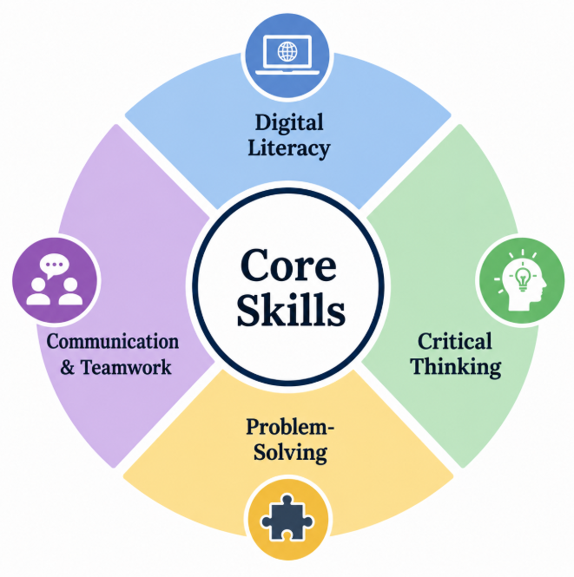
Figure 1: Four-Part Skills Wheel Showing Core Academic and Employability Skills
Source: Created By Author
Reference
[1] “BCS Essential Digital Skills: Qualifications for work | BCS.” https://www.bcs.org/qualifications-and-certifications/digital-literacy-qualifications/bcs-essential-digital-skills-qualifications-for-work/.
[2] “Critical thinking, logic, and argument | Athabasca University Press.” https://www.aupress.ca/books/oer-202403-critical-thinking-logic-and-argument/.
[3] B. Đorđević, S. M. Zbiljić, and M. Radosavljević, “Impact of the digital Skills
on Employability: Cross-Sectional Analysis,” Economies, vol. 13, no. 7, p.
196, Jul. 2025, doi: 10.3390/economies13070196.
[4] OpenAI’s ChatGPT, private communication, June 2026

