Student name: | YEUNG KUEN CHRISTINE | Student ID number: | 1922287
Programme: | DBA
Module: | Managing in Complex environments: Strategies, Insights and Solutions
Module code: | HKBM7002 | Contribution to Overall Module Assessment (%): | 100%
Lecturer: | Dr. Leo Ho | Internal Verifier:
Assignment Title: | Project report | Word count (or equivalent): | 7500 (+/- 10%)
Submission deadline: | 15 February 2021 | Return date of provisional marks & written feedback:
Submission method: | All written assessments, where practical and possible, must be submitted via Turnitin unless otherwise instructed by the Lecturer. (Please DO NOT put this assessment specification into Turnitin or it will match many similarities with other students’ submissions.)  Alternative submission method (if applicable):  Late submission of the assessment will result in a late penalty mark. Penalties for late submission: Up to one week late, maximum mark of 50%. Over one week late, 0%. Only the Extenuating Circumstances Panel may approve a change to submission dates.
Academic honesty / referencing: | Academic honesty is required. In the main body of your submission you must give credit to authors on whose research and ideas your work is based. Append to your submission a reference list that indicates the books, articles, etc. that you have used, cited or quoted in order to complete this assessment.

LEVEL 7 ASSESSMENT SPECIFICATION

The importance of people management in M&A: A case study of Sun Pharmaceuticals and Ranbaxy Laboratories

Christine Kuen Yeung

University of Wales Trinity Saint David

Executive Summary
In the current economy that focuses on speed under intense competition, most top business executives believe that the quickest way to improve company’s financial performance, achieve a quantum leap in market share or ensure a sustainable long-term growth is through acquiring other companies rather than building internally. Not surprisingly, worldwide merger and acquisition (M&A) activity is on an upswing in recent years. An increasing number of companies are using the M&A deal to branch out into new markets, customer segments, products and services. However, many researches on post-merger performance evaluation shows that two-thirds of the newly formed companies perform well below the industry average. The productivity improvement envisaged after the acquisition synergy strategy seems never materialized. When tracing the causes back to their roots of the dismal performance, people and culture issues are prominently the root causes in the failure of reorganization after M&A. Unfocussed leadership, internecine politicking, lack of open communication, the loss of key talent employees and culture clash. All these people and culture issues can turn a great opportunity into a failure. Therefore, the role of human resource professional is vital and identified as one of the strongest influences on the ultimate outcome of M&A process. Nevertheless, this important people management issue is always neglected during the process resulting in unfavorable outcomes. In this report, a case study of Ranbaxy Laboratories being acquired by Sun Pharmaceuticals (Sun Pharma) in 2015 was selected to evaluate the impact of people management issue in M&A process. This transaction was chosen because it was one of the biggest M&A deals in the Indian market and the largest deal in pharmaceutical industry. After the acquisition, Sun Pharma has become the India’s largest and world’s 5th largest pharmaceutical company.

Introduction
The world is changing and moving at a rapid pace under current globalization and dynamic landscape, most corporation are in hurry to expand their business either by internal or external expansion under intense competitive environment. In case of internal expansion, a corporation grows gradually but in external expansion a corporation can achieve a quantum leap of bigger market share overnight by an acquisition or takeover of a running business through corporate restructuring. This corporate restructuring is currently one of the widely adopted strategic tools for improving financial performance and ensuring long term growth. It involves re-organization or re-orientation of assets and liabilities of a company through a series of conscious management actions to increase company’s productivity, to improve future cash flow stream and to become a more operational efficient and profitable company. The most common type of corporate restructuring is merger and acquisition. Many international corporations believe in the philosophy of “growing through acquisition” as continuous growing is central to the new economic environment. In particular, an increasing trend of corporate restructuring through merge and acquisition is observed in the Pharmaceutical industry during the last decade. Merge and acquisition process is a delicate process in which even a minor issue can become significant issue if it is unaddressed or not well managed, but if the process is effectively implemented, it can create an innovative path of new markets, customers, products and technologies that the acquiring corporation can benefit from. Many researches reveal that during the implementation of merge and acquisition transaction, people management issues are commonly deferred to the later stage of the process or even neglected. It is evidenced by a number of researches that two-thirds of merge and acquisition transactions fail and one of the major reasons behind the failure is negligence of human resource aspect. This merge and acquisition process creates stressful situation, anxiety, fear of losing job or compensation being affected, loss of identify and recognition since many uncertain factors are involved in the heart of affected employees. In this report, the impact of human resource issue is thoroughly analyzed on a case study of Sun Pharma and Ranbaxy.

The acquisition of Ranbaxy Laboratories by Sun Pharmaceuticals completed on March 25, 2015 at the cost of US$4 billion was one of the biggest merge and acquisition deals in the Indian market and the largest deal in pharmaceutical industry. After the transaction, Sun Pharmaceuticals (Sun Pharma) had become the world’s 5th largest generics drugs manufacturer after acquisition of Ranbaxy Laboratories from the hand of Japan’s Daiichi Sankyo Co. Ltd. In addition, it also became the largest pharma company in India with over 10% market share and the sales of US$ 4.2 billion in 2013-14. The need for acquisition was mainly two folds. First, Sun Pharma acquired Ranbaxy for external expansion to become the top Pharmaceutical company in India. Second, Sun Pharma believed that it was more economical to acquire the next blockbuster drug than to develop it internally.

Although the company’s founder and managing director of Sun Pharma Dilip Shanghvi was expecting the synergy benefits through the acquisition deal, he was also facing a big challenge in merging Ranbaxy into Sun Pharma organization due to a number of substantial differences in corporate culture, management team capabilities, employee competency, finance/business models and operational technology. Sun Pharma needed to close the gap and aligned the differences in order to achieve the benefits synergy projected. It was a big deal facing a lot of difficulties. One of the key integration processes crucially affecting the successful rate of merge and acquisition transaction was human capital integration. The merger had to focus on strengthening Sun Pharma’s multi-cultural team of around 30,000 people with as diverse as 50 global cultures. Integrating two firms on work cultures and alignment of rewards and recognition framework onto the common platform was the greatest operational challenge facing Sun Pharma.

However, half of the work force of the Ranbaxy had quit the company during the transaction. Some employees of Ranbaxy had even lodged a court case on Sun Pharma about dissatisfaction of work place relocation and after 18 months following acquisition, Ranbaxy’s employees had won the battle and received the full compensation from Sun Pharma. Share price was dropping after acquisition, they lost the trust of employees as well as investors. Sun Pharma needed to restore employees’ faith towards the culture integration as the common post deal phenomenon since the loss of identity was adversely impacting not only the morale of Ranbaxy’s employees but also Sun Pharma’s employees as well.

Relevant Literature Review on the Role of Human Resource
There are previous literatures on the roles of human resource professional in merger and acquisition. The involvement of Human Resource is a crucial determinant factor in effectively managing the merged organization in particular transparent communication is most important to handle various employee reactions to the merger. Nevertheless, Pablo Maran and Christine Panasian (2015) revealed that the attention level of people management issues during merger and acquisition transaction have not been given adequate level that they should be given in practice. Uday Bhaskar (2012) found that human resource professional positioned as business partner involving from pre-acquisition phase to integration stage is crucial to a successful acquisition deal. After the merger, managing culture differences in the newly formed organization is a major challenge to human resource. In addition, Linda (2000) discussed the key people issues that should be taken into account when merger and acquisition process occurs. She emphasized on cautious planning and early involvement of human resource professionals at the beginning of the process. By reducing the fears and dissatisfaction feeling of employees at work, human resource professionals can help corporation maximize the likelihood of success. Craig (2007) examined the role of human resource management in the phase of merger and acquisition. He studied that over 65% of M&A transactions that fail because of a number of unresolved people issues, culture issues and communication issues. This is because there is no clear role defined for human resource in the merger process, thus he suggested a best practice checklist covering focused leadership, dedicated transition management team and transparent communication at all levels of employees are critical elements. Teresa (2010) in her study of human resources management in the phase of merger and acquisition also showed that incompatible culture, poor motivation, loss of key talents, lack of communication, diminished trust and uncertainty of company goals are the key reasons of low employee productivity in the merged corporation.

India Pharmacy Industry Overview
Since 1950s, India pharmaceutical industry has demonstrated a booming performance in manufacturing and distributing medical drugs at an affordable price. The pharmaceutical industry is successful not only in fulfilling its domestic market needs of the world second largest pollution country but also in accomplishing a leading position in the pharmaceuticals sector around the world. In particular, India’s pharmaceutical industry has demonstrated its strengths and world class capabilities to innovate and timely distribute the life critical drugs to the world that needs it during the COVID-19 pandemic. India now has become the world’s largest supplier of low-cost generics, vaccines and most affordable medicines and has the second-largest number of United States Food and Drug Administration (USFDA) approved medicine manufacturing plants.

The India’s pharmaceutical industry significantly contributes to the country’s foreign trade. India is the largest generic drugs provider globally exports 20% generics by volume representing USD 19.13 billion in 2018-19. The four leading Indian pharmaceutical companies are among top 10 global generic companies. Although India currently ranks 14th globally in the measure of production value, it ranks the third globally in terms of sales volume. The large export volume is mainly attributed by the growing global demand of India pharmaceutical products at the lower affordable costs to millions of people across the globe. Therefore, riding on its well-established domestic manufacturing experiences and low-cost skilled manpowers, India’s governments are now positioned themselves as ‘Pharmacy of the World’, a global hub for world pharmaceutical manufacturing.

The market size amounted to USD41 billion in 2018-19 and expects to continue growing to USD100 billion in 2025 at an average growth rate of 10-12% per year. The development potential of India’s pharma sector is substantial because of the expanding population, growing prosperity, increasing awareness towards health especially following the COVID-19 pandemic and most importantly the demographical change of aging population in large parts of the world. All these factors contribute to the increasing demand of active medical care treatment. India pharmaceutical industry aims to transform into the world’s largest supplier of medical drugs by 2030 with revenue to USD 120-130 billion. Thus, India’s government will continue to support the development of the pharmaceutical industry by investing in more drug R&D and pharma research within India. India continues to play a pivotal role in suppling medical facilities worldwide in particular where affordable healthcare is most needed. Prime Minister Narendra Modi’s vision is not only to position India as a healthy country but also a healthy world and he sees India as a global caregiver.

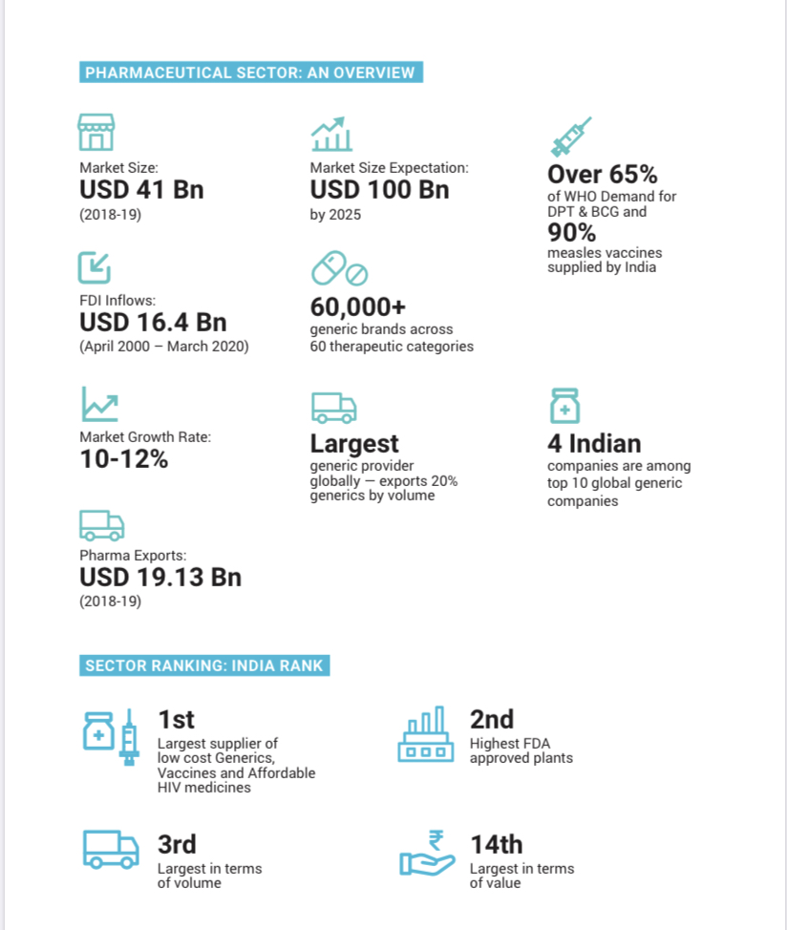

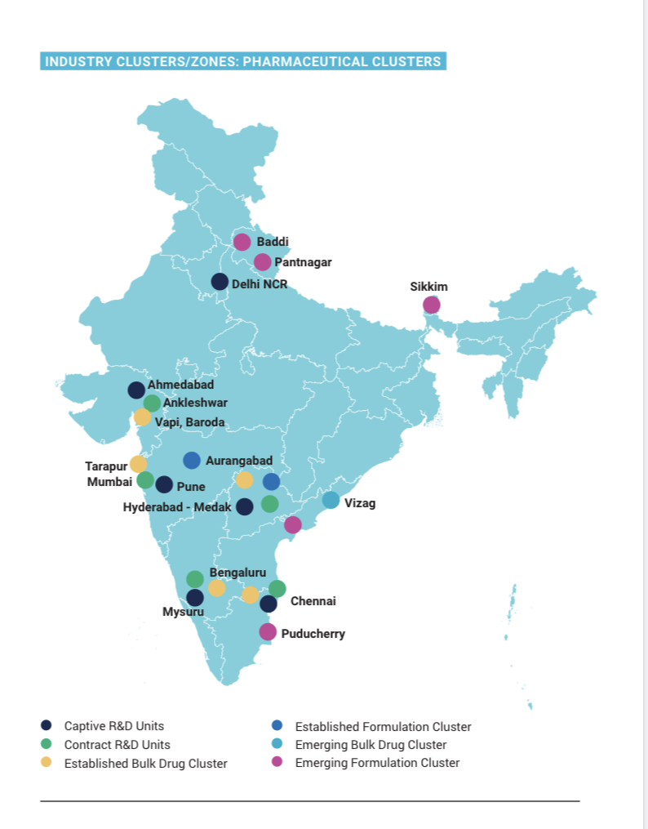
Company Profile of Sun Pharmaceuticals
In 1983, the Sun Pharma was established by the founder Dilip Shanghvi with headquarter located in Mumbai. It is a multinational, integrated, specialty pharmaceutical company offering formulations in various therapeutic drugs. Sun Pharma has its own research center formed in 2007 and named as Sun Pharma advanced research company limited (SPARCL) focusing on Pharma research and drugs innovation development to enhance the productivity of new generic and differentiated drugs for domestic and global markets. It has full capabilities across dosage forms like injectables, sprays, ointments, creams, liquids, tablets, and capsules. Its businesses include producing generics, branded generics, specialty, over the counter (OTC) products, anti-retrovirals (ARVs) and intermediates in the full range of dosage forms. It also manufactures specialty active pharmaceutical ingredients (APIs). The company has strongly demonstrated its competency in wide range of product innovation and producing complex specialty drugs forms and APIs.
It produces and promotes a lot of pharmaceutical formulations as branded generics in India, the US and several other markets worldwide. Domestically, the company is leading in niche therapy areas of neurology, psychiatry, diabetology, cardiology, ophthalmology and orthopedics after acquiring local pharma company called Dadha Pharma to start operations on oncology and gynecology technology. On the other hand, Sun Pharma’s sales are mainly from markets outside India contributing over 70% while 60% turnover comes from United States. To support the sales volume in overseas market, manufacturing plants are located across 26 locations within US, Mexico, Brazil, Canada and Israel.
Sun Pharma went public in 1994 listing on the Bombay and the National Stock Exchange. In the past three decades, it has transformed into one of the most profitable corporation in the pharmaceutical industry around the world through joint ventures and acquisitions in India and abroad. Sun Pharma completed nearly 20 acquisitions deals since 1983, mainly 12 acquisitions completed between the 1997 and 2012, starting with the purchase in 1997 of Detroit-based Caraco Pharmaceutical Laboratories. During that year, Sun Pharma also acquired shares in two Indian pharma firms, namely MJ Pharmaceuticals Ltd and Tamilnadu Dadha Pharmaceuticals Ltd. In 2010, Sun Pharma bought a majority stake in Israel-based Taro Pharmaceutical Industries, a decision made, resulting in over 200% growth in its revenue to US$1.1 billion following the acquisition. In the following two years, Sun Pharma acquired two more drug makers in the US — Dusa Pharmaceuticals Inc. and the generic business of URL Pharma Inc, which further fueled its growth.

Today Sun Pharma is the biggest and one of the most profitable pharmaceutical company in India, as well as the largest pharmaceutical company by market capitalization on the Indian stock exchanges. The founding family holds the major stake in the company.
Company Profile of Ranbaxy Laboratories
Ranbaxy was originally started by Singh brother (Ranbir Singh and Gurbax Singh) in 1937 as a distributor for a Japanese company Shinogi. The name Ranbaxy was the name of a port manteau of its first owners Ranbir and Gurbax. The company was then incorporated in India in 1961 with headquarter located in Gurgaon.
Ranbaxy is a multinational research based pharmaceutical company manufacturing a wide range of affordable and quality generic medicines and most importantly trusted by healthcare professionals. With its concerted efforts on drugs research and development over a long period of time, the company has achieved extensively good recognition and reputation, many of which incorporated the proprietary of Novel Drug Delivery Systems for technologies invented at its own laboratories. It has put efforts on its strengths on generics research and is focusing on more complex and specialty areas.
Ranbaxy’s memorable moment happened in 1998 when it first time opened up the market in the United States, the world’s largest pharmaceutical market. It was the first foreign pharma manufacturer to sell drugs in the US. Nowadays, Ranbaxy expands its customers base with the impressive portfolio of products sold in over 150 countries through expanding international portfolio of affiliates, alliances and joint ventures. It has operations in 40 countries and 21 manufacturing facilities located in 8 countries.
Ranbaxy was listed public in 1973. In 2008, Daiichi Sankyo acquired a controlling stake of 63.92% in Ranbaxy from Malvinder Mohan Singh and family in a deal of worth US$4.6 billion. Following this deal, Ranbaxy become a member of the Daiichi Sankyo Group. Daiichi Sankyo is a leading global pharma innovator, headquartered in Tokyo, Japan. Daiichi Sankyo Co Ltd, Japan continues holding approximately 63.4% shares in the company before the merger and acquisition. In 2009, Singh resigned due to Ranbaxy’s poor performance leading to a net loss. Since then, Daiichi Sankyo are more actively involved in the Ranbaxy’s operation.
Since 2011, Ranbaxy has been struggling to improve its financial position, yet still suffering a declining in net worth of the company. It can be attributed by a series of mismanagement incidents, such as the amount of US$ 515 million was paid to the US Department of Justice (DOJ) in May 2013 after civil and criminal charges were brought against it for misrepresentation of data and irregularities found in two of its facilities in India, shrinking in the value of its investments and a loss on foreign currency option derivatives.

Finally, Daiichi Sankyo decided to sell Ranbaxy at a crucial time in 2014 to Sun Pharma when Ranbaxy was under financial distress and struggling to survive.

The Merge and Acquisition Transaction
On Apr 2014, following the regulatory approval, Sun Pharma and Daiichi Sankyo jointly announced the sales of his entire Ranbaxy’s stake of 63.4% to Sun Pharma at the cost of US$4 billion. It comprised of two transactions. Sun Pharma took over all outstanding shares of Ranbaxy in an all-stock transaction for US$3.2 billion. The shareholders of Ranbaxy including Daiichi Sankyo received 0.8 shares of Sun Pharma in exchange for each Ranbaxy share. The remaining of US$800million was on debt loan.

The acquisition of Ranbaxy Laboratories by Sun Pharmaceuticals completed on March 25, 2015, which was one of the biggest merge and acquisition deals in the Indian market and the largest deal in Indian pharmaceutical industry. After the combination with Ranbaxy, Sun Pharma has become India’s largest drug manufacturer with local market share of around 10% and the world’s 5th largest pharmaceutical company with sales of US$4.2 billion in 2013. The combined entity had its footprint over 55 countries and over 40 manufacturing plants over the world.

After the completion of the merge, the holding of Sun Pharma’s original shareholders in the new corporation were diluted to 55% while Daiichi Sankyo had 9% and the public shareholders of Ranbaxy and Sun Pharma had 14% and 22% stake respectively. Daiichi Sankyo became the second largest shareholder in Sun Pharma and possessed the right to delegate one director to Sun Pharma’s Board of Directors.

The rationale of the Merger and Acquisition
The merger and acquisition transaction created a new pharma company ranked the 5th largest global specialty generic company and the 1st largest domestic pharmaceutical company with market leading position in 13 specialty drug segments.
Investors commented the deal was favorable to Sun Pharma as it helped fill therapeutic gaps in the US market, get better access to emerging markets and strengthen presence in domestic market. A combined entity had a diversified, greatly complementary portfolio of specialty and generic products covering an extensive range of chronic and acute medicines.
Geographically, the new merged entity had operations over 65 countries, 47 manufacturing facilities across 5 continents in total, providing a solid platform of specialty and generic products targeted worldwide market. In addition, Sun Pharma’s proven track record on specialty drug capabilities coupled with Ranbaxy’s long history of global footprint in generics segment posited the great opportunities for exceptional growth. Ranbaxy had brought in not only an increased exposure to high-growth emerging markets such as South Africa, Romania, Brazil, Russia and Malaysia (where Sun Pharma did not have a footprint) for cross-selling and building better brand, but also further strengthening its presence in the United States and India local markets. The benefits of being more diversified with US market plus the rest of the world and India contributing 47%, 31%, 22% of sales respectively following the merger.

Sun Pharma expected to benefit from Ranbaxy’s global distribution network and its strengths in over-the-counter drugs, chronic therapy and hospitalization products. Therefore, Sun Pharma forecasted to realize the synergy benefits of US$ 250 million by third-year since the deal closure. Increased revenue, cost management, procurement with supply chain efficiencies were the expected benefits. Additionally, Sun Pharma planned to leverage the combined human capitals from both companies to further fuel the sustainable growth.
Given Sun Pharma’s past successful track record of turning distressed and difficult businesses around into a growing and profitable business, investors generally assumed the merger won’t have any major cultural or people integration issues. Surprisingly, half of the work force of the Ranbaxy had quit during and after the merger and acquisition process and the results of the acquisition were not as satisfactory as what was expected before the merger.
Merger and Acquisition Review on People Management Issue
In today’s world, in order to maintain competitive advantage under the intense competition business environment, company executives constantly look for a faster growing path through acquiring another company. However, statistics shows that the success rate of merger and acquisition is usually less than 50%. Research findings show that one of the root causes underlying the failure is the ignorance of important human factor throughout the whole process from the beginning of planning to post-merger and acquisition. When a company decides to kick start the merge or acquisition process, company executives always emphasize on the due diligences on business, strategic, financial, legal and compliance aspect issues, but often put people management issue as a secondary consideration to financial aspects or even neglect it throughout the process. People issue is in fact a very central risk to the merger and acquisition process requiring proper evaluation and dedicated management, which is actually as important as financial or compliance risks. Companies failing to recognize the importance of human issues could suffer unfavorable financial consequences or even end up with deal breaking situation. Therefore, a company must involve HR professionals as early as possible throughout all phases of merger and acquisition from pre-merger phase, due diligence, acquisition to post-merger phase.

For the case of Sun Pharma and Ranbaxy merger and acquisition, there were around 30,000 employees after merger under one entity. However, for such a big workforce, Sun Pharma’s executives did not give enough attention to critical human resource issues and involve any experienced HR professionals since the early stage of the merger and acquisition process. The most affected person during merger and acquisition were employees at all levels of the company who were the backbones of a company. However, nearly 25% of ground to middle level of Ranbaxy’s employees resigned when the deal was announced and almost all top executives of Ranbaxy quit the company after merger which negatively impacting the morale of junior employees. They had experienced psychological and financial pains because there was no certainty of the role and responsibility, job profile, designation, salary structure and lack of recognition for them. This had created a fear of decline in status, career prospects and feelings of despair. The big difference in culture between the acquiring and acquired companies was also a crucial barrier for a successful merger and acquisition. For example, Sun Pharma required employees to work 6 days in a week but in Ranbaxy, employees used to work 5 days. Ranbaxy’s employees took it negatively as they were not ready for adjusting themselves on culture changes and alignments with Sun Pharma. These had increased their stress level leading to a substantial declination in productivity and staff retention rate.

Some employees of Ranbaxy were forcedly transferred to a long-distanced region from their actual working space. They did not accept it and filed a court case on Sun Pharma. After 18 months, Ranbaxy’s employees had won the battle and received a full compensation from Sun Pharma. The frustration of employees could have been avoided if HR professionals could proactively give adequate advices on handling sensitive people issues. Sun Pharma finally took almost 2 years to integrate Ranbaxy’s operation process, technologies and the most importantly is people integration. According to the post-merger employee engagement survey after 2 years of integration, it showed that employees were delightfully working for Sun Pharma because they felt that they got better rewards and recognition than before. Sun Pharma organized an annual award presentation to recognize those employees who had achieved the target and outperformed throughout the year.

On the other hand, not only Ranbaxy was adversely affected, the merger and acquisition process also exerted negative impacts on Sun Pharma’s employees because they also confronted with lots of problem during operation process integration and knowledges transfer. In particular, there was a big gap in employee’s productivity for two companies. Sun Pharma’s employee productivity was very high at 9 lakhs per man per capita productivity versus Ranbaxy’s employee productivity was as low as 1.5 lakhs, which was only 17% of Sun Pharma’s employees productivity. Sun Pharma provided skill transfer trainings and money incentives to Ranbaxy’s employees in order to close the difference in the productivity between two companies. However, this arrangement had created extra workload to Sun Pharma’s employees and at the same time they were pressurized by taking up an increased target from Ranbaxy after the merger.

In addition, the special development fund that used to be allocated to departments in Sun Pharma for business expansion purposes was cut substantially compared to pre-acquisition period due to reallocation of resources after merger. It had created internal conflicts between two group of employees which could be destructive to the company. Therefore, the alignment of human resources issues for both acquiring and acquired company is crucial from the early stage of merger and acquisition to integration and post-merger evaluation.

Recommendation and Implementation Plan for Recommended Changes
Early HR professional’s involvement will help company better prepare for merger and acquisition integration and thus increase the chance of a successful deal. It is because HR professionals have the opportunity to influence the important human capital decisions that could impact business’ financial value since human capital is crucial assets of a company. HR professionals are expert in people issues and expected to be change agents to help employees cope with the changes and new culture. It is HR responsibility to bring clarity and stability to the situation through effective and transparent communication so that employees can stay focused on their jobs. In addition, they need to provide coaching to leaders to help them identify company’s talents and accommodate various company changes during the merger and acquisition process.

One of the key HR roles is to perform a detailed planning of human resources for the merged company through talent mapping process to identify the gap of existing employees’ skill sets and those required for future roles. An effective talent retention strategy is definitely vital to the success of merger and acquisition as most talented employees would easily leave the company if they feel uncertainty about career aspiration in the new company. Therefore, prompt and timely actions are essential. The following are key steps of talent retention action plan:
- Identify key employees at all levels of the company including leaders from both companies
- Ensure frequent and open communication with employees in different channels so that they would not feel that they have been kept in dark
- Host training sessions, workshops and seminars for employees to embrace changes and make them feel like being part of the change that is about to take place
- Explain new roles and expectation to employees and get them familiar with new culture
- Arrange orientation programs on performance management, new compensation and benefits
- Involve senior management in the decision process and hold them accountable of getting employees engaged

In addition to above, a successful retention strategy during a merger should include adequate financial remuneration scheme for top executives with a retention bonus for at least one to two years.

The alignment of culture between the acquiring and acquired company is another central people issue to deal with during merger and acquisition. Culture differences consists of more than just different geography, language and custom. They also represent divergent attitude toward work, company vision and mission. It takes time to understand people and look for culture similarities and differences between two companies. The bigger the differences, the harder for the merger to succeed. When two different companies are merged, there are four potential approaches to culture alignment: maintain two distinct cultures, adopt the acquiring company’s culture to the acquired company, mix and match culture from both companies, or create an entirely new culture of new company. No matter which approach is chosen, the key is clear and open communication with employees and focus on what can motivate them for achieving team cohesiveness under a synergistic culture.

Conclusions
The trend of merger and acquisition in today’s global business world is increasing. The reasons behind this move are to create the desired synergies benefits for business expansion and to provide sustainable competitive advantages. However, there are many challenges and complexities facing the company and employees. In particular, handling HR sensitive issue during merger and acquisition is a very dedicated process, which is as important as financial and compliance issues. It requires extensive planning, people evaluation and effective and transparent communication with different level of organization hierarchy.

In this report, the downward trend of Sun Pharma performance at the initial phase of merger was attributed by the ignorance of important HR role during the integration process, thus arising a number of unfavorable human resources problems, such as uncertainty about salary and status, unnecessary downsizing of labor force and most importantly the lack of effective and transparent communication between employees and new company. The results of the acquisition at initial phase were not satisfactory as reflected in the decreasing share price of Sun Pharma. They lost the trust of employees as well as investors.

It is recommended that respective HR who plays a vital role in giving advices on people issues should be involved as early as possible in handling culture and hierarchy changes, alignment of compensation and welfare benefits, and the impact of potential redundancy. Only if sensitive HR issues are addressed and effectively implemented during the merger and acquisition, it is beneficial to all employees working in the acquiring and acquired companies and is definitely helpful to the merged company in delivering the desired objectives and outcomes.

References
Arpita Mehrotra and Dr. Arunaditya Sahay (2016), ‘Sun Pharma acquires Ranbaxy: The Postmerger Blues’.

Craig W. Fountaine (2007), ‘Mergers and Acquisitions: Understanding the role of Human Resource Management’, North eastern University UK.

Kristen B. Donahue (2001), ‘How to Ruin a Merger: Five People-Management Pitfalls to Avoid’, Harvard Management Update, volume 6 (9).

Linda Johnson (2000), ‘The Human Resource Perspective in Merger and Acquisition’.

Neha Mareja and Dr. Vaishali Sharma (2019), ‘Impact of Corporate restructuring on Employee Reward and Recognition: A case study of Sun Pharmaceuticals and Ranbaxy Laboratories’, International Conference on Advancement in Computing and Management.

Neha Mareja and Dr. Vaishali Sharma (2016), ‘A Study on role of Human Resource post Acquisition: A case study of Sun Pharmaceuticals and Ranbaxy Laboratories’, International Journal of Research in Commerce & Management, volume 7(9), pp. 62-64.

Pablo Maran and Christine Panasian (2005), ‘The Human Side of Merger and Acquisition: A look at the evidence’.

Teresa A. Daniel (2010), ‘Managing Human Resources in Mergers and Acquisitions’.

Uday Bhaskar (2012), ‘Human resource as business partner during mergers and acquisitions’.

