Digital Business
BMSP6002
Assignment 2

Contents
1. Introduction
2. An Evaluation of Airbnb as an example of the sharing economy
2.1 Airbnb Landscape
2.2 BMC
2.3 Strategic formulation framework
2.4 Tools and Systems
3. Conclusion and Recommendations
4.References

- Introduction.
This report aims to critically evaluate Airbnb as an example of the sharing economy, Examining the evolution of the company and the landcape in which it operates, including the current position, current and expected challenges and opportunities, as well as completing a business model canvas to clarify these areas, and identifying Airbnbs position on the Grand Strategy Matrix, an exploration of the tools and systems used by Airbnb is to be carried out, with recommendations for moving forward.
A number of relevant sources and academic theorists have been researched and referenced for completion of this report.

- An Evaluation of Airbnb as an example of the sharing economy
  - Airbnb Landscape
In 2007 Airbnb entered the accommodation market, the company was not expected to grow as exponentially as it did, the founders of the company rented out a room in their own property to fund a trip away (Sherwood, 2019) and stumbled across the key to a business that would change the world, challenge the hotel industry and create huge growth in the sharing economy. By 2015 the company were facilitating an average of 425,000 guests per night (Li & Tabari, 2019) and providing a very real threat to the giant Hotel companies that had dominated since tourism became a real possibility for people of all backgrounds in the mid-19th century (Šnajdar, 2023).
Airbnb are operating in a competitive and ever-changing landscape. Although not the first of their kind, Airbnb caused the concept of peer to peer tourism to be embraced around the globe, for reasons of cost, guest experience and perceived environmentally friendly tourism; the company still have challengers and they have to carefully manage the competition that still arises from traditional accommodation providers. The Covid-19 Pandemic had a huge impact on Airbnb, with a 2021 paper by Gyódi finding that following the pandemic “hotel supply quickly returned to a level close to 2019, (while) the average number of Airbnb listings was lower by more than 15%. Furthermore, the price analysis showed that Airbnb rates decreased more moderately than hotel prices. These findings suggest that a significant share of hosts pivoted from short-term accommodation provision and used their property differently”.

Airbnb were not the first company to trade in short term accommodation and their competitors were at first not very concerned about Airbnb, but the company succeeded in attracting a large market share and concerns about Airbnb as a serious competitor were raised from approx. 2017 (Von Briel & Dolničar, 2021) – Airbnb were at this time operating in an unregulated environment, and not restricted to compliance with the same restrictions and safety factors that hotels and other traditional operators had to comply with. Competitors and authorities raised safety, security and regulatory concerns and authorities and governments introduced a range of restrictions, ranging from limiting the percentage of nights per annum a property is allowed to be let, to only allowing lets where the owner is in occupancy (no whole property rentals.) The regulations vary around the globe, and can vary widely within countries, as in many cases local authorities are responsible for setting the regulation. In the UK, governments are consulting on the regulations to be introduced for Airbnb and other short term lets, in a climate of housing shortage and economic downturn restrictions are likely to impact property owners and make short term lets less appealing (Clarke-Ezzidio, 2023).
Airbnb currently have the following ‘plus points’ and value proposition for consumers and these may continue to benefit them despite a changing competitive landscape-
- Choice (location and accessibility)
Airbnb have penetrated the accommodation/location market beyond the possibility of traditional accommodation, with types property ranging from houses and apartments to tree-houses and igloos, there is also the option to stay in someone else’s home while they are in residence and spend time with them/receive local tips.
- Cost
Airbnb have a wide ranging option of prices, from the low cost of a tent to a luxury apartment, accommodation is likely to appear ‘cheaper’ to consumers as the hosts are not liable for the overheads and high energy costs of a traditional accommodation provider.
- ‘Add-on’s’
hosts are able to provide bespoke tips, guidance and additional packages, such as walking tours or meals.
- ‘authenticity’ and hosting experiences
Airbnb is built upon the ethos of shared homes and lives, guests/consumers may feel that they are truly immersed in a traditional or authentic type of accommodation or way of living.

As well as the above ‘plus points’ which will appeal to consumers, Airbnb use the following strategies to harness the sharing economy and continue to see profits.
- Airbnb follow a ‘platform’ business model, where they are the facilitators for hosts, consumers and 3rd parties who can offer additional services, Airbnb do not sell or own any of the listings, but as a broker they enable communication and sharing between interested parties. Airbnb make profits from a percentage point per booking, and this allows them to provide insurance and security to property owners and hosts.
- In order to have (1) working as well as possible, and to be as appealing and easy to use as possible, Airbnb have invested heavily into smoothly operating, streamlined technology, with ease of use and AI and algorithms being the cornerstone of their systems, a consumer will have a ‘virtual CV’, as will a host, and the algorithms will learn a customers preferences to ensure that appropriate listings are offered, as well as storing data on reply time and the ability to ‘instant book’ some locations.
- The emphasis on community and trust- throughout all of Airbnbs advertising, as well as the communication methods via the website and help centre forum there runs a common thread of ‘community’- reinforcing the feeling of being part of something larger, and not just of purchasing as an anonymous consumer. Airbnb promise “risk scoring, background checks, 24/7 global assistance, secure payments and account protection” in order to ensure customers and hosts feel safe and supported (Airbnb Business Strategy: A Brief Overview, 2019)

2.2 BMC
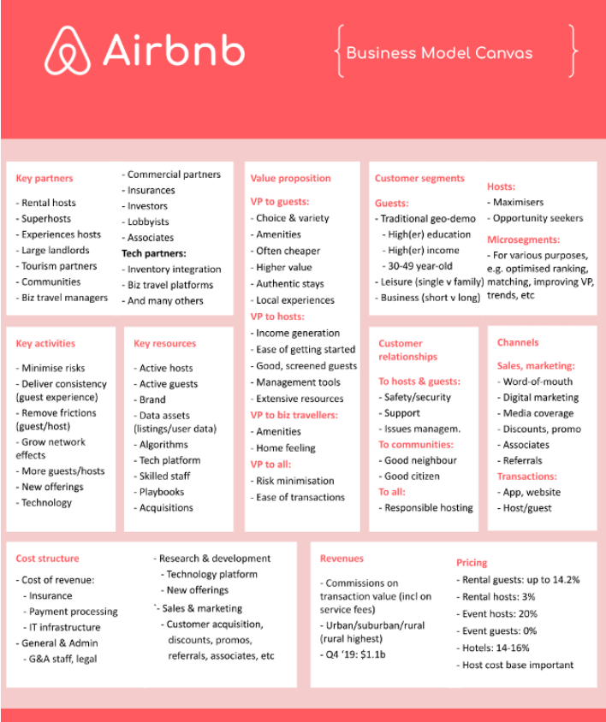
https://www.digitalbizmodels.com/ 1
Osterwalder, Pigneur & Tucci (2005) define a business model as the rationale of how an organization creates, delivers, and captures value. The Above Business Model Canvas, as designed by DigitalBizmodels.com gives us access to the building blocks that are key to remaining a successful business model. The business model canvas, designed by Alex Osterwalder in 2005 provides a revolutionary overview of a business and allows us to ‘deep dive’ into the elements of a company (Alex Osterwalder, 2023) although commenters and academics argue that additional building blocks should be added to the canvas when considering particular types of business, for example social enterprises and charities (Vial, 2016)
In the case of Airbnb, being recently restricted by regulations and heavily in competition with ‘traditional’ accommodation providers, as well as hinging a large part of their success on being embraced by the sharing economy, the addition of ‘social and environmental costs’, ‘social and environmental impact’ and ‘problems’ which would allow additional information to be captured.
Social and Environmental Costs | Social and Environmental Impact | Problems
- Sharing economy- limited in control re: environmental sustainability.  - Negative impact on housing availability and detriment to communities. | - Championing sustainable tourism.  - Carbon Credit Purchases  Grants to sustainable orgs and projects.  - Reduced emissions compared to ‘traditional’ accom providers.  - Boosting economies through ‘local’ tourism.  - Increased ‘responsibility’ and ownership of guests= less damage and impact. | - Risk of greenwashing by hosts.  - Increased regulation by governments and authorities.  - Lack of consistency in standards and regulations.

2.3 Strategic formulation framework
The Strategic formulation framework aids strategic thinking for an organisation by allowing them to identify which direction it needs to go and focus on actions and sub-strategies to realise a goal or goals. There are a large amount of tools and matrixes used within the strategic formulation framework in order to provide the tools to examine resources, construct a financial plan and select appropriate strategies, such as Internal Factor Evaluation (IFE), SWOT and PEST and the Grand Strategy Matrix (GSM)

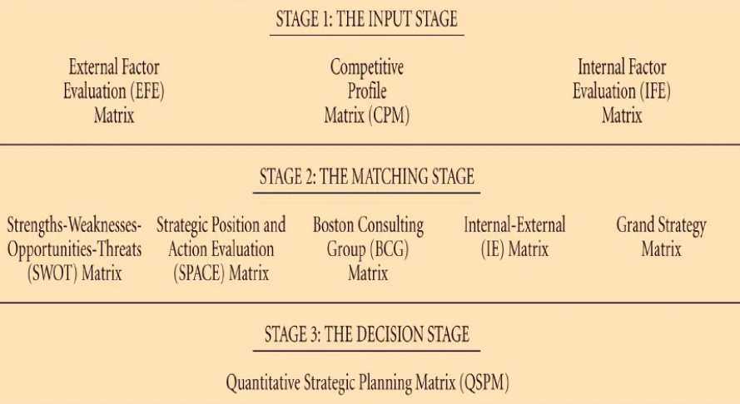
www.studocu.com
For the purposes of this report, we have chosen to plot Airbnb on the Grand Strategy Matrix. The matrix is based on four quadrants, these being ‘rapid market growth, slow market growth, strong competitive position and weak competitive position’, companies or organisations can be plotted on the matrix based on the companies’ competitive state and growth, thus giving direction to the companies’ ongoing required strategy.

Airbnb can be placed in Quadrant One, as they display Fast Market Growth and Strong Competitive Position, as such, in order to retain this position Airbnb should focus on Market Development, (further) Market Penetration, additional product development, Horizontal, vertical and concentric diversification (Concentric Diversification, 2023).

2.4 Tools and Systems
Airbnb, being a remote company that operate at a physical distance from its ‘product’ have had to invest heavily in technology and ensure that the systems and tools in place are fit for purpose and will not fail the consumers and drive sales and traffic elsewhere. The first step in the user process for consumers and hosts is via the website or mobile app, which is constructed to lean heavily on Amazon web services to host its cloud-based data, with the software architecture being based on a microservices premise, where multiple application premise interfaces communicate with each other to complete single system requests (Airbnb Tech Stack Explained: The Tech Behind the Airbnb App, 2023)
Airbnb uses AI or machine learning to learn from algorithms and create suggestions for hosts and customers, as well as to detect fraudulent behaviour within the system, the company have a partnership with Google maps to provide accurate directions and locations and to create the ‘search area’ function that allows guests to narrow their search. The apps ‘Presto, Druid, and Airpal’ are used by Airbnb to manage its data stores and retain records on guests and hosts, and perhaps most importantly, a partnership with major financial institutions and security systems streaming into ‘Braintree’ allows payments and transactions to be guaranteed secure and safe for consumers. Verification checks are carried out ‘in the background’ using credit reference agencies, banking apps and government gateway systems to avoid fraudulent activity (Braintree | Online Payment Solutions and Global Payment Processor, n.d.)
The internal messaging system and the reviews and ratings facility are custom built for Airbnb, which means that the technology teams managing the apps and data are juggling a complex combination of in house and third party apps, as well as using several cloud hosting systems. A key component in the ongoing success of Airbnb, is its ongoing dedication to user friendly tools, seamless transition between devices and user-centric product development, this means that the website and app will always be simple and ergonomic to use, as the company understand that ease of use and accessibility is one way to retain customers (Thomson, 2017)

3. Conclusion and Recommendations
In conclusion, it is clear that Airbnb are pioneers of the sharing economy and have grown exponentially with the exploring of the internet and with the increase in ‘experience tourists’ and have had a major impact on traditional providers and the micro economies of destinations and have brought tourism to many areas that would not traditionally have experienced this.
However, it is important to consider that Peer to Peer accommodation networks such as Airbnb also have negative affects on communities and economies, with the impacts of over tourism, accommodation provision and the impact this has on housing options for local residents and workers including gentrification and ‘pricing out’, and tourism planning (or lack of) not to be understated (Wachsmuth & Weisler, 2018).
Airbnb provide high value proposition for consumers and ‘suppliers’ although the statistics on Airbnb Vs Traditional providers following the pandemic demonstrate that the amount of suppliers dropped and prices rose, meaning there is less choice for consumers, and this may draw consumers back to more traditional forms of accommodation.
In recommendation, Airbnb should focus on further market development, including building relationships with authorities, agencies and governments, which would allow them to access corners of the market they have been unable to reach thus far, for example; contracts for accommodation for civil service staff when travelling for work, or contracts with large companies such as BT or British Gas (UK) to provide accommodation for travelling workforce. Traditionally these types of ‘guest’ would be housed in a chain hotel, as per the contract with the hotel company and employer.
Airbnb should focus further on market penetration, with targeted add campaigns for the countries in which they are not yet prevalent, and where regulations are perhaps not as severe. It would be helpful to communicate with government and local authorities prior to launching marketing campaigns, and Airbnb need to know that any marketing campaign will be successful and profitable in the long run, rather than only short term.
Airbnb could also consider partnerships with other digital disruptors, for example a partnership with Uber (in applicable locations) would mean that travellers or guests would be able to book travel while booking their accommodation.
The above suggestions are examples of market diversification and horizontal, vertical and concentric diversification (Dhir & Dhir, 2015) but Airbnb also need to ensure that they maintain a good reputation, deal with any arising issues promptly and ensure that safety and security remains paramount. Continuous investment into the IT and app services that are the cornerstone of this business, and ensuring that the company keep up to date with the latest developments and remain known for being user friendly, as remaining relevant in a digital age where users move onto ‘the next big thing’ very quickly is very important (Kim, 2019)

(2265 words.)

References
Airbnb business strategy: a brief overview. (2019, September 13). Research-Methodology. https://research-methodology.net/airbnb-business-strategy-a-brief-overview/
Airbnb Tech Stack explained: The tech behind the Airbnb app. (2023, December 28). Intuji. https://intuji.com/airbnb-tech-stack-explained-airbnb-app/#:~:text=Airbnb%20uses%20a%20combination%20of,%2C%20analyse%2C%20and%20manage%20it.
Alex Osterwalder. (n.d.). https://www.alexosterwalder.com/
Alyse. (2023, June 12). Should we use Airbnb? 8 troubling problems you didn’t know. The Invisible Tourist. https://www.theinvisibletourist.com/why-you-shouldnt-use-airbnb-issues-you-didnt-know/
Bouwman, H., Nikou, S., Molina‐Castillo, F., & De Reuver, M. (2018). The impact of digitalization on business models. Digital Policy, Regulation and Governance, 20(2), 105–124. https://doi.org/10.1108/dprg-07-2017-0039
Braintree | Online payment solutions and global payment processor. (n.d.). https://www.braintreepayments.com/gb
Butler, R. (1991). Tourism, environment, and sustainable development. Environmental Conservation, 18(3), 201–209. https://doi.org/10.1017/s0376892900022104
Casadesus‐Masanell, R., & Ricart, J. E. (2010). From Strategy to Business Models and onto Tactics. Long Range Planning, 43(2–3), 195–215. https://doi.org/10.1016/j.lrp.2010.01.004
Chen, H., Chiang, R. H. L., & Storey, V. C. (2012). Business Intelligence and Analytics: From big data to Big impact. Management Information Systems Quarterly, 36(4), 1165. https://doi.org/10.2307/41703503
Clarke-Ezzidio, H. (2023, October 12). Could new regulation kill off short-term holiday lets? New Statesman. https://www.newstatesman.com/spotlight/economic-growth/regional-development/2023/05/wrong-legislation-new-housing-regulation-kill-off-airbnb-tourism
Concentric diversification. (2023, April 3). Monash Business School. https://www.monash.edu/business/marketing/marketing-dictionary/c/concentric-diversification#:~:text=a%20growth%20strategy%20in%20which,%2B1%20%2D1
Dhir, S., & Dhir, S. (2015). Diversification: literature review and issues. Strategic Change, 24(6), 569–588. https://doi.org/10.1002/jsc.2042
Dolničar, S. (2019). A review of research into paid online peer-to-peer accommodation: Launching the Annals of Tourism Research Curated Collection on peer-to-peer accommodation. Annals of Tourism Research, 75, 248–264. https://doi.org/10.1016/j.annals.2019.02.003
Dolnicar, S., & Reinhold, S. (n.d.). Peer-to-peer Accommodation Networks: Pushing the Boundaries (Chapter 3). 2017.
Ecotourism Market Size, Share & Trends Analysis Report By Activity Type (Land, Marine), By Group (Solo, Group), By Booking Mode, By Age Group, By Region, And Segment Forecasts, 2022 - 2030. (n.d.). https://www.grandviewresearch.com/industry-analysis/ecotourism-market-report
Foth, M., Bilandžić, A., & Guaralda, M. (2021). The impact of peer-to-peer accommodation on place authenticity: A placemaking perspective. In Elsevier eBooks (pp. 283–306). https://doi.org/10.1016/b978-0-12-818636-7.00015-9
Gurran, N., & Phibbs, P. (2017). When Tourists Move In: How Should Urban Planners Respond to Airbnb? Journal of the American Planning Association, 83(1), 80–92. https://doi.org/10.1080/01944363.2016.1249011
Gyódi, K. (2021). Airbnb and hotels during COVID-19: different strategies to survive. International Journal of Culture, Tourism and Hospitality Research, 16(1), 168–192. https://doi.org/10.1108/ijcthr-09-2020-0221
Hati, S. R. H., Balqiah, T. E., Hananto, A., & Yuliati, E. (2021). A decade of systematic literature review on Airbnb: the sharing economy from a multiple stakeholder perspective. Heliyon, 7(10), e08222. https://doi.org/10.1016/j.heliyon.2021.e08222
How data sharing between platforms and tax agencies affects short-term rental markets. (2023, January 19). EUROPP. https://blogs.lse.ac.uk/europpblog/2023/01/19/how-data-sharing-between-platforms-and-tax-agencies-affects-short-term-rental-markets/
Kim, B. (2019). Understanding Key Antecedents of Consumer Loyalty toward Sharing-Economy Platforms: The Case of Airbnb. Sustainability, 11(19), 5195. https://doi.org/10.3390/su11195195
Li, L., & Tabari, S. (2019). IMPACT OF AIRBNB ON CUSTOMERS’ BEHAVIOR IN THE UK HOTEL INDUSTRY. Tourism Analysis, 24.
Martin, C. (2016). The sharing economy: A pathway to sustainability or a nightmarish form of neoliberal capitalism? Ecological Economics, 121, 149–159. https://doi.org/10.1016/j.ecolecon.2015.11.027
Multi-Sided platforms. (n.d.). https://www.digitalfluency.guide/multi-sided-platforms/multi-sided-platforms
NI Business Info. (n.d.). Business growth through diversification | nibusinessinfo.co.uk. https://www.nibusinessinfo.co.uk/content/business-growth-through-diversification
Paulauskaite, D., Powell, R., Coca‐Stefaniak, J. A., & Morrison, A. M. (2017). Living like a local: Authentic tourism experiences and the sharing economy. International Journal of Tourism Research, 19(6), 619–628. https://doi.org/10.1002/jtr.2134
Pfister, D. S., & Yang, M. (2018). Five theses on technoliberalism and the networked public sphere. Communication and the Public, 3(3), 247–262. https://doi.org/10.1177/2057047318794963
Puebla, J. G., Palomares, J. C. G., Romanillos, G., & Salas-Olmedo, M. H. (2017a). The eruption of Airbnb in tourist cities: Comparing spatial patterns of hotels and peer-to-peer accommodation in Barcelona. Tourism Management, 62, 278–291. https://doi.org/10.1016/j.tourman.2017.05.003
Puebla, J. G., Palomares, J. C. G., Romanillos, G., & Salas-Olmedo, M. H. (2017b). The eruption of Airbnb in tourist cities: Comparing spatial patterns of hotels and peer-to-peer accommodation in Barcelona. Tourism Management, 62, 278–291. https://doi.org/10.1016/j.tourman.2017.05.003
Sherwood, H. (2019, May 5). How Airbnb took over the world. The Guardian. https://www.theguardian.com/technology/2019/may/05/airbnb-homelessness-renting-housing-accommodation-social-policy-cities-travel-leisure
Šnajdar, T. G. (2023, November 22). History of Travelling: How people started to travel. Culture Tourist. https://culturetourist.com/cultural-tourism/history-of-travelling-how-people-started-to-travel/
Thomson, C. (2017, April 21). Airbnb: Is it worth the hype? Suitcases and Sandcastles. https://suitcasesandsandcastles.com/airbnb-is-it-worth-the-hype/
Vial, V. (2016). A business model canvas for social enterprises. Sains Humanika, 8(1–2). https://doi.org/10.11113/sh.v8n1-2.825
Von Briel, D., & Dolničar, S. (2021). The evolution of Airbnb’s competitive landscape. Airbnb Before, During and After Coivid-19, 79–100. https://doi.org/10.6084/m9.figshare.14195960
Wachsmuth, D., & Weisler, A. (2018). Airbnb and the rent gap: Gentrification through the sharing economy. Environment and Planning A: Economy and Space, 50(6), 1147–1170. https://doi.org/10.1177/0308518x18778038
Wu, S. (2023, September 7). Web Scraping Basics - towards Data science. Medium. https://towardsdatascience.com/web-scraping-basics-82f8b5acd45c
Wu, S., Lee, F., & Reynard, J. (2012). Airbnb. UCLA Economics106T. https://www.econ.ucla.edu/sboard/teaching/tech/Airbnb.pdf

