Consumer trust in online shopping
Approaches to Research and Academic Communication
DR GLADIUS DAVID KULOTHUNGAN
.
University of Wales Trinity Saint David
OUSSAMA HAJJAJI 1815857

Table of content
Introduction 3
Portfolio 1: Literature review: 4
Online shopping: 4
E-shopping share of retail shopping: 5
Consumer trust 6
Trust by age group. 7
Perceived risk 8
The determinants of online trust and drivers to purchase decision 9
Merchant related variables: 9
Website related variables: 10
Consumer related variables 11
Survey outcomes: 12
Conclusion 12
Portfolio Part B: Discussion of one research paper: 13
Introduction 13
Research philosophy: 13
Ontology 13
Epistemology 14
Axiology 14
Ethical consideration in the research 14
Non-maleficence (do no harm) 15
Privacy 15
Respect for Intellectual Property 15
Validity of the research 15
Reliability of the research 16
Conclusion: 17
References: 18

Introduction

The non-delivery of products, the hacking of credit card numbers, the misuse of personal data are all examples of practices that explain why many consumers are still refractory or remain reluctant towards electronic Shopping. Such fears are far from unfounded. Indeed, the proliferation of fraud and the upsurge in complaints are real.

Therefore, gaining the trust of consumers becomes a major imperative for any site that wishes to succeed. The inherent uncertainty in the context of electronic commerce in general and in "mainstream" commerce in particular places the concept of trust at the center of the concerns of researchers and practitioners. Theoretical vacuum and practical necessity make it all the more important to understand the mechanisms underlying its development. What are the factors explaining consumer confidence when buying from a merchant site? This is the question to which we will attempt to give some answers in the present study.

From a managerial perspective, all electronic merchants must be concerned about the issue of establishing trust with their site. Indeed, trust is a very important condition for the success of a commercial site. The problem is all the more acute for merchants who are still little known or unknown to the general public. It is true that the notoriety of the brand contributes to a large extent to establish a level of confidence likely to reassure Internet users still for their majority rather suspicious. For merchants suffering from a reputation deficit, the question of trust is all the more problematic. In the absence of image capital - a pledge of a certain confidence - electronic merchants would benefit from reflecting on the means likely to establish confidence in their sites. This exploratory study is part of a general understanding of better buying behavior on the Internet. Its main objective is to identify the determinants of consumer confidence in a merchant site. In the first part, we will return briefly to the concept of trust as it was developed in marketing. We will then present the results of the qualitative study carried out.

Portfolio 1: Literature review:

Online shopping:
Online shopping describes the operation or practise of the Internet purchasing of products or services (Guruswamy, 2014). This needs you to go online, land on a seller's website, pick and arrange your delivery. The customer pays online or on delivery for the goods or services via credit or debit card (Guruswamy, 2014).
The term includes not only buying things online, but also searching for them online. In other words, I may have shopped online, but have ordered nothing (Zaman and Wang, 2010). There's been about 25 years of online shopping; it has become much more common, nearly we can buy anything online today (POWELL, 2018). Nonetheless, online shopping experts say that the conventional shopping will be overtaken by online shopping (Turban, 2018).
Online shopping is part of Electronic -Commerce, when a consumer shops from a digital platform, AMAZON or ALIEXPRESS is an example of this platform (Krafft and Mantrala, 2014). One of the main advantages of online shopping is geographic coverage.
For various reasons, online shopping is becoming more and more popular.
External factors like increased gas prices, difficulty in getting to traditional shops, and troubles often linked to shopping malls and other traditional stores are certainly contributing to the growing interest in online shopping (Gnanadhas, 2014).

With their reviews passed by existing users, consumers can get complete information about the product. When you want to buy a product, you can't just ask your friends and families because there are tonnes of product reviews that give opinions about the product's existing users. Online shopping sites contain a broad range of quality and low-quality products, taking people's levels into account (Gnanadhas, 2014).
- National and international borders are not in effect.
- Customers are in a demanding position when shopping online, so vendors are not in the dominant position.
- In online shopping there are huge job openings.

E-shopping share of retail shopping:

Online shopping is one of the world's most popular online shopping activities with global e-commerce sales of close to US$ 3.5 trillion in 2019 (Statista, 2019). While digital technology expands in Asia-Pacific, it's no wonder that India, followed by Spain and China, are the fastest growing online retail markets. The digital retail growth in those countries is closely connected to the continual enhancement of online access, especially in first-line cell communities that have been struggling for long because of financials or network constraints with conventional fixed broadband connectivity but enjoy the benefits of cheap mobile broadband now (Statista, 2019).
The chart bellow demonstrates E-commerce share of total global retail sales from 2015 to 2019 and a forecast from 2020 to 2023.
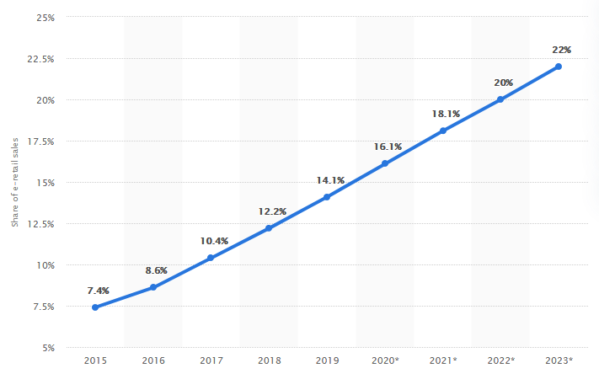

Global retail e-commerce market size 2014-2023 | Statista. [online]

In the United Kingdom for instance the share of online sales from all retail sales is very significant, this chart bellow demonstrate it throughout the last decade (Ons.gov.uk, 2019).

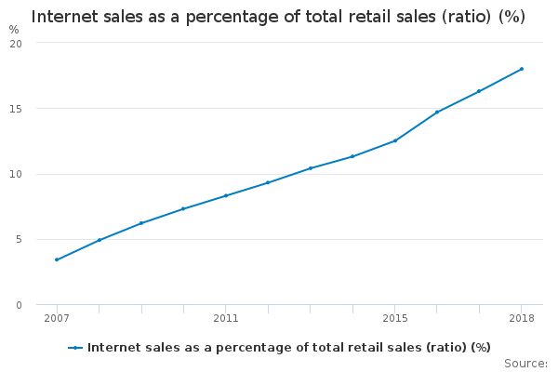
Source: Ons.gov.uk

Consumer trust
A review of the literature on trust in consumer-business exchanges reveals a plurality of entities likely to be the subject of consumer confidence: confidence in the brand, confidence in the seller and confidence in the consumer. Some research allows us to understand the interaction mechanisms between these different "types" of trust (Pennanen, 2009). In 2002, Sirdeshmukh, Singh and Sabol, highlighted the interrelationships between trust in the seller and trust in the company. The advent of electronic commerce has created a new entity that an e-consumer can trust: the company's website (Figure below). Indeed, since the Internet has become a transaction medium, new avenues of research are emerging on the study of confidence in the explanation of online shopping behaviour.
Consumer Trust
Trust towards the seller

Trust towards the website

Trust towards the brand
Trust towards the company

Figure 1: Entities likely to be the subject of consumer confidence
Even if they are considered in this figure as separate constructs, these different "types" of trust are likely to influence each other. So for example, it would be legitimate to think that trust in the site can be influenced by trust in the company owning the site (Sirdeshmukh, Sabol and Singh, 2001).
The effect of trust is mediated by risk on the consumer's intention to purchase (Kim, Ferrin, Rao, 2007). Several trust researchers have shown a direct relationship between trust and willingness to buy online from Internet vendors. Kim, Ferrin, Rao, (2007) added trust as critical variable in electronic commerce and also stated that the consumer will be more likely to engage in an internet purchase when trust is high (direct effect). They have successfully examined the direct and indirect effects of trust on a consumer's intention to purchase. The consumer's trust toward the selling party or entity will also increase his intention to purchase indirectly by reducing his or her perceptions of risk (indirect effect) (Kim, Ferrin, Rao, 2007).

Trust is the magnet that brings together the other strengths and competencies, the table bellow demonstrates the reasons that make relationships stronger with vendor, and trust is number 1.

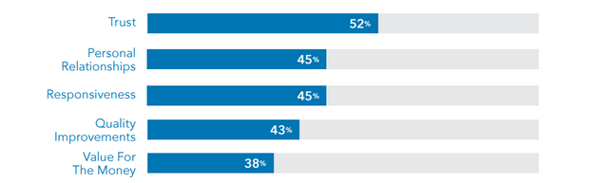
Obtained from “Study: Why B2B Marketers Waste 19% of Their Budgets” (Contently, 2016)

Trust by age group.
It is very important as well to demonstrate the age group of online shoppers, this will give us an insight about who does trust more the online world, or in other words who is more comfortable shopping through the internet, as well as an insight about the future and what e-commerce is expecting in the next couple of decades (Ec.europa.eu, 2018).
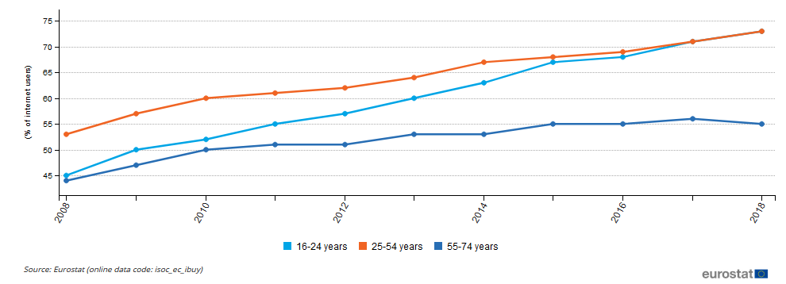
This chart below demonstrates internet users who bought or ordered goods or services for private use by age group (during the last 12 months) in the European Union between 2008 and 2018 (Ec.europa.eu, 2018).
(Ec.europa.eu, 2018)
Nearly 7 out of 10 internet users made online purchases in the same period in the 12 months preceding the survey. Overall, e-shoppers ' share of internet users is rising, with the largest concentrations in the 16-24 and 25-54 age groups (73 percent each).

Perceived risk
The definition of risk relates to confusion as to the potential negative consequences of a purchase decision (Bauer, 1960). Three dimensions of perceived risk are particularly significant in conjunction with a transaction on the web: financial risk (inherent to payment via the web), private risk and performance risk. A potential illegal use of the bank database relates to financial risk. Private risk refers to the fact that for other ends personal data supplied on a commercial website may be used (Lee and Moon, 2015). The risk of performance relates to the product's true quality. In reality, it becomes invisible, not evident in a visual sense, the commodity as the object of the transaction. To make a decision, the user must be happy with a few pictures of the product and trust the explanation on the website (Lee and Moon, 2015).

Research has also been based on a wider view that the vulnerability in the online environment is unpredictable, hazardous, harmful and with negative results (Doolin, 2011). Such conceptions are often linked to use of the medium, which is called the transaction risk, in the security and reliability of web transactions. Nevertheless, the payment amount or the actual product itself, is not necessarily in danger of becoming a loss of money through the theft of credit cards (Doolin, 2011). Substantial evidence suggests that risk understanding of the use of the Internet for buying will surpass customer expectations about the advantages and function as the main obstacle. Therefore, the risks of the Internet climate remain a matter of concern to individuals who make online purchases (Doolin, 2011).

Perceived risk is a crucial factor in customer purchase behavior as customers intend to maximize the purchasing utility by avoiding risks and mistakes (Ghotbabadi, Feiz, & Bahrarun, 2016). The uncertainties are seen as one of the main problems for customerswhoto hesitate to make theonlinetransaction (Yang et al.,2015).

The determinants of online trust and drivers to purchase decision
A literature review especially on marketing or e-commerce, allowed us to differentiate three forms of trust determinants on a commercial site: site-related variables, individual related variables and merchant-related variables. Such determinants are addressed to the customer as they are interpreted and understood.

Merchant related variables:

Merchant reputation

For (Bobot, 2010), reputation refers to the belief that the partner is honest and that he is concerned with the interests of his clients. Specific scholars find it as a firm's ability to fulfil its obligations. Indeed, when a company manages to keep its commitments on a regular basis, it succeeds in building a good reputation (Bobot, 2010). The company's reputation is a mechanism that has been developed and which grows over time, a process that requires time and expenditure in it. In essence, this process is a result of accumulated judgements in this respect.
But if a good reputation requires a lot of time and investment, an error as small as possible would make every effort, which is why the reputation is "fragile" (Bobot, 2010). The prestige of the company is strengthened by a good reputation, but once it is intertwined, its survival can be put in doubt (Bobot, 2010).
Reputation improves website trust (Jarvenpaa and Tractinsky, 1999). A business with a good reputation in the physical world already has an important advantage in the virtual world. Many businesses, which are still unknown to the public, will make greater efforts.

Satisfaction with past experiences with the merchant

Confidence is not a static term, but part of a dynamic logic (Leonidou and Aykol, 2010). Nevertheless, trust means a slow development that evolves over time: trust is formed, maintained, nourished, strengthened or deteriorated. Given the acknowledgment from the researchers that trust is a term slowly established, there is a restricted nuanced interpretation of the definition in work in this field (Leonidou and Aykol, 2010). The addition of variables such as the age of relations between sellers, length of partnerships, past-term association with a company are important. Confidence is therefore a dynamic concept built up and developed through the consumer's experience. As such, the company's goal is to maintain or even improve it as property).

Website related variables:

Perception of privacy
The right to privacy applies to the individual's ability to decide when how, and to what degree personal information is transmitted to others (SAGE Journals, 2017). The secrecy of shared data is a key element for the growth of online shopping in the electronic commerce market. The problem of confidentiality arises acutely for cyberbuyers, in that they have no control over the access and management of their personal data. A prime example of this was the Toysmart1, a toy distribution service on the internet. The organisation tried to sell its product inventory as an asset because of bankruptcy (SAGE Journals, 2017).

The Internet also makes consumers even more sensitive when it comes to protecting their personal information by proliferating certain practices such as intrusive prospecting. It is therefore necessary to convince customers of the secrecy of the information collected, in order to gain consumer confidence. To do this, the website privacy policies will clarify: what kinds of user details are gathered? How will the knowledge be used and for which purpose? Who's going to share it with? What data protection measures are in place? (Consumer Perception towards Online Shopping, 2017)
69% of Internet users refuse to provide websites with their personal data, because no guidance on how to use such pages is provided, in informative claims of facts on the internet, regard for privacy are often considered a key element. Research validates the effect on trust in the electronic transactions of the belief that the web protects privacy.

Labeling website by trusted third parties:

The labeling of sites by trusted third parties can play a central or even crucial role in the confidence of cyber buyers in their approach to sites. This demonstrates that the online retailer is ready to commit to meeting those requirements with regard to clients. Nonetheless, website labeling includes the marking and emblem on Web sites which recognize and suggest that they obey the standards (SAGE Journals, 2017).

Consumer related variables

The propensity to trust:
It is an individual personality trait which, regardless of trade relations, manifests in different degrees in individuals. Several scholars consider the tendency to build confidence as a trait. The degree to which the individual is willing to trust others is known as such. The underlying assumption is that some people tend to be optimistic while others tend to be careful. We therefore postulate that trust is a moderating force between the background of the faith that has been established and customers ' interest in the trader's website (Fillis, 2012).

Familiarity:
Familiarity is a precondition for confidence for certain authors. In addition, familiarity tends to build these standards because morale is built when others (organisations or individuals) act in accordance with existing expectations. It is defined as the number of user interactions (Fillis, 2012).

Purchase intention:

The idea of happiness has been established in research on consumer behaviour, owing to its predictive power for future behaviour. Over recent years though, scholars have begun to understand that trust can also predict future behaviour. Garbarino and Johnson found that trust and loyalty are decided for certain consumers (relations). Recent research has shown that consumer trust plays the dominant role in understanding the decision to buy online (Fillis, 2012).

Survey outcomes:
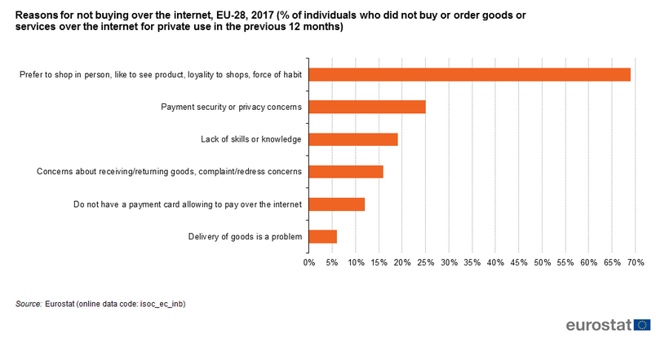
After a 2018 governmental survey made by EUROSTAT on Information and Communication Technology (ICT), the main reason given for not making purchases online in the 12 months prior to the survey were as show the figure below:

(Ec.europa.eu, 2018)

The chart above demonstrate the main reasons for not buying online and the strongest motive is the preference for shopping in person in order to be able to see the products before purchasing them, out of loyalty to shops or by force of habit (69 %).

Conclusion
Many e-commerce studies have shown that consumer intentions to engage in online transactions are a significant predictor of consumers' actual participation in e-commerce transactions. Kim, Ferrin, Rao, (2007) also proved that purchase intention is a strong predictor of purchase behavior. They found that these effects of trust, perceived risk, and perceived benefit on purchase intentions ultimately had a “downstream” effect on consumers' actual purchase decisions.

Portfolio Part B: Discussion of one research paper:

Introduction
In the last chapter a thorough investigation have been carried out about the consumer trust in online shopping, while reviewing the literature, I had a chance to explain and discuss Online shopping, consumer trust in online shopping and the perceived risk from online shopping. Now that I have a chance to discuss in a detailed manner one of the research studies mentioned in the literature review, I will go through Online shopping and focus more on the research philosophy, ethics, reliability and validity of it, also this chapter will examine the ethical considerations in research.

Research philosophy:
The term research philosophy corresponds to the belief system and the concept of knowledge creation. While that sounds very complex, it's exactly what you do when you start on research: build expertise in a specific field.
The advancement of knowledge that you pursue may not be just as revolutionary as a modern theory of human motivation, but you still develop new expertise to address specific issues in a particular organisation. When you know or do not know them, a variety of conclusions must be drawn at each stage in your analysis (Burrell and Morgan 1979). These include theories about human knowledge (epistemological assumptions), the facts you experience in your study (ontological assumptions) and how your own beliefs influence your research process (axiological assumptions). Basically, these assumptions form your understanding of your study problems, the methods you use, and how you perceive your results (Crotty 1998). A well thought-out and coherent set of hypotheses will be a valid science theory that will guide the methodological decision, study policy and data collection and analysis techniques. Johnson and Clark (2006) note that as business and management scholars, we need to be mindful of the ethical contributions we make in our choice of research approach, as this will have a significant impact on what we do and how we interpret what we are researching.

Ontology
Ontology refers to hypotheses regarding reality's existence. While this may sound vague and far from the planned research project, the ontological premises shape the way the research objects are interpreted and examined. These items include websites, online shopping clients, and products available through websites in the online business. Therefore, Ontology decides how you see the online business world and hence the option of what to study for the research project (Thomas and Hardy 2011).

Epistemology
Epistemology addresses knowledge concepts, what is reasonable, true and appropriate knowledge, and how information can be conveyed to others (Burrell and Morgan, 1979). Although ontology may seem very vague at first, epistemology's importance is more apparent. The multidisciplinary nature of online business means that different forms of information can all be considered legitimate–ranging from numerical data to textual and graphic data, from facts to representation. Different business scholars thus adopt different epistemologies in their work, including archival research projects and autobiographical, myths and literary literature (De Cock and Land 2006).

Axiology
Axiology refers to the position in the research process in values and ethics. It raises concerns about how scholars address both their own beliefs and those of the subjects in the study.
The position that your own convictions play in all stages of the research process is of great importance as research results are to be accurate. Heron (1996) argues that our values drive all human action. He further proposes that scholars show axiological abilities by being able to articulate their convictions as a prerequisite for determining what they are doing and how they are doing it. Choosing one subject instead of another means you are more interested in one of the topics. Your selection of ideology represents your beliefs
For example, over the internet nowadays you can find any kind of products or services for sale, either banned or allowed for sale, here personal values, beliefs or a person ethics play a major role on if this merchant will commercialize this specific banned product or not.

Ethical consideration in the research
Ethics is concerned with creating a trusting relationship between the researchers and the researcher when applied to social research. It is essential to carefully plan and manage communication to ensure that trust is established, to minimize risks and maximise benefits. Scientists adhere to a variety of ethical principles when establishing a trusting relationship that they extend to their work-namely charity; autonomy; non-malfeasance; justice; truthfulness and privacy (Velip, 2018).

Beneficence (doing good)
Work should only be carried out if some kind of benefit or gain (i.e. improvement to information or enhanced service / treatment) can be gained from it. Therefore, in the researcher's view, the issue of whether or not a research project is worth pursuing should always be at the centre. The project is unethical if no benefit can be derived (Velip, 2018).

Non-maleficence (do no harm)
The policy of non-maleficence places an obligation on researchers not to harm others or expose people to unnecessary risks. In many situations, damage may come from slashes to self-esteem, loss of money or income, depression, unhappiness or time consumption. It is a good practise to presume that any research project entails any sort of damage and think how best to deal with it in advance (Velip, 2018).

Privacy
Privacy issues regard for limited access, mentally, emotionally or cognitively, to another person. For example, while participants grant access to their thoughts and feelings as they agree to participate, unconditional access is not agreed. Therefore, they always have the right to refuse to speak or answer specific questions about certain topics (Velip, 2018).

Respect for Intellectual Property
Never plagiarise or steal the work of other people and try to carry it on as your own. Before using software or techniques of other individuals, confidential data or tests, you should always ask for permission. It's not plagiarism. Obviously, together with other forms of intellectual property, you must respect copyrights and patents and always recognise contributions to your research. Recognize, if in doubt, to eliminate the chance of plagiarism (Velip, 2018).

Validity of the research
The term validity implies utility. This is the most important criterion that shows the extent to which the finding aid interventions are to be calculated, what they are to be assessed.
Instead of a systematic and random error, it simply measures to what extent the differences discovered with the scale reflect real differences between objects on the characteristics studied. It must not contain any measuring error in order to be considered perfectly accurate. There are three validity forms (Cargan, 2007), namely:
- Validity of the content: otherwise known as apparent validity, this is where the scale provides adequate coverage of the test subject.
- Criterion of validity: type of validity that measures the performance of a measuring instrument, i.e. that it works as expected or is estimated as a significant parameter in relation to the other variables.
- Construction validity: a measure's construction validity shows the degree to which it adheres to the predicted associations with other statistical theories.

This research has dealt with the consumer trust in internet shopping, throughout the research we find referenced data and statistics, the researcher has gone through the important aspects of the subject and tried to explain the reasons why some shoppers still doesn’t trust the online world and the variables that play a major role in trust determination. A literature review has been carried out in the first portfolio as well relying on good sources to achieve the construction validity.

Reliability of the research
Reliability is the degree to which the measuring tool provides consistent results when measuring is done on an ongoing basis. Test-retest techniques, internal accuracy tests and alternative forms are used to determine the reliability strategies used. There are two key aspects to be separately listed (Kirk and Miller, 2005):
- Stability: The degree of stability can be checked by comparing the results of repeated measurements.
- Equivalence: Equivalency can be tested by comparing the results of the same events for two participants.
Systemic errors have no effect on reliability, but spontaneous errors allow outcomes to be unreliable and therefore less accurate. If the finding aid is accurate, then one can be confident that it does not conflict with transient and situational factors. In several ways (Kirk and Miller 2005) stability can be increased:
- The standardization of the conditions under which the measurement is made, like the source by which the variation takes place, must be eliminated or minimized.
- Design carefully the directions to be measured by employing people who have sufficient experience and who are also motivated, to carry out research and also to increase the number of samples tested.

This kind of research could have different conclusions and findings depending on the researcher background and way of thinking, or depending on the moment in time the research has been going, during the research I tried to use the most updated information available in order to make it reliable for this period of time, and have used trusted sources as references to give it even more reliability.

Conclusion:

Online trust has been a focus of research in various academic disciplines. This paper reviews only studies on consumer online trust in online shopping conducted and published in the last ten years. This research contributes to an on-going dialogue about the growing importance of trust in online shopping sites as new places for individuals to shop safely without worrying about their personal information, spam or other risks.
In fact, without trust, transactions are hardly possible. Indeed, it is trust that authorizes exchanges. In the context of the Internet, trust is crucial. It plays a pivotal role in the adoption of electronic commerce. The increasingly abundant literature on the subject only confirms this observation.

References:

- Guruswamy, M. (2014). Online Shopping Habits and Consumer Behavior. 1st ed. Munich: GRIN Verlag GmbH.
- Zaman, M. and Wang, T. (2010). E-business Technology and Strategy. Berlin, Heidelberg: Springer Berlin Heidelberg.
- POWELL, G. (2018). MARKETING MACHINE. [Place of publication not identified]: LULU Publishing SERVICES.
- Turban, E. (2018). Electronic Commerce 2018. Cham: Springer.
- Krafft, M. and Mantrala, M. (2014). Retailing in the 21st Century. Berlin: Springer Berlin.
- Gnanadhas, E. (2014). Online Shopping - An Overview. Ph.D. Scott christian college.
- Statista. (2019). Global retail e-commerce market size 2014-2023 | Statista. [online] Available at: https://www.statista.com/statistics/379046/worldwide-retail-e-commerce-sales/.
- Ons.gov.uk. (2019). Internet sales as a percentage of total retail sales (ratio) (%) - Office for National Statistics. [online] Available at: https://www.ons.gov.uk/businessindustryandtrade/retailindustry/timeseries/j4mc/drsi [Accessed 6 Jan. 2020].
- Pennanen, K. (2009). The initial stages of consumer trust building in e-commerce. Vaasa: Universitas Wasaensis.
- Sirdeshmukh, D., Sabol, B. and Singh, J. (2001). Consumer trust, value, and loyalty in relational exchanges. Cambridge, MA.
- Kim, D.J. Ferrin, D.L, Rao, H.R. (2007). A trust-based consumer decision-making model in electronic commerce: The role of trust, perceived risk, and their antecedents
- Contently. (2016). Study: Why B2B Marketers Waste 19% of Their Budgets. [online] Available at: https://contently.com/2016/04/07/study-b2b-marketers-waste-19-budgets/ [Accessed 6 Jan. 2020].
- Ec.europa.eu. (2018). E-commerce statistics for individuals - Statistics Explained. [online] Available at: https://ec.europa.eu/eurostat/statistics-explained/index.php/E-commerce_statistics_for_individuals#General_overview [Accessed 6 Jan. 2020].
- Bauer, R.A. (1960) Consumer Behavior as Risk Taking. In Hancock, R.S., Ed., Dynamic Marketing for a Changing World, Proceedings of the 43rd. Conference of the American Marketing Association, 389-398. - References - Scientific Research Publishing. [online] Available at: https://www.scirp.org/(S(351jmbntvnsjt1aadkposzje))/reference/ReferencesPapers.aspx?ReferenceID=1409819.
- Lee, H. and Moon, H. (2015). Perceived Risk of Online Apparel Mass Customization.
- Doolin, B. (2011). Perceived Risk and the Internet Shopping Experience in Online Purchasing Behaviour. Hamilton, New Zealand: University of Waikato.
- Ghotbabadi, A. R., Feiz, S, & Baharun, R. (2016). The Relationship of Customer Perceived Risk and Customer Satisfaction, 7(1).
- Yang, Q., Pang, C., Liu, L., Yen, D. C., & Tarn, J. M. (2015). Exploring consumer perceived risk and trust for online payments: Anempirical study in China’s younger generation. Computers in Human Behavior.
- Bobot, L. (2010). Dysfunctional and Functional Conflicts in Buyer-Seller Relationships. SSRN Electronic Journal.
- Jarvenpaa, S. L., Tractinsky, N., & Vitale, M. (1999). Consumer trust in an Internet store. Information Technology Management (forthcoming).
- Leonidou, L. and Aykol, B. (2010). Advances in global marketing.
- Consumer Perception towards Online Shopping. (2017). Asian Research Journal of Business Management.
- SAGE Journals. (2017). Effects of Online Shopping Values and Website Cues on Purchase Behaviour: A Study Using S–O–R Framework - Sanjeev Prashar, T. Sai Vijay, Chandan Parsad, 2017. [online] Available at: https://journals.sagepub.com/doi/full/10.1177/0256090916686681 [Accessed 6 Jan. 2020].
- Fillis, I. (2012). Book Review: S. Zappala and Colin Gray (eds) Impact of e-Commerce on Consumers and Small Firms. Aldershot: Ashgate, 2006. 280pp, ISBN 0—7546—4416—2, £60.00 (hbk). International Small Business Journal: Researching Entrepreneurship, 25(4), pp.445-449.
- Ec.europa.eu. (2018). E-commerce statistics for individuals - Statistics Explained. [online] Available at: https://ec.europa.eu/eurostat/statistics-explained/index.php/E-commerce_statistics_for_individuals#General_overview [Accessed 6 Jan. 2020].
- Burrell, G. and Morgan, G. (1979) Sociological Paradigms and Organisational Analysis. London:
- Heinemann.
- Crotty, M. (1998) The Foundations of Social Research. London: Sage
- Johnson, P. and Clark, M. (2006) ‘Editors’ introduction: Mapping the terrain: An overview of business and management research methodologies’, in P. Johnson and M. Clark (eds) Business and Management Research Methodologies. London: Sage.
- Thomas, R. and Hardy, C. (2011) ‘Reframing resistance to organizational change’, Scandinavian Journal of Management, Vol. 27
- De Cock, C. and Land, C. (2006) ‘Organization/Literature: Exploring the seam’, Organization Studies.
- Velip, P. (2018). Ethical Issues in Research Writing. International Journal of Trend in Scientific Research and Development.
- Cargan, L. (2007). Doing social research. Lanham, Md.: Rowman & Littlefield Publishers.
- Kirk, J. and Miller, M. (2005). Reliability and validity in qualitative research. Newbury Park, Calif: Sage.

