Data Analysis and Visualisation
Assignment Two
ACCB4002

Crina Elena Iordache (2112903)
Koushik Modak
Cloud Computing Term 2
Deadline: 6th of May
Table of Contents

Table of Figures 1
Introduction 2
Description of the dataset 2
Visualisation of the dataset 3
The Analysation Process 4
T-Test for independent samples 4
The Null Hypothesis 4
The Alternative Hypothesis 4
Hypotheses testing to various levels of significance 5
A. P>α=0.10 5
Outliers 6
Factors affecting the hypothesis testing 6
Results 6
Conclusion 7
References 7

Table of Figures

Figure 1.Descriptive Statistics 3
Figure 2.Dataset Visualisation 4
Figure 3. Dataset evolution visualisation 4

Introduction

This report will outline the analysation, visualisation and comparison through numerous tests and theories and hypothesis of the given dataset. The data set is the result of a study conducted on primary school children’s tests results when studying using conventional methods compared to using the application that the researchers have offered. This report aims to deliver a better and easier understanding of which study method is best and offers the best reports with substantiable evidence such as visuals and scientific and mathematical research based on data statistics.

Description of the dataset

The given dataset is compiled of the test results of 40 Year five primary school children that were selected by a local company to assess their mathematical learning application and there are two categories of data, the results obtained from the conventional way of learning and the results obtained after using the application. The study’s purpose is to verify whether or not they should continue the development of the application.
Statistics are resulted from a complex and verifiable process, and they are helpful in a multitude of domains as they deliver clear mathematical results that can sustain a studied hypothesis, they are of two main types, inferential statistics, and descriptive statistics.
Descriptive statistics are used to present the fundamental characteristics of data in a study, they provide concise summaries of the sample, and they form the foundation of almost every quantitative data analysis, along with simple visual and graphic analysis. They break down into two branches, the measures of central tendency and the measures of variability some of which will be provided based on the above-mentioned dataset.

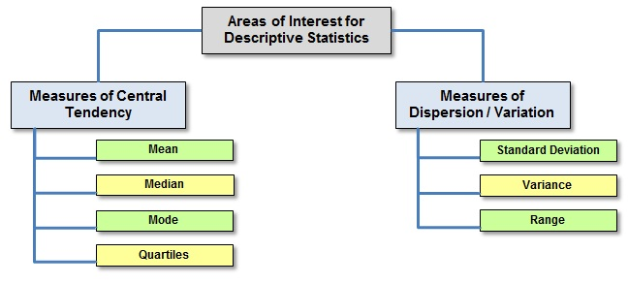
Figure 1.Descriptive Statistics

Visualisation of the dataset
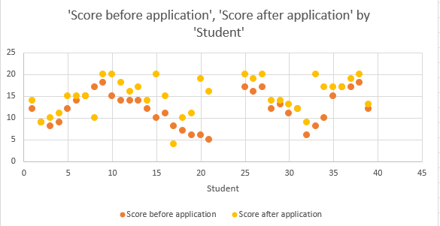

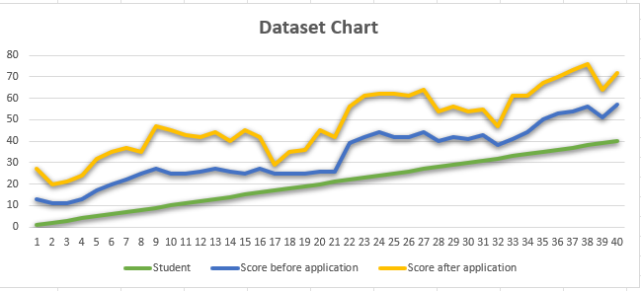
Figure 2.Dataset Visualisation

Figure 3. Dataset evolution visualisation

- Both of the given dataset charts provide a better and clearer understanding of the evolution of the test results before and after the usage of the application per each child that has taken part in the study, and it is also helpful in identifying whether there are any outliers in the dataset.

The Analysation Process

A hypothesis is a statement that can be tested in order to obtain a predicted or proposed reasoning and it is based on analysing the relationship among two or more variables.
The hypothesis that will be verified and tested is that the application has for the most part positively influenced the results of the primary school children and should be further studied and developed.

T-Test for independent samples

The t-test is a regularly used statistical test and it will be used to verify whether or not the hypothesis that the application has improved the results of the primary school children, the t-test is befitting of comparing if the evolution of the two groups is related to the application having no effect or if it has indeed influenced the results. The t-test is seldom used when a sample is taken from the population and then it is randomly allocated to two groups.
The t-Test for independent samples will be used in this scenario as the samples are not paired in any way. The analysation process will be performed through the usage of the t-Test for two samples assuming equal variances as we are trying to refute the null hypothesis that the two samples means are equal and it has no effect.

The Null Hypothesis

The null hypothesis H₀ will determine whether the application has had any effect or has made any difference to the children’s test results or if it had no effect, it will be rejected, and the alternative hypothesis will be accepted.
- H₀ states that the application has for the most part not had any effect on the results of the primary school children nor has it influenced it in any way.
- H₀: µ₁=µ₂
- If the difference between X₁ and X₂ is statistically substantial, then we will reject H₀ and deduce that there is a difference between the two groups.

The Alternative Hypothesis

The alternative hypothesis H₁ is the alternative for the null hypothesis and il will be tested whether it contradicts the latter and if it is accepted.
- H₁ states that the application has had a positive effect on the results of the primary school children, and it had mostly made a beneficial difference.
- H₁: µ_{1≠}µ₂

Hypotheses testing to various levels of significance

P>α=0.10

The level of significance is known as α(alpha) which represents the probability of getting a Type I Error. If T_{stat} or T_{obt} is higher than T_{crit,} consequently it is statistically significant at the 0.10 level, this means that there is less than 10% probability that this difference in means occurred by chance alone. + type one error and mean and standard deviation

Outliers

Outliers are variables that vary significantly to the rest of the dataset, and they can be identified after the analysation of the dataset is performed, the given dataset has not shown any outliers.
Outliers can impact the analysation process and lead to inaccurate results as it can affect the man and standard deviation which leads to unsatisfying results and they should be found before starting the examination and finding of the samples, means and standard deviation.
Some outliers are true values resulting from natural variation in the population. Other outliers could be caused by incorrect data entry, equipment malfunctions, or other measurement errors, outliers aren't always a sign of inaccurate or incorrect data, so you have to be cautious when dealing with them during data cleansing.
The main ways of identifying outliers are through visualising the dataset and as per Figure 1 there is not any present outlier, severe data points can be converted into z scores, which indicate how many standard deviations they are from the mean.
- An outlier is described as a value with a z score that is either too high or too low. Outliers are frequently concluded to be values with a z score greater than 3 or less than –3.
Identifying them through the interquartile range:
- The interquartile range (IQR) describes the range of your dataset's middle half. You can use the IQR to draw "boundaries" around your data and identify outliers as any values that are beyond of those boundaries.

- Sorting the dataset will also provide a concise and clear point of view in identifying outliers.

Factors affecting the hypothesis testing

- The study could be affected by external factors that are out of the control of the test such as the physical and mental state of the primary children, how motivated they felt when they studied for the test in both instances and what amount of time or number of hours, they have spent on studying through both resources
These factors could also be analysed, and they should be recorded by having the children complete a form with the above information this will greatly improve the accuracy of further analysation of the application and its efficiency.

- Level of Significance could also be a factor that affects the hypothesis testing as the lower the level of significance will be the lower the strength of it will become and the probability of rejecting the null hypothesis will decrease as well.

Results

For the level of significance of 0.10 the result was that the
Should the company continue the development of the application?

Conclusion

In conclusion the study has provided plenty of theoretical and practical evidence of visualisation, analysation and examination of the given dataset in order to reach the an acceptable result with using the t-Test sampling for equal variances and in return finding the accepted hypothesis which is the alternative hypothesis at all of the required levels of significance.

References

[1]D. Sarka, “Descriptive Statistics,” in Advanced Analytics with Transact-SQL, Apress, Berkeley, CA, 2021, pp. 3–29. doi: 10.1007/978-1-4842-7173-5_1.
[2]J. Shreffler and M. R. Huecker, “Exploratory Data Analysis: Frequencies, Descriptive Statistics, Histograms, and Boxplots,” PubMed, 2021. https://www.ncbi.nlm.nih.gov/books/NBK557570/
[3]S. Greenland, “Analysis goals, error‐cost sensitivity, and analysis hacking: Essential considerations in hypothesis testing and multiple comparisons,” Paediatric and Perinatal Epidemiology, vol. 35, no. 1, pp. 8–23, Dec. 2020, doi: 10.1111/ppe.12711.
[4]F. Emmert-Streib and M. Dehmer, “Understanding Statistical Hypothesis Testing: The Logic of Statistical Inference,” Machine Learning and Knowledge Extraction, vol. 1, no. 3, pp. 945–961, Aug. 2019, doi: 10.3390/make1030054.
[5]J. Shreffler and M. R. Huecker, “Types of Variables and Commonly Used Statistical Designs,” PubMed, 2021. https://www.ncbi.nlm.nih.gov/books/NBK557882/
[6]E. PMC, “Europe PMC,” europepmc.org, Sep. 19, 2021. https://europepmc.org/article/NBK/nbk574574 (accessed May 04, 2022).
[7]L. Lyutikova, “Logical Analysis of Data for outliers detection,” Procedia Computer Science, vol. 169, no. Special Issue, pp. 330–336, 2020, doi: 10.1016/j.procs.2020.02.192.
[8]R. P. Mcdonald, Factor analysis and related methods. Hillsdale, N.J.: Lawrence Erlbaum Associates, 1985.

