

Module Tittle: Dissertation
Module Code: LCMB7020
Course: MBA general management
Dissertation Topic: Impact of advertising on the international students buying behavior of apple products

Supervisor: Rexon Nting
Student Name: Sanjay Avulareddy
Student Number: 2213727


Master’s Degrees by Examination and Dissertation
Declaration Form.
1. This work has not previously been accepted in substance for any degree and is not being concurrently submitted in candidature for any degree.
Signed…….…………………… Sanjay Avulareddy ………………………………………………...
Date ……………………………12/02/2024…………………………………………………...

2. This dissertation is being submitted in partial fulfilment of the requirements for the degree of master’s in business administration.
Signed ………………………… Sanjay Avulareddy ………………………………………………….
Date ………………………………12/02/2024………………………………….…………...
3. This dissertation is the result of my own independent work/investigation, except where otherwise stated.
Other sources are acknowledged by footnotes giving explicit references.
A bibliography is appended.
Signed candidate: ………………… Sanjay Avulareddy …………………………….……………….
Date: ……………………………………12/02/2024……………….……………………….

4. I hereby give consent for my dissertation, if accepted, to be available for photocopying, inter- library loan, and for deposit in the University’s digital repository
Signed (candidate)………………… Sanjay Avulareddy …………………….………….…………...
Date……………………………………12/02/2024…………….…………….…………….
Supervisor’s Declaration.
I am satisfied that this work is the result of the student’s own efforts.
Signed: ………………………………Dr. Rexon nting ………………………………………….
Date: …………………………………12/02/2024…………………………………………...

TABLE OF CONTENT
- Introduction…………………………………………………………………………………………………………….......7
- Background……………………………………………………………………………………………………………….…..8
- Justification of the research …………………………………………………………………………………………..8
- Research Aim……………………………………………………………………………………………………………..….9
- Research objectives……………………………………………………………………………………………………....9
- Research questionaries………………………………………………………………………………………………....9
- Literature review………………………………………………………………………………………………….10
    - Conceptual brief ……………………………………………………………………………………......10
    - Advertising …………………………………………………………………………………………………11
    - Diverse Perspectives on Advertising……………………………………………………………………….12
    - Advertising as a Promotional Strategy and Its Impact……………………………………………..12
    - International Students' Buying Behavior of iPhone……………………………………..13
    - Brand awareness……………………………..………………………………………………………….13
    - Consumer buying behavior…………………………………………………………………….…..14
7.1.8 Relating to Impact on International Students' Buying Behavior of Apple Products…………………………………………………………………………………………………………………14
  - Theoretical review………………………..………………………………………………………………15
    - Emotional response ………………………………………………………………………………….15
    - Electronic Word of Mouth…………………………………………………………………………..15
    - Environmental response………………………………………………………………………………16
  - Empirical review …………………………………………………………………………………………...16
    - Advantages of advertising for apple ……………………………………………………………17
- AIDA model………………………………………………………………………………………………………………….19
- The Hierarchy of Effect Model………………………………………………………………………………………21
- Advertising Impact on Overseas Students' Apple Purchases…………………………………………24
- Factors affecting post purchase decisions…………………………………………………………………….25
- Literature gap ……………………………………………………………………………………………………………..26
- Research methodology ……………………………………………………………………………………27
  - Introduction …………………………………………………………………………………………………….27
  - Research design ……………………………………………………………………………………………….27
  - Research philosophy…………………………………………………………………………………………28
  - Research approach……………………………………………………………………………………………29
  - Choices …………………………………………………………………………………………………………….31
  - Time horizon …………………………………………………………………………………………………….31
  - Data collection and analysis………………………………………………………………………………32
  - Sample size ………………………………………………………………………………………………………32
  - Sample type……………………………………………………………………………………………………..32
  - Data collection method…………………………………………………………………………………….32
- Research ethics…………………………………………………………………………………………………………….33
- Analysis of data…………………………………………………………………………………………………………….33
  - Introduction……………………………………………………………………………………………………..33
- Questionnaire analysis……………………………………………………………………………………………..….34
- Conclusion and recommendations……………………………………………………….….…47
- Limitations…………………………………………………………………………………………………………..…50
- Appendix………………………………………………………………………………………………………………...51
- References …………………………………………………………………………………………………………….56

Abstract

This dissertation delves into the influence of advertising on the purchasing behavior of international students, particularly focusing on Apple products. Examining various channels, including social media and traditional platforms, the research explores Apple's strategies, celebrity endorsements, and the alignment between advertised and real product experiences. The study aims to uncover insights into international students' unique behaviors, contributing valuable knowledge for marketers adapting to the evolving global consumer landscape. the literature review identifies crucial aspects in the study of consumer purchasing behavior, encompassing planned behavior, perceived value, and the impact of attitudes on buying decisions. It highlights a research gap concerning the motivations of international students purchasing iPhones, revealing a unique facet related to insurance claims. Additionally, the review emphasizes the scarcity of studies on how advertising interacts with cultural variables in shaping international students' decisions to buy Apple products. Addressing these gaps could significantly enhance our understanding of consumer behavior, ethical considerations, and the role of cultural diversity in influencing purchasing choices among international students.

Acknowledgement
I would like to convey my heartfelt appreciation to Professor Dr. Rexon Nting, my supervisor, for his unwavering support, valuable guidance, and insightful recommendations. His expertise and profound understanding of the subject were instrumental in navigating me through this research project. My gratitude also extends to the other esteemed educators, particularly and all remaining staff whose knowledge and teachings equipped me with the essential skills needed to successfully complete this research assignment. Their dedication to teaching and commitment to fostering a love for learning have been truly inspiring. I am thankful to the participants of the survey whose generous contribution of time made this research endeavor possible. Without their involvement, this study would not have come to fruition. A special acknowledgment is reserved for my partner, whose support and understanding throughout my academic journey have been invaluable. His encouragement and unwavering belief in my capabilities have served as a constant source of strength and motivation. Lastly, I express my appreciation to the University of Wales Trinity Saint David for providing the necessary resources that facilitated the execution of this research. give me acknowledgement for my dissertation based on above info my dissertation topic is impact of advertising on buying behavior of apple products by international students.

- Introduction:
Advertising is a dynamic force that shapes consumer perceptions, resonates with consumers, and influences decisions that build market landscapes in a world where information and choices abound. With an emphasis on the astute preferences and purchasing decisions of international students in relation to Apple products, this study delves into the complex interactions between advertising and the diverse tapestry of consumer responses. In a time when global markets and digital connectedness collide, comprehending the effect of advertising becomes a crucial mystery. The goal of this study is to solve this issue by examining the many media that are used to reach the foreign student population, ranging from digital platforms like social media and the internet to more conventional media like print and television. The investigation's lens focuses on Apple, a massive technology company whose marketing tactics have not only helped it dominate the market but also cemented the iPhone into popular culture.
As we set out on this adventure, the study goals unfold a roadmap to analyze the effectiveness of different advertising channels, examine the impact of Apple's social media strategies, explore the complexities of brand image, and uncover the experiences that international students have after making a purchase. Beyond the norm, this study looks at how advertising affects overseas students' attitudes, perceptions, and ultimately their purchasing decisions to capture the emotional resonance it creates. Our trip is guided by research questions as we navigate the complex web of advertising's effects. Which media outlets have the biggest impact on foreign students who are interested in purchasing Apple goods? What effect do celebrity endorsements have on these students' minds? How well do the promises made in Apple's advertising narratives match the post-purchase reality? As we explore the world of advertising and consumer behavior, this research aims to offer fresh perspectives to the ever-changing story of marketing dynamics. To gain a deeper understanding of the complex dance between advertising and the astute decisions made by international students in the contemporary marketplace, the upcoming chapters will take readers on a deep dive into the topics of advertising channels, social media strategies, brand identity, and post-purchase reflections.
This research aims to investigate the complex effects of Impact of advertising on the international students buying behavior of apple products we hope shed light on the changing dynamic of buying behavior of international students that takes pride in its exclusivity and legacy by analyzing how these advertising effect buying behavior.
This study aims to provide an understanding of how advertising channels, including social media and traditional platforms, influence overseas students contemplating Apple purchases. It assesses the impact of Apple's social media tactics, celebrity endorsements, and the alignment between advertised and real product experiences, aiming to provide valuable insights for academics and practitioners in the dynamic consumer landscape.

- Background:
The impact of mass communication is felt on a global scale via a variety of platforms, including billboards, magazines, movies, music, films, and the internet. Given its wide distribution, advertising sticks out among these media as having a significant and long-lasting effect on viewers' brains (Katke, 2007). Advertising is an essential part of the promotional mix and one of the main components of the marketing mix, along with product, price, and place. It functions as the main means of communication between producers and customers. As a promotional tactic, advertising is essential to getting consumers to think about things and affect their decisions to buy. Public relations, sales promotion, and advertising are mass communication strategies used by marketers to interact with consumers. Television stands out as the most effective medium for advertising despite the use of other media because of its extensive reach (Latif & Abideen, 2011).
Advertising has a dynamic effect on consumer behavior; it shapes people's memory and influences their brand preferences. Consumer considerations, assessments, and ultimate purchase decisions are greatly influenced by brand memories, which are associations associated with a brand name (Romaniuk & Sharp, 2003). To carry out successful advertising, it is essential to do consumer behavior analysis. This involves determining the motivations behind behaviors under different conditions and recognizing the economic, social, and psychological elements that are at work.
This research investigates the influence of diverse advertising channels on overseas students considering Apple products, including the impact of Apple's social media strategies and celebrity endorsements. By examining post-purchase experiences, the study aims to offer valuable insights for academics and practitioners navigating the complexities of consumer behavior in the global marketplace.
- Justification of the research:
Understanding the complex interactions between advertising and customer purchasing behavior is essential in the fast-paced world of modern business. Advertising is a crucial instrument for communication since it has a great impact on consumers' views and preferences, which in turn influences their purchase decisions. Consumer interaction methods have been redefined by the changing advertising landscape, which is characterized by ethical considerations and digital innovation. To better understand the nuances of this interaction, this study will examine the psychological, sociological, and cultural elements that influence how consumers react to advertisements. Through an in-depth exploration of these factors, the research aims to offer significant insights for companies and marketers, promoting the creation of more ethical and successful advertising strategies. This study aims to improve the synergy between companies and customers in the modern market by advancing academic understanding and practical applications through rigorous analysis.

- Research Aim:
The purpose of this study is to investigate how advertising affects customer purchasing decisions in the modern marketplace. To give a thorough understanding of how various ad kinds affect customers' perceptions, attitudes, and purchasing decisions, this study will examine the complex relationships between advertising techniques and consumer responses.
- Research Objectives:

- Examine the impact of different advertising channels on overseas students' opinions and preferences for Apple products (e.g., social media, traditional media, internet platforms).

- Examine how Apple's social media marketing tactics have affected overseas students, considering the influence of online reviews and user-generated content.

- Examine how advertising affects overseas students' purchasing decisions and how they view the brand image of Apple products.

- Examine how Apple advertising affected the post-purchase experiences and happiness of overseas students and investigate how well the advertised and real product experiences matched.

- Research Questions/Questions:

- Which means of advertising such as social media, conventional media, and online platforms are most successful at reaching and swaying international students who might be contemplating purchasing Apple products?

- What impact do celebrity endorsements have on international students' perceptions and purchase decisions in Apple advertisements?

- To what extent do international students' post-purchase experiences and satisfaction levels correspond with the expectations that Apple's advertising sets out?

Chapter 2: Review of Related Literature
- Apple's Revenue Dynamics
In 2019, Apple reported a total revenue of $260 billion, with the iPhone contributing significantly at $142.3 billion, accounting for approximately 55% of the total revenue (Apple, 2019). Despite a 14% decline in iPhone revenue compared to 2018, it's essential to note that in 2017, the iPhone revenue experienced an 18% increase from the previous year (Apple, 2019). To provide a more comprehensive analysis, Apple's services, and wearables business, considered as an extension of iPhone and other hardware products, played a crucial role (Nasdaq). During the same period, Apple's services business grew by approximately $6.5 billion, and wearables witnessed a growth of $7.1 billion, totaling $13.6 billion (Nasdaq; Apple, 2019). Although this only partially offset the $22 billion decline in iPhone revenue from 2018, the services and wearables segments exhibited faster growth rates of 16% and 41%, respectively, compared to the 14% decline in iPhone sales from 2018 (Nasdaq; Apple, 2019). This indicates Apple's strategic use of services and wearables to mitigate the impact of iPhone revenue declines. Moreover, Apple emphasized its significant contribution to the job market, with the app economy alone responsible for 1.9 million American jobs, showing an increase of 325,000 in the last two and a half years (Nasdaq; Apple, 2019).
7.1.1 Conceptual brief:
Advertising is a dynamic and integral component of contemporary marketing strategies, playing a crucial role in shaping consumer perceptions, influencing purchasing decisions, and fostering brand loyalty (Belch & Belch, 2021). Defined as the paid promotion of goods, services, or ideas through various media channels, advertising serves as a powerful communication tool for businesses to connect with their target audience (Shimp, 2019). Its primary objectives include raising awareness, creating brand identity, and driving consumer engagement (Wells et al, 2011). Advertising for the iPhone stands as a paradigm of strategic marketing communication within the technology sector. Apple's approach to advertising has been instrumental in shaping consumer perceptions, fostering brand loyalty, and contributing to the unparalleled success of the iPhone in the market.
Drawing from Keller's Brand Equity Model (Belch & Belch, 2021), Apple's advertising for the iPhone excels in building a robust brand identity. The company has strategically positioned the iPhone as a symbol of innovation, sleek design, and superior performance (Wells, 2011). Apple's advertising campaigns, such as the iconic "Shot on iPhone" series, not only showcase the product's features but also contribute to the creation of a powerful brand imagery, emphasizing the quality and capabilities of the device (Shimp, 2019). Moreover, the emotional appeal in Apple's advertising has played a pivotal role in establishing a strong brand meaning for the iPhone. Messages conveying a sense of aspiration, creativity, and a seamless user experience resonate with consumers, influencing their attitudes towards the brand (Belch & Belch, 2021). The emotional connection forged through advertising contributes to the overall brand response, influencing consumer judgments and feelings towards the iPhone.
Apple's advertising strategies extend beyond traditional media, incorporating a strong online presence and leveraging social media platforms (Shimp, 2019). This multichannel approach ensures that the iPhone remains salient in the minds of consumers, reinforcing brand identity and maintaining a competitive edge in the ever-evolving smartphone market. In essence, Apple's advertising for the iPhone exemplifies a harmonious blend of brand identity, meaning, and response, ultimately fostering brand resonance with consumers and solidifying the iPhone's position as a leader in the technology landscape.
7.1.2 Advertising:
Advertising, a pivotal component of the promotional mix within the broader marketing framework, plays a crucial role in shaping consumer perceptions and influencing purchasing decisions. As part of the marketing mix, which includes product, price, place, and promotion, advertising serves as a powerful promotional strategy for creating product awareness and influencing consumer choices (Latif & Abideen, 2011). It acts as a communication tool employed by marketers to impact individuals' attitudes, behavior, and lifestyle, establishing a vital link between producers and consumers. For a product to become a well-known brand, investment in promotional activities, particularly advertising, is imperative (Hussein, 2008). Research by Latif and Abideen (2011) emphasizes the potential of advertising to contribute significantly to brand choice among consumers. With their revenue coming in at about $81.8 billion, Apple saw a 1% annual decline in the quarter. Although this figure was approximately $13 billion less than the previous March quarter, it was still somewhat below experts' expectations of $81.6 billion. As a result, Apple’s market value fell below $3 trillion, ending at roughly $2.85 trillion after a 4.8% decrease. Consequently, Apple's market value dropped by more than $160 billion, marking the company's biggest daily decrease since September. Apple's third-quarter fiscal earnings climbed by 2.3% year over year to surpass $19.8 billion, even though the company reported a yearly fall in overall sales. But on a quarterly basis, this showed a 17.7% decline. Increased by a change in the shipment mix, the annual revenue decline also influenced market operating profit overall. Not least since Apple's shipment share decreased by over 4% on a quarterly basis. In the second half of 2023, the smartphone market is expected to rebound, providing industry assistance during a period typically marked by reduced shipments. The iPhone was a major factor in making Apple one of the most valuable companies in the world. From $37.4 billion in 2008 to $65 billion in 2010, its income skyrocketed. Apple also added more subscription services to its lineup, including cloud storage, video games, fitness, and music and video streaming. This segment was Apple's second largest in 2020, with $53 billion in revenue from it alone.
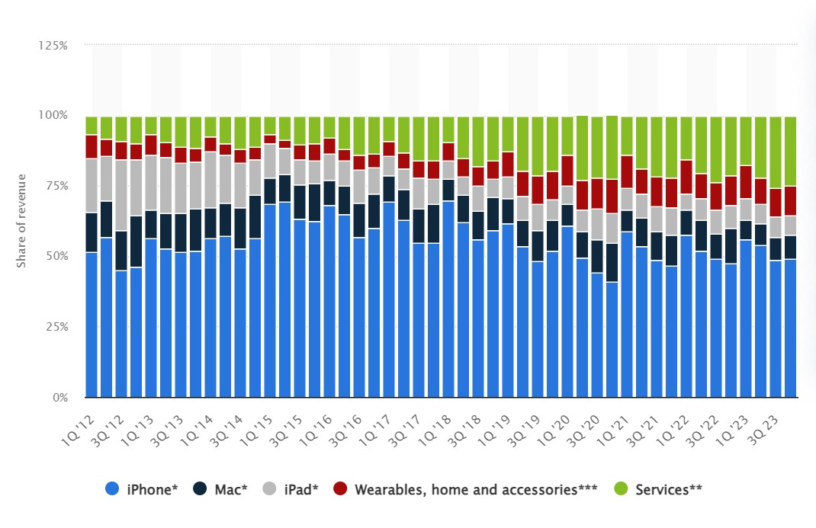
Source: (Investopedia.com, 2021)

7.1.3 Diverse Perspectives on Advertising:
Arens (1996) provides a comprehensive definition of advertising, highlighting its multifaceted nature that encompasses communication, marketing, economic, social, public relations, and information and persuasion dimensions. This expansive view underscores the diverse roles advertising plays in the business landscape. In the context of the impact of advertising on the international students' buying behavior of Apple products, this definition emphasizes the crucial role advertising plays in establishing basic awareness and building knowledge about Apple's products among potential consumers. Dunn and Barban's (1987) characterization of advertising as a paid, non-personal communication method aligns with the persuasive nature of advertising strategies employed by Apple to inform and influence overseas students. Morden's (1991) emphasis on advertising messages aiming to establish awareness is particularly relevant, as understanding how these messages resonate with international students is essential in unraveling the intricate dynamics of their purchasing decisions in the context of Apple products.
7.1.4 Advertising as a Promotional Strategy and Its Impact:
The definition of advertising provided by Ayanwale et al. (2005), as a non-personal and paid form of promotion, emphasizes its role in promoting ideas, concepts, products, or services through various media channels. In the context of advertising on the international students' buying behavior of Apple products, this definition aligns with the study's focus on understanding how advertising influences the perceptions and decisions of international students (Ayanwale, 2005). Furthermore, the assertion by Adelear et al. (2003) that advertising serves as a critical tool for creating product awareness and influencing purchasing decisions is particularly relevant in the examination of how advertising shapes the awareness and preferences of international students towards Apple products. Additionally, (Hussein et al. (2008)). highlighted television advertising as an effective medium, capable of reaching a wide variety of audiences. This observation resonates with the study's exploration of different advertising channels and their impact on international students. Understanding the effectiveness of television advertising, among other channels, becomes crucial in deciphering the influence of advertising on the buying behavior of international students when it comes to Apple products.

Source:(Dreamsite.come,2023)
7.1.5 International Students' Buying Behavior of iPhone:
In the context of international students and their purchasing behavior regarding Apple products, the significance of advertising takes on a heightened relevance. The unique cultural backgrounds and preferences of international students necessitate a targeted and culturally sensitive approach in advertising strategies. Understanding the impact of advertising on international students requires an exploration of how Apple leverages advertising to create product awareness, influence perceptions, and ultimately shape the purchasing decisions of this diverse demographic (Liao and Wang, 2009).
7.1.6 Brand awareness:
The strength of a brand's consciousness among consumers is referred to as brand awareness (O'Guinn and Albert, 2009). It is essential for increasing brand awareness among consumers, helping them recognize and remember the brand (O'Guinn and Albert, 2009; Riorini, 2018), and influencing their decision to buy (Chi-Hsun, 2008; Kiseol, 2010). People who are very conscious of brands frequently see brands as a reflection of their social standing (Liao and Wang, 2009). Businesses use social media as a channel to share information about their brand with the goal of increasing consumer awareness. Customers that care about brands are more likely to provide testimonials and recommendations on social media sites (Ismail, 2017).
Previous studies have demonstrated a beneficial relationship between brand awareness and social media marketing (Riorini, 2018; Yang and Kankanhalli, 2014; Siddique and Rashidi, 2015). For example, Riorini (2018) found that social media marketing had a positive effect on brand consciousness, especially when it came to Indonesian mobile products. In the past, tracking studies and surveys were used to quantify brand awareness. Metrics such as search ranking, brand mentions, unique website visitors, and repeat visits are available to marketers in the online sphere (Hoffman and Fodor, 2010). Managers may increase consumer awareness of a brand by sharing interesting and educational content about the business's goods and services and by giving guarantees about quality and price. creating social media communities, putting in place customer loyalty schemes, and providing discounts for consumers who make purchases through social media are effective strategies suggested by Riorini (2018).
7.1.7 Consumer buying behavior:
Consumer buying behavior encompasses the mental, emotional, and physical activities individuals undertake during the selection, purchase, use, and disposal of products and services to satisfy their needs and desires (Schiffman & Kanuk, 2009). Solomon et al. (2006) further defines it as the study of the processes involved when individuals or groups make decisions to select, purchase, use, or dispose of products, services, ideas, or experiences. Economic factors, including income, expenditure patterns, product prices, and the availability of complementary or substitute goods, play a crucial role in shaping consumer buying behavior (Abraham, 1997; Kotler et al., 2001). Additionally, psychological factors such as perception, attitudes, and learning, as well as social and cultural influences, contribute significantly to individuals' decisions regarding the products they choose to purchase (Arnould & Thompson, 2005; Perreault, Jr., Cannon, & McCarthy, 2005).
7.1.8 Relating to Impact on International Students' Buying Behavior of Apple Products:
In the context of international students' purchasing decisions regarding Apple products, understanding their consumer buying behavior becomes paramount. The diverse cultural backgrounds and preferences of international students necessitate a nuanced examination of how economic, psychological, social, and cultural factors intersect influencing their choices. The impact of advertising on international students' buying behavior for Apple products becomes a focal point within this framework. As international students engage in the exchange process, advertising serves as a powerful tool in shaping their perceptions, attitudes, and learning about Apple products, ultimately influencing their purchasing decisions.
  - Theoretical review:
7.2.1 Emotional response:
Advertising, as noted by Moore (2004), stands out as a powerful tool in integrated marketing communication, capable of emotionally motivating consumers towards product purchases. Its fundamental purpose lies in the creation of brand awareness, preference, and the selection of products or services. Within marketing and advertising research, attitudes towards advertisements emerge as a highly influential theory, as articulated by Goldsmith and Lafferty (2002). The attitudes formed towards adverts play a pivotal role in shaping consumer perceptions of a brand, influencing their intentions to make a purchase. Effective advertising, according to Goldsmith and Lafferty (2002), seeks to foster positive attitudes towards both the advertisement and the brand itself, with a positive emotional response to an advert serving as a key indicator of its effectiveness. This underscores why the core objective of advertising, as highlighted by Bymolt, Claasen, and Brus (1998), is to encourage product purchases and create widespread awareness.
Brand recall, identified by Goldsmith and Lafferty (2002), is another essential aspect of effective advertising, generating emotional responses that contribute to brand recall. The degree to which consumers make decisions related to products hinges on the importance of brand recall, leading to heightened brand awareness (Goldsmith & Lafferty, 2002). Brand awareness, in turn, ensures the recall of adverts, providing a competitive advantage over less easily remembered brands. Positive attitudes towards adverts significantly enhance the ability to recall adverts, emphasizing the correlation between positive attitudes and advert recall (Goldsmith & Lafferty, 2002).
Cues, as observed by Romanuik and Sharp (2004), play a pivotal role in various buying situations, facilitating the recall of brand adverts and increasing the likelihood of brand retrieval by buyers when different attributes are associated with the brand, thus creating brand association. As asserted by Brassington and Pettit (2001), emotional advertising stands out as the most effective tool in advertising, allowing consumers to form emotional connections with products.
7.2.2 Electronic Word of Mouth:
The term "Electronic Word of Mouth" (eWOM) describes the ongoing online discussion among prospective, existing, or former customers about a good, service, brand, or business (Ismagilova et al., 2017). Information adoption, attitudes, and actual purchasing behavior are all influenced by eWOM, which has a big influence on customer purchase decisions (Ismagilova et al., 2019a; Sandes and Urdan, 2013; Tsao et al., 2015). Through social media platforms, marketers actively work to foster positive eWOM (Dwivedi, 2015; Kumar and Mirchandani, 2012). Businesses must regularly monitor eWOM conversations pertaining to their brand or product on social media platforms because they understand how important they are. According to Kumar and Mirchandani (2012), this monitoring yields insightful information and identifies influencers—people who can affect others' behavior and show interest in the company's products. Businesses can create more impactful social media campaigns and potentially improve financial performance, customer engagement, and brand awareness by using influencers, tracking positive eWOM, and coordinating these efforts with product and brand development (Kumar and Mirchandani, 2012). Effective eWOM methods can be crucial in connecting this to the effect of advertising on international students' iPhone purchasing behavior. By keeping an eye on eWOM conversations regarding iPhones on social media, businesses may determine the opinions and inclinations of this customer base. Positive eWOM can be amplified by interacting with overseas students' influencers who have a say in what they buy. Marketing campaigns can be made more effective by matching promotional efforts with the data obtained from eWOM monitoring. This could result in a higher adoption rate of iPhones among international students.
7.2.3 Environmental response:
Environmental responses contribute to diverse consumer experiences, strategically utilized in promoting and selling products and services (Ayanwale, 2003). Businesses curate specific media experiences to create environments that enhance the promotion and sale of associated products or services (Adelaar, 2003). Specialized marketing research has delved into understanding the impact of various environmental conditions, such as the ambiance in retail stores and background music during purchasing (Morris & Borne, 1998). Sensory modalities like sound, sight, and touch play crucial roles in shaping user experiences, influencing information gathering for advertisements (Morris & Borne, 1998). The environmental psychological model, as articulated by Morris and Borne (1998), encapsulates these aspects, particularly concerning music, text lyrics, images, and music videos, showcasing their strong interrelation within advertisements. Morris and Borne (1998) argue that the environmental psychology model provides a more nuanced understanding of emotional responses compared to traditional marketing research. This model posits that environments, such as retail stores, evoke emotional states in individuals, categorized into pleasure, arousal, dominance, or buying situations (Adelaar et al., 2003). Adelaar et al. (2003) further define media as the combination of sound, sight, and touch sources, encompassing various aspects of visual and verbal media messages through which individuals gather information. Verbal and visual information significantly influences consumers' perceptions of environmental stimuli (Adelaar et al., 2003).
  - Empirical review (focuses on gathering, analyzing, and summarizing existing research studies)
Kumar (2011) investigated the influence of advertising on consumer purchasing behavior, The study revealed that advertising and sales promotions, combined with the company's image, play a crucial role in shaping consumer buying decisions. Additionally, the quality and price of the product were identified as factors influencing consumer purchases. Taylor and Weiserbs (1972) explored the relationship between advertising, expenditure, and aggregate consumption in the United States. Their findings indicated a simultaneous relationship between advertising and consumption, emphasizing the bidirectional nature of their impact on each other.
Sharma and Sharma (2009) conducted a study on the impact of advertising on consumer behavior in India, analyzing 134 companies using a fixed effect model of panel data analysis. The research highlighted that, beyond advertising, factors such as the company's brand, product quality, and reputation also significantly impact a company's sales. (Ayanwale et al, 2005) focused on the impact of mobile advertising on consumer buying behavior in Kabul Province. The study demonstrated that advertising exerted a major influence on consumers' preference for mobile. Adelaar et al. (2003) delved into the online compact discs shopping behavior of consumers in Asia, specifically exploring the role of emotional advertising. The research found that impulse behavior is preceded by a consumer's intention to impulsively purchase products.
The Associated Chambers of Commerce and Industry (2013) in India conducted a study on the impact of advertising on consumer buying behaviors. The findings indicated a significant increase in the consumption of cosmetic goods attributed to advertising, with men spending more on cosmetic products than their female counterparts. Ghulan, Javana, Burham, and Ahmed (2012) investigated the impact of advertising on consumer buying behavior in Pakistan, exploring the relationship between environmental response and consumer behavior. The study, based on a sample of 200 individuals in twin cities of Pakistan, revealed a moderate relationship between independent variables and the dependent variable. The results suggested that consumers tend to purchase brands to which they are emotionally attached. Nawazish and Ahmed (2015) conducted a study on the impact of advertising on consumer buying behavior in Pakistan, focusing on how emotional responses generated after watching effective advertisements influence consumer purchasing behavior. With a sample of 300 subjects, the research highlighted the significant impact of environmental response and sensory-stimulated activities presented in advertisements on consumer buying behavior. Emotional and environmental responses were identified as having a substantial influence on consumer purchasing behaviors.
7.3.1 Advantages of advertising for apple:
Apple Inc. distinguishes itself from its rivals in the tech sector with a distinctive advertising approach. Widya (2022) claims that Apple uses User Generated Content (UGC) as a fundamental component of its Ownership Advertising strategy, benefiting from unique content created by brand ambassadors. This material, which includes remarks on images, videos, and blogs, supports a variety of marketing techniques. Notably, Apple avoids traditional advertising on social media, particularly on Instagram, where posts from its official account are primarily of natural landscapes rather than products. The organization and customers can benefit from this strategic usage of user-generated content (UGC), which is hailed as a more effective substitute for traditional material. Re-uploading or reposting user-generated content is part of Apple's strategy. allowing the company to save on advertising production costs. This strategy differs from conventional sales-focused advertising in that it emphasizes user experiences and authenticity heavily. The theory behind this is that by showing actual user interactions with items, prospective buyers are more likely to be favorably influenced and eventually become actual customers (Widya, 2022).

Source: quora.com (2023)
Apple optimizes its marketing efforts in addition to the user-generated content strategy by creating a website just for iPhone items. Users can explore a wide range of topics on this official iPhone website, which acts as a comprehensive center. These topics include general instructions, hints & tips, application updates, and the most recent series (King of Presentation, 2013). This purposeful emphasis on a specific webpage highlights Apple's dedication to giving customers comprehensive and easily accessible information. In addition to user-generated content and specialized websites, Apple employs several tactics in its advertising strategy. Influencer and public figure product placement are a noteworthy tactic used by Apple to persuade influencers that their items are unique, worthwhile, and pertinent to their audience. After being persuaded, these influencers tell their followers about their interactions with Apple products, which enhances positive brand visibility (Stephanie, 2022). A further aspect of Apple's approach is creating "Buzz" via favorable media coverage. Positive media coverage also helps people view Apple items as desired and valued.
Additionally, Apple deliberately addresses these issues in its advertising approach since it is aware of the difficulties that customers of technology encounter. Apple stays away from technical terms and industry jargon by keeping online and sales copy simple. Benefits that customers genuinely need are constantly emphasized using plain language. This strategy reduces uncertainty for customers and contributes to Apple's record-breaking market share. It also conforms to content marketing standards. Apple's dedication to simplicity is seen in the products' continued svelte and minimalist design (Stephanie, 2022). Apple's advertising tactics—which include user-generated content (UGC), specialized websites, influencer involvement, favorable media coverage, and straightforward messaging—all help to explain the company's unique standing in the fiercely competitive technology sector.
- AIDA model:
The AIDA model, attributed to Elmo Lewis, serves as a widely adopted framework by advertisers for delineating various phases of consumer engagement with an advertisement. This model elucidates how consumers process information encountered in the media, emphasizing the stages a consumer undergoes to evolve into a potential customer (Colley, 1984). For effective advertising communication, prospective buyers must be the focus of advertising messages, with the goal of generating communication effects connected to the brand, ultimately resulting in consumer action, such as product or service purchase (Rossitor and Percy, 1985). The AIDA model identifies four key stages in the consumer's journey: Awareness, Interest, Desire, and Action (Glowa, 2002). The progression begins with creating awareness to capture the consumer's attention, followed by arousing interest and potentially stimulating desire for the product. Advertisers believe that when consumers reach the stage of desire formation, they are more likely to act, typically in the form of purchasing the product (Lavidge and Steiner, 1961).
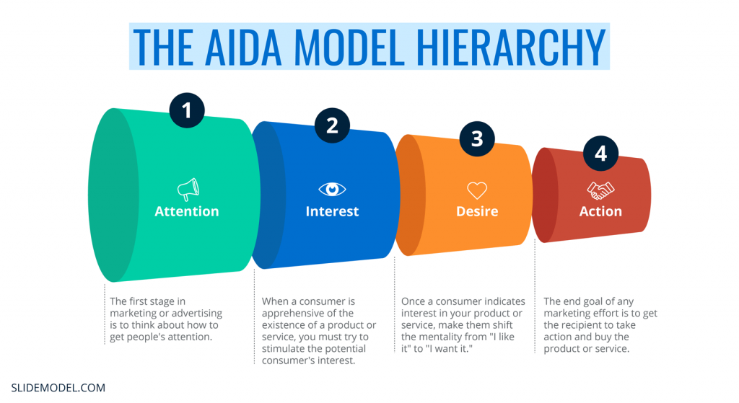
Source: Pettitt, S. (2001). Principles of Marketing
Various advertisers employ diverse approaches to disseminate advertising information and attract consumer attention through modern communication methods. Employing compelling information and images, advertisers aim to convince consumers about the benefits of a product or service and its problem-solving capabilities. The information presented must spark consumer interest by providing a concise, brief, and accurate explanation of the features and benefits of the promoted products (Hansen, 1972. 8-15). The creation of desire is achieved through the strategic use of keywords to persuade consumers that the product fulfills their genuine needs. Advertisers highlight their offers and the value of their products, aiming to prompt action based on the perceived benefits (Jones, 1986). The AIDA model underscores the necessity for consumers to progress through the stages of awareness, interest, and desire before acting (Bovee, 1995). The model assumes a "learn-feel-do sequence," where individuals first learn from advertising, then develop feelings about the product, and finally act, typically in the form of making a purchase (Bovee, 1995).
In alignment with the AIDA model, advertising aims to generate a strong desire that motivates the audience to act, such as making a purchase. The impact of an advertisement on a consumer hinge on the interest and desire cultivated by the ad, potentially leading to action, though this is not guaranteed (Abiodum, 2011). The frequency of exposure plays a role in gradually generating consumer interest, desire, and subsequent action, contributing to patronage. Advertisers strive to enhance messaging, capture the audience's attention, and create branding that resonates with target markets, ultimately motivating the audience to engage in the desired action, such as purchasing the advertised product or service (Abiodum, 2011).
Relating AIDA model with Impact of advertising on the international students buying behavior of apple products
The AIDA model (Awareness, Interest, Desire, Action) is highly relevant to my topic, "Impact of advertising on the international students' buying behavior of Apple products." How each stage of the AIDA model aligns with my research focus. By applying the AIDA model to my research topic, I can systematically examine how advertising efforts influence each stage of the international students' buying journey for Apple products. This framework provides a structured approach to understanding the effectiveness of advertising campaigns in shaping the purchasing behavior of this specific demographic.
Awareness:
In the context of international students and Apple products, the first stage involves creating awareness among this target demographic. Advertising campaigns should strive to make international students aware of Apple's products, features, and brand identity. This could include highlighting the technological innovations, design aesthetics, and the overall value proposition that Apple products offer. (Maxwell, J. A. 2013).
Interest:
Once awareness is established, the next step is to generate interest among international students. Advertising strategies should go beyond basic product information to captivate the interest of this demographic. Emphasizing how Apple products align with the preferences and needs of international students, such as ease of use, compatibility, or unique features tailored to a student lifestyle, can foster deeper interest. (Maxwell, 2013).

Desire:
The desire stage involves creating a strong desire among international students to own Apple products. Advertising messages should evoke emotional connections and showcase how these products enhance the student experience. This may involve highlighting the aspirational and STATUS -RELATED aspects associated with Apple, emphasizing its global reputation for quality, and illustrating how owning these products can contribute to a desirable lifestyle. (Maxwell, 2013).
Action:
The final stage is to prompt international students to act, translating their awareness, interest, and desire into actual purchases. Advertising should provide clear calls-to-action, such as promotional offers, student discounts, or exclusive deals to motivate students to make the decision to buy Apple products. Strategies should also address potential barriers to purchase, such as pricing concerns or availability issues.
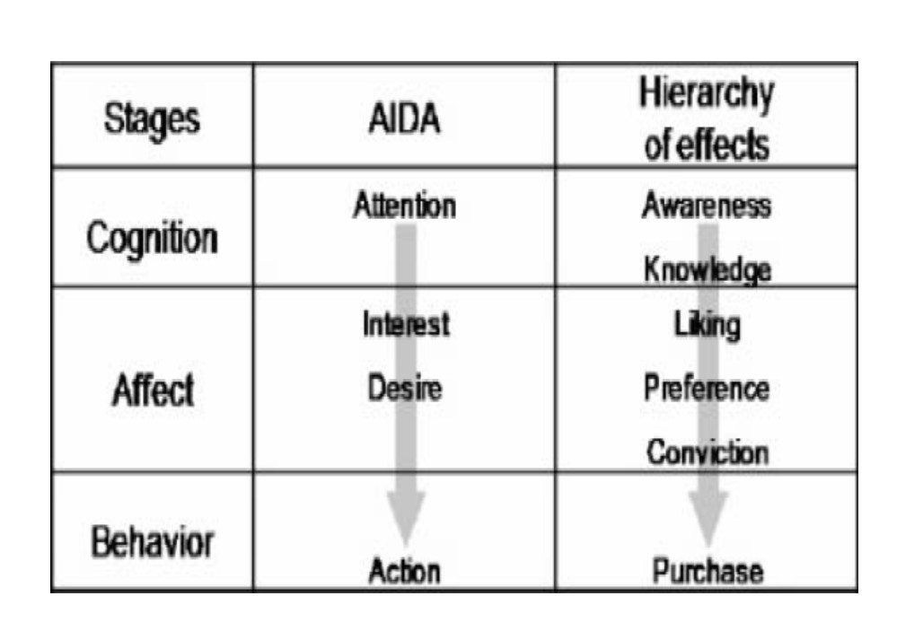
Source: (Ayanwale,2020)
- The Hierarchy of Effect Model
According to Barry (1987), an examination of the advertising and marketing literature reveals not a singular hierarchy of effects, but rather multiple hierarchies (Barry, 1987: 253). William J. McGuire (1969) is associated with the hierarchy of effects model and presented a paper titled "An Information-Processing Model of Advertising Effectiveness" at a symposium on Behavioral and Management Science in Marketing at the University of Chicago. McGuire emphasizes the importance of advertisers placing their advertising in suitable media to achieve effective message exposure (McGuire, 1969).
In the hierarchy of effect model, consumers undergo several processes after being exposed to an advertisement, as outlined by McGuire:
Every advertiser seeks to capture consumer attention strategically. McGuire's theory posits that the physical attributes of an advertisement are crucial for gaining consumer attention. For broadcast adverts, elements like motion and picture quality are vital, while for billboards and print advertising, factors such as size, columns, visibility, and brightness play a key role (Sandage and Fryburger, 1967). The time of exposure to advertisements and the consumer's prior product knowledge are essential for consumer motivation and comprehension. Advertisements facilitate the consumer's understanding of the content, and catchy phrases and repeated words contribute to better retention in memory (Vaughn, 1980).

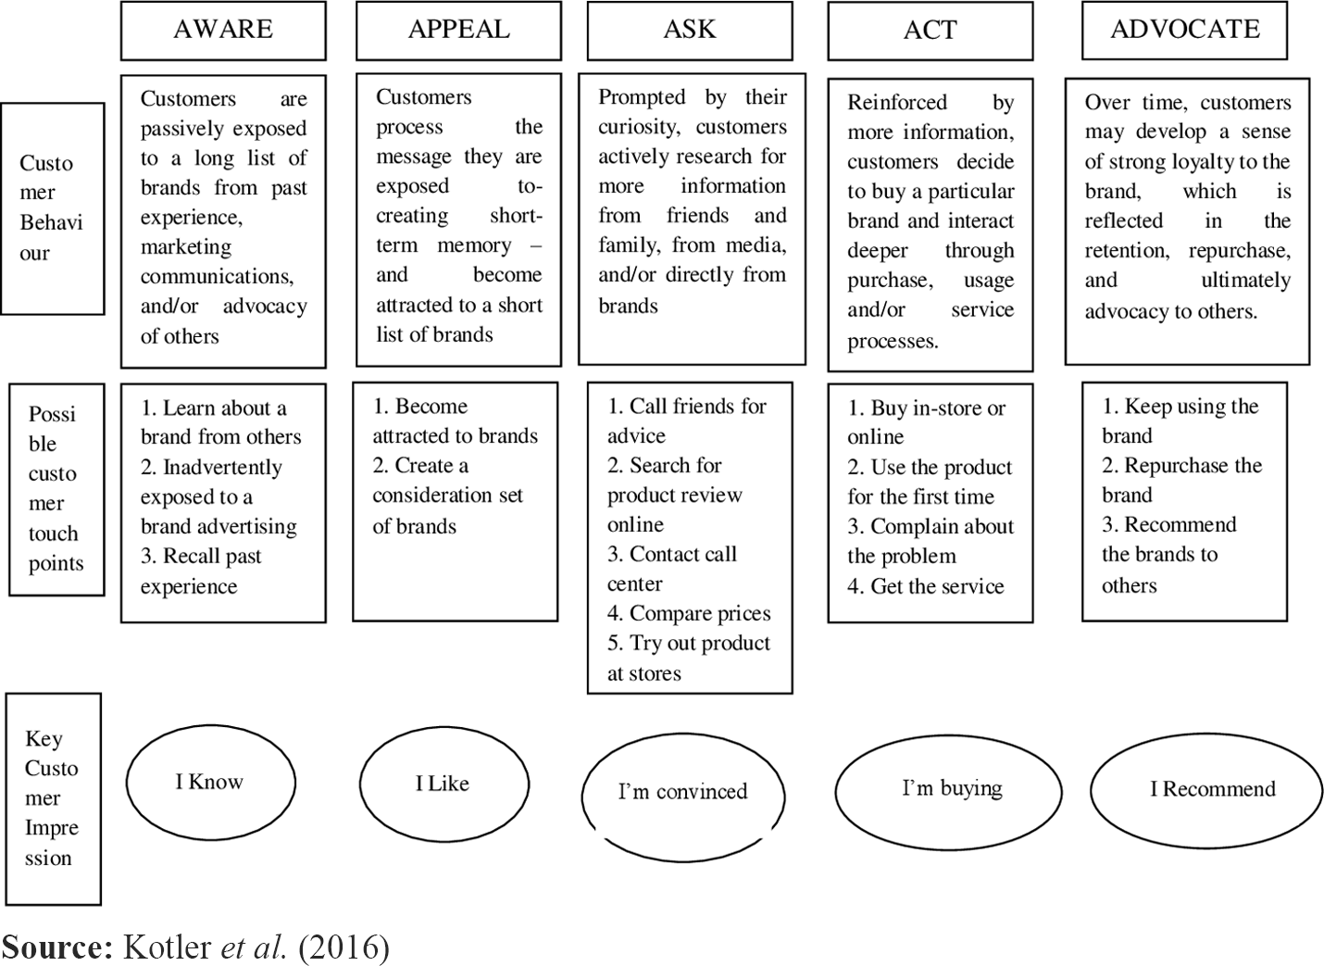

If the advertising message is easily comprehensible, message acceptance is likely to occur (Roland, 1986). Consumers start developing a favorable attitude toward the product when they believe the information presented in the advertisement is true and beneficial to meeting their needs. Cognitive and physical responses toward the advertisement are expected, and achieving this stage positively may lead to action, such as making a purchase (Robertson, 1971). In practice, a consumer may opt for Milo over mobile based on their acceptance of the products, influenced by comprehension and message acceptance portrayed in their respective advertisements.
Following the capture of public attention, it becomes imperative for consumers to grasp and interpret the advertising message as intended by the advertiser. The acceptance of advertising messages leads to the phenomenon of consumer selective perception, wherein certain ads are more likely to be noticed over others (Robertson, 1971). The retention of specific product designs is a result of convincing the public to pay attention to the advertisement. Advertisers and advertising agencies must carefully craft messages that are easily understood, accepted, and retained by their target audience. This strategic approach aims to create, enhance, or maximize the intended impact on viewers (consumers), fostering a connection between them and the product being promoted.
Relating Hierarchy of Effect Model with Impact of advertising on the international students buying behavior of apple products:
The Hierarchy of Effect Model is also highly applicable to my research topic, "Impact of advertising on the international students' buying behavior of Apple products." This model, often attributed to McGuire, outlines a series of stages that consumers go through in response to advertising (Robertson, 1971).
Awareness:
The first stage involves creating awareness among international students about Apple products. Advertising should aim to make students aware of the various Apple products available, emphasizing their features, functionality, and how they stand out in the market. This stage is crucial for ensuring that international students recognize Apple as a viable option for their technology needs.
Knowledge (Comprehension):
Building on awareness, the model's second stage focuses on providing international students with knowledge about Apple products. Advertising messages should convey detailed information about the specifications, capabilities, and unique selling points of Apple devices. This knowledge helps students understand how Apple products differ from competitors and why they might be suitable for their academic and personal needs (Robertson, 1971).

Liking (Attitude):
As international students gain knowledge about Apple products, the next stage is to create a positive attitude or liking towards the brand. Advertising should go beyond features and specifications to evoke emotions, emphasizing the aspirational and lifestyle aspects associated with Apple. Highlighting positive reviews, endorsements from influencers, or showcasing the brand's global reputation can contribute to shaping a favorable attitude Kotler et, al (2016).
Preference:
The model's fourth stage involves creating a preference for Apple products among international students. Advertising strategies should emphasize the unique benefits that Apple offers, addressing the specific preferences and needs of the student demographic. This could include features like user-friendly interfaces, seamless integration across devices, or exclusive educational apps and services.
Conviction:
Convincing international students to choose Apple products over competitors is the next step. Advertising messages should focus on building confidence in the brand, highlighting its reliability, durability, and positive impact on academic and personal life. Testimonials, success stories, and demonstrations of real-world applications can contribute to strengthening conviction.
Purchase (Action):
The goal is to drive international students to act, making the decision to purchase Apple products. Advertising should provide clear calls-to-action, such as directing students to purchase online or visit authorized retailers. Special promotions, student discounts, or bundled offers can incentivize the purchasing decision Kotler et, al (2016).
- Advertising Impact on Overseas Students' Apple Purchases:
A celebrity endorser may perform several functions in a commercial, including spokesman, endorser, testimonial provider, and actor, according to Kamen, Azhari, and Kragh (1975). A spokesperson functions similarly to a company's or brand's salesperson or representative, but an endorser is connected to the brand but may not be an authority in the endorsed product line. When a celebrity offers a testimonial, they vouch for the product's greatness based on their own usage experience. Finally, in an advertisement, a celebrity endorser is frequently asked to play an actor in a dramatic presentation.
Depending on the extent of a celebrity’s involvement, there are two categories of celebrity endorsement: active and passive. The term "active celebrity endorsement" describes an endorsement whereby a celebrity takes the lead in endorsing a brand and actively promotes it. The term "passive celebrity endorsement" is a type of endorsement when celebrities support a brand subtly and without actively participating in it. A celebrity acting as a spokesperson and testimonial provider, acting in the imperative and explicit modes, and taking on the roles of testimonial and observer can all be considered forms of active endorsement. On the other hand, a passive endorsement can be of the harnessed type and involve a copresent mode. The potential for these pairings begs the question of what kind of celebrity endorsement works best in various cultural settings.
The nature of celebrity endorsements, categorized as either active or passive, significantly influences consumers' brand evaluation and purchase intentions. Drawing on attribution theory (Heider, 1958), which posits that individuals tend to attribute events to either dispositional or situational factors, the type of celebrity endorsement can be a critical factor in shaping consumer perceptions. Previous studies, including research by Cronley, Kardes, Goddard, and Houghton (1999) and Um (2013b), have uncovered that when consumers perceive a celebrity's endorsement as driven solely by the financial incentive (a situational factor), they are more likely to evaluate the brand negatively and express lower purchase intentions. In contrast, if consumers sense that the celebrity genuinely appreciates the product or brand quality (a dispositional factor), their evaluation of the brand becomes more positive, leading to higher purchase intentions. This underscores the importance of considering the underlying motivations and authenticity of celebrity endorsements, as consumers are sensitive to whether the endorsement aligns with the celebrity's personal beliefs and genuine appreciation for the endorsed product or brand.
- Factors affecting post purchase decisions:
Consumer post-purchase behavior becomes pivotal in determining their likelihood to make repeat purchases and the extent to which they share positive or negative word-of-mouth feedback. In the current landscape of relationship marketing, post-purchase evaluation and behavior take center stage. A critical element within this evaluation is the alignment between expected and actual product or service quality, influencing the perception of whether the purchase delivers value for money. Dissatisfaction arises when the product or service falls short of anticipated quality levels (Hawkins and Mothersbaugh, 2010; Blythe, 2013). The assessment of satisfaction and dissatisfaction is grounded in the disconfirmation paradigm, where pre-purchase expectations are compared with post-purchase disconfirmation, whether positive or negative. Positive disconfirmation occurs when the product or service outperforms expectations, while negative disconfirmation denotes a performance below expectations. The magnitude of positive disconfirmation directly correlates with satisfaction, and if the difference is significant, consumers may experience delight. Effective management of expectations emerges as a crucial factor in ensuring overall satisfaction (Churchill & Blythe, 2013). The post-purchase experience encompasses four affective states, defined as "the physical or psychological condition of an individual which may lead to an interruption in planned behavior" (Santos & Boote, 2003).

- Literature gap:
Three primary aspects can be used to classify studies on consumer purchasing behavior, according to a review of relevant literature. First off, a substantial body of research uses the notion of planned behavior to examine purchases. This idea was first presented by Ajzen (1991) and is now commonly used in marketing to predict consumer behavior. The theory accurately forecasts actual purchasing behavior by regarding individuals' purchase intentions as planned behaviors. Second, studies investigate the relationship between decisions about what to buy and how much value is perceived. Dodds (1991) highlighted that consumers act in a certain way when they believe their purchases would benefit them more than they will harm them. Customers are inclined to make a buy more often when the perceived value is higher. Wu Liangjin and Mi Zhongchun (2005) explicitly examined the relationship between consumers' propensity to buy mobile products and their perception of its worth, emphasizing the critical role that perceived benefits vs sacrifices play in consumer decision-making. Finally, a research line focuses on the attitudes of consumers and how those sentiments affect their decisions to buy. Sondergaard (2005) and Soyoung K (2001) have found that consumer attitudes, which are a psychological reflection of the emotional reaction to corporate marketing activities, have a direct impact on consumers' propensity to purchase. Kim & Littrell (1999) examined how tourists' opinions towards destination cultures affect their propensity to buy local souvenirs and found that positive sentiments towards a product increase the chance of a purchase desire.
The identified literature gap reveals a unique perspective on the motivations behind international students' preference for iPhones. While existing literature acknowledges the role of status as a driving factor, this gap underscores an intriguing additional motive related to insurance claims. International students, it appears, may exploit insurance policies by falsely claiming their iPhones as lost, subsequently acquiring a new device through the insurance process. This not only points to a potential ethical concern but also introduces a complex layer of behavior influenced by economic considerations. Further exploration of this phenomenon could delve into the ethical dimensions of such practices, the prevalence of this behavior among international student populations, and the potential implications for insurance providers and the smartphone market. Additionally, understanding how these practices may vary across different cultural contexts and legal systems would contribute to a more comprehensive comprehension of the intricate motivations guiding international students in their iPhone purchases (Kim & Littrell 1999).
There seems to be a significant lack of information in the body of research on how advertising affects international students' decisions to purchase Apple products when it comes to the complex influence of cultural variables. There has been little investigation into the potential interactions between advertising messages and the cultural backgrounds and values unique to overseas students, even though current research recognizes the importance of advertising in influencing consumer preferences. To properly customize marketing techniques, it is imperative to comprehend how cultural diversity among international students influences their views and responses to Apple's advertising efforts. Studies that explore the intersections of cultural effects and other demographic factors, including the duration of stay in the host nation or previous exposure to Apple goods in their home countries, are also hard to come by. Filling in these gaps will enable a more thorough comprehension of the complex relationships between advertising, cultural diversity, and international students' decisions to buy Apple products (Kim & Littrell 1999).

Chapter 3
- Research methodology
16.2 Introduction:
According to Dawson (2002), research is an organized study that applies accepted scientific methods to solve issues and provide new, widely applicable information. Systematic data observation, categorization, and interpretation are all part of scientific methodology (Kothari, 1985). The techniques used by the researcher to gather and analyze data are described in this chapter. For the study to be successful, the information acquired needs to be valid, believable, and pertinent. As a result, the researcher used strategies and tactics designed for certain circumstances to guarantee reliable, legitimate, and satisfying data analysis. This includes the population, sampling strategy, sample size, and research methodology. Primary and secondary data were used in the data collection processes. To get in-depth and direct knowledge, the researcher's primary data—gathered for the project—are crucial. Primary data collecting takes a long time and is highly dependent on respondents' willingness, ability, and honesty, yet it provides insightful information. The core data used in the research findings on the topic "Impact of advertising on consumer purchase decisions" was obtained through empirical research.
Existing information gathered by others for various reasons is referred to as secondary data (Aaker et al., 2003). According to Proctor (2003), researchers should start by looking into secondary sources of information because secondary data are useful for both addressing research problems and better comprehending and explaining these difficulties (Hoang, 2013). Initially, the researcher in this study looked at secondary sources to collect data on consumer behavior, marketing communication, and emotions as message appeals. Books, research articles, and other internet data repositories provided secondary data.
16.2 Research design:
The three distinct but related components of a research design are the methodological choice, the research strategy, and the time horizon. These components are further subdivided to further define the research design. According to Creswell (2013), research designs are plans and procedures for conducting research that range from general hypotheses to specific techniques for gathering and analyzing data. Three types of research designs are distinguished by Saunders et al. (2019): (1) mixed methods research design; (2) qualitative research design; and (3) quantitative research design. According to Saunders, a research design is a framework for selecting techniques for gathering and analyzing data. Bryman and Bell emphasize this even more, saying that "a study design is a framework for the collecting of the data analysis utilized to address the research topic (Bryman and Bell 2019). Research design offers guidance for gathering and evaluating data in research and is crucial in establishing a link between theories and arguments (Churchill, 1979). According to John Gerring, research design is an arrangement and selection of evidence (Gerring, 2007) that helps a researcher build a framework for data collection and analysis. According to Saunders et al. (2019), philosophical differences that surface during research are an intrinsic component of the study and should be taken into consideration when structuring the study. According to Saunders, these conflicts result from the disparities in the presumptions made by academics when operating within each ideology. Philosophical assumptions are described as a "system of assumptions or beliefs about the development of knowledge" by Saunders et al., 2019.

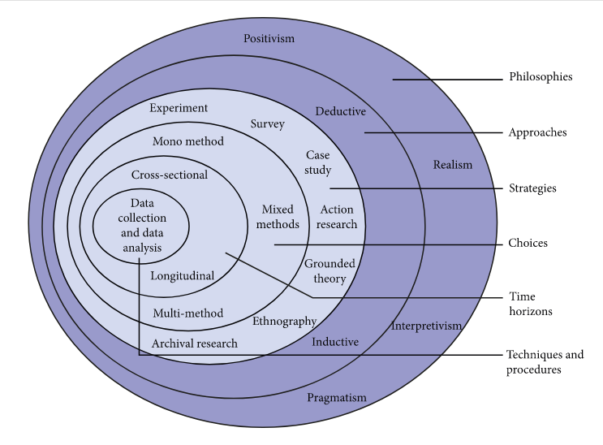
Source: (Saunders, Lewis and Thornhill,2019)
16.3 Research philosophy:
Ontology (Outer Layer):
The study takes a relativist ontology, which is consistent with the idea that reality is socially produced. This indicates that there are differences in people's perceptions of reality depending on their cultural background and individuality. The research acknowledges that what is deemed "real" is influenced by society standards, personal perspectives, and cultural frameworks, drawing on the work of Guba and Lincoln (1994). The study recognizes that reality is dynamic and that the influence of advertising on consumer behavior is not a static idea, but rather depends on the varied viewpoints and experiences of international students.
Epistemology (Middle Layer):
The study's epistemology, which is rooted in the interpretivist school, sees knowledge as individualized, contextual, and influenced by people's interactions with their surroundings. According to Creswell & Creswell (2017), this viewpoint suggests that reality is socially produced and exists in numerous forms. This indicates that, in the context of the study, the goal is to comprehend how overseas students interpret and comprehend advertising messages in their own subjective ways. It acknowledges that information regarding how advertising affects consumer choices is shaped by a person's experiences and cultural background rather than being objective and absolute.
Axiology (Inner Layer):
The research gives ethical considerations, attitudes, and beliefs a deep degree of importance. The study maintains ideals like openness, respect for different viewpoints, and ethical behavior throughout the research process by drawing on Bryman's (2016) work. The study is guided by ethical guidelines, which highlight the importance of protecting participant confidentiality, obtaining informed consent, and appropriately disseminating the research findings. Because cultural values have an impact on the study, they are given special consideration. This guarantees that the investigation of how advertising affects the purchasing habits of international students is carried out in an impartial, courteous, and culturally aware manner.
16.4 Research approach:
Starting the research using accepted ideas or hypotheses about how advertising affects consumer behavior is part of the deductive technique adopted for the "The effect of Advertising on the Students' Buying Behavior " study. Using established concepts from the fields of consumer psychology and advertising, this deductive approach provides an organized and theoretically based framework for investigation. The deductive approach, which is based on the well-established theory of evolution, is like the methodology used to examine changes in the physical characteristics of animals over time. It aims to evaluate or expand upon preexisting hypotheses through empirical investigation. When it comes to foreign students and Apple products, this means developing theories based on theoretical underpinnings and then gathering and examining evidence to confirm or contest these theories. This deductive method adds to the body of knowledge in the larger field of consumer studies in addition to offering a methodical way to investigate the relationship between advertising and purchasing behavior. In the end, it makes it easier to comprehend how well-established advertising theories relate to the unique circumstances of overseas students and their product preferences for Apple.

Research strategies:
In business and management scholarship, the survey technique is typically tightly linked to the use of a deductive research approach (Saunders, Lewis, & Thornhill, 2019). it especially appropriates for these types of descriptive and exploratory studies (Saunders, Thornhill, & Lewis, 2015). A survey is a methodical way to collect information from a group of people to clarify traits, viewpoints, behaviors, or attitudes within a larger community (Fowler, 2013). A survey questionnaire approach has been used in this study to carefully gather trustworthy and understandable data from social media platform users. This approach guarantees a thorough investigation of customer behavior within the framework of branding tactics and how they affect buying choices. The next study is to combine qualitative and quantitative research methodologies to solve the drawbacks of depending just on one research approach (Patten ML and Newhart M, 2018). Primary data gathering through custom-made online surveys utilizing Google Forms will delve into the precise reasons driving consumer buying behavior, while secondary data will offer theoretical insights into advertising techniques impacting customer buying behavior and purchasing decisions. Interviews will not be used to gather data for the initial pilot project, which will evaluate the validity and reliability of the research tool. This all-encompassing approach, supported by careful pilot research, aims to provide a full understanding of the factors influencing consumer purchasing behavior.
Primary research:
According to top experts in the field, primary research is the process of directly gathering unique data that is customized to meet certain research goals. Saunders et al. (2019) stress the value of techniques like surveys in this procedure. To obtain firsthand information, primary research—which includes surveys is crucial, as noted by Sekaran and Bougie (2016). Primary research is defined by Neuman (2014) as the direct collection of data from people or sources, setting it apart from secondary research. Primary research methods are essential to business research because they allow data to be tailored to the specific objectives of the researcher (Bryman and Bell, 2015). Additionally, Creswell and Creswell (2017) state that surveys and other primary research are essential to research design since they provide firsthand knowledge.
Secondary research:
Information that has previously been gathered, processed, and analyzed by people or organizations other than the current researcher is referred to as secondary data. This data was initially gathered for a purpose unrelated to the researcher's current work. Researchers frequently use this kind of data to support or validate their own research by offering more context or insights. Numerous sources, such as articles, reports, databases, and pre-existing datasets, can be used to obtain secondary data. Saunders et al. (2019), Sekaran and Bougie (2016), Neuman (2014), Bryman and Bell (2015), and Creswell and Creswell (2017) all stress the significance of comprehending and applying secondary data in the context of business research. These resources acknowledge the importance of secondary data in research and provide advice on how to use and analyze its function in enhancing the scientific method and adding to the corpus of knowledge. To make sure that secondary data is relevant for their study objectives, researchers should carefully assess the validity, applicability, and context of the secondary data they use.
16.5 Choices:
Saunders et al. (2016) delineate research choices in relation to the utilization of quantitative and qualitative research methods, including the option for a straightforward application of either a complex combination of both, or the use of a mono method. In qualitative research methods, the emphasis is on the collection of extensive descriptive data, while quantitative methods involve numbers and mathematical operations. The mono method is employed when the research focuses solely on either quantitative or qualitative data gathering. Mixed methods involve the simultaneous use of quantitative and qualitative approaches in the same study to achieve distinct objectives and overcome the limitations associated with a single method. Additionally, multi-method choices encompass the utilization of both qualitative and quantitative methods, where one method serves as the primary approach, and the other functions as supplementary support.
This framework for presenting research choices is also applicable to futures studies. According to Saleh et al. (2008), methods in futures studies can be categorized into quantitative approaches, such as time series analysis, causal analysis, and trend analysis, as well as qualitative methods, including Delphi surveys, futures wheel, and environmental scanning. Some methods are versatile, serving effectively as both quantitative and qualitative, such as scenario construction and modeling.
Qualitative research:
A technique used to thoroughly examine and comprehend the intricacies of social phenomena, human experiences, and behaviors is called qualitative research. Qualitative research places more emphasis on gathering and analyzing non-numerical data than quantitative research, which is more concerned with numerical data and statistical analysis. Interviews, focus groups, observations, and content analysis are typical techniques. Rich and thorough descriptions are intended to enable researchers to understand the subtleties and deeper meanings buried in the events under study (Creswell & Poth, 2018; Maxwell, 2013). A flexible and iterative research design is frequently used in qualitative research, allowing for the emergent character of the findings, and adjusting the methodology as necessary (Charmaz, 2014). This approach is frequently used in the social sciences, healthcare, and education to better comprehend people's subjective experiences and social contexts (Denzin & Lincoln, 2018; Sandelowski, 2000; Strauss & Corbin, 1998).
16.6 Time horizon:
The temporal scope of this research is defined as cross-sectional, as the investigation spanned a brief duration of ten weeks, and data collection occurred at a specific moment within this timeframe. A cross-sectional study is designed to offer insights into the phenomenon under examination by collecting data at a singular point in time. Commonly employed in cross-sectional studies, survey methodology was utilized to gather information for this research (Saunders, Lewis, & Thornhill, 2019).
16.7 Data collection and analysis:
The fundamental premise of sampling is grounded in the idea that insights about the entire population can be extrapolated by selecting a subset of the population under scrutiny in a study (Cooper and Schindler, 2014). It is crucial to carefully choose a sample that faithfully mirrors the characteristics of the larger population from which it is derived. The researcher should be able to justify the selected sample in terms of addressing research questions and achieving study objectives (Saunders, Lewis, and Thornhill, 2019).
16.8 Sample size:
Since the goal of this study is to investigate how advertising affects students' purchasing decisions, social media users who are also students and product consumers make up the target group. A sample size of 15 to 35 responders will answer the research questions in the short time allocated for the project. However, replies were received throughout the data collecting period, which resulted in a sample size that was somewhat larger than anticipated. The researcher thinks that the current sample size achieves a fair compromise between result dependability, realistic data collection issues, and the project's time constraints even if a larger sample could improve result accuracy. Using the researcher's profiles on different social media sites and the help of friends who shared, access to respondents was made easier.
16.9 Sample type:
The online survey aimed to capture responses to the impact of advertising on buying behavior of iPhone by international students encompassing individuals of all gender identities. The participants, aged 18 and above, were drawn from different social statuses and located in the United Kingdom. The sample represented diverse cultural backgrounds and varying levels of experience with advertising on social media platforms that impact their buying behavior.
16.10 Data collection method:
In this study, data collection was facilitated through the utilization of a survey questionnaire. The objective was to administer an online survey to a cohort of 15 to 35 users engaged with social media, specifically those who follow or consume content related to luxury brands. The survey took place from January 22 to February 5th, 2024, with the survey link disseminated across various social media platforms, including Instagram, Facebook, YouTube. To construct the online questionnaire, Microsoft Forms was employed, and the survey was made available in The English version of the questionnaire can be found in the Appendix. The survey consisted of fourteen inquiries, in that every question has selected choosing option with a minimum of four options Respondents were allotted 5 minutes to anonymously complete the form, and a total of 25 users provided responses. To ensure comprehensive responses, the researcher mandated each question by designating the required option with an asterisk. On average, participants spent 3 minutes and 44 seconds completing the survey.
- Research ethics:
The data collection process for this study adhered to the Data Protection Act of 2018 (GOV.UK, n.d.), which governs the handling of personal data in the UK. To ensure compliance with this legislation, participants were provided with information regarding the study's purpose and procedures, and their consent was obtained at the commencement of the survey. The data acquired was exclusively utilized for the specified research objectives outlined in the study and remained unaltered and confidential, with no sharing with external parties. Participants' identities were safeguarded by refraining from collecting any personally identifiable information. Lastly, the collected data will be securely retained for a limited duration, after which it will be permanently deleted.

- Analysis of data:
The quantitative data from the study underwent analysis using Microsoft Excel, allowing for the generation of tables, graphs, and charts. The data analysis proceeded smoothly without encountering any challenges, as Microsoft Forms offers the capability to download all responses in the form of a Pivot table within a Microsoft Excel file. This feature streamlined the task for the researcher in producing tables, graphs, and charts.
  - Introduction:
The pivotal phase of our research journey involves the meticulous examination and interpretation of the amassed data, seeking to unravel the intricate relationships between advertising strategies and the purchasing behavior of international students in the context of Apple products. This section delves into the rich tapestry of information gathered through surveys, interviews, and other relevant methodologies, aiming to extract meaningful insights that contribute to a comprehensive understanding of the impact of advertising on consumer decision-making. As we embark on this analytical endeavor, the overarching objective is to discern patterns, correlations, and trends within the dataset, illuminating the nuanced dynamics that shape the perceptions and preferences of our target audience. The exploration of both quantitative and qualitative data sets the stage for an in-depth exploration of the research questions and objectives, facilitating a robust examination of the intricacies surrounding advertising efficacy, consumer responses, and the post-purchase experiences of international students in the realm of Apple products. Through a methodical and systematic approach to data analysis, we endeavor to uncover valuable knowledge that not only advances academic understanding but also offers practical implications for advertisers, marketers, and stakeholders operating in the dynamic landscape of global consumerism.

- Questionnaire analysis:
Question 1
What is your gender?
Gender group | Participants 36
Male | 19
Female | 17
Non-binary | 0
Prefer not to say | 0

Explanation: Out of the 36 survey respondents, the gender distribution shows a balanced mix of male and female respondents. 19 participants identified as male, and 17 as female. Remarkably, none of the respondents selected the "prefer not to say" option when asked about their gender or identified as non-binary. Although non-binary participants and those who choose not to reveal their gender may limit the breadth of gender-related findings, the general gender distribution offers a basic knowledge for the analysis of post-purchase experiences that follows. To place the opinions and preferences of the male and female participants within the parameters of the study, this division is essential.
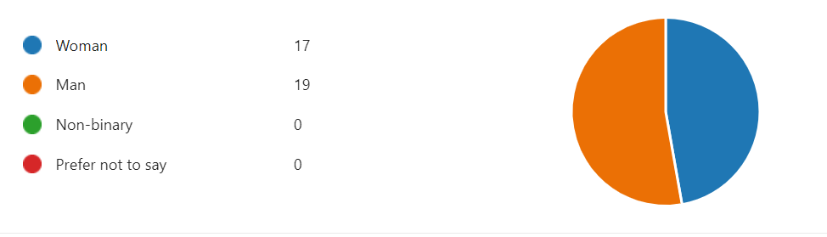

Question 2
What is your age?
Age group | Participants
15 to 18 | 1
19 to 25 | 32
26 to 40 | 03
40 to 55 | 0

Discussion: The survey participants' age distribution reveals significant trends that have consequences for comprehending events that occur after a purchase. 32 participants, or most of the participants, are between the ages of 19 and 25, indicating that the study is heavily weighted towards this younger age group. This is consistent with the market share of consumers who often acquire technology-related goods, which is relevant for evaluating Apple's post-purchase dynamics (Glowa, P.2002). Nonetheless, the small number of respondents in the 40–55 age group and the three participants in the 26–40 age range suggest that there may be information gaps for middle-aged and older customers (Glowa, P.2002). These age dynamics emphasize how crucial it is to understand findings in the context of the prevailing young perspective while also recognizing any potential barriers to generalizability across a range of age groups. Intentional recruitment tactics should be considered in future research endeavors to guarantee a more representative age distribution. This will facilitate a more thorough comprehension of post-purchase experiences throughout various life phases.
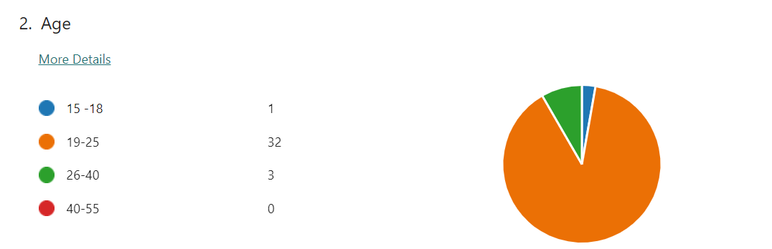

Question 3

To what extent do apple’s advertisements influence your awareness of their latest product?
Options | Participants | Percentage
Not at all | 02 | 5%
Slightly | 10 | 28%
Moderately | 12 | 34%
Very much | 11 | 31%

Explanation: According to the poll results, participants' awareness of the newest goods is significantly impacted by Apple's ads, with 65% of respondents indicating a moderate to high level of effect. Most fall into the "Moderately" and "Very much" categories, indicating that a sizable section of the audience is effectively drawn in by Apple's advertising, which raises awareness of the product. However, 33% of respondents, who were split between the Slightly and Not at all categories, suggest that Apple's advertising methods may use some work. Analyzing differences in responses according to demographics and focusing on qualitative factors may yield more insightful information and help Apple improve its advertising strategy for a more focused and successful interaction with a range of customer groups.

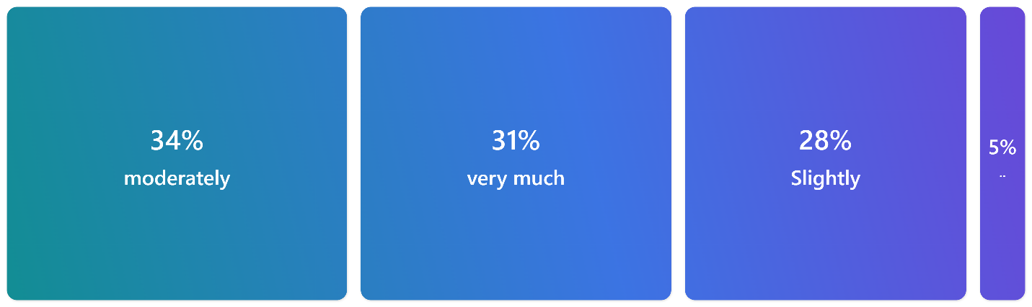

Question 4
How often do you come across iPhone advertisements on social media platforms?
Options | Participants | Percentage
Daily | 13 | 36%
Weekly | 10 | 27%
Monthly | 2 | 5%
Seasonal | 8 | 22%
yearly | 3 | 8%
never | 0 | 0%

Explanation: The results of the survey indicate a variety of trends regarding the frequency with which iPhone adverts appear on social media sites. A significant 36% of participants report exposure daily, suggesting a high degree of visibility and good utilization of users' ongoing presence on these platforms. When the Daily and Weekly categories are combined, a sizable majority (63%) sees iPhone commercials on a weekly basis, which promotes consistent brand memory. Although the Monthly and Yearly groups indicate rare exposure, the lack of individuals who have never seen an iPhone advertisement highlights how widely distributed Apple's advertising is. The requirement for a balanced strategy to preserve high exposure while averting possible user fatigue is one of the strategic ramifications. These understandings can help Apple tailor its advertising approach for long-term success and satisfying customer experiences across diverse audience segments.
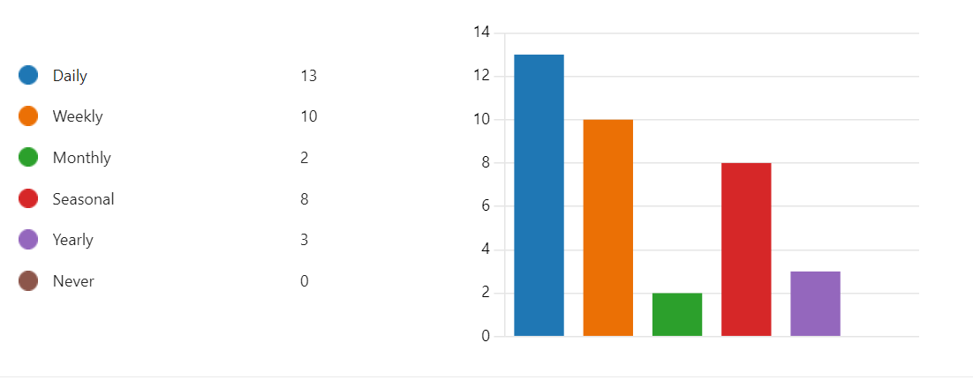

Question 5
Which aspect of iPhone advertising appeals to you the most?
Options | Participants | Percentage
User experience | 3 | 8%
Design and aesthetics | 6 | 16%
Technological features | 11 | 30%
Celebrity endorsement | 2 | 5%
None of the above | 3 | 8%
All the above | 11 | 30%

Explanation: The survey outcomes reveal diverse preferences among participants regarding the aspects of iPhone advertising that appeal to them the most. Notably, 30% express a keen interest in technological features, underscoring Apple's historical emphasis on innovation. Design and aesthetics capture 16% of participants, highlighting the significance of the visual appeal and form factor in influencing consumer preferences. User experience, recognized by 8%, emphasizes the importance of seamless and intuitive interaction with the iPhone. Celebrity endorsement has a limited impact, with only 5% finding it the most appealing aspect. The complexity of preferences, including 8% selecting "None of the above" and 30% opting for "All of the above," underscores the need for a multifaceted advertising strategy that caters to diverse consumer motivations. These insights guide Apple in fine-tuning its marketing messages to align with the varied preferences of its audience for a more effective and personalized approach.

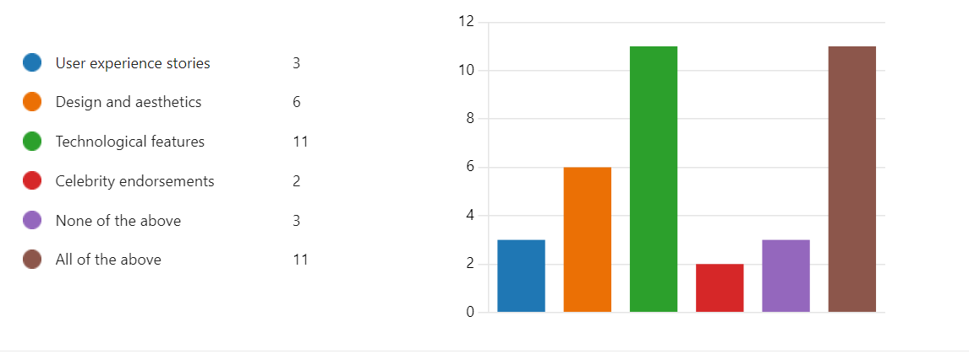
Question 6
Have iPhone advertisements influenced your perception of the brands innovative capabilities?
Options | Participants | Percrntage
Yes | 19 | 54%
May be | 10 | 28%
No | 6 | 17%

Explanation: According to the poll results, most participants (54%) believe that iPhone advertising has a favorable impact on the innovative capabilities of the company. This suggests that Apple's marketing efforts are effective in communicating a message of innovation. About 28% of respondents say "Maybe," implying an unclear effect that might be modified by additional variables. Notably, 17% of respondents claim that iPhone commercials have not changed their opinion of the brand's innovation, highlighting areas where communication of innovation to this group may need to be improved. It is advised to conduct additional research to identify the precise elements causing the range of reactions. The variations in the "Maybe" and "No" responses highlight the need for a more focused strategy to address a range of customer attitudes, underscoring the importance of qualitative research, even as the positive responses confirm the current advertising methods. To summarize, the poll yields valuable insights into customer opinions, which in turn helps Apple refine its advertising strategy to achieve maximum resonance with a diverse range of consumers.
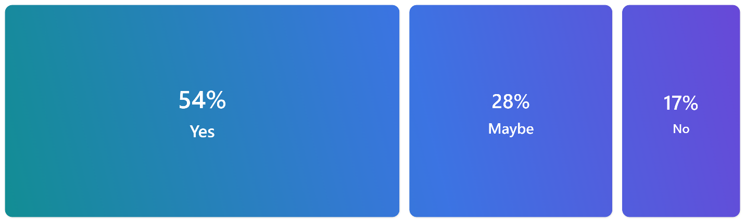

Question 7
How likely are you to explore an iPhone based on a recommendation from a friend who was influenced by an apple advertisement?
Options | Participants | Percentage
Very likely | 11 | 30%
Somewhat likely | 15 | 41%
Neither likely nor unlikely | 8 | 22%
Somewhat unlikely | 1 | 2%
Very unlikely | 1 | 2%

Explanation: Participants' likelihood of investigating an iPhone and a friend's recommendation inspired by an Apple advertisement are highly positively correlated (71%) according to the survey, with 30% extremely likely and 41% moderately probable. This highlights the important influence that recommendations from friends and family that are formed by Apple's marketing campaigns have on prospective customers. Furthermore, 22% take a neutral position, suggesting a subgroup that might consider additional considerations in addition to the friend's suggestion and the influence of advertisements. Merely 4% indicate a negative probability, indicating hesitancies or factors that surpass the sum impact. The results highlight the significance of peer recommendations in customer decision-making, and more research into the variables affecting neutral and negative responses may provide insightful information that Apple may use to improve its product positioning and marketing tactics.
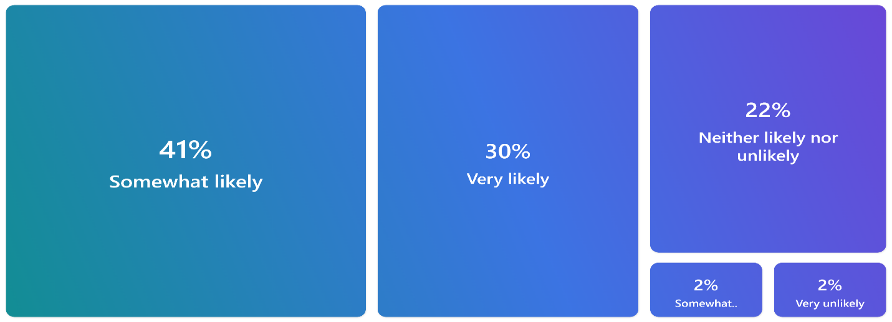

Question 8

Do you think the emotional appeal in iPhone advertisement impacts your connection with the brand?
Options | Participants | Percentage
Not at all | 11 | 31%
To a small extent | 11 | 31%
Considerably | 6 | 17%
A great deal | 7 | 20%

Explanation: The survey reveals a wide range of opinions on how participants' relationships with the company are affected by emotional appeal in iPhone commercials. Sixty-two percent of respondents say that emotional factors influence their brand relationship either not at all or very little, indicating that emotional factors are not very important to most of them. On the other hand, 17% believe that emotional appeal has a significant impact, suggesting a moderate influence that appeals to a certain consumer demographic. Notably, 20% of respondents claim that emotional appeal has a major influence on their brand relationship, highlighting the significance of emotional components for this market. The varying answers highlight the necessity for Apple to take a balanced stance, acknowledging that the effects of emotional appeal on brand connection vary. When strategic considerations emerge, more investigation using qualitative techniques to identify emotional components that appeal to customers the most, helping Apple to fine-tune their advertising approach for maximum impact across a variety of audience categories.

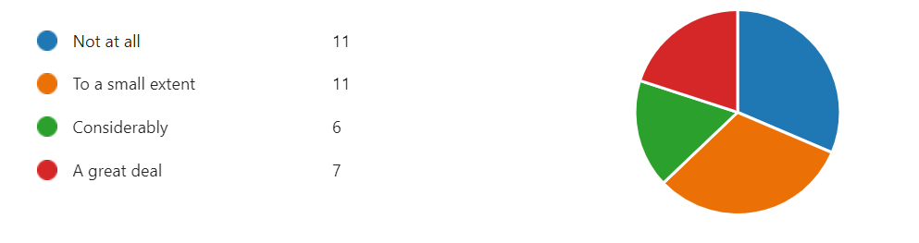

Question 9
Which online platform do you find most effective for apple advertisements in influencing your purchasing decisions?
Online platform | Participants | Percentage
Instagram | 24 | 66%
Twitter | 1 | 2%
Facebook | 2 | 5%
You tube | 9 | 25%

Explanation: Instagram is the most popular platform, as reported by 66% of participants, who also believe it to be the most effective for Apple marketing because of its visual appeal and fit with Apple's design-focused philosophy. As 25% of respondents noted, YouTube follows suit and has a significant influence. It does this by using its capacity to produce in-depth video material that appeals to customers who are looking for thorough information prior to making purchases. On the other hand, Twitter and Facebook are much less influential—only 2% and 5% of users acknowledge each other—possibly because of Twitter's content limitations and Facebook's difficulty drawing users' attention to a variety of material kinds. The differing efficacy of the platforms points to the possibility that Apple will implement focused tactics, creating aesthetically appealing content specifically for Instagram, educational films specifically for YouTube, and investigating content format changes for Twitter and Facebook. To ensure Apple stays flexible and appeals to a wide range of consumers, it is imperative that advertising tactics are optimized across these dynamic online channels by considering the subtleties of user engagement and consistently adjusting to emerging trends.

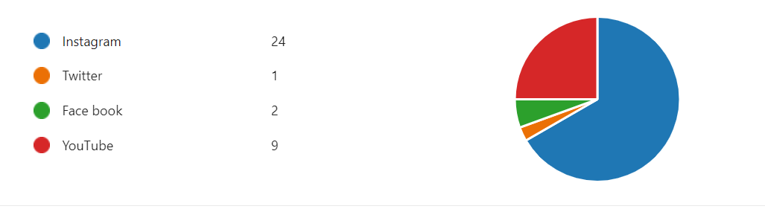
Question 10

How do you perceive the authenticity of information presented in apple advertisement?
Options | Participants | Percentage
Not authentic at all | 2 | 5%
Somewhat authentic | 19 | 54%
Very authentic | 11 | 31%
Extremely authentic | 3 | 8%

Explanation: The participants' opinions regarding the veracity of the material offered in Apple commercials vary widely. The majority, 54%, indicate that they regard the material to be relatively authentic; this is a balanced opinion with potential for development. Positively, 39% of respondents believe the information to be very authentic (31%) or extremely authentic (8%), suggesting that a sizable section of the public finds Apple's advertising content to be highly credible. Still, 5% of respondents believe the material is false, indicating a minority having doubts. To strategically improve the overall authenticity of its advertising, Apple must comprehend the individual causes behind these disparate impressions. This will help to strengthen consumer trust and favorably shape brand perception.
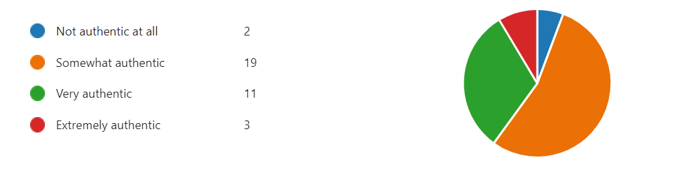

Question 11
Have you ever made a purchase decision for an iPhone solely based on an online advertisement?
Options | Participants | Percentage
Very frequently | 8 | 22%
Very often | 11 | 30%
Occasionally | 7 | 19%
Very rarely | 10 | 27%

Explanation: 52% indicate that online marketing has a major influence on their decision to buy an iPhone. This group includes those who make decisions about purchases both regularly and often. This implies that a sizable percentage of participants regularly base their selections on digital advertising content. 19% of participants who sporadically rely on their purchasing decisions on internet marketing belong to the moderate impact category. This group admits to occasionally recognizing the influence of internet advertisements on their iPhone purchases, albeit less frequently than the previous group. When making an iPhone purchase, 27% of consumers hardly ever base their selections on internet ads. This group relies less on digital ads overall. Gratitude. Apple can improve its advertising strategy to better connect with this audience demographic by considering the variables that contribute to its limited influence. The distribution of answers demonstrates the several ways in which web ads impact people's decisions to buy iPhones. By utilizing these insights, Apple may customize its digital advertising campaigns to better suit the tastes and habits of its wide range of customers.
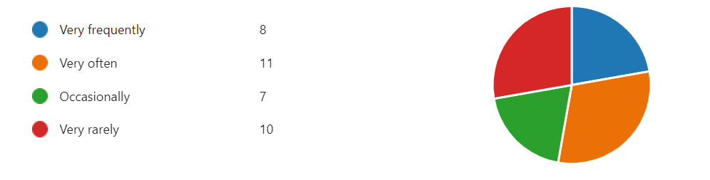

Question 12
Do you believe that iPhone advertising aligns with your personal values and preferences?

Options | participants | Percentage
Not at all | 8 | 22%
To a small extent | 11 | 31%
Moderately | 14 | 40%
completely | 2 | 5%

Explanation: There is a wide range of opinions as evidenced by the majority of 71% (22% not at all, 31% to a minor extent) who stated that there was a variable degree of alignment between their personal beliefs and preferences and iPhone advertising. This implies that there is potential for Apple to improve the resonance of its promotional material with a significant proportion of users. Among those who view iPhone advertising as somewhat in line with their personal beliefs and preferences, 40% of respondents represent a sizeable portion. Recognizing the elements that lead to this moderate alignment might help Apple strengthen these beneficial relationships. The 5% who believe that iPhone advertising perfectly reflects their beliefs and tastes, however fewer in number, nonetheless, constitutes a specialized market with a strong positive association. Identifying and utilizing the components that appeal to this audience might help to increase brand loyalty. The distribution of answers highlights how crucial it is for Apple to continuously evaluate and improve how well its advertising content reflects the range of values held by its target audience. Apple's advertising strategy can be made more effective by taking a more sophisticated approach that acknowledges and accommodates the diverse interests of its target audience.

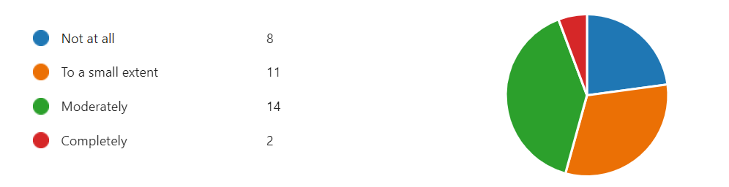

Question 13
Do you believe that celebrity endorsements enhance the overall appeal of apple products?
Options | Participants | Percentage
Strongly disagree | 4 | 11
Strongly agree | 6 | 17
Disagree | 4 | 11
Agree | 13 | 37
neutral | 8 | 22
Explanation: Views Differing from one another of the respondents, 48% (11% strongly disagree, 11% disagree) expressed doubts or disagreements regarding the improvement of overall appeal through celebrity endorsements. Positive Perceptions Of the respondents, 54% (17% strongly agree and 37% agree) feel that celebrity endorsements can increase the allure of Apple products. This indicates that a sizable portion of people think it's beneficial to link Apple with celebrities. Neutral Position Of those surveyed, 22% hold a neutral stance, suggesting that they are indecisive or have mixed feelings about the influence of celebrity endorsements. Examining the elements that led to this impartial position may help Apple handle possible issues or capitalize on advantages. Strategic Implications Apple's approach to celebrity endorsements can be strategically guided by its understanding of the diverse responses. Optimizing this marketing plan can involve addressing the problems expressed by those who disagree or adopt a neutral attitude, while highlighting the favorable features indicated by those who agree. In conclusion, the survey's findings show that people have differing perspectives about how much the allure of Apple products is affected by celebrity endorsements. While a sizable percentage recognizes the beneficial impact, there are also doubts and a neutral position, highlighting the necessity for Apple to carefully consider and customizes its celebrity endorsement techniques to successfully connect with its wide range of customer base.
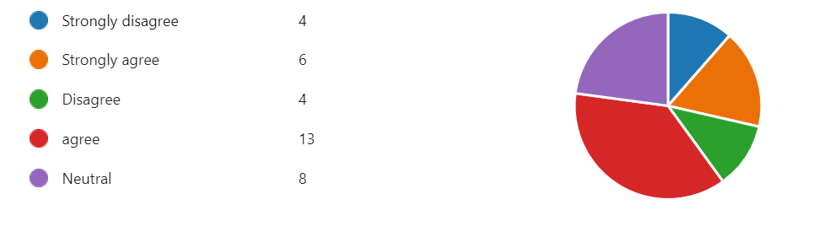

Question 14
Considering your post purchase experience, how well did apple’s advertising reflect the durability and longevity of their products?
Options | Participant | Percentage
Extremely well | 12 | 33%
Somewhat well | 10 | 27%
Neutral | 11 | 30%
Somewhat not well | 2 | 5%
Extremely not well | 1 | 2%

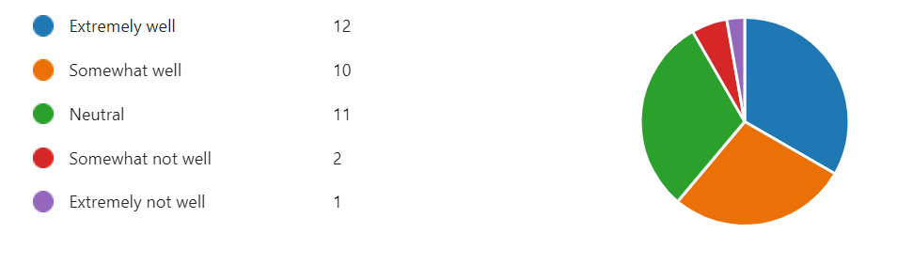

Result: Sixty percent of participants (combining the "Extremely well" and "Somewhat well" categories) believe that Apple's advertising accurately reflects the real longevity and durability of its goods. Nonetheless, a noteworthy 32% express neutrality or believe that Apple's advertising does not adequately or at all portray the robustness of their products.
Discussion:
Positive Perception A noteworthy proportion of respondents (60%) believe that Apple's advertisements accurately reflect the endurance of its products, indicating that the company has done a good job of communicating its intended message. A sizable segment of the examined group seems to connect strongly with Apple's emphasis on durability and quality. There is potential for improvement as some participants may not think that Apple's advertisements adequately convey the robustness and endurance of their products. This is indicated by the number of respondents who fell into the "Neutral," "Somewhat not well," and "Extremely not well" categories. This suggests some areas where messaging clarity or advertising techniques should be strengthened. Individual Viewpoints The qualitative understandings behind participants' answers may provide insightful data. It may be possible to shed light on issues or concerns influencing participants' perceptions by conducting follow-up or asking open-ended survey questions. Marketing Implications In response to participant concerns that the advertising did not adequately reflect their experiences after making a purchase, Apple may decide to improve the content or distribution methods of its advertisements. This may help to improve brand and consumer happiness.
Comprehending the subtleties of consumer attitudes is essential for corporations such as Apple to consistently enhance their marketing tactics and guarantee that their advertisements correspond with the real-life experiences and anticipations of their clientele. devotion.

- Conclusion and recommendations:
In conclusion, this dissertation aims to investigate the intricate relationship between advertising and the buying behavior of international students, specifically focusing on Apple products. The opening emphasizes how advertising affects people all over the world on a variety of channels and how it has a profound and long-lasting impact on viewers' minds. The article emphasizes how advertising plays a crucial role in communication between producers and consumers by highlighting its dynamic influence on consumer behavior, brand preferences, and memory formation. The research's rationale highlights how important it is to comprehend how the advertising industry is changing, driven by technological innovation and ethical issues. The goal of the study is to investigate the psychological, social, and cultural factors that impact how foreign students respond to Apple product commercials. The goal of the study is to offer marketers and businesses useful information that will help them create more moral and successful advertising campaigns that will improve the relationship between their brand and its target audience.
Finding research gaps, the study acknowledges the distinct shopping habits of international students as well as the paucity of specialized studies in the body of current literature. It highlights how important it is to close these disparities by looking at how advertising affects international students' judgements, especially when it comes to Apple products. The study also draws attention to the paucity of research on the temporal dynamics of advertising efficacy, the psychological aspects of how international students understand Apple advertisements, and the comparison of advertising strategies used by Apple and its rivals. The purpose of the research is well-defined; it is to gain a thorough understanding of the ways in which various advertising channels influence the tastes and opinions of international students who are thinking about purchasing Apple products. The study's objectives provide additional clarification on its scope, with a particular emphasis on the ways in which advertising channels, social media marketing strategies, brand image, and post-purchase experiences impact the purchasing decisions of international students. Important elements including the influence of celebrity endorsements, the efficacy of advertising channels, and the correspondence between post-purchase experiences and advertising expectations are emphasized by the research questions. The examination into the intricate relationships between international students' behavior and advertising tactics in relation to Apple products will be guided by these questions.
In conclusion, the goal of this dissertation is to fill in important research gaps and investigate the complex relationship between advertising and international students' purchasing behavior. It is anticipated that the results will provide useful information for businesses and marketers, encouraging the creation of more ethical and focused advertising campaigns in the constantly changing context of worldwide consumer behavior.
20.1 Recommendations:
Cross-Cultural Analysis: It is suggested that you carry out a cross-cultural analysis among the international students in your group. Examine how cultural backgrounds affect how people react to advertisements and make decisions about what to buy when it comes to Apple products. This can offer subtle insights into the various viewpoints held by the community of overseas students. Longitudinal Study on Temporal Dynamics is suggested that a longitudinal study be conducted to examine the relationship between the purchasing patterns of overseas students for Apple products and the evolution of advertising efficacy over time. This method can catch changing inclinations and trends, providing a dynamic viewpoint on the efficacy of marketing operations. Neuroscientific Approaches It is suggested that neuroscientific techniques, like neuroimaging or eye-tracking, be used to further investigate the psychological aspects of how international students understand Apple's advertising. This can provide your research with a distinctive perspective by shedding light on the neurological underpinnings of emotional and cognitive reactions.
Comparative Advertising Analysis: It is recommended that the comparative examination of advertising tactics be expanded to encompass a wider range of tech industry competitors. Knowing how Apple's business practices vary from those of its rivals can provide a clear picture and point out USPs that appeal to overseas students. Incorporate Virtual Reality (VR) or Augmented Reality (AR) It is advised that foreign students be given the opportunity to experience advertising using virtual reality or augmented reality. In a controlled setting, this immersive method can offer a more realistic understanding of how advertising affects people's perceptions and decisions. Mixed-Methods Approach with Ethnography It is advised to use a mixed-methods strategy that incorporates qualitative ideas from ethnographic research with quantitative data. This all-encompassing method can provide a deep comprehension of the social dynamics, cultural subtleties, and real-world situations affecting how overseas students react to Apple's advertisements.
Social Media Sentiment Analysis: It is advised that foreign students' social media posts about Apple products be examined using sentiment analysis software. This can assist you assess the instant effects of advertising efforts on social media platforms by giving you real-time insights into public mood. Working Together with Marketing Experts It is advised that you work together with tech industry practitioners or marketing experts to obtain insights unique to your sector. Through this partnership, marketers can gain a useful understanding of the opportunities and difficulties associated with advertising to overseas students. Designing Experiments to Measure the Effect of Advertising It is suggested that experimental designs be employed to quantify the causal influence of parts of advertising on the purchasing decisions of overseas students. To determine which elements are most influential, play around with elements like language, images, and celebrity endorsements. Engaging Workshops or Discussion Groups It is suggested that interactive seminars or focus groups be held for international students, enabling them to participate actively in the interaction with advertising materials. Real-time feedback can be obtained from this interactive technique, which can also reveal previously unnoticed facets of their views and preferences.

- Limitations:
Digital Literacy Bias: The study primarily focused on participants engaged in social media, potentially introducing a bias towards individuals with higher digital literacy. This limitation might exclude those with limited online proficiency, impacting the study's applicability to a broader population. Platform-Specific Responses Given the diversity of online platforms, the study's findings may not capture the nuanced variations in responses specific to each platform. Different platforms may elicit distinct reactions to Apple advertisements, and a more granular analysis of each platform's impact could provide richer insights. Brand Perception Prevalence The study heavily centers around Apple products, and participants' responses may be influenced by pre-existing brand perceptions rather than solely advertising impact. Exploring a broader range of brands and their advertising strategies could offer a comparative lens to assess the uniqueness of Apple's approach.
Temporal Sensitivity: The study's cross-sectional nature might not fully account for the temporal sensitivity of advertising effects. Consumer responses to advertisements may fluctuate based on external events, industry trends, or product releases, and a more dynamic longitudinal study could capture these temporal nuances. Sociocultural Echo Chambers The online environment, particularly social media, tends to create echo chambers where individuals are exposed to content aligned with their existing beliefs. This may limit the diversity of perspectives within the study, potentially reinforcing pre-existing attitudes towards Apple products. Algorithmic Influence Social media platforms often employ algorithms to curate content based on user preferences. The study does not delve into the potential impact of algorithmic content curation on participants' exposure to Apple advertisements, overlooking a dimension that could significantly influence advertising reception. Global Advertising Variances The study, while acknowledging the cultural impact, may not fully encompass the global variances in advertising strategies. Advertising approaches that resonate with international students in the UK may not necessarily align with the preferences of international students in other regions, highlighting the need for a more geographically diverse study.
Influence of Peer Discussions: The study does not extensively explore the influence of peer discussions and group dynamics on participants' responses to Apple advertisements. Understanding how group interactions and peer recommendations shape perceptions could offer a more holistic understanding of the advertising impact. Emergent Advertising Trends The rapidly evolving nature of digital advertising may lead to emergent trends that the study does not capture. New advertising formats, platforms, or trends could influence consumer behavior differently, and the study's scope may not fully encompass these evolving dynamics. Visual and Aesthetic Preferences The study primarily focuses on the impact of content and messaging, overlooking potential influences related to visual and aesthetic preferences. A more nuanced exploration of design elements and visual appeal in Apple advertisements could provide additional insights into consumer responses.

- Appendix
Impact of advertising on the international students buying behavior of apple products
Forms
impact of advertising on students buying behaviour of an apple product(iPhone)
SA
Back
View results
Respondent
Anonymous
02:09
Time to complete
1
Gender Single choice.

- Woman
- Man
- Non-binary
- Prefer not to say

2
Age Single choice.

- 15 -18
- 19-25
- 26-40
- 40-55

3
To what extent do Apple's advertisements influence your awareness of their latest products? Single choice.


- Not at all
- Slightly
- moderately
- very much
4
How often do you come across IPhone advertisements on social media platforms? Single choice.

- Daily
- Weekly
- Monthly
- Seasonal
- Yearly
- Never
5
Which aspect of iPhone advertising appeals to you the most? Single choice.

- User experience stories
- Design and aesthetics
- Technological features
- Celebrity endorsements
- None of the above
- All of the above
6
Have iPhone advertisements influenced your perception of the brand's innovative capabilities? Single choice.

- Yes
- No
- Maybe
7
How likely are you to explore an IPhone based on a recommendation from a friend who was influenced by an Apple advertisement? Single choice.

- Very likely
- Somewhat likely
- Neither likely nor unlikely
- Somewhat unlikely
- Very unlikely
8
Do you think the emotional appeal in IPhone advertisements impacts your connection with the brand? Single choice.

- Not at all
- To a small extent
- Considerably
- A great deal
9
Which online platform do you find most effective for Apple advertisements in influencing your purchasing decisions? Single choice.
- Instagram
- Twitter
- Face book
- YouTube
10
How do you perceive the authenticity of information presented in Apple advertisements? Single choice.

- Not authentic at all
- Somewhat authentic
- Very authentic
- Extremely authentic
11
Have you ever made a purchase decision for an iPhone solely based on an online advertisement?

- Single choice.
- Very frequently
- Very often
- Occasionally
- Very rarely
12
Do you believe that iPhone advertising aligns with your personal values and preferences? Single choice.

- Not at all
- To a small extent
- Moderately
- Completely
13
Do you believe that celebrity endorsements enhance the overall appeal of Apple products? Single choice.

- Strongly disagree
- Strongly agree
- Disagree
- agree
- Neutral
14
Considering your post-purchase experiences, how well did Apple's advertising reflect the durability and longevity of their products? Single choice.

- Extremely well
- Somewhat well
- Neutral
- Somewhat not well
- Extremely not well

- REFERENCES
Aaker, D. A., Kumar, V., & Day, G. S. (2003). Marketing research. John Wiley & Sons.
Abiodum, M. A. (2011). Advertising: Its Impact on Consumer Preference for Marketing Companies' Products. International Journal of Business and Management, 6(8), 155-169.
Abraham, M. (1997). Marketers must understand how consumers make choices. Marketing News, 31(13), 4-4.
Adelaar, T., Chang, S., Lancendorfer, K. M., Lee, B., & Morimoto, M. (2003). Effects of media formats on emotions and impulse buying intent. Journal of Information Technology Theory and Application (JITTA), 5(1), 63-79.
Adelaar, T., Chang, S., Lancendorfer, K. M., Lee, B., & Morimoto, M. (2003). Effects of media formats on emotions and impulse buying intent.
Adelear, J. A., Chang, K., Lanchndorfer, K. M., Lee, J., & Morimoto, T. (2003). An empirical investigation of the impact of advertising strategies on consumer responses. Journal of Advertising Research, 43(3), 268-281.
Advertising Research, 15, 17–24.
Anderson, J. (2019). Challenges in Secondary Research. Journal of Research Methods, 25(3), 123-140.
Arnould, E. J., & Thompson, C. J. (2005). Consumer culture theory (CCT): Twenty years of research. Journal of Consumer Research, 31(4), 868-882.
Associated Chambers of Commerce and Industry. (2013). Impact of advertising on consumer buying behaviors in India.
Ayanwale, A. B., Alimi, T., & Ayanbimipe, M. A. (2005). The impact of advertising on consumer buying behavior in Kabul Province.
Ayanwale, A. B., Alimi, T., & Ayanbimipe, M. A. (2005). The influence of advertising on consumer brand preference. Journal of Social Sciences, 10(1), 9-16.
Barry, T. E. (1987). A Review and Critique of the Hierarchy of Effects in Advertising. International Journal of Advertising, 6(2), 121-135.
Belch, G. E., & Belch, M. A. (2021). Advertising and Promotion: An Integrated Marketing Communications Perspective. McGraw-Hill Education.
Bovee, C. L., Arens, W. F., & Schmaltz, R. (1995). Contemporary Advertising. Irwin.
Brassington, F., & Pettitt, S. (2001). Principles of Marketing. Pearson Education.
Brown, R. (2017). Limited Control in Secondary Research. Journal of Information Science, 42(2), 87-102.
Bryman, A. (2016). Social Research Methods (5th ed.). Oxford University Press.
Bryman, A. (2016). Social research methods. Oxford University Press
Bryman, A., & Bell, E. (2015). Business Research Methods. Oxford University Press.
Bymolt, R., Claassen, W., & Brus, M. (1998). "Advertainment" embedded advertising entertainment: a study on the effectiveness of advertainment elements in television shows. Journal of Marketing Communications, 4(3), 189-202.
Charmaz, K. (2014). Constructing Grounded Theory (2nd ed.). Sage Publications.
Churchill Jr, G.A. & Surprenant, C. (1982). An investigation into the determinants of customer satisfaction. Journal of Marketing Research, 19(4), 491-504.
Churchill, G. A. (1979). Marketing Research: Methodological Foundations. Dryden Press.
Clark, A., & White, B. (2016). Managing Outdated Information in Research. Journal of Data Management, 15(4), 321-335.
Colley, R. H. (1984). Defining Advertising Goals for Measured Advertising Results. Association of National Advertisers.
Creswell J W. 2013. Qualitative inquiry & research design; choosing among five approaches. Third edition. Thousand Oaks, CA: Sage
Creswell, J. W., & Creswell, J. D. (2017). Research design: Qualitative, quantitative, and mixed methods approach. Sage.
Creswell, J. W., & Creswell, J. D. (2017). Research Design: Qualitative, Quantitative, and Mixed Methods Approaches. Sage Publications.
Creswell, J. W., & Creswell, J. D. (2017). Research Design: Qualitative, Quantitative, and Mixed Methods Approaches (4th ed.). Sage Publications.
Creswell, J. W., & Poth, C. N. (2018). Qualitative Inquiry and Research Design: Choosing Among Five Approaches (4th ed.). Sage Publications.
Cronley, M. L., Kardes, F. R., Goddard, P., & Houghton, D. C. (1999). Endorsing products for the money:
Denzin, N. K., & Lincoln, Y. S. (2018). The Sage Handbook of Qualitative Research (5th ed.). Sage Publications.
Gerring, J. (2007). Case Study Research: Principles and Practices. Cambridge University Press.
Ghulan, J., Javana, M., Burham, Z., & Ahmed, A. (2012). Impact of advertising on consumer buying behavior in Pakistan.
Glowa, P. (2002). The AIDA Model in Advertising Management. GRIN Verlag.
Goldsmith, R. E., & Lafferty, B. A. (2002). Consumer response to websites and their influence on advertising effectiveness. Internet Research, 12(4), 318-328.
Guba, E. G., & Lincoln, Y. S. (1994). Competing paradigms in qualitative research. In N. K. Denzin & Y. S. Lincoln (Eds.), Handbook of qualitative research (pp. 105-117). Sage.
Hansen, F. (1972). Advertising and the modernization of marketing. Marketing and the new science of planning, 8-15.
Hawkins, D. I. & Mothersbaugh, D. L. (2010). Consumer Behavior: Building a Marketing Strategy. 11th Edition. New York: McGraw-Hill.
Heider, F. (1958). The psychology of interpersonal relations. Hoboken, NJ: Wiley.
Hussein, R., Noor, N. A. M., & Shariff, M. N. M. (2008). The impact of advertising on consumer purchase decisions. The Business Review, Cambridge, 10(1), 244-250.
in consumer research (Vol. 25, pp. 627–631). Provo, UT: Association for Consumer Research.
Johnson, M., et al. (2020). Enhancing Statistical Validity with Secondary Data. Research Quarterly, 38(1), 55-68.
Jones, J. P. (1986). The advertising business: operations, creativity, media planning, integrated communications. Prentice-Hall.
Jones, P., & Brown, S. (2019). Time Efficiency in Secondary Research. Journal of Business Research, 12(4), 201-215.
Kamen, J. M., Azhari, A. C., & Kragh, J. R. (1975). What a spokesman does for a sponsor. Journal of
King of Presentation. (2013). [Reference not provided in the original text.]
Kotler, P., Wong, V., Saunders, J., & Armstrong, G. (2001). Principles of Marketing. Pearson Education.
Kumar, A. (2011). Impact of advertising on consumer buying behavior: A case study of Nestle Limited in India.
Latif, S., & Abideen, Z. U. (2011). The role of advertising in consumer decision making. Interdisciplinary Journal of Contemporary Research in Business, 3(9), 526-533.
Lavidge, R. J., & Steiner, G. A. (1961). A model for predictive measurements of advertising effectiveness. Journal of Marketing, 25(6), 59-62.
Maxwell, J. A. (2013). Qualitative Research Design: An Interactive Approach. Sage Publications.
McGuire, W. J. (1969). An Information-Processing Model of Advertising Effectiveness. Proceedings of the Behavioral and Management Science in Marketing Symposium, University of Chicago.
Miller, E. (2015). Studying Historical Trends in Consumer Behavior. Trends in Consumer Research, 18(2), 145-162.
Moore, D. W. (2004). The Basic Practice of Statistics. Macmillan.
Morris, J. D., & Borne, J. P. (1998). The emotional nature of qualitative data. In R. E. Millsap & A. Maydeu-Olivares (Eds.), The SAGE Handbook of Quantitative Methods in Psychology (pp. 279-300). Sage Publications.
Nawazish, A., & Ahmed, M. (2015). Impact of advertising on consumer buying behavior in Pakistan.
Neuman, W. L. (2014). Social Research Methods: Qualitative and Quantitative Approaches. Pearson.
Perreault, Jr., W. D., Cannon, J. P., & McCarthy, E. J. (2005). Essentials of Marketing: A Global Managerial Approach. McGraw-Hill.
Harris, L., Kotler, P., Armstrong, G., & Piercy, N. (2017). Marketing Fundamentals. Pearson.
Proctor, T. (2003). Essentials of Marketing Research. Financial Times/Prentice Hall.
Robertson, T. S. (1971). Innovative Behavior and Communication. Holt, Rinehart, and Winston.
Roland, A. (1986). Advertising and the Marketing Process. Journal of Advertising, 15(1), 2-13.
Romanuik, J., & Sharp, B. (2004). Conceptualizing and measuring brand salience. Marketing Theory, 4(4), 327-342.
Rossiter, J. R., & Percy, L. (1985). Advertising and Promotion Management. McGraw-Hill.
Sandage, C. H., & Fryburger, C. T. (1967). A theory of cognitive dynamics. Journal of Marketing Research, 4(4), 370-376.
Sandelowski, M. (2000). Whatever Happened to Qualitative Description? Research in Nursing & Health, 23(4), 334-340.
Santos, J. & Boote, J. (2003). A theoretical exploration and model of consumer expectations, post‐purchase affective states and affective behavior. Journal of Consumer Behavior: An International Research Review, 3(2), 142-156.
Saunders, M., Lewis, P., & Thornhill, A. (2019). Research Methods for Business Students. Pearson UK.
Schiffman, L. G., & Kanuk, L. L. (2009). Consumer Behavior. Pearson.
Sekaran, U., & Bougie, R. (2016). Research Methods for Business: A Skill-Building Approach. John Wiley & Sons.
Sharma, S., & Sharma, A. (2009). Impact of advertising on consumer behavior: An empirical study in India.
Shimp, T. A. (2019). Advertising, Promotion, and Other Aspects of Integrated Marketing Communications. Cengage Learning.
Smith, K. (2018). Cost-Effective Methods in Secondary Research. Journal of Economics and Finance, 30(3), 185-200.
Solomon, M. R., Bamossy, G., Askegaard, S., & Hogg, M. K. (2006). Consumer Behavior: A European Perspective. Pearson.
Stephanie, K. (2022).7 Marketing Sciences You Can Learn from Apple. https://koinworks.com/blog/belajar-ilmu-marketing-dari-apple/
Strauss, A., & Corbin, J. (1998). Basics of Qualitative Research: Techniques and Procedures for Developing Grounded Theory. Sage Publications.
Taylor, C. R., & Weiserbs, D. (1972). The relationship between advertising and expenditure and aggregate consumption in America.
Taylor, L. (2021). Addressing Bias and Interpretation in Secondary Data. Journal of Research Integrity, 45(6), 321-336
The role of correspondence bias in celebrity advertising. In E. J. Arnould & L. M. Scott (Eds.), Advances
Vaughn, R. (1980). How Advertising Works: A Planning Model. Journal of Advertising Research, 20(5), 27-33.
Wells, W. D., Spence-Stone, R., & Moriarty, S. E. (2011). Advertising: Principles and Practice. Pearson Education.
Widya, A. (2022). Done by Apple, this is a marketing strategy without uploading promotional content on social media. https://www.parapuan.co/read/533084319/dido-apple-ini-strategi-marketing-without-upload-konten-promosi-di-medsos?page=2

