Synopsis
This report looks into the companies TALA and Shreddy and how they have used social media to their advantage to promote themselves and together as a brand to gain attraction online and the new and current way to advertise as an online company. The report looks at what the two companies are and how they use social media to their advantage. The findings that both companies have realised and acted upon the modern way to advertise, promote and sell without the need of a physical store but to be all online based.

Introduction
In this report I will be looking into two companies TALA and Shreddy and even though both companies are separate how TALA uses Shreddy to advertise and promote their clothing and brand in Shreddy’s online post apps and advertisement’s and how you often see both companies’ hand in hand when marketing.

1.The principal drivers for the innovation
Grace Beverley who is the CEO founded both TALA and Shreddy in 2019. In this time social media has grown to be a big influence on customer and the they decisions.
From their website TALA describes themselves as “sustainably- produced active ware that doesn’t let you down on performance, flattering fits, quality or style, and without the hefty price tag.” (ABOUT US, 2022)
Shreddy on the other hand is “The number 1 Female fitness transformation platform” (Shreddy. 2022)
TALA and Shreddy are both online based companies and do not have any physical store. Because of this gaining online attraction in their products and brand key for their success.

As both companies are based within the same industry that being the health and fitness industry, this means they go well together, using this to their advantage to advertise and promote each other and their products. By doing this it means that the customer can at times see both company’s presence simultaneously.
“Whilst promoting through social media, let your products and description aim to delight and attract the people.” (SydiGate Media Inc, 2016) what we can take form this is that the products and the way they are being presented to the audience catch their attention and draw them into what you want them to see and purchase.
TALA wanted to create sportswear that was not only good for the environment but would also make women feel good wearing it. Shreddy on the other hand wanted to create an app that creates a community where women could work out and focus on their health journey through fitness and relationship with food.
2. The barriers and risks faced by the company in developing this innovation
As shreddy is a fitness app that is aimed towards women and TALA is a fitness clothing brand that as of now only has clothes for women, this mean that both target audience is very clear, but also means to an extent they are limiting themselves to a specific target audience.
Connecting with the correct target audience is key to make this work when it is limited to a specific group of people and online. As mentioned in by SydiGate “sell an experience to let the people connect with your products instantly” (SydiGate, 2016) To sell the products it needs to be displayed and promoted in a way that makes it more than just a product that customers are spending their money on.
If we look at the Figure 1 this is an image that was taken from Shreddy’s Instagram account that is promoting women who are new to the gyms some guidance. But when we look at the main image, we see the logo on the back of the gym ware is TALA. Even though there is no directed information about TALA in this post, there is still enough for it to grab our attention to see the brand name and to be interested.
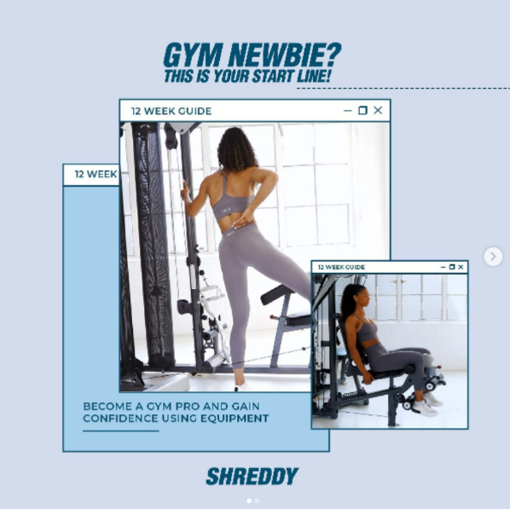

Figure 1 advertisement image form Shreddy Instagram.

For example, a customer sees this advert and is interested in the experience that is being sold as it was mentioned by SydiGate, now that the customer has been drawn in to this and attention has been caught, that another name becomes familiar. This type of advertisement also could attract the customer to think now that they have the app, they also want the clothing that they will see on images like this one.
By having the clothes on the model as part of the advertisement this could come across as part of the experience. Meaning for the customer to have the full experience they need to purchase the clothes seen in the advertisement and app to have the full and best experience.
As most of both companies’ advertisements are done on social media one risk that comes with this is that the brand pages or the advertisement posts do not reach the correct people.
As mentioned, before they have a very clear and specific target audience in mind and that being women. This means that they need to connect with their audience. As Piercy writes “The online audience on social networking sites like Facebook is getting fed up with the avalanche of ads- they are spending less time on these sites, seeking out ad-free environments like blogging and paying little attention to the ads, because they went there to meet their buddies not to buy stuff. (Piercy,2017) People don’t want to go online and be flooded with companies trying to sell a variety of products to them, so the way things are presented to the desired customer to not only catch their attention and interest, but to interact whether that is sending it to a friend or sharing it for more to see.
As we saw in figure 1 what was being advertised was the fitness app in this post specificity for beginners. But, the way this was being presented looked more like they wanted to offer help and advice to those who wanted it. For TALA on the other hand the clothes being in this images and their name in the imagine being visible was enough. It is a form of advertisement without being direct or something that the customers online do not want to see.

3. The key determinants in the process of committing to develop the innovation.

One thing that worked in the advantage for Shreddy and TALA was the lockdowns that happened because of Covid-19. Not only were the gyms closed but more and more people were online and actively using social media and a lot more frequented as well.
On the government website under Coronavirus information and reports it mentions regarding the furlough scheme “Since the star of the scheme a cumulative total of 11.6 million jobs have been supported by the CJRS at various times.” (GOV, July 2021)
it also further on in the June report includes “at May 31 2021, provisional figures show that 30% of employers had staff on furlough, down for 35% at April 30 2021. (GOV, July2021)
This meant now more than even being online was important to grow the brand and increase advertisements as many people where at home with more time on their hands and an increase of people could be on their phones and using any form of social media.
With so many people now either working from home or on a part of the furlough scheme, people had a lot more time on their hands and in some cases more money to spend on themselves as everyone was unable to go anywhere.
If we look figure 2 below form a graph from the government website showing in millions and by gender how many where on furlough between July 2020 and May 2021 during the pandemic.
As seen on the graph up until May 2021 there was a higher number of women on furlough compared to men.
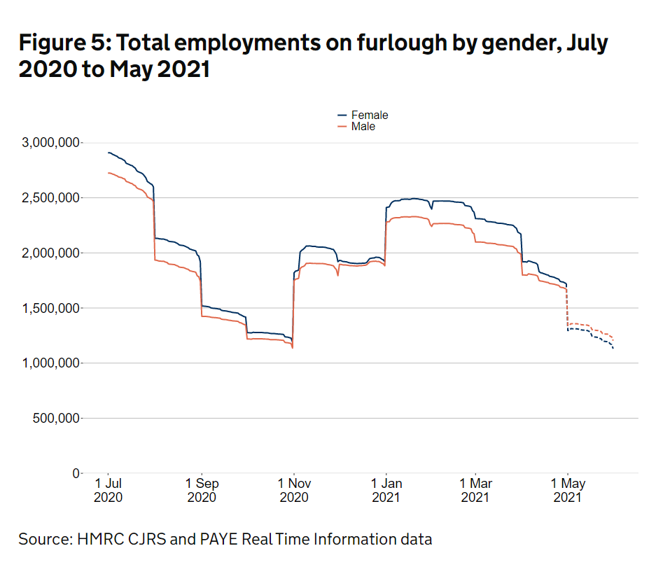
This would have been to the advantage to both Shreddy and TALA as their products and target customers are women.

Figure 2: Total employment on furlough by gender, July 2020 to May 2021.

Because of this, being active on social media platform when more women are anticipated to be online and using their phones and social media is a key part to gain more attraction to something that fits in the market especially in the current time. With more women being at home this was the gap in the market that was needed for both of the companies to excel.
In the Market-led strategic change book it mentions about value innovation. When explaining about Migrators it reads “these offer conventional value improvements over competitors e.g in products function improvements or design.” (Piercy,2017) this is what they have done. What shreddy has created is not something that has not been done before. Fitness apps already exists, this is nothing new to the market or the fitness world.
The way they have become successful is using what is already out there but have narrowed down their target and found a way to reach and connect with the correct people and also in the correct way.
4. The processes and technologies which the company used to carry this development forward.
As we already know from earlier in this report social media is one of the companies key focuses to sell and attract customers. Without technology both of these companies would not have grown on such a scale in a short amount of time as they have. For example, TALA has no physical stores, all of the sales are made online through their website.
TALA have collaborated with ASOS the online clothing website to sell their fitness clothing line with some pieces that are exclusive to ASOS, but similar to TALA, ASOS also are a company that are exclusively online and do not have any physical stores.
For shreddy the app needed to be created that would be able to share videos to customers that needed to be updated on a regular basis. On their website the way the app works seems to have taken inspiration from existing apps and taking the social side and including this into their app.
If we look at rule number 8 in Satells 9 rules of innovation that is “Rule 8: In a digital world, we need to use platform’s to access ecosystem’s.”( Satell, 2016) Not only can they use their Social media to promote and sell their products but they can also use it to their advantage as some basic research. What post gets more interaction, likes, comments, shares when they upload something new. Each item they upload something new to one of their social media accounts they can track and analyses how well that post performs in numbers. This can provide data for what post seems to work best to gain customer attraction with the way it looks and how the have presented the product, but also to get to know customers habits.
As Paul Trott talks about consumption patterns “Consumption patterns refers to the degree of change required in the thinking and behaviour of the consumer in using the product” (Trott, 2017) social media is a powerful platform that now have many people that use these sights on a regular basis. If presented in the correct way it can convince people that they need something that they don’t have, or alternatively they see someone they know or follow as they are popular with a product and they want to be like that individual.
the CEO of both companies already had a following on social media before she set up TALA and shreddy. This meant that she already had an audience following her. On the accountancy cloud blog about Grace it writes “Grace Beverley began her career as a fitness influencer- but not of the typical variety. Her succeeding is largely owning her personality, dedication to her causes and of course, a mega-dose of hard work.” (accountancy cloud,2021)
Before she had began both Shreddy and TALA as she was an online fitness influencer she already had some background knowledge and experience in the industry and how to use social media to her advantage.

5.The extent to which the development relied on resources external to the company and the ways in which the development of these resources was managed
Social media has been mentioned in this report as something that they rely on heavily, but to be more specific the main social media they seem to focus on using to reach and interact with their customers is Instagram.
On Instagram’s website they described the app as “People can upload photos or videos to our service and share them with their followers or with a selected group of friends. They can also view, comment and like posts shared by their friends on Instagram.” (What is Instagram? |Instagram help centre, 2022) From this description of what they are we can see that this app is one that is intended to be interactive.
This is why it is beneficial to companies like Shreddy and TALA as not only does it mean that they can interact with the people who follow them on their pages but, it also means that their page and posts can be shared further to some that might not know about the company or any of their pages existing.
Another benefit for these companies like many others is that there is no charge for using these platforms. Although companies would be charged if they wanted to post an advert, there is no charge to posting an image or video. This means that the brand can and are advertising by posting images and videos without it being label as a advert it is simple showing the customer who they are and what they sell.
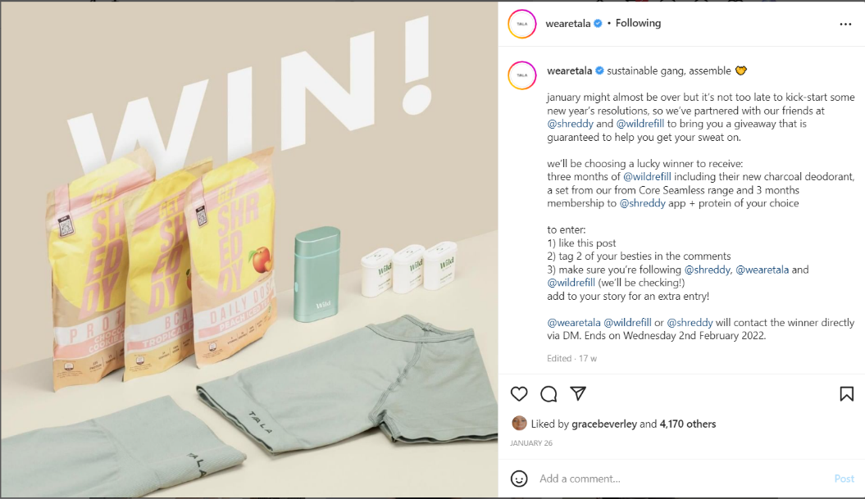
“As social media is being increasingly used by corporation to get their message across to consumers, studies into the effects of various communication tactics in these media on consumers ought to be of critical importance to both those who design and those who run these tools within organizations.” (Marden, 2018) Understanding how to use social media to receive the best feedback and to reach the maximum amount of people is so important, especially considering how these platform’s are for these companies this is mainly how people will come to find out about them.

Figure 3: Image taken form TALA Instagram page advertising a competition.
If we look at figure 3 here is an image posted taken from TALA’s Instagram page. We can link this with Satell 9 rules of innovation “Rule 9 : Collaboration is the new competitive advantage” (Satell.2016) What we see here is three companies collaborating together to create a competition to win the products shown in the image. Even though they are giving away these products for free to an individual this is a way of expanding their audience.
Collaboration with another company means they could reach and audience and gain and interest of new customers who had not heard of come across of these companies before. As we see on the right-hand side where it explains how to entre the competition is another benefit these three companies gain as the contestant have to interact with these pages involved by liking the images follow the accounts and share the post with friends. What the companies are doing here is using the customers and people who follow them to do some promoting for them, as sharing and interacting with the post is what they have to do in order to entre more people are likely to see the post and go look at the companies that are involved and who they are.
6. How management overview of the development was maintained.
Social media growth is something that a lot of companies are not focusing on as this is the way to keep up with the world when it comes to growing a brand and gaining attention. But this will only take a company so far there is still more that is needed to develop the company further. “ The £4.2 million investment will be used by TALA to develop inventory, hiring new staff and pursing international growth” (Smith. 2022) From starting at social media they are now growing and have plans to go further and with the funding that they not have received they are able to take things further and grow the brand bigger and offer more, as smith says if they are developing inventory they can push even more on social media has they will have more to show.
As the lockdowns eased the way people buy products has permanently changed, that meaning online shopping is now the new normal and popular. Since both companies were already based online this meant it was nothing new to them to have to suddenly adapt to when lockdowns came in place. They were papered to used everything based online, they as two companies where doing what now most companies are trying to adapt to do, grow their online following and customers.

Conclusion
This process of using the resource of social media to grow both of the brands together and not against each other works well as TALA and Shreddy are both successful companies that do not need any physical location to gain peoples attraction to by the products.
By exclusively being an online brand, money that would be spend on a shop and staff can be invested elsewhere to, and as the way the world has change since the recent pandemic, these companies have reacted in the best way to how the world has changed in recent years and have a clear understanding how to not only adapt to the new way of selling and marketing.
The outcome of this way of promoting and advertising a business is setting up a modern way of how consumers see brand, I believe that using social media can come across to the customers as a more personal way, as they get to know the brand more as it is not a single advert like we would see on TV, but regular updates that for some happens on a daily basis. This can make the costumer feel like a part of the brand and they know more and more about them. The result of this is that customers gain trust in the brand as they can see on a regular basis what they are doing and what is being offered.
As the pandemic hit and all shops closed this hit many companies hard. But as both companies mentioned in this report were ones that were based online it means that the pandemic and lockdowns did not affect them in the same way. For them it was an advantage that helped them as people had no option but to by fitness clothing online. They could not go to the gym so a fitness app that was new was an alternative that was needed at the time to take place the gym.
Even though is not a direct collaboration, these brands are collaborating with the social media app Instagram. As more people get the know about the brand and how to find them it attracts people to follow them. This could gain the interest and attention of people who either do not have the Instagram app to download it to follow companies they enjoy to keep up with what they are doing, this benefits the app as it means that they have more and more people using their service. So going back to satell’s collaboration rule, this even though it not a direct one is still a collaboration to grow both brands.

Reference list
TALA.2022. ABOUT US. Available at : https://www.wearetala.com/pages/about-us (accessed 16 May 2022)
SHREDDY. 2022.SHREDDY. – The number 1 female fitness transformation app Available at : https://shreddy.com/ (accessed at 16 May 2022)
SYDIGATE. 2016. Marketing your matters business online: Top business marketing strategies you need to know! Page 1 Available at : https://www.proquest.com/docview/1849318498/citation/AB334F7709B7492DPQ/1?accountid=130472&parentSessionId=yY6g7RAwOI0ewMVbeTLQKQCOQg33sYJoilu0lpGJteY%3D (accessed at 22 May 2022)
Satell (2016): G. Satell “ The 9 rules of Innovation” DigitalTonto 6th March 2016 (Online) Available at: https://digitaltonto.com/2016/the-9-rules-of-innovation/ Accessed 24 May 2022)
Smith,S, 2022, Sustainable activewear brand TALA raises £4.2 million to develp business inventory (Blog) The industry fashion, Available at https://www.theindustry.fashion/sustainable-activewear-brand-tala-raises-4-2-million-to-develop-business-inventory/ (Accessed 26 May 2022)
GOVE.UK.2022 Coronavirus Job Retention Scheme statistics: 1 July 2021. [online] Available at : https://www.gov.uk/government/statistics/coronavirus-job-retention-scheme-statistics-1-july-2021/coronavirus-job-retention-scheme-statistics-1-july-2021 (Accessed 25 May 2022).
Piercy, N, 2017. Market-led strategic change. 5th ed. London: Routledge Taylor & Francis Group, p.205.

