  LOCATION Swansea | LLEOLIAD abertawe
LEVEL 5 | LEFEL 5
EXAMINATION PERIOD | CYFNOD ARHOLIADAU
May 2021 | Mai 2021

MODULE CODE: ACDA5002
Electronics 1
TIME: 2 Hours
answer all questions

Equipment or materials required – None

ANSWER ALL QUESTIONS

QUESTION ONE (30 marks total)

- Provide a basic circuit schematic of a ‘Buck Converter’ and hence explain its general theory of operation. (7 marks)
- Provide a basic circuit schematic of a ‘Boost Converter’ and hence explain its general theory of operation. (7 marks)
- You have a design that obtains power from a single +5v USB input, however your circuit also requires low power op-amps that require a negative rail (approximately -5V) and also a higher supply rail of approximately +10V. Sketch a circuit using ICL7660 devices that will allow you to power your op-amps and explain how these integrated circuits achieve the desired voltage conversion. (16 marks)

QUESTION TWO (35 marks total)

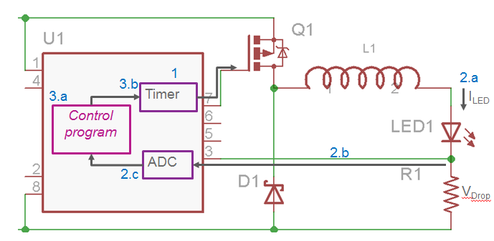

The diagram above depicts an embedded microcontroller (U1) that is being used to control a high power LED in a flashlight.
- Provide a detailed description of the function and purpose of each component, as well as a comprehensive explanation of the overall system operation. (15 marks)
- What advantages does using an embedded system as shown give over a dumb/passive implementation where an LED is simply driven via a current limiting resistor? (4 marks)
- Pins 5 and 6 of the Micro are currently unused and can be configured as either digital or analogue inputs. If this circuit was implemented into a ‘smart rear bicycle light’, suggest four additional features that could be incorporated to the flashlight system if additional hardware was connected to these additional inputs. Sketch your proposed circuit implementation and briefly describe how the features would be implemented. (16 marks)

QUESTION THREE (35 marks total)

- When designing embedded electronic systems, you often have five general categories of solution to choose from:
Use an Embedded PC
Design around a Microcontroller
Design a custom ASIC
Use generic programmable devices such as FPGA or PLD
Design using discrete logic

For each of the five options, provide:
One significant advantage of that method
One significant disadvantage
One real life scenario where that option might be the best choice
Justify your answers.
(20 marks)

- Provide an overview of the PC104 system. Explain why you might want to use a system such as this as an embedded controller.
In mission critical environments, what type of operating system would you choose for the above – explain your reasoning.
(15 marks)

