
Module Assignment Submission
Student Name: | Monica Iftode
Student Number: | 2008839
Module Code: | BMSK5003
Module Title: | Understanding and Engaging in the Customer Experience

Statement of Confirmation of Authenticity
By the act of making this submission, the student declares that this is the work of the student named above. The work has not, in whole or in part, been knowingly presented elsewhere for assessment, or where assessment has been built on a previous assessment, this has been identified. Where materials have been used from other sources it has been properly acknowledged. If this statement is untrue, the student acknowledges that an assessment offence has been committed.
Attention is drawn to the plagiarism and unfair practice policies of the University.

Table of Contents

Understanding and Engaging in the Customer Experience 0
Abstract 2
Introduction 2
Customer satisfaction 5
Customer Relationship Management 6
Customer Relationship Management conclusion 10
Characterization and analysis of the Hoogah restaurant 11
Customer relationship analysis at HOOGAH 13
Data Analysis and Results 13
Exploratory Factor Analysis 14
The restaurant can be improved based on experience-based suggestions 20
Conclusions based on qualitative and quantitative research. 21
References 22
Appendix 1 Restaurant survey questions 24

Abstract

The purpose of this study is to identify both positive and negative aspects of the relationship the population has with the restaurant in question (opinions regarding staff, products, and services). A series of proposals will be formulated based on results obtained to improve the relationship between the organization and its customers. These proposals will be a part of a comprehensive managerial program to be implemented during the course of the program. An analysis of how CRM (Customer Relationship Management) is implemented at my former restaurant, with a focus on how it is applied to the company as a whole.

Introduction

Business customers are those who purchase products or services through the mediation of financial transactions. According to Nguyen & LeBlanc (1998), a company's image improves when customers feel valued, and the company offers better customer service. The term "customer" refers to a buyer or consumer. They can be categorized as active or inactive, frequent, or sporadic, large, or small in volume, satisfied or dissatisfied, and based on their potential.
Customer relationships represent the real "capital" of performing companies, which determines their future market value through the accumulation of knowledge and experience. Companies exist to serve their clients, earning the loyalty of their customers, which generates high profitability by providing impeccable service, (Kopp, 2022). Organizations will operate according to the principles of customer orientation (Riserbato ,2021).

This figure illustrates the fundamental principles of a profitable, customer-focused business:
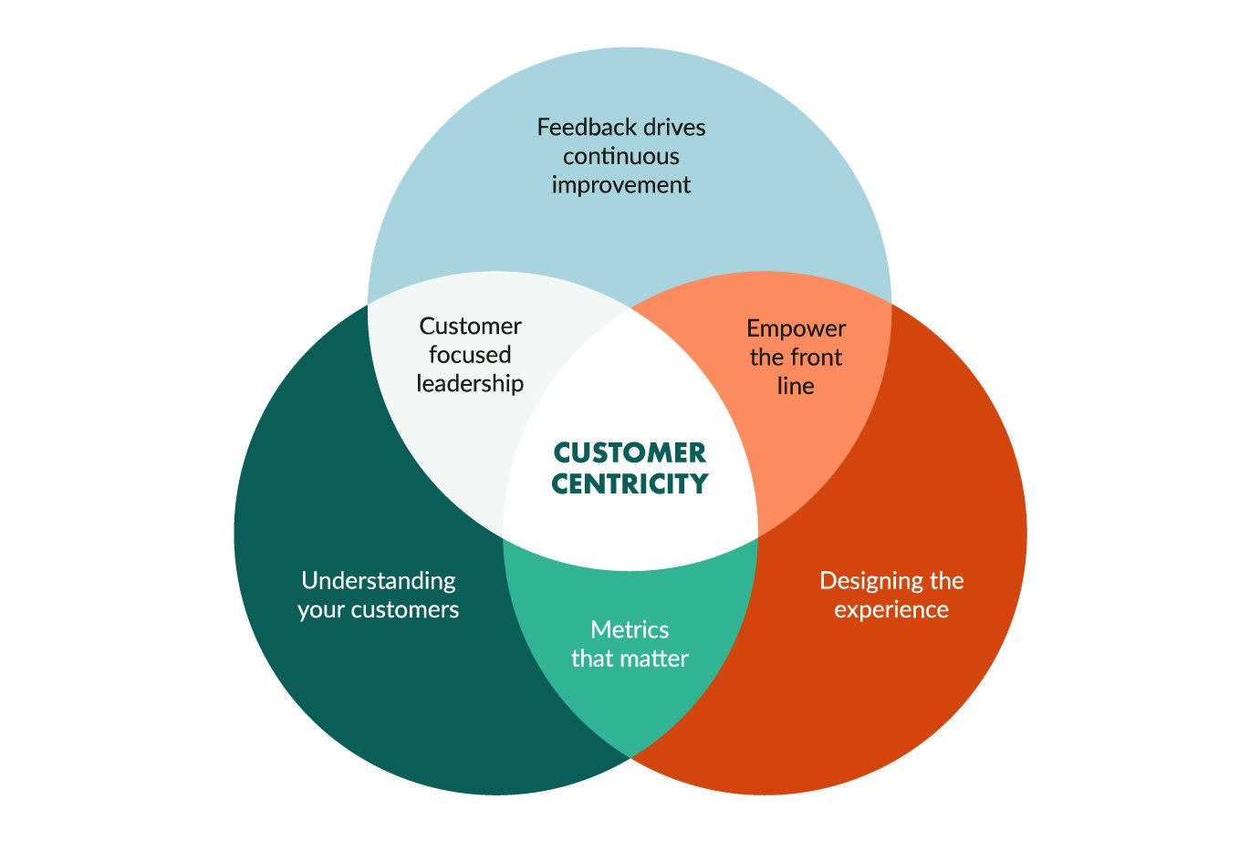
Steven MacDonald (2022)
Organizations that are successful place a high priority on improving relationships with their supply chain partners and especially on establishing closer, lasting relationships with their customers. Managing the relationship between firms, distributors, and consumers has undergone significant changes over the past 30 years. In order to increase customer loyalty levels, companies need to pay more attention to determining customer loyalty coefficients (Dick & Basu, 1994) It is critical for companies to consider several activities when adopting a customer-oriented strategy (Hartline, et al. ,2000). Define and measure the rate at which new customers are attracted and current customers are retained. An excellent way of identifying the causes behind the loss of customers and finding ways to combat them is to create a graph showing the share of customers lost for each cause (Tonthat, 2021).
Calculate the unrealized profit resulting from the loss of customers. When a customer purchases products or services regularly from a firm, it represents the value of his loyalty (Flint, et al., 2011). In a certain number of years, this is the profit that the customer would have brought. Assess the costs associated with a reduction of the loyalty coefficient, and devise programs to prevent customers from migrating to the competition. According to Weinstein (2020), organizations should master the 5-S formula - speed, service, selection, sociability, and solutions - if they want to provide more value to customers. A company's customer satisfaction is determined by the quality of its offers and very stable service, but as time passes, customer expectations are sensitive to changes in service (Bolton, & Drew, 1991). According to Morgan (2016), individual preferences and a company's ability to innovate contribute to the evolution of customer requirements over time.
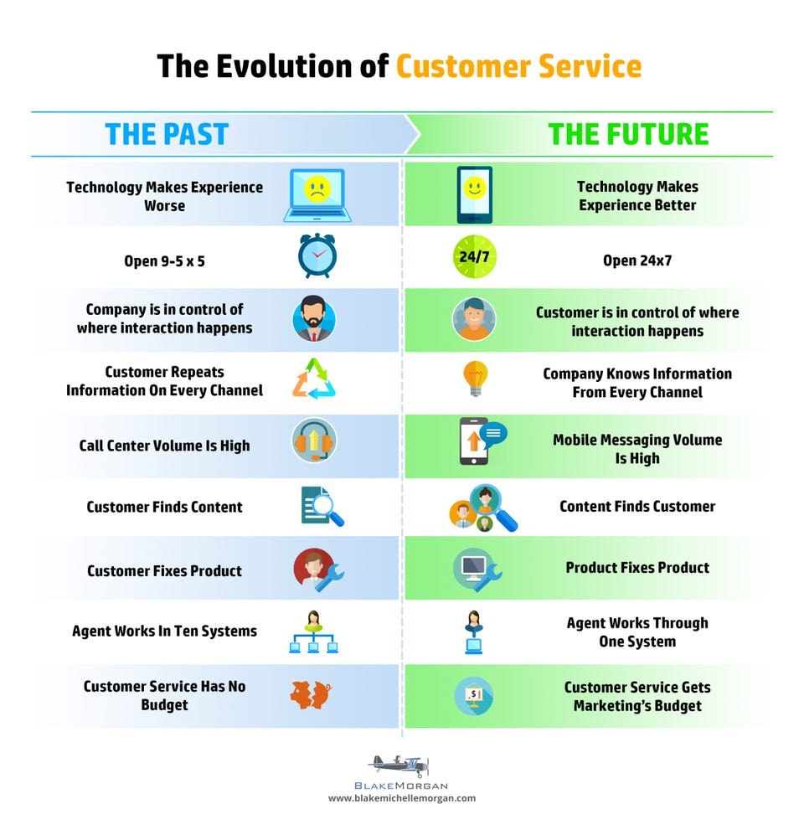
Blake Morgan (2016)
Globalization and the development of information and communication technologies have given customers the opportunity to choose the offer they consider most advantageous. This has led to an increase in expectations and demands.
Buyer satisfaction is the result of a successful relationship with a company that exceeds expectations. It is satisfying for buyers when they are able to fulfil their expectations and delightful when those expectations are exceeded. Those who are satisfied stay loyal longer, buy more, are less influenced by prices, and recommend the company to others.

Customer satisfaction

A repeat customer is someone who repeats the act of purchasing.
After the purchase, customers will spread the post-purchase feeling of satisfaction to others (friends, relatives, colleagues), which will project a positive image of the company.
As a result, he feels more confident about the choice he made.
Ensure that competitive publications are less important.

The following consequences result from the satisfaction of a consumer for the vendor:
Winning and converting it into a client.
The increase in sales volume (and implicitly, profit) occurs because the satisfied consumer takes the initiative to promote the product.
Establishing a positive market image and reputation.

Customer Relationship Management

Chen and Popovich (2003) define CRM (Customer Relationship Management) as the practice of developing and maintaining personal relationships with customers in order to increase profits. In contrast, Payne and Frow (2005) say maintaining a long-term and strong relationship is no longer the ultimate goal of CRM (Customer Relationship Management). This concept is well established in specialized literature and business practice. By implementing a CRM strategy, organizations are able to quickly adapt their behaviour to changes in the market in order to better satisfy the demands of their customers. The goal of customer relationship management is to identify and analyse customer needs and behaviour in order to develop the strongest relationships possible.
Even though technology is a significant component of CRM, focusing only on technology may not result in a successful implementation. People, processes, and technology integration are necessary for successful CRM deployment. Many companies are having trouble implementing CRM due to misunderstanding what CRM is and how it works. (Chen & Popovich ,2003).
Customer relationships are structured on five different levels:
Traders in the first level sell products without contacting customers.
The second lever is encouraging customers to contact the trader if they have any doubts or complaints.
As a third step, the trader calls the customer shortly after the sale to see if the product meets the customer's expectations. Furthermore, he asks the customer about any dissatisfaction with the product and suggestions for improvement. As a result of the information, the company will be able to improve its products and services.
The fourth level is offensive: the trader regularly calls the customer to offer him suggestions about new ways to use the product or information about new products.
In the fifth level, the company works continuously with the client to improve efficiency or save money.
In order to turn them into customers, companies use marketing campaigns. Essentially, a casual customer is one who easily migrates to a competitor's offering. Customers who are constant customers are those who maintain business relationships with organizations on a regular basis, being satisfied with the quality of the products or services they purchase. “Long-term customers buy more, take less of a company’s time, are less sensitive to price and bring in new customers. Best of all, they have no acquisition or start-up cost” (Reichheld, 1996). Organizations can turn customers into supporters by implementing customer relationship management strategies. A satisfied customer is more likely to remain loyal to the service provider (Bolton et al., 2000). Customer loyalty is evident when customers are devoted to the brand, becoming its promoters as a result. The groups of people who recommend these brands are those who are loyal to these brands. On the other hand, a growth market may compensate for the lost customers, according to Hartley (1986), in the short run.
In response to the ongoing development of customer relationships, customer relationship management can be described as an iterative process that involves four stages according to Xu et al. (2002):
First stage: Collecting and processing information about past customer behaviours and revenues.
The second phase involves updating the profile of customer needs and requirements on a continuous basis.
Third stage: Analysing the efficiency of the CRM (Customer Relationship Management) strategy by tracking customer feedback.
The fourth stage is to constantly adapt and improve customer service.
There are a number of CRM (Customer Relationship Management) objectives companies pursue: understanding the needs of customers and anticipating their needs, decreasing the migration rate by increasing their level of satisfaction, motivating customers to become loyal by providing them with offers that provide them and even exceed their expectations, bringing in new customers through online communication, and using information technology to automate sales forces and improve service. In CRM, the activities of contact with the customer are automated at the operational level. There are many CRM solutions available from software solution providers that automate marketing, sales, and customer service.
Activities associated with the automation of the marketing function include:
- in the case of customer segmentation, the data is transformed into relevant information, which is then used to substantiate strategies related to the customer. Segmenting the client portfolio is possible through the systematization of data and identification of customer profiles.
- management of communication campaigns. The software solutions manage the coordination of the activities carried out by the different specialists involved in the design and implementation of communication campaigns. The CRM solution automates the process of monitoring and evaluating campaign performance.
- responding to customer inquiries
Services provided by CRM software solutions include coordination of communication flows between the different channels utilized by the organization. This enables automation of the following activities:
- Interactive voice response (IVR) operations conducted by telephone marketing companies and contact centres.
- Services provided over the Internet. A supplier's website may present technical books and troubleshooting instructions without the need for a technician's assistance, for example, for technical equipment.
- collaborating partners' activities. This manages information about prospects, orders, stock availability, and product specifications
CRM's analytical level includes the following main aspects:
- Customer identification. Customer relations management involves the collection and storage of identification data about clients from the organization. Each department of the supplying organization has access to the identification data stored in a central database. It is essential to keep these data up to date.
- Establishing customer profiles. Data and information about each customer's behaviours as a buyer, user, person, or organization can be used to adapt the strategy. Several variables related to the following main aspects are used to establish client profiles in an organization's portfolio:
a. Customer value: the annual value of the customer's purchases, the customer share, and the net present value of the profit generated during the estimated period of the relationship.
b. Buying behaviours: type of products purchased by the customer, quantities ordered, frequency of orders, payment behaviours
c. Communication between the supplier and the customer: communication channels and types preferred by the customer (phone, Internet, etc.), types of messages that the customer responded positively to, and how the customer uses the channels to communicate.
d. Customer satisfaction is defined by how satisfied the customer is with the company's products, services, employees, and the way in which the company interacts with them.
e. Individual clients may also provide information about their lifestyle: their interests, activities, and opinions.

Customer Relationship Management conclusion

The goal of Customer Relationship Management is to build a long-term relationship with customers that is profitable and sustainable. Centralized databases provide customer information and ensure the coordination of marketing, sales, and service departments. Customer relationship management (CRM) orchestrates processes related to the relationship with customers. By capturing and using customer and partner information, the company can improve relationships with them and keep its knowledge current. Communication and promotion play an imperative role in informing, persuading, and reminding the public about a company's goods, services, image, and community involvement. In the process of achieving goals, promotion often plays a crucial role. Regardless of whether the products are of high quality, their ability to sell themselves is unlikely if potential consumers do not know them. A promotional campaign is designed to capture the attention of potential customers and increase sales. Points of sale are used to inform, persuade, train, and maintain customers who are attracted to the product.
In order to increase sales, Bell (1972) outlined seven basic objectives of promotional strategies. Segmenting the market and maintaining or improving it. Making a brand more recognizable, acceptable, or maintainable. Facilitating the sale of products and services. Market education and information. Creating competitive advantage. Enhancing the efficiency of promotional activities.
It is crucial to understand how advertising works, and what its purpose is. Advertising has the purpose of informing the market of the existence of a new product, suggesting new uses, communicating the price change, describing the available services, correcting false impressions, reducing buyers' fears, and creating the company's image. Consumers are persuaded to buy a product by attracting their preferences towards it, encouraging their orientation, changing the way they perceive its attributes, and persuading them to buy it. Recalling a future need, remembering the place of purchase, keeping the product in mind, keeping the buyer informed about the product are some of the goals of recalling.

Characterization and analysis of the Hoogah restaurant

hello@hoogah-swansea.com
01792 449731
68 Bryn Y Mor Road
Swansea
SA2 4JJ
hygge [HOO-gah]
The company promotes a healthy lifestyle by offering organic products as well as events like live music, fundraisers, and community workshops. There are several stages and objectives in terms of relationships with customers. As part of a product awareness campaign, the product will be advertised to attract new customers. This will achieve recognition on their list of alternatives, stimulate interest in the product, and encourage testing. Responding to the needs and desires of the customer, exceeding their expectations, and meeting or exceeding product specifications to encourage repeat purchases. The goal of creating a community is to become a part of the company's life and to make sure the customer is reluctant to end the relationship. This is achieved by building social connections that prevent the customer from switching products and suppliers. It is also achieved by generating group activities that allow the client to interact with one another. This company has developed a strong organizational structure since entering the market by following the same principles and model. An organization's strategic pyramid is held by the main shareholder, who also serves as its administrator. This ensures everything is aligned and forms a unitary whole so all members can successfully carry out their duties.
Staff members in the service area include bartenders, waiters, and cooks. In addition to their moral and intellectual qualities, they must also possess psychological and physical traits. As a result of paying close attention to consumer demands, the company remains aware of the market demand and knows what offers to offer. The company strives to broaden its status on the market while maintaining its position on the market. The vast majority of customers are Swansea residents. In order to improve the quality of its products and services, management has concluded that finding out what customers want is the key to its success. The supply system is largely influenced by customers, and their purchasing decisions can greatly influence the system. The main objective is to gain and keep customers since the assets of the firm have no value without clients. A positive aspect of HOOGAH is the lack of complaints from customers during the activity, as the quality level of the services is adequate. In addition, it is helpful to appreciate the client's recommendation of the restaurant to others. When a good outcome is achieved, it means that society reaches a high level of consumer satisfaction.
There are numerous advantages to collaborating with local suppliers. Reduces prices compared to more distant suppliers by offering smaller quantities. The company keeps a stock of the products it needs and delivers them only when needed, thus reducing its storage costs. Because of its geographical proximity, it can facilitate closer collaboration between suppliers and society. Due to the fact that transport is only a minor factor in delivery times, delivery times are much safer. Several companies in the same area submit orders on the same transport, which reduces transportation costs. Product delivery time is reduced between the launch of orders and the delivery of products.
HOOGAH is a company that operates bars and restaurants. Consolidation of its position in comparison with its major competitors through increased sales and market share. Market research is conducted by the company to determine how well customers are satisfied and how to establish a lasting relationship with them. This is in order to offer services to young people and people of the second generation. Increasing customer relationships is the goal of this project. Finding out customer needs, ensuring customer satisfaction, and building a solid relationship with customers.

Customer relationship analysis at HOOGAH

Objectives:
Customer perception of the brand.
Images will be categorized according to their nature (favourable or unfavourable).
The attitude of the customer toward the offered products and services.
Assessing the degree of customer satisfaction in terms of price, quality, and variety of products and services.
Identifying the importance of price in the purchase decision.
Identifying the level of awareness of promotional campaigns among customers.
Competitor knowledge assessment.
Complaint management.

Data Analysis and Results

Participants were informed of the methodology of the research before the data was obtained. Therefore, it should be noted that the data collection process took place after the participants had been informed about it. This study was designed to ensure the successful conduct of the study, and from the onset, was specified in which fields we desired qualitative information to be collected, as well as how it would be utilized; consent was required from participants since the information would only be used as part of the present study.

Exploratory Factor Analysis

In this study, a qualitative research method called a survey was used. A questionnaire was used to collect the sample for this study as the primary research tool. One hundred people participated in the survey. A total of 54% of the participants were females, while 46% were males. Therefore, there is no significant difference between the number of females and males who responded.

According to the research, 51% of respondents are between the ages of 18-25 years, representing the majority of respondents. Among the respondents, 19% are between the ages of 26 and 33, and 13% are between the ages of 34 and 41. Only 7% of respondents are over 50 years old, and 10% of respondents are between 42-49 years old. As a result of the pleasant environment offered by the restaurant, the majority of respondents are between 18 and 25 years old.
Despite there being no significant differences between female and male customers, the most frequent respondents are in the 18-25 age range, because young people prefer to socialize and spend time with friends.

There are 40% of clients who have no solid image of the brand, 60% who have a very positive impression of the brand, 25% who have a very unsaid impression, and 15% who fall somewhere in the middle. The majority of restaurant customers are satisfied with its products and services. Customers were saturated with the variety of products and services, but they were less saturated with the price.

According to the research, 74% of restaurant customers heard about it from friends. In contrast, 19% found out from city residents, and 7% from family members. As a result, friends are a very effective advertising method, gaining momentum among customers and having a positive impact on the company as a whole.

The restaurant ambiance is one of the reasons why 50% of customers choose to be customers. Additionally, customers choose to be customers because of the seriousness, the price, and the quality of products. The price of the goods and services offered by the restaurant is satisfactory to more than half of the customers. The majority of respondents indicated that they are satisfied with the price of the services and products offered by the bar. In addition, 34% said that they are more than satisfied. Only 11% of respondents indicated that they are neutral about the price of the bar's products and services. The remaining 2% said that they are very dissatisfied with the price of the bar.

60% of customers are satisfied with the variety of services and products offered by the company, 27% are very satisfied, and only 9% are very unsatisfied with the variety. The remaining 4% are unsatisfied with the variety of services and products offered by the company.

According to the survey, 84% of respondents think the company practices access pricing, which is extremely significant to the consumer. In contrast, 12% said that the company charges low prices, and 4% said that the company charges very high prices.

According to the respondents, 56% would choose the competitor's services if they couldn't find the products they were looking for, 16% would choose the competitor's services if the price was lower, 25% would choose the competitor's services if they were disappointed with the quality of services, and 3% would choose the competitor's services for other reasons. In over 75% of cases, customers were satisfied with the way complaints were handled.

What makes the competition's services more appealing to you?
Gender | Because of the prices | Unable to find the products you were looking for. | The service is below expectations | Other reasons | Total
Females | 12 | 28 | 14 | 0 | 54
Males | 4 | 28 | 11 | 3 | 46
Total | 16 | 56 | 25 | 3 | 100

According to a total of one hundred respondents, twelve people thought the price charged by the company was low, including eight women and four men, eighty-four people believed the price was affordable, including both women and men, and the remaining four respondents, all women, believed the price was very high.
What is your opinion of the company's prices?
Gender | Low | Accessible | High | Total
Females | 8 | 42 | 4 | 54
Males | 4 | 42 | 0 | 46

The restaurant can be improved based on experience-based suggestions

Providing a variety of leisure options and additional services.
A larger operating space for the company would be beneficial.
A program extension is being considered.
The ability to negotiate discounts with agents so that the price can be lowered.
A better promotion of promotional campaigns would be beneficial.
As part of its growth strategy, the restaurant now accepts online orders.
The vast majority of customers have positive experiences and are satisfied with the services it provides.

Conclusions based on qualitative and quantitative research.

HOOGAH is a company that places a high level of emphasis on the needs of its customers. One of the biggest advantages is that the management knows the customers well and has a close relationship with them. The promotional campaigns offered and changes to the ambiance have enhanced customer attraction, and it has also been observed that customers pay attention to prices. The company constantly strives to maintain its position in the market and expand its status in the market. Monitoring prices closely, as opposed to competitors, helps maintain a high level of customer satisfaction. The restaurant's main marketing strategy is to promote the brand through the mouths of its customers as well as bring in more people over 30. In order to increase customer satisfaction, new products need to be added, and the price/quality ratio needs to be monitored. In addition, live bands and happy hours will be introduced on quiet days. Because customers enjoy the prices as they are, they should stay the same.

References

Bell, M. L. (1979). Marketing, Concepts and Strategy. Houghton Mifflin.

Bolton, R. N., & Drew, J. H. (1991). A Longitudinal Analysis of the Impact of Service Changes on Customer Attitudes. Journal of Marketing., 55(1), 1–9. Retrieved July 17, 2022, https://doi.org/10.1177/002224299105500101

Bolton, R. N., Kannan, P. K., & Bramlett, M. D. (2000). Implications of Loyalty Program Membership and Service Experiences for Customer Retention and Value. Journal of the Academy of Marketing Science., 28(1), 95–108. Retrieved July 19, 2022, from, https://doi.org/10.1177/0092070300281009

Chen, I. J., & Popovich, K. (2003). Understanding customer relationship management (CRM). Business Process Management Journal., 9(5), 672–688. Retrieved July 18, 2022, from, https://doi.org/10.1108/14637150310496758

Dick, A. S., & Basu, K. (1994). Customer Loyalty: Toward an Integrated Conceptual Framework. Journal of the Academy of Marketing Science., 22(2), 99–113. Retrieved July 28, 2022, from https://doi.org/10.1177/0092070394222001

Flint, D. J., Blocker, C. P., & Boutin, P. J. (2011). Customer value anticipation, customer satisfaction and loyalty: An empirical examination. Industrial Marketing Management the International Journal for Industrial and High-Tech Firms, 40(2), 219–230. Retrieved July 17, 2022, https://doi.org/10.1016/j.indmarman.2010.06.034

Hartley, R. F. (1983). Marketing fundamentals. HarperCollins Publishers.

Hartline, M. D., Maxham, J. G., & McKee, D. O. (2000). Corridors of Influence in the Dissemination of Customer-Oriented Strategy to Customer Contact Service Employees. Journal of Marketing., 64(2), 35–50. Retrieved July 30, 2022, from, https://doi.org/10.1509/jmkg.64.2.35.18001
Kopp, C. M. (2022, June 8). Brand loyalty. Investopedia. Retrieved July 19, 2022, from, https://www.investopedia.com/terms/b/brand-loyalty.asp

Morgan, B. (2016, April 18). The evolution of customer service. Forbes. Retrieved July 17, 2022, from,https://www.forbes.com/sites/blakemorgan/2016/04/18/the-evolution-of-customer-service/

Nguyen, N., & LeBlanc, G. (1998). The mediating role of corporate image on customers' retention decisions: An investigation in financial services. The International Journal of Bank Marketing, 16(2), 52-65. Retrieved July 10, 2022, from, https://doi.org/10.1108/02652329810206707

Payne, A., & Frow, P. (2005). A Strategic Framework for Customer Relationship Management. Journal of Marketing., 69(4), 167–176. Retrieved July 28, 2022, from, https://doi.org/10.1509/jmkg.2005.69.4.167

Reichheld. (1996). Learning from customer defections. Harvard Business Review., 74(2).

Riserbato, R. (2021, August 4). Customer orientation: What it is and how to implement it [+examples]. Retrieved July 19, 2022, from, https://blog.hubspot.com/service/customer-orientation

Tonthat, K. (2021, June 28). 4 Visualizations for Your Customer Satisfaction Data. Displayr. Retrieved July 16, 2022, from https://www.displayr.com/visualize-your-customer-satisfaction-data-with-displayr/

Weinstein, A. (2020). Creating Superior Customer Value in the Now Economy. Journal of Creating Value., 6(1), 20–33. Retrieved July 16, 2022, from, https://doi.org/10.1177/2394964319898962

Xu, Y., Yen, D. C., & Lin, B. (2002). Adopting customer relationship management technology. Industrial Management & Data Systems, 102(8), 442–452. Retrieved July 19, 2022, from, https://doi.org/10.1108/02635570210445871

Appendix 1 Restaurant survey questions

What is your opinion of the company's prices?
- High
- Good
- Low

What makes the competition's services more appealing to you?
- Because of the prices
- Unable to find the products you were looking for.
- The service is below expectations
- Other reasons

What do you think the restaurant practices access pricing?
- High
- Good
- Low

How satisfied you are with the variety of services and products offered by the restaurant?
- More than satisfied
- Satisfied
- Neutral
- Unsitisfied

How satisfied you are with price and quality of products?
- More than satisfied
- Satisfied
- Neutral
- Unsitisfied

How did you hear about us?
- Friends
- Family
- City residents

What age are you?
- 18-25
- 26-33
- 34-41
- 42-59
- 50+

