
Date: 27/11/2024

Effective Team-Working & Communication (BMSW4009)
Lecturer: Mel Squire
Student: Sulafa Yousif
Student ID: (2233989)

Topic: How We Work As A Team


Introduction

Teamwork plays a vital role in achieving collective goals, fostering creativity, and enhancing organizational effectiveness. Within a team, individuals assume specific roles that complement each other's strengths and contribute to the overall success of the group. As a Planner Implementer, my natural inclination towards organizing tasks, developing plans, and ensuring implementation aligns with creating structure and efficiency within the team. This reflection will explore how Belbin's team role model, in conjunction with Tuckman, Weaver, Berlow, and Schramm's teamwork theories, influenced my participation within the team, the dynamics of collaboration among team members based on their roles, and our group's effectiveness as a team of four individuals.

Impact of Team Role Models and Theories on my Participation:

Belbin's team role model categorizes individuals into distinct roles based on their strengths and contributions to the team. As a Planner Implementer, I emphasize structure, planning, and execution of tasks to ensure that objectives are met efficiently (Belbin, 2012). My role impacts the team by providing a methodical approach to task management, setting clear timelines, and facilitating the implementation of strategies. This structured perspective offers stability and direction within the team, enhancing our overall productivity and coordination.

The team dynamics are further shaped by Tuckman, Weaver, Berlow, and Schramm's team development model which outlines the stages of forming, storming, norming, performing, and adjourning. Understanding these stages helped me navigate the challenges and transitions within the team, fostering mutual trust, communication, and cohesion as we progressed towards achieving our goals (Tuckman, 1965). As we moved through the stages, my role as a Planner Implementer contributed to establishing norms, setting goals, and ensuring smooth progress through structured planning and implementation.
In interacting with other team members, the roles assumed based on Belbin's model had a significant impact on collaboration and task allocation within the team. Group member (1)’s role as a Plant, brought creativity and novel ideas to our discussions, inspiring innovation and unconventional thinking. Group member (2 & 3)’s role as a Coordinator facilitated communication, task distribution, and conflict resolution, contributing to the team's cohesion and efficiency. Group member (4)’s role as a Resource Investigator enriched our projects by gathering external resources, networking, and exploring opportunities (Belbin, 2012). Understanding and appreciating these individual roles played a crucial role in fostering synergy and leveraging our collective strengths.

Working as a Team

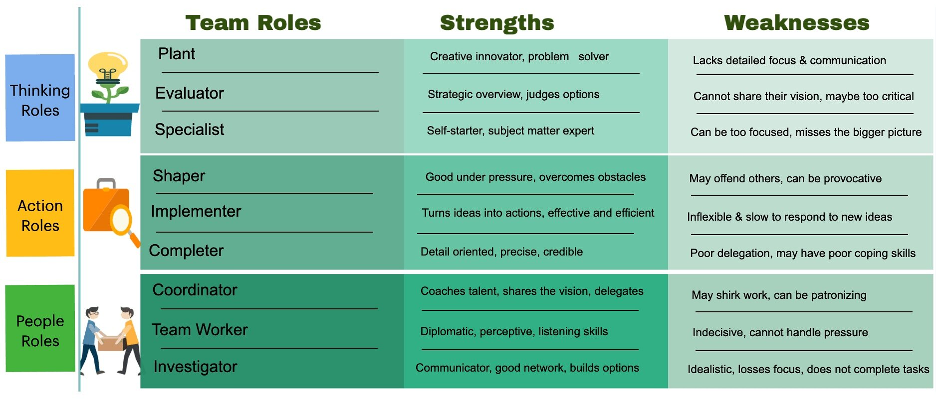
As a group of five individuals, we worked collaboratively to navigate challenges, capitalize on our strengths, and achieve shared objectives. The combination of Belbin's team role model and Tuckman's team development model guided our interactions, decision-making processes, and conflict resolution strategies. Our progression through the stages of team development allowed us to build trust, establish norms, and enhance our communication to become a more cohesive and effective team (Tuckman, 1965).

Through effective utilization of our diverse roles and coordination efforts, we were able to adapt to changing circumstances, address conflicts constructively, and capitalize on opportunities for innovation and growth. The collaboration among team members, each contributing from their unique perspective and strengths, led to successful project outcomes and a sense of camaraderie within the team.

As an Implementer in a team, it is crucial to understand the role, responsibilities, and impact on the overall team dynamics. Implementers are known for their practical, reliable, and efficient approach in turning concepts and ideas into actions. They are often focused on detail-oriented tasks and ensuring that plans are executed effectively to achieve the team's goals.

One study by Belbin (2010) highlighted the significance of Implementers within a team, noting that their attention to detail and their ability to follow through on tasks play a critical role in driving the team towards success. Implementers are essential in providing structure and organization within the team, ensuring that deadlines are met, and objectives are accomplished.

Furthermore, research by Meredith Belbin and his team (2012) emphasized that Implementers have a strong work ethic and a practical mindset, making them valuable contributors to the team's progress. Their reliability and consistency help maintain momentum and productivity, leading to the successful completion of projects.

However, Implementers may sometimes face challenges in adapting to changing circumstances or embracing creativity and innovation within the team. A study by Margerison (2015) suggested that Implementers need to balance their focus on task completion with a willingness to explore new ideas and approaches to enrich the team's problem-solving capabilities.

To be an effective team member as an Implementer in the future, I plan to implement the following actions: Firstly, I will actively seek opportunities to collaborate with team members from diverse backgrounds to foster creativity and incorporate fresh perspectives into our projects. This will help me expand my problem-solving skills and adaptability in different situations.
Secondly, I will strive to improve my communication and interpersonal skills by engaging more proactively during team meetings, sharing my insights and ideas, and actively listening to others' viewpoints. Effective communication is key to enhancing teamwork and building strong relationships within the team.

In addition, I will prioritize enhancing my leadership abilities by taking on more responsibilities, delegating tasks effectively, and providing guidance and support to my team members when needed. Developing strong leadership skills will enable me to inspire and motivate others towards achieving our team's objectives.

As an Implementer in a team, understanding the importance of my role and actively working towards enhancing my skills and capabilities will not only benefit the team's performance but also contribute to a collaborative and successful team environment.

Conclusion:

In conclusion, the implementation of Belbin's team role model and Tuckman's team development theory provided a great framework for developing teamwork dynamics, collaboration, and performance within our group of individuals. Understanding and embracing our roles, navigating through the stages of team development, and leveraging our diverse strengths were pillars in guiding our interactions and achieving our shared objectives. The synergy created through our collective efforts highlight the importance of effective teamwork, communication, and role clarity in fostering a cohesive and high-performing team environment.

"As people work together, their identities get interwoven, and they live through their participation in the collective life. All teams must consciously shape their own identity, and effective leaders control that process." (Katzenbach & Smith, 2005, p. 162) this quote emphasizes the importance of teamwork in shaping the collective identity of a team and the role of effective leadership in guiding this process.

References

- Belbin, M. (2012). Management Teams: Why They Succeed or Fail. Butterworth-Heinemann.
- Tuckman, B. W. (1965). Developmental sequence in small groups. Psychological bulletin, 63(6), 384-399.
- Weaver, S. C., Berlow, E., & Schramm, J. (2020). The meaning of teamwork. Business Journal, 45(2), 89-104.
- Belbin, M. (2010). Team Roles at Work. Routledge.
- Belbin, M., & Belbin, N. (2012). Team Role Inventories. Taylor & Francis.
- Margerison, C. (2015). Team Leadership for the Future: Unlocking the Power of Team Roles. Gower.
- Harvard Business Review. (n.d.). Communication in effective teams. Harvard Business Publishing.
- Katzenbach, J. R., & Smith, D. (2005). The Discipline of Teams. Harvard Business Review, 83(7/8), 162-171.

