Shape up Gyms Database
ACCA5014 – Dr Kemi Ademoye

Isobel Sutcliffe – 1808257
1808257@student.uwstd.ac.uk

Abstract
The intention of this report is to determine the benefits of using secondary indexes when running queries on an SQL database using secondary indexes, do they enhance query performance? Alongside looking at the appropriate use of distributed databases for the business itself.

Content
Section 1 – Performance Tuning 1
Section 1.1 Secondary Index 1 3
Section 1.2 Secondary Index 2 5
Section 1.3 Secondary Index 3 7
Section 1.4 Results of Index Performance Tuning 9
Section 2 – Distributed Databases 10
Section 2.1 – Distributed Databases 10
Section 2.2 – Horizontal Fragmentation 11
Section 2.3 – Vertical Fragmentation 12
Section 2.4 – Mixed Fragmentation 14
Section 2.5 – Derived Fragmentation 16
Section 3 – Conclusion 17
References 18

Section 1 – Performance Tuning
Performance tuning is the ability to ensure that the database can return data as efficiently as possible when an SQL query is run by an application. It can be thought of as a way to find the fastest walk to your favourite restaurant. (find an appropriate reference)
One of the first tasks when considering performance tuning is to understand and analyse what queries may be run on the data to enable them to be examined and to determine what time of day which queries will be ran.

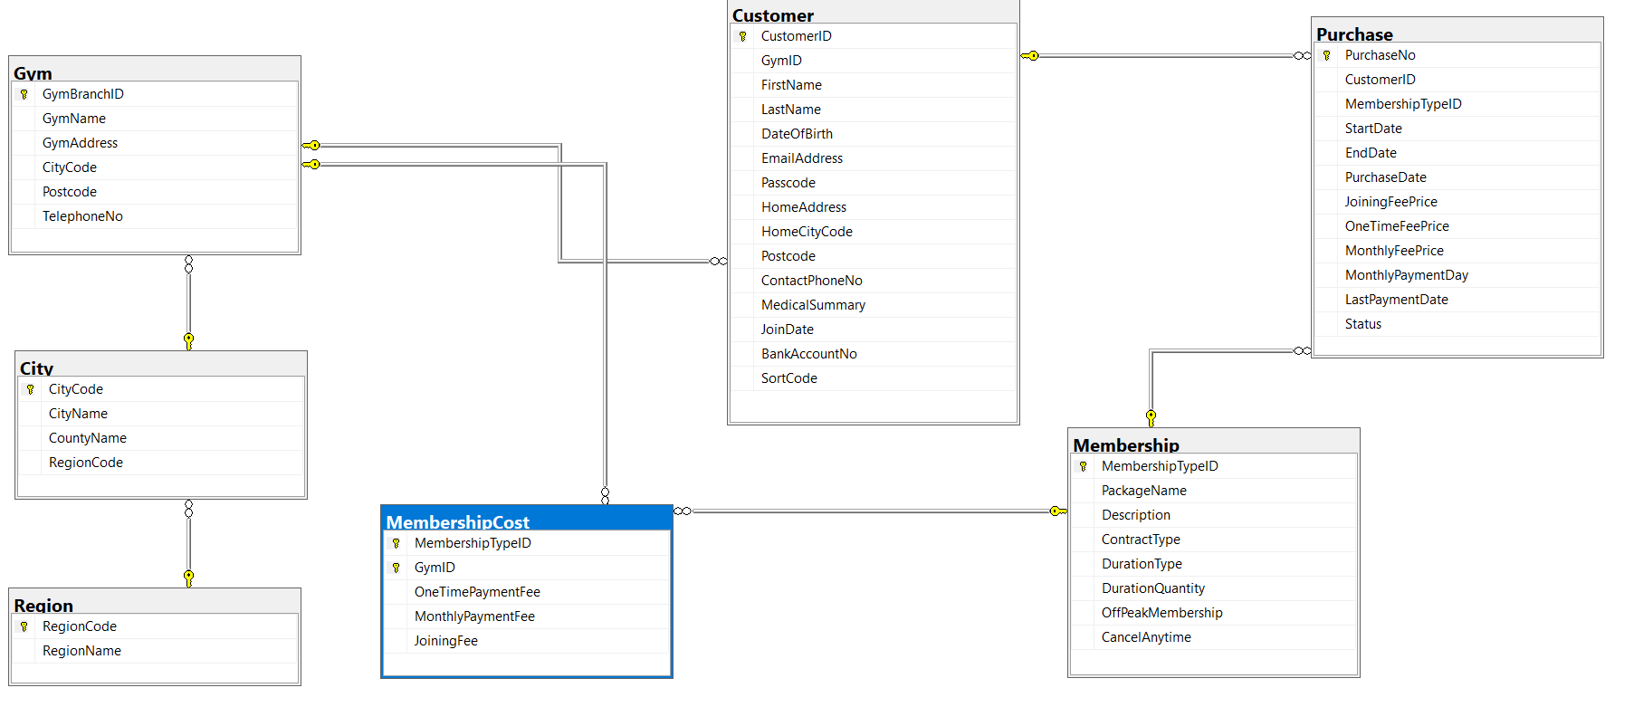
Figure 1 - Diagram showing the current Entity Relationship Diagram (ERD).

One area of performance tuning that often gets overlooked is the use of indexes. Indexes are used to speed up the performance of a query, this is done by lowering the number of database pages that the query has to look through by placing a pointer in the data.
One of the main advantages is that an index helps speed up the SELECT and WHERE elements of the request, if you are inputting data into the table, indexing can make the system seem slow. The suggestion in this instance would be not to use fields that may be regularly updated when looking to improve timing’s with indexes.
There are two types of indexes that should be considered:
- Clustered Index – this is a column or combination of columns that can be used to sort the rows into order within the table. A table can only have one clustering index;
- Secondary Index – is a way to efficiently access the records in a database by a different means to the primary key. [1]
When selecting data to use for secondary indexing it is important to consider the following:
- Whilst secondary indexes can improve functionality, it has to be offset by the overhead of maintaining the indexes when the table is being updated;
- The database can have as many indexes as you require, but 2 per table should be enough, so chose your index columns carefully.
The secondary indexes that have been chosen to help with the performance of the Shape Up Gym are as below:
- City Query;
- Gym Membership Query;
- Membership Last Payment Date.

Section 1.1 Secondary Index 1
City Query
One query that might be used quite often could be looking for gyms that are in a particular area, so a secondary index on the city would be useful when running such a query.
Query
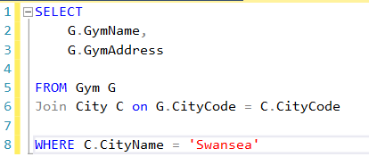
Figure 2 - Select statement for query looking for Gym's in a particular city.
Non-Indexed query
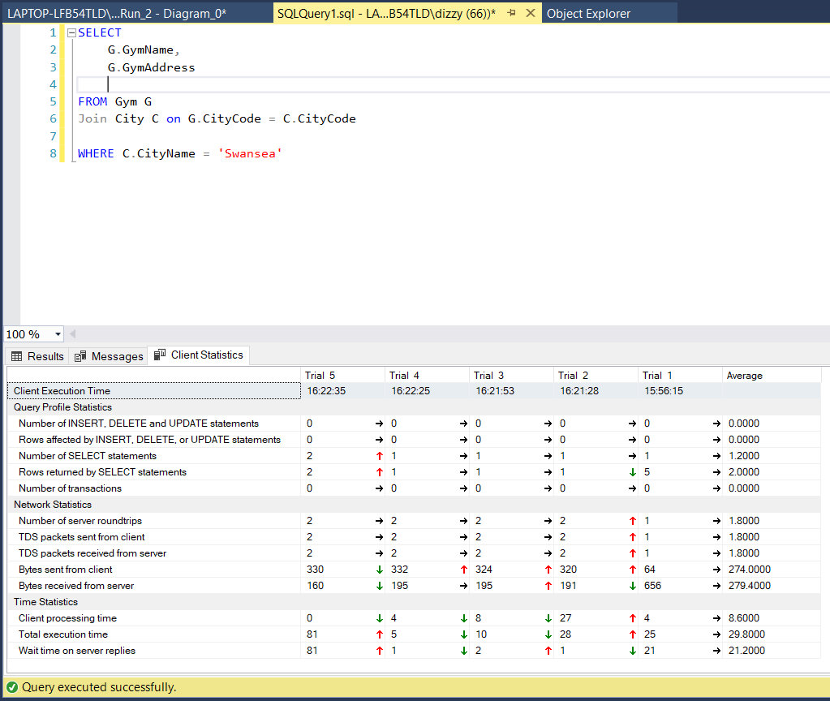
Figure 3 - Details of non-indexed query City Name (Trial 5)
Index Query
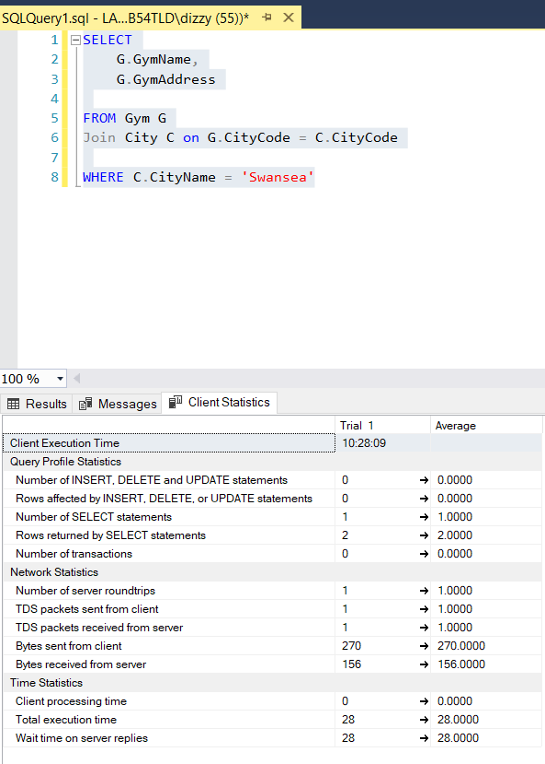
Figure 4 - Details of indexed query on City Name (Trial 1)

Section 1.2 Secondary Index 2
Membership Query
A second query that could be useful would be the ability to check if a customer is a member of the gym they are attending or if they are visiting out of the area. It would be a query used to be all the gyms within the network and could therefore have a high volume of traffic especially at peak times.
Query
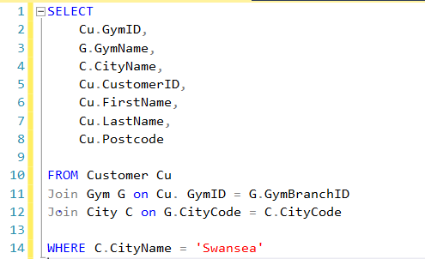
Figure 5 - Select statement for query looking for a Customers on the system.
Non-Indexed Query
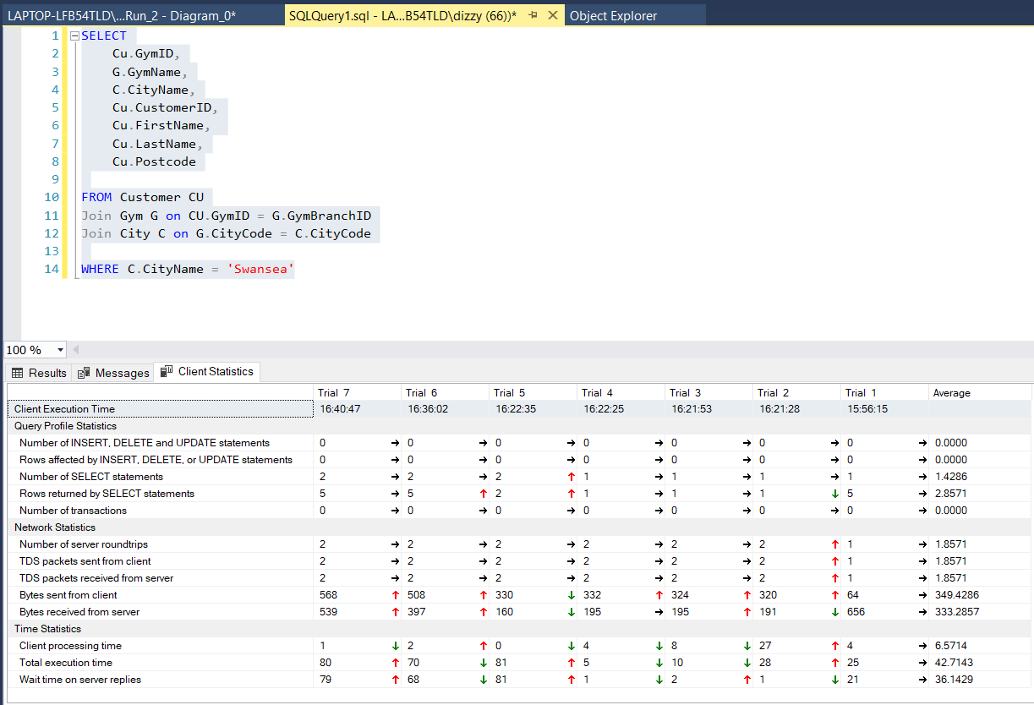
Figure 6 - Details of non-indexed query Customers (Trial 7)
Indexed Query
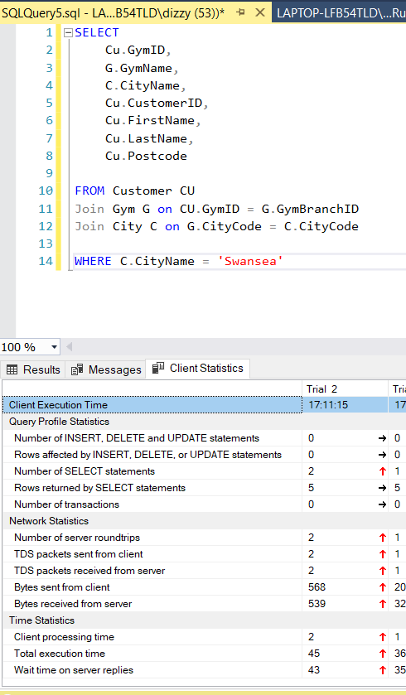
Figure 7 - Details of indexed query on Customer (Trial 2)

Section 1.3 Secondary Index 3
Payment Date Query
A third query that could be useful would be the ability to check which customers are getting close to their last payment date, this would be a query run by the finance section of the company on a regular basis.
Query
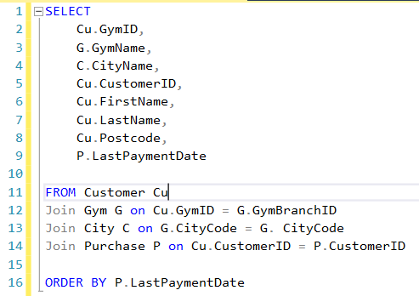
Figure 8 - Select statement for query looking for a Last Date Payments on the system.
Non-Indexed Query
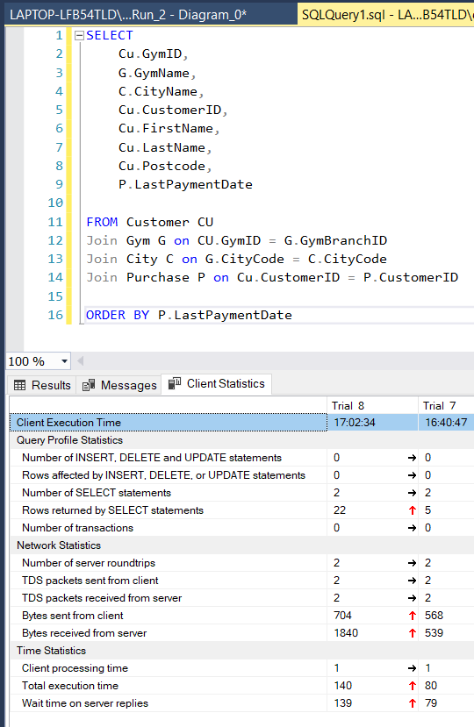
Figure 9 - Details of non-indexed query Last Payment Date (Trial 8)
Indexed Query
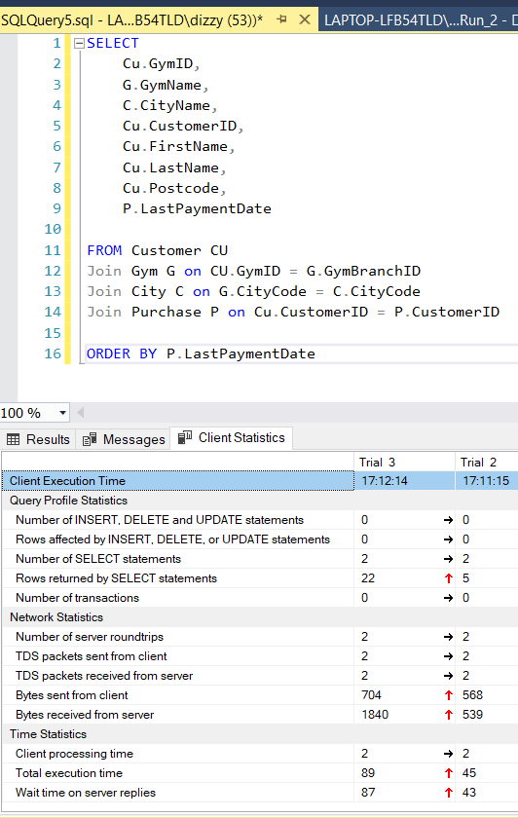
Figure 10 - Details of indexed query on Last Payment Date (Trial 3)

Section 1.4 Results of Index Performance Tuning

Trial Results
Execution Time | City Query |  | Membership Query |  | Payment Date Query
Execution Time | Non-Indexed | Indexed | Non-Indexed | Indexed | Non-Indexed | Indexed
Number of server roundings | 2 | 1 | 2 | 2 | 2 | 2
TDS packets sent | 2 | 1 | 2 | 2 | 2 | 2
TDS packets received | 2 | 1 | 2 | 2 | 2 | 2
Bytes sent | 330 | 270 | 568 | 568 | 704 | 704
Bytes received | 180 | 156 | 539 | 539 | 1,840 | 1,840
Processing time | 0 | 0 | 1 | 2 | 1 | 2
Total execution time | 81 | 28 | 80 | 45 | 140 | 89
Wait time on server | 81 | 28 | 79 | 43 | 139 | 87

Figure 11 - Table of the query results with Non-Indexed and Indexed Query times
As can be seen in Figure 11, the total execution time for all three indexes is reduced as well as the wait time for the server, suggesting that despite it being a small database that significant milliseconds can be saved by introducing second indexes.
The city query is reduced from 81 milliseconds to 28 milliseconds, this is a reduction of 65%, whilst the membership is reduced from 80 to 45 milliseconds, a reduction of 44%. The last payment date for membership reduces from 140 to 89 milliseconds, a reduction of 36%.
From this table it can also be seen that as the structure of the query gets more complex the query time reduction decreases. This suggests that at some point a complex query will not benefit from an indexed query, so this des need to always be a consideration when determine what can be indexed.
Section 2 – Distributed Databases

Section 2.1 – Distributed Databases

What is a distributed database – A distributed database is defined as a collection of multiple, logically interrelated databases distributed over a computer network.[2] To put is simply it is a centralised database that has been split into several parts or fragmented to allow users to access the data at their own site as well as across multiple sites.
The advantages to such a distributed database are:
- Usage – since the applications are working with subsets of the data ;
- Efficiency – relevant data is normally stored close to the location so the efficiency is increased [3];
- Parallelism;
- Security – due to the nature of only relevant data being stored at the location, security and privacy is easier to maintain [3].
There are a couple of disadvantages that would need to be taken into consideration:
- Performance;
- Integrity.
The types of fragmentation that could be considered are:
- Horizontal;
- Vertical;
- Mixed;
- Derived.
See Sections 3.2 to 3.5 for individual details on the fragmentation description and which tables could fit into the types of fragmentations.
When considering fragmentation, it is important to note that the data fragmentation must following three rules:
- Completeness;
- Reconstruction;
- Disjointedness.

Section 2.2 – Horizontal Fragmentation

Horizontal Fragmentation is a relation that is partitioned into a set of sub-relations, each of which have a subset of the tuples (rows). [2]
Horizontal fragmentation groups the rows of the table together based on the values contained in one of more fields. This type of fragmentaiton should ensure that all fragmented tables have the same number of columns and column names.
When looking at Shape Up Gyms and the data tables, one of the first tables that lends it self to horizontal fragmentation easily is the Gym table. This is because the table can be split on the City ID, allowing gyms in the city to see which gyms are in their areas with their address to enable customers to access other local gyms should they need to.
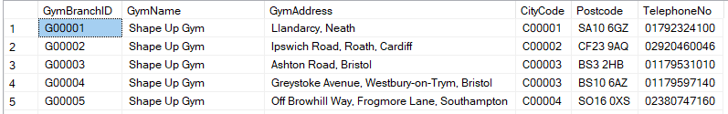
Figure 12 - View of Gym Table
This table can be split into the individual gym, using the “GymID” number in column two. This would allow each gym to have immediate access to their own members, but with access to other tables on other sites as and when out of area visitors attend their gyms.
Using the horizontal split, the new tables could look like the tables below (only showing Gym ID C00001 to C00003):
Figure 13 – City ID C00001 (C₁)
Figure 14 - City ID C00002 (C₂)
Figure 15 - City ID C00003 (C₃)
With horizontal fragmentation there is a need to ensure that the data is complete, ensuring that each row of the table appears in one of the fragments. When reconstructing the fragments to form the table use the union command, in this instance it would be:
Original City Relation = $c_{1}∪c_{2}∪c_{3}$ . . .

Section 2.3 – Vertical Fragmentation

Vertical Fragmentation is where each sub-relation is defined on a subset of the attributes (columns) of the original data. [2]
This means that the columns of the dataset are grouped together to form fragments, each group should contain the primary key field(s) to aid the reconstruction of the data if required. This type of fragmentation can help with privacy and security of data as it only allows access to the new tables for those that require the information.
When looking at Shape Up Gyms and the data tables, the table that lends it self to a vertical fragmentation easily is the Purchase table. This is because the table can be split to provide information to the gym itself and provide separate information to any sales or finance teams.
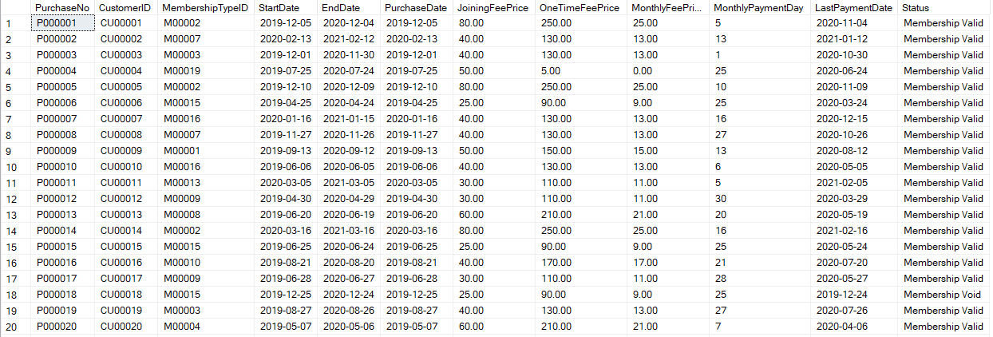
Figure 16 – View of the Purchase Table
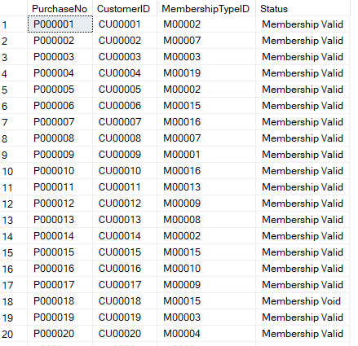
Figure 17 - Vertical split showing valid membership (for gyms use)
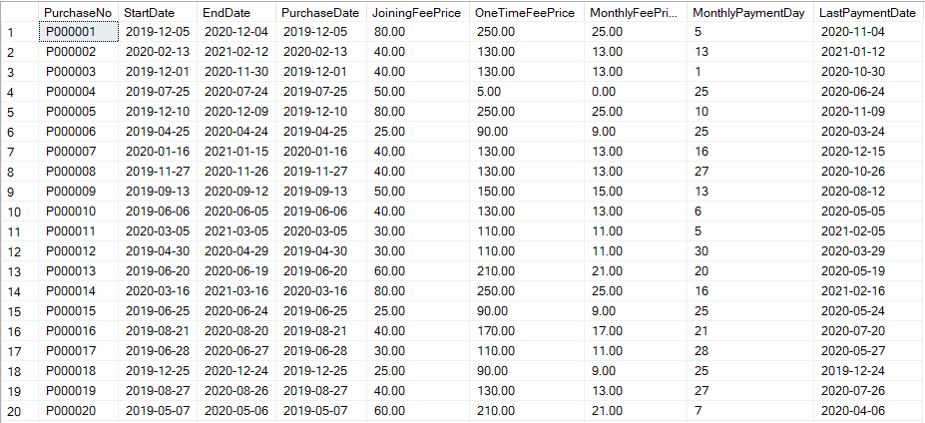
Figure 18 - Vertical split showing the purchase data for the sales and finance teams
With vertical fragmentation, as with horizontal fragmentation, there is a need to ensure that the data is complete, ensuring that each attribute (column) of the table appears in one of the fragments, whilst using the same primary key as the primary key in all fragments. When reconstructing the fragments to form the table use the join command, in this instance it would be:
Original Purchase Relation = p₁ ⋈ p₂ . . .

Section 2.4 – Mixed Fragmentation

Mixed fragmentation is in essence a mixture of both horizontal and vertical fragmentation, thus enabling the table to be split in a variety of ways, depending on the users’ needs.
When looking at Shape Up Gyms and the data tables, the table that lends it self to mixed fragmentation easily is the Customer table. This is because the table can be split vertically on the bank details and then horizontially on the Gym ID to provide address for the individual gym, if there was an issue.
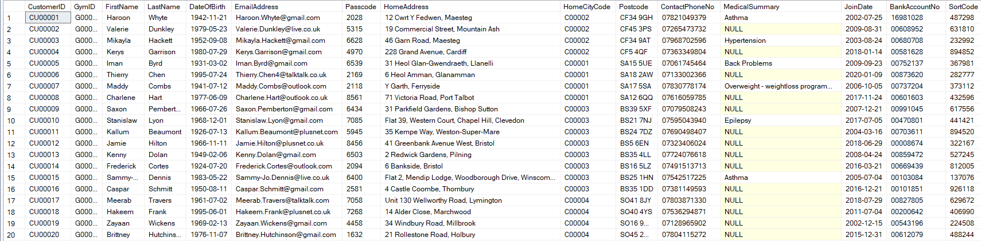
Figure 19 - View of Customer Table
Going with the vertical split we could use the Customer table, Finance might not be as concerned about having the address of the customer, but the bank details would be very important, and to help with data protection these details should really only be seen by those that need to see them. The initial split could look as below:
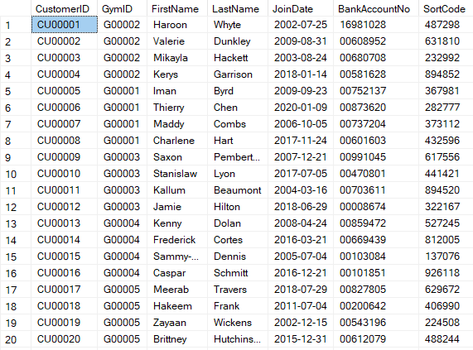
Figure 20 – Vertical fragmentation for Finance
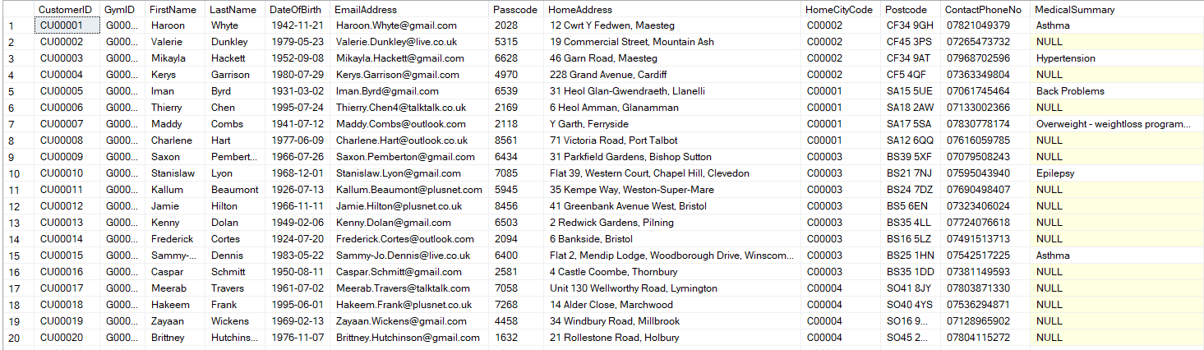
Figure 21 – Vertical fragmentation for splitting horizontally
Below is the horizontal splitting from the initial vertical fragmentation, that places each customer with the gym databases of the customer (only showing example of gym code G00001 and G00002) below:
Figure 22 - Gym Code G00001
Figure 23 - Gym Code G00002
With mixed fragmentation, as with both horizontal and vertical fragmentation, there is a need to ensure that the data is complete, ensuring that each row and each attribute (column) of the table appears in one of the fragments, whilst using the same primary key as the primary key in the vertical fragments. When reconstructing the fragments to form the table use theboth the union and join command, in this instance it would be:
Original Customer Relation = CU₁ ⋈ (CU₂₁ ∪ CU₂₂ ∪ CU₂₃ . . .)

Section 2.5 – Derived Fragmentation

Derived fragmentation is the also known as derived horizontal fragmentation and is the partitioning of a relation that results from predicates being defined on another relation. [2]
In this instance the customer table is the parent of the purchase table and so it would make sense to have the partitions or fragmentation of the purchase table that relate to the customer to be kept in the same, ie at the gym level.
If the customer table had been fragmented by gym code then the purchase table should also be partitioned in the same way. It would create the following table for customers
Cu₁: σ_{GymID} = G00001 (Customer)
Figure 24 - Parent horizontal derived table
The corresponding purcahse table would be:
P₁: P⊳customerID Cu₁ (Cu₁ is a horizontal fragment GymID = G00001)
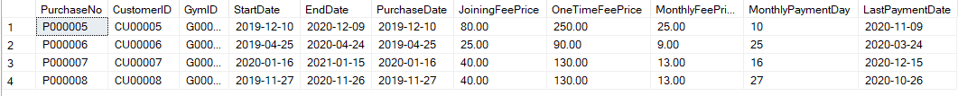
Figure 25 - Child horizontal derived table

Section 3 – Conclusion

Whilst looking at the two solutions for the Shape Up Gym, it became evident that there would be some benefits to be had.
First benefit is using secondary indexes to help with the performance of the databases. With simple regular queries, they can help cut timings by over 50%, this does however decrease to about 36% with a more complicated query. So, consideration does need to be made when choosing suitable attributes (columns) for placing secondary indexes.
Secondly using fragmentation would certainly help each gym to manage and look after their own members details, without having to access a large central database. This could also mean that there could be more confidentiality and security around the members details as they would not be able to be inadvertently accessed by other gyms in error.

References
[1] “Berkeley DB Programmers Reference Guide,” 2010. [Online]. Available: https://docs.oracle.com/cd/E17275_01/html/programmer_reference/am_second.html. [Accessed: 22-Mar-2020].
[2] P. Ozsu, M. T. & Valduriez, Principles of distributed database systems. 1999.
[3] tutorialspoint, “Distributed DBMS - Design Strategies,” 2020. [Online]. Available: https://www.tutorialspoint.com/distributed_dbms/distributed_dbms_design_strategies.htm. [Accessed: 15-Mar-2020].

