

Bethan Davies-Jones

Rates of Reactions Lab Report

University of Wales Trinity Saint David
Ordnance Munitions and Explosives – L4 Chemistry

April 2025

Abstract
An experiment was conducted to evaluate the effect that concentration, temperature and surface area had on the rates of reactions. The volume of hydrogen gas produced from the reaction was recorded and used to calculate the average and instantaneous rates. The limitations of the experiment are discussed, as well as the importance of rates of reactions in an ordnance munitions and explosives environment.

Keywords:
Hydrogen gas, Concentration, Temperature, Surface area, Average rate, Instantaneous rate

Table of Contents
Abstract ii
List of Figures iv
List of Tables v
List of Equations vi
List of Abbreviations vii
1 Introduction 1
1.1 Purpose of Experiment 1
1.2 Hypothesis 1
1.3 Variables and Equations 1
2 Results 2
2.1 Procedure 1 2
2.2 Procedure 2 7
2.3 Procedure 3 10
3 Discussion 12
3.1 Interpretation of Experimental Results 12
3.1.1 Procedure 1 12
3.1.2 Procedure 2 14
3.1.3 Procedure 3 16
3.2 OME Applications 17
3.3 Limitations 17
4 Conclusion 18
5 References 19
Appendices 20
Appendix A Materials and Equipment 20
Appendix B Method 21
Appendix C Images of the Original Data Sheets 23
Appendix D Images of the Tangents used to Calculate the Rates of Reactions 27

List of Figures
Figure 1 – Graphed results for 0.5M HCl in Procedure 1 3
Figure 2 – Graphed results for Mg ribbon in 1.0M HCl at 24.7°C in Procedure 1, 2 and 3 4
Figure 3 – Graphed results for 1.5M HCl in Procedure 1 5
Figure 4 – Graphed results for 2.0M HCl in Procedure 1 6
Figure 5 – Graphed results for 1.0M HCl at 36.5°C in Procedure 2 8
Figure 6 – Graphed results for 1.0M HCl at 43.3°C in Procedure 2 9
Figure 7 – Graphed results for Mg powder in 1.0M HCl 11
Figure 8 – Calculations for the average rate of reaction of 0.5M HCl 12
Figure 9 – Calculations for the average rate of reaction of 1.0M HCl 12
Figure 10 – Calculations for the average rate of reaction of 1.5M HCl 13
Figure 11 – Calculations for the average rate of reaction of 2.0M HCl 13
Figure 12 – Calculations for the instantaneous rate of reaction of 0.5M HCl 13
Figure 13 – Calculations for the instantaneous rate of reaction of 1.0M HCl 13
Figure 14 – Calculations for the instantaneous rate of reaction of 1.5M HCl 14
Figure 15 – Calculations for the instantaneous rate of reaction of 2.0M HCl 14
Figure 16 – Calculations for the average rate of reaction of 24.7°C HCl 14
Figure 17 – Calculations for the average rate of reaction of 36.5°C HCl 14
Figure 18 – Calculations for the average rate of reaction of 43.3°C HCl 15
Figure 19 – Calculations for the instantaneous rate of reaction of 36.5°C HCl 15
Figure 20 – Calculations for the instantaneous rate of reaction of 43.3°C HCl 15
Figure 21 – Calculations for the average rate of reaction of 1.0M HCl with Mg powder 16
Figure 22 – Calculations for the instantaneous rate of reaction of 1.0M HCl with Mg powder 16

List of Tables
Table 1 – Results for 0.5M HCl in Procedure 1 3
Table 2 – Results for Mg ribbon 1.0M HCl at 24.7°C in Procedure 1, 2 and 3 4
Table 3 – Results for 1.5M HCl in Procedure 1 5
Table 4 – Results for 2.0M HCl in Procedure 1 6
Table 5 – Results for 1.0M HCl at 36.5°C in Procedure 2 7
Table 6 – Results for 1.0M HCl at 43.3°C in Procedure 2 9
Table 7 – Results for Mg powder in 1.0M HCl 10

List of Equations
Equation 1 – Rate of reaction equation 1

List of Abbreviations
HCl  Mg  OME  DI Water | Hydrochloric acid  Magnesium  Ordnance, munitions and explosives  Deionised water

Introduction

Purpose of Experiment
The aim of the rate of reaction experiment is to ascertain the effect that concentration (procedure 1), temperature (procedure 2) and surface area (procedure 3) have on the rate of a reaction.

Hypothesis
An increase in concentration of hydrochloric acid (HCl), temperature of HCl and surface area of magnesium (Mg) will all individually increase the rate of the reaction. This can be measured through a decrease in the time taken for the same volume of hydrogen gas to release.

Variables and Equations
The independent variables are different for each procedure. In procedure one it is the concentration of the HCl, for procedure 2 it is the temperature of the HCl and in procedure 3 it is the surface area of the Mg. The dependent variable for all three procedures is the volume of the hydrogen gas released. The control variables are the person reading the value from the gas syringe, the apparatus used, and temperature of the surroundings.
Only one equation is used to evaluate the results of the rates of reactions experiment.
Equation 1 – Rate of reaction equation
$$rate= \frac{∆V_{H_{2}}}{∆t}$$
Where Δ is “change in”, V is volume, $H_{2}$ is hydrogen gas and t is time.

Results

Procedure 1
0.5M HCl
Time / s | Volume of Hydrogen Gas / mL
0 | 0
20 | 3
40 | 5
60 | 7.5
80 | 9
100 | 11
120 | 12.5
140 | 14
160 | 15
180 | 16
200 | 16
220 | 17
240 | 17
260 | 18.5
280 | 18.5
300 | 18.5
320 | 20.5
340 | 20.5
360 | 20.5
380 | 20.5
400 | 20.5
420 | 20.5
440 | 25
460 | 25
480 | 25
500 | 25
520 | 25
540 | 25
560 | 25
580 | 25
600 | 28
620 | 38.5
640 | 38.5
660 | 38.5
680 | 38.5
700 | 38.5
720 | 38.5
740 | 38.5
760 | 38.5
780 | 38.5
800 | 38.5
820 | 38.5
840 | 38.5
860 | 38.5
880 | 38.5
900 | 38.5
920 | 38.5
940 | 38.5
960 | 38.5
Table 1 – Results for 0.5M HCl in Procedure 1

Figure 1 – Graphed results for 0.5M HCl in Procedure 1
1.0M HCl
Time / s | Volume of Hydrogen Gas / mL
0 | 0
10 | 11
20 | 21
30 | 29
40 | 35
50 | 41
60 | 47
70 | 52
80 | 58
90 | 60
100 | 62.5
110 | 62.5
120 | 62.5
130 | 64
140 | 64
150 | 64
160 | 64
170 | 64
180 | 64
Table 2 – Results for Mg ribbon 1.0M HCl at 24.7°C in Procedure 1, 2 and 3

Figure 2 – Graphed results for Mg ribbon in 1.0M HCl at 24.7°C in Procedure 1, 2 and 3
1.5M HCl
Time / s | Volume of Hydrogen Gas / mL
0 | 0
10 | 21
20 | 35
30 | 45
40 | 53
50 | 57
60 | 60
70 | 62
80 | 67
90 | 69
100 | 69
110 | 70
120 | 71.5
130 | 71.5
140 | 71.5
150 | 71.5
160 | 71.5
170 | 71.5
180 | 71.5
Table 3 – Results for 1.5M HCl in Procedure 1

Figure 3 – Graphed results for 1.5M HCl in Procedure 1
2.0M HCl
Time / s | Volume of Hydrogen Gas / mL
0 | 0
10 | 32
20 | 51
30 | 55
40 | 61
50 | 65
60 | 68
70 | 70
80 | 70
90 | 70
100 | 70
110 | 70
120 | 70
Table 4 – Results for 2.0M HCl in Procedure 1

Figure 4 – Graphed results for 2.0M HCl in Procedure 1

Procedure 2
Table 2 and Figure 2 act as the first reading for procedure 2. The initial temperature was 24.7°C.
Initial Temperature = 36.5
Time / s | Volume of Hydrogen Gas / mL
0 | 0
10 | 15
20 | 25
30 | 37
40 | 47
50 | 51
60 | 57
70 | 61
80 | 63
90 | 63
100 | 64
110 | 64
120 | 64
130 | 66
140 | 66
150 | 67
160 | 67
170 | 68
180 | 68
190 | 68
200 | 68
Table 5 – Results for 1.0M HCl at 36.5°C in Procedure 2

Figure 5 – Graphed results for 1.0M HCl at 36.5°C in Procedure 2
Initial Temperature = 43.3
Time / s | Volume of Hydrogen Gas / mL
0 | 0
10 | 20
20 | 30
30 | 38
40 | 45
50 | 51
60 | 55
70 | 58
80 | 58
90 | 59
100 | 60
110 | 60.5
120 | 62
130 | 62
140 | 64
150 | 65
160 | 65
170 | 65
180 | 66.5
190 | 66.5
200 | 67.5
210 | 67.5
Table 6 – Results for 1.0M HCl at 43.3°C in Procedure 2

Figure 6 – Graphed results for 1.0M HCl at 43.3°C in Procedure 2

Procedure 3
Table 2 and Figure 2 act as the first reading for procedure 3.
Mg Powder
Time / s | Volume of Hydrogen Gas / mL
0 | 0
10 | 8
20 | 14
30 | 19
40 | 24
50 | 30
60 | 34
70 | 37
80 | 41
90 | 45
100 | 47
110 | 50
120 | 53
130 | 55
140 | 57
150 | 59
160 | 60
170 | 61
180 | 61
190 | 62
200 | 62.5
210 | 63
220 | 63
230 | 63
240 | 63
Table 7 – Results for Mg powder in 1.0M HCl

Figure 7 – Graphed results for Mg powder in 1.0M HCl

Discussion

Interpretation of Experimental Results
The hypothesis proposed is due to the kinetic particle theory. An increase in concentration of HCl will increase the number of molecules within the solution. An increase in temperature of the HCl will increase the velocity of the particles moving within the solution. An increase in surface area of the Mg will increase the number of particles exposed to the HCl. The increase of these three variables all individually cause an increase in the frequency of random collisions between HCl and Mg particles, therefore increasing the rate of the reaction.
This is shown in the results obtained, which were used to calculate the average and instantaneous rates of reaction for each experiment. This was done by drawing a tangent on the graphed results (Appendix D) and Equation 1. When calculating the average rates, the same value for ∆t was used for each procedure.

Procedure 1

Average Rates
Figure 8 – Calculations for the average rate of reaction of 0.5M HCl
$$rate= \frac{∆V_{H_{2}}}{∆t}$$
$$rate= \frac{10-0}{100-0}$$
$$rate= 0.1 {cm}^{3}s^{-1}$$
Figure 9 – Calculations for the average rate of reaction of 1.0M HCl
$$rate= \frac{∆V_{H_{2}}}{∆t}$$
$$rate= \frac{63-5}{100-0}$$
$$rate= 0.58{ cm}^{3}s^{-1}$$
Figure 10 – Calculations for the average rate of reaction of 1.5M HCl
$$rate= \frac{∆V_{H_{2}}}{∆t}$$
$$rate= \frac{80-10}{100}$$
$$rate= 0.7{ cm}^{3}s^{-1}$$
Figure 11 – Calculations for the average rate of reaction of 2.0M HCl
$$rate= \frac{∆V_{H_{2}}}{∆t}$$
$$rate= \frac{108-10}{100}$$
$$rate= 0.98 {cm}^{3}s^{-1}$$
These calculations for average rates of reaction show that as the concentration of the HCl is increased, the rate of reaction increases.

Instantaneous Rates
Figure 12 – Calculations for the instantaneous rate of reaction of 0.5M HCl
$$rate= \frac{∆V_{H_{2}}}{∆t}$$
$$rate= \frac{27-0}{200-0}$$
$$rate= 0.135=0.14{ cm}^{3}s^{-1}$$
Figure 13 – Calculations for the instantaneous rate of reaction of 1.0M HCl
$$rate= \frac{∆V_{H_{2}}}{∆t}$$
$$rate= \frac{54-0}{50-0}$$
$$rate= 1.08=1.1 {cm}^{3}s^{-1}$$
Figure 14 – Calculations for the instantaneous rate of reaction of 1.5M HCl
$$rate= \frac{∆V_{H_{2}}}{∆t}$$
$$rate= \frac{80-0}{38-0}$$
$$rate= 2.105…=2.1 {cm}^{3}s^{-1}$$
Figure 15 – Calculations for the instantaneous rate of reaction of 2.0M HCl
$$rate= \frac{∆V_{H_{2}}}{∆t}$$
$$rate= \frac{73-0}{20-0}$$
$$rate= 3.65=3.7 {cm}^{3}s^{-1}$$
These calculations for instantaneous rates of reaction show that as the concentration of the HCl is increased, the rate of reaction increases.

Procedure 2

Average Rates
Figure 16 – Calculations for the average rate of reaction of 24.7°C HCl
$$rate= \frac{∆V_{H_{2}}}{∆t}$$
$$rate= \frac{55-5}{75-0}$$
$$rate= 0.6666…=0.67 {cm}^{3}s^{-1}$$
Figure 17 – Calculations for the average rate of reaction of 36.5°C HCl
$$rate= \frac{∆V_{H_{2}}}{∆t}$$
$$rate= \frac{66-5}{75-0}$$
$$rate= 0.81333…=0.81 {cm}^{3}s^{-1}$$
Figure 18 – Calculations for the average rate of reaction of 43.3°C HCl
$$rate= \frac{∆V_{H_{2}}}{∆t}$$
$$rate= \frac{65-5}{75-0}$$
$$rate= 0.8 {cm}^{3}s^{-1}$$
These calculations for average rates of reaction show that as the temperature of the HCl is increased, the rate of reaction increases on average. Figure 18, however, does not increase but decreases by 0.1${cm}^{3}s^{-1}$. As the calculations for the instantaneous rates support the hypothesis, this can be discredited due to operator error in the drawing of the tangents.

Instantaneous Rates
The value of the instantaneous rate of reaction of a sample of 1.0M of HCl at 24.7°C was taken to be the same as in procedure 1 (figure 13), at 1.1${cm}^{3}s^{-1}$.
Figure 19 – Calculations for the instantaneous rate of reaction of 36.5°C HCl
$$rate= \frac{∆V_{H_{2}}}{∆t}$$
$$rate= \frac{80-0}{50-0}$$
$$rate= 1.6 {cm}^{3}s^{-1}$$
Figure 20 – Calculations for the instantaneous rate of reaction of 43.3°C HCl
$$rate= \frac{∆V_{H_{2}}}{∆t}$$
$$rate= \frac{80-0}{36-0}$$
$$rate= 2.222…=2.2 {cm}^{3}s^{-1}$$
These calculations for instantaneous rates of reaction show that as the temperature of the HCl is increased, the rate of reaction increases.

Procedure 3

Average Rates
The value of the average rate of reaction of a sample of 1.0M of HCl reacting with a Mg ribbon was taken to be the same as in procedure 1 (figure 9), at 0.58 ${cm}^{3}s^{-1}$.
Figure 21 – Calculations for the average rate of reaction of 1.0M HCl with Mg powder
$$rate= \frac{∆V_{H_{2}}}{∆t}$$
$$rate= \frac{50-0}{100-0}$$
$$rate= 0.5 {cm}^{3}s^{-1}$$
These calculations for average rates of reaction do not support the hypothesis and instead show that as the surface area of the Mg is increased, the rate of reaction decreases. This, however, was caused by a random error due to the operator in the experiment. The full mass of Mg powder did not enter the test tube, which led to invalid results.

Instantaneous Rates
The value of the instantaneous rate of reaction of a sample of 1.0M of HCl reacting with a Mg ribbon was taken to be the same as in procedure 1 (figure 13), at 1.1 ${cm}^{3}s^{-1}$.
Figure 22 – Calculations for the instantaneous rate of reaction of 1.0M HCl with Mg powder
$$rate= \frac{∆V_{H_{2}}}{∆t}$$
$$rate= \frac{70-0}{87-0}$$
$$rate= 0.8045…=0.80 {cm}^{3}s^{-1}$$
These calculations for instantaneous rates of reaction do not support the hypothesis. This was due to the experiment being performed incorrectly and the production of invalid results.

OME Applications
In an ordnance, munitions and explosives environment, knowing a substance’s rate of reaction is crucial to safety. It can be used to work out the sensitivity of an explosive [1], which is vital when considering operators’ handling, and safety of those who come into contact with the material. It is primarily used however, to calculate the detonation type, or zone, of an explosive [2], which is critical to the use of explosives, ensuring the safety of the operators and manufacturers as well as the accuracy of the product. A high explosive’s rate of reaction is measured by its detonation velocity, which would typically have a value of over 5000 feet per second [3] (over 1500 metres per second). By classifying these explosives correctly, they can be appropriately handled.

Limitations
Considering the limitations of an experiment reduces the potential for error, and therefore more accurate results will be gathered. One limitation of the rate of reaction experiment was the precision of the apparatus, particularly the gas syringe. If the increments had been to a higher degree of precision, more accurate readings for the volume of hydrogen gas would have been obtained. A further limitation of the experiment was that the full mass of Mg powder did not enter the HCl during procedure 3. This was down to a random error caused by the operator, and greatly skewed the validity of the results.

Conclusion
In conclusion, the results for procedure 1 and 2 supported the hypothesis. An increase in concentration of HCl and temperature of HCl individually increased the rate of the reaction. This was shown through a decrease in the time taken for the same volume of hydrogen gas to release.
The results for procedure 3 did not support the hypothesis due to a random error in the experiment that caused invalid results. If the experiment had been carried out correctly it would have likely supported the hypothesis that a higher surface area of Mg will increase the rate of reaction.
If the experiment were to be carried out again to attempt to gain more accurate results, the limitations would be addressed. This would be done by ensuring that the same mass of magnesium powder and ribbon were used during procedure 3.

References

[1] | A. Macek, “Sensitivity of Explosives,” Chemical Reviews, vol. 62, no. 1, p. 47, 1962.
[2] | B. G. Loboiko, “Reaction Zones of Detonating Solid Explosives,” Combustion, Explosion and Shock Waves, vol. 36, no. 1, pp. 716-733, 2000.
[3] | N. P. Service, National Park Service Handbook for the Storage, Transportation, and Use of Explosives, Washington DC, 1999.

Appendices

Materials and Equipment
- Test tube with arm
- Gas syringe
- Rubber bung and delivery tube
- Two large beakers
- Pipette and pipette filler
- Two clamp stands
- Test tube holder
- Thermometer
- Bunsen burner
- Ring stand
- Clay triangle
- Stopwatch
- Magnesium ribbons 4cm length
- Magnesium powder same mass as ribbons
- Hydrochloric acid 1.0M and 2.0M
- Deionised water

Method
Procedure 1 – Effect of concentration
- Four 20mL solutions of HCl were prepared. Their concentrations were 0.5M, 1.0M, 1.5M, 2.0M. The different concentrations were measured out by using a pipette to create the correct ratios of 2.0M HCl solution and DI water.
- The temperature of the 1.0M HCl was measured and recorded for use in procedure 2.
- The 0.5M HCl was poured into the test tube with the arm.
- A 4cm strip of Mg was added to the test tube. The bung was quickly replaced, and the stopwatch started simultaneously.
- The volume of hydrogen gas given off was recorded at 20second intervals until it stopped increasing.
- The solution was discarded into the waste beaker when the reaction was complete.
- Steps 3-6 were repeated for the other 3 concentrations of HCl, however the volume of hydrogen produced was recorded at 10second intervals for the higher concentrations.
Procedure 2 – Effect of temperature
- A water bath was set up and allowed to raise to roughly 10°C above the measured temperature of the 1.0M HCl in procedure one.
- 2 test tubes of 20mL of 1.0M HCl were prepared.
- One test tube was placed into the water bath and allowed to reach thermal equilibrium before it was quickly transferred into the test tube with the arm.
- A 4cm strip of Mg was added, the bung replaced, and the stopwatch started.
- The volume of hydrogen gas was recorded at 10second intervals until it stopped increasing.
- The solution was discarded into the waste beaker when the reaction was complete.
- Steps 3-6 were repeated for the other sample of 1.0M HCl, however it was allowed to raise to roughly 20°C above the measured temperature of the 1.0M HCl in procedure one.
Procedure 3 – Effect of surface area
- One test tube of 20mL of 1.0M HCl was prepared and transferred to the test tube with the arm.
- The Mg powder was added, the bung replaced and the stopwatch started quickly.
- The volume of hydrogen gas was recorded at 10second intervals until it stopped increasing.
- The solution was discarded into the waste beaker when the reaction was complete.

Images of the Original Data Sheets
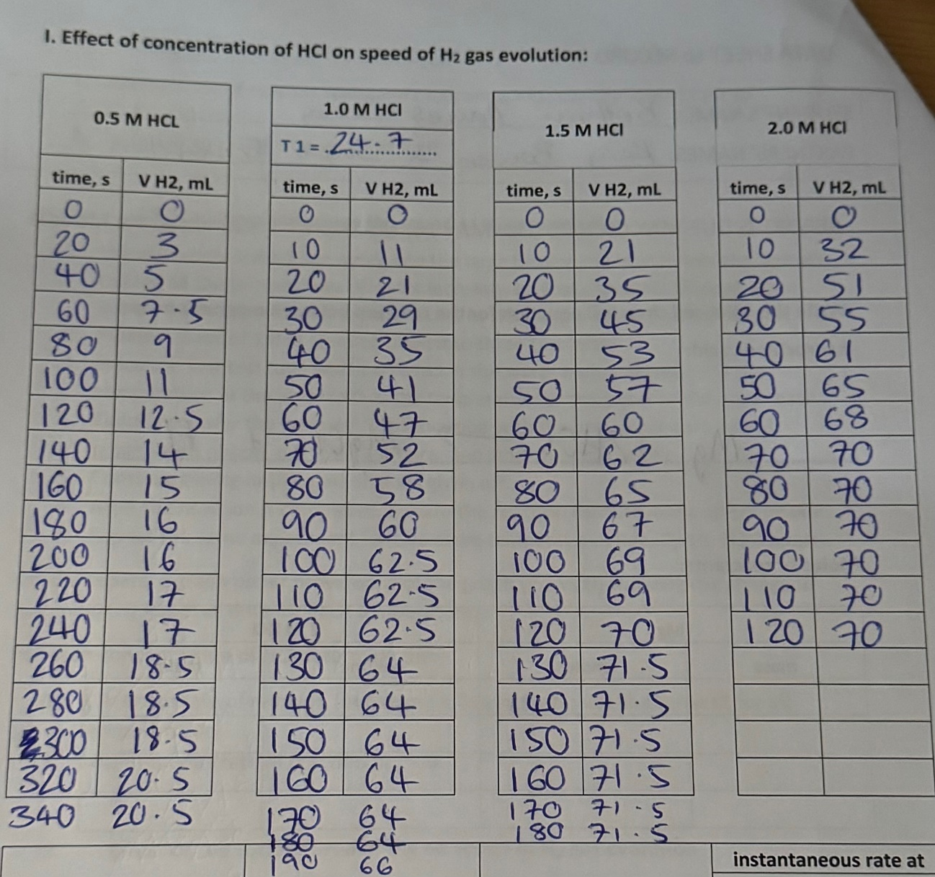
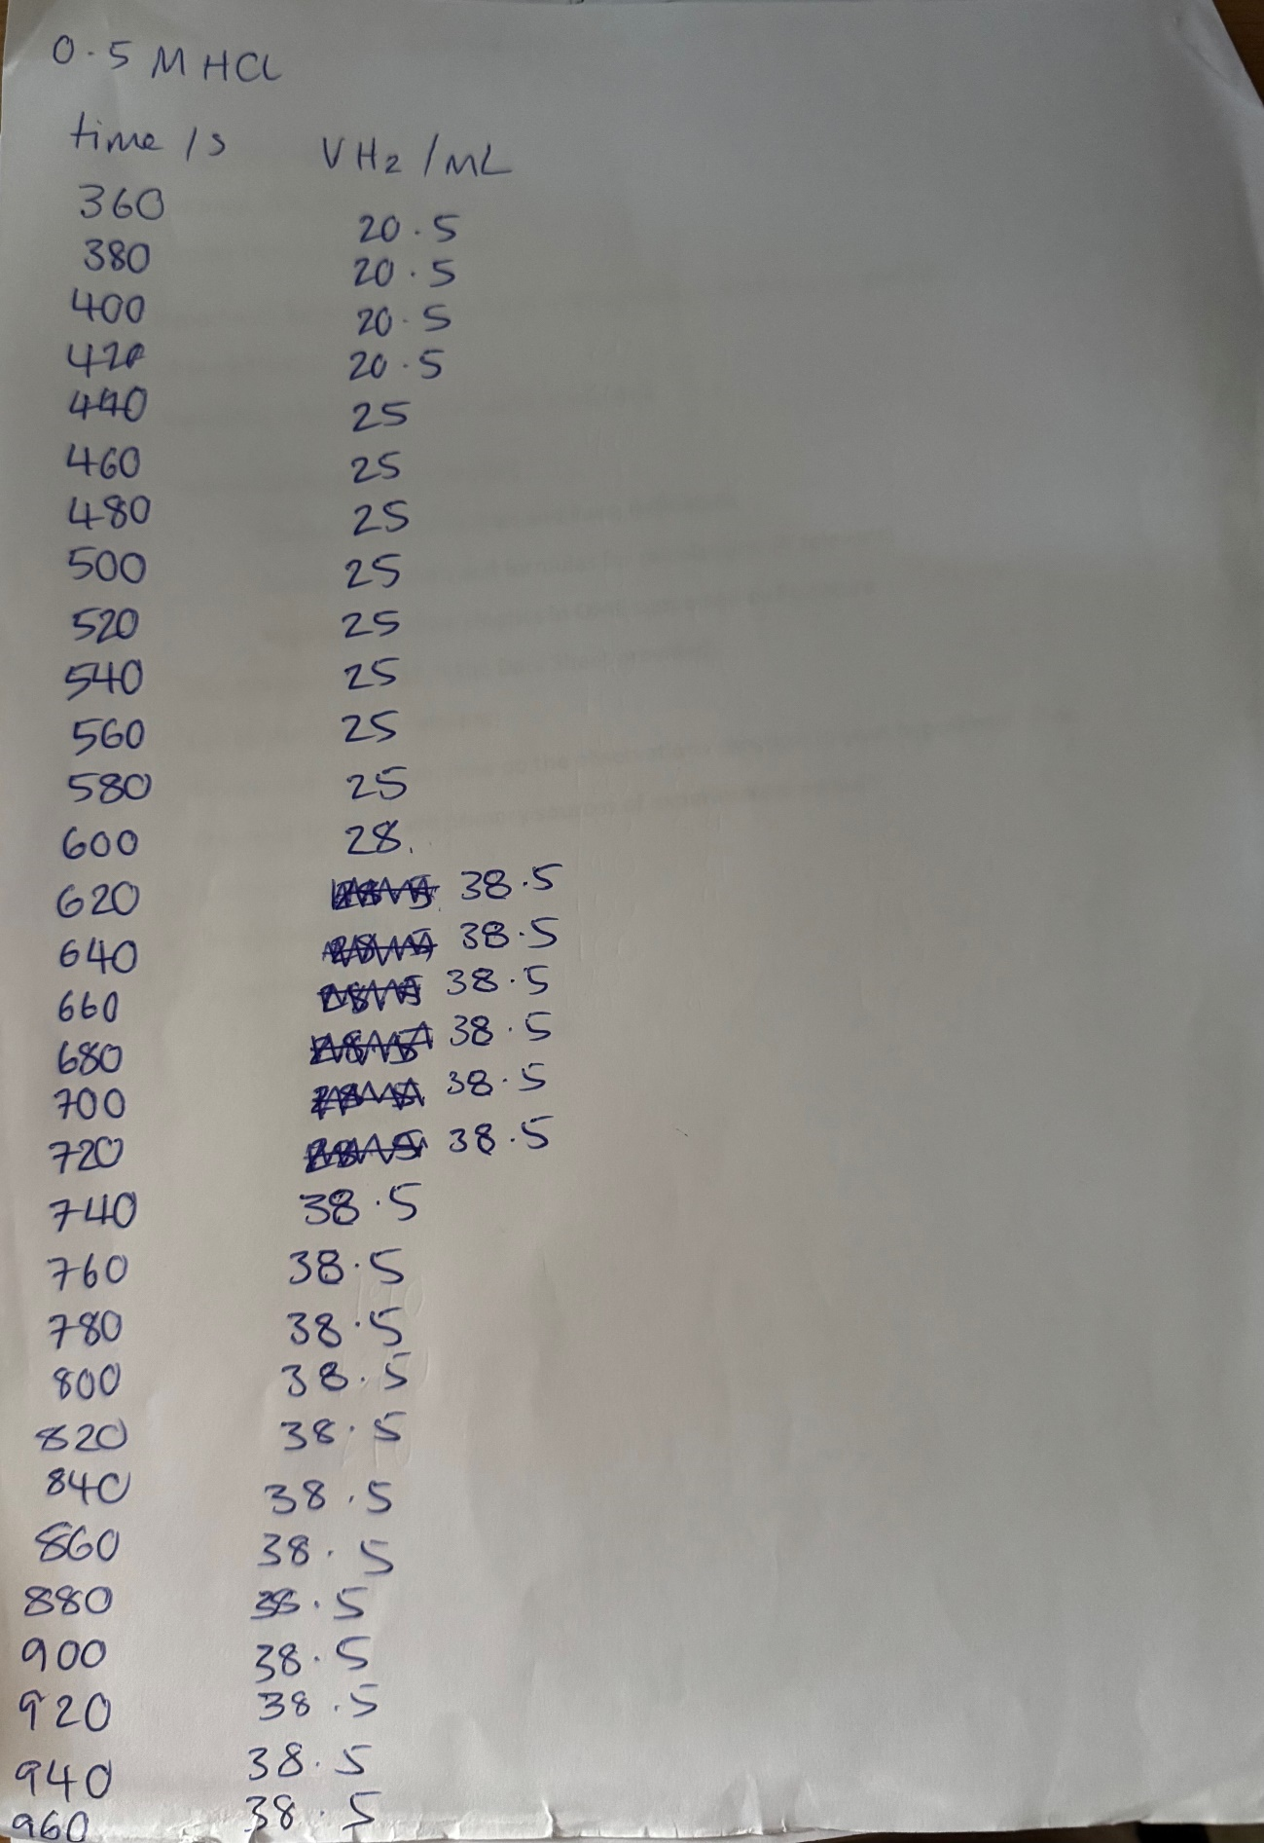
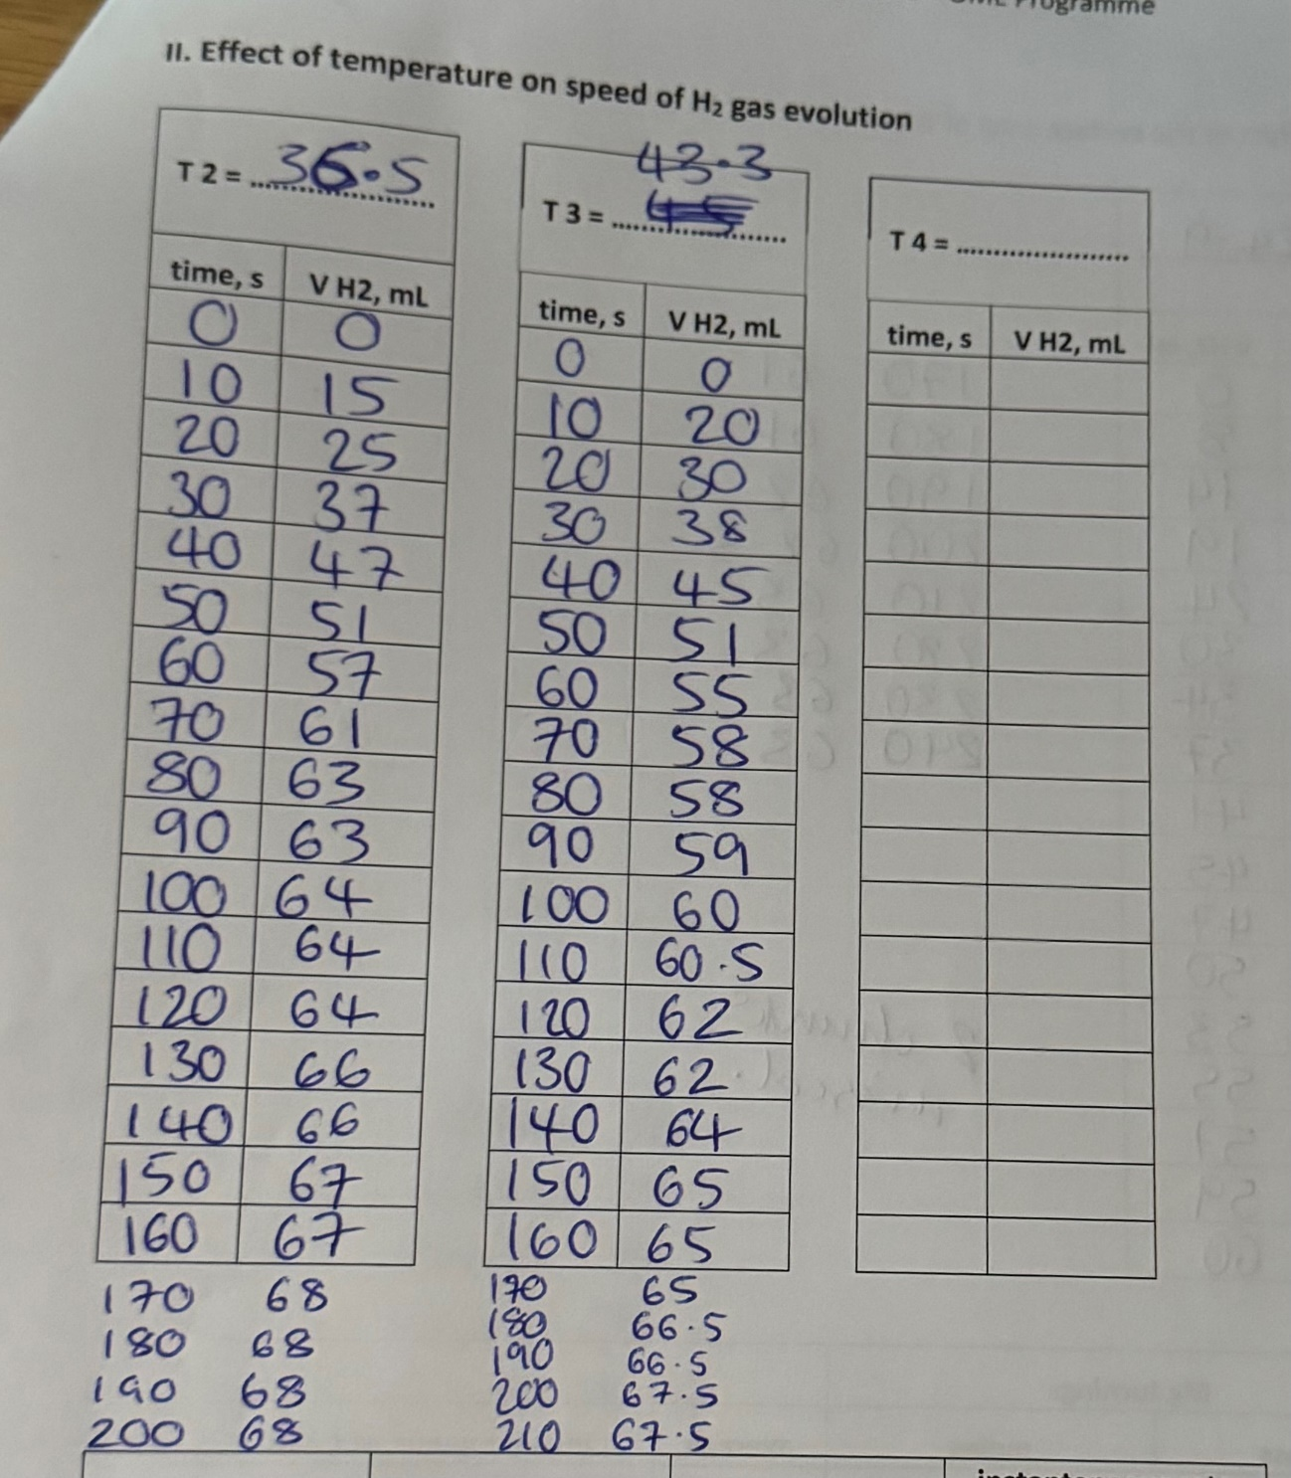
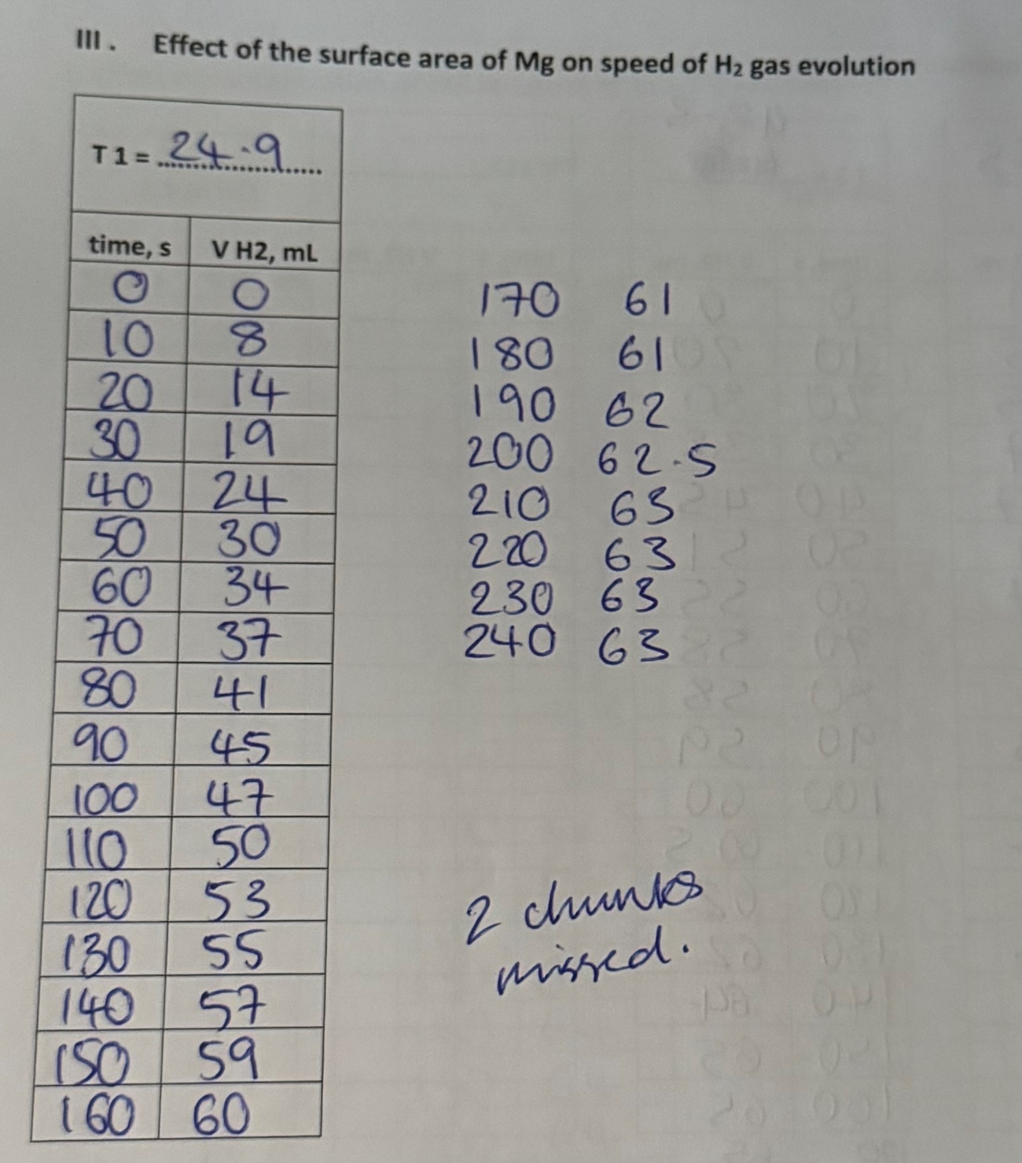

Images of the Tangents used to Calculate the Rates of Reactions


