

ARTIFICIAL INTELLIGENCE FOR
CREDIT RISK ASSESSMENT
Leakage-Free, Imbalance-Aware and Explainable Machine Learning Models
Programme | MSc Data and Artificial Intelligence
Module | L7 – Artificial Intelligence
Module Code | ACCA7026
Assessment | Component 1 – Machine Learning Model
Lecture Name: | Malik Mehmoud
Submission Date | 27 July 2026
Report Word Count | 3000 words (excluding references and appendices)

Abstract
Operationally important but methodologically challenging are credit default prediction under the condition of low default rates and the presence of information generated after loan origin. This study proposes two leakage-free models: Logistic Regression and Random Forest models with 10000 loan records from Lending Club dataset and compares these two models critically. There were 111 cases (1.11%) that were either delinquent or in default. A preprocessing step was used to remove repayment-derived variables, the data were split into representative training, validation and test datasets prior to preprocessing, nominal variables were one-hot encoded, numerical variables were imputed and scaled as necessary, and the imbalance strategies were compared within reproducible pipelines. Hyperparameters were chosen with five-fold stratified cross-validation on the basis of precision-recall area under the curve (PR-AUC) and probability thresholds were optimised on the validation set using the F2-score. Logistic Regression yielded ROC-AUC 0.7489, PR-AUC 0.0772 and default recall 0.4091 on thresholding of the untouched test set with 0.015. Random Forest achieved ROC-AUC 0.7178, PR-AUC 0.0369 and recall 0.2273 at a 0.025 threshold. The important feature for interest rate was the one that appeared the most frequently in all coefficients, permutation and SHAP analyses. The results indicate that accuracy is an inadequate primary evaluation metric for this data and that emergent threshold design features, leakage control, interpretability, auditing via proxy-bias and human oversight are important to deploy credit-risk responsibly.
Keywords: credit risk; class imbalance; target leakage; Logistic Regression; Random Forest; threshold tuning; explainable AI; fairness.

Table of Contents
Abstract 2
Table of Contents 3
List of Figures 3
List of Tables 3
1. Introduction 4
1.1 Background 4
1.2 Problem Statement 4
1.3 Aim, Objectives and Structure 4
2. Related Work 4
2.1 Linear Credit-Scoring Models 4
2.2 Ensemble Learning 5
2.3 Imbalanced Evaluation 5
2.4 Explainability and Fairness 5
3. Methodology 5
3.1 Dataset and Target Definition 5
3.2 Leakage Control and Feature Selection 6
3.3 Preprocessing and Data Partitioning 7
3.4 Model Development and Imbalance Handling 9
3.5 Evaluation, Interpretation and Fairness Audit 9
4. Results and Discussion 9
4.1 Exploratory Findings 9
4.2 Imbalance Strategies, Tuning and Generalisation 10
4.3 Final Model Comparison 11
4.4 Model Interpretation 12
4.5 Fairness, Ethics and Responsible Deployment 14
4.6 Limitations and Robustness 15
5. Conclusion and Recommendations 16
5.1 Conclusion 16
5.2 Recommendations 16
5.3 Staged Implementation Roadmap 17
References 18
Appendix A: Supplementary Interpretability Figures 19

List of Figures
Figure 1. Target-class distribution
Figure 2. Features with the highest missingness
Figure 3. Selected numerical correlations
Figures 4-5. Validation threshold diagnostics
Figures 6-7. Test confusion matrices
Figures 8-9. ROC and precision-recall curves
Figure 10. Logistic Regression coefficients
Figure 11. Random Forest permutation importance
Figures A1-A3. Partial dependence plots
Figure A4. Random Forest SHAP global importance

List of Tables
Table 1. Dataset and split profile
Table 2. Leakage variables removed
Table 3. Selected model configurations
Table 4. Final test-set performance
Table 5. Selected proxy-audit results

1. Introduction

1.1 Background
Credit-risk assessment involves putting into perspective the chances that a borrower may default on contractual repayment requirements. Well-specified models are essential for pricing, loss prevention and capital allocation; models which are poorly specified may lead the lending organization to turn down creditworthy borrowers or to be vulnerable to unnecessary losses. While structured financial data provides an opportunity to use machine learning for identification of complex relationships, the actual predictive value is demonstrated to differ across datasets and should be considered not only in terms of the accuracy but also in terms of transparency, stability and operational relevance [1], [2].

1.2 Problem Statement
The present set of data forms three intertwined problems. But first, only 111 out of 10000 loans are deemed to be default or seriously delinquent and a classifier predicting that each of the cases is indeed “non-default can reach 98.89% accuracy”. Second, some variables like paid principal, paid interest and outstanding balance apply to repayments after origination and would otherwise lead to a "leaky" target. Thirdly, in financial decisions, even variables that are not directly race and gender based can manifest socioeconomic disadvantage through correlated variables like level of income, homeownership, state, grade/verification status etc.

1.3 Aim, Objectives and Structure
The study is therefore set to build a linear Logistic Regression model and non-linear Random Forest model for predicting defaults and compare and interpret the models with the linear one. To achieve the following: build a leak-proof pre-processing pipeline, compare imbalance treatments, tune model parameters and decision thresholds without polluting the test set, assess the performance of the minority class using the correct measures, learn the risk factors that influence decision-making, and critically analyse the limitations in terms of fairness, explainability and deployment. The report is in the format of related work, methodology, result and discussion, and conclusion with recommendations, as required.

2. Related Work

2.1 Linear Credit-Scoring Models
Logistic Regression continues to be a powerful means of credit-scoring baseline because the additive log-odds form of the model is easy to interpret and can be computed readily. Risk specialists can convert coefficient to odds and review. Linearity on the logit scale, however, makes it hard to model interactions and non-linear patterns of risk. Comparative probability-of-default research hence suggests utilizing statistical baselines and more flexible machine-learning approaches and not considering one class to be superior across the board [3].

2.2 Ensemble Learning
Random Forest aggregates predictions from an ensemble of partially decorrelated decision trees and is able to capture threshold effects, heterogeneous borrower profiles and interactions. The ensemble methods have been shown to be competitive in the loan-default studies, but the complexity of the methods may make it difficult to understand the rationale of the individual predictions [2] [5]. Predictive discrimination, auditability and explanation are treated as a combined property in credit-scoring research, therefore [4]. Such tension exists particularly in matters that relate to access to finance, if there is an adverse prediction.

2.3 Imbalanced Evaluation
Conventional evaluation has new meaning within class imbalance. The majority class dominates accuracy and weighted averages; recall focuses on the number of actual defaults that are detected, precision focuses on the reliability of alerts to defaults, and F1/F2 summarizes the compromise between the two. PR-AUC would be useful when the positive class is infrequently occurring as it would assess how well performance was over the low event prevalence [7], [8]. Threshold independent measures like ROC-AUC must therefore, be interpreted independently of the results at the selected threshold.

2.4 Explainability and Fairness
The explainability methods complement the model level metrics. Logistic coefficients offer a clear explanation of the model on a global level and permutation importance, partial dependence and SHAP values can shed light on the global usage of model features [9]. However, post hoc explanations also cannot remove the risk of the model, nor models which are easy to explain have no value in settings with high stakes [10]. Proxy variables and historically derived labels can have differential impacts, even without the presence of protected attributes, necessitating group-level testing, governance and recourse in the responsible lending process [11], [12].

3. Methodology

3.1 Dataset and Target Definition
In the public Lending Club schema there were originally 10,000 rows and 56 variables. The binary variable was coded as 1 for the following categories: Charged Off, Default, Late (16-30 days), and Late (31-120 days); and 0 for other categories noted. This resulted in 9,889 cases of non-default and 111 cases of default. The definition includes a censoring effect as in the case of the Current status category, which might include loans that are actually in repayment distress after the data was taken. Further, the data set is of loans that are funded and not applications that have been denied; this means that results cannot be translated directly to the total applicant population.
Table 1. Dataset and split profile
Partition | Rows | Defaults | Default rate
Full dataset | 10,000 | 111 | 1.110%
Training | 6,000 | 67 | 1.117%
Validation | 2,000 | 22 | 1.100%
Test | 2,000 | 22 | 1.100%

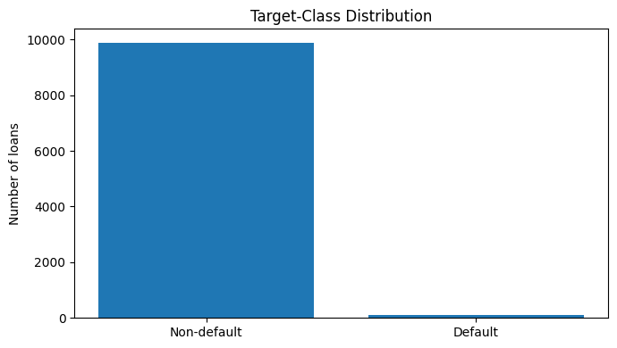
Figure 1. Target-class distribution. Source: author’s analysis.

3.2 Leakage Control and Feature Selection
A number of post-origination variables (paid_total, paid_principal, paid_interest, paid_late_fees, and balance) were dropped prior to modelling. These would be information that is directly or indirectly an indicator of the repayment performance and wouldn't be available at the time of making the credit decision. An additional row index was also deleted, as well as the employment title free-text element, which has high, non-standard cardinalities, leaving 48 predictors. The aim of this intervention is to ensure that input features and preprocessing indeed correspond to information accessible during the prediction phase, or else that the performance estimates may be significantly optimistic [6].
Table 2. Leakage variables removed
Variable | Reason for exclusion
paid_total | Cumulative repayment information generated after origination
paid_principal | Principal repayment observed after origination
paid_interest | Interest repayment observed after origination
paid_late_fees | Direct post-origination delinquency indicator
balance | Outstanding balance after loan issuance

3.3 Preprocessing and Data Partitioning
The data set was divided in a stratified fashion of 60:20:20 to form 6,000 training, 2,000 validation and 2,000 test observations of which 67, 22 and 22 defaults in each set respectively. The splitting preceded the imputation, the encoding, the scaling and the resampling. The variables used were numerical (median imputed) and categorical (most frequent imputation, one hot encoded with unknown category handling). For Logistic Regression, numerical inputs were standardised and for Random Forest imputed numerical scale was not put in the model. Only scikit-learn pipelines with imbalanced-learn were used to fit all the transformations on training data.
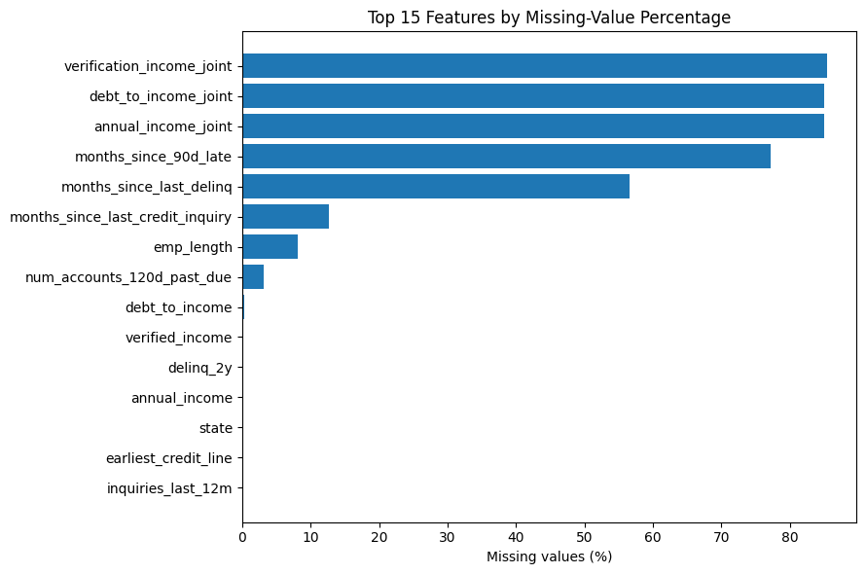
Figure 2. Fifteen features with the highest missing-value percentages. Source: author’s analysis.
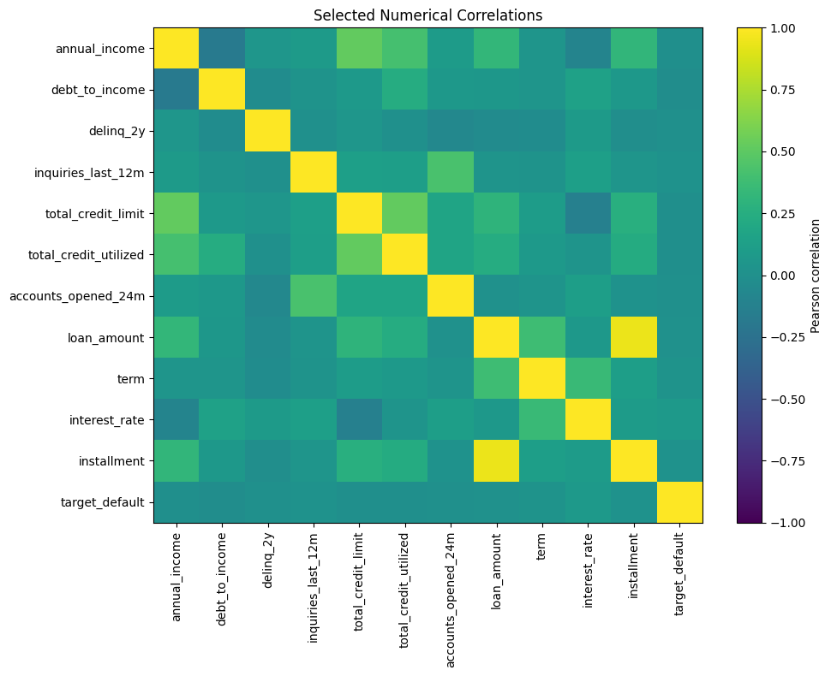
Figure 3. Correlation matrix for selected numerical variables after leakage exclusion. Source: author’s analysis.

3.4 Model Development and Imbalance Handling
The following three imbalance strategies are contrasted for each algorithm: no explicit imbalance, class weighting and random oversampling. Standard SMOTE was not applied after one-hot encoding because interpolating between nominal dummy variables can generate unrealistic fractional feature combinations. Random oversampling was therefore evaluated as the data-level balancing alternative. Logistic Regression hyperparameters included regularisation strength and L1/L2 penalty, while Random Forest were tree count, depth, feature sampling and minimum split/leaf sizes. Randomised search was performed with five-fold stratified cross validation and PR-AUC as refit criterion.
Table 3. Selected model configurations
Model | Selected strategy | Selected hyperparameters | Mean CV PR-AUC
Logistic Regression | No explicit balancing | L2 penalty; C = 0.1 | 0.0525
Random Forest | No explicit balancing | 150 trees; depth 14; min. leaf 10; max features √p | 0.0473

3.5 Evaluation, Interpretation and Fairness Audit
A traditional probability threshold of 0.50 was compared to a validation-derived decision threshold which maximised F2 using a larger weight for recall. The untouched test set was then finally tested only once with results such as accuracy, BA, default precision, default recall, F1, F2, ROC-AUC and PR-AUC and confusion matrices. Interpretation: integrated the results from logistic regression (coefficients and odds ratios) with those from Random Forest (permutation importance, partial dependence and SHAP). A descriptive proxy audit was performed to compare between homeownership, verified-income, application-type, grade, loan-purpose, state, and training-derived income bands each predicted-default rate, TP rate, and FP rate. These diagnostics were not considered conclusive that the law is fair, due to a lack of protected attributes and the fact that counts for subgroups are small.

4. Results and Discussion

4.1 Exploratory Findings
The result of the exploration confirmed an extreme value of the event rate at 1.11% (Figure 1). Joint-application variables and variables that documented the delinquency history had the most missingness, such as verification_income_joint, annual_income_joint and debt_to_income_joint had greater than 85% missing and months_since_90d_late and months_since_last_delinq had 77.15% and 56.58% missing respectively (Figure 2). Therefore, the limited sample was maintained in regard to the imputation of missing items, which was performed using the Median/mode method instead of observed zeros. The resulting correlation matrix revealed high correlation between loan amount, instalment and related credit quantities, but did not provide evidence of inclusion justifying the retention of repayment derived leakage fields (Figure 3).

4.2 Imbalance Strategies, Tuning and Generalisation
All the final models predicted zero defaults at the unadjusted threshold of 0.50. For the raw imbalance comparison, class weighting and random oversampling gave Logistic Regression 0.50 recall on the validation set but led to less PR-AUC (approx. 0.024 compared with 0.0316). Random Forest achieved its highest validation PR-AUC with no explicit balancing (0.0676). For this reason, those final pipelines were kept with the training distribution observed and decision-threshold tuning was only done by the validation set. This is a decision – not that resampling is generally ineffective but that there is evidence.
Logistic Regression with L2 regularisation (C=0.1) and Random Forest with 150 trees, max depth 14, min leaf size 10, n_features_squared_root) were chosen in cross-validation. Logistic Regression had a mean validation PR-AUC score of 0.0525 and Random Forest had a mean validation PR-AUC score of 0.0473. The training PR-AUC was 0.8533 which resulted in training-validation gap of 0.8060 as opposed to 0.0792 of Logistic Regression. This is a strong indication that the ensemble was overfitting; in the presence of regularisation, it could be said that the ensemble had learned some rare training patterns that did not generalise.
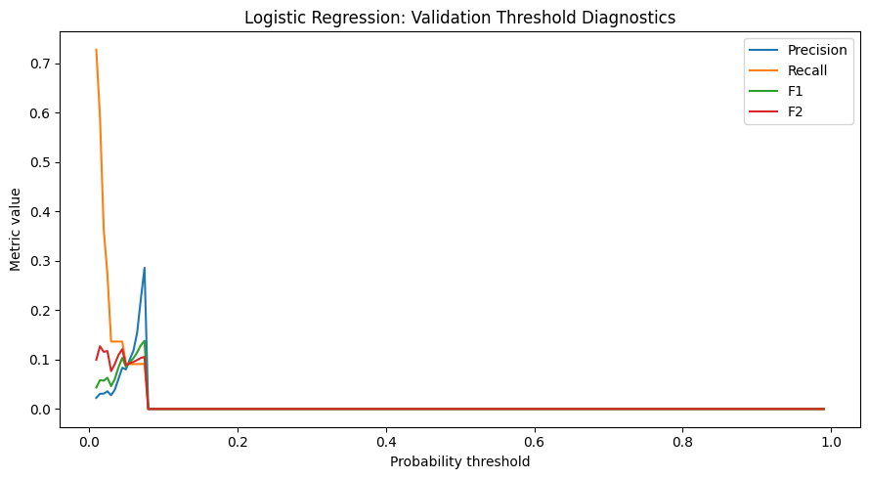 | 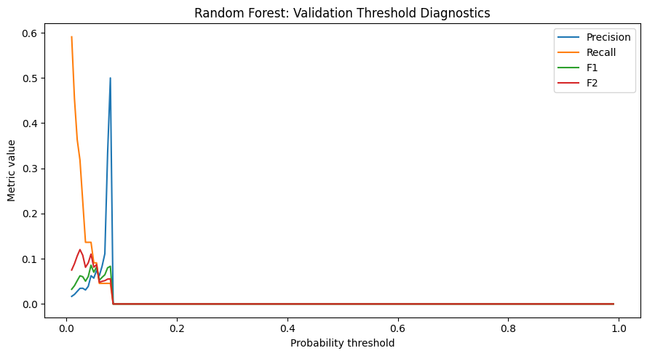
Figure 4. Logistic Regression validation-threshold diagnostics. | Figure 5. Random Forest validation-threshold diagnostics.

4.3 Final Model Comparison
Validation-set threshold analysis was used to select probability thresholds of 0.015 for Logistic Regression and 0.025 for Random Forest by maximising the F2-score (Figures 4 and 5). For the final test set, Logistic Regression's ROC-AUC was 0.7489 and PR-AUC was 0.0772, while Random Forest's ROC-AUC and PR-AUC were 0.7178 and 0.0369 respectively. So, it can be concluded that the Logistic Regression approach also gave superior threshold independent discrimination to the Random Forest approach, in the final run. However, both PR-AUC values surpassed the assumption of a "no-skill prevalence" of 0.0111, and absolute precision was below average given that the default rates were very low.
Table 4. Final test-set performance
Model / threshold | Accuracy | Balanced accuracy | Precision | Recall | F1 | F2 | ROC-AUC | PR-AUC
Logistic Regression / 0.015 | 0.8055 | 0.6095 | 0.0234 | 0.4091 | 0.0442 | 0.0951 | 0.7489 | 0.0772
Random Forest / 0.025 | 0.9015 | 0.5681 | 0.0270 | 0.2273 | 0.0483 | 0.0916 | 0.7178 | 0.0369

Logistic Regression achieved a recall score of 0.4091 (at 9 of its 22 detected defaults), a precision score of 0.0234 (376 false detected defaults), and a F1 score of 0.0442. Random Forest identified 5 defaults (recall 0.2273) and 180 false positive (precision 0.0270) with F1 score 0.0483. Therefore, slightly higher F1 and slightly higher overall accuracy was provided by Random Forest while Logistic Regression provided considerably higher recall, ROC-AUC and PR-AUC. As illustrated in the confusion matrices and ROC/Precision Recall curves (Figures 6-9), there isn't a single point that suggests one method is superior, since the value of trade-off will depend on how much money is lost for missing a default, wrongly paying for manual review, or restricting credit on a default incorrectly identified as safe.
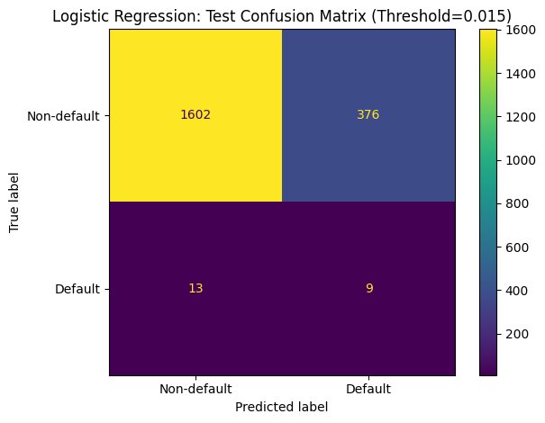 | 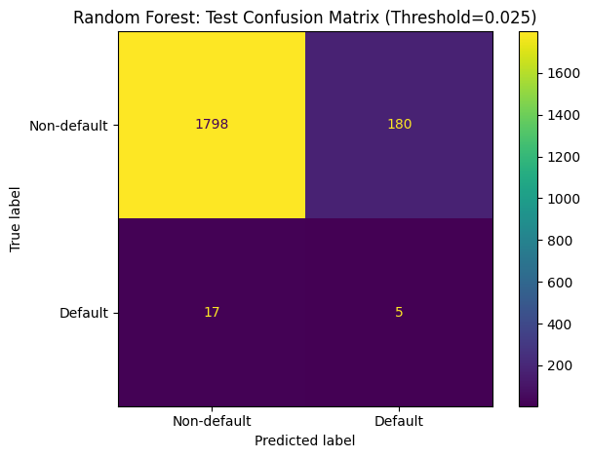
Figure 6. Logistic Regression test confusion matrix (threshold 0.015). | Figure 7. Random Forest test confusion matrix (threshold 0.025).
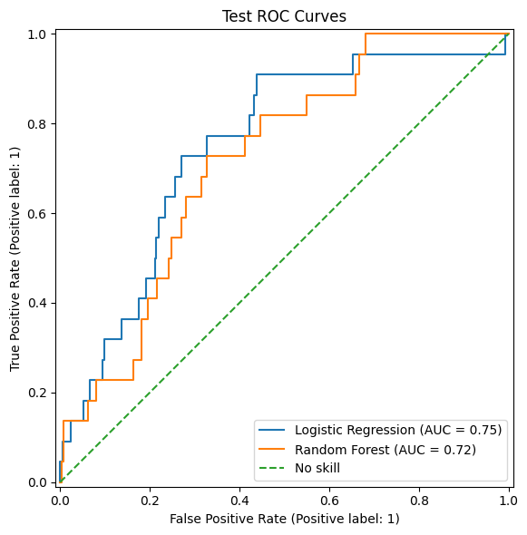 | 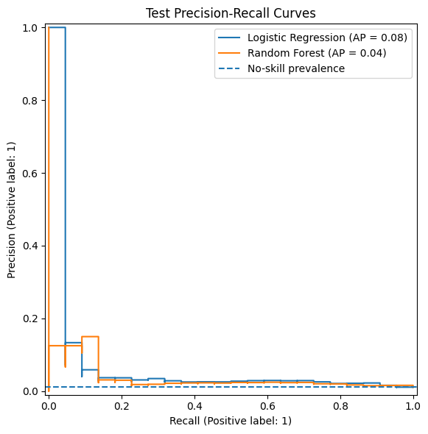
Figure 8. Test ROC curves. | Figure 9. Test precision-recall curves.

4.4 Model Interpretation
Logistic Regression showed that the largest positive coefficient was interest_rate (0.5402) with an odds ratio of 1.716 per one-standard-deviation increase. The multivariable fit showed that state_NY, sub_grade_D1, verified income and homeownership_OWN were all positively associated, while loan_purpose_debt_consolidation and debt_to_income were negatively correlated. These directions are not causal effects, but conditional ones, and the conditional associations may be unstable because of the small number of defaults used for training (67).
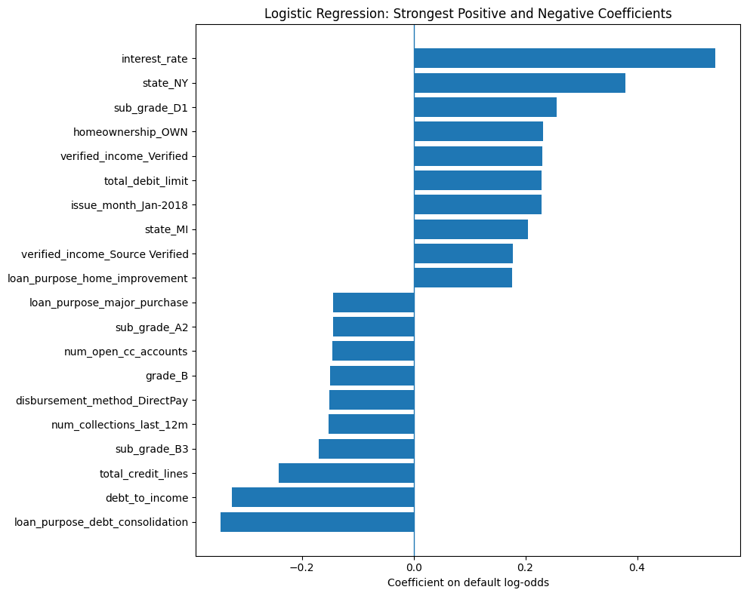
Figure 10. Strongest positive and negative Logistic Regression coefficients. Source: author’s analysis.
Permutation analysis on Random Forest also identified interest_rate to be the top among the variables, followed by months_since_last_credit_inquiry, installment, grade, issue_month and annual_income (Figure 11). SHAP validated variables of interest rate, debt-to-income, instalment, income, grade and credit-line. Partial-dependence plots showed a strong positive trend in model dependence at higher interest rates – the relationship became particularly salient at around 12 to 16% interest, a non-linear debt-to-income profile, and a strong positive trend at higher incomes. Cautions about causal interpretations of these patterns: Distinctiveness of interest rate and grade may reflect first a process of underwriting; closely correlated predictors may lead to misleading marginal explanations. Appendix A contains the complete figures for partial-dependence and SHAP effects.
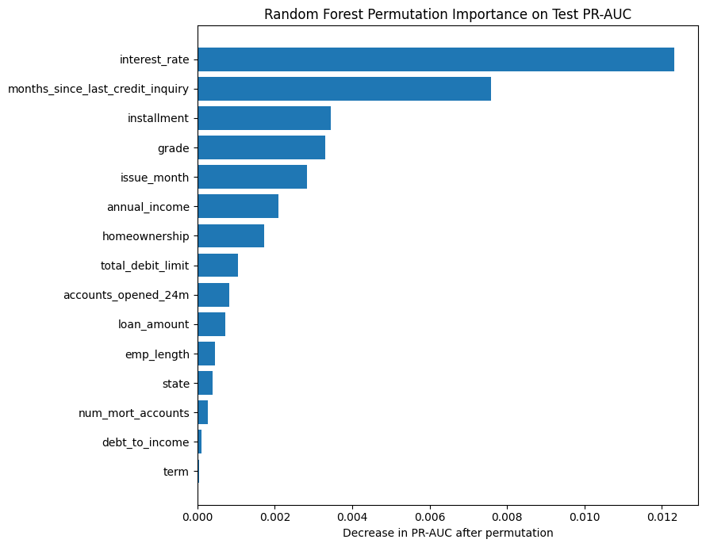
Figure 11. Random Forest permutation importance measured by test PR-AUC decrease. Source: author’s analysis.

4.5 Fairness, Ethics and Responsible Deployment
Native variation was found in predicted-default rates in the proxy audit. The predicted-default rates were 15.99% for mortgage holders, 21.82% for homeowners in the ‘Own’ category and 22.19% for renters. The rates were 8.41% for "no verification of the income source," 24.97% for "income source verified" and 27.63% for "verified income. The predicted default rates rose steadily by grade, from 4.95% for grade A to 53.33% for grade D to 72.13% for grade E. These are differences in model-produced outputs, not approval rates themselves and include two variables specifically created to reflect credit quality.
Table 5. Selected proxy-audit results for the Logistic Regression model
Proxy group | N | Actual default rate | Predicted default rate | Default TPR | False-positive rate
Homeownership: Mortgage | 932 | 0.64% | 15.99% | 33.33% | 15.87%
Homeownership: Rent | 793 | 1.26% | 22.19% | 50.00% | 21.84%
Verified income: Not verified | 761 | 0.79% | 8.41% | 0.00% | 8.48%
Verified income: Verified | 438 | 2.28% | 27.63% | 70.00% | 26.64%
Grade A | 525 | 0.19% | 4.95% | 0.00% | 4.96%
Grade D | 300 | 1.33% | 53.33% | 25.00% | 53.72%

There is no way for the audit to verify fairness. The test set only has 22 defaults, meaning that a few of the subgroup recall estimates are based on 1 or 2 observation(s). Information on gender, age and race was not available, and an error parity of protected groups was not directly tested. Furthermore, income, ownership of home, geographical location, verifications status, employment and grade could serve as a proxy for structural disadvantage. Hence, Responsible AI research suggests the use of context-specific fairness criteria, the monitoring and explicit analysis of the benefit-performance trade-off, and the avoidance of removal of sensitive field and assuming neutrality [11] [12].
Implement a controlled deployment process: Document training data–and targeted construction–Validate temporally and externally–Monitor calibration, drift and subgroup errors–Provide adverse-action explanations and appeals–Keep human accountable review process. This NIST AI Risk Management Framework highlights governance, metering and continued managing of trustworthiness hazards [13]. The evaluation of creditworthiness is also considered as a high-risk use under the European Union's AI Act, which further emphasizes the need for data governance, technical documentation, human oversight and performance monitoring [14].

4.6 Limitations and Robustness
There are some limitations in the ability to make empirical claims. Data to fit the model were sparse (67 default observations were available and 22 were used for final testing). Thus, recall, precision and rates or true positives in the subgroups could change significantly with a change of two or three cases. Single random split also estimates performance under the assumption that future loans are similar to the split time period. A temporally ordered out-of-time test is more useful than random hold-out validation alone for deployment because credit portfolios might be liable to changes in macroeconomic conditions, changes in policy and drift in borrower behaviour [1], [3]. There would also be stratified validation or bootstrap confidence intervals that would quantify the uncertainty for the reported metrics for repeated validations.
The result format adds further layer of uncertainty to the process. The current loans were classified as non-default and though a few loans were not due, rejected applications were excluded. The analysis thus captures distress in funded loans that is available at the available snapshot and not unconditional applicant creditworthiness. A threshold for validation was optimised for F2 and no assessment of a probability calibration was carried out. Finally, associations learned from this data set, such as coefficient, permutation, partial-dependence, or SHAP results, do not mean that alterations in the feature would impact default risk. However, these constraints have hindered the extent to which it could be adopted for direct operation even with the corrected methodology.

5. Conclusion and Recommendations

5.1 Conclusion
This study remedied the most evident flaws of the original draft formalizing the leakage from after the original, fitting the preprocessing only within training pipelines, encoding nominal predictor variables using one-hot encoding rather than label encoding, assessing imbalance strategies, interpreting results outside the test set, and extending the assessment of the minority class into multiple methods. Logistic Regression outperformed both Random Forest (ROC-AUC, PR-AUC and default recall) and tuned-threshold F1 (for Random Forest). Random Forest, although slightly better in (tuned-threshold F1, accuracy), has shown severe overfitting in the cross-validation. Given the lower precision and smaller number of events, the corrected evidence thus reinforces the idea that Logistic Regression should be the baseline for this set.

5.2 Recommendations
For operational applications, the model should be reconstructed from a larger, temporal order set of mature loan outcomes, with protected attributes, if allowed by law, for controlled fairness testing. Thresholds must be carefully designed using an explicit cost matrix and not just F2; reviewed within the context of portfolio risk appetite and manual-review capacity. A requirement for probability calibration, repeated or nested validation, external benchmarking, stability analysis and prospective monitoring. Some incorporation of the models along with actual policy guidelines and human judgment should be part of the production decision; the current models are not suitable to be applied as independent lending systems, merely as a means of comparison in academic studies.

5.3 Staged Implementation Roadmap
A ramped-up implementation pathway has been recommended. Firstly, create a regulated data dictionary, which types all features according to their presence or absence at application's run time, their origins, their missingness and possibly their proxiness. Second, retrain and validate candidate models using well-established, time-stamped cohorts, and out-of-time and external validation. Thirdly, test the chosen model as a decision support system with known rules of overrides, explanations of adverse-action decisions and/or escalation strategies for borderline cases. Fourth, track population stability, calibration, threshold outcomes, and subgroup error rates, and realised losses, to pre-approved limits. An investigation for drift or difference in material should be initiated, followed by recalibration or withdrawal, depending on the situation.

References
[1] V. Chang, S. Sivakulasingam, H. Wang, S. T. Wong, M. A. Ganatra, and J. Luo, “Credit risk prediction using machine learning and deep learning: A study on credit card customers,” Risks, vol. 12, no. 11, Art. no. 174, 2024. [Online]. Available: https://doi.org/10.3390/risks12110174
[2] Y. Song, Y. Wang, X. Ye, R. Zaretzki, and C. Liu, “Loan default prediction using a credit rating-specific and multi-objective ensemble learning scheme,” Information Sciences, vol. 629, pp. 599–617, 2023. [Online]. Available: https://doi.org/10.1016/j.ins.2023.02.014
[3] L. Coenen, W. Verbeke, and T. Guns, “Machine learning methods for short-term probability of default: A comparison of classification, regression and ranking methods,” Journal of the Operational Research Society, vol. 73, no. 1, pp. 191–206, 2022. [Online]. Available: https://doi.org/10.1080/01605682.2020.1865847
[4] M. Bücker, G. Szepannek, A. Gosiewska, and P. Biecek, “Transparency, auditability, and explainability of machine learning models in credit scoring,” Journal of the Operational Research Society, vol. 73, no. 1, pp. 70–90, 2022. [Online]. Available: https://doi.org/10.1080/01605682.2021.1922098
[5] A. Akinjole, O. Shobayo, J. Popoola, O. Okoyeigbo, and B. Ogunleye, “Ensemble-based machine learning algorithm for loan default risk prediction,” Mathematics, vol. 12, no. 21, Art. no. 3423, 2024. [Online]. Available: https://doi.org/10.3390/math12213423
[6] S. Kapoor and A. Narayanan, “Leakage and the reproducibility crisis in machine-learning-based science,” Patterns, vol. 4, no. 9, Art. no. 100804, 2023. [Online]. Available: https://doi.org/10.1016/j.patter.2023.100804
[7] H. He and E. A. Garcia, “Learning from imbalanced data,” IEEE Transactions on Knowledge and Data Engineering, vol. 21, no. 9, pp. 1263–1284, Sep. 2009. [Online]. Available: https://doi.org/10.1109/TKDE.2008.239
[8] T. Saito and M. Rehmsmeier, “The precision-recall plot is more informative than the ROC plot when evaluating binary classifiers on imbalanced datasets,” PLOS ONE, vol. 10, no. 3, Art. no. e0118432, 2015. [Online]. Available: https://doi.org/10.1371/journal.pone.0118432
[9] S. M. Lundberg and S.-I. Lee, “A unified approach to interpreting model predictions,” in Advances in Neural Information Processing Systems 30, 2017, pp. 4765–4774. [Online]. Available: https://proceedings.neurips.cc/paper_files/paper/2017/hash/8a20a8621978632d76c43dfd28b67767-Abstract.html
[10] C. Rudin, “Stop explaining black box machine learning models for high-stakes decisions and use interpretable models instead,” Nature Machine Intelligence, vol. 1, pp. 206–215, 2019. [Online]. Available: https://doi.org/10.1038/s42256-019-0048-x
[11] E. Purificato, F. Lorenzo, F. Fallucchi, and E. W. De Luca, “The use of responsible artificial intelligence techniques in the context of loan approval processes,” International Journal of Human–Computer Interaction, vol. 39, no. 7, pp. 1543–1562, 2023. [Online]. Available: https://doi.org/10.1080/10447318.2022.2081284
[12] N. Kozodoi, J. Jacob, and S. Lessmann, “Fairness in credit scoring: Assessment, implementation and profit implications,” European Journal of Operational Research, vol. 297, no. 3, pp. 1083–1094, 2022. [Online]. Available: https://doi.org/10.1016/j.ejor.2021.06.023
[13] E. Tabassi, Artificial Intelligence Risk Management Framework (AI RMF 1.0), NIST AI 100-1. Gaithersburg, MD, USA: National Institute of Standards and Technology, 2023. [Online]. Available: https://doi.org/10.6028/NIST.AI.100-1
[14] European Parliament and Council of the European Union, “Regulation (EU) 2024/1689 laying down harmonised rules on artificial intelligence (Artificial Intelligence Act),” Official Journal of the European Union, 2024. [Online]. Available: https://eur-lex.europa.eu/eli/reg/2024/1689/oj

Appendix A: Supplementary Interpretability Figures
The following figures are reproduced directly from the freshly executed, leakage-free Colab notebook. They supplement the interpretation in Section 4.4 and are not used to infer causality.
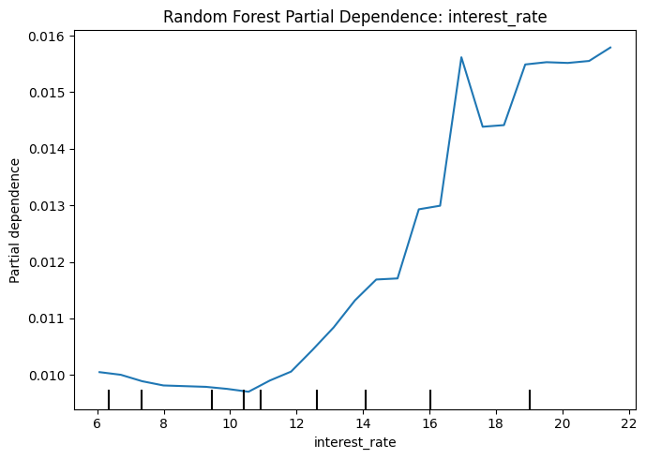
Figure A1. Random Forest partial dependence for interest rate.
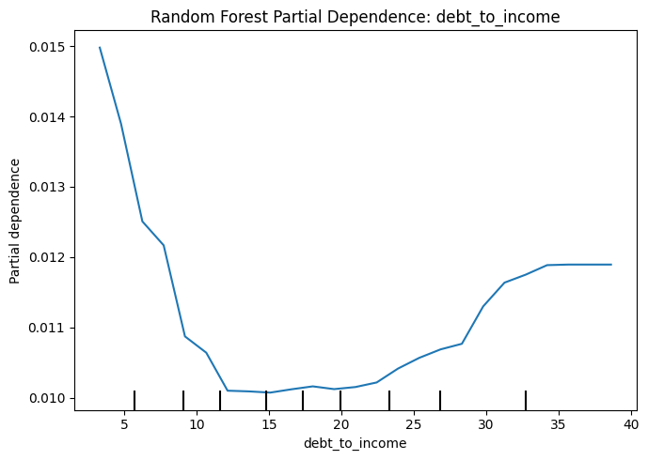
Figure A2. Random Forest partial dependence for debt-to-income ratio.
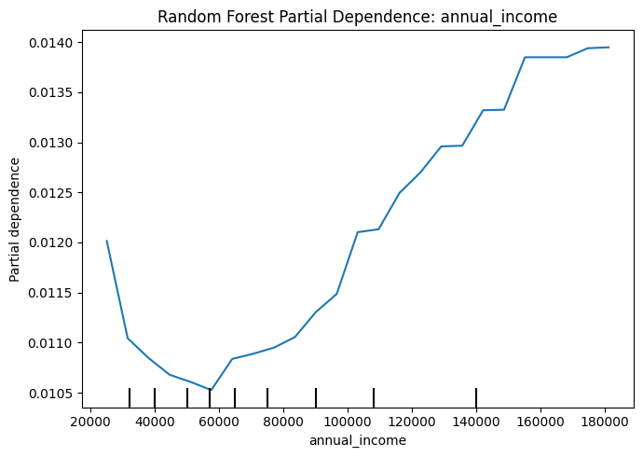
Figure A3. Random Forest partial dependence for annual income.
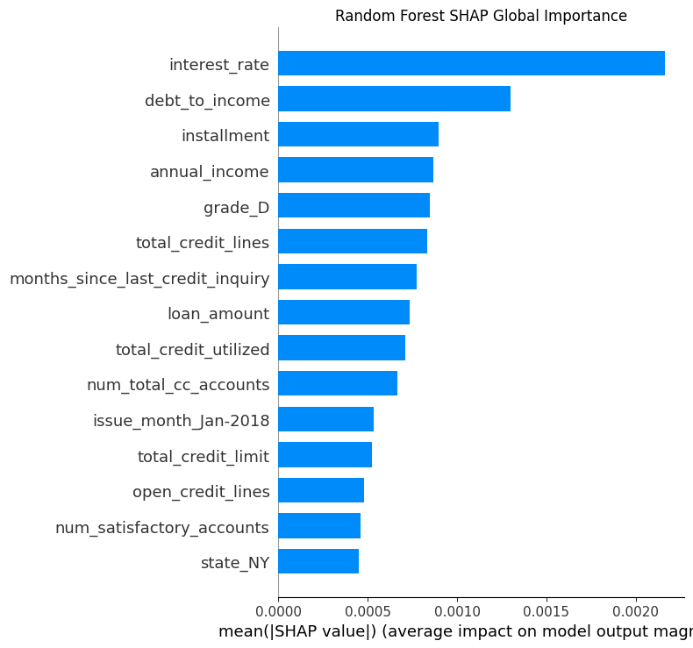
Figure A4. Random Forest SHAP global feature importance.

