Eco Bike Hub database design
Abstract: This report firstly discussed the SQL database and NO SQL database, compared them from many aspects, and then the Eco Bike Hub company's database entity-relationship was designed. This paper designed 12 tables including store information, customer information, employee information, reservation information ,and so on, and showed the relationship between them with clear diagrams. In addition, indexes and transaction was added to improve some questions existing in this database. Finally, a distributed database was also designed.
Keywords: SQL Database NO SQL Database Database Design

1.SQL and NoSQL databases
1.1 SQL Database
SQL database is a database management system based on relational model ^{[1]}. It is a relational database, which mainly uses the set algebra idea of mathematical concept to organize and manage data. Data structure, operation set and integrity constraint were included in the relational database.
In addition, one of the most important characteristics of relational database is transaction which is a complete logical process composed of a variety of database operations. ACID refers to Atomicity, Consistency, Isolation, and their synonyms for correctly executing database transactions.
- Atomicity: the execution of things is atomic, and the transaction will be rolled back to its initial state if an error occurs in the execution process;
- Consistency: before and after transaction execution, it is indispensable to guarantee that the integrity constraint of the database is unbroken;
- Isolation: when different transactions are executed concurrently, they are isolated from each other and not visible to each other. Transactions do not view data in the intermediate state.
- Persistence: After a transaction completes, the results of its operations on the database are persisted in the database permanently.
Relational databases maintain atomicity, consistency and persistence of transactions through logging, while transaction isolation is achieved through locking mechanism.

1.2 NO SQL Database
The traditional relational databases encounter performance bottlenecks when facing massive data. However, No SQL data can better solve the "four high" problems -- high concurrent reading and efficient access of massive data and high scalability and high availability of database ^{[2]}.
No SQL database is restricted by CAP theory, it is impossible to achieve the perfect design of high consistency, high availability and high fault tolerance of partition at the same time, but only two of them can be satisfied at most. CAP theory is shown in Figure 1.
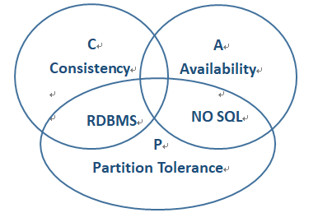
FIG. 1 CAP theory
Traditional relational databases choose high availability and consistency, which inevitably leads to poor partition performance, so the scalability of relational databases is poor ^{[1]}. No SQL databases, on the other hand, sacrifice strong consistency and usually only need to meet the ultimate weak consistency in exchange for the system's high partition fault tolerance and high availability.

1.3 Comparison between SQL Databases and NO SQL Databases
The main differences between the two ^{[1][3]} are shown in Table 1.
Table 1 Comparison of relational and non-relational databases
 | SQL | NO SQL
Storage | Stored in tables, tables are connected by keys | To store as a collection of data
Storage structure | Predefined structured data | Unstructured, based on dynamic structure, no need to define
Storage specification | High standard requirements, need to avoid data redundancy | Low normative requirements and often redundant data
Storage extension | Vertical scaling, limited by computer power | Scale-out and distributed storage has no upper limit on performance
Query | SQL language | There is no standard
Transaction | Transaction support is great | Weak transaction support
Performance | Data consistency results in poor read/write performance | Memory mapping, weak consistency requirements, fast read and write

2 Database Design
The following article designs entity relationship for the database of Eco Bike Hubs. Twelve entities were created according to the actual needs of the company, Including Customer table, Bicycle table, Booking table, WorkShop table, Rent table, Staff table, RentLevel table, Sell table, Shop table, Part table, Repair table and Mechanician table. Only the Booking table is shown in Figure 2, and the remaining tables are shown in Appendix 1.
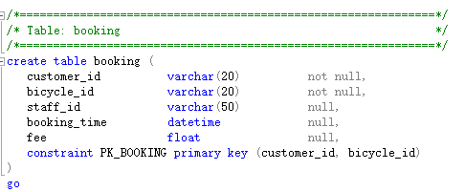
Figure 2 Data table
Among them, Shop table, Customer table and Staff table contain store details, Customer details and Staff details respectively. Information of all vehicles is stored in the Bicycle table, including its production information, related customer information and price. In addition, Booking information is recorded in detail in the Booking table, including booked customers, booked vehicles, Staff in charge of Booking, etc., which is closely related to Customer table, Bicycle table and Staff table. Finally, for the Rent table, Sell table, Part table and Repair table, they respectively contain the four specific information of bicycle rental business, second-hand bicycle sales business, bicycle accessories business and bicycle Repair business. The detailed relationship between tables is shown in Figure 3.
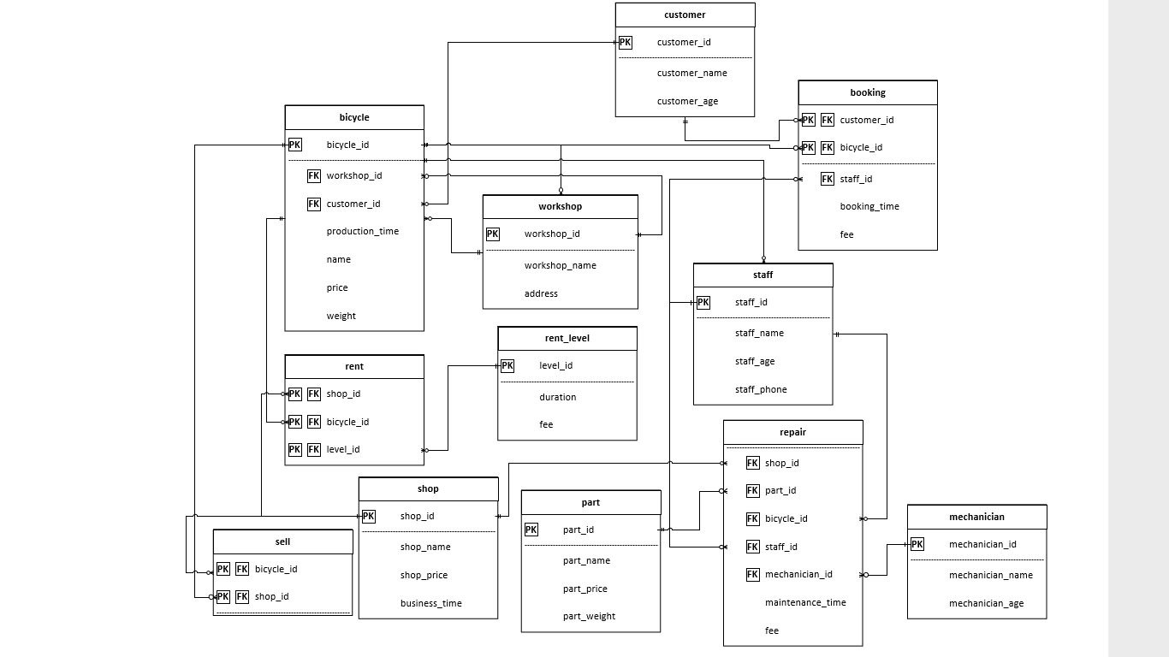
Figure 3 Data table relationships
3. Add index
As time goes by, the number of system users increases, and the latency of system operations increases significantly. Operations that can be completed at the second level are delayed for a long time during peak access hours. To solve this problem, we added indexes. An index is a data structure used to quickly find records. Indexes are critical for good performance, especially as the volume of data in business tables increases, and their impact on performance becomes more important. Therefore, index optimization is the most effective way to optimize query performance. A good index can easily improve query performance by several orders of magnitude.
Indexes mainly include normal indexes, unique indexes, full-text indexes, union indexes and primary key indexes. The common index can speed up the query. Unique index can not only speed up the query speed, but also limit the uniqueness of field values and allow them to be empty. Full-text index is mainly used for word segmentation of text content to speed up information query of text type. Joint index is an index composed of multiple columns, and the query efficiency is higher than the efficiency of multiple single-column index combination. A primary key index is similar to a unique index. Primary keys are unique and speed up queries, but cannot be empty. So we added the following indexes to solve the problems in the system:
Add the following indexes:
create index index_bicycle on bicycle(name,price,weight);
create index index_bicycle_name on index_bicycle(name);
create index index_bicycle_price on index_bicycle(price);
create index index_bicycle_weight on index_bicycle(weight);
For example, using secondary indexes can quickly increase the speed of fuzzy queries. SELECT name,price FROM bicycle WHERE name LIKE 'S%'; Shown in SQL as Figure 4:
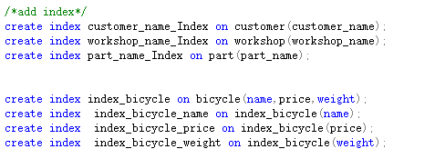
Figure 4 Index information

4. The transaction
In the process of database operation, sometimes to execute a SQL statement block, there may be one or several statements due to unexpected failure and interrupted execution, so there is to be able to produce inconsistent data in the database, the solution to this problem is database transactions.
A transaction in a database is a set of T-SQL statements, which must be executed as a whole. Either each statement is executed successfully, or a statement is not executed unexpectedly, then all operations are restored and the database is restored to the state before the statement was executed. The transaction starts with BEGIN TRAN and ends with a COMMIT TRAN or ROLLBACK TRAN statement.
Add the property return_goods_date, return_date indicates the time to return the reservation information and the time to return the maintenance reservation respectively. Set a property is_register on the bike. If the value is null or 0, it is not registered and will be read during the transaction. The transaction is committed if is_register > 0 and rolled back if <0. See Figure 5 below for details in SQL:
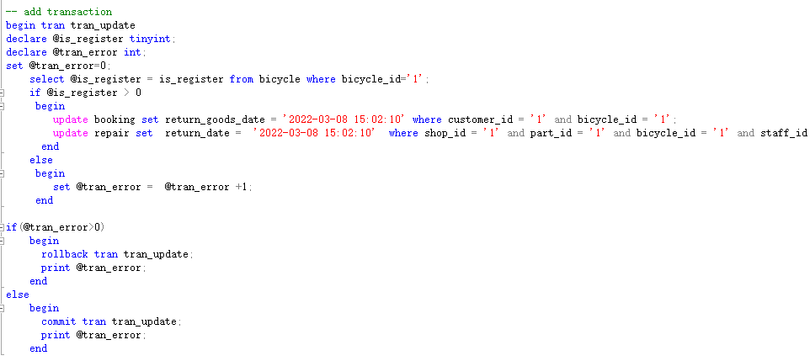
Figure 5 Transactions

5. Distributed database
With the deepening of enterprise informatization, business data keeps accumulating and becoming larger and larger, and centralized database enters the bottleneck period, which is manifested as slow system response, poor user experience, difficult data space expansion, and system performance decline when multiple users are concurrent, etc. Traditionally, distributed database is used to solve such problems.
Distributed database is composed of independent database systems which are distributed in different network sites and are logically connected to each site through computer network. Distributed database can adjust its structure and expand its function flexibly for different application fields. In different application scenarios, its structure, function and efficiency are widely different, and its design ideas are also different.  
The design goal of this system is a relational database (SQL) distributed system, it divides the table according to certain rules into several pieces, each piece is a is the same as the original table structure, part stores the data table, are stored in different SQL server, provides an entry on the slice of the data on the add and delete operation.
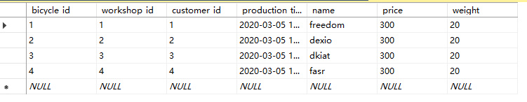
Figure 6 Bicycle table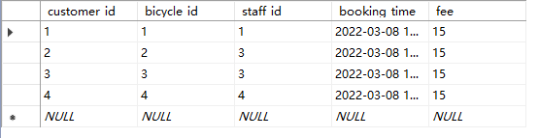
Figure 7 Booking table
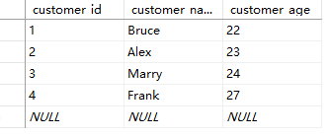
Figure 8 Customer table
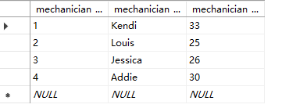
Figure 9 Mechanician table 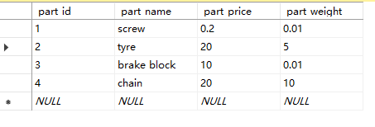
Figure 10 Part table
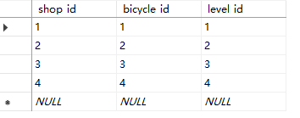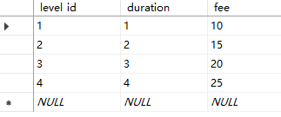
Figure 11 Rent table and Rent-level table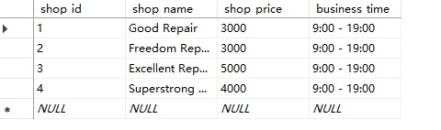
Figure 12 Shop table
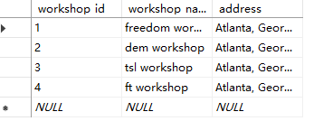
Figure 13 WorkShop table
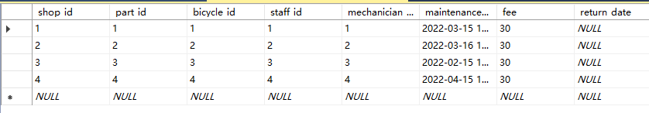
Figure 14 Repair table 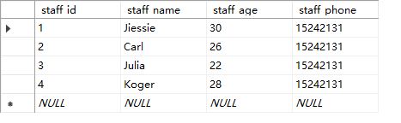
Figure 15 Staff table

6. SQL Screenshot
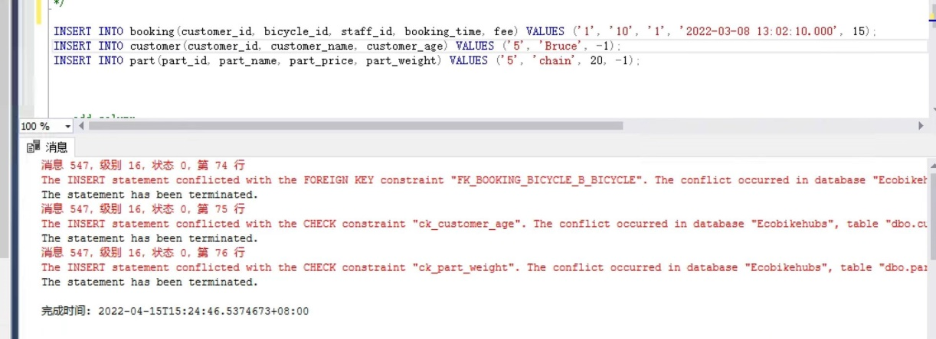
Figure 16 illustrates the foreign key constraint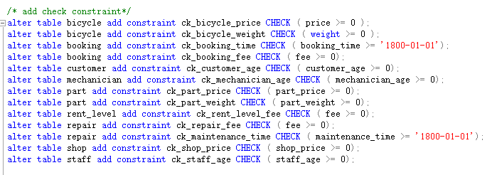
Figure 17 Check constraints

Reference
[1] Li Y , Manoharan S . A performance comparison of SQL and NoSQL databases[C]// IEEE. IEEE, 2013.
[2] Jing, H. , Haihong, E. , Guan, L. , & Jian, D. . Survey on NoSQL database. 2011 6th International Conference on Pervasive Computing and Applications. IEEE.
[3] Parker Z , Poe S , Vrbsky S V . Comparing nosql mongodb to an sql db[C]// Proceedings of the 51st ACM Southeast Conference. ACM, 2013.

Appendix 1


