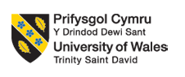

Programme: Master of Business Administration
Module: Human Capital Management
Module Code: LCMB7023
Lecturer’s Name: Dr. Lakshani Mendis (London)

Assignment Title: Assessment component 1: Individual report – HR strategy
Word Count: 2525

Topic: Integrated Human Capital Blueprint

Student Name: Jay Shaileshbhai Patel
Student I’D: 2529400

Table of Contents
Part 1: Option 2: Building a culture of innovation and future work practices 3
• Recent practices in culture and work among tech companies 3
• Recommendations of cultural and structural initiatives that embedded innovation 4
• Propose a Future of Work Model 6
• How a new approach motivates and activates to perform properly 8
Part 2: Reflection writing 9
• My learning journey in this module and how they provided me a baseline to design proper L&D approaches using Gibbs reflective cycle 9
• My plan is to stay relevant as AI is increasingly capable of handling jobs and positions, and to what extent I can use AI 11
References 13

Part 1: Option 2: Building a culture of innovation and future work practices

Recent practices in culture and work among tech companies
Organisational culture is instrumental in the modern digital economy in influencing the innovation, engagement of employees and organisational performance. The business environment of technology companies is very dynamic and competitive, so the process of innovation is quite quick, and learning is an ongoing process. Consequently, the culture of most technology giants has moved towards experimentation, teamwork, independence and safety of mind (Decker et al. 2025).

Emphasis on innovation-driven organisational values is one of the widely recognised characteristics of the technology company culture. Studies have shown that companies which emphasise innovative cultures have a much higher chance of attaining high financial performance and product development results. A global study conducted by Maity and Lee (2025) states that organisations that have a solid innovation culture have three times higher chances of beating competitors in increased revenue.

As argued by Tenakwah and Otchere-Ankrah (2024), psychological safety is a major constituent in the innovation culture, and the notion is extensively debated in the organisational behaviour literature. Psychological safety is a condition in which employees feel free to communicate and raise ideas, ask questions, and own errors without having to be punished. In a famous research conducted by Google under the name Project Aristotle, it was revealed that psychological safety was the key variable that affected team performance in the company. High levels of psychological safety in teams showed that they had stronger collaboration, more output in innovation and greater performance results.

Continuous learning and skill development is another popular practise, as technological change is happening fast and employees should keep up with the current developments by updating their knowledge. Training of companies like Amazon and Microsoft, in learning platforms, technical training and programmes of leadership development are costly. As influenced by Doargajudhur et al. (2026), when organisations invest in the career development of their employees, 94% of them would remain longer in the organisation.
Thus, a review of the cultural practises of the top technology organisations will offer useful insights to Aether Innovations. Learning about the way innovation-driven cultures work in successful companies will help the organisation focus on the gap existing in its current practises and devise the methods to enhance the level of collaboration, engagement, and creativity within the workforce.

Recommendations of cultural and structural initiatives that embedded innovation
Inculcating innovation into an organisation does not just entail promoting innovativeness, as it entails the designing of cultural norms, leadership behaviours and organisational structures that are perpetually favourable to experimentation and idea generation. In the case of Aether Innovations, the company may use specific cultural and structural programmes to overcome the existing performance issues.

The introduction of innovation sprints or hackathons is one of the effective initiatives that are common in technology companies. Innovation sprints are brief, intensive sessions that involve the employees working hard to come up with new ideas, prototypes, or solutions to certain organisational issues (Stasiła-Sieradzka et al. 2023). Other companies like Google and Facebook hold regular internal hackathons where members of various departments come together to work on experimental projects. According to research conducted by Prasoppokakorn and Prasittisopin (2026), innovation sprints have the potential to solve the problem of employee engagement, as well as speed up the development of products by promoting quick experiments. In the case of Aether Innovations, innovation sprints would offer workers formal chances to find creative solutions to product, service, or internal process improvement. This would also enhance teamwork and generate a feeling of the organisation's purpose as well.

The other significant initiative is the creation of intrapreneurship programmes, as the term intrapreneurship denotes the promotion of employees to be business-like in the organisation by inspiring new ideas, services, or technologies. Firms like 3M and Google have long advocated intrapreneurship by sponsoring projects like the notorious 20% time policy, which allows employees to devote some of their time to test the viability of new ideas not necessarily within the scope of their usual job (Doargajudhur et al. 2026). It is worth noting that a number of successful products like Gmail and Google Maps came through this effort. For example, Apple and Tesla are companies that have a distinct cross-functional partnership between engineers, designers, marketing specialists, and product managers to come up with innovative products. It has been found that organisations employing cross-functional teams are approximately 35% more apt to provide successful innovation results since they blend divergent views and competencies. Lastly, organisations that want to incorporate innovation should have recognition and reward systems that support creative behaviour. The conventional performance management systems are usually short-term, productivity-oriented, as opposed to an experimental orientation. Nevertheless, innovation must have employees trying out new ideas, and this can turn out to be unsuccessful. Innovation reward systems have been introduced by companies like Adobe that reward employees who have come up with new solutions or improvements to the processes. Thus, this may be applied in Aether Innovations to reward mechanisms that may be implemented by the company, which can motivate the employees to engage in innovation initiatives.

Propose a Future of Work Model
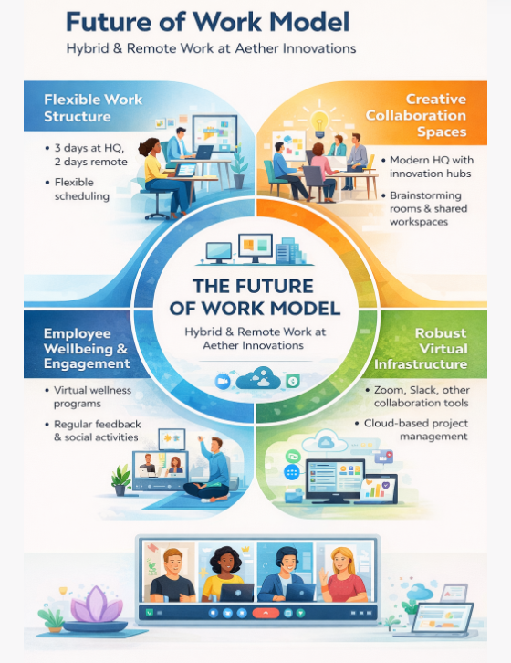
Figure 1: The Future of Work Model (hybrid/remote)
(Source: Self-created)
The above image shows that an effective future of work model is critical to technology organisations interested in ensuring that they continue to be innovative, employee engagement is enhanced, and organisational performance is boosted. The hybrid and remote work model proposed by Aether Innovations is a blend of flexible work format, collocated workspaces, digital infrastructure, and employee well-being programmes (Tahlyan et al. 2024). This model of integration allows employees to work efficiently and at the same time retain their independence and flexibility, which are principal creativities in contemporary organisations.

The first part of the model is the flexible work structure, which gives employees the option to work in the office and remotely. The diagram suggests that it can be a system of three days in the company headquarters and two days at home. The hybrid working has become a trend in the technology industry. A global workforce research by Nikiforova et al. (2023) found that about 71% of digital organisations currently have hybrid work models, since they allow a balance between collaboration and flexibility. Hybrid work also enhances the retention rate of employees and a study conducted by the International Workplace Group indicates 72% of employees believe that a flexible working arrangement is a significant consideration when selecting an employer (Waldrep et al. 2024). In the case of Aether Innovations, this would help decrease turnover rate with employees because of better work-life balance and job satisfaction.

The second factor is the establishment of innovative partnership areas in the head offices of the organisation. Innovation spaces, brainstorming and workrooms help to allow the interaction and sharing of ideas between employees in various teams. Such areas embrace spontaneous discussions and problem-solving, which are crucial in innovation. In a study conducted by Selvaraju and Anuar (2024), it was discovered that firms employing organised team workspaces registered a 25% growth in knowledge sharing across teams. In the case of Aether Innovations, the spaces would enable the engineers, designers and product managers to collaborate on customer-oriented innovations. Lastly, the model focuses on both employee well-being and engagement programmes, as online social, feedback sessions and virtual wellness programmes assist in sustaining good interpersonal relationships. According to a study conducted by Newbold et al. (2022), high employee engagement in organisations results in profitability, which is 23% greater and productivity, which is 18% greater, in comparison to organisations which are less engaged.

How a new approach motivates and activate to perform properly
Innovation-oriented culture and a hybrid work model suggest that there is a high potential for increasing employee motivation and performance at Aether Innovations. Motivation theories argue that employees would work better when they feel autonomous, recognised, meaningfully working, and have growth opportunities. Such elements are incorporated in the new organisational approach in terms of flexible working arrangements, collaborative working conditions, and innovative practises.

Firstly, the hybrid work arrangement enhances worker independence and work-life balance, which are key motivational elements. The flexibility in the schedule enables the employees to cope better with the tasks, and it minimises the commuter stress and time pressure. According to the study conducted by Tahlyan et al. (2024), organisations that embrace flexible work models record increased employee satisfaction and engagement rates up to 20%. Increased engagement has the tendency to result in better productivity and reduced turnover.

Secondly, innovation programmes like innovation sprints, intrapreneurship programmes, and cross-functional teams are innovation initiatives that encourage employees to give new ideas and take part in decision-making processes. Once employees realise that their ideas are appreciated, they will be more dedicated to organisational objectives. Research shows that, on average, firms that promote innovation among employees produce around 30% of new product ideas as opposed to conventional hierarchical firms (Doargajudhur et al. 2026).

Moreover, digital collaboration tools and mutual work areas improve communication and knowledge sharing among teams. Such an environment helps the employees to address issues more efficiently and work out innovative ways out of the predicament of the customer. Together with wellbeing programmes and recognition systems, the practices result in a positive working environment where staff members are encouraged to deliver their potential and help in the ongoing organisational innovation.

Part 2: Reflection writing

My learning journey in this module and how they provide me a baseline to design proper L&D approaches using Gibbs reflective cycle
Description
In this Human Capital Management module, I gained a better insight into the role of people management practises in determining the performance of the organisation, its innovation and employee engagement. It is in the module that several key concepts were introduced, including strategic HRM, organisational culture, talent management, employee motivation and performance management systems (Ahmadpour et al. 2025). I studied the way human capital strategies can be used to directly achieve business objectives through lectures, readings, and discussions of cases. Among the most critical things I learnt during the module was that organisations cannot only succeed by using technology or products but also by managing people and skills in an effective way.
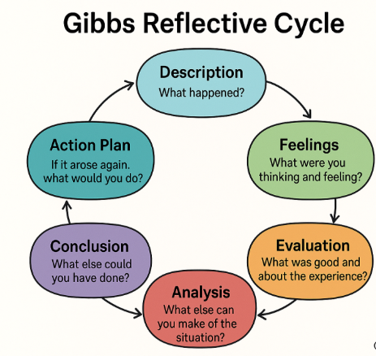
Figure 2: Gibbs Reflective Cycle
(Source: Ahmadpour et al. 2025)
Feelings
Early in the module, I believed that the primary HRM activity was on the administrative aspects, like training and recruitment. Nevertheless, my opinion was altered dramatically as the module went on. I started to realise that HRM has a strategic contribution to influencing organisational culture and eventual competitiveness. I was interested in certain issues, including the culture of innovation, employee motivation, and leadership development, in particular, as they are directly associated with organisational success.

As I acquired these concepts, I also knew that people management in contemporary organisations is not an easy task. Global competition, workforce changes and rapid technological changes demand that organisations keep changing their HR practises.

Evaluation
The learning process in this module was generally very helpful, as the module was able to relate the theoretical aspects of academics and practical organisational challenges. Theory tools like Job Characteristics Model, employee engagement strategies and innovation culture models assisted me to learn how HR can be utilised in practise (Maity and Lee, 2025).

The focus on the relationship between theory and real business cases was one of the positive elements of the module. This strategy enabled me to observe the ways companies apply HR measures to address issues of high turnover or low engagement. In fact, the discussion about innovation culture revealed how organisations stimulate staff to exchange their ideas and try new solutions.

Analysis
The education of this course gave me a powerful background in developing my learning and development plans. Among the lessons learned is that ongoing learning is critical to professionals who desire to be relevant in contemporary organisations (Maity and Lee, 2025). High amounts of innovation and employee engagement are frequently attained through organisations that encourage learning cultures.
The other important idea that formed in my mind was the need to cultivate a mindset that could be applied in terms of growth. Growth mentality helps one to look at a problem as a chance to learn instead of a hindrance. This viewpoint is especially significant in the dynamic industries where skills and knowledge are dynamic. Personally, I understood that technical knowledge alone cannot make a person successful in his or her place of work. There are also other skills like communication, teamwork, problem solving and leadership which are also important.

Conclusion
This module has played a big part in enhancing my knowledge of strategic human capital management and its contribution towards organisational success. The learning process has made me understand that effective HR practises can enhance the motivation of employees, promote innovation, and make organisations perform well. I also got to know that to build a culture of continuous learning is necessary not only for organisations but also for individuals. Using the skills acquired during this module, I will be able to develop my own learning and development strategy that will facilitate my professional development and enable me to become a valuable member of future organisations.

Action Plan
In accordance with the experience of this module, I will employ two strategies to grow my skills and sustain the growth mindset. First, I will be reading and reviewing scholarly literature and industry reports on the issue of human resource management, leadership and organisational behaviour. This will enable me to keep up with the trend and best practises. Second, I will acquire useful skills in the areas of communication, teamwork, and problem-solving through professional training and through working on a team. These are the skills required in dealing with individuals and leading creative teams.

My plan is to stay relevant as AI is increasingly capable of handling jobs and positions, and to what extent I can use AI
AI is shifting the trend of numerous sectors and altering the character of work. The AI systems have become more effective in performing many of the traditional tasks like data processing, scheduling and routine analysis. This revolution in technology presents opportunities and challenges to professionals. As an AI-driven workplace, one should also prioritise the skills that are not simple to substitute with technology. Critical thinking, creativity, emotional intelligence, leadership and complex problem-solving are all human abilities that are still vital in contemporary organisations. Skills enable professionals to comprehend information, deal with individuals, and make strategic decisions which involve human judgment.

In the future, I will employ AI as an aiding tool and not as a substitute for human decision-making in my future profession. AI systems can be used to process large volumes of data, draw trends, and present information that can be used to make improved decisions. As an illustration, AI can assist HR members in interpreting the data on employee engagement, anticipating trends in a workforce, and enhancing hiring operations based on data.

To successfully collaborate with AI, I will train my digital literacy and analytical skills that will enable me to comprehend the functioning of AI systems and how they can be utilised responsibly. Meanwhile, I would concentrate on developing interpersonal ability, leadership and strategic thinking.

References
Ahmadpour, N., Shariati, A. and Moghadam, M.P., (2025). Effect of narrative writing based on Gibbs’ reflective model on the empathy and communication skills of nursing students. BMC Medical Education, 25(1), p.10. DOI: https://doi.org/10.1097/CCM.000000000000164
Decker, G., Butler, W.P. and Meriac, J.P., (2025). Best of Both Worlds: The Benefits of Hybrid Work Compared With Remote and In‐Person Roles. Human Resource Management, 64(6), pp.1803-1814. DOI: https://doi.org/10.1002/hrm.70013
Doargajudhur, M., Lichy, J., Hardin-Ramanan, S., Brodie, J., Huzooree, G., Dutot, V. and Hosanoo, Z., (2026). Hybrid work and HRM practice in a global south context: a job demands-resources perspective. Journal of Management Development, pp.1-21. DOI: https://doi.org/10.1108/JMD-10-2025-0546
Maity, R. and Lee, K.L., (2025). The impact of remote and hybrid work models on small and Medium-sized enterprises productivity: a systematic literature review. SN Business & Economics, 5(10), p.158. DOI: https://doi.org/10.1080/09540962.2020.1764206
Newbold, J.W., Rudnicka, A., Cook, D., Cecchinato, M.E., Gould, S.J. and Cox, A.L., (2022). The new normals of work: a framework for understanding responses to disruptions created by new futures of work. Human–Computer Interaction, 37(6), pp.508-531. DOI: https://doi.org/10.1080/07370024.2021.1982391
Nikiforova, O., Zabiniako, V., Garkalns, P.Ā.V.E.L.S., Kornienko, J.U.R.I.J.S., Nikulsins, V.L.A.D.I.M.I.R.S. and Romanovs, A., (2023). Monitoring and calibrating the efficiency of the remote and hybrid remote work. WSEAS Transactions on Systems, 22, pp.463-474. DOI: 10.37394/23202.2023.22.48
Prasoppokakorn, T. and Prasittisopin, L., (2026). Hybrid work in post-pandemic world (impact on AEC professionals): current trend and unexplored topics. AI & SOCIETY, pp.1-13. DOI: https://doi.org/10.14246/irspsd.11.4_185
Selvaraju, P. and Anuar, M.A.M., (2024). Exploring the impact of hybrid and remote work models on business efficiency and employee Well-being: A scoping review. International Journal of Academic Research in Business and Social Sciences, 14(6), pp.1564-1576. DOI: http://dx.doi.org/10.6007/IJARBSS/v14-i6/21842
Stasiła-Sieradzka, M., Sanecka, E. and Turska, E., (2023). Not so good hybrid work model? Resource losses and gains since the outbreak of the COVID-19 pandemic and job burnout among non-remote, hybrid, and remote employees. International Journal of Occupational Medicine and Environmental Health, 36(2), p.229. DOI: https://doi.org/10.13075/ijomeh.1896.02026
Tahlyan, D., Mahmassani, H., Stathopoulos, A., Said, M., Shaheen, S., Walker, J. and Johnson, B., (2024). In-person, hybrid or remote? Employers’ perspectives on the future of work post-pandemic. Transportation Research Part A: Policy and Practice, 190, p.104273. DOI: https://doi.org/10.1016/j.tra.2024.104273
Tenakwah, E.S. and Otchere-Ankrah, B., (2024). The rise of the distributed workforce: strategic HR’s role in optimising hybrid and remote models. Strategic HR Review, 23(6), pp.211-216. DOI: https://doi.org/10.1108/SHR-05-2024-0034
Waldrep, C.E., Fritz, M. and Glass, J., (2024). Preferences for remote and hybrid work: Evidence from the COVID-19 pandemic. Social sciences, 13(6), p.303. DOI: https://doi.org/10.3390/socsci13060303

