

Student Name: Belly Calderon Crisostomo
Student Number:2333264
Course Name: Business Intelligence
Lecturer Name: Dr Xavier Matieni
Session: June 2026 Term

Table of Contents
INTRODUCTION 4
Trends in Business Intelligence (BI), Data Warehousing (DW), and Data Mining (DM). 5
Data Warehousing in the Organisation Application (Chanel)al., 6
Predictive Analysis 12
Ethical and Data Security Considerations 13
Reporting and Dashboard Solutions 15
Conclusion 16
References (Harvard Style) 17
Appendices 18
Appendix A – Proposed Data Warehouse Architecture for Chanel 18
Appendix B – CRISP-DM Framework 18
Appendix C – Sample Power BI Dashboard 18

Executive Summary
This report critically evaluates the role of Business Intelligence (BI), Data Warehousing (DW), and Data Mining (DM) in supporting strategic decision-making within Chanel, one of the world’s leading luxury fashion companies. Operating in a highly competitive global luxury retail market, Chanel generates vast amounts of customer, sales, inventory, marketing, and supply chain data across boutiques, e-commerce platforms, and digital channels. Effectively analysing this information enables the organisation to improve operational efficiency, customer experience, and long-term profitability.
The report first explains the concepts of Business Intelligence, Data Warehousing, and Data Mining while discussing current technological trends including artificial intelligence (AI), cloud data warehousing, real-time analytics, and predictive analytics. It then evaluates how a centralised data warehouse could support Chanel by integrating data from multiple business functions to improve reporting, forecasting, and executive decision-making.
The report also analyses suitable data mining techniques such as customer segmentation and association rule mining to improve personalised marketing and product recommendations..
Furthermore, ethical considerations surrounding GDPR compliance, customer privacy, cybersecurity, and data governance are examined. Finally, the report recommends interactives BI dashboards that provide executives with real -time insights into key performance indicators (KPIs) enabling faster and more informed strategic decisions.
(Sharda, Delen and Turban,2023)

INTRODUCTION

Founded in 1910 by Gabrielle “Coco” Chanel, Chanel is recognised as one of the world’s most prestigious luxury fashion houses. The company operates globally through boutiques, online retail platforms, beauty stores, and authorised distributors, offering luxury handbags, ready-to-wear fashion, fragrances, cosmetics, jewellery, and accessories. As a global luxury retailer, Chanel generates significant volumes of transactional and customer data every day, creating opportunities to leverage Business Intelligence (BI) technologies to improve organisational performance.
The purpose of this report is to critically evaluate how Business Intelligence, Data Warehousing, and Data Mining can support Chanel’s strategic and operational decision-making. The report examines current BI trends, explores the application of data warehousing within Chanel, evaluates suitable data mining techniques, discusses predictive analytics solutions, considers ethical and security challenges, and recommends dashboard reporting tools that can improve organisational performance and competitive advantage within the luxury retail industry.
(Chanel, 2025)

Trends in Business Intelligence (BI), Data Warehousing (DW), and Data Mining (DM).

Business Intelligence (BI) refers to the technologies, applications, and processes used to collect, analyse, and present business data to support informed decision-making (Sharda et al., 2023). Data Warehousing (DW) is a centralised repository that integrates data from multiple sources, enabling organisations to analyse historical and current business information efficiently (Kimball and Ross, 2020). Data Mining (DM) involves discovering hidden patterns, trends, and relationships within large datasets using statistical and machine learning techniques (Han et al., 2022).
Within the luxury retail industry, Chanel uses modern BI technologies to strengthen decision-making and maintain a competitive advantage. One key trend is real-time Business Intelligence, which enables managers to monitor sales performance, customer demand, and inventory levels instantly. This allows Chanel to respond quickly to changing consumer preferences, particularly during new product launches and seasonal collections.
Another important trend is cloud data warehousing, which stores and manages business data on secure cloud platforms instead of traditional on-premises systems. Cloud-based solutions improve scalability, collaboration, accessibility, and operational efficiency across Chanel’s global business operations.
Artificial Intelligence (AI) has also transformed Business Intelligence by enabling predictive analytics, customer segmentation, demand forecasting, and personalised shopping experiences. AI-powered insights help Chanel understand customer purchasing behaviour, automate reporting, and make faster, data-driven strategic decisions.
Theoretical frameworks further support these technologies. Kimball’s Data Warehouse Architecture integrates sales, Customer Relationship Management (CRM), inventory, marketing, and supply chain data into a unified repository for efficient analysis (Kimball and Ross, 2020). Additionally, the CRISP-DM (Cross-Industry Standard Process for Data Mining) framework provides a structured process for analysing customer data and developing predictive models that support business objectives (Han et al., 2022).
.

Data Warehousing in the Organisation Application (Chanel)a

l.,
Data warehousing is the process of collecting, integrating, and storing data from multiple business systems into a central repository to support reporting, business analysis, and strategic decision-making (Kimball and Ross, 2020)
Advantages (Good Points)

1. Better Decision-Making A centralised data warehouse allows Chanel’s managers to access accurate and up-to-date information from different departments. This enables faster and more informed strategic decisions regarding product launches, pricing, inventory, and customer preferences.

2. Improved Customer Insights By integrating customer purchase history, Chanel can identify buying patterns, customer preferences, and seasonal trends. This helps the company create personalised marketing campaigns, improve customer loyalty, and increase repeat purchases.

3. Efficient Inventory Management Data warehousing helps Chanel monitor inventory across its global boutiques and online stores. This also reduces stock shortages and overstocking.

.

Disadvantages (Bad Points)

1. High Implementation Cost Building and maintaining a data warehouse requires significant investment in software, cloud infrastructure, skilled employees, and ongoing maintenance.

2. Complex Data Integration Chanel collects data from boutiques, websites, CRM systems, finance, and supply chain operations worldwide. Integrating these different systems can be technically difficult and time-consuming.

3. Cybersecurity Risks Because customer and financial information is stored in one central location, the data warehouse becomes an attractive target for cyberattacks. ons.

Limitations of Data Warehousing at Chanel Although data warehousing provides valuable business insights, it has several limitations.

* A data warehouse mainly analyses historical data and may not always reflect sudden changes in customer behaviour or luxury fashion trends.

* Predictive models depend on the quality of the stored data. Incorrect or outdated data can produce inaccurate forecasts.

* Developing and updating the system requires continuous investment in technology and skilled professionals.

* Integrating data from multiple global operations may result in delays before information becomes available for analysis.

.

Critical Evaluation

Overall, implementing a data warehouse provides Chanel with significant strategic advantages, including improved decision-making, enhanced customer insights, better inventory management, and stronger forecasting capabilities. However, these benefits come with challenges such as high implementation costs, cybersecurity risks, data quality issues, and the complexity of integrating global business systems. Therefore, Chanel should combine a well-managed data warehouse with strong data governance, employee training, and robust cybersecurity measures to maximise its Business Intelligence capabilities while minimising potential risks.

(Kimball and Ross, 2020)
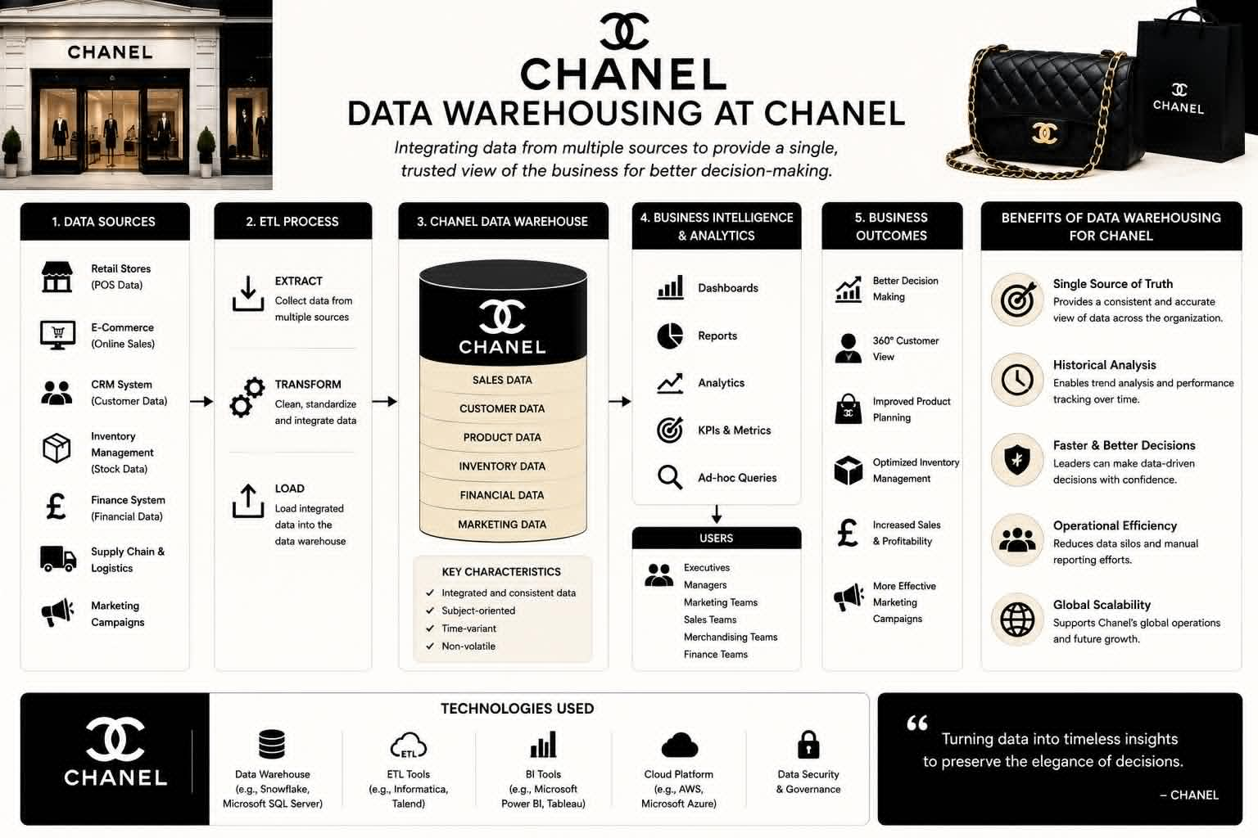

respond quickly to changing consumer preferences, particularly during new product Data Mining Techniques
Data Mining Techniques at Chanel provides with valuable insights that improve customer understanding, sales performance, and operational efficiency. Customer segmentation enables Chanel to identify high-value customers and deliver personalised marketing campaigns. These techniques support better decision-making and strengthen Chanel’s competitive advantage in luxury industries. However, data mining also presents several challenges. business decisions. Customer preferences in the luxury fashion industry also change rapidly due to trends, making historical data less reliable for predicting future demand. Furthermore, collecting and analysing customer data raises privacy and ethical concerns, requiring Chanel to comply with the UK GDPR and other data protection regulations. Therefore, data mining should be combined with human judgement, continuous data monitoring, and strong data governance to ensure accurate and responsible business decisions.
Regression Analysis for Chanel Regression analysis is a predictive data mining technique that examines the relationship between a dependent variable and one or more independent variables. Chanel can use regression analysis to predict future handbag sales based on factors such as advertising expenditure, seasonal demand, product pricing, customer income, or online engagement.
(Han et al., 2022).

Advantages
* Predicts future sales accurately.
* Supports pricing and marketing decisions.
* Improves inventory planning.
* Reduces business risks.

Disadvantages
* Results depend on high-quality data.
* Relationships may change due to fashion trends.
* Cannot explain all customer behaviour. Limitations
* Assumes relationships remain stable over time.

Correlation analysis measures the strength and direction of the relationship between two variables. Unlike regression, correlation identifies whether variables are related but does not prove that one variable causes the other. For Chanel, correlation can be used to examine relationships such as:
* Advertising expenditure and handbag sales.
* Customer satisfaction and repeat purchases.
* Website traffic and online sales.
* Product price and customer demand

Limitation
* Only measures the strength of relationships
. * Cannot explain why two variables are related.
* May overlook hidden factors affecting business performance.
Critical Comparison:
Regression vs Correlation. Regression analysis is more suitable when Chanel wants regression can estimate future sales of the Chanel Classic Flap Bag based on advertising expenditure, whereas correlation can determine whether advertising or sales.to predict future sales or customer demand, while correlation analysis is more appropriate for identifying relationships between business variables.
(Sharda et al., 2023)
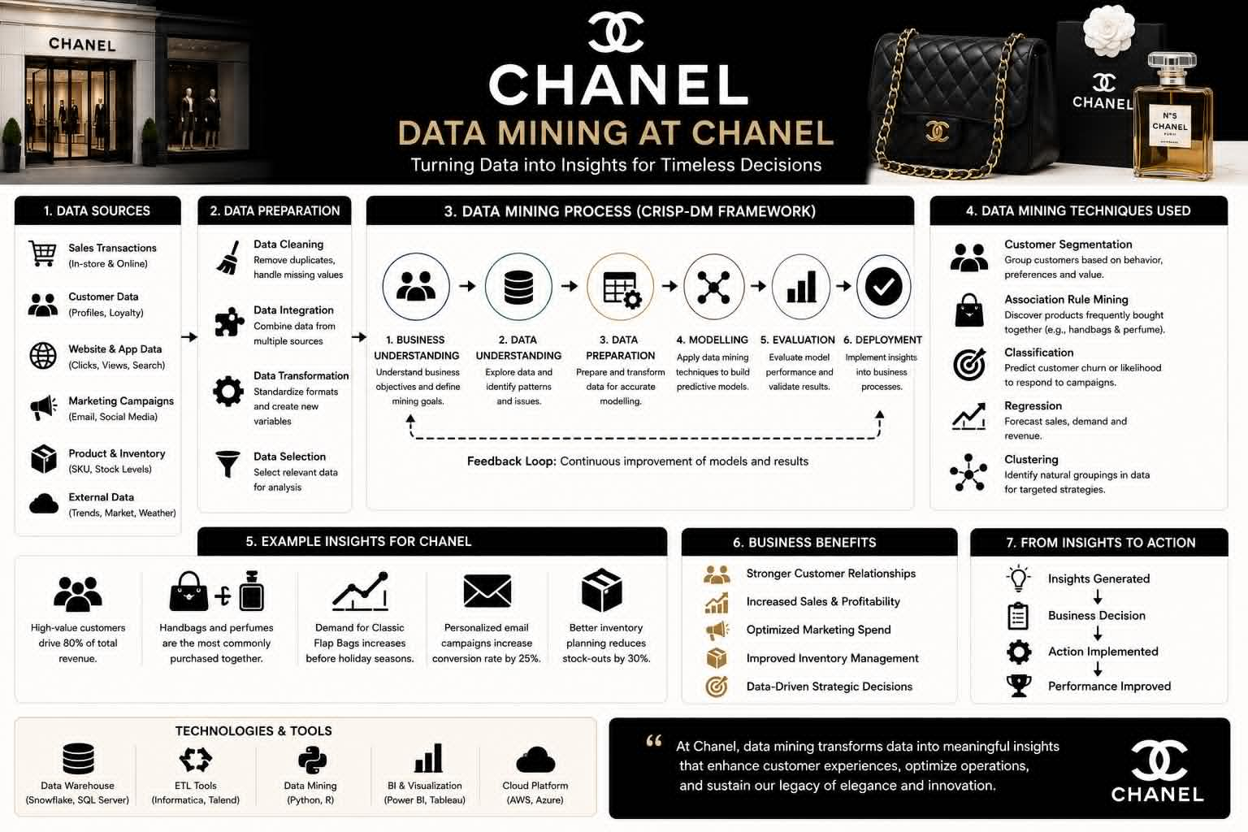

Predictive Analysis

Predictive analytics uses historical and real-time data, statistical algorithms, and machine learning techniques to forecast future business outcomes and support strategic decision-making (Sharda et al., 2023). For a global luxury retailer such as Chanel, predictive analytics can improve demand forecasting, inventory management, customer relationship management (CRM), and marketing effectiveness.
Several predictive analytics tools are suitable for Chanel, including Microsoft Power BI, IBM SPSS Modeler, Microsoft Excel, and RapidMiner. Among these, Microsoft Power BI is the most appropriate because it integrates seamlessly with multiple data sources, provides interactive dashboards, and offers AI-powered forecasting features. Managers can monitor sales performance, customer purchasing trends, and inventory levels in real time, allowing faster and more informed decision-making.
IBM SPSS Modeler is particularly useful for advanced statistical analysis and predictive modelling. It enables Chanel to predict customer purchasing behaviour, identify potential high-value customers, and estimate future demand for luxury ducts. RapidMiner supports machine learning and data mining with a user-friendly interface, making it suitable for customer segmentation and forecasting. Although Microsoft Excel can perform basic forecasting and trend analysis, it is less suitable for handling Chanel’s large and complex datasets compared with specialised BI platforms.
One of the major advantages of predictive analytics is reporting automation. Instead of manually preparing reports.

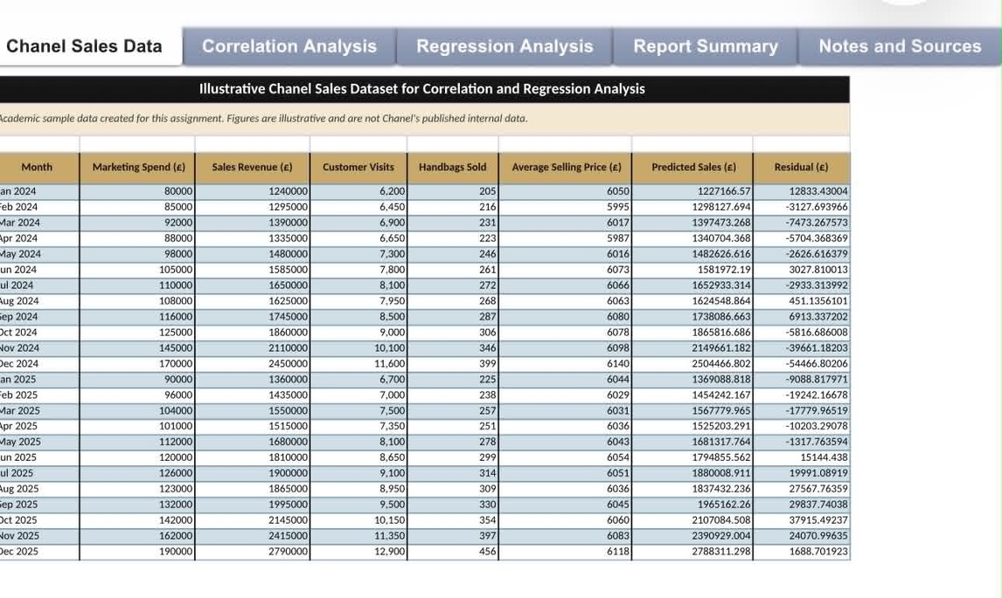

Ethical and Data Security Considerations

As a global luxury retailer, Chanel collects and processes large amounts of customer information, including personal details, purchase histories, payment information, and online browsing behaviour. Therefore, maintaining high ethical standards and robust data security practices is essential to protect customer trust and comply with legal requirements.
One of the key ethical issues is customer privacy. Chanel must ensure that customer data is collected transparently and only for legitimate business purposes. Customers should be informed about how their data will be used and should have the ability to access, update, or delete their personal information. As Chanel operates within the United Kingdom and European markets, it must comply with the General Data Protection Regulation (GDPR), which requires organisations to process personal data lawfully, fairly, and securely (European Union, 2016).
Cybersecurity is another critical consideration. Chanel should implement strong security measures such as data encryption, multi-factor authentication (MFA), role-based access control, and regular security audits to protect sensitive business and customer information from cyberattacks and data breaches. Employee training is also essential to reduce risks associated with phishing, weak passwords, and human error.
Furthermore, Chanel should establish effective data governance policies to ensure data accuracy, consistency, accountability, and regulatory compliance. Ethical use of Business Intelligence and Data Mining technologies.

Reporting and Dashboard Solutions

Business Intelligence dashboards are essential tools for transforming complex business data into meaningful visual insights that support timely and informed decision-making. For Chanel, implementing an interactive dashboard using Microsoft Power BI would enable managers and executives to monitor key business performance indicators (KPIs) across global retail operations in real time.
A Power BI dashboard could display metrics such as total sales revenue, sales by product category, regional sales performance, inventory levels, customer acquisition and retention rates, and marketing campaign effectiveness. Interactive features, including charts, maps, filters, and drill-down capabilities, would allow decision-makers to analyse business performance at different levels, from individual boutiques to global operations. This enables managers to identify trends, detect underperforming regions, and respond quickly to changing customer demand.
In addition, dashboards improve communication by providing consistent and accurate information to different departments, including marketing, finance, sales, and supply chain management. Automated data refresh ensures that reports remain up to date, reducing manual reporting efforts and improving decision-making efficiency. For example, Chanel executives can use dashboard insights to monitor inventory shortages, forecast demand for luxury handbags, and evaluate the success of new product launches.
.

Conclusion
Business Intelligence (BI), Data Warehousing (DW), and Data Mining (DM) have become essential technologies for organisations seeking to improve decision-making and maintain a competitive advantage. This report has demonstrated how Chanel can benefit from implementing an integrated Business Intelligence strategy to enhance operational efficiency, customer relationship management, and strategic planning.
The adoption of a centralised data warehouse would enable Chanel to consolidate information from multiple business functions, while data mining techniques such as customer segmentation and association rule mining would provide valuable insights into customer behaviour and purchasing patterns. Furthermore, predictive analytics and Microsoft Power BI dashboards would support accurate forecasting, automated reporting, and real-time performance monitoring. However, these technological advantages must be supported by strong data governance, cybersecurity measures, and compliance with GDPR to ensure customer trust and ethical data management.
Overall, investing in modern Business Intelligence technologies would enable Chanel to make evidence-based decisions, improve customer satisfaction, optimise business operations, and strengthen its long-term position as one of the world’s leading luxury fashion brands.

References (Harvard Style)
European Union (2016) Regulation (EU) 2016/679 of the European Parliament and of the Council of 27 April 2016 (General Data Protection Regulation). Official Journal of the European Union.
Han, J., Kamber, M. and Pei, J. (2022) Data Mining: Concepts and Techniques. 4th edition. Burlington, MA: Morgan Kaufmann.
Kimball, R. and Ross, M. (2020) The Data Warehouse Toolkit: The Definitive Guide to Dimensional Modelling. 3rd edition. Hoboken, NJ: John Wiley & Sons.
Laudon, K.C. and Laudon, J.P. (2023) Management Information Systems: Managing the Digital Firm. 18th edition. Harlow: Pearson.
Microsoft (2024) Microsoft Power BI Documentation. Available at: https://learn.microsoft.com/power-bi (Accessed: 7 July 2026).
Sharda, R., Delen, D. and Turban, E. (2023) Business Intelligence, Analytics, Data Science, and AI: A Managerial Perspective. 6th edition. Harlow: Pearson.
Chanel (2025) Official Website. Available at: https://www.chanel.com (Accessed: 14 July 2026).
Christopher, M. (2022) Logistics & Supply Chain Management. 6th edition. Harlow: Pearson.
DAMA International (2022) The DAMA Guide to the Data Management Body of Knowledge (DAMA-DMBOK2). 2nd edition.

Appendices

Appendix A – Proposed Data Warehouse Architecture for Chanel
* Data Sources (POS systems, CRM, E-commerce, Inventory, Finance)
* ETL Process (Extract, Transform, Load)
* Central Data Warehouse
* Business Intelligence Tools (Power BI)
* Dashboards and Reports

Appendix B – CRISP-DM Framework
1. Business Understanding
2. Data Understanding
3. Data Preparation
4. Modelling
5. Evaluation
6. Deployment

Appendix C – Sample Power BI Dashboard
Include example KPIs such as:
* Total Sales Revenue
* Sales by Region
* Best-selling Chanel Handbags

* Customer Retention Rate
* Inventory Levels
* Monthly Sales Trend
* Marketing Campaign Performance
Kimball and Ross (2020)


