Research Methodology Chapter
Introduction
In the previous chapter, the literature review, of this dissertation existing literature and research was complied and examined. In this chapter the, the methodology, will now explain to the reader how the study will be conducted. When doing a systematic research process for a dissertation, a methodology is a group of systems, approaches, processes, or concepts. The objective is to deliver a distinctive and significant outcome that will advance the subject of study. For understanding and learning, research is necessary. It is the action of improving knowledge, understanding and awareness surrounding a given subject (Saunders, 2016).
By improving the knowledge and understanding of a subject, you can identify the weaknesses in the research which will highlight areas to target for new research and grow the field of study.
The question that this dissertation is looking to answer by improving the already vast information and research available is “Evaluate Strategies of self-control and stress management in emergency situations as well as what methods officers use to recover from the stresses of dealing with day-to-day policing”.
This also included the aim of finding out the following objectives:
- What are the main contributors to stress in the police
- Methods of de-stressing & relaxing
- If the subject has considered leaving the police and why
- Techniques used to remain calm during incidents

During the literature review chapter of this dissertation, it was highlighted that there is considerable room for improvement in to the amount of research that exists in relation to
how police officers stress and general mental wellbeing were affected by having to complete the PCDA and the covid pandemic, if at all.
The research onion
The research onion as pictured below in figure one was developed by Saunders et al and provides a flexible route map for researchers to follow to provide a clear path of developing an effective methodology (Saunders et al, (2016).
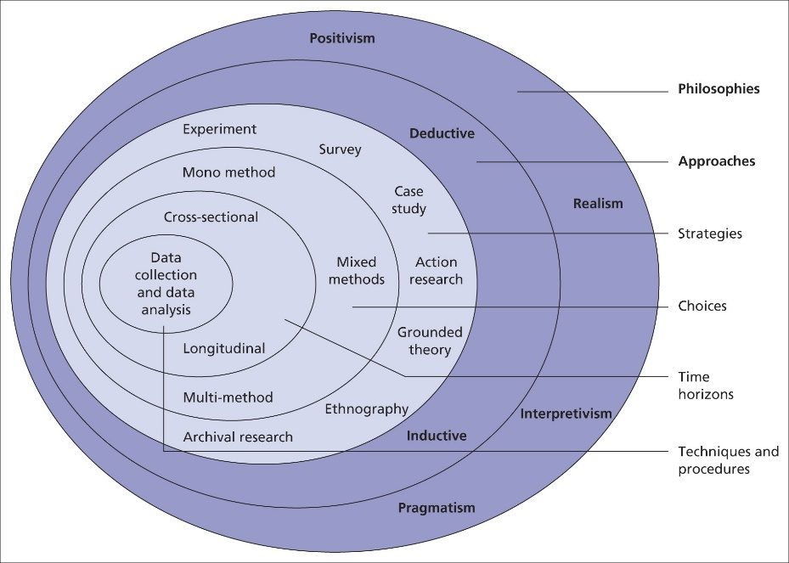
Figure 1 The Research Onion
Types of research
There are two main types of research: primary and secondary. Primary research is data and information which has been gathered directly by the researcher from individuals. Secondary research is research that relies on data that has already been collected by previous research studies (Bryman, 2016).
This dissertation will use a mixture between quantitative and qualitative research, but with more of a concentration on the quantitative aspect.
Quantitative data can be transformed into numbers or numerical data, which can be easily quantified, compared, and analysed. Quantitative data is collected through the quantitative research method. This can then be analysed and result expressed in many ways, including graphs and charts. To fully achieve the research goal, qualitive research will also be conducted. The definition of qualitative research is data that provides non-numerical information, while the definition of quantitative research focuses on numerical data. To understand why people act the way they do, quantitative research focuses on the participants' beliefs, feelings, and values. They produce many forms of data, including quotations, symbols, pictures, and written testimonies. (Qualtrics, 2022).
Data Collection
Using a mixed method approach can help to understand a research problem more effectively (Creswell, 2014). When both methods are used in conjunction with each other, quantitative and qualitative methods work well together and allow for further completed analysis (Greene et al, 1989).
The research will be conducted in the format of surveys/questionnaires. These will be made and shared online amongst currently serving and ex police service personnel. This will be the targeted group, as the purpose of this dissertation is specific to policing.
The Survey/questionnaires will be shared online as this will be the most efficient way to distribute them and receive the responses in a clear and concise manor allowing for ease of analysis and interpretation. The results of these will form the basis of the primary research which will be collated, understood and explained.
Sample
A sample is a dedicated section of a greater population (Bryman, 2016). It is important when carrying out research to sample a small cross section of the population as the total population would be impossible to compare (Ghauri et al, 2020)
However, on the opposite side, if the sample is too small, less than 25, the results can produce distorted answers, generally, the bigger the sample size the more reliable the data will be (Flick, 2011) This is particularly true for quantitative research. So for greater accuracy and reliability quantitative research requires a greater number of participants to ensure the studies findings are a true reflection of the population in question, for this sample, this will be police officers with the target of at least 40 responses.
Time
It alludes to the duration of the study. On the basis of time horizons, observations can often be divided into two categories: cross-sectional and longitudinal. When all observations are made at a single moment in time, as is the case in most surveys, cross-sectional data is employed. In contrast, longitudinal data refers to observations for a specific variable that are available over a period of several years, quarters, months, or days. (Setia, 2016)
In this dissertation, the cross sectional method will be utilised as this is the most effective model when completing population based surveys, it is especially suited when research is conducted over shorter periods of time (Mann, 2003).
Limitations
With any study there are limitations to the data and accuracy of results. It will be reliant on willing volunteers to undertake the surveys/questionnaires. No volunteers means no data! It will also be reliant on the volunteers being honest in their responses to give a true and accurate reflection of the population, there is no way to monitor this. This is not a study being done from choice, it is an academic necessity therefore there are time restraints and restrictions and on word counts, this will also affect the amount of secondary research that can be conducted as it will be impossible to compress all the available research.
Conclusion
All the different components of this research approach have been identified and detailed in this chapter. The objective of the subsequent chapter is to gather, examine, and present the results of the data collection techniques mentioned in this chapter.
Word count: 1029

Bibliography
- Bryman, A. (2016). Social Research Methods. 5th ed. Oxford: Oxford University Press. Last accessed 3rd December 2022

- Creswell, J. (2014) A Concise Introduction to Mixed Methods Research. 3rd edn. London: SAGE Publications. Last Accessed 4th December 2022

- Flick, U., (2011). ‘A beginner’s guide to doing a research project’. Introducing Research. Last Accessed 5th December 2022

- Greene, J., Caracelli, V. and Graham, W. (1989) ‘Towards a Conceptual Framework for Mixed-Method Evaluation Designs’, Educational Evaluation and Policy Analysis, 11(3), pp. 255-274 last accessed 4th December 2022

- Ghauri, P., Gronhaug, K. and Strange, R. (2020) Research Methods in Business Studies. Cambridge University Press. Last accessed 5th December 2022

- Saunders, M., Lewis, P. & Thornhill, A. (2016). Research Methods for business students. 7th ed. Essex: Pearson Education Limited. Last Accessed 3rd December 2022

- Qualtrics. (2022). Your ultimate guide to quantitative research. [Online]. Qualtrics. Available at: https://www.qualtrics.com/uk/experience-management/research/quantitative-research/ [Accessed 5 December 2022].

