BSc Health and Social Care
Introduction to Physiology
Emeline Tatiana Loemba Yagazou
Student ID: 2416832
Lecturer: Shaila Hussain

The Respiratory System and Asthma:
Helping Adolescent Patients Understand and Track Their Condition
A patient-education report prepared for the adolescent asthma clinic
CASE STUDY 2

Table of Contents
1. Introduction 3
2. The structure of the respiratory system and how breathing works 3
3. Gas exchange in the lungs 4
4. How smoking, vaping, and infections cause airway swelling 5
5. Tracking respiratory data: peak flow monitoring 6
6. Lifestyle changes that can help 7
7. Conclusion 9
References 10

1. Introduction
Asthma is a chronic disease of the lungs. It involves the air passages, or tubes that move air in and out of the lungs. In people with asthma, these airways become swollen and narrow. This makes it difficult to breathe. Asthma sufferers typically experience wheezing, coughing, chest tightness, and shortness of breath (Global Initiative for Asthma, 2025).
There are lots of things that can increase the risk of asthma or worsen asthma. These include exposure to cold air, dust, pollen and infections of the airways (NICE, 2024). This risk can also increase for teens when they start new habits. For many, exposure to smoke or vape from others or to smoke-filled, crowded environments like bars and clubs can trigger asthma symptoms (Alnajem et al., 2020).
This report is for young children attending a fortnightly asthma clinic. It describes the function of the lungs and how the body uses them to breathe in oxygen and remove carbon dioxide, and why smoking, vaping, and infections worsen asthma. It also provides reasons for monitoring peak flows and provides simple, evidence-based guidance on lifestyle changes (Di Cicco et al., 2022).

2. The structure of the respiratory system and how breathing works
Air passes through various structures to reach the lungs. It is inhaled through the nose or mouth, travels through the pharynx (throat) and larynx (voice box) and goes into the trachea (windpipe), which is lined with rings of cartilage. The trachea branches into two bronchi, one into each lung, which further branch into smaller bronchioles. Millions of alveoli are located at the end of the bronchioles: oxygen enters the bloodstream and carbon dioxide is expelled from the blood (Kenhub, 2023). The diaphragm and intercostal muscles between the ribs are the primary muscles involved in breathing. At the time of inhalation, the diaphragm is contracted and flattened, and the intercostal muscles raise the ribs, thus expanding the chest cavity and decreasing the pressure inside the lungs, which allows air to enter the lungs. These muscles relax during normal exhalation, the lungs recoil to their normal resting position, the pressure within the lungs increases and air is pushed out naturally (Kenhub, 2023).
Figure 1: The structures of the human respiratory system
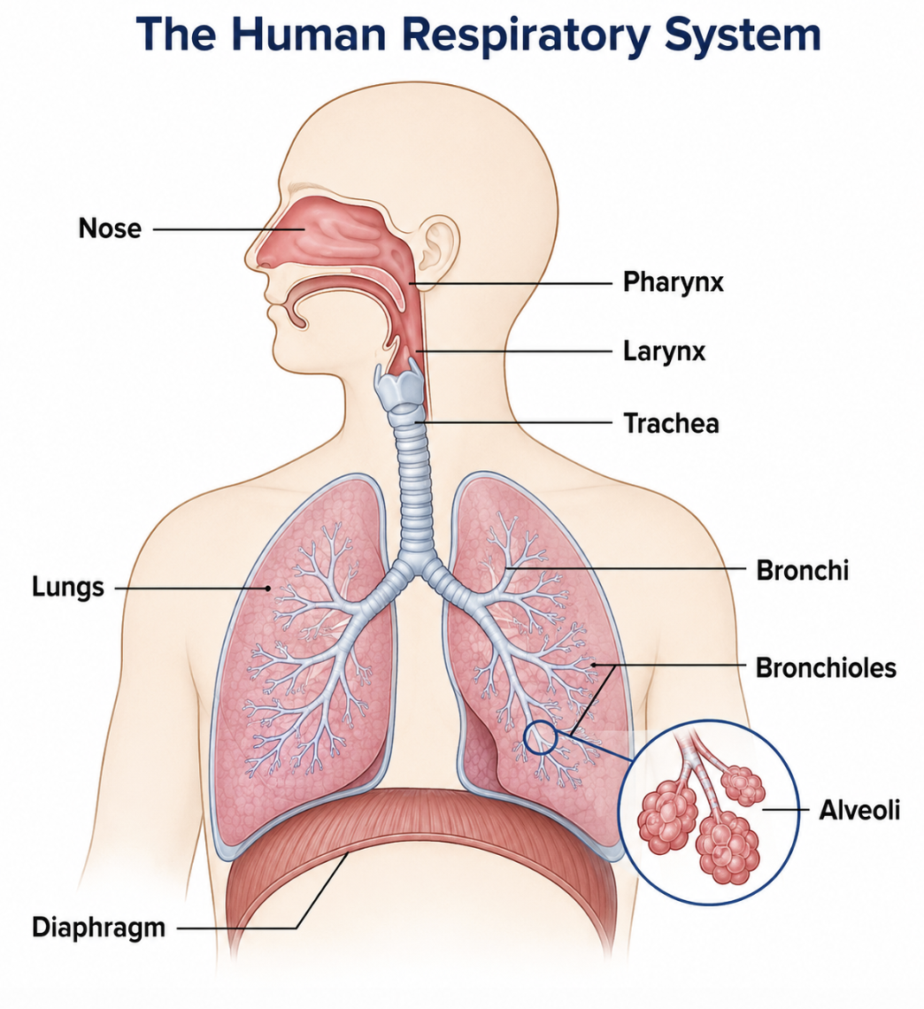
This pathway and muscle system is functional in a healthy individual, where significant amounts of air are moved in and out with minimal effort, as illustrated in Figure 1. This is a simple pattern that describes normal, easy breathing. It also provides a clue to understanding the problem of asthma. In asthma, the airways are already narrowed by swelling – particularly the bronchioles. This means that the same amount of muscle effort is required to move less air, and the person has to work harder to breathe (Global Initiative for Asthma, 2025). It is important to understand this normal process first, since the changes observed in asthma can only be adequately explained when compared with the normal system.

3. Gas exchange in the lungs
The alveoli are small, thin-walled air sacs that have a network of capillaries around them, where gas exchange occurs. O2 and CO2 diffuse across the alveolar wall from high to low concentration. The alveoli are filled with oxygen-rich air, and the surrounding capillaries have less oxygen, so oxygen diffuses into the blood (Global Initiative for Asthma, 2025). Meanwhile, CO₂, which is a waste product of body cells, diffuses from the blood into the alveoli where it is expelled during exhalation (Kenhub, 2023).
Figure 2: Gas exchange between the alveolus and the blood
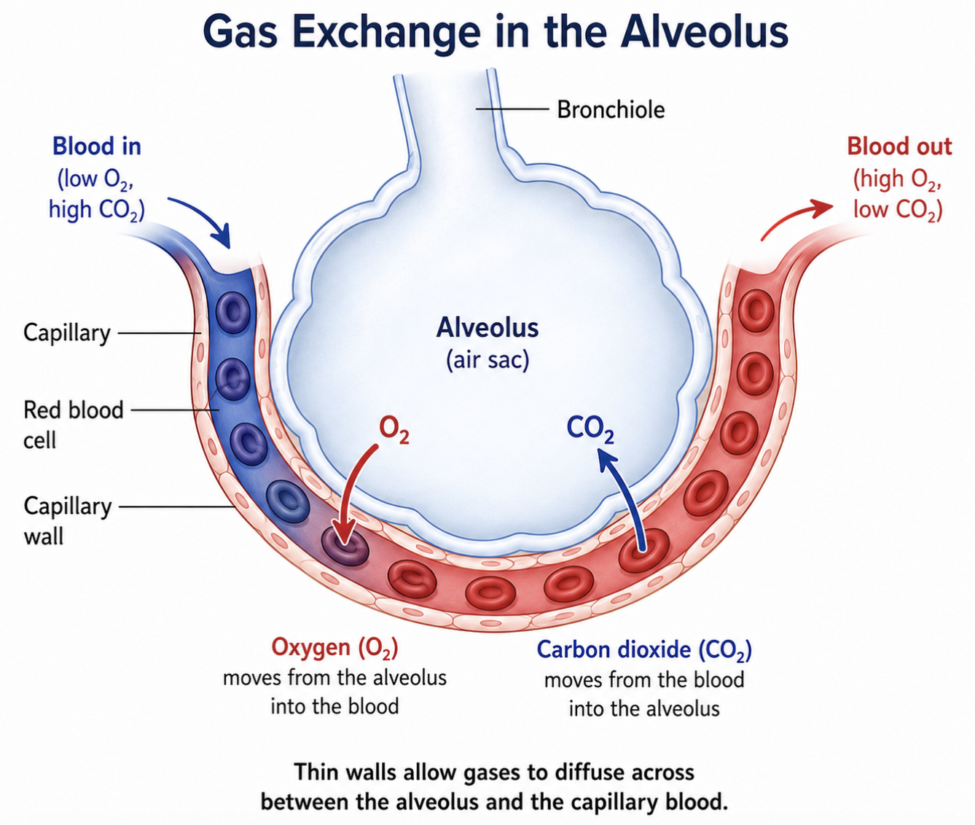
In those with asthma, this exchange process is not typically impaired as illustrated in Figure 2. The alveoli and capillaries still function as they did before. The true asthma issue occurs at an earlier stage of the pathway: in the airways as outlined in the previous section. The airways are swollen and narrow, so less air reaches the alveoli the first time. This does not indicate abnormal gas exchange, but rather a decrease in the amount of oxygen entering the blood, and carbon dioxide leaving the blood (NICE, 2024). This demonstrates the need for the structure of the airways and the function of gas exchange to be considered together. If there is a problem in one part of the system, it affects the outcome of the system, even if gas exchange is not directly involved.

4. How smoking, vaping, and infections cause airway swelling
Asthma symptoms often get worse when the airways come into contact with irritants. Common irritants include cigarette smoke, chemicals in vape aerosol, allergens (pollen or dust) and viruses that can trigger respiratory infection (Global Initiative for Asthma, 2025).
The immune system responds to the irritation of the lining of the airway. Chemicals such as histamine are released. These chemicals make the lining of the airways swell, make excess mucus, and make the muscle in the airways tighten. These three changes combine to make the airway smaller (NICE, 2024). The narrower the airway, the harder it is to get the same amount of air. This is perceived as wheezing, coughing, chest tightness and shortness of breath. It also causes the peak flow reading, discussed in the next section, to drop.
This is directly applicable to the adolescent patients in the clinic. Cigarette smoke contains chemicals that directly irritate the lining of the airway and studies have shown that children and teens exposed to secondhand smoke have more severe asthma symptoms and hospital visits. Another study also discovered a correlation between exposure to secondhand vape aerosol at home and increased asthma symptoms in teens (Alnajem et al., 2020). The vape aerosol contains nicotine, ultrafine particles, and flavouring chemicals. They have been found to irritate and inflame the airways, and teens who vape regularly are more likely to experience coughing, wheezing and breathlessness than those who don't vape (Li and Guan, 2025). There's an additional risk when you're in a crowded bar or club, as being close to more people increases the risk of you catching a respiratory infection, which is also a common trigger for asthma attacks (Di Cicco et al., 2022).
Results of many years of research support the link between smoking and the irritation of the airways, and the evidence is strong and consistent. The evidence regarding vaping is newer, and researchers point out that long-term studies in teens are still limited, as vaping is a newer habit (Di Cicco et al., 2022). Nevertheless, there is already clear evidence from the short term that there is irritation of the airways and symptoms are deteriorating. This is sufficient to justify providing unambiguous guidance to patients today, although there is still a need for further research into the long-term consequences (Li and Guan, 2025).

5. Tracking respiratory data: peak flow monitoring
Peak flow is the amount of air a person can expel from his/her lungs in a single, forceful breath. It is measured using a small handheld device known as a peak flow meter and the result is known as the peak expiratory flow or PEF (Asthma + Lung UK, 2026). If the airways are swollen and narrow, it will be more difficult to blow air out and the peak flow reading will be lower. This means that peak flow is a helpful and inexpensive measure of how open the airways are, without the use of hospital equipment.
Patients are typically asked to keep a diary of their peak flow for 2-3 weeks to determine their personal best score. This score is then used to establish a written asthma plan of action which may be presented as a three-zone system as illustrated in Table 1.
Table 1: Peak flow zones and recommended actions
Zone | % of personal best | What it means | Action
Green | 80–100% | Well controlled | Continue usual treatment
Amber | 50–79% | Caution — symptoms increasing | Follow the action plan; extra reliever may be needed
Red | Below 50% | Danger — poor control | Seek urgent medical help
Source: adapted from Asthma + Lung UK (2025).
A reading between 80 and 100 percent of the personal best is in the green zone, indicating that the asthma is well controlled. See Table 1 for more details. The Amber Zone is for a reading of 50 – 79 per cent – caution is required and additional treatment may be necessary. If the reading is below 50 per cent, this is the red zone and immediate medical assistance is required (Asthma + Lung UK, 2025). It is also important to record this information on a regular basis for the benefit of the individual patient. It provides a numerical value for doctors and nurses to compare with the patient's own perception of how they are feeling and can help identify a worsening trend at an early stage, before an asthma attack occurs.
The value of peak flow monitoring has not been as clear as it seems. There have been some trials that have shown that peak flow monitoring is as effective as symptom monitoring alone, and in some cases does not offer additional benefit on its own; the current national guidance is to avoid routine peak flow monitoring unless there is a personal reason for doing so (NICE, 2024). A recent review of the methods used to monitor children and young people also highlights that peak flow readings do not always correlate well with the way the airways are functioning, and that many children and young people are not recording regularly over time (Rhee and Katchamat, 2025). This is not to say tracking of peak flow is of no use. If administered correctly, in conjunction with an action plan for the patient, and with regular symptom monitoring, it is clearly effective in helping patients and clinicians to identify problems earlier and act appropriately and safely (Asthma + Lung UK, 2025). A realistic perspective is that peak flow monitoring is most effective as part of a comprehensive self-management plan, rather than a stand-alone approach.

6. Lifestyle changes that can help
From the evidence provided, there are a number of lifestyle changes that can help adolescent patients to manage their asthma in a safer manner. The first step to take is to quit smoking and vaping, as both are associated with airway irritation and aggravated symptoms (Alnajem et al., 2020). This can be assisted by local stop smoking and vaping support services. Other recommendations include reducing exposure to places with smoke and crowding, keeping up to date with immunizations to reduce the risk of infection, using inhalers properly, and having a written action plan (Global Initiative for Asthma, 2025).
It is not easy to give this advice, however. Peer pressure and the importance of social life at that age are factors that are not considered when advising a teenager to avoid going to a smoky bar or social gathering. This fact is not taken into account when giving advice, and it is less likely to be followed (Li and Guan, 2025).
The Health Belief Model provides a helpful perspective on this issue (Alyafei and Easton-Carr, 2024). The model proposes that the factors that increase the likelihood of a person changing their behaviour are: believing that they are personally at risk, believing that the risk is serious, believing that changing the behaviour will help, and believing that the change is realistic to make. Many teens can be aware of the negative health effects of smoking or vaping but may not feel a personal threat, particularly if they feel healthy the majority of the time. This model implies that warnings on a general level will not be effective. Advice is more likely to be successful when it's specific to the individual, such as: “Here is your peak flow pattern after you've vaped, or been in a smoky place.” This is because the advice is connected to the individual, and not just a rule to follow.

7. Conclusion
This report has described the structure of the respiratory system from the nose to the alveoli and the mechanism of breathing provided by the diaphragm and intercostal muscles. It has demonstrated the exchange of oxygen and carbon dioxide at the alveoli and how irritants like smoke, vape aerosol and infections make the airways swell and narrow making breathing more difficult. It has also demonstrated the value of being able to track peak flow readings as a useful, if imperfect, way of identifying problems early, and the value of lifestyle advice that is felt to be realistic and personal, rather than a set of rules.
With the adolescent patients attended in the fortnightly asthma clinic, this understanding can help with better engagement in care plans. Understanding these factors and being able to monitor and respond to changes can assist them in maintaining their respiratory health safely as they get older.

References
- Alnajem, A., Redha, A., Alroumi, D., Alshammasi, A., Ali, M., Alhussaini, M., Almutairi, W., Esmaeil, A. and Ziyab, A.H., 2020. Use of electronic cigarettes and secondhand exposure to their aerosols are associated with asthma symptoms among adolescents: a cross-sectional study. Respiratory research, 21(1), p.300.
- Alyafei, A. and Easton-Carr, R., 2024. The health belief model of behavior change. StatPearls.
- Asthma + Lung UK (2025) Completing an asthma action plan with your patients, Asthma + Lung UK. Available at: https://www.asthmaandlung.org.uk/healthcare-professionals/adult-asthma/AAPs/completing-asthma-action-plan-your-patients (Accessed: 02 August 2026).
- Asthma + Lung UK (2026) Peak flow test, Asthma + Lung UK. Available at: https://www.asthmaandlung.org.uk/symptoms-tests-treatments/tests/peak-flow (Accessed: 02 August 2026).
- NICE (2024) Home, NICE. Available at: https://www.nice.org.uk/guidance/ng245 (Accessed: 02 August 2026).
- Di Cicco, M., Sepich, M., Beni, A., Comberiati, P. and Peroni, D.G., 2022. How E-cigarettes and vaping can affect asthma in children and adolescents. Current Opinion in Allergy and Clinical Immunology, 22(2), pp.86-94.
- Global Initiative for Asthma (2025) 2025 gina strategy report - global initiative for asthma, GINA. Available at: https://ginasthma.org/2025-gina-strategy-report/ (Accessed: 02 August 2026).
- Kenhub (2023) Anatomy of breathing, Kenhub. Available at: https://www.kenhub.com/en/library/anatomy/anatomy-of-breathing (Accessed: 02 August 2026).
- Li, C. and Guan, T., 2025. Pulmonary function and physical performance in adolescent e-cigarette users: a narrative review. Frontiers in public health, 13, p.1703712.
- Rhee, H. and Katchamat, N., 2025. Asthma symptom self-monitoring methods for children and adolescents: present and future. Children, 12(8), p.997.

