GIS - Assignment 1

  - By Owen Jones

Contents
The History and the origins of Geographic Information Systems 1
Emergence of Geographical Information Systems in application 1
Geovisualisation 4
Access and QGIS as SDSSs 5
Access 5
QGIS 10
Comparing Access and QGIS as SDSSs 18
Using GIS for healthcare informatics analysis 18

The History and the origins of Geographic Information Systems
Geographic information systems or GISs are information systems that handle and manipulate spatial or geographic data and can produce a visual representation of the data, the earliest versions of which were drawn maps that were used most famously to find the sources of viral outbreaks like with the cholera outbreak on Broad Street in 1854 where John Snow tracked down the source of the outbreak to an infected water pump (1).
The first computer driven geographic information systems were made in the 1960s, with one of the first being credited to Roger F. Tomlinson, who has been cited as the “father of GIS” (2) for his paper “An Introduction to the Geo-information System of the Canada Land Inventory” (3) which he explains the system requirement and capabilities for the GIS he worked on for the Canadian government for storage and analyses of data about land usage in Canada.

Emergence of Geographical Information Systems in application
GISs have been used more and more, being integrated with different application to different extents, giving the users of these application various interactions with GISs giving them various views on GISs.
Niantic is a software development company that has become famous in recent years for its mobile games, Ingress and the much more famous Pokémon Go (5), both of which are augmented reality games that use a form of Geographical Information System to run them. Ingress is basically a capture the flag game, with the flags being GPS coordinates on a map of world that players can capture for their “faction”, Pokémon Go also had an aspect similar to this in its “Gym Battles” but also added the feature of caching monsters or “Pokémon” that spawn on the map and they spawn in areas and region that the Pokémon would most likely live, i.e. a fish/water based Pokémon being near bodies of water (8).
Both games use a GIS that tells the user’s phone what to show the user, where they are and what is near to them, this is shown to the user as their game avatar on a map that has point of interest on it, be that flags, Gyms or Pokémon, the GIS does this by refinancing and comparing the user’s GPS coordinates to the app’s map of the local surrounding area to know what and where to spawn it.

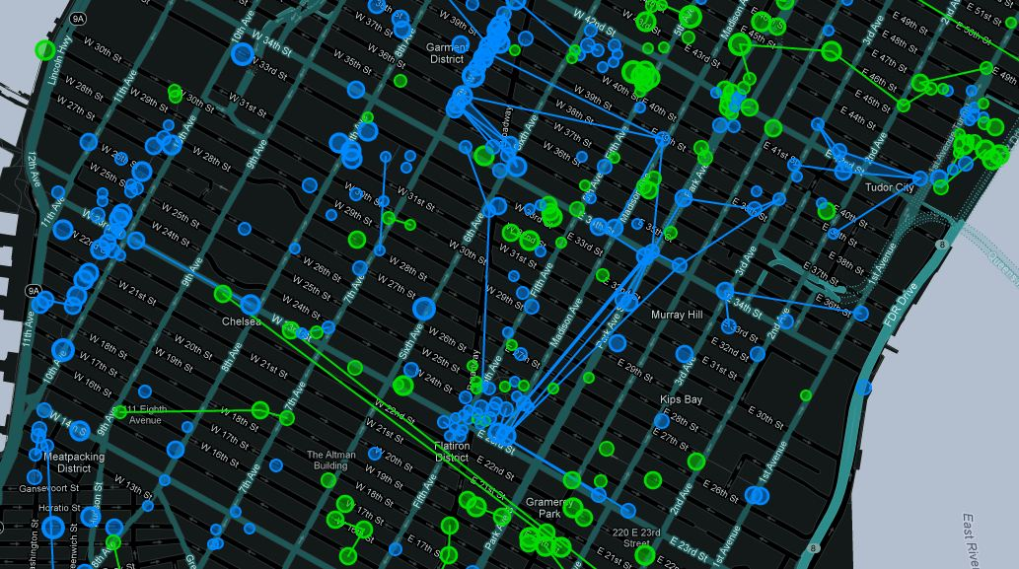(6)
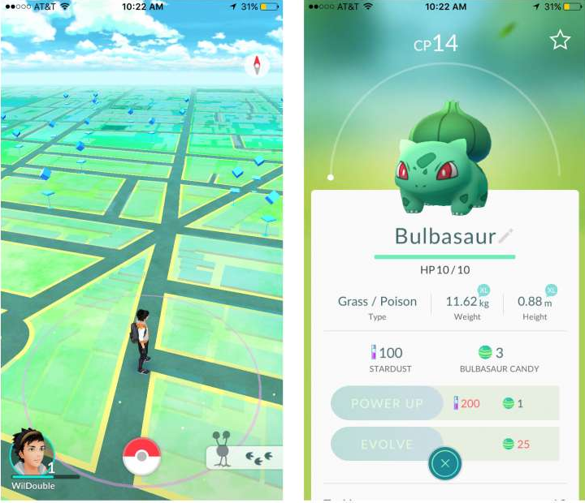(7)

Geographical Information Systems have also been used to help in the study and conservation of wildlife(9), by mapping the areas that animals have live and travelled to show migratory routes and territory, plotting population density over time to show changes to population due to outside influences, like global climate change, habitat loss, pollution and deforestation.
There have been many GIS application made to track and model animal movement, one of which is a GIS system that records the movement of birds and models the potential danger the birds will pose to aircrafts, these systems are called Bird Avoidance Models or BAMs which used collected data on bird distribution and movement to assess the chance of a bird strike (10). For the user this GIS application would out put a map of area that would show areas of Bird Strike Risk levels that would tell the user, with the help of radar, which areas would be moderately safe to fly in.
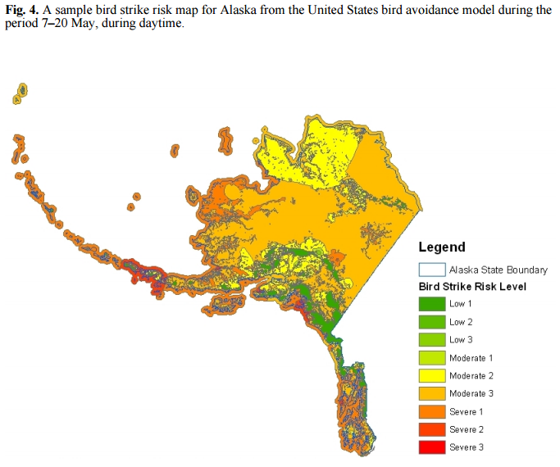(10)

Geovisualisation
Geovisualisation is the concatenation of Geographic and Visualization and is used to describe the tools and techniques that are used to visualise or depict geographic and spatial data in such a way to convey information about an area, in the scope of socio-demographic data this information will relate to the local population, (age, sex, ethnicity, employment, religion ext.) and the society within the area. Geovisualisation lends itself to analysis of socio-demographic data as it can convey information a way that graphs, tables and reports cannot, they can show how data about one area can relate to another with just a glace for example if you had data on farmable land in two regions of similar size and region A had a lot more farmable land than region B, on a table or graph you would only see that but if you used a GIS to over lay that data on map of both areas you could see if there a geographic reason for the different like region B had more mountainous terrain or urban development than region A, which would take up the available space, for socio-demographic this could applied to why certain areas have a higher mix of people of different ethnic backgrounds, because of the area having a major port or airport so immigration higher, or why people in an area are more likely to develop depression, because of the area being large and sparsely populated.

Access and QGIS as SDSSs

In this section I will make two Spatial Decision Support Systems, one in Access and one in QGIS, for the welsh local health boards to assess how they are handling Cancer and if they have improved over the years, for this I will look at the rate of hospital admissions and morality due to Cancer and if there has been any improvements between 2006 and 2015, and if there are any differences between males and females.

Access
Access is a database creation application made by Microsoft, which allows users to create and manipulate relational databases via a combination of relationship keys, SQL queries and reports, this allows it be used as and help make decisions by displaying the information in graphs and forms.
The data I used to make this database was the Cancer Mortality rate and Hospital Admissions due to Cancer csv. Files from Health Maps Wales for both 2006 and 2015, and the Local Authority District Population for England and Wales from the Census 2011, but I only wanted data that corresponds with the welsh local health boards and not the English so I wrote a query to find only the local health board’s codes for wales
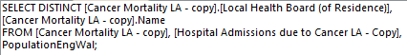
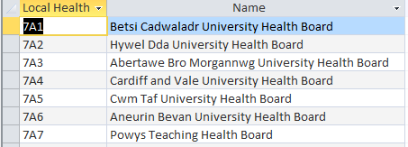
From this I removed data I didn’t need and move onto manipulating the data to show the information I wanted. First I wanted to see the difference in rate of hospital admissions due to cancer in 2006 and 2015 so I first made wrote a query to find the data on admissions in 2006 and 2015 individually and then made a graph for each which made it look like there has been a fall in admissions between 2006 and 2015, especially i Abertawe Bro Morgannwg University Health Board, which could be down the health boards or some other outside factor, but as I connected the graphs I found that while the rates as a whole where going down , Powys Teaching Health Board’s rate had increased.
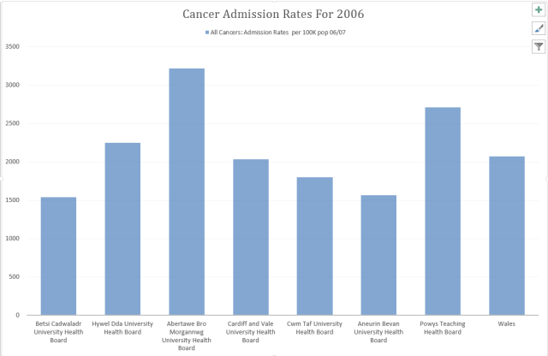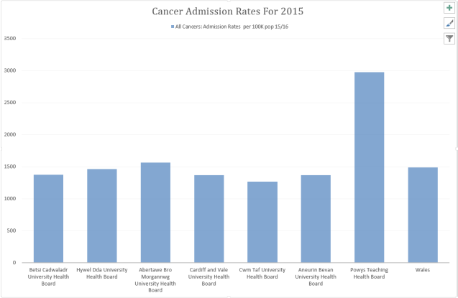
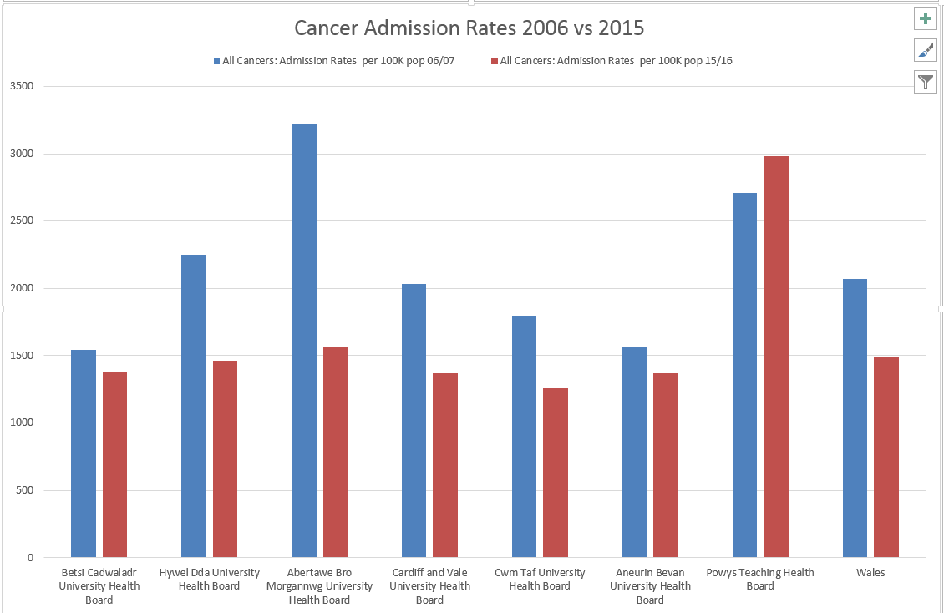

After looking at hospital admissions I then look at Cancer Mortality rates in both years and similarly made two tables for the data which showed that 2006 was a lot more varied on the rate of mortalities than 2015 but as you can see when you see them together over all the cancer mortality rates are going down.
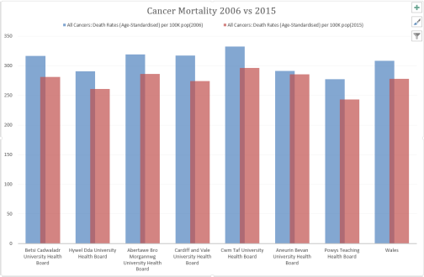
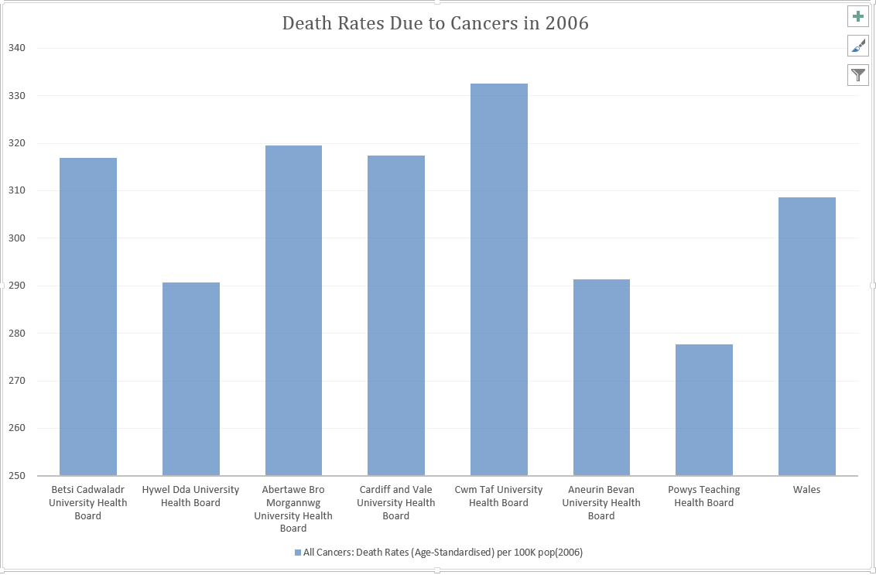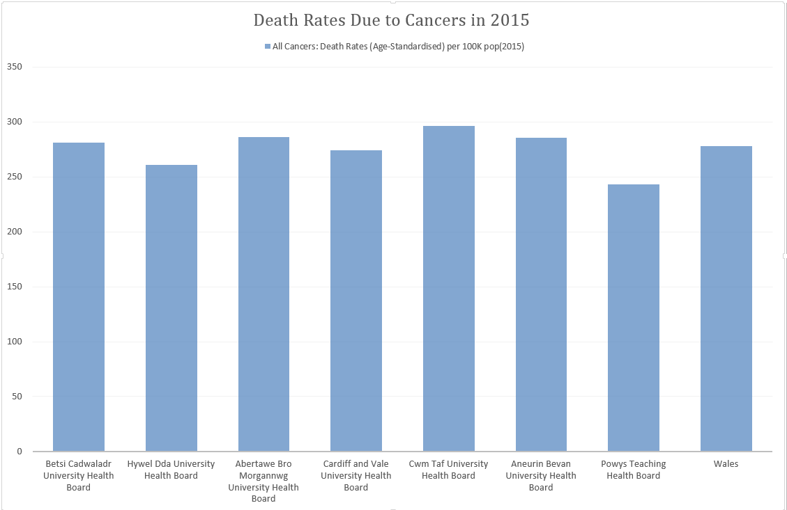

The last subject I looked at was the male and female cancer mortality rates in both 2006 and 2015, to see if there were any differences between them or if they were about the same what I found was that over all male mortality rates were higher in both years than the female mortality rates, and had increased between 2006 and 2015 while female mortality rates had gone down slightly.

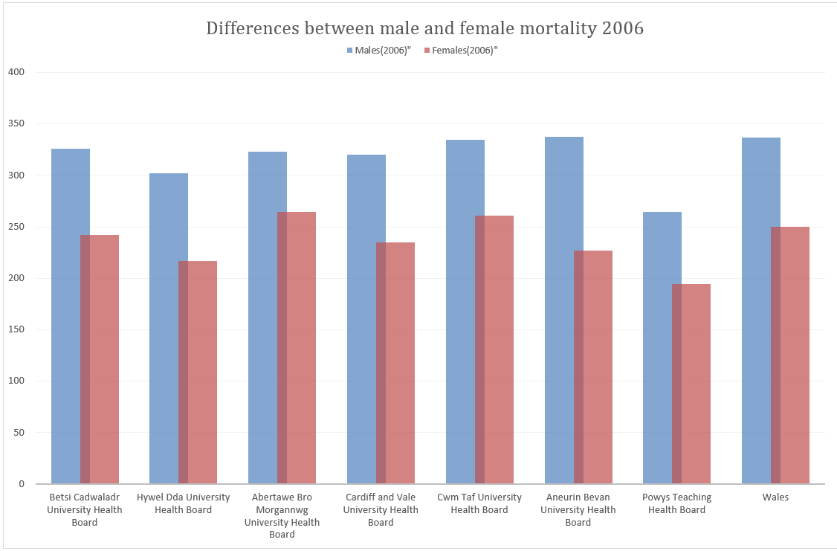
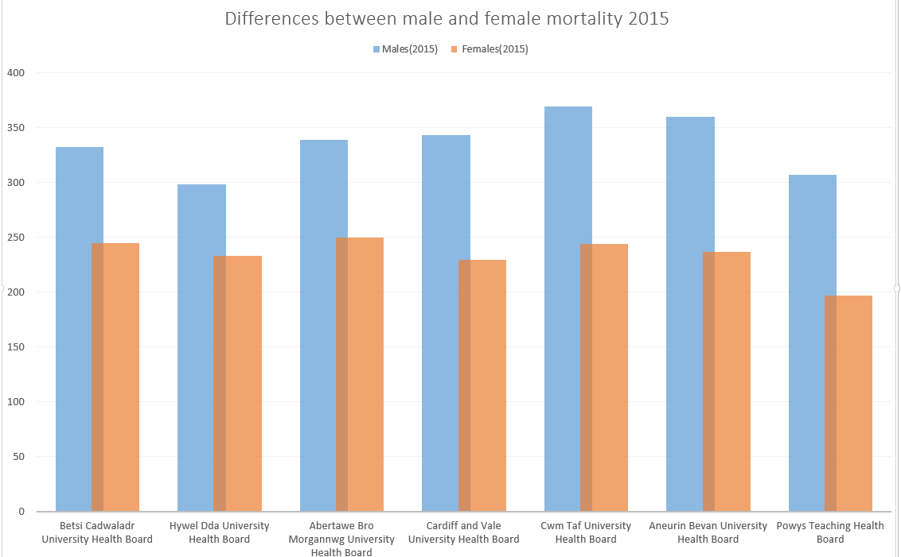

QGIS
QGIS is an Open Source GIS application that allows the user to create, edit, view and analyse geospatial data. QGIS uses graphical layers, both vector and raster, to create maps and attribute tables to populate the maps with data, this can be used to show different aspects to an area like population data, boundaries of different organisations, predictions of movement, and other information this means QGIS can be used as a Spatial Decision Support System.
I used the same data as with the Access but in addition I had to add the shape files to define the boundaries of the local health authorities in wales and local authorities but I could only get the shape files for the local authorities in Wales and England so I used the intersect tool to make a new layer which had both the attributes of local health authorities and the local authorities but only the ones that were in the same area as the local health authorities in wales, this allowed me to both cut out the English local authorities and to show who many of the 26 local authorities were encompass by each local health authority

Figure 1 26 local authorities in wales
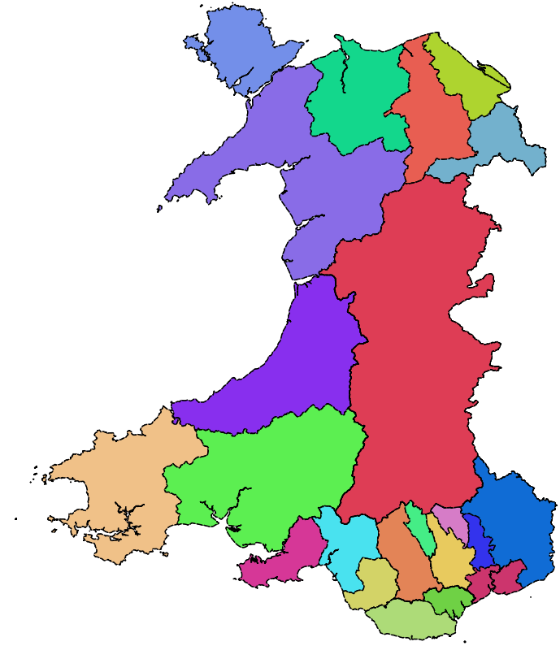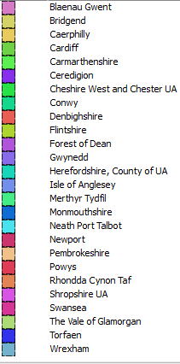
Figure 2 local health authorities in wales
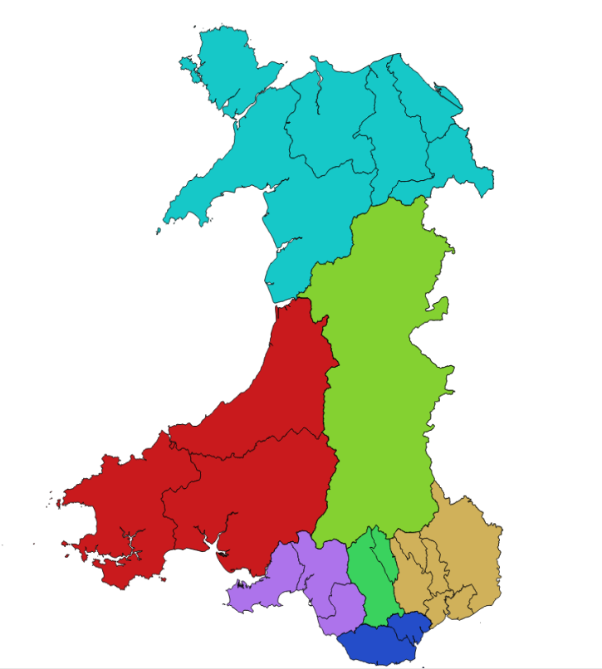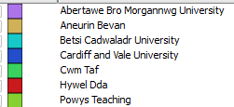
To test if the shape file had the data connected to it I did a quick query to show the population in each local authority with most populated to be shown in dark green and the less populated in a lighter green
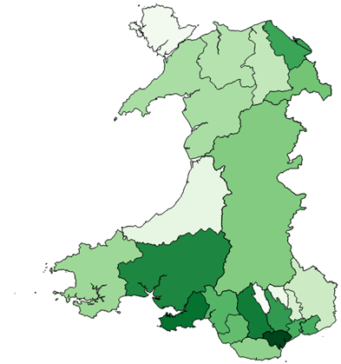
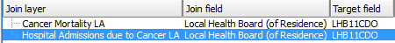
After getting the shape files in order I then linked the Cancer Mortality rate and Hospital Admissions due to Cancer CSV files to the shape file, I did this by linking the code given for the local health authority given in each CSV file to the proper local health authority on the shape file, this allowed me to query the CSV files and out put the results to style of the shape files.

Again the first thing I looked at was the admission due to cancer and I got the same results but instead of just showing the results in a graph, with QGIS I could use the style of the shape files to change how the map looked so it would show more red in the areas with higher admission rates more blue in areas with lower admission rates which shows a lot more clearly the difference between local health authorities which can be used to show problem areas.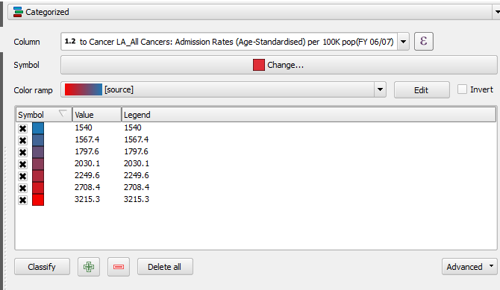
Figure 3 admissions due to Cancer (2006)
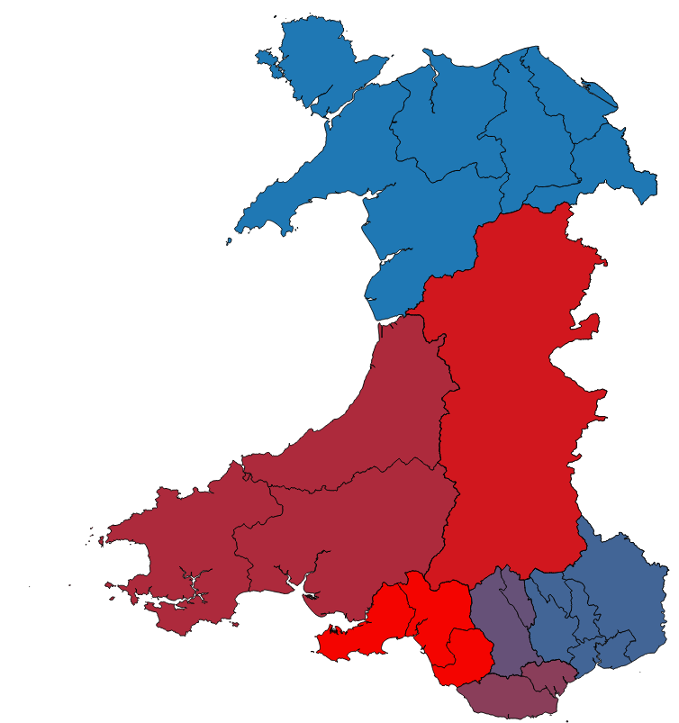
Figure 4 admissions due to Cancer 2015
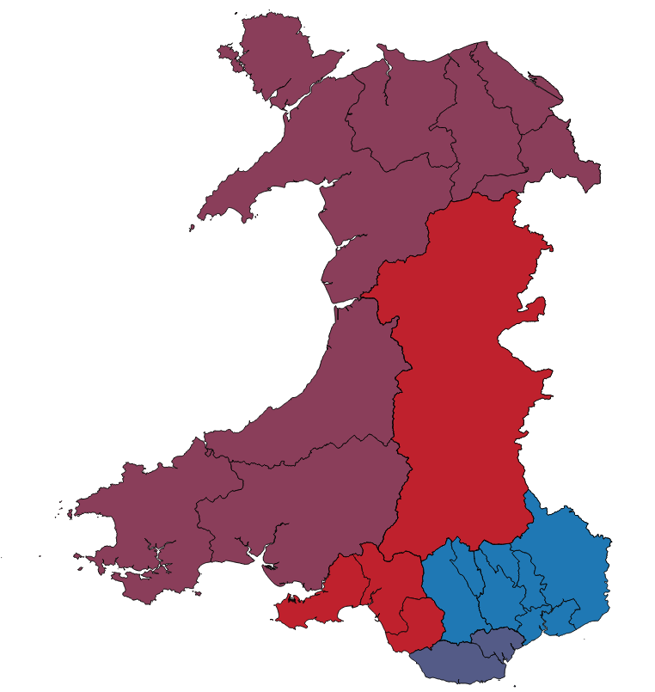

I then used the expression builder to show calculate the difference between 2006 and 2015 in each local health authority and then used the result to make a range to show the which local health authority had the biggest drop of admissions, with blue being the biggest drop, the purple being the smallest drop and red being a rise in admissions.
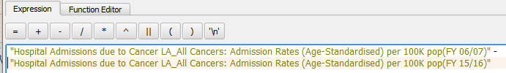
Figure 5 Difference of Admission rates due to Cancer 2006 between 2015
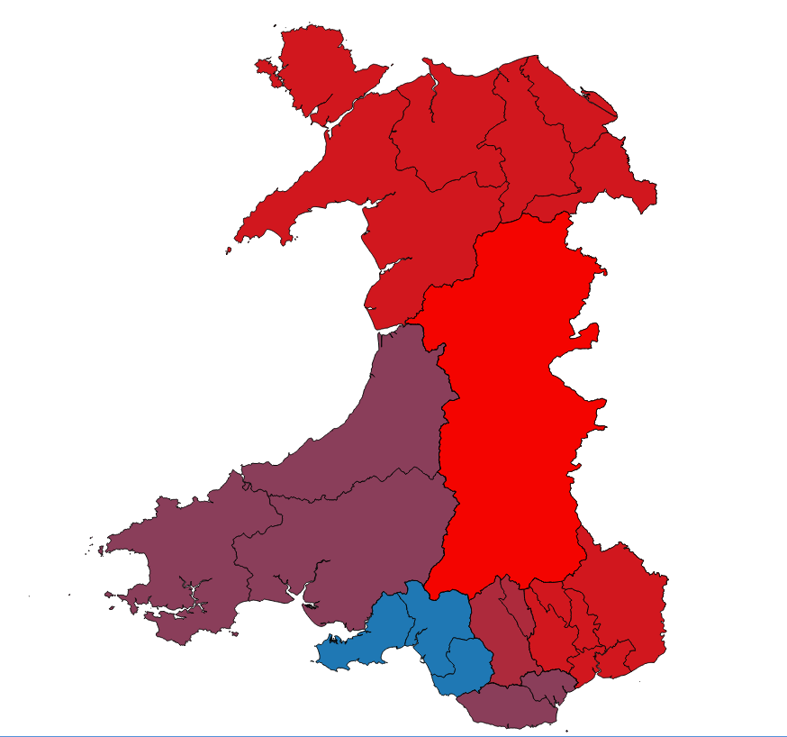
In the next subject I looked at was the mortality rate due to cancer in each local health authority for both 2006 and 2015, I did the same as before and made two maps showing mortality rate due to cancer in both years but made it grey scale with black having a higher mortality rate than white which showed little difference over all with the south of wales having higher mortality rate than the middle and west of wales, this is probably due to the low population in the middle of wales, but after I made an expression to show the drop of mortality rate between the two years and made it so the map shows more blue if there was a large drop and red if there was a small drop I found that most areas had quite a large drop in mortality rate between 2006 and 2015 bar one Aneurin Bevan University Health Board.
Figure 6 Death due to Cancer (2006)
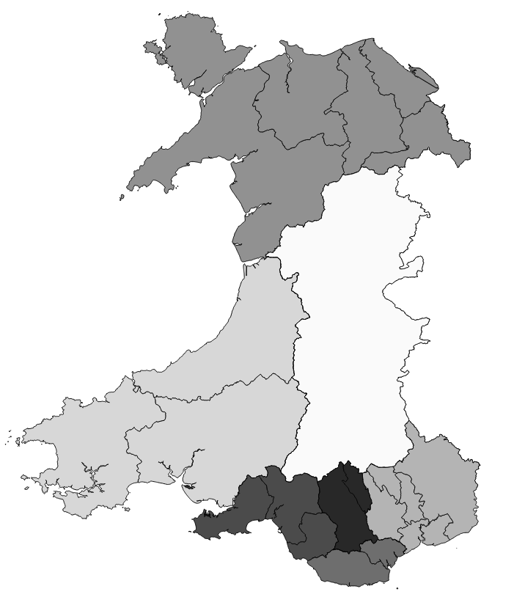
Figure 7Figure 7 Death due to Cancer (2015)
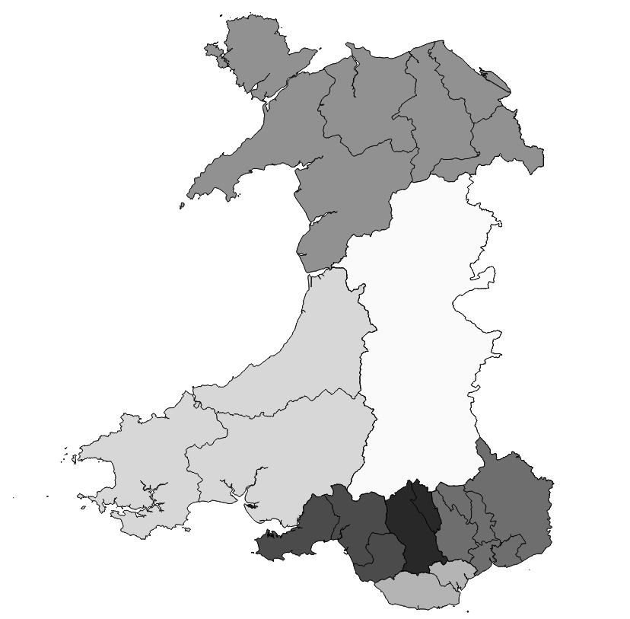

Figure 8 Difference of Cancer Mortality rates between 2006 and 2015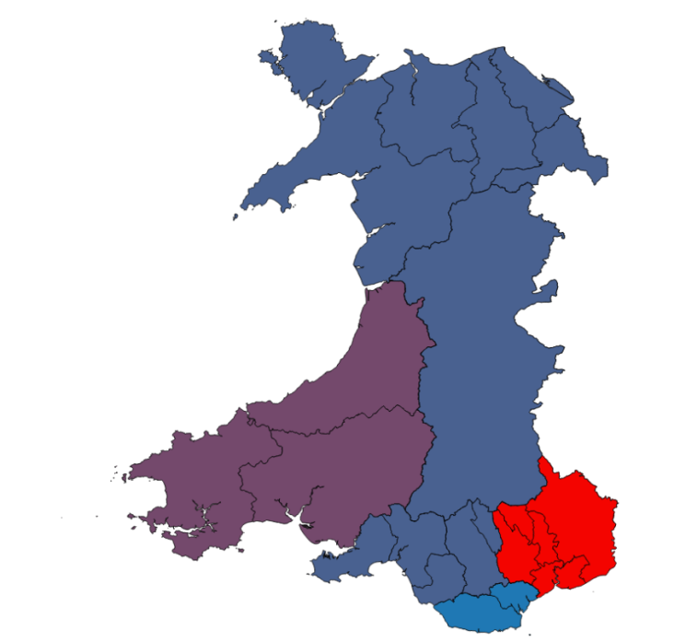

The last subject I looked at was the difference in male and female cancer mortality rates in both 2006 and 2015 which I made the map show the difference with a colour gradient with red having a higher difference than white, which shows that the difference in each area had changed quite drastically from 2006 to 2015 as the north had the biggest difference in 2006 but had one of the lowest in 2015, the same with the west of wales as well.
Figure 9 Difference of Cancer Mortality rates between Males and Females in 2006
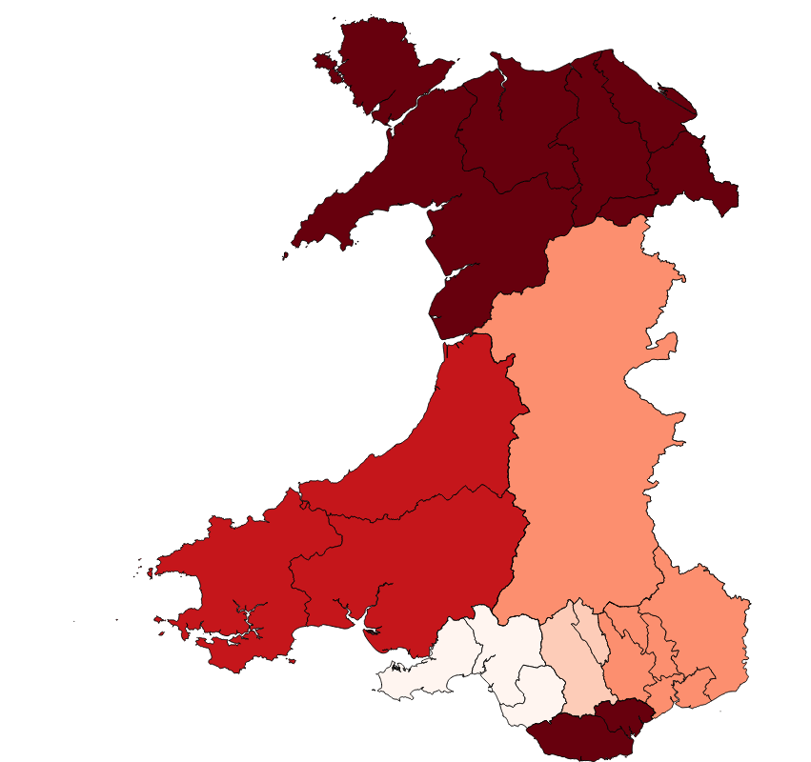

Figure 10 Difference of Cancer Mortality rates between Males and Females in 2015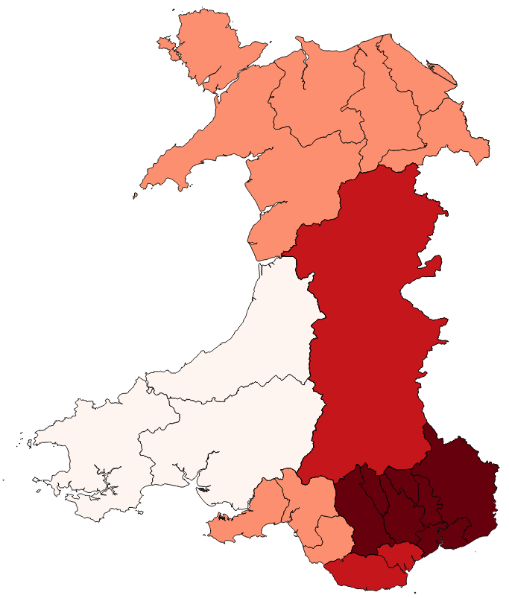

Comparing Access and QGIS as SDSSs
After using both Access and QGIS as Spatial Decision Support Systems I have found that both work well as Decision Support Systems but QGIS does better job at conveying the spatial part of the data than access, as it actually shows the user the information about area on a map of an area, or shows the information in relevance to the area in question, while Access can only show information about a single point or area it cannot show that information in comparison with neighbouring points or areas, for example if you had list of crimes in town, access could only show the list and the attributes of the crimes, while QGIS could show that crimes involving physical and verbal violence are more common near the local pub or bar by showing the crimes as points on the map. One of the few flaws QGIS that Access doesn’t have is that it struggles with querying large amounts of data for display, as the software needs to render all data as well as look through it, while Access can handle a lot more data at once.

Using GIS for healthcare informatics analysis
A Geographic information system could be used to analyse healthcare data is such a way as to show where certain problems areas are with a health authority which can used to help more efficiently delegating resources to cover problems areas, for example one health authority could have an increase number of cases of illicit drugs use and overdose after in short period of time, using a GIS the health authority could map the places that the people live and work to see if there is a common source or overlap in their move, so they now where they should focus on their Anti-drug / Drug safety campaigns. A GIS could also help with deciding where to put new medical facilities, by using the data they have on older facilities to show how far a facility of its size could affect and where an effective place to put the new facility would as putting it next to an existing would be pointless.
Bibliography
1. Snow J. On the Mode of Communication of Cholera, [Internet]. Collections.nlm.nih.gov. 1849 [cited 19 November 2017]. Available from: https://collections.nlm.nih.gov/ext/cholera/PDF/0050707.pdf
2. GREINER L. Putting Canada on the map [Internet]. The Globe and Mail. 2007 [cited 19 November 2017]. Available from: https://www.theglobeandmail.com/technology/putting-canada-on-the-map/article1092101/
3. Tomlinson R. An Introduction to the Geo-information System of the Canada Land Inventory [Internet]. Library.wur.nl. 2017 [cited 19 November 2017]. Available from: http://library.wur.nl/isric/fulltext/isricu_i00017260_001.pdf
4. Rhind D, Coppock J. The history of GIS [Internet]. Geos.ed.ac.uk. 2017 [cited 19 November 2017]. Available from: https://www.geos.ed.ac.uk/~gisteac/ilw/generic_resources/books_and_papers/Thx1ARTICLE.pdf
5. Products - Niantic [Internet]. Niantic. 2017 [cited 29 November 2017]. Available from: https://nianticlabs.com/products/
6. Decode Ingress - TOOLS [Internet]. Decodeingress.me. 2017 [cited 29 November 2017]. Available from: http://decodeingress.me/wp-content/uploads/2013/03/ingress-intel-total-conversion-0-8.jpg
7. iOS App of the Week: Pokémon GO [Internet]. Iphonefaq.org. 2017 [cited 29 November 2017]. Available from: https://www.iphonefaq.org/files/styles/large/public/pokemon_go_final.jpg?itok=5pWiovB0
8. Piburn J, Morton A. The Science Behind Pokemon GO (Multimedia) | SciTech Connect [Internet]. Osti.gov. 2016 [cited 29 November 2017]. Available from:https://www.osti.gov/scitech/biblio/1283236 https://www.osti.gov/scitech/servlets/purl/1283236
9. Boyd D, Foody G. An overview of recent remote sensing and GIS based research in ecological informatics [Internet]. Core.ac.uk. 2017 [cited 5 December 2017]. Available from: https://core.ac.uk/display/9703950?recSetID=2af33947fdd12d4289a594db47c5f09d::5a26615e2b7740.18626703
10. Shamoun-Baranes J, Bouten W, Buurma L, DeFusco R, Dekker A, Sierdsema H et al. Avian Information Systems: Developing Web-Based Bird Avoidance Models [Internet]. https://www.ecologyandsociety.org. 2008 [cited 5 December 2017]. Available from: https://www.ecologyandsociety.org/vol13/iss2/art38/

