

Programme: BA Business Management

  - Module: The Global Business Environment
  - Module code: LCCB4005
  - Module Lecturer: John Malagila

Assignment Title: Assessment 2 – Environmental analysis of fashion industry
Student Name: Boscanean Maria
Student ID: 2021937

Table of Contents

Executive Summary 3
Introduction 4
Fashion industry 4
Porter’s 5 Forces – Fashion industry 5
About Zara 6
Changes Zara has made to its business model 7
Evaluation 8
Recommendations 10
Conclusion 11
References: 12
Appendix 14
PESTLE Analysis – Zara 14
SWOT – Zara 17

Report – Critical analysis of the changes of Zara’s business model in response to the issues were raised by the stakeholders (CSR)

Executive Summary

The follow report – which is the second part of the coursework- is written with the aim of critically analysing what changes Zara have made in the recent years in its business model in response to the concerns that were raised by the stakeholders, such as environmental issues and corporate social responsibility. Followed by an analysis and explanation of what competitive advantages Zara was given by the implemented changes.
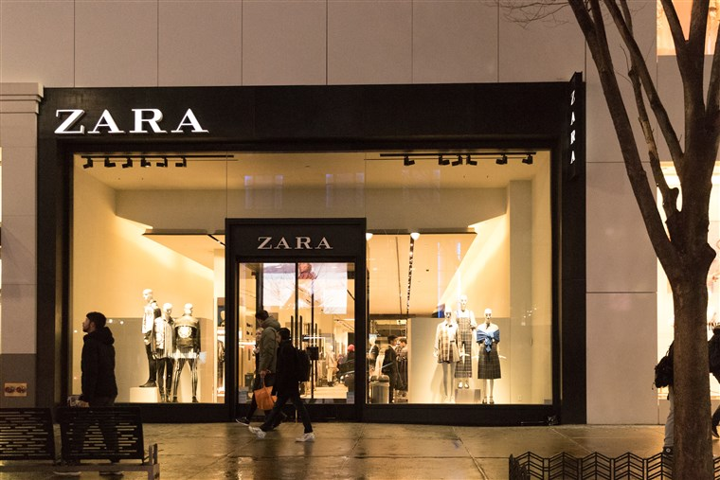

Zara – Case Study

Introduction

Fashion industry was observed to be the second most polluting industry globally. More than 8% of the global greenhouse gas emissions is accounted to apparel and footwear production. As the fashion industry is expected to grow 5 % yearly the annual production is expected to grow by more than 100m tons within the next 10 years. Therefore, actions need to be taken as textile manufacturing may cause 60% more emissions. (Chua, 2019)
There environmental pollution has diverse forms, such as soil, water and air, which are fuelled by the fibres and garments’ productions and distributions. The fashion items have overproduction and the raw materials are used unsustainably. The demands of the consumers of fashion industry especially in western countries has been rapidly growing which are aimed to be met by the industry players by ensuring the cheapest products that are available as quickly as possible. In less developed countries the labour markets are less regulated and cheaper which encourages some industry players to outsource their production; Which is brings concerns into the stakeholders’ eyes in regards to flaunting environmental standards and exploited cheap labour. (McFall-Johnsen, 2019)
The global business environment is ever changing due to major forces, including the buyers, which significantly influence on firms’ strategies and the international economy. As firms’ main objectives include building profitable relationships with the stakeholders, making changes in their business models in accordance with the concerns that are raised by the numerous stakeholders is essential. (Hill, 2014)

Fashion industry

In the 21st century, due to the changes in the macro environment, the fashion industry has become highly competitive. There are numerous brands making the market saturated and offering relatively similar items. The fashion industry is populated with numerous fashion brands, indeed, new brands constantly entering the industry with their new concepts. Every market is significantly impacted by several factors, for example by the fluctuations in the global economy, advances of technology and rise of the digital, as well the constantly changing demand due to changes in the trends. (Morrison, 2017) According to Hill (2014) in this era the customers have powers in their hands which urges brands to improve their consumers’ experiences. Hence, fashion brands’ market positions are constantly affected by forces, which will be illustrated by utilizing Porter’s 5 forces model.

Porter’s 5 Forces – Fashion industry

Bargaining power of buyers: Despite individuals may have very low power the fashion industry, various factors make the group of consumers to be influential forces. The advances of technology made consumers to be well-informed and eased them to choose and switch from one brand to another easily. In addition to that, the industry is saturated, the competition is at a high level, so consumers have numerous options. To attract and retain the consumers brands compete with each other and tend to spend a lot on marketing. Plenty discounts and membership schemes are the types of retention strategies that firms use, which gives a significant power to consumers. Despite a brand’s position may not be influenced by customers directly they do indirectly. Hence, brands like Zara utilize technologies to improve customer experience and get them engaged, including CSR. (McFall-Johnsen, 2019)
Bargaining power of suppliers: Zara has over 1500 suppliers. Due to their high number, they have no significant force. Little action goes on, and majority of them are from the 3rd world countries that are forced to follow the huge buying brands’ rules. Brands like Zara or H&M has a huge purchasing power and easily can switch from one supplier to another.
Threat of new entrants: The industry is highly saturated and densely populated which lowers the force of the new entrants. Significant differentiation is essential to a new brand to become successful. However, some innovative small brands still find the ways to acquire success, which explains the fast fashion’s growing popularity. E.g.: Schein.
Threat of substitutes: arise from the industry, which is highly competitive. Therefore, brands are not assured of the continuous success without constantly creating value for the consumers. (Kotler, 2014) Despite a single item may not have substitute, brands may several. For example, those who cannot afford to purchase high-end luxury brands like Channel or Hermes, Zara offers high-end styles on lower prices. (Zara.com, 2021)
Rivalry: is very intense in the fashion retail industry. Numerous brands with similar product offerings are available. Based on the products’ features and quality some brands like Zara drives loyalty, though the rivalry is intense, which creates a race to win customers. To do so, brands offer discounts which leads to overconsuming and negative impacts on the environment. (Wise, 2019)

About Zara

Zara is a fast-fashion industry player and changes its design twice in a month compared to its rivals that change their designs 4-6 times in a year. As industry analysis above indicated, the industry is highly competitive, which urges Zara to stay innovative and come up with new designs to create value to its consumers. The firm owns thousands of stores worldwide and it produces nearly 450m garments and releases 20,000 new designs a year by being the largest fast-fashion retailer globally. (Chua, 2019) The successful fast-fashion model of Zara has been extremely successful and inspired the whole industry. This decade is the era of the climate crisis and hyper consumption. According to statista.co.uk (2021) the by 2014 the clothing production doubled from 2000. With increasing production numbers, it is questionable how fast-fashion retailers can claim sustainability. (Segran, 2021)

Changes Zara has made to its business model

To understand why Zara made changes, above Porter’s 5 forces were utilized.
As it was above-mentioned, the fast-fashion is diverging due to changes in the macroenvironment. (See appendix for PESTLE). While low prices attract younger shoppers, their concerns about the environmental and social impacts of the fast-fashion brands’ apparels are also important. As Zara’s main targeted segment was the millennial and Gen Z consumers, it struggled to attract them without making changes. In 2019 the parent company of Zara, Inditex decided to increase its sustainability efforts. Zara announced to its stakeholders that by 2025 all of the cotton, linen and polyester that are used by the brand will be organic. (Wise, 2019) Therefore, Zara stopped using globally in its clothing, shoes and accessories synthetic fibres that derived from fossil fuels. In the retail industry from a big player as Zara this is a substantial commitment. According to Zara (2021) despite the firm faces setbacks in some markets, the revenue is predicted to continue to grow. Zara is faced with 2 diverse consumer demands, such as sustainable yet fashionable clothes on competitive and low price. These demands are tough to merge. Zara tried to respond and made changes by making its supply chains less sprawling and complicated. According to Patel (2019) the key to Zara’s business success is the firm’s highly responsible supply chain which has a highly automated distribution centre. It is referred to the Cube. Moreover, Zara became toxic free.
In addition to that, Zara had struggles with volatile social issues and with labour issues in its supply chains as well. Inditex, the mother company of Zara is famous from diverse culture, innovation and creativity which was also a driving force for sustainability. In terms of clothing production, such as becoming toxic free, using organic cotton, etc, new goals were also set around business’ operation side, too. Zara started to eliminate the plastic bags in its stores in 2020 and has an ambitious objective of eliminating all single-use plastics for consumer’s sales by 20223. (Zara, 2021)
Due to the consumer trends, the sustainable movements of fashion is growing, which is why Zara and it biggest competitors e.g.: H&M carries on making similar commitments. Despite the giants, there are new small fashion firms that are built up with a sustainability mindset and threatening Zara, such as Schein. (Wise, 2019) Therefore, according to Zara (2021) the firm continues to shift the focus to sustainable transformation as it is associated with promotion of growth. The concept of only using sustainable fabrics by Zara is still criticised by stakeholders. Producing fashion clothing under the same model while switching to sustainable fabrics does not make the firm a sustainable retailer. (theconversation.com, 2021)To produce fabrics there is a need for huge amount of energy and national resources despite their environmental impact is reduced. Due to Zara’s huge consumer base and demand, strategies like producing made-to-order cannot be considered. While waste is a big concern of Zara and ensures durability and longevity of the clothes, consumers’ purchase more and more. Zara does not seem to change its fundamental business model though it aims to crate a sustainability culture.
According to Zara (2021) the business model is built up on 2 fundamental strategies, such as coming up with new designs and update the collections regularly and stocking less merchandise. By bringing out numerous collections by seasons, Zara revolutionized the fashion industry globally. Despite producing a lot and coming up with new designs, by using the advantages of technology, and constant analysis of the demand, the firm manages not only to design and produce, but distribute and sell the collections in a month.

Evaluation

Zara is one of the largest fast-fashion retailers and similarly to the large rivals, it uses a fast-fashion growth model which is based and predicted on limitless growth and disposable consumption. (Wise, 2019)
Despite corporate social responsibility reports are voluntary, Zara provides statistics about how it aims to reduce their impact on the environment. Even though, the measurement of the improvements are not consistent hence consumers may face challenges to compare one brand to another. This may give an advantage to Zara, as its loyal consumer base does not seem to be decreasing. While the whole fashion industry’s performance was negatively impacted by the Covid-19 pandemic, Zara reported profit growth due to innovations, such as supply chain, distribution channels, e-commerce channels and its own website. (Elle, 2021)
Zara is skilled to identify what consumers wants. Its successful process lines in having over 200 designers who analyses the purchasing decisions of the consumers and prove the latest trends and design the latest creations. Despite the design, Zara has other great competitive advantages since it made changes in its business model. Such as production and logistics which are not outsourced, all manged by the firm. Zara’s strategy lies on flexibility, which is crucial in fashion industry. Consumers’ tastes are changing constantly, and flexibility enables the firm to adapt immediately. The distribution centre of Zara offers another competitive advantage compared to its rivals. Timing is curial. Zara produces the clots itself and racks them op on shelves in a timely manner and only continues ask the suppliers to manufacture them if the products sell best in the stores, which urges consumers to buy something they like immediately because later on they may not have a chance. (Williams, 2021)
The limited production seasons and the products’ high turnover such as 15days indicates another strengths of Zara’s business model. This enables the firm to lower its inventory and warehousing costs. If a firm knows exactly what it will sell, the business risks can be significantly lowered. Zara does not spend much on advertisements. It focuses on its word of mouth and positioned its stores in high-end locations instead. (Zara, 2021)
Despite the advantages, Zara’s business model hinders risks. For example, creating a product quicker than other brands and retailers, may lead towards not finding market and consumers’ current tastes may not be met. Even tough McFall-Johnsen (2019) stressed that Zara’s greatest advantage is its capacity for adaption.

Recommendations

Zara launched online sales in variety of countries worldwide and it has an ambitious goal to grow and expand by opening new stores in new markets. According to Wise (2019), despite Zara’s and big brands’ promises in terms of reducing their impact on the environment, the western consumerism is continued to be exported by fast fashion into Global South, which may have disastrous consequences. The success is defined through growth in capitalist economies, where the continuous consumption is required. In the next 30 years the global population is expected to grow by 2billion and to stop the climate crisis, emissions must be cut. Hence, Zara must change how it operates, and most importantly, change the source, manufacturing, distributing and approach to the market. For example: e-commerce.
Due to the nature of the firm, due to its size and volume, to change the packaging or switch the textiles for more sustainable versions is very costly and challenging for Zara. Therefore, in order to sustain profitability and build profitable relationships with the stakeholders, the solutions to sustainability in response to the stakeholders’ concerns must include cultural change. There are still plenty concerns can be raised by the variety of stakeholders despite the garments are produced by sustainable materials. Zara has more than 1500 suppliers in its supply-chain. Zara changes its designs twice in a month. (Zara, 2021) The speedy production and cheap costs lead towards unfavourable labour conditions. To ensure the stakeholders’ needs are met, Zara should disclose details of the audits of its suppliers in order to ensure compliance.
The more responsible consumption behaviours are not encouraged by fast-fashion players like Zara because that would ultimately impact negatively on its bottom line. Potentially the stakeholders would have more faith in the sustainability initiatives of Zara if the alternative sustainable business model practices would be introduced by the firm. For example, introducing services offered by outlets that are promoting sustainability, e.g.: repairing clothes and shoes or tailoring services. By offering tailoring and repairing services the emotional value would be subsequently increased as consumers’ clothes that did not fit impeccably would be sorted and potentially resulting in consumers would keep the items and garments longer.
Zara should act socially responsibly and benefit the humanity and earth, too. To do so, the continuous supply, offerings and new products should be replaced by looking at new ways.

Conclusion

The Porter 5 forces and PESTLE analysis both indicated that the fast-fashion industry is highly competitive which urges brands to create value for their consumers. To do so, brands tend to come up with new designs and produce items by aiming to reduce their costs. To reduce their costs large firms often outsource manufacturing tasks to companies in under developed countries as the labour is cheaper there. Which creates unfavourable conditions and situations which raises concerns in the eyes of consumers in terms of CSR. This is a never-ending circle, and makes it tough for firms to combine strategies in order to lower the costs and meet the consumer demands by creating them value while ensuring other stakeholder’s needs are met as well in terms of sustainability and creating good for the planet and societies.
PESTLE analysis (see appendix) concluded that due to Covid-19 the medical waste increased which further raised the consumers’ environmental awareness. In response to the changes in the global environment, the social, legal, political, economical and technological factors have changed, too, which shifts the preferences and demands of the consumers as well the supply. In response, Zara adopted more sustainable ways which ensures competitive advantages. (Zara, 2021)

References:

Annual Report, (2021). [online] Static.inditex.com. Available at: <https://static.inditex.com/annual_report_2018/pdfs/en/Inditex%20Annual%20Report%202018.pdf> [Accessed 11 April 2021].
BBC News. (2021). Coronavirus: UK Economy Hit By Worst Contraction In 41 Years. [online] Available at: <https://www.bbc.co.uk/news/business-53231851> [Accessed 2 April 2021].
Bush, T., (2021). PESTLE Analysis of Zara. [online] PESTLE Analysis. Available at: <https://pestleanalysis.com/pestle-analysis-of-zara/> [Accessed 4 April 2021].
Chua, J., (2019). The environment and economy are paying the price for fast fashion — but there’s hope. [online] Vox. Available at: <https://www.vox.com/2019/9/12/20860620/fast-fashion-zara-hm-forever-21-boohoo-environment-cost> [Accessed 1 May 2021].
ELLE. (2021). Zara Fans Queue Outside Re-Opened Stores In Paris Following Lifting Of Lockdown. [online] Available at: <https://www.elle.com/uk/fashion/g32015646/coronavirus-fashion-brands/> [Accessed 1 April 2021].
Environment Audit Committee, (2021). Fixing fashion: clothing consumption and sustainability - Environmental Audit Committee. [online] Publications.parliament.uk. Available at: <https://publications.parliament.uk/pa/cm201719/cmselect/cmenvaud/1952/full-report.html> [Accessed 10 April 2021].
Hill, C. W., (2014). International Business: Competing in the Global Marketplace. 10th ed. New York: McGraw-Hill.
Kotler, P., (2014). Kotler on marketing. [Place of publication not identified]: Free Press.
Marketforecast.com. (2021). Porter's Five Forces | Market Forecast. [online] Available at: <https://www.marketforecast.com/methods/porter-s-five-forces> [Accessed 2 April 2021].
McFall-Johnsen, M., (2019). The fashion industry emits more carbon than international flights and maritime shipping combined. Here are the biggest ways it impacts the planet.. [online] Business Insider. Available at: <https://www.businessinsider.com/fast-fashion-environmental-impact-pollution-emissions-waste-water-2019-10?r=US&IR=T> [Accessed 5 May 2021].
Morrison, J.,(2017). The Global Business Environment: Challenges and Responsibilities. 4th ed. Basingstoke: Palgrave.
Patel, P., (2019). Zara uncovered: Inside the brand that changed fashion. [online] BBC News. Available at: <https://www.bbc.co.uk/news/business-49268965#:~:text=Most%20of%20Zara's%20clothes%20are,nearby%20Portugal%2C%20Morocco%20and%20Turkey.> [Accessed 1 May 2021].
Segran, E., (2021). Zara built a $20B empire on fast fashion. Now it needs to slow down. [online] Fast Company. Available at: <https://www.fastcompany.com/90379824/zara-built-a-20b-empire-on-fast-fashion-now-it-needs-to-dismantle-it> [Accessed 13 April 2021].
Sudhakaran, A., (2021). Zara SWOT Analysis 2020: Ultimate Guide. [online] PESTLE Analysis. Available at: <https://pestleanalysis.com/zara-swot-analysis/> [Accessed 2 April 2021].
The Conversation. 2021. Fast fashion lies: Will they really change their ways in a climate crisis?. [online] Available at: <https://theconversation.com/fast-fashion-lies-will-they-really-change-their-ways-in-a-climate-crisis-121033> [Accessed 2 May 2021].
Zara.com, (2021). COVID-19 INFO | ZARA United Kingdom. [online] Zara.com. Available at: <https://www.zara.com/uk/en/events-corp1484.html?v1=1737253> [Accessed 2 April 2021].
Williams, C., (2021). The Devil Wears Zara: Threat of Climate Change from Fast Fashion is Heating Up - Technology and Operations Management. [online] Technology and Operations Management. Available at: <https://digital.hbs.edu/platform-rctom/submission/the-devil-wears-zara-threat-of-climate-change-from-fast-fashion-is-heating-up/> [Accessed 10 April 2021].
Wise, L., (2019). Zara Reboots Its Strategy to Compete with Sustainable Apparel Brands. [online] Triplepundit.com. Available at: <https://www.triplepundit.com/story/2019/zara-reboots-its-strategy-compete-sustainable-apparel-brands/84326> [Accessed 3 May 2021].

Appendix

PESTLE Analysis – Zara
(Source: own elaboration – Report 1)

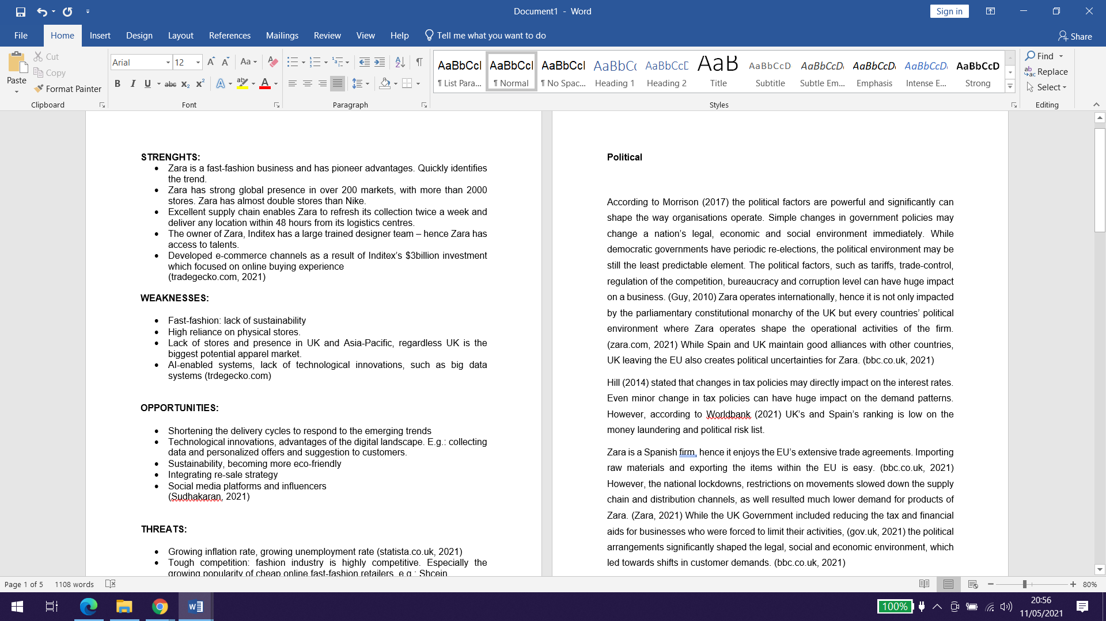
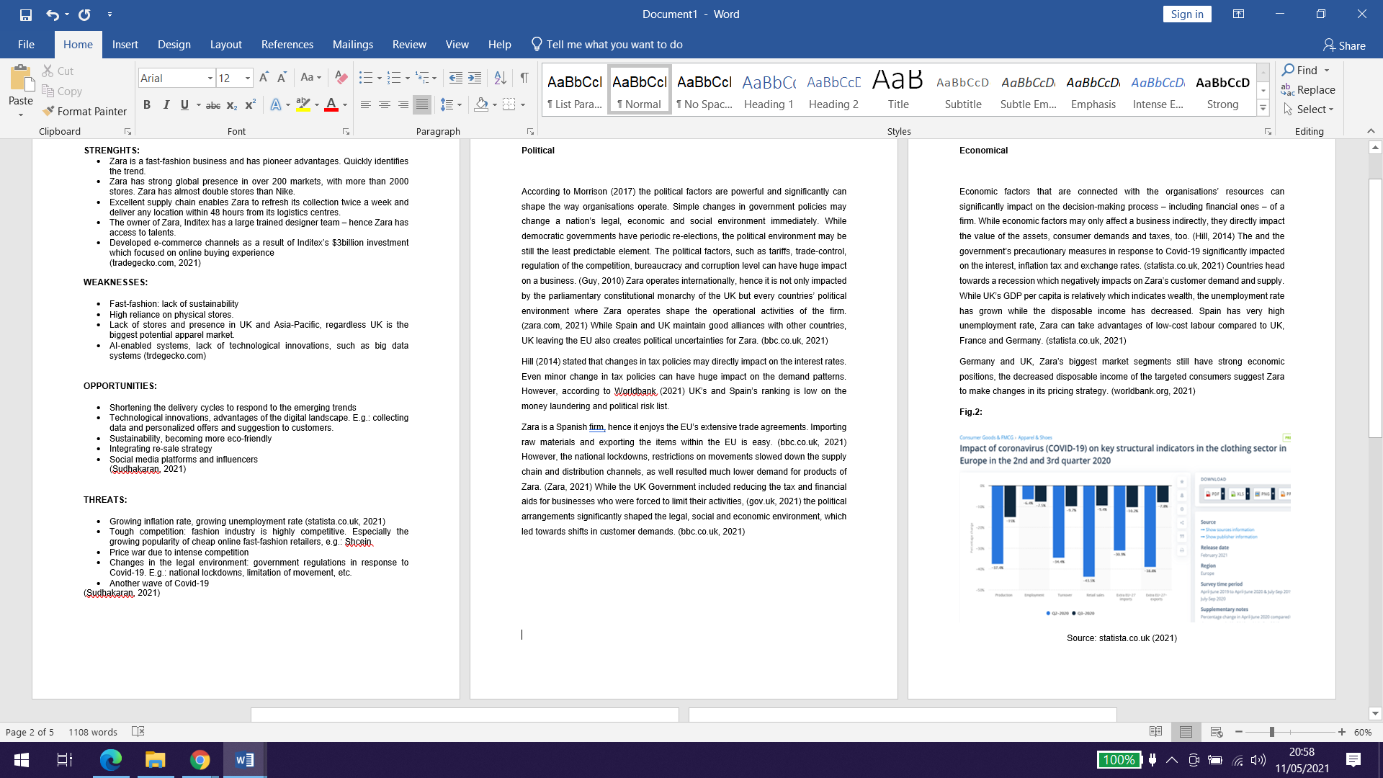

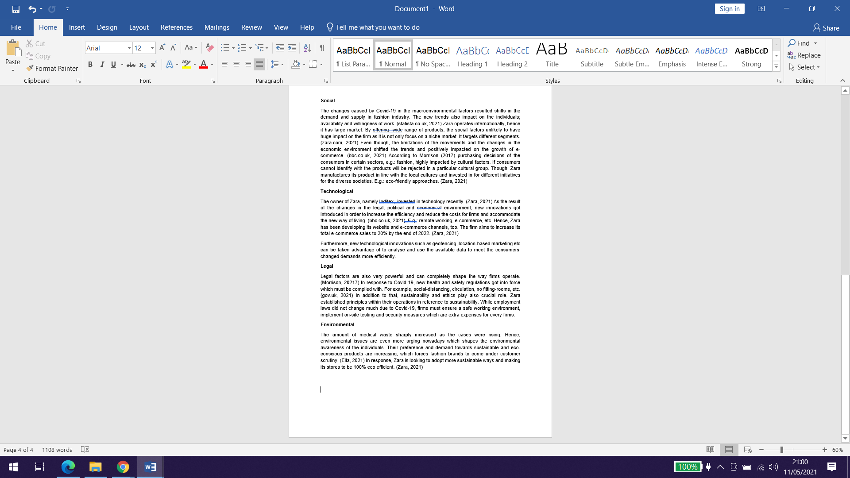

SWOT – Zara

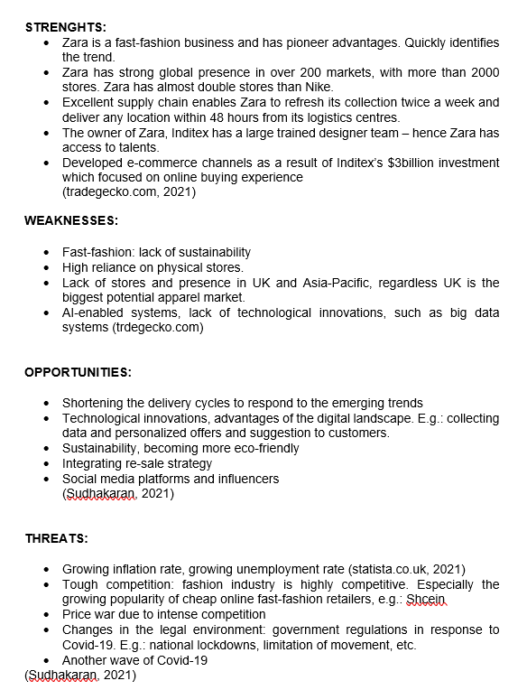
Source: own elaboration – Report 1 (2021)

