Changemakers: Building your Personal Brand for Sustainable Employment
Module Code: BMHP5015_BIRM
E-Portfolio: Evidence of Learning
Student: Sadeka Khatun (1920267) Lecturer: Chloe Harries
University of Wales| Trinity Saint David

Table of Contents
Curriculum Vitae 2
Personal Statement 3
Pitch 4
Overview 4
References 6

Curriculum Vitae
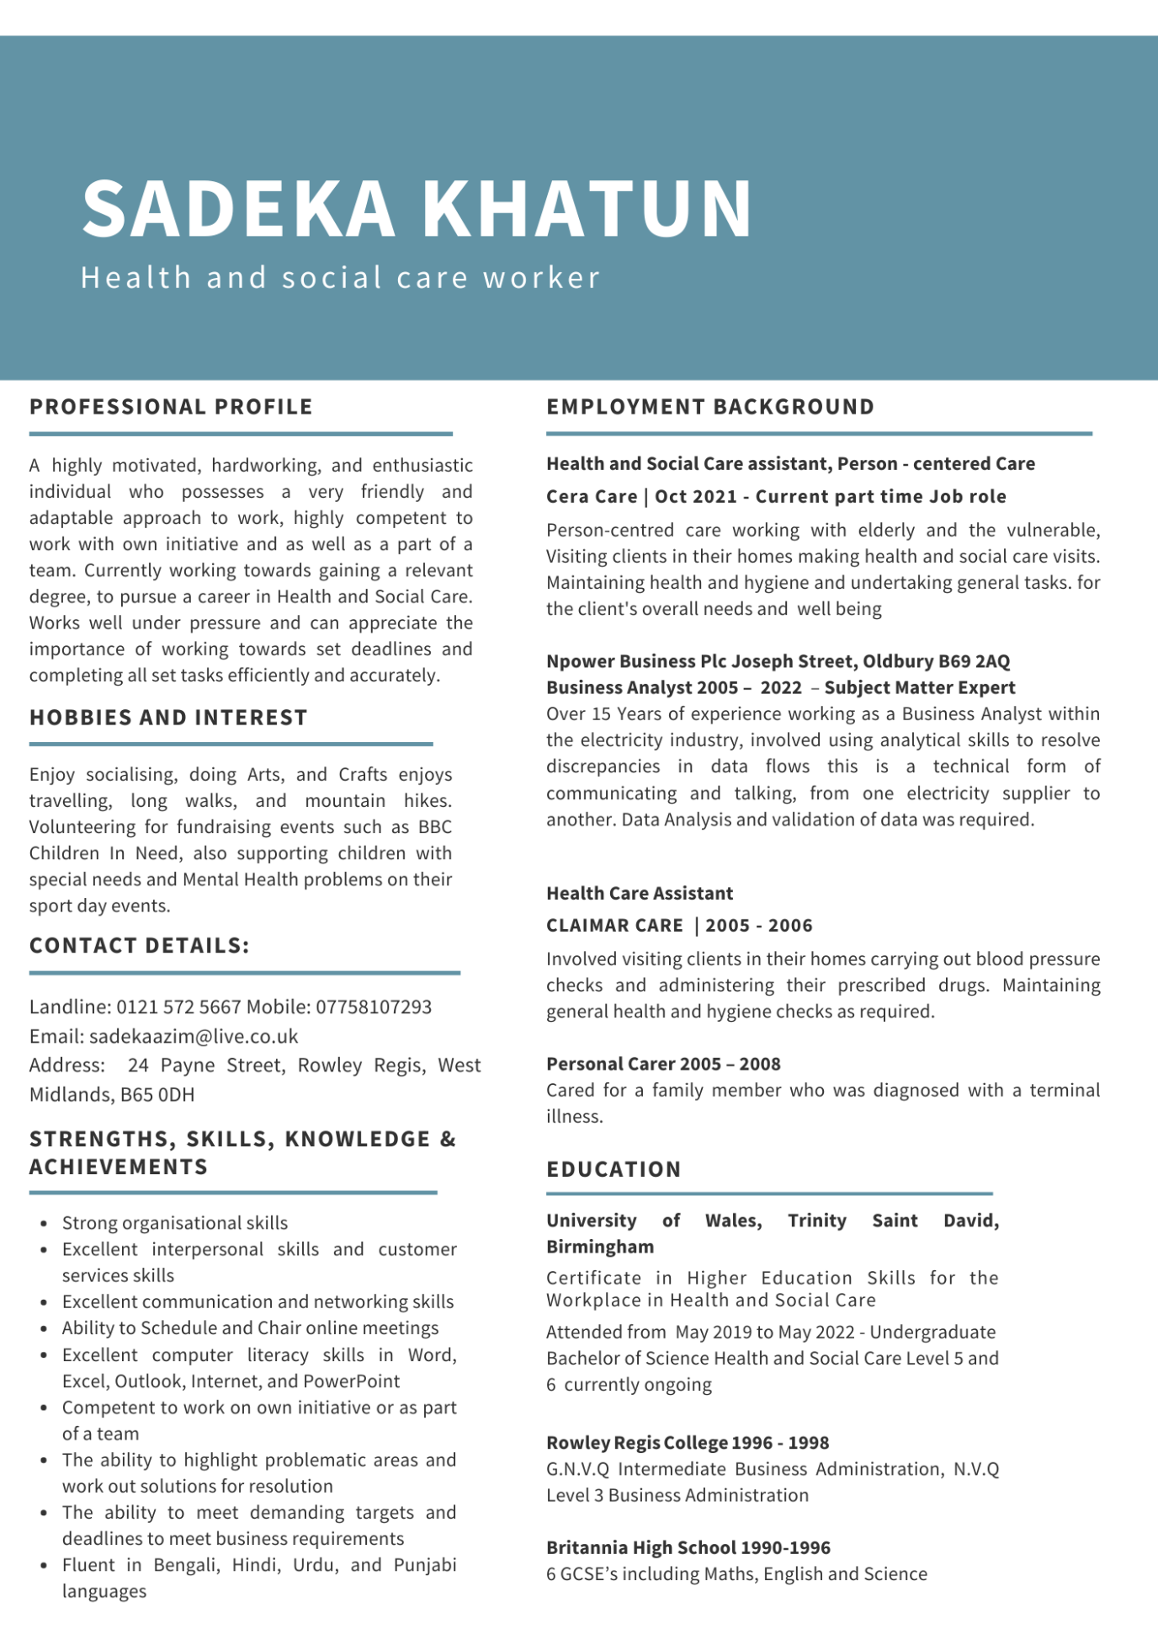

Personal Statement
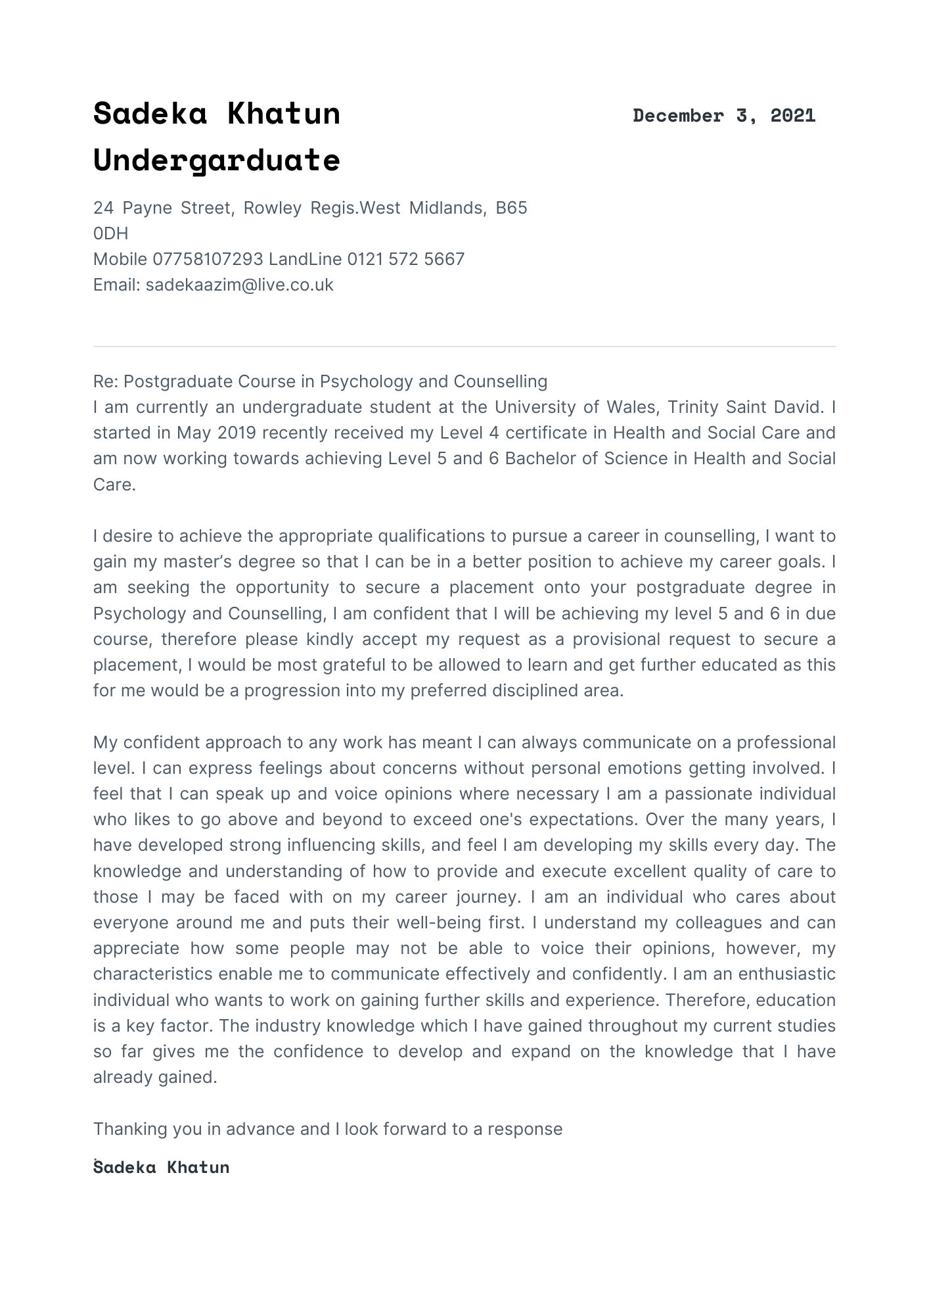

Pitch

Overview
As the new year approaches, soon will be in March, and in preparation for Endometriosis Awareness month, the proposal would be to request for the opportunity to have this awful disease as the subject area of discussion on ‘Loose Women ITV Talk Show’. The following request is for 4 episodes 15 min slot between 3rd to 9th March 2022 to be dedicated to the topic. A discussion, about the causes, symptoms, and management of the disease. In the hope that it can bring more awareness by speaking about women who unfortunately struggle with this disease day in day out for the rest of their lives. Knowledge is so important and making women aware on a greater scale via a talk show which does have a larger audience of women, what better way to create awareness to thousands and thousands of women who tune in every day, The aim is to create awareness globally. The outcome from this possible broadcast on this show would be so beneficial for the cause going forward.

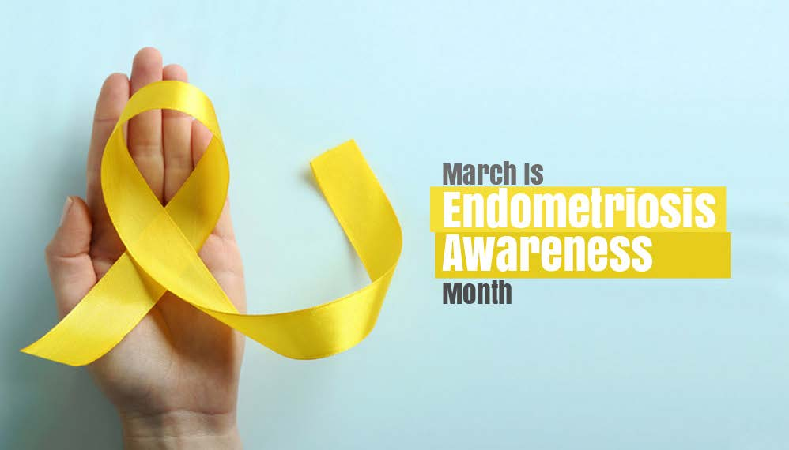
Walnut Lake OBYGN, (2019)

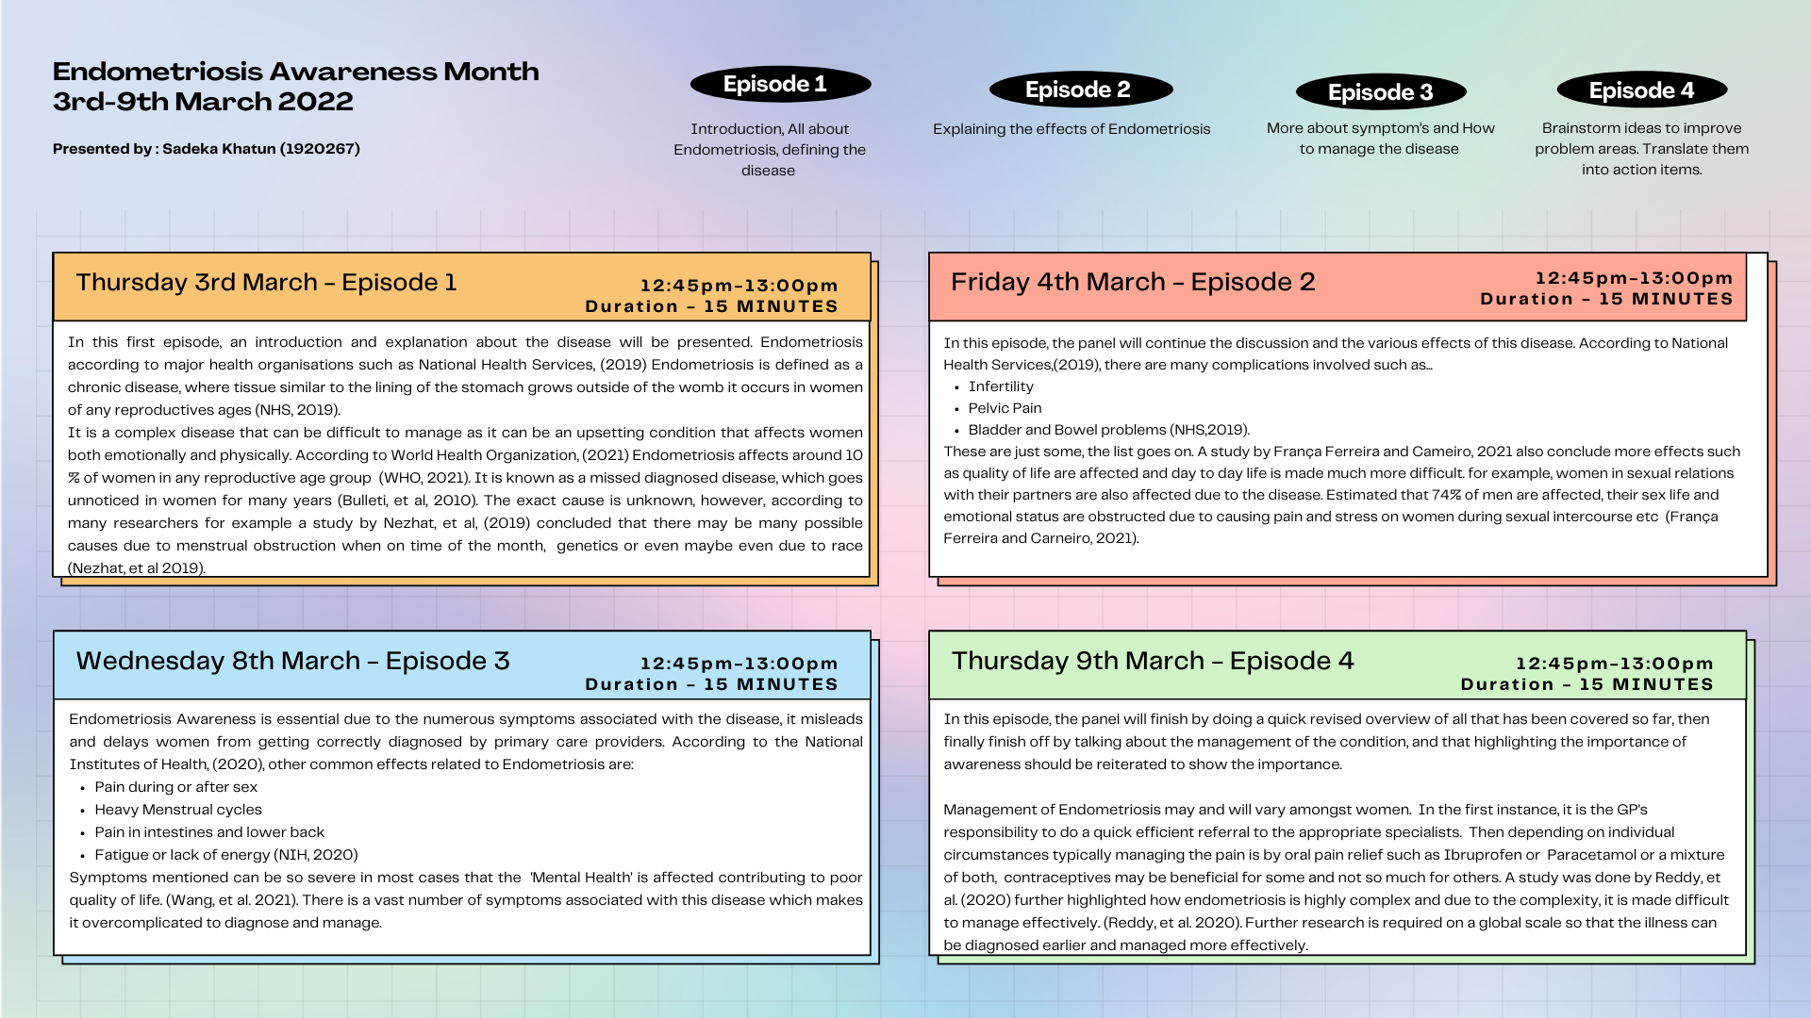

References

- Bulletti, C. Coccia, M.E. Battistoni, S. and Borini, A. (2010) ‘Endometriosis and infertility’, Journal of Assisted Reproduction and Genetics volume, 12(1), pp. 441-447.

- França Ferreira, M. and Carneiro, M. (2021) ‘Endometriosis awareness: screaming at the top of our voices’, Women & Health, 61(4), pp.323-324.

- National Health Services, (2019) Complications Endometriosis, Available at: https://www.nhs.uk/conditions/endometriosis/complications/ (Accessed: 20 November 2021).

- National Health Services, (2019) Endometriosis, Available at: https://www.nhs.uk/conditions/endometriosis/ (Accessed: 20 November 2021).

- National Institute of Health, (2020) What are the symptoms of endometriosis?, Available at: https://www.nichd.nih.gov/health/topics/endometri/conditioninfo/symptoms (Accessed: 30 November 2021).

- National Institutes of Health, (2020), Healthy Pregnancies, Healthy Children, Healthy and Optimal Lives, Available at: https://www.nichd.nih.gov/health/topics/endometri/conditioninfo/symptoms (Accessed: 1 December 2021).

- Nezhat, C. Vang, N. Tanaka, P.P. and Nezhat, C. (2019)’ Optimal Management of Endometriosis and Pain’, Endometriosis: Current Commentary, 134(4), pp. 834-839.

- Reddy, S. McLaughlin, J. Stansbury, N. and Knudtson, J. (2020) ‘Patterns in the Management of Endometriosis Among Physicians’, Obstetrics & Gynaecology, 135, p.15.

- Walnut Lake OBYGN, (2019) March is Endometriosis Awareness Month, [IMAGE], Available at: https://walnutlakeobgyn.com/march-is-endometriosis-awareness-month/ (Accessed: 30 November 2021).

- Wang, Y. Li, B. Zhou, Y. Wang, Y. Han, X. Zhang, S. He, Z.et al. (2021) ‘Does Endometriosis Disturb Mental Health and Quality of Life? A Systematic Review and Meta-Analysis’, Gynaecologic and Obstetric Investigation, 86(4), pp. 315-335.

- World Health Organization, (2021) Endometriosis, Available at: https://www.who.int/news-room/fact-sheets/detail/endometriosis (Accessed: 20 November 2021).

