Evangeline Opoku
2107270
Digital skills and research methods.

Is there a need to provide training on technological use to collaborate at UWTSD?

The report I’ve chosen is based on the question at hand “is there a need to provide training on how to use technology to collaborate at UWTSD?”I have chosen this question due to its relatability to me in this academic year and previous years. I’ll be highlighting the importance of such training with the aid of my personal research on results. In the most previous years we have all in one way or another been affected by the COVID-19. The COVID-19 has affected education in several different ways such as blended learning both online and in person, digital deck technology difficulties, individuals dropping out due to difficulties faced and the lack thereof training within the university.

Digital skills are advantageous when educating yourself and others. The use of technological skills can assist you in not only educational but also work settings. Majority of the assignments whether work or education related required the use of your digital skills. Although you may not be putting yourself in a position whereby high levels of education or qualifications are required. It is likely that your employer will require a standard or basic understanding of digital Technology. With technology growing as fast as it is today, we can see the results of more exciting job opportunities and careers in relation to technology. This means that the employees must know how to operate both safely and lady online. Working from home or a remote location for example zoom or Microsoft Teams. We can see the use of this now more than ever in both educational settings and work settings as a result of the worldwide pandemic that occurred in recent years, because of this the communication online via e-mail and social media is an important digital skill also .

Those who may have just returned to education after a long period of time can find themselves struggling with their technology for instance the use of Office 365. Without effective training it would be difficult for students to complete and understand their work to its fullest sent. Clubbing technology training can increase the access to education. This can result in the growth of the students at a university. Educators are always searching for new ways to personalise learning for their students. They can also do so by giving them a sense of ownership in the way in which they learn this can be done with the right resource is and the right training, leaving students to be problem solvers, critical thinkers and creators. If technology is introduced and used effectively in education students are more likely to develop a lifelong love of learning.

I have chosen this research question because I believe that technology has a huge impact on how successful and individuals education is and because of this I believe that technological training is essential for success. Personally I know that I have a good understanding of digital technology.But as the years have gone on technology is always evolving and without updating my training on certain use of technology I know I would and could struggle in life especially in studies as not all education institutions use digital technology in the same form .

The method of research that I used included individual conversations and observations of my classmates. In order to actively aid-research we conducted a survey with five questions. This participants of this survey consisted of seven of our classmates. The five questions in the survey asked 1. How confident are you in using digital technology at UWTSD? 2. Before starting at UWTSD , how much knowledge did you have of office 365 and all the technology required at university ? 3. Do you believe it is essential for your progress that UWTSD provide training on digital technology? 4. Which technology are you most most confident in using ? Word , excel , power point or outlook? 5. Do we have your consent to use this data in a presentation.

At you UWTSD it is clear to see this university is very welcoming and catering to mature students or students who may have not been an education for a period of time. In our class we have a mixture of mature students and younger students with the mature students taking the majority. From class observations, it’s clear to see that the majority of the students struggling with the technological aspect of the course are those who may have taken a break from education for a short while. Personally I have had to help students log into their computers, access assignment briefs and start PowerPoints.

Ethical considerations when researching our set of values and principles are essential in order to address questions of what is good or bad in human affairs. These will not only protect the participant but the researcher also. These ethical considerations were completed by ensuring our research material did not contain material that could cause emotional or physical harm to our classmates.For instance the questions were asked in a less intrusive manner or personal to the participant .We were sure to get informative concerns on all data. All participants involved had the choice to join on their own accord. Confidentiality when conducting this research was very important , you may find that not all students would appreciate nor want other students to know what they may have selected or even if they had taken part in the research.

As stated earlier on we conducted this survey to actively research our question at hand of the need of technology training at UWTSD. The results clearly stated in order for students to not only only succeed but to thrive , technological training in collaboration at UWTSD was essential.

The survey conducted contained five questions with the results of questions one being two students stated they were very confident in using digital technology, four students stated they were fifty-fifty and one student stated they were unsure of what they were doing. Question two , three students stated the had much knowledge on the use of office and digital technology, three students stated they had partial knowledge and one student stated they had no knowledge of office and digital technology. Question three resulted in 6 of the seven participants stated the needed training in order to progress effectively. Question four , three students selected word , three students selected power point and one student selected outlook and zero student selected excel. The final question was to gather consent to use the data in which all seven students granted.

Overall based on the research conducted it is apparent that the results are in favour of that hypothesis. Indeed a collaboration of training on the use of technology would be essential for the growth of not only the student with the university but as a whole, such as staff and students. With this training students can benefit when conducting and completing group tasks and assignments. Future study and research can be accessed easier for instance the instant access of lecture power points and recordings which can be accessed through the university’s moodle port and the study and workshop timetables emailed through the university’s email address which is allocated to all students. Meetings via zoom and Microsoft teams and communication with lecturers can be made easier to set up for students and lecturers.

.I was slightly surprised to see the all students until the answer the question three which was do you as she didn’t believe you need additional technology training. I was surprised you stuff like that based on class observations the students range from a choice Ian’s to young students. After you will see the younger students assisting the older students one account to technology so my prediction not two students may have said no. But if anything it shows that the collaboration is essential and you can always learn more.

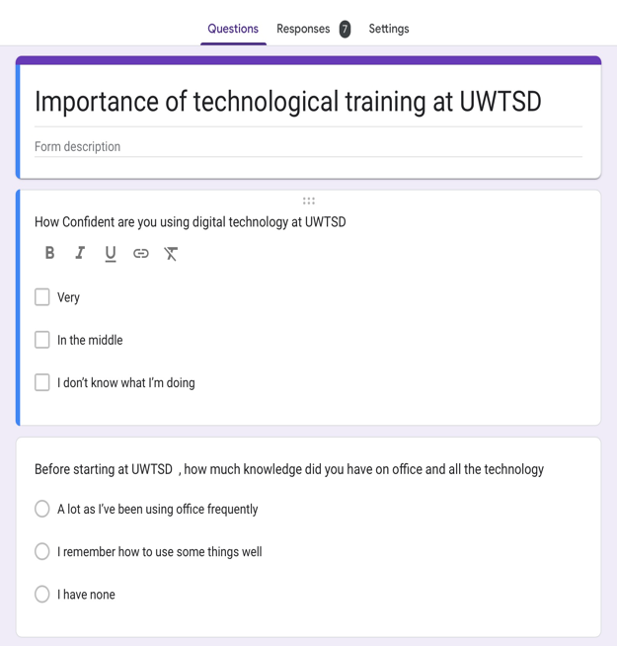
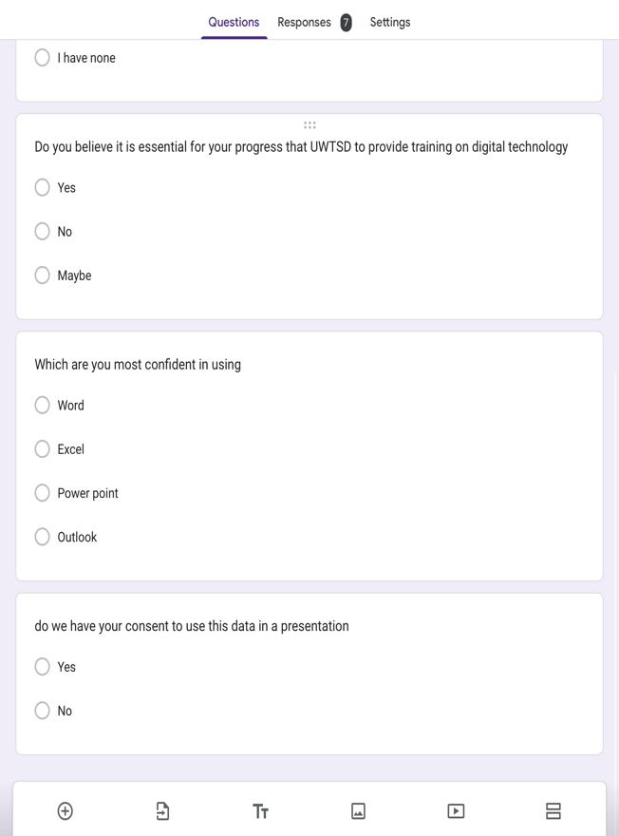
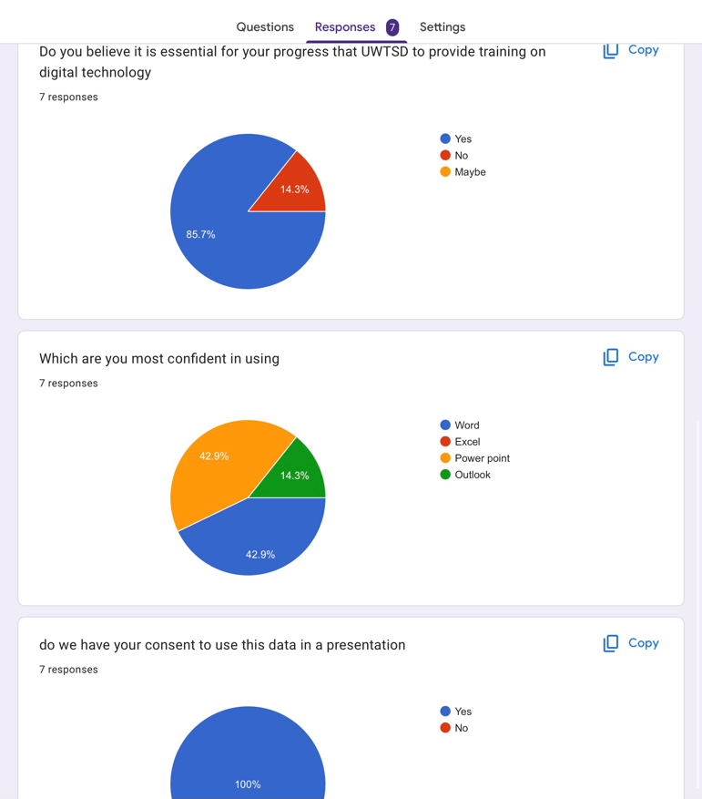
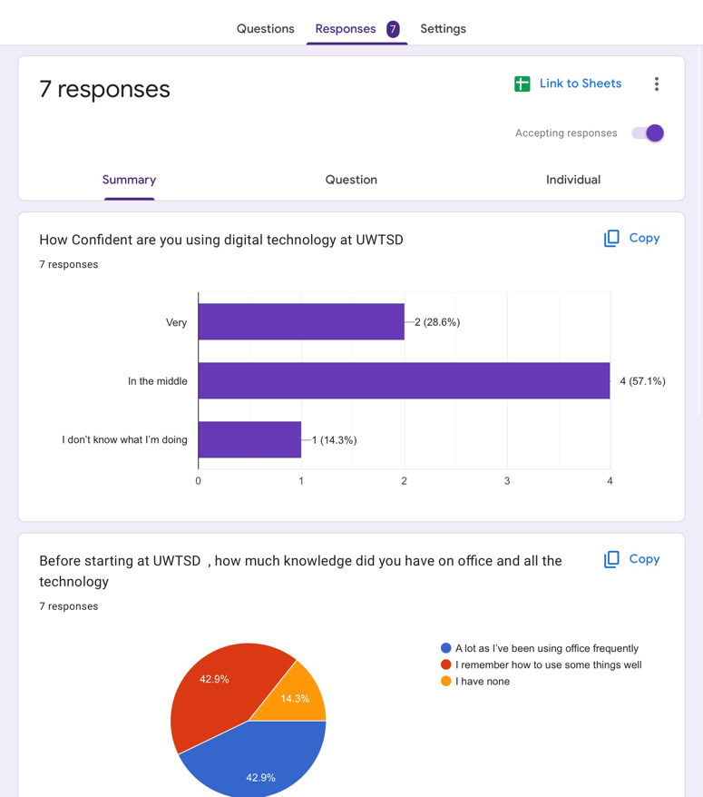

Reference list

Australian . S (2006) , Ethical Considerations , community health Research
unit n.d.c Trochim.

https://nationalcareers.service.gov.uk/careers-advice/build-foundation-digital-skills-to-help-your-career

Wiederhold.K.B (2019), Connecting through technology During the Coronavirus
Disease pandemic : Avoiding "Zoom fatigue" page 437-438

